Mission Performance Report

July – December 2018

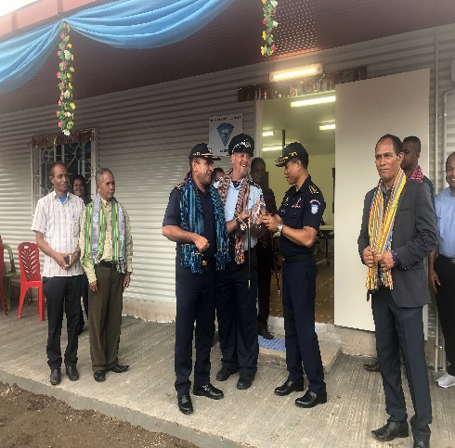
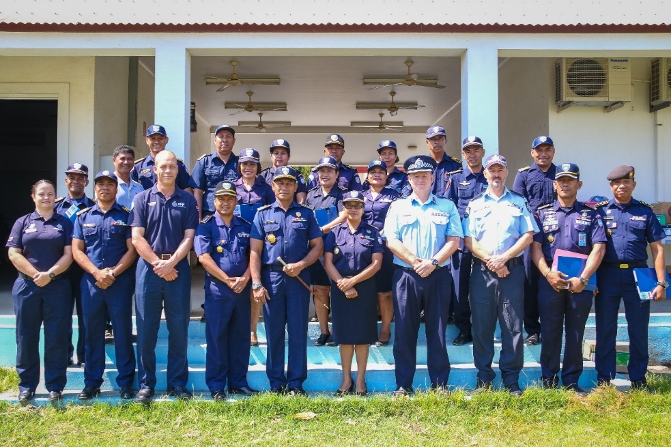
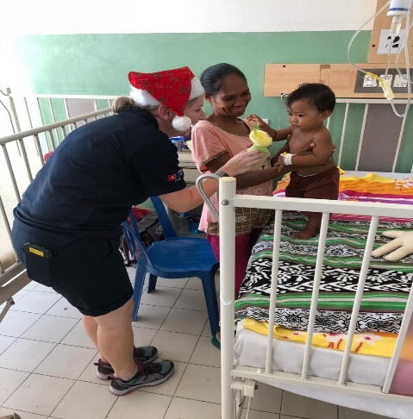
TLPDP

Overview
The primary audience for this report is the AFP-IO Executive and IO-Strategy, Development & Training (SD&T). Information provided in this MPR will be used by SD&T to develop a summary report (Development Performance Report) for the IO-Executive on the overall performance of programs across the portfolio. Other uses for the MPR include informing evaluations and other reporting requirements including senate estimates, talking points and external request for information.
MPR guidance note is available from IO-Strategy&Development@afp.gov.au and is designed to help programs complete this template.
CAVEAT – This document records results against the TLPDP Program Design 2018 – 2022 which is still in Draft form and the Timor-Leste Country Program Performance Assessment Framework (PAF).

Effectiveness
The reduction of staff to 10 members does impact upon effectiveness. TLPDP continues to deliver support in six (6) broad fields as outlined below:
- Training and Management Development
- Intelligence (SIP)
- Trans National and Serious Crime
- Information Management (IMS)
- Gender, and
- Governance
A visible indicator of effectiveness in this period has been the repeated self-analysis of performance carried out by the PNTL where issues have been identified and help sought in the first instance from TLPDP. The AFP through TLPDP is a respected brand with the PNTL. The level of trust between the two agencies is at a very high level.
The Commander of PNTL Investigations (NID) has recently performed an audit on the quality of Investigations within the PNTL. This audit identified shortcomings and previously this would have been kept for internal PNTL dissemination. The Commander of NID has identified a solution and sought TLPDP assistance in implementing it. This assistance will be delivered in the way of specialised training delivered to 40 members identified by him to champion more professional investigations throughout the PNTL. The curriculum for this training will be developed by the TLPDP supported and trained Police Training Centre Staff in cooperation with TLPDP trained Investigations Trainers (SME) and TLPDP members. The PNTL (NID) have also requested the assistance of the TNC Advisor to be an on-site advisor for active operational matters. An example of this is the TNC advisor travelled to Oecusse on 20 January 2019 to assist on a historic child sexual abuse matter allegedly perpetrated by an US national with over 100 alleged victims.
The PNTL Commander of Investigations has asked for the direct operational input of the TNC Advisor role to increase. This forms a part of his plan to upskill PNTL Investigations and his subsequent appreciation that the quality of Investigations throughout the PNTL is not yet commensurate with forming an effective Transnational Crime Unit.
In the Intelligence portfolio since the commencement of the 2018/2019 financial year TLPDP's focus has been on building the capability within SIP to develop relevant intelligence training, deliver the training and to identify improvements which will allow SIP to support the key goals of the PNTL.
Leveraging off the recent Certificate IV in Workplace Training and Assessment which was facilitated for PNTL members (SME’s), including two SIP members, SIP have taken on full responsibility for the development and improvement of the Basic Intelligence Workshop (expanding the workshop from one to two days in duration). In line with the TLPDP supported sustainable training model, SIP members have delivered this training to all PNTL District Trainers. Whilst responsibility for the maintenance of the course content will remain with SIP, the District Trainers will now be able to deliver this course across the PNTL to all operational members in a timely manner.
Effectiveness in IMS assistance has been evidenced through the PNTL now identifying future needs for the system as well as fully costing such needs. This analysis has resulted in the PNTL IMS section having a true idea of the cost of maintaining the current system as well as implementing future identified upgrades. Because of this the PNTL are now able to effectively seek funding from Government through the budget process, fully understanding that this is not an area that can be indefinitely funded through donor support. Relying on this level of evidence the Commander General has recently identified budget short falls in the Government offered 2019-2020 budget cycle and has successfully submitted a supplementary budget application.
TLPDP supported IMS trainer (SME’s) have now also effectively trained the TLPDP supported District Trainer network in the delivery of basic IMS use and data entry. This will in turn allow cost neutral training to be delivered in this area through the Sustainable District Training model (see Sustainability section below).
The effectiveness of the Gender Program is clearly evident in the undertaking of the Commander General to provide 30% female participants to all training where possible which has been the case in the past six months particularly. This is a significant achievement given that the percentage of female members is marginally over 13%.
Effective gender mainstreaming is also evident whereby all training delivered now includes topics or examples utilizing Gender Based Violence examples as well as those issues identified in the AFP IO Gender Strategy.
The effectiveness of training and management development is well documented in other areas of this document.

Efficiency
The joint TLPDP/PNTL Program Coordination Board (PCB) is key to the efficient and flexible use of TLPDP resources to assist the PNTL in priority areas. The PCB protects the TLPDP relationship with the PNTL and ensures our aims are synonymous. A positive example of the efficiencies provided by the PCB is the planning, implementation and completion of United Nations Pre-Deployment training for 19 PNTL members in October 2018.
In May 2018 a visit was made by Nobel Laureate Dr.Ramos Horta and the Commander General PNTL (CG) to the United Nations (UN) Headquarters in New York. At the request of the UN undertakings were made to the UN around the provision of PNTL members to UN missions in the future.
Because of this meeting the CG approached TLPDP to seek assistance in training PNTL members to prepare them to undergo compulsory UN testing prior to deployment. The PCB process (out of session) was utilised to formally agree to this deviation from the original agreed focus of TLPDP assistance to the PNTL. This clearly demonstrated that as Government of Timor-Leste (GoTL) and PNTL priorities shift so too can TLPDP priorities in response whilst ensuring that TLPDP priorities are still met.
In response to the CG’s request, dialogue began immediately with the PDT team and both Australia based, and Timor-Leste based solutions were considered. TLPDP Coordinator Operations and Training attended Canberra and met with T/L PDT and dates were agreed to conduct the course in Timor-Leste ensuring efficiency and economy of training due to the large number of PNTL to be qualified.
In October 2018 this course was successfully conducted in Dili with all 19 participants being deemed suitable and highly likely to pass UN qualification standards. The quality of the course was positively commented on by both Senior PNTL attending members and the T/L PDT training who stated it was the most dedicated group of students he had ever experienced (T/L PAF Indicator 8).
It is also worthy of note that this group of participants nominated by the PNTL CG contained 6 female members (30% +), which being well above the overall female ratio (13.5%) of PNTL members highlights the import on Gender Equity promoted by the CG (T/L PAF indicator 14).
This course clearly demonstrated effective bi-lateral cooperation between Timorese and Australian based AFP teams and the PNTL to achieve a priority goal for the PNTL. It has strengthened the capabilities of the PNTL, ensured their capacity to serve in an International role and improved the reputation of the PNTL with the GoTL and the Timorese public.
The United Nations testing team is scheduled to attend Timor-Leste in January 2019 to undertake testing of this group preceding the offer of a Mission.

Sustainability
OUTCOME COMPONENT 1 – Sustainability, Self-Improvement and Organisational Leadership
TLPDP has invested heavily in the upskilling of trainers and provision of high quality learning environments in the past three years along with capacity developing the ability of trainers to effectively prepare training proposals for consideration of TLPDP funding. To ensure sustainability and continual improvement PNTL instructors have been mentored and developed by the TLPDP to:
- Develop Curriculum utilising Subject Matter Experts and in accordance with Organic Law and Internal regulations.
- Identify and implement required training
- With the support of the CG recommend mandatory training requirements
- Deliver and Assess Curriculum, and
- Cost Training and prepare budget requests (to Donors due to non-funding by GoTL)
In the past six months TLPDP have fostered these improvements through:
- The provision of Training to Trainers including Certificate IV in workplace training and assessment.
- Fostering and Maintaining an environment of cooperation to encourage PNTL to approach TLPDP and seek assistance where THEY identify a need. These requests are provided by way of proposal showing cost benefits, expected positive effect, proposed curriculum and target audience.
- Upskilling of SME from various PNTL functional units through Cert IV training to support Police Training Centre members with expertise and experience in the development of specialised training.
- Upskilling of District based trainers to centralise the formulation of training and de-centralise the delivery culminating in consistent quality training delivered to a much broader audience
- Providing quality training infrastructure and equipment, and
- Assisting in the writing and adoption of Standard Operating Procedures (SOP’s).
An example of sustainable improvement and demonstrated leadership utilising TLPDP provided skills and resources is the recently adopted KSOT course (Course to develop Senior Sergeants to prepare for promotion to Inspector rank).
This course curriculum has been developed entirely by PNTL trainers and includes topics on Gender Violence, Ethics, Accountability and Leadership at the request of TLPDP.
The proposal presented to and ultimately endorsed by the TLPDP executive was highly professional. It was budgeted accurately and represented real value for money. It clearly articulated expected improvements and benefits and was appropriate for the target audience.
This course in the last six months of 2018 was delivered to over 120 prospective Inspectors in five different districts utilising TLPDP provided facilities and delivered entirely by PNTL Instructors. The course is now deemed highly desirable for any application for Inspector Level promotion.
Whilst a brief example, this clearly demonstrates an increased understanding of business principles, an improvement in the quality of training developed and delivered by the PNTL and a very positive and sustainable return on investment for TLPDP. Whilst 100% sustainability cannot yet be claimed the provision of TLPDP input and funding for this course is now limited to minor Instructor fees and per diems and minor additions to curriculum to include contemporary policing and business principles.

Gender Equality
Please identify the top three domestic and/or transnational gender-based crime types and partner police capability in your host country or region.
Crime type  (i.e. domestic violence, human trafficking; sexual abuse, exploitation (including online/ cyber etc.) | Data source  (i.e. how do we know this) | Partner police capability
Mistreatment of Spouse | – Source – PNTL Annual Crime Statistics Report 2017 | Limited to VPU/NID (maybe some NGO’s)
Sexual Assault | Source – PNTL Annual Crime Statistics Report 2017 | Limited to VPU/NID (maybe some NGO’s) Psychosocial Recovery & Development in East Timor (PRADET) victim medical and emergency accommodation service and ALFeLa (legal service)
Human trafficking/Sexual Servitude | There is no statistical data available for TNC related offences (it’s not recorded), TNC Advisor, advised this is the most prevalent gender based offence. | The Partner Police capability is through the NID. They are extremely under resourced and supported, by both the Executive and Government.

IO Gender Strategy Theme: Lead and Role Model
[This includes improving gender composition of International Operations deployments and Gender Mainstreaming across deployment activities]
[For example: What initiatives have the AFP implemented to mainstream gender in i.e. advocacy and influence work with senior police partners; gender advisor/focal point role; including gender considerations in work plans]

TLPDP is aware of the IO Gender Strategy 50:50 gender composition and is working towards this target.

Gender focused issues are a consideration by TLPDP Advisors across all projects and programs. For example, the TLPDP supported Annual Investigator’s Conference involved 60 Police National Timor Leste (PNTL) senior investigators plus three (PNTL) mentors of which 13 were females (20%). There was good balance of male and female presenters and TLPDP mentors included both genders. Additionally, the course was largely scenario based with one of the two transnational crime themes being based on the gender-based crime of human trafficking.

Notably, the Locally Engaged Les (LES) who works with TLPDP Gender Advisor is male; he is extremely well respected by both PNTL and TLPDP and he demonstrates how males can champion change in the gender space.

IO Gender Strategy Theme: Build Capability
[This includes improving gender composition and capacity with partner police and improving capability on gender related law enforcement operations]
[For example: How is the AFP supporting partner law enforcement responses to gender based domestic and transnational crimes (as identified in above section – top 3 gender based crimes]

During the reporting period, TLPDP commenced a new development program (2018-2022) that aims to assist the PNTL to put in place frameworks, processes and pathways that enable and support women to become more effective members of, and contributors to, the PNTL. Furthermore, the project will continue to develop initiatives to reduce domestic violence in Timor-Leste by improving PNT’Ls policing responsiveness to domestic violence and other gender related crime.

TLPDP has worked closely with the PNTL Executive to encourage them to eliminate barriers to women’s participation within the organization. As a direct result of this outstanding relationship, the CG has given an undertaking to C-TLPDP that where possible, 30% of participants will be females on all TLPDP sponsored/ supported training courses. This was demonstrated in October (2018), 19 Police Officers, including six females (32%) completed the inaugural UN Pre-Deployment Training in Timor Leste sponsored by TLPDP. Feedback from the course coordinators was that the officers, who ranged from middle to senior ranks, worked extremely well together as a respectful cohesive unit, regardless of gender.

The most significant TLPDP GBV project that commenced during this period was planning for the construction of a new VPU facility at Dili District Police Station. The new structure will replace the dilapidated, inadequate building that is currently being used at the station. This location was chosen because Dili has the highest recorded cases of GBV in Timor Leste. The aim of the project is to improve services for victims and witnesses of GBV by providing a secure, modern, professional facility for the VPU which will in turn encourage victims and witnesses to report GBV crimes therefore, strengthening community confidence in the PNTL.

IO Gender Strategy Theme: Engagement & Collaboration
[This includes increasing stakeholder engagement and collaboration including across AFP, Government agencies, NGO’s and Civil Society

[For example: How are AFP supporting partner police to collaborate and engage with external agencies or NGOs to address gender based crimes?]

TLPDP continued to support the PNTL Gender Working Group which is the PNTL’s primary coordination platform for engagement with government agencies, aid partners and NGO’s. The forum meets quarterly to discuss individual programs and share mutually beneficially initiatives. The OIC of the Gender Unit has shown an increased understanding of the importance of cooperation and collaboration to achieve organisational objectives. However, the TLPDP Gender Advisor still drives and manages this forum because the Gender Unit is still somewhat dysfunctional and lacks basic modern administration skills. Furthermore, OIC Gender Unit has no respect for the team members, subsequently, team members have no faith in her leadership. TLPDP continues to work to develop the capability of the members of this team.

The TLPDP Gender Advisor attended DFAT led gender and disability forums including the quarterly Gender and Disability Workshop and the Gender and Disability Community of Practice event. Outcomes include enhanced network contacts and information sharing about achievements, challenges and current programs which allows the TLPDP to have a holistic appreciation of Australian aide programs in Timor Leste.

During the reporting period, the OIC of the National VPU (NVPU) has increased his engagement with other stakeholders and partners who are working in the GBV space. This is largely due to the TLPDP’s mentoring and support that has enable the VPU to realise that collaboration and strong partnerships with other organisations will enhance the PNTL’s effectiveness. For example, the OIC of the NVPU proved direct advice to The Asia Foundation in the development and launch of an application (App) for smart phones and (soon to be) website in Timor Leste. The App lists the phone numbers of all referral network members (VPU, shelters, PRADET, ALFeLa) in each municipality, their hours of operation, their location and short description of the services that they provide. The launch occurred during activities in support of International Day for the Elimination of Violence Against Women, 25 November 18.

Risk Management
[How is risk being managed? Discuss issues that have arisen over this reporting period. Highlight ongoing risks for relevant themes and how the program is managing and mitigating these.]
Each portfolio has identified and treated risks within the project management work frame.

Checklist
Please submit to IO-Strategy&Development@afp.gov.au by 15 January or July for each period.
☐ Up-to-date project work plan or project register or guiding is included
☐ ODA training statistics spreadsheet is completed and included
Author/s | Geoffrey Turner, Ross Williams, Sandra Allan
Cleared By

Case Studies/Other Supporting Material

