Mission Performance Report

July – December 2019

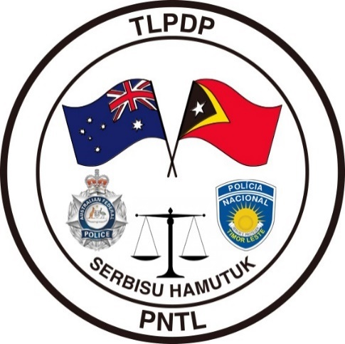
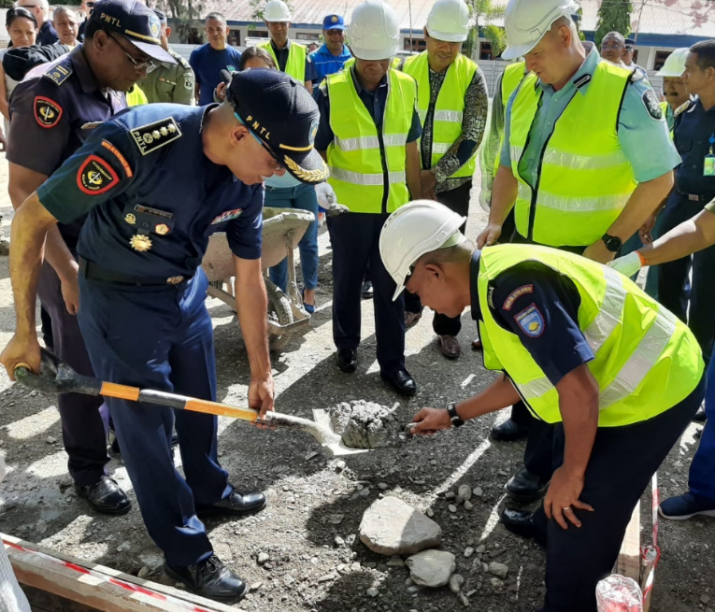
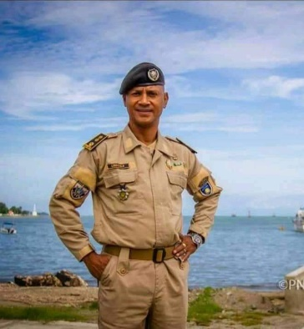
TLPDP

Overview
The primary audience for this report is the AFP-IO Executive and IO-Strategy, Development & Training (SD&T). Information provided in this MPR will be used by SD&T to develop a summary report (Development Performance Report) for the IO-Executive on the overall performance of programs across the portfolio. Other uses for the MPR include informing evaluations and other reporting requirements including senate estimates, talking points and external request for information.
MPR guidance note is available from IO-Strategy&Development@afp.gov.au and is designed to help programs complete this template.
The TLPDP is a bi-lateral capacity building program providing assistance to the PNTL and is supported by the RDTL and the Government of Australia. The objective of the TLPDP has been to assist the PNTL to build the foundations of an effective and accountable police service. The design builds on three previous phases of support in developing the PNTL.
The overarching objective of the Program is for the PNTL to deliver skilled and professional policing services which respond effectively to community needs and contribute to a stable and secure Timor - Leste.
Three core components contribute to the achievement of those goals;
- Sustainability, Self-improvement and Organisational Leadership
- Operational Effectiveness, and
- Responsive Policing Services.

The TLPDP uses a bi-lateral approach under a joint management agreement through a Project Coordination Board (PCB). The PCB meets quarterly to discuss progress to date, monitors outcomes and provides a forum for the introduction or modification of new and existing programs or projects.
The six months covered by this report has been a difficult period for the program with political uncertainty affecting our ability to deliver on some programs. A request from the Minister of Interior for the TLPDP to assist in a reform process for the PNTL would require an expansion of the program, a considerable increase in the funding level and an increase in the FTE requirement for the TLPDP.
The undersigned led a delegation, including the Minister of Interior (MoI) to Melbourne on 7 November 2019 to meet with the Minister for Home Affairs to discuss this request. The Minister was supportive in principle pending discussions with his Ministerial Counterpart – the Minister of Foreign Affairs and Trade. In January 2020 a submission was sent by the AFP to Minister Dutton seeking his intent based on several options for an expansion of the program. Despite the intent of the 2017 Foreign Policy White Paper in relation to Timor Leste (Chapter Seven – A shared agenda for security and prosperity, pp 105-106), the much lauded Australia-Timor-Leste bilateral reset and the Australian Prime Ministers visit to Timor Leste, DFAT is reluctant to support any expansion of the TLPDP or to increase the level of funding. This was communicated to the Minister as part of the AFP’s submission.
Priorities for the remainder of FY 19/20
PNTL Reform Process
The MoI has instructed the PNTL (February 2020) to prepare a fifteen-year reform project for the PNTL with the assistance of the TLPDP. The initial reservations for both DFAT and TLPDP has been the ambiguity around the level of support from within the government of Timor-Leste for the Ministers reform process.
On 18 February 2020, the undersigned met with the 2nd Commander General of the PNTL who has been appointed the change manager for the PNTL Reform Program. The 2nd CG stated that the major political parties had committed to bi-partisan support of the PNTL reform program. The 2nd CG has enlisted TLPDP support to assist in a road map for change and a Strategic Plan for 2020-2035. The 2nd CG is to brief the Council of Ministers on the reform program and secure agreement prior to the PNTL Anniversary on 27th of March 2020. It is anticipated that the reform program will be announced by the government on PNTL Anniversary day.
There is an expectation that Australia will play a significant role in the reform process and expectations are going to have to be managed. The Australian Ambassador has been briefed on the reform proposals. TLPDP has bought forward a proposal to conduct a True Cost of Policing Analysis (TCoPA) and this has been assessed by AFP IO-Strategy and approved by Commander Pacific. The intent is to use this independent assessment for the RDTL to understand the costs associated with the reform process and the need to secure funding from its own sources. The reform process is beyond the scope and funding level of the TLPDP and other donor nations. The 2nd CG has stated that the RDTL is aware of this and is prepared to fund the reform project based on the TCoPA and the reform plan and strategy. It is envisaged that the TCoPA will commence in April 2020 and be completed within three months. TLPDP are submitting tender documents in late February 2020.
Monitoring and Evaluation
In November 2019 the undersigned requested the mid-term review be bought forward six months over my concerns on the TLPDP monitoring and evaluation framework as well as ensuring this was completed prior to the new Mission Commander commencing duties in May 2020. The final report is yet to be completed but the key findings articulate that the TLPDP has excellent relationships, is delivering on the intended outcomes as defined in the Program Logic 2018-2022 and has demonstrated flexibility in program delivery in a complex political environment. It has, as expected, also identified that TLPDP Monitoring and Evaluation procedures are inadequate and make it difficult to measure the effectiveness of the project.
The Evaluation team met with the DFAT funded M&E House and have recommended that the TLPDP not utilise them for M&E support (M&E House is currently being reviewed by DFAT and receives $9 Million in funding (2017-2021)). A number of proposals are being considered including a FIFO model or the use of a locally engaged contractor to design a more effective suite of documents and measures to ensure TLPDP complies with its M&E obligations.
A small team from TLPDP has drafted documents and processes as we work with the evaluation team and DFAT at post to ensure we have the right tools and systems in place.

Effectiveness
OFFICER SAFETY – Use of Force Training
Following an unlawful Police Shooting in November 2018, by off-duty PNTL officers, the Commander General of the PNTL requested the assistance of TLPDP to formulate a training package to assist in lessening the risk of this type of incident reoccurring. TLPDP are leading a project with International partners including the New Zealand Police and United Nations and have developed a human rights focused Officer Safety Course for delivery to all PNTL members.
In April 2019, 41 PNTL members were selected to become OST instructors and undertook a four-week Certificate IV in Workplace Training and Assessment Course, followed by a six-week instructors’ course which graduated in June 2019. The PNTL now have certified trainers and an approved OST curriculum. In addition, the Norms of Operations Procedures (NOP’s) have been authorized and the district trainers are now included as part of the Police Training Centre as opposed to coming under the command of individual districts.
The current Timor-Leste Decree Law covering the Use of Force, and the PNTL Normal Operating Procedures (NOPS), both contain similar areas as the UN model (understandably, as they were initially developed in consult with UN), however, there is no ongoing training in Use of Force that helps to reinforce the ‘range of means’ available to police when dealing with an incident that may involve force, and the Human Rights issues involved.
This project has taken longer than anticipated, but once the new Operational Safety Manual is approved by the CG, the OST’s in the districts will be delivering an initial five-day refresher across the whole of the PNTL, which will be followed by an annual two-day requalification. Successful completion will result in the issue of their Operational Safety Permit to carry and use each ‘range of means’. Each member must maintain their qualification in a particular accoutrement to be issued for their shift. (Most equipment will be patrol issue and the funding for personal issue does not exist).
TLPDP is currently negotiating with the US Security Advisor in Timor Leste who believes they may be able to fund this as part of a US step-up in Timor Leste and is currently progressing this through the Department of Justice and the US State Department. (Patrol issue also assists with accountability of equipment). In addition to the classroom component of the five-day refresher PNTL instructors will deliver training in the use of batons, handcuffs, and OC Spray. The refresher will culminate in assessment scenarios which will range from Presence/Communication scenarios, to the use of lethal force scenarios. This places the PNTL in line with the UN ‘ongoing professional training’ requirements of member states and Law Enforcement Officer obligations for Use of Force.

The CG has also asked that new NOP’s be developed for the implementation of a revised Use of Force Policy, the governance around the issue of accoutrements and Operational Safety Permits, and the conduct of training by the OST’s in all districts. This has been drafted and currently sits with the Commander of the PTC. Training equipment has been procured for the purpose of the delivery of Operational Safety Training in each District. This training will take place in the TLPDP built District Training Centres. Currently the equipment is held by TLPDP until the Manuals and NOPs have been approved by the CG.
Further TLPDP involvement for this financial year will be the printing of Use of Force report books, Manuals, Operational safety Permits, Critical Decision-Making Model posters for Police Stations, and the supporting of PNTL PTC trainers to visit Districts to quality assure the training that is being delivered by the OST’s.
VULNERABLE PERSONS UNITS (VPU)
Timor-Leste has high rates of Gender and Family based violence. TLPDP continues to support PNTL’s response to the victims of Gender and Family based violence through the Vulnerable Person Units (VPU).
n August 2019, TLPDP provided PNTL with a new VPU which is located at Dili District Police station. The location was chosen as Dili has the highest recorded cases of Gender and Family based violence in Timor Leste. The unit consists of three separate pavilions under one roof line which includes a modern office and reception area, interview rooms and temporary crisis accommodation. The facility improves services for victims and witness of Gender and Family based violence by providing a secure, professional environment for the PNTL VPU Investigators to operate. A TLPDP Gender Advisor is imbedded in the unit working hand in hand with PNTL VPU Investigators with a mandate to improve their investigative methods and victim care.
As a direct result of the TLPDP Advisor working within the VPU a number of areas requiring further support have been identified, including a need for specialised training in sexual assault, child abuse and first response to domestic violence incidents. As a result, TLPDP with the assistance of PPDPR, Subject matter experts from Canberra Sexual Health Centre and Canberra Child at Risk Health Unit, will deliver a two-week course to all VPU Investigators in May 2020. In addition, a First Responders to Gender and family-based violence module is being developed and added to PNTL’s current First Responders training program.
In October 2019, two PNTL VPU Investigators were part of the TLPDP sponsored two-week Northern Territory Police (NTP) Observation trip. The VPU Investigators spent time with the NTP Sexual Assault and Child Abuse Teams including a visit to two remote indigenous communities which have very high rates of child abuse incidents. As a result of this visit, a new PNTL VPU Victims Support Working group was established. The working group is held quarterly and is attended by numerous PNTL partners and NGO’s.

The working group is a coordination point for partners and NGO’s wishing to provide Gender and family-based violence training to PNTL and a forum, to ensure all victims who attend a VPU are provided with the support services available, including medical, legal and housing. The meetings are attended by PRADET, FOKUPERS, ALFELA, UN WOMEN, CASA VIDA, MSS, CODIVA, UNDP and UNICEF.
In November 2019, TLPDP supported PNTL in the creation of a Gender and Family based violence brochure. The brochures are titled ‘It’s never your fault’ and contains educational information on Gender and Family based violence and contact telephones for PNTL’s VPU’s. 14,000 copies of the brochure have been produced and TLPDP are supporting PNTL VPU Investigators deliver Gender and Family based Prevention Presentations in the districts, where the brochures are being distributed.
ASSISTANCE WITH TRANS-NATIONAL CRIME INVESTIGATIONS
The PNTL are aware of their exposure to Trans-National Crime Issues due to their geographical location and difficulties in policing their borders. TLPDP continue to focus on this area with the PNTL and have continued with the development of the identified 40 Investigators to undergo extensive Investigations training to form the nucleus of a Trans-National Crime Unit.
In conjunction with PNTL a major new Trans-National Crime Centre has been planned and designed and construction has commenced. The TNC building has been communicated with the Minister of Home Affairs through AFP International Operations as part of the Pacific Step-Up. The TNC building is due for completion in September 2020.
FORENSIC ADVISOR
A TLPDP Forensic Advisor has commenced in mission and is currently conducting a scoping project around capability and capacity. A partnership has been established with Northern Territory Police (NTP) Forensics as well as connectivity with the AFP Forensics Working Group. Recommendations and project proposals are to be forwarded for consideration as part of the PCB and AFP/DFAT Steering Committee for FY 20/21.
LEARNING AND MANAGEMENT DEVELOPMENT
During the reporting period, TLPDP and consulting company New Intelligence delivered Authority, Accountability and Responsibility (AAR) training for 46 senior officers of the PNTL. Part of the learning outcomes for this course required attendance over a number of days combined with a number of modules to be completed between periods of face to face training. Thirty-Five (35) of the Forty-Six (46) participants have completed all AAR tasks. The completion rate of 76% was the highest that New Intelligence has achieved anywhere in the Indo-Pacific with most countries only recording a completion rate of between 30 and 45%. A train the trainer component is planned for FY 20/21.

NORTHERN TERRITORY POLICE OBSERVATION PROGRAM
TLPDP supported the NTP Observation Program which saw nine (9) selected members of the PNTL undertake police observation duties in Darwin and remote communities. A paper submitted by the Commander of the PNTL Police Training Centre (PTC) on his return from the NTP Observation Program has been a major catalyst of the RDTL PNTL reform agenda. The paper recommended a number of changes to the structure, training regimen and composite of the PNTL.

Efficiency
The TLPDP has delivered some significant projects during the reporting period, in particular the completion of the Dili District Vulnerable Persons Unit – on time and on budget, the continuation of the core investigators training continuum, the NTP Observation Program and the move to the new Use of Force model across the PNTL.
TLPDP has entered into several strategic partnerships for the joint development of programs, particularly with the NZ Police and the US Regional Security Advisor. Traction with Portugal and the GNR remains problematic.
Further efficiencies have been met through the in-principle agreement with the Northern Territory Police Force to continue with the second phase of the observation/embedded program with selected officers of the PNTL to undertake training in FY 20/21 – primarily aimed at general duties policing supervisors, traffic police and sexual assault investigators.
The PNTL are still pushing for the development of a detector dog program in the PNTL. This is not supported by TLPDP or the ABF dog detector program. The TLPDP is currently evaluating drug detection equipment (Tru-Narc and Tru-Defender) as well as the introduction of Automated Fingerprint Identification Systems (AFIS) as being a more suitable approach to drug identification and deterrence in Timor Leste.
Adherence to budget has been a challenge as TLPDP has to deal with a fluctuating US dollar for projects and associated costs in Timor-Leste. TLPDP is currently on budget for FY 19/20.

Sustainability
Sustainability within Timor-Leste is a challenge as the budgets of organisations are small and predominantly service the salary costs of staff and minor administrative budgets. The RDTL are currently operating on the duo-decimal system due to the budget impasse and political uncertainty. The TCoPA is to be used to identify the level of funding required by the RDTL to adequately fund the PNTL.

Gender Equality

IO Gender Strategy Theme: Lead and Role Model
As at January 2020, TLPDP comprises of nine members including one contracted through Coffey International, seven males and two females. TLPDP together with IO Resourcing are working to improve the gender composition of deployed members in Timor-Leste.
TLPDP uses a Gender Mainstreaming Checklist in development of all projects and training courses. The checklist is completed by the event/ program manager together with the Gender Advisor. It is a living document that is amended if required as the program develops. A measuring tool has also been developed to record, evaluate assess and implement required changes for future training and programs.
To reinforce gender mainstreaming considerations, an operationally consultative diagram has been developed that is in line with the checklist. The diagram is made available in all operational workspaces as a referral tool for all TLPDP Advisor to consult.
In July 2019, TLPDP Gender Advisors attended the inaugural AFP IO Gender Advisor’s Workshop in Canberra. TLPDP was selected as part of a discussion panel to speak about AFP efforts to promote gender equality offshore as it is acknowledged that TLPDP is successfully incorporating gender mainstreaming into all its programs and projects.

IO Gender Strategy Theme: Build Capability
The current disaggregated breakdown of PNTL members as at January 2020 is:
Total 4164 Females 622 = 15%
Constable ranks 2751 - Females 401 = 14.57%
Sergeant ranks 1072 - Females 189 = 17.6%
Inspector rank 283 - Females 30 = 10.6%
Superintendent rank 55 - Females 3 = 5.45%

There is a total of 622 female police officers listed at all ranks. Male officers dominate all divisions within the PNTL, from the highest level of command to the lowest level of constable, including at all decision-making levels.

Improvements have commenced in this area with the introduction of the recently released PNTL Gender Strategy. The strategy is assisting PNTL to provide appropriate services that meet the security needs of the community in Timor-Leste and ensure inclusive institutional participation within the PNTL. Furthermore, the Strategy will support PNTL’s efforts to fulfil its responsibilities under the National Action Plan for UN Security Council Resolution 1325 on Women, Peace and Security (2016 -2020) and the National Action Plane on Gender Based Violence (2017-2021).
With the Implementation of the Gender Strategy, PNTL seeks to achieve two key impacts by the year 2022: 1) Guarantee that female and male PNTL officers have equal access to opportunities for training and equal access to education; and 2) Guarantee that the laws, policies and regulations that govern PNTL reflect gender equality. TLPDP will continue to support PNTL with the implementation of the recommendations.
In September 2019, TLPDP sponsored the PNTL Gender Team Chief Inspector and a district second Commander’s attendance at the Australasian Council of Women and Policing (ACWAP) Conference, themed ‘Collaboration – The future belongs to us.’ The conference focussed on how law enforcement responds to women in communities we serve and how leadership can be strengthened especially for women. Whilst in Canberra, they also met with Learning and Development Commander, Kylie Flower, to discuss strategies used by the AFP to support women becoming more effective leaders, female recruitment and university scholarships.
In November 2019, TLPDP produced two videos as part of a PNTL gender balance marketing and recruiting project. The themed videos highlight female PNLT officers actively performing their roles as well as the importance of gender balance in law enforcement. AFP Media team also used the production as a development opportunity for PNTL Media & Public Relations Unit, developing the unit’s capabilities in the area of production and marketing.

IO Gender Strategy Theme: Engagement & Collaboration
During the reporting period TLPDP continued to support the PNTL Gender Working Group which is the PNTL’s primary coordination platform for engagement with government agencies, aid partners and NGO’s. These quarterly meetings have developed into an outcome focused forum with key stakeholders working together on a number of projects to enhance PNTL capabilities.
The TLPDP Gender Advisors continue to attend DFAT led gender and disability forums including program gender the Gender and Disability Workshops as well as regular informal with DFAT. Outcomes include enhanced network contacts and information sharing in relation to achievements, challenges and current programs which allows the TLPDP to have a holistic appreciation of Australian aide programs in Timor Leste.

Risk Management
Normal AFP Fraud control and accountability mechanisms are in place. The requirements of the PGPA Act 2013 are adhered to and all expenditure for LVSP and HVSP is administered and checked through AFP Contracts and Procurement. Monthly financial updates and meetings are held to sense check expenditure and appropriate and authorised delegations are also adhered to.
The greatest risk to the Program financially relates to the fluctuating USD and the exchange rate. Payments are administered through DFAT under the terms of the current Service Level Agreement. Oversight is conducted by IO Finance.

Checklist
Please submit to IO-Strategy&Development@afp.gov.au by 15 January or July for each period.
☒ Up-to-date project work plan or project register or guiding is included
☒ ODA training statistics spreadsheet is completed and included
Author/s | Detective Superintendent Geoff Turner
Cleared By | Detective Superintendent Geoff Turner C-TLPDP

Case Studies/Other Supporting Material
Annex A – ODA STATISTICS

COURSES | TOTAL | FEMALE | MALE
English Language Training Sols 24 | 67 | 48 | 19
District Trainer Refresher Course | 28 | 2 | 26
Gender Mainstreaming Conference/ Workshop | 65 | 23 | 42
Intelligence Course for Practitioners | 50 | 3 | 47
Level 2 Investigations (TNC) | 24 | 3 | 21
Certificate IV Training and Assessment | 30 | 1 | 29
Operational Safety Trainer | 42 | 1 | 41
Accountability, Authority and Responsibility | 65 | 11 | 54
Task Force Municipal Training - Lautem | 82 | 0 | 82
Quality Assurance, Audit and Internal Audit Training | 10 | 2 | 8
Microsoft Intermediate Excel Training | 4 | 0 | 4
Information Management System Training | 26 | 4 | 22
TOTAL TRAINED | 493 | 98 | 395

ANNEX B – Core Projects FY 2019-2020
PROJECT | Budget USD  FY 19/20 | Expenditure to date 31 December 2019 | Balance  31 December 2019
LMD 001  AAR | $80,000.00 | $57,129.00 | $22,871.00  Phase One completed FY 19/20
LMD 002  Auditorium Refurbishment | $164,000.00 | $125,765.00 | $38,235.00
LMD 003  Online Learning | $8,850.00 | Nil  Jan-June 2020 | $8,850.00
LMD 006  KSOT | $40,000.00 | Nil  Jan-June 2020 | $40,000.00
LMD 007  Joint Curriculum Design Team | $4,325.00 | Nil  Jan-June 2020 | $4,325.00
LMD 008  District Trainers Support Program | $25,000.00 | $83.00 | $24,917.00
LMD 009  Northern Territory Police Observation Program Phase One | $56,000.00 | $60,341.50 | -$4,341.50  Complete Phase One
LMD 010  English Language Training | $29,000.00 | Nil  Jan-June 2020 | $29,000.00
LMD 011  UEP Training | $5,645.00 | $5,645.00 | Nil
ME – 001  Fundasaun Mahein  (Grant Authority)  Monitoring of PNTL Behaviours and Community Perception | $30,000.00 | $30,000.00 | Complete
EXEC – 001  CG PNTL Support | $29,450.00 | $9,911.00 | $19,539.00
PROJECT | Budget USD  FY 19/20 | Expenditure to date 31 December 2019 | Balance  31 December 2019
EXEC – 003  2nd CG and PNTL Visit to Australia and New Zealand – co-funded with NZP TLCPSP | $50,000.00 | $55,192.00 | -$5,192.00  Complete
OST UoF 001 | $100,000.00 | $84,873.75 | $15,126.25
GENDER – 002  Marketing | $20,000.00 | $9,372.81 | $10,627.19
GENDER – 003  Gender Working Group | $10,000.00 | $349.75 | $9,650.25
GENDER – 004  International Women’s Day | $15,000.00 | Nil  IWD is in March 2020 | $15,000.00
GENDER - 005  Australian Council for Women in Policing Conference | $15,000.00 | $12,513.00 | $2,487.00
VPU-001  Furnish/Fit Out | $25,000.00 | $31,371.75 | -$6,371.00  Complete
VPU -002 School Visit Program | $650.00 | $650.00 | Nil  Complete
VPU – 004  Stakeholder Support | $5,000.00 | Nil | $5,000.00
VPU – 005 Sexual Assault Investigations Training | $40,000.00 | $3,192.00  Major Expenditure for this project occurs in April 2020 | $36,806.00
VPU – 008 VPU Equipment | $10,000.00 | Nil  As above | $10,000.00
IMS – 001  Staff Development | $6,000.00 | $3,992.00 | $2,008.00
PROJECT | Budget USD  FY 19/20 | Expenditure to date 31 December 2019 | Balance  31 December 2019
IMS – 002  SIP Module | $21,000.00 | $15,000.00 | $6,000.00
IMS – 004  Systems upgrade | $25,000.00 | $9,050.00 | $15,950.00
IMS – 005  Computers | $25,000.00 | $19,275.00 | $5,725.00
IMS – 006  Training Delivery | $8,000.00 | $5,500.00 | $2,500.00
TNC – 002  Investigations Training | $20,400.00 | Nil  Expenditure to occur in March 2020 | $20,400.00
TNC – 003  Scenario Based Training | $15,500.00 | Nil  As above | $15,500.00
TNC – 006  NID Support | $25,000.00 | $3,048.00 | $21,952.00
FORENSICS – 001 | $10,000.00 | Nil | Advisor commenced in January 2020
GD – 001  GD District Support | $34,000.00 | Nil | $34,000.00
GD – 002 K9 Scoping Project | $23,800.00 | $6,715.00 | $17,285.00
Budgeted | $976,620.00
Expended |  | $549,059.50
Balance |  |  | $427,560.00

Please note the above table does not include $510,000.00 allocated to phase one of the TNC building.

