# Trading nation: How trade and investment contribute to Australian prosperity

ISBN: 978-1-74322-623-0

The Department of Foreign Affairs and Trade (DFAT) acknowledges the Traditional Owners and Custodians of Country throughout Australia and acknowledges their continuing connection to land, waters and community. We pay our respects to the people, the cultures and the Elders past, present and emerging.

Economy and commodity figures throughout the report are adjusted by DFAT from the raw monthly trade data published by the Australian Bureau of Statistics (ABS), using the latest available annual data as of May 2024.

This publication is protected by copyright.

The material in this publication is licensed under a Creative Commons Attribution 4.0 International Licence (https://creativecommons.org/licenses/ by/4.0/), with the exception of: R the Commonwealth Coat of Arms; R the Department of Foreign Affairs and Trade logo; R any material protected by a trademark; and R all images (images are licensed individually as set out below in the image credits). Creative Commons Attribution 4.0 International Licence is a standard form license agreement that allows you to copy, distribute, transmit and adapt this publication provided that you attribute the work.

The full legal code for the licence (which includes any relevant licence conditions) is available on the Creative Commons website accessible by using this link: https://creativecommons.org/licenses/by/4.0/legalcode. The Commonwealth’s preference is that you attribute this publication (and any material sourced from it) using the following wording: Source: Licensed from the Commonwealth of Australia under a Creative Commons Attribution 4.0 International Licence.

The Commonwealth of Australia does not necessarily endorse the content of this publication

## TABLE OF CONTENTS

TABLE OF CONTENTS 3

About this report 4

Key statistics from the report 4

Executive Summary 5

Australia’s trade today 6

How did we get here? 7

Setting the scene: Global trends 10

Section 1: Trade makes us more prosperous 11

Trade lifts our living standards 11

Trade boosts productivity and economic growth 12

Trade delivers better jobs and higher wages 13

Trade provides consumers more choices and lower prices 13

Trade helps support government services 14

Benefits for First Nations Australians 15

Maximising Australia’s benefits from trade 17

Trade diversification supports economic resilience 19

Digital trade 20

Section 2: Foreign investment helps build Australia 23

Foreign investment supports Australia’s economic prosperity 23

How foreign investment benefits Australia 26

Foreign investment will support the energy transition 29

Australia’s foreign investment framework 31

The benefits of australians investing overseas 32

Appendix A – data and methodology 34

Input-output (IO) model of the Australian economy 34

Structural gravity model of international trade 34

FTA utilisation 35

References 36

## About this report

The international trading system is increasingly under pressure, contributing to a slowing in the growth of international trade. This report brings original research, case studies and insights illustrating why international trade and investment are critical to Australia’s prosperity and benefits for everyday Australians. It reflects how trade and investment settings have changed over time and played a significant role in growing and shaping the Australia we know today, including our history as a trading nation in an interconnected world. It then discusses challenges facing the rules-based system and the importance of ensuring the benefits of free, fair and open trade are realised.

## Key statistics from the report

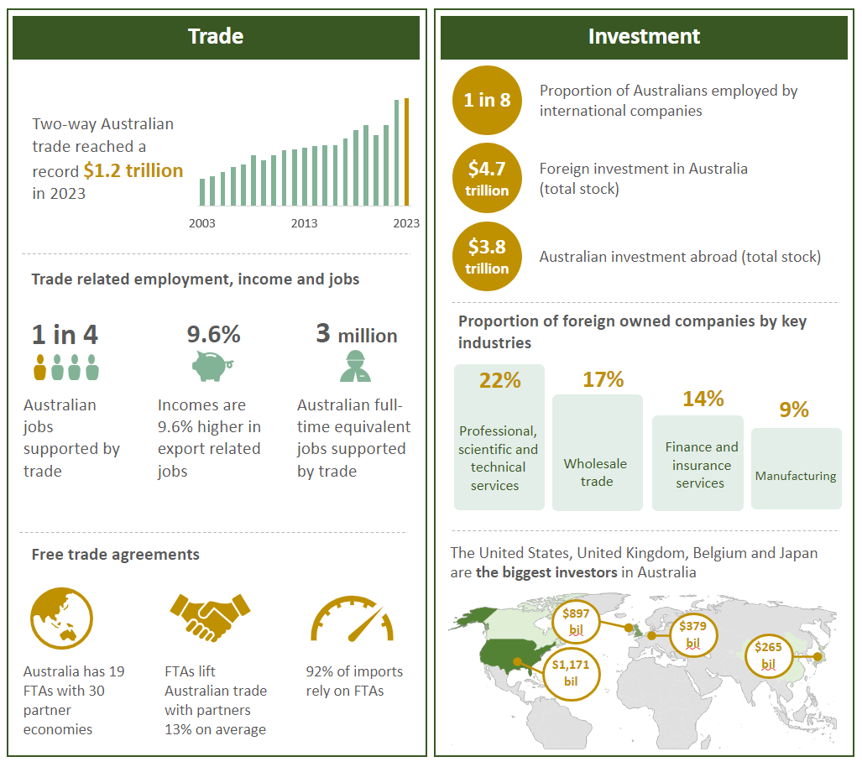

## Executive Summary

Historically, Australia has been a trading nation and our early openness to trade and investment has supported our prosperity and high standard of living. Today, Australia continues to enjoy the benefits of free, fair and open trade. Looking forward, trade and foreign investment will be a key part of how Australia continues to build a secure and stable economic future.

Trade benefits Australians by increasing productivity and economic growth, building a stronger labour market, generating more choices for consumers and raising government revenues that support government services.

* 31 per cent of Australia’s economic output is supported by trade activity.
* One in four Australian jobs are connected to trade.
* Jobs directly associated with exports are paid 9.6 per cent more than the national average.
* Foreign companies employ one in eight Australian workers.

The benefits of trade are also shared with the community through the ongoing participation of women and First Nations Australians. First Nations Australians have engaged in international trade for thousands of years, and they continue to share in the benefits of trade today, including through inclusive trade provisions in agreements with our trading partners. The Government is focused on generating new international trade and investment opportunities to drive Australia’s employment and grow our economy.

Global trade rules underpin stability of the trading environment we face and are one of the foundations of Australia’s prosperity. The World Trade Organisation (WTO) and our network of free trade agreements (FTAs) open markets for our exporters. Building on the foundation of global trade rules, Australia’s FTAs increase bilateral trade by an average of 13 per cent. Deepening and diversifying our trade relationships with partner countries can also reduce risks associated with reliance on a particular market or product in an uncertain global economic environment where the commitment to free, fair and open trade and investment is being tested. New innovative agreements like the Singapore-Australia Green Economy Agreement (GEA) stimulate trade, create business opportunities and enable investment in sectors that drive net zero transition while promoting economic growth and reducing emissions.

Foreign investment is closely related to the growth of our export industries and our prosperity. Australia’s openness to foreign investment has helped to build Australia, create jobs and raise living standards through the introduction of new technology and by fostering competition. Foreign investment provides access to additional capital and supports higher levels of investment by pooling risk – and return – across domestic and foreign investors.

Foreign investment was central to the development of our agriculture, resources, energy, infrastructure and financial sectors. In the future, it will be critical to realising our transition to net zero.

**Future Made in Australia (FMA)**

The Future Made in Australia (FMA) agenda is about maximising the economic and industrial benefits of the global net zero transformation and securing Australia’s place in a changing global economic and strategic landscape. Scaling up Australia’s clean energy industries will assist in strengthening global clean energy supply chains and will underpin our ongoing role as a reliable energy supplier. Given the scale needed for the energy transformation, Australia is eager to work with international partners to build new clean energy industries, ensure regional energy security and advance practical action on climate change. FMA is focused on encouraging and facilitating the private sector investment needed to harness these opportunities.

## Australia’s trade today

Australia’s two-way trade reached record highs in the post COVID period.[1] Australia exported a record $673 billion in 2023, including $560 billion in goods exports and $113 billion in services exports.[2] This was underpinned by high mining, energy and agricultural commodity prices, and increased international visitors following the reopening of Australia’s borders.

**Total trade as a percentage of GDP**

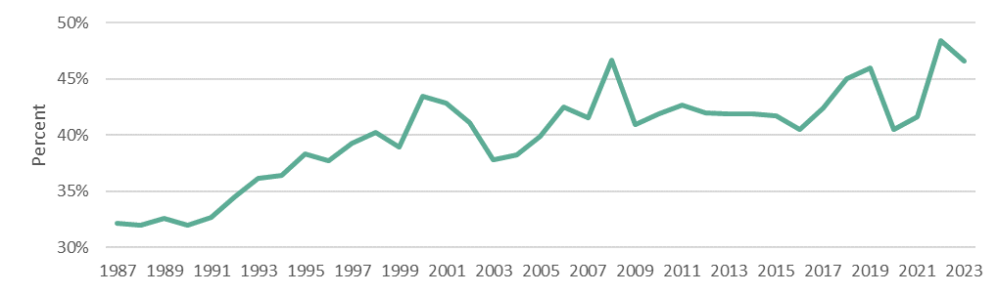

Source: ABS Balance of Payments and International Investment Position, Australia, March 2024

**Australia’s goods exports**

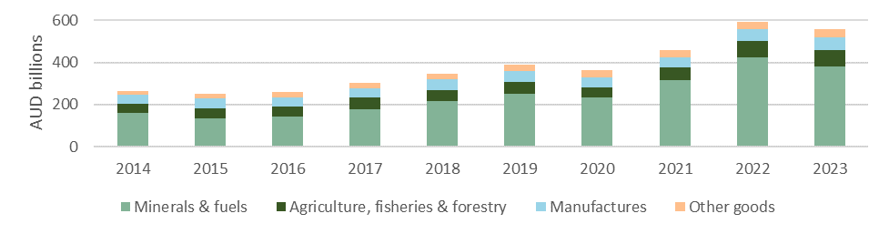

Source: Based on ABS data in DFAT Trade statistical pivot tables, March 2024 and Trade time series data, February 2024

Australia’s trade is highly integrated within the Indo-Pacific with China, Japan, the United States, the Republic of Korea (ROK), Singapore, and India being our largest two-way trading partners. Australia’s services exports trade is linked to large markets like China, India and Singapore, along with the United States and the United Kingdom.

**Top six Australian services export destinations**

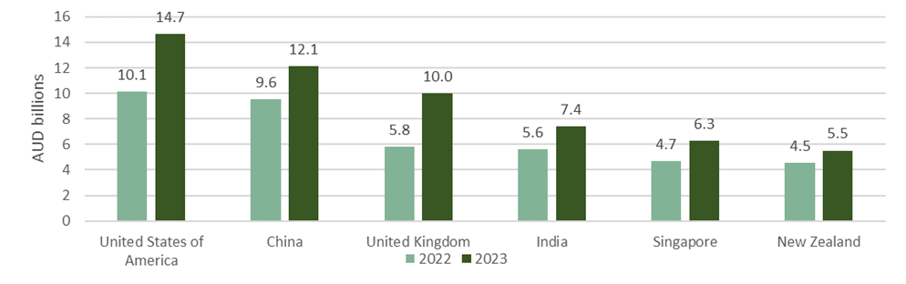

Source: ABS, International Trade: Supplementary Information, April 2024

## How did we get here?

Australia has always been a trading nation. Australia’s First Nations People were our first exporters, trading turtle shell, ironwood, and mother-of-pearl in return for meats, sugar, rice, axes, nails, and fishing line with Makassar people from Sulawesi in what is now Indonesia. This rich heritage, derived from one of the world’s oldest continuing cultures, shaped our early trading relationships and continues to shape them to this day.

Trade underpinned Australia’s early economy following the arrival of the First Fleet in 1788. For the first years of its existence, New South Wales was entirely dependent on imports from Europe before its local industry developed and exports began. First exports included coal from Newcastle to India in 1799, followed by whale oil and wool.

In the 19th century, Australia’s main exports were wheat, wool and gold. Our links to Britain meant our exports found a market much larger than would be possible domestically. However, reliance on a single market meant colonial economies were sensitive to shifts in export prices and capital flows from Britain, particularly in the more fragmented global market of the time.

Wheat was one of the first crops planted in 1788 and has since become Australia’s largest and most valuable crop. The first Australian-produced merino fleece was sold in England in 1807 and by 1850 Australia supplied more than half of Britain’s wool imports.

The gold rushes from the 1850s onwards brought Australia’s mineral wealth to the world’s attention and completely changed the course of Australia’s development through a massive influx of people, money and know how. Between 1851 and 1871, the Australian population quadrupled from 430,000 people to 1.7 million, as migrants from across the world arrived in search of gold. Today, gold is Australia’s fourth largest goods export.[3]

Australia’s early openness to trade and investment, alongside the development of institutions like the rule of law, separation of powers and parliamentary democracy, saw Australia become one of the wealthiest countries in the world. From the mid-1850s to the end of the nineteenth century, Australians enjoyed the world’s highest per capita incomes.[4]

From 1788 until the 1950s, Australia’s primary trading partner was the United Kingdom. Since then, our trade relationships have diversified and 75 per cent of our trade is now with Asia.[5] In the 1960s, Japan became a primary trading partner as a major importer of Australian wool, iron ore, and cereal grains, and a key investor in the Australia’s earliest iron ore mines. In the 21st century, China became our top trading partner.

Foreign investment has played a long-standing role in Australia’s economic development. Before Federation, investment from Britain was crucial in developing our agricultural resources, mineral wealth and infrastructure like roads and rail. Today, the United Kingdom remains one of Australia’s top sources of foreign investment along with the United States and Japan.

Australia has been a leader in and advocate for the creation of global rules which helped underpin growth in global trade after World War II. Australia was a founding member of the General Agreement on Tariffs and Trade (GATT) and the WTO, which is at the heart of the rules-based multilateral trading system that underpins our trade today. Through the 1970s and 1980s, Australia actively sought to reduce its tariffs and barriers to trade.

In the 21st century, Australia enjoys the benefits of free, fair and open trade and investment, which supports our prosperity and high standard of living. We are the world’s 13th largest economy with a track record as a high performing and flexible economy. This reflects who we are as a society – diverse, resourceful and entrepreneurial. Our ability to continue to adapt to the challenging strategic environment we face will be instrumental to our future prosperity.

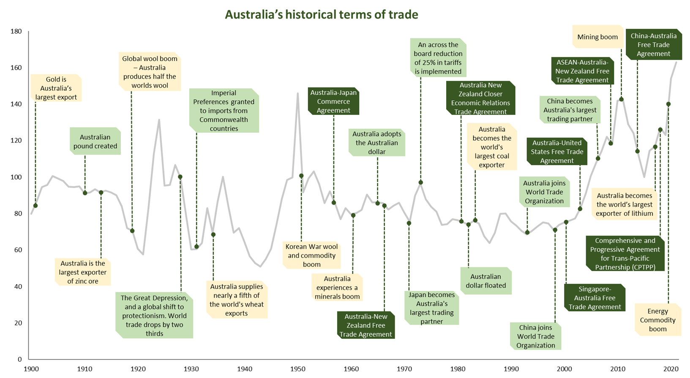

Source: ABS, Australian National Accounts: National Income, Expenditure and Product, September 2023. Australia’s terms of trade refer to the ratio of export prices to import prices. If this index increases, it implies that Australia is receiving relatively more for its exports; if it decreases then Australia is receiving relatively less. An increase in export prices relative to import prices implies that Australia is better off. The graph has been indexed at FY2015-16=100.

## Setting the scene: Global trends

In recent decades, Australia has benefited from the **integration of the global economy** through flows of trade, finance, people, technology, and information.[6] This has been driven by deeper integration of **global value chains** – where different stages of production (design, manufacturing, assembly, professional services, technology, marketing) are shared across different countries.

Today, over 70 per cent of global trade is in intermediate components and services, which later form a final product for consumption by a consumer or business. Australia has benefited significantly from its links to global value chains. For example, intermediate goods imported from abroad, such as petroleum, electrical equipment and plastics are incorporated into nearly a quarter of the value added embodied in Australia’s exports. Services, such as ICT and professional services, are also an input to the creation of Australian exports. Services made up nearly half (45 per cent) of the inputs needed to make Australian exports.[7]

The pace of economic integration reached its peak from the 1980s through to the early 2000s, underpinned by a range of factors including improvements in technology, the spread of the internet and significant trade cost reductions driven by faster shipping methods. Other factors include the founding of the WTO, reductions in trade barriers, and China’s entry into global markets. **World trade-openness** (as measured by global goods and services trade as a percentage of world GDP) increased from 36 per cent in 1998 to 61 per cent in 2008.[8] However, this pace of growth could not be sustained indefinitely. While in the two decades before the Global Financial Crisis global trade in goods grew at double the pace of global GDP growth, since then global goods and services trade growth has slowed to be in line with global GDP growth. This slowing, labelled **slowbalisation**, was partly driven by the maturation of China’s integration into global markets.[9]

**World goods and services trade as a percentage of GDP**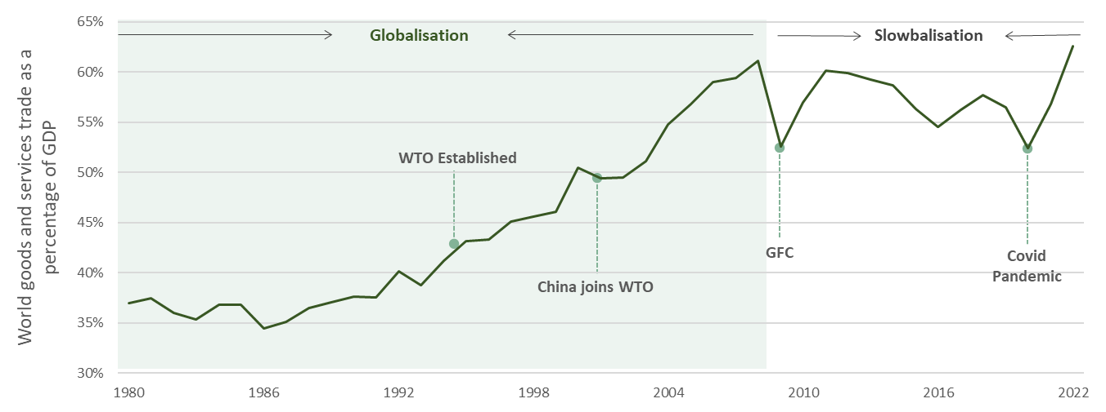

Source: The World Bank (2024), Trade (% of GDP), World Bank national accounts data, and OECD National Accounts data

After decades of increasing global economic integration, the world now faces a slowing in the growth of international trade. Over the last decade, increasing trade barriers have made doing business overseas more challenging. The number of barriers imposed on trade has increased, and countries have imposed about 3,200 new restrictions on trade in 2022 and about 3,000 in 2023.[10] According to WTO data, the share of world imports facing import restrictions rose from 3.6 per cent in 2016 to 9.2 per cent in 2022.[11] The International Monetary Fund (IMF) estimates that the reversal of global economic integration - which is termed ‘**geo-economic fragmentation**’ - could cost from 0.2 per cent to 7 per cent of global GDP.[12]

## Section 1: Trade makes us more prosperous

**Section snapshot**

* Trade benefits Australians through higher productivity, more economic growth, a stronger labour market, more choices for consumers and increased revenues for government.
* First Nations Australians have engaged in international trade for thousands of years, and they continue to share in the benefits of trade today, including through inclusive trade provisions within our bilateral and multilateral trade arrangements.
* The multilateral trading system is fundamental to Australia’s prosperity and security. Successive Australian governments have further reduced barriers to trade including through bilateral and regional trade agreements, to the benefit of Australian industry and consumers.
* Trade diversification can mitigate the risks associated with over-exposure to any one market or product.

Infographic shows: 
- 3 million Australian full-time equivalent jobs supported by trade-related activity
- 1 in 4 jobs supported by trade related economic activity
- The contribution of trade-related economic activity to Australia's Gross Domestic Product was 31%
-There is 9.6% higher annual average incomes in jobs directly associated with exports.  

### Trade lifts our living standards

Decades of increasing openness to international trade has materially increased Australian living standards. Trade is a driver of inclusive economic growth and greater economic wellbeing for all Australians, with the benefits of trade shared across the community in several ways:

* higher **productivity** through increased competition;
* higher **economic growth** through access to export markets and inputs from abroad
* a stronger **labour market** through more jobs
* more **choices for consumers** resulting in lower prices for Australians
* **sustainable government services** though stronger **revenues for government** through taxation.

The first two channels are how trade ‘grows the pie’ (grows the economy and national income) and the rest are how the ‘bigger pie’ is shared among the community (how the benefits are distributed).

### Trade boosts productivity and economic growth

International trade drives global economic growth because it lets countries **specialise** in production of goods and services. For example, Australia specialises in exports like mining and related services because of our mineral wealth, and higher education because of our world-class universities. We focus on producing goods and services where we have a comparative advantage and trade them for the imports we need.

Trade means Australian and overseas businesses **compete** to provide customers with the highest quality and best value products. This drives **productivity growth** as labour and capital are allocated to the most competitive businesses, meaning that more economic output can be produced from the same inputs. This raises national income (grows the economic pie), which increases living standards.

For Australian **businesses** trade means access to larger markets and more potential customers to buy their products and services. This unlocks **economies of scale** that reduce the average cost of production per unit which then reduces the average cost. This drives lower prices for **consumers** and makes our products more competitive at home and abroad. Trade also lowers the cost of production for businesses that use imported inputs, ranging from farmers using imported fertilisers to vehicle servicing workshops using imported tools.

**Thirty-one per cent ($719 billion) of Australia’s Gross Domestic Product** (total economic output) is supported by trade activity. Half of this contribution relates to industries directly engaged in trade such as iron ore mining, and half relates to economic activity throughout the economy linked *indirectly* to sectors involved in trade, for example road transport and professional services.

**Trade related activity contributed 31% of GDP in 2021-22, through exports and imports both directly and indirectly**

**Pie chart showing the economic contribution of trade-related activity in 2021-22.

Trade related activity contributed 31% of GDP in 2021-22 equating to $719 billion 

Proportion of trade related economic activity:  

42% relates to industries directly engaged in exporting

12% relates to industries directly engaged in importing

21% relates to economic activity  linked indirectly to sectors involved in exporting

25% relates to economic activity  linked indirectly to sectors involved in importing.
**

DFAT analysis, 2024. See Appendix A – Data & Methdology

### Trade delivers better jobs and higher wages

Almost **three million** Australian full-time equivalent **jobs** are supported by trade-related economic activity, which is **one in four jobs**. Sectors that export directly (such as tourism, education, agriculture, and mining), and those which indirectly support exporting industries (for example, mechanics that repair mining or agricultural machinery) account for a large share of Australian employment. Other Australians are employed in jobs that facilitate trade, in industries like transport and logistics, energy, and services.

Jobs directly associated with exports have a more than **9.6 per cent higher annual average income** ($100,132 p.a.) than the national average income ($91,331 p.a.).[13] Employees engaged in activity directly related to services trade earned around 10 per cent more on average (approximately $10,000 p.a. more) relative to the national average income.[14]

**Trade related activity contributed to 3 million jobs in 2021-22, through exports and imports both directly and indirectly**

Pie chart showing the contribution of trade-related activity to employment (FTE jobs) in 2021-22.

Trade related activity contributed to 3 million FTE jobs which equates to 26% of total hours supplied. 

19% of these jobs were directly associated with exporting

18% of these jobs were directly associated with importing

27% of the these jobs were indirectly linked to exporting

36% of the these jobs were indirectly linked to importing. 


DFAT analysis, 2024. See Appendix A – Data & Methodology

### Trade provides consumers more choices and lower prices

Through international trade, Australian consumers have access to a wider range and quality of products from around the world. This supports a **higher quality of life**, for example by providing a range of cars, technology, fruit all year round, critical life-saving medicines, medical equipment and machinery. Trade also delivers higher living standards for Australians by increasing their **disposable income** and **purchasing power**. Lower prices for imports mean Australians can buy more with their money, helping ease the cost of living. These benefits are widely shared among the Australian community. The graphic below shows that over recent decades prices for goods exposed to the competition of international trade have risen less than those not exposed.

**Changes in prices of goods and services over the last two decades**

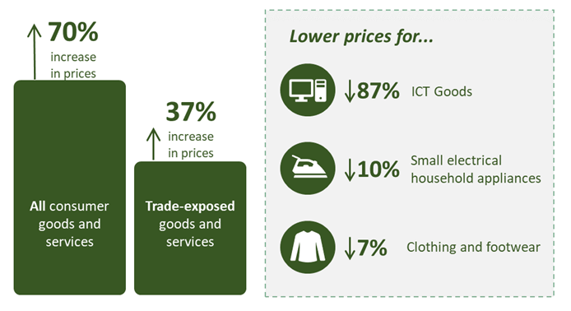

Source: ABS, Consumer Price Index, March 2024.

### Trade helps support government services

Another channel through which the benefits of trade are shared widely among the Australian community is through the **contribution trade related economic activity has on government revenues**. Redistribution of taxes collected, including in the form of government services, is one way governments ensure international trade is a driver of inclusive economic growth and greater economic wellbeing for all Australians.

#### More information: Contribution of trade to government revenue

International trade plays an important role in contributing to State and Commonwealth government revenue, which helps fund the provision of government services on which Australians rely. The contribution of trade to government revenue primarily comes from company taxes paid by trade-related businesses, mining royalties, income tax paid by individuals in jobs supported by trade-related activity and the collection of remaining tariffs.

Commodities exports also contribute significant revenue to the Commonwealth through company tax. Sustained high commodity prices and increased profitability in the resources sector have provided significant additional tax revenue to the Commonwealth Budget in consecutive budget updates. Trade also contributes to the Budget by generating higher average incomes that support personal income tax collections.

Mining royalties contribute a significant share of government revenue in major mining states.

**Royalty income share of own source revenue 2021-22** 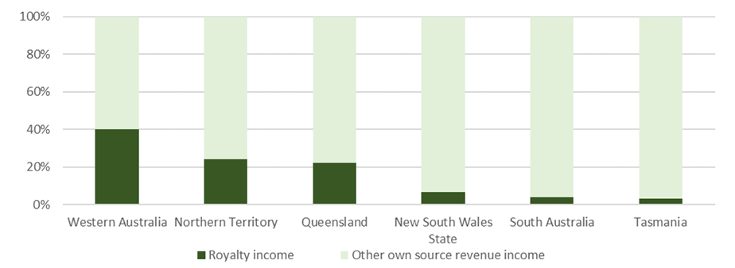

Source: ABS, Government Finance Statistics, April 2023 (Note data is excluding GST)

### Benefits for First Nations Australians

Australia’s **First Nations businesses** have been engaged in international trade for thousands of years, drawing on the rich heritage of one of the world’s oldest living cultures. Today, First Nations exporting businesses span all industries, from food and agriproducts, energy transition and technology, to cultural services, tourism and the creative industries sectors. First Nations businesses engaged in international trade and tourism create jobs and contribute significantly to economic activity through sales to international buyers and tourists.

First Nations exporters on average
Employed 15 people 
Exported $14,558 by value
Exported to a single market. 

Source: DFAT, Austrade, Supply Nation, Business Longitudinal Analysis Data Environment (BLADE) data 2022-23, 2024. These results reflect analysis on a cohort of Fist Nations exporters and tourism operators.

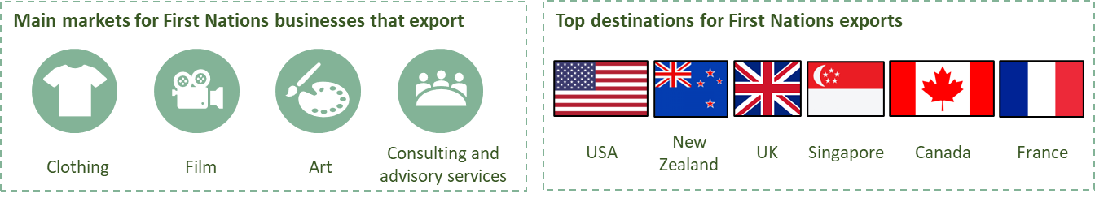Source: Supply Nation, 2024. These results reflect analysis on a cohort of Fist Nations exporters and tourism operators.

The Australian Government is committed to ensuring that all Australians, including First Nations Australians, benefit more equally from Australia’s trade and investment activities. The Government is working across Australia’s bilateral, regional and multilateral trade agenda to promote the excellence, ideas and unique offerings of First Nations businesses to international markets, as well as incorporate First Nations business interests into trade negotiations, global engagements and export growth strategies.

To ensure First Nations Australians share the benefits of trade, opportunities for First Nations peoples and businesses are a particular focus of current and new trade agreement negotiations. For example, the recent UK-Australia FTA includes specific commitments around recognition of the importance of genetic resources, traditional knowledge, and traditional cultural expression. It also includes commitments to establish reciprocal arrangements to provide for royalties to be paid to Australian artists, including Indigenous artists, where artworks are resold in the UK.

Reflecting the Government’s priority for a **First Nations approach to foreign policy**, Australia’s inaugural ambassador for First Nations People was appointed in April 2023. The Government will engage in a genuine partnership with Australia’s First Nations business sector and their communities to take forward this agenda, led by the Ambassador. The Government will also strive to build stronger networks with our international networks as we pursue opportunities for our First Nations communities.

#### Case study: Kirrikin showcasing First Nations fashion

Founded by Hunter Valley Wonnarua woman, Amanda Healy, Kirrikin is a 100 per cent Indigenous-owned and registered business that produces luxury clothing accessories using contemporary Indigenous Australian designs and sustainable, handcrafted fabrics. Kirrikin is a Wonnarua word that translates roughly to ‘Sunday best clothes’.

Based out of Perth, proximity to Southeast Asia and assistance from the Australian Government have been key factors in expanding the Kirrikin brand internationally. Utilising an e-commerce fashion platform for sales, Kirrikin has seen sales from across Europe and Southeast Asia, including Indonesia, Vietnam, Singapore, Thailand and Malaysia.

Stockists in Australia have also seen high sales from those visiting Australia from the region and wishing to bring authentic Indigenous fashion and accessories back with them. Kirrikin is looking for opportunities to take advantage of luxury tastes in the region and to stock its products in Southeast Asian and European markets.

Source: Kirrikin

### Maximising Australia’s benefits from trade

Global trade rules seek to ensure the benefits of trade are realised by improved stability and predictability in our trade environment. This is achieved by removing unfair trade barriers such as tariffs and other protectionist measures that increase the cost of trade. The WTO has 166 Members which account for 98 per cent of global trade. Around two-thirds of trade is under zero tariffs, through most favoured nation or preferential access, while the other third is under most favoured nation tariffs.[15] Were it not for the multilateral trading system (especially the WTO’s rulemaking, transparency, and dispute settlement functions), trade disputes would be more likely to be resolved through the raw exercise of power. This, in turn, would favour countries with greater economic heft and make mid-sized economies such as Australia worse off.

The rules-based trade system is one of the foundations of Australia’s prosperity. Australia is building on this source of strength by negotiating further multilateral and plurilateral agreements in the WTO. These negotiations seek to further reduce barriers to trade in both established and emerging sectors including in services, investment and digital trade. Australia is also advocating reforms to strengthen the WTO so it is able to tackle global trade challenges into the future, including by restoring a fully functioning dispute settlement system.

Australia has successfully negotiated 19 bilateral and regional free trade agreements (FTAs) with 30 partner economies, including two significant agreements - the Comprehensive and Progressive Agreement for Trans-Pacific Partnership (CPTPP) and the Regional Comprehensive Economic Partnership (RCEP). As of 2022, FTAs cover around 78 per cent of Australia’s two-way goods and services trade.[16] Additionally, on average Australia’s FTAs lift our bilateral trade by 13 per cent.[17]

Through FTAs, the Australian government has effectively reduced a range of barriers to international trade and investment for the benefit of Australian businesses and consumers. As a result of Australia entering the CPTPP, Australian exports are estimated to increase by USD23 billion ($34 billion) and real incomes increase by USD12 billion ($17.8 billion) a year by 2030.[18] Likewise, a study of seven Australian FTAs[19] found that USD1.8 billion ($2.8 billion) in Australian agricultural exports have been created as a consequence of entering these agreements.[20]

The benefits of contemporary FTAs are much broader and include improved rules for intellectual property, digital trade and government procurement. The Australia-Singapore Digital Economy Agreement, for example, built on the CPTPP to establish new world-leading rules and standards for businesses and consumers to take advantage of the digital economy, including commitments on the free flow of data and prohibiting data localisation.

A growing number of agreements, such as the Indo-Pacific Economic Framework for Prosperity (IPEF), contain minimum social and labour commitments, reference international standards, and provide for dispute resolution systems. Enhanced labour standards and commitments to enforce them help level the playing field for Australian workers and businesses, enhancing their international competitiveness.

**Snapshot: Singapore-Australia Green Economy Agreement (GEA)**

The GEA is a first of its kind agreement to fully combine trade, economic and climate objectives. Collaboration and joint initiatives conducted under this agreement are geared towards galvanising practical action. They seek to stimulate trade, create business opportunities and enable investment in sectors that drive net zero transition while promoting economic growth and reducing emissions. Work conducted under the agreement is also spearheading the development of policies, standards, regulations and practices that help establish and facilitate trade in new areas, including for example cross border electricity trade in renewable energy. In addition, the GEA also cultivates the development of partnerships that foster innovation, catalyse new commercial prospects and pioneer solutions through pathfinder approaches.

#### More information: Tariffs and non-tariff measures

**Tariffs** are taxes that governments levy on imports. They raise prices for consumers of those imports, meaning that foreign exporters are not competing on a level playing field with domestic producers. By raising prices, tariffs impede trade and undermine productivity by shielding less competitive domestic industry from competition. **Non-tariff measures** can also impede trade by increasing compliance costs. While non-tariff measures include legitimate policies, such as food safety regulations and biosecurity protections, they can also be misused to unfairly advantage domestic industry.

Infographic showing key FTA statistics including:

Australia has 19 FTAs with 30 partner economies, 
FTAs lift Australian bilateral trade 13% on average,
 92% of imports into Australia make use of our FTAs, 
Australian exports increased $34 billion per year through CPTPP, there was $2.8 billion additional in agricultural exports from just 7 FTAs. 

#### Snapshot: Aid for Trade - Strengthening global and regional rules-based trade and protecting Australia’s interests

Through its Aid for Trade programs, Australia helps to enhance engagement in the WTO and implementation of WTO and FTA obligations. These programs support developing and Least Developed Countries across the Indo-Pacific to participate in transparent rules-based approaches to trade. This benefits Australian businesses by bolstering regional trade opportunities and encouraging sustainable and inclusive economic growth across the region.

The Regional Trade for Development (RT4D) initiative, to which Australia contributes $46 million up to 2028, provides world-class capacity building and technical assistance support to ASEAN (Association of Southeast Asian Nations) Member States to realise the full benefits of the upgraded ASEAN-Australia-New Zealand FTA (AANZFTA) and Regional Comprehensive Economic Partnership (RCEP) agreement. Through this work, RT4D builds Australia’s regional influence while expanding certainty and consistency for businesses through the delivery of negotiated outcomes under these two agreements.

#### Snapshot: FTA benefits

Australia imports more than $300 billion worth of goods annually, of which more than $200 billion is from countries covered by Australia’s FTAs.[21] Analysis indicates that Australian businesses used the preferential arrangements available through FTAs for almost 92 per cent of the value of goods for which preferences were available in 2022.[22] This represents a significant increase in the ‘utilisation rate’ which was 61 per cent in 2015 and equates to tariff savings of more than $4 billion annually. Use of preferential arrangements is highest (around 95 per cent) for imports from China, ROK, Japan, Thailand and Chile.

### Trade diversification supports economic resilience

**Trade diversification** can mitigate the risks associated with over-exposure to any one market or product – whether importing or exporting. Free, fair and open rules-based trade enables diversification and contributes to economic resilience and the capacity to adapt when disruptions occur.

The importance of trade diversification and having a wide range of trading relationships was demonstrated by sudden trade disruptions in recent years. These disruptions have included impediments impacting a range of Australian exports to China, and supply chain disruptions initially caused by the COVID-19 pandemic, that were then exacerbated by Russia’s illegal invasion of Ukraine. Supply chain disruptions have impacted a broad range of industries and businesses around the world. Australian businesses responded with agility. Many businesses diversified their sources of supply and export destinations and embraced new markets.

Their efforts are supported by the Government’s trade diversification agenda, including through FTAs which open more markets to Australian businesses.

#### Snapshot: Economic complexity of Australian exports

Efforts to diversify our trade will further diversify Australia’s economy and deepen economic complexity. This is because higher economic complexity economies provide employment opportunities in ‘sophisticated’ sectors that support higher wages.[23] Our specialisation in the production and export of primary products, and geographic distance from global value chains means Australian exports contain less manufacturing than other similar advanced economies. [24] This, however, does not mean that Australia’s exports are not sophisticated. Australian trade is instead highly ranked for economic complexity when considering the level of specialised technology, managerial capability, and research that are inputs into the mining and agricultural sectors. This means that Australia’s workers are employed in sophisticated, high-wage activities. For example, **Australia now ranks eighth in technological complexity and third in research complexity**.[25] These capabilities mean Australia is well placed to take advantage of the opportunities in the future global economy.

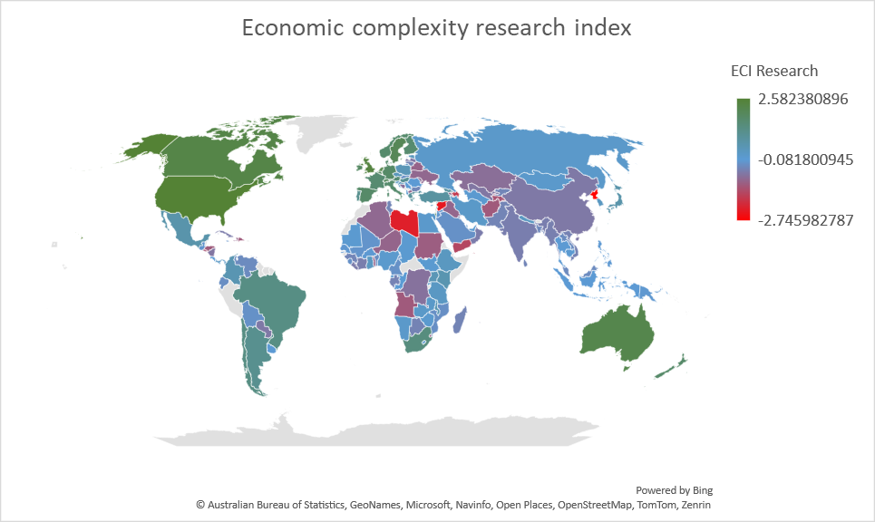

Source: Strojkosi, Koch & Hidalgo, 2023. Economic complexity index (ECI) based on research data

### Digital trade

**Digital trade** is an increasingly important area of global trade growth, and one that can deepen global economic interdependence. Digital trade includes not only e-commerce, in which goods and services are traded online, but also the transmission of digital content, including software, books, music, film and apps, as well as **digitally-enabled services** including legal, financial, education and consultancy. It is also a central input and enabler to the majority of Australian businesses. Consequently, Australia’s potential digital exports have been estimated to be as high as $192 billion by 2030.[26]

Online uptake and cross border online transactions accelerated during the pandemic, fundamentally changing consumer activity. Australia Post expects a third of Australian domestic spending to be online by 2033, up from 18 per cent in 2022.[27] Globally, over 2.3 billion people now shop online.[28] World trade in digitally deliverable services rose to USD3.8 trillion in 2021, rising from 53 per cent to 63 per cent of all services trade at the beginning of the decade.[29] The emergence of new consumer and business technologies such as artificial intelligence (AI) and deep learning language models will further change how cross-border transactions are conducted.

The **digitalisation of trade** has reduced trade and search costs. This has encouraged increased trade, competition, and productivity, and made it easier for businesses to enter the global market.[30] In addition, it has a role to play in improving access to financing, as well as improving unequal access to the global economy, particularly for women and girls.

#### Case Study: FTAs supporting the growth of Australian startups

Australian startup WithYouWithMe (WYWM) is re-inventing the employment sector to help marginalised people – including veterans and neuro-divergent applicants – build a meaningful career in tech.

WYWM quickly secured traction in the UK. It signed the UK’s Armed Forces Covenant with UK Defence People and Veterans to provide free digital skills training and job placements to UK veterans and their dependents. To date, WYWM has more than 2,000 UK veterans on its platform.

Alicia Kouparitsas, Chief Marketing Officer for WYWM says the Australia-UK Free Trade Agreement will support the company’s business growth: ‘As an Australian business with operations in the UK, we’ll benefit from the new visa provisions under the FTA that make intra-company transfers easier’.

The FTA also enables the free flow of data and will make it easier to collaborate on innovations and insights across borders. This removes barriers and helps WYWM’s expansion in the UK market.

Source: WithYouWithMe

#### Snapshot: Focus on Australia’s services sector – tourism and education exports

Though services exports are a smaller proportion of Australia’s total trade than exports of commodities/goods, they are an important part of our industry mix and a significant employer nationally. **Travel services, incorporating business, education and leisure travel,** is Australia’s largest services export, contributing $65.5 billion to the Australian economy in 2019.[31]

**Tourism** is particularly important to the economy in our regional centres. One in seven Australian businesses is tourism related.[32] Australia is well placed to take advantage of the recovery in global tourism, with forecasts for strong arrivals from traditional markets such as New Zealand, China, the United States, the United Kingdom, and Japan; as well as visitors from emerging (but fast growing) markets like Republic of Korea, India, Malaysia, and Indonesia.

**Education-related travel** contributed $47 billion in 2023, having rebounded to pre pandemic levels.[33]  New South Wales, Victoria and Queensland continue to be the biggest education exporting states, respectively representing 38, 31 and 14 per cent of enrolments of international students. China, India, and Nepal were the largest sources of international education exports. The fastest growing were Denmark, Norway, and Fiji, reflecting an increasingly diversified mix of students.[34] Education also strengthens Australia’s partnerships with other countries and connects us to our region. International students that stay in Australia to pursue work opportunities make an ongoing contribution to the economy and community.

Infographic showing: 

Education contributes 42% of services exports 

Melbourne is Australia's number 1 student city (and 4th globally)

Education is Victoria's biggest export 

One in seven Australian businesses is tourism related. 

#### Snapshot: Focus on Australian agricultural exports

Free, fair and open trade is crucial to the success of Australia’s agricultural sector, with around 70 per cent of Australian agricultural production exported each year.[35] In recent years, Australia agricultural, fisheries and forestry exports remained close to record levels.[36]

**Exports of agricultural, fisheries and forestry exports by destination**

Graph shows that Australia's exports of  agricultural, fisheries and forestry products have increased from almost $30 billion in 2007 to almost $80 billion in 2023.


Source: DFAT, Country and commodity pivot table 2006 to 2023 based on ABS data

Australia is one of the most competitive agricultural producers in the world.[37] However, agricultural subsidies paid to farmers in other countries can disadvantage Australian farmers, who must compete in global markets.

Support provided directly to farmers globally equated to USD842 billion per year.[38] While not all support distorts markets, around half of that total is provided as direct subsidies to farmers.[39] Direct subsidies can influence farmers’ production decisions, distorting global markets, accelerating environmental degradation and potentially lowering prices received by Australian farmers. Australia advocates for reductions to and the removal of trade-distorting agricultural subsidies and protection through our role as chair of the Cairns Group, a group of 20 countries advocating for fairer trade in agricultural products.

Australia’s FTAs bring a range of benefits to the agricultural sector, including the removal or reduction of tariffs and expanded quota access. This increases the competitiveness of Australian agricultural exports, providing opportunities for growth and building the reputation of Australian farmers in overseas markets. Three quarters of Australia’s agricultural trade is destined for Australia’s FTA partners.[40] New export opportunities are also supported through improved access for Australian agricultural products. The Government works closely with industry and trading partners to meet import country requirements before trade can occur.

## Section 2: Foreign investment helps build Australia

**Section snapshot**

* Foreign investment has been central to the development of our agriculture, resources, energy, infrastructure and financial sectors; and it will be critical for the energy transition.
* Foreign investment provides access to additional capital, diversifies risks of higher risk ventures, strengthens bilateral relationships, and boosts productivity through capital deepening and technology transfer.
* Foreign direct investment creates more jobs by fostering new industries, and increased trade through larger productive capacity (e.g., from largescale projects and building ‘world scale industries’).

Infographic showing the proportion of foreign owned companies by key industries. 

These are: 
22% Professional, scientific and technical services
17% Wholesale trade
14% Finance and insurance services
9% Manufacturing.

Labour productivity was 40 percent higher for companies receiving FDI

The most significant investors in foreign companies were the US, UK, Japan and Germany.

1 in 8 Australians were employed by companies receiving FDI

Australian industry value added from companies receiving FDI was $209 billion. 

Source: University of Adelaide, Austrade (2024), Economic Activity of companies receiving foreign direct investment in Australia, estimates using the Business Longitudinal Analysis Data Environment (BLADE).

### Foreign investment supports Australia’s economic prosperity

Australia’s long history of openness to foreign investment has contributed to economic prosperity and higher living standards for Australians. Foreign investment supports greater economic growth and wellbeing through:

* more **capital** to fund investment which builds our economy and supports higher economic growth;
* more **jobs** through the creation of new industries and ‘scaling up' of existing industries;
* higher **productivity** through capital deepening and spill over benefits; and
* sharing of **risk.**

Today foreign investment in Australia is valued at over $4.5 trillion.[41] This investment has played a key role in Australia’s economic development by funding new industries and scaling up existing industries. Overseas funding has been crucial to developing Australia’s abundant natural resources, particularly minerals, energy and agriculture, and funding the ports, roads, and rail needed to build the economy.

Investment contributes to economic activity in the short-term – spending money and creating jobs now – but is also key to improving our future living standards in the long term by expanding the productive capacity of the economy.

Investment from overseas can supplement domestic savings. Historically, Australia has had more opportunities for productive investment than can be funded through domestic savings alone. For example, over three decades from the early 1980s, the gap between domestic savings and investment averaged around 4 per cent of GDP.[42]

#### Snapshot: Why is Australia currently a net exporter of capital?

Since 2019, Australia has regularly been a net capital exporter. This is unusual, as for much of Australia’s history, Australia had imported capital through foreign investment to fund its productivity capacity.

There are several factors behind this contemporary shift. The conclusion of the resources investment boom in the mid-2010s has now given way to production, with record mining and gas exports generating net trade surpluses. This has increased Australian national incomes through wages and investment earnings, which contributes to increased domestic savings. Additionally, the large amount of savings held in superannuation through compulsory contributions has not been offset by a decline in other household savings.

At the same time, investment as a share of GDP has fallen sharply since 2013, with the end of the mining boom. Investment has partially recovered since 2021 but continues to be near multi-decade lows. As a result, Australia's economy now generates greater savings than domestic investment. Australia’s domestic savings are increasingly invested in foreign equities as funds seek international diversification and the highest returns. Companies have reinvested less of their earnings in Australia (as FDI) and instead paid out larger dividends to their investors, many of which are foreign. This trend is likely to change as Australia undergoes the energy transition over the coming decade requiring significant levels of public and private investment to achieve its energy goals.

**Relationship between national savings, national investment and the current account balance**

**First graph shows the relationship between national savings and national investment since 1980. From 2019 onwards, national savings have been larger than national investment.

The second graph shows the current account balance since 1980. The current account balance has been positive since 2019.  **

Source: ABS, Balance of Payments and International Investment Position, Australia, December 2023

Foreign investment can enter Australia in the form of debt (by borrowing overseas) or equity (by selling an ownership stake in an asset). Australia is a net exporter of equity. This means Australians own more equity in foreign companies than non-residents own in Australian companies. At the end of 2023, Australians held $2.2 trillion in foreign equity, while foreign residents held just almost $1.9 trillion in Australian equity. The majority – 60 per cent – of the stock of foreign investment in Australia is in the form of debt.

**Foreign investment in Australia and abroad**

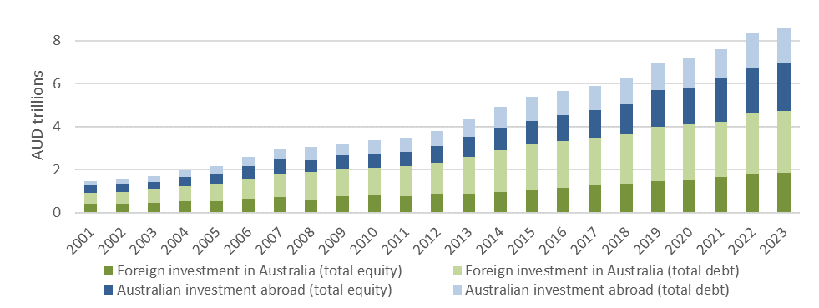Source: ABS, International Investment Position, Australia: Supplementary Statistics, May 2024

#### More information: Types of Foreign Investment in Australia

There are two main types of foreign investment in Australia, portfolio investment and foreign direct investment.

1. **Portfolio investment** is where a foreign investor purchases securities (such as stocks or bonds) or conducts other equity and debt transactions. The purchase of shares in Australian companies or government bonds by foreign institutional funds, for example. Such investments tend to be shorter term, and the foreign owner has less influence on operations. Foreign investment accounts for half of the investment in Australian private capital funds.
2. **Foreign direct investment** is where a foreign investor establishes a new business or acquires 10 per cent or more of an Australian enterprise. The foreign investor has some influence or significant control over its operations such as, where a corporation opens a subsidiary, or establishes a joint venture between Australian and foreign companies. Because of this level of control, the investment tends to be longer term, and there can be a higher degree of employment and positive spillover benefits for the host economy.

**Largest investors in Australia by level of foreign investment (stocks) in 2023**

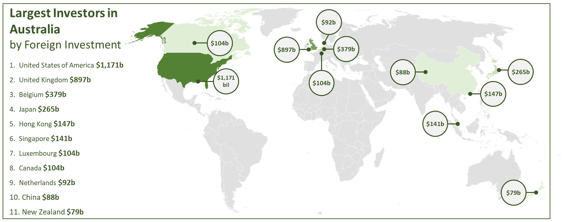

Source: ABS, International Investment Position, Australia: Supplementary Statistics, May 2024

### How foreign investment benefits Australia

Primarily, foreign investment benefits Australia through access to **additional capital** to establish new enterprises and build new infrastructure. The greater availability of capital makes funding projects cheaper and in turn grows the economy and increases living standards by allowing more capital spending.

Foreign investment also allows Australian investors to ‘share risk’ with foreign investors on higher risk investments such as new technologies and ventures. This fosters new industries by supporting investment that would otherwise be too risky to be financed by Australian companies, banks or superannuation funds. This has occurred in the resources and energy sectors since the 1960s, when joint ventures between Japanese and Australian businesses supported the expansion of Australia’s coal and iron ore export industries (see Case Study – Japanese Investment in the Australian Resources Sector).

The 20th century also saw significant foreign direct investment into Australia by British, American, European and Japanese manufacturers and consumer brands which helped establish local industries. This in turn **created jobs** both directly and indirectly through the many SMEs that supply goods and services and in the supply chains of related industries (see Boeing Case Study).

The additional capital from foreign investment contributes indirectly to Australia’s **productivity** growth. Workers become more productive through increases in the stock of capital, both tangible (e.g. tools, machinery, vehicles, factories) and intangible (intellectual property). This contributes to productivity growth, which in turn contributes to higher wages growth and economic growth.

Foreign companies establishing businesses in the Australian economy can increase competition, which reduces prices and increases choice for consumers while driving better performance in domestic firms (see ALDI Case Study). Foreign investors can transfer new technologies, provide new skills to local workers, and share new production methods and management techniques. These innovations can then diffuse from their Australian subsidiary to other domestic firms that supply inputs or services to them.

**Total stock of world Investment for OECD Countries in 2022** 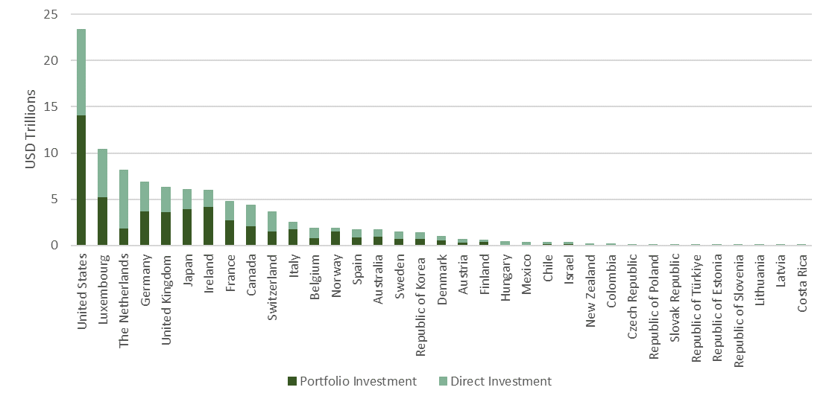

Source: International Monetary Fund (IMF), External Sector selected indicators, International Financial Statistics, 2023

#### Case Study: Aldi supermarkets bring lower prices

ALDI first entered the Australian market in 2001 with a new model for selling groceries. The discount retailer is a part of the ALDI South Group (based in Austria) and operates independently in Australia under an Australian-based Chief Executive Officer. Since opening its first stores in Sydney, ALDI’s operations in Australia have grown to include over 580 stores and multiple distribution centres across six states and territories. It now employs over 16,000 people in Australia and partners with approximately 1,000 local suppliers.

ALDI Australia stocks a limited product range of around 1,800 exclusive-branded products. Its entry into Australia has encouraged competition in the supermarket sector. Earlier this year, third-party data estimated ALDI had delivered $3.1 billion in savings directly to its customers in 2022.[43] In addition to providing an alternative option for Australian consumers, the Australian Competition and Consumer Commission (ACCC) noted that ‘ALDI has been a vigorous price competitor since its entry into Australia[44] and has significantly influenced pricing at competitor supermarket chains, particularly in private label (own brand) products where similar products are stocked by ALDI. In 2023, ALDI was named Australia’s best-rated supermarket for overall satisfaction by consumer review website Canstar Blue, and Supermarket of the Year by Roy Morgan. ALDI’s market share among Australian competitors is currently the third highest at 10.1 per cent.

Source: Aldi

The mining investment boom at the turn of the century illustrates how Australians have reaped the benefits from the development of new industries financed by capital from abroad. The boom is estimated to have increased Australian living standards by over 25 per cent between 2003 and 2010.[45] Significant increases in the prices of commodity exports in iron ore, coal and natural gas stimulated the largest resources investment boom in Australian history. Higher investment and increased mining revenues increased demand for workers (resulting in higher wages), a higher government tax take, and more revenue for our businesses.

#### Case Study: Japanese Investment in the Australian Resources Sector

Japan is Australia’s third largest foreign direct investor, second largest export market and third largest trading partner. The first Japanese firm to invest in the Australian market was Kanematsu-Gosho Ltd in 1908, a trading house which exported Australian wool, timber and tallow to Japan. Japan has been actively investing in Australia’s resources industry for over 50 years. Early joint ventures cemented the energy-security partnership between Australia and Japan. Today Australia provides 70 per cent of Japan’s coal, 42 per cent of its LNG and about 60 per cent of its iron ore imports.46

Japanese companies Mitsubishi and Mitsui & Co are investors in Australia’s largest resource development project, the North West Shelf Venture in Western Australia, with investments totalling $25 billion since the early 1980s47. The Venture involves the extraction of natural gas and condensate at offshore production platforms, onshore processing and export of LNG, and production of natural gas for industrial, commercial and domestic use within WA. Owned by a joint venture of six partners, it is an example of foreign investment enabling the development of industry through risk sharing. ASX listed company Woodside Energy is the project operator on behalf of the other participants (BHP, BP, Shell, Chevron, and a joint venture between Mitsubishi and Mitsui & Co).

#### Case Study: Boeing Australia – investing in local industry

Boeing Australia represents one of the company’s largest operational footprints outside the United States. Boeing’s history in Australia dates to 1927, and today it employs more than 4800 Australians.

Boeing Australia invests heavily in local supply chains, and its supplier network is made up of more than 2,300 local suppliers and partners including small-to-medium enterprises, First Nations, veteran and women-owned businesses generating an annual spend of $385 million.

Boeing plays an integral role in the region’s aerospace and defence industry as a leader in advanced manufacturing for commercial airplane components, defence systems and sustainment, training and services, research and development, and uncrewed systems.

Boeing Australia has invested over $70 million in R&D, including an investment partnership with CSIRO based in Brisbane and Melbourne, generating home-grown space technology breakthroughs such as topcoat reactivation software, and Total Airspace and Airport Modelling (TAAM) simulation software.

Boeing is also a long-term investor in Australia’s regions, including plans to build the Australian designed MQ-28, an autonomous aerial vehicle in Toowoomba, Queensland.

Source: Boeing Australia

### Foreign investment will support the energy transition

The global energy transition will create opportunities for Australia to become a renewable energy superpower and foreign investment will be crucial to achieving this goal. The energy transition will see a transformation of our economy in coming decades.

The investment needed for Australia’s transition to net zero will exceed domestic savings. To that end, A Future Made in Australia (FMA) focuses on encouraging and facilitating the private sector investment needed to harness the opportunities of the international move to net zero and includes initiatives to attract private and foreign investment and support the investment-enabling environment. Australia will develop a new ‘front door’ for investors with major transformational investment proposals related to the FMA agenda. The Government is also investing in strengthening and streamlining the approvals process for major renewable energy projects.

Australia is uniquely placed to take advantage of the transition to net-zero by becoming a net-exporter of renewable energy alongside sustainable metals and agriculture. Analysis by the Business Council of Australia illustrates that by 2040, investment in **clean export markets** could add $89 billion and 395,000 jobs to the Australian economy.[46] Increased investment in renewable energy (e.g., solar, wind and pumped hydro) and the development of critical minerals to supply the transition provides Australia significant trade opportunities.

Investment in critical minerals will create jobs and downstream industries, strengthen global supply chains, and help Australia to become a renewable energy superpower. The Australian Government is providing financial support to priority critical minerals projects and downstream processing and refining initiatives, through support such as the $4 billion Critical Minerals Facility and the 10 per cent production tax incentive under FMA. Foreign investment is required to support the green energy transition. As a country with high environmental, social and governance standards, Australia can be a reliable, secure supplier of raw and processed critical minerals to the world.

Hydrogen is expected to play a key role in the net zero transformation. Australia partnered with Japan in a world-first shipment of liquid hydrogen in 2022, and Australia is expected to become the second largest net-exporter of low-emissions hydrogen by 2030 and the largest by 2050.[47]  The Australian Government announced in 2024 an additional $2 billion for the Hydrogen HeadStart program, which will help large-scale renewable hydrogen projects get going by bridging the commercial gap between the cost of producing renewable hydrogen and the market price. The Government also announced the introduction of a hydrogen production tax credit of $2 per kilogram of renewable hydrogen produced from 2027.

#### Making Australia a Renewable Energy Superpower

The net zero transformation is a critical global challenge that requires clear market signals and consistent policy direction. At the same time, a more contested geostrategic environment and recent shocks have increased the value of resilient and diversified global supply chains. A recent report from the Australian Industry Energy Transitions Initiative found that around $625 billion of coordinated investment is required to decarbonise Australia’s industry and energy system.[48]

Developing largescale net zero industries require substantial investment in infrastructure. This includes port infrastructure, electricity networks, water infrastructure, as well as broader transport and social infrastructure to support regional workforces. Many of these infrastructure requirements have common use benefits so may require coordinated or public investment to justify efficient investment. In other instances, new net zero industries require bespoke commercial infrastructure. This includes dedicated pipelines to transport hydrogen and new commercial scale green metals facilities.

Our natural advantages, most notably our abundant renewable energy resources and critical mineral deposits mean we are well placed to prosper in the years ahead and play a critical role in the net zero global economy. Australia has the ability to leverage its track record as a trusted and reliable trade partner, with established links into key markets in Asia, the United States and Europe, to be a reliable supplier into the growing markets of the future.

#### Central Queensland hydrogen (CQ-H2)

The CQ-H2 project is partnering with international countries from across the hydrogen supply chain to develop Queensland’s largest renewable hydrogen project in Central Queensland. If progressed, the project’s aim is to export renewable hydrogen via its different carriers, to Japan and Singapore, as well as supplying large industrial customers in Central Queensland.

The proposed project involves the development of a Hydrogen Production Facility, Hydrogen Transport Facility (hydrogen gas pipeline) and Hydrogen Liquefaction Facility, as well as supply of hydrogen to an ammonia production facility.

Stanwell are working with Japanese foundation companies Iwatani Corporation, Kansai Electric Power Company, Marubeni and Singapore-headquartered Keppel Infrastructure to undertake a Front-End Engineering Design (FEED) study for the project, with a commitment of $117 million from government and consortium partners.

### Australia’s foreign investment framework

#### Foreign investment in Australia

Foreign investment is crucial to Australia’s prosperity and is a core part of the Government’s economic policy and investment strategy. It helps drive economic growth, creates skilled jobs, improves access to overseas markets and improves productivity, competition and innovation. Since its establishment in 1975, the foreign investment framework has been successful in maintaining Australia’s attractiveness as an investment destination while managing risks to the national interest. Foreign investors look to Australia as a stable economy with low sovereign risk and a strong rules-based system that provides the opportunity to invest capital safely and consistently.

#### Screening of investment proposals

The Government reviews foreign investment proposals on a risk based and case-by-case basis to ensure they are not contrary to the national interest. The foreign investment framework operates according to a ‘negative test’ – meaning there is a presumption that proposals should proceed unless they are found to be contrary to the national interest or to national security. The overwhelming majority of proposed investments are approved. In the 2022-23 financial year, over 99 per cent of foreign investment proposals were approved. If a proposal is determined to be contrary to the national interest, it will not be approved, or conditions will be applied to safeguard the national interest.

When making foreign investment decisions, the Treasurer is advised by the Foreign Investment Review Board (FIRB), which examines foreign investment proposals and advises on the national interest implications. FIRB is a non-statutory body. Responsibility for decision-making rests with the Treasurer. Decision making delegations exist to allow Treasury portfolio ministers and Treasury and Australian Taxation Office (ATO) officials to make decisions on behalf of the Treasurer.

#### Recent changes to Australia’s foreign investment framework

Australia’s foreign investment framework strikes a balance between ensuring that it remains an attractive investment destination, while safeguarding Australia’s national interests, including national security.

Risks to Australia’s national interest and national security have evolved and increased because of rapid technological advances and changes in the international security environment, leading to closer scrutiny of investments from all countries. Australia’s response to these trends has not been unique. Many countries have updated their foreign investment screening systems in recent years, including Canada, China, the EU, India, Japan, New Zealand, the UK, and the United States. Australia’s foreign investment framework remains one of the most liberal in the region, and one of the most mature globally. There is no sector of the Australian economy in which foreign investment is prohibited, and the framework applies to investments from all countries of origin.

On 1 May 2024, the Treasurer announced changes to streamline and strengthen the foreign investment framework. These changes deliver a stronger, faster, and more transparent approach to foreign investment. These changes will ensure that Australia can attract the significant foreign capital needed to support its economic priorities while protecting the national interest in an increasingly complex economic and geostrategic environment. The changes include streamlining consultation and assessment processes to enable decisions on foreign investment proposals that are low-risk be made more quickly, while also dedicating greater resources and applying more scrutiny to higher-risk foreign investment proposals in critical and sensitive sectors of Australia’s economy

**Value of approved investment proposals by industry sector in FY2022-23**

($ billion)

Pie chart showing the value of approved investment proposals by industry sector in 2022-23.

Commercial real estate was the highest ($50.2 billion) followed by services ($42.5 billion), finance and insurance ($32.4 billion), manufacturing, electricity and gas ($24.8 billion), mineral exploration and development ($13.1 billion), agriculture, forestry and fishing ($8.5 billion) and residential real estate ($7.9 billion). 

Source: Department of the Treasury, Quarterly Report on Foreign investment, 1 April to 30 June 2023, September 2023

### The benefits of australians investing overseas

Australians also benefit from the ability to invest abroad. Investing overseas enables Australian households and businesses to diversify their savings and investment into other industries, given Australia’s share market is heavily weighted towards finance and resource companies. It also mitigates against the risk of a downturn in the Australian economy.

Expansion of Australian companies abroad makes Australian companies bigger, employing more Australians and bringing profits back for Australian owners. Foreign direct investment by Australian companies overseas can broaden access to global markets and expose them to new technologies, methods and skills required to be successful in the host country. This can then lead to knowledge transfer and implementing these new methods, skills and technologies in Australia. Other countries share in the benefits of Australian foreign direct investment abroad, including the transfer of knowledge and technology, growth of industries and additional employment opportunities.

The $3.8 trillion in Australian investment abroad is primarily located in United States ($1.20 trillion), United Kingdom ($732 billion), European Union ($460 billion) and Japan ($136 billion). Direct investment and portfolio investment make up 71% of Australian investment abroad.[49]

**Australian investment abroad by type of investment**

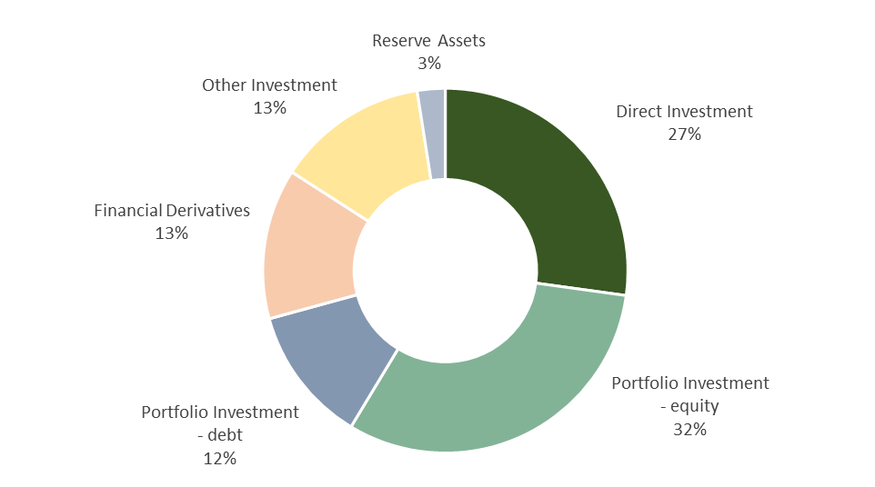

Source: ABS, International Investment Position, Australia: Supplementary Statistics, May 2024

#### Case study: Macquarie Asset Management’s investment in AirTrunk

Macquarie Group (Macquarie) is an Australian-headquartered global financial services group operating in 34 markets in asset management, retail and business banking, wealth management, leasing and asset financing, market access, commodity trading, renewables development, specialist advisory, capital raising and principal investment.

Macquarie has been active in Asia for almost 30 years, building deep local expertise in sectors ranging from energy and renewables to commodities, real estate, technology and infrastructure. Over that time, digital infrastructure has transformed from being an emerging asset class to one increasingly recognised by investors as a critical foundation of modern society, playing a central role in everything from connecting communities to facilitating transportation and supporting utilities across the world.

In 2020, a consortium led by Macquarie Asia Infrastructure Fund 2 (MAIF2), a fund managed by Macquarie Asset Management (MAM), in partnership with Public Sector Pension Investment Board (PSP Investments), acquired a majority stake in AirTrunk, a leading hyperscale data centre platform for large cloud, content and enterprise customers. Foreseeing the significant growth of digitalisation in the region, AirTrunk was founded in Australia by Robin Khuda in 2015 to deliver scalable digital infrastructure in the Asia Pacific and Japan region for the world’s largest technology companies. Since 2020, MAM and PSP Investments have worked with AirTrunk to accelerate its expansion and meet the increasing demand in the region caused by rapid population growth, rising digital adoption and the ongoing shift to the cloud.

AirTrunk has now expanded its platform across five markets, seven cities and 11 data centres, offering over 1.4 gigawatts of capacity, helping its large technology customers to establish their services in key markets in the region and providing benefits for communities such as increased digital access and connectivity.

Source: Macquarie Group

## Appendix A – data and methodology

### Input-output (IO) model of the Australian economy

IO models mathematically describe the interdependent relationships between sectors in an economy.  This quantifies the significance of the economic contributions of sectors of the economy to other sectors, to trade (imports or exports) and to the economy as whole. Economic contribution is measured in terms of economic output, value-added, or employment.

IO models measure both direct and indirect contributions of specific sectors. Direct contributions reflect direct outputs of a sector, while indirect contributions measure the contribution that a sector makes in the form of intermediate inputs to other sectors (for example, fruits and vegetables represent an input to food processing, or food retailing). This analysis has considered both the direct and indirect contributions.

DFAT’s IO model draws on data from ‘*Australian National Accounts: Input-Output Tables’* for the 2021-22 year, as well as the ‘*Labour Force, Australia’* and the ‘*Census’*, published by the Australian Bureau of Statistics.

DFAT’s analysis calculated two types of “import supported jobs” which capture more fully the employment that is associated with import-related activity.

* Firstly, a proportion of employees in all industries which used imports as inputs to their productive activities, where that proportion was based on the share of imported input.
* Secondly, to take account of final consumption of imported goods by the household sector, DFAT’s methodology included a proportion of employees in selected “facilitating industries” (e.g., transport) with the proportion determined by the value of such activities.

DFAT’s measure of average wage of employees associated with trade is based on the employment cost-share of export activities. Employees in jobs directly associated with trade had on average annual income exceeding $87,000 and five per cent higher than non-trade related jobs. Measures of average wages may be sensitive to methods and make comparison to a cohort of smaller domestic firms that do not engage in trade, and within export firms’ employees that do not engage in export activities.

### Structural gravity model of international trade

Structural Gravity models are an established tool in international economics, which attempt to capture the effects of trade costs on country-to-country trade relationships while controlling for the many differences that exist between countries and country-pairs.

This analysis follows the contemporary modelling approach initially outlined by Anderson and Wincoop (2003).[50] That is, the propensity of two countries trading with one another is determined by their trade costs relative to the trade costs across all alternate trading partner pairs – not measures of the actual or absolute trade costs. Empirically, this theoretical notion is captured econometrically through a ‘Poisson Pseudo Maximum Likelihood’ estimation technique. DFAT’s model also draws upon Yotov et al (2016),[51] in using a Poisson regression to respond effectively to the non-linear nature of trade data.[52] This occurs where trade is zero, or very low, due to the relative productivity between economies, such that it is not profitable to export to that country.

* DFAT’s Structural Gravity model is trained on data sourced from the United States International Trade Commission's *Dynamic Gravity Dataset and International Trade and Production Dataset.*[53] This data captures 264,048 rows of information on annual international and intranational goods and services bilateral trade flow values (in nominal USD), covering relationships between 246 countries, over 19 years (for the period 2001-2019, at 3-year intervals).
* The key observed regressors in DFAT’s Structural Gravity model include variables for the existence of any preferential trade agreement (PTAs) (including bilateral FTAs, customs unions, regional economic integration agreements, or partial scope agreements), as well as WTO membership. Another variable set is also included to capture the effects of globalisation and international border effects (e.g., arising from improvements in freight, customs procedures, technology).

### FTA utilisation

DFAT uses a quantitative method to estimate the value of imports to Australia where a tariff preference under an FTA was available (i.e., 'eligible' imports), as well as the value of imports where a tariff preference under an FTA was actually claimed. This analysis draws on two data sources:

* Monthly Australian Import Clearance data collected by Australian Customs (Border Force) Integrated Cargo System and compiled by the Australian Bureau of Statistics.
* Tariff schedule data collated and reported on an annual basis by the WTO within Tariff Analysis Online database, originally sourced from the Department of Foreign Affairs and Trade.

In combination, these data sources capture information on imports to Australia from all countries, at an 8-digit Harmonised Tariff Item Statistical Code (HITC) level, along with accompanying tariff rates and preferential/concessional arrangements accessed.

The basis for calculating the preference utilisation rate (PUR) is:

**Total customs value of imports accessing a preferential rate under an FTA** divided by the **total customs value of imports eligible for an FTA preference.**

Excluded from this calculation are import items classified as:

* Government purchases
* Most Favoured Nation (MFN) tariff rate is such that there is no Margin of Preference available
* Confidential
* Concessional, or 'special rate'

References

1. Australian Bureau of Statistics (ABS), [Balance of Payments and International Investment Position](https://www.abs.gov.au/statistics/economy/international-trade/balance-payments-and-international-investment-position-australia/latest-release), December 2023.
2. Australian Bureau of Statistics (ABS), Balance of Payments and International Investment Position, December 2023.
3. Australian Bureau of Statistics (ABS), International Trade: Supplementary Information, Calendar Year, 30 April 2024.
4. IW McLean, *Why Australia Prospered*, Princeton University Press, Princeton and Oxford, 2012, p.33.
5. Australian Bureau of Statistics (ABS), International Trade: Supplementary Information, Calendar Year, 30 April 2024.
6. Peterson Institute for International Economics, [What is Globalization?](https://www.piie.com/microsites/globalization/what-is-globalization), 24 October 2022.
7. Organisation for Economic Co-operation and Development (OECD), [Trade in Value-Added](https://www.oecd.org/sti/ind/measuring-trade-in-value-added.htm), 13 March 2024.
8. The World Bank, [Trade (% of GDP)](https://data.worldbank.org/indicator/NE.TRD.GNFS.ZS), 2024.
9. The Economist, [The steam has gone out of globalisation](https://www.economist.com/leaders/2019/01/24/the-steam-has-gone-out-of-globalisation), 24 January 2019.
10. Global Trade Alert, [GTA Database](https://www.globaltradealert.org/data_extraction), 26 October 2022.
11. World Trade Organization, [Report of the Trade Policy Review Body from the Director-General on Trade-related Developments](https://d3ipxbzibstf0l.cloudfront.net/reports/57-report.pdf), 14 July 2023.
12. S Aiyar, J Chen, C Ebeke, R Garcia-Saltos, T Gudmundsson, A Ilyina, A Kangur, T Kunaratskul, S Rodriguez, M Ruta, T Schulze, G Soderberg, J Pedro Trevino, [Geoeconomic Fragmentation and the Future of Multilateralism](https://www.imf.org/en/Publications/Staff-Discussion-Notes/Issues/2023/01/11/Geo-Economic-Fragmentation-and-the-Future-of-Multilateralism-527266), Staff Discussion Notes No. 2023/001, International Monetary Fund (IMF), 15 January 2023.
13. DFAT analysis. Please see Appendix A – Data and Methodology.
14. DFAT analysis. Please see Appendix A – Data and Methodology.
15. United Nations Conference on Trade and Development (UNCTAD), [Key Statistics and Trends in Trade Policy 2023](https://unctad.org/system/files/official-document/ditctab2024d2_en.pdf), 2024.
16. Australian Bureau of Statistics (ABS), International Trade: Supplementary Information, Calendar Year, 30 April 2024.
17. DFAT analysis. Please see Appendix A – Data and Methodology.
18. PA Petri, MG. Plummer, Mega-Regional Agreements and their Impact on Australia, *Australian Economic Review,* (Vol 52, No. 4), December 2019, pp. 468-475.
19. AANZFTA, ChAFTA, ACIFTA, JAEPA, KAFTA, AUSFTA and MAFTA.
20. KP Timsina, RJ Culas, Impacts of Australia’s free trade agreements on trade in agricultural products: an aggregative and disaggregative analysis, *Australian Journal of Agricultural and Resource Economics* (Vol.64), 4 May 2020, pp. 889-919.
21. DFAT analysis. Please see Appendix A – Data and Methodology.
22. DFAT analysis. Please see Appendix A – Data and Methodology.
23. P Koch, Economic complexity and growth: can value-added exports better explain the link?, *Economic Letters*, (Vol. 198), January 2021.
24. Observatory of Economic Complexity, [Trade Data](https://oec.world/), Datawheel, 2023. Methodology sourced from AJG Simoes, CA Hidalgo. The Economic Complexity Observatory: An Analytical Tool for Understanding the Dynamics of Economic Development. Workshops at the Twenty-Fifth AAAI Conference on Artificial Intelligence, 2011.
25. V Stojkoski, P Koch, CA Hidalgo, [Multidimensional economic complexity and inclusive green growth](https://www.nature.com/articles/s43247-023-00770-0#msdynttrid=M8BUyGaiBph1Bo20CifxbX0QxcQAGLqk0i_rW8LGJFQ), *Communications Earth and Environment*, 21 April 2023.
26. Alphabeta, Export Council of Australia, From Resource Boom to Digital Boom: Capturing Australia’s Digital Trade Opportunity at Home and Aboard, August 2021.. Telstra and PwC, [Be What’s Next: Embracing the Digital Economy in Australia](https://www.telstra.com.au/business-enterprise/news-research/research/the-digital-economy-report), 2020.
27. Australia Post, [Inside Australian Online Shopping, eCommerce Industry Report](https://auspost.com.au/business/marketing-and-communications/access-data-and-insights/ecommerce-trends/annual-report), 2023..
28. World Bank, [Global Findex Database 2021](https://www.worldbank.org/%20en/publication/globalfindex/Data), 2021.
29. UNCTAD, [International trade in digitally-deliverable services, value, shares and growth, annual](https://unctadstat.unctad.org/wds/TableViewer/tableView.aspx?ReportId=158358), 2022.
30. D Dollar, Global Value Chain Development Report 2019: Technological Innovation, Supply Chain Trade, and Workers in a Globalised World, 2019, Geneva: WTO, World Bank Group.
31. Australian Bureau of Statistics (ABS), International Trade: Supplementary Information, Calendar Year, 30 April 2024.
32. Tourism Research Australia, [Tourism businesses | Tourism Research Australia](https://www.tra.gov.au/en/economic-analysis/tourism-businesses), July 2024.
33. Australian Bureau of Statistics (ABS), International Trade: Supplementary Information, Calendar Year, 30 April 2024.
34. Department of Education, [International student numbers by country, by state and territory](https://www.education.gov.au/international-education-data-and-research/international-student-numbers-country-state-and-territory), 16 November 2024.
35. Department of Agriculture, Fisheries, and Forestry (DAFF), [Snapshot of Australian Agriculture 2024](https://daff.ent.sirsidynix.net.au/client/en_AU/search/asset/1035603/0), March 2024
36. Department of Agriculture, Fisheries, and Forestry (DAFF), [Snapshot of Australian Agriculture 2024](https://daff.ent.sirsidynix.net.au/client/en_AU/search/asset/1035603/0), March 2024.
37. Australian Competition and Consumer Commission (ACCC), [Competition in Australian agriculture keynote address](https://www.accc.gov.au/about-us/media/speeches/competition-in-australian-agriculture-keynote-address), 11 June 2021.
38. Organisation for Economic Co-operation and Development (OECD), [Agricultural Policy Monitoring and Evaluation 2024](https://www.oecd.org/en/publications/2024/11/agricultural-policy-monitoring-and-evaluation-2024_b4c72370.html), 6 November 2024.
39. Department of Agriculture, Fisheries, and Forestry (DAFF), [Reshaping agricultural support to build a competitive agricultural sector](https://daff.ent.sirsidynix.net.au/client/en_AU/search/asset/1033761/0), Issue 5, 2022.
40. Department of Agriculture, Fisheries, and Forestry (DAFF), [Australia’s future agricultural trade advantage](https://www.agriculture.gov.au/abares/products/insights/australias-future-agricultural-trading-advantage#:~:text=Three%20quarters%20of%20Australia%27s%20agricultural,exporters%20to%20access%20key%20markets.), 9 May 2023.
41. Australian Bureau of Statistics (ABS), [International Investment Position, Australia: Supplementary Statistics, 2024](https://www.abs.gov.au/statistics/economy/international-trade/international-investment-position-australia-supplementary-statistics/2022), May 2024.
42. Reserve Bank of Australia (RBA), [The Significant Shift in Australia's Balance of Payments](https://www.rba.gov.au/publications/bulletin/2022/mar/the-significant-shift-in-australias-balance-of-payments.html), Bulletin – March 2022, 17 March 2022.
43. ALDI, [ALDI doubles down on Price Promise, delivering billions of dollars in savings for shoppers](https://aus01.safelinks.protection.outlook.com/?url=https%3A%2F%2Fwww.aldiunpacked.com.au%2Faldi-doubles-down-on-price-promise-delivering-billions-of-dollars-in-savings-for-shoppers%2F&data=05%7C01%7CAshley.Brosnan%40dfat.gov.au%7C7f79c4146cb14f0aa52108dbd4d95c86%7C9b7f23b30e8347a58a40ffa8a6fea536%7C0%7C0%7C638337802242992276%7CUnknown%7CTWFpbGZsb3d8eyJWIjoiMC4wLjAwMDAiLCJQIjoiV2luMzIiLCJBTiI6Ik1haWwiLCJXVCI6Mn0%3D%7C3000%7C%7C%7C&sdata=6xfgpi%2FQt7IrzI2U4nz0c0NEpiJ8Ce8WsRh6KzRqmZ8%3D&reserved=0), 26 April 2023.
44. Australian Competition and Consumer Commission (ACCC), Report of the ACCC inquiry into the competitiveness of retail prices for standard groceries, July 2008, p. xiv
45. RG Gregory, Living standards, terms of trade and foreign ownership: reflections on the Australian mining boom, *Australian Journal of Agricultural and Resource Economics* (Vol.56), 27 March 2012.
46. Business Council of Australia, [Sunshot: Australia’s opportunity to create 395,000 clean export jobs](https://www.bca.com.au/sunshot_australia_s_opportunity_to_create_395_000_clean_export_jobs), 14 October 2023.
47. International Energy Agency (IEA), [World Energy Outlook 2022](https://www.iea.org/reports/world-energy-outlook-2022), October 2022.
48. Australian Industry Energy Transitions Initiative, [Pathways to industry decarbonisation](https://energytransitionsinitiative.org/wp-content/uploads/2023/08/Pathways-to-Industrial-Decarbonisation-report-Updated-August-2023-Australian-Industry-ETI.pdf), Phase 3 Report, February 2023.
49. Australian Bureau of Statistics (ABS), [International Investment Position, Australia: Supplementary Statistics, 2024](https://www.abs.gov.au/statistics/economy/international-trade/international-investment-position-australia-supplementary-statistics/2022), May 2024.
50.
51.
52.
53.