

Strategic Review of the Papua New Guinea–Australia Partnership in TVET

Final 12 July 2024

Human Development Monitoring and Evaluation Services

© Commonwealth of Australia, 2024

Copyright protects this publication. Except for purposes permitted by the *Copyright Act 1968* of the Commonwealth of Australia, reproduction, adaptation, electronic storage, and communication to the public is prohibited without prior written permission. To make enquiries or request a copy of this report, contact the Public Affairs Team, Australian High Commission, Port Moresby, at email Public-Affairs-PortMoresby@dfat.gov.au.

All third-party material, including images, contained in this publication remains the property of the specified copyright owner unless otherwise indicated, and is used subject to their licensing conditions.

Contact Details

|  |  |  |
| --- | --- | --- |
| Details | Human Development Monitoring and Evaluation Services (HDMES) | Australian High Commission (AHC) |
| **Name** | Valerie Haugen | Eloise Saif |
| **Job title** | Team Leader, HDMES | First Secretary, Higher Education and TVET |
| **Telephone** | +675 7000 1552 | +675 7090 0177 |
| **Email** | Valerie.Haugen@hdmes-png.com | Eloise.Saif@dfat.gov.au |

Disclaimer

This document has been produced with information supplied to HDMES by the specified sources/data collection methods. While we make every effort to ensure the accuracy of the information contained in this report, any judgements as to the suitability of the information for the client’s purposes are the client’s responsibility. HDMES extends no warranties and assumes no responsibility as to the suitability of this information or for the consequences of its use. The findings, observations, and recommendations offered were compiled by independent consultants and do not necessarily represent the views of the Australian Government or the Government of Papua New Guinea.

Contents

Executive Summary 1

Introduction 1

Review Purpose and Methodology 3

Conclusions 3

Lessons 6

Recommendations 7

1. Introduction 10

1.1. Background 10

1.2. Review Purpose 11

1.3. Review Methodology and Limitations 12

2. Key Findings and Conclusions 14

2.1. TVET Subsector 14

2.2. Joint Statement of Intent 20

2.3. DFAT Investments 24

3. Lessons Learned 37

4. Overall Conclusions against Key Review Questions 39

5. Recommendations 42

Annexes 45

Annex 8 – Bibliography 46

Annex 9 – Joint Statement of Intent 50

The list below is a complete list of annexes compiled to support this report and may be provided as a separate document by email request to [Public-Affairs-PortMoresby@dfat.gov.au](mailto:Public-Affairs-PortMoresby@dfat.gov.au). Annexes 8 and 9 are also included in this document, as per the contents listed above.

Annex 1 – Methodology Plan

Annex 2 – Strategic Review Team Schedule

Annex 3 – Key Informants

Annex 4 – TVET Subsector Visuals

Annex 5 – Joint Statement of Intent Analysis

Annex 6 – Investment: APTC PNG–SNGI

Annex 7 – Investment: Australia (or GoA)-supported Technical Assistance

Annex 8 – Bibliography

Annex 9 – Joint Statement of Intent

Abbreviations and Acronyms

|  |  |
| --- | --- |
| Term | Definition |
| **ADB** | Asian Development Bank |
| **AHC** | Australian High Commission [Port Moresby] |
| **APTC** | Australia Pacific Training Coalition |
| **ARoB** | Autonomous Region of Bougainville |
| **ASI** | Adam Smith International |
| **AUD** | Australian Dollar |
| **BTC** | Bougainville Technical College |
| **DAL** | Department of Agriculture and Livestock |
| **DBTI** | Don Bosco Technical Institute |
| **DFAT** | Department of Foreign Affairs and Trade [Australia] |
| **DHERST** | Department for Higher Education, Research, Science and Technology |
| **DNPM** | Department of National Planning and Monitoring |
| **DOLIR** | Department of Labour and Industrial Relations |
| **DOT** | Department of Treasury |
| **DOW** | Department of Works |
| **DP** | Development Partner |
| **DPLGA** | Department of Provincial and Local-level Government Affairs |
| **DPM** | Department of Personnel Management |
| **DPMNEC** | Department of Personnel Management National Education Commission |
| **ECDF** | Education Capacity Development Facility |
| **EOIO/EOPO** | End of Investment Outcome/End of Program Outcome |
| **ESS** | Education Support Services |
| **EU** | European Union |
| **FLC** | Flexible Learning Centre |
| **GDP** | Gross Domestic Product |
| **GEDSI** | Gender Equality, Disability and Social Inclusion |
| **GIZ** | Deutsche Gesellschaft für Internationale Zusammenarbeit |
| **GoA** | Government of Australia |
| **GoPNG** | Government of Papua New Guinea |
| **GPS** | Global Positioning System |
| **HAC** | Highlands Agricultural College |
| **HDMES** | Human Development Monitoring and Evaluation Services |
| **HELP** | Higher Education Loans Policy |
| **HR** | Human Resources |
| **IRG** | Industry Reference Group |
| **ISG** | Industry Skills Group |
| **IST** | International Skills Training |
| **ITVET4E** | Improved TVET for Employment |
| **JSOI** | Joint Statement of Intent |
| **JICA** | Japan International Cooperation Agency |
| **JSC** | Joint Steering Committee |
| **KII** | Key Informant Interview |
| **KRQ** | Key Review Question |
| **M&E** | Monitoring and Evaluation |
| **MCC** | Millennium Challenge Corporation |
| **MFAT** | Ministry of Foreign Affairs and Trade [New Zealand] |
| **MHTC** | Mount Hagen Technical College |
| **MTC** | Manus Training Centre |
| **NATTB** | National Apprenticeship and Trade Testing Board |
| **NC** | National Certificate |
| **NDoE** | National Department of Education |
| **NPIPNG** | National Polytechnic Institute of Papua New Guinea (Lae) |
| **NQF** | National Qualifications Framework |
| **NSDA** | National Skills Development Agency |
| **NTC** | National Training Council |
| **PD** | Professional Development |
| **PGK** | Papua New Guinea Kina |
| **PNG** | Papua New Guinea |
| **POM** | Port Moresby |
| **POMTECH** | Port Moresby Technical College |
| **PSC** | Project Steering Committee |
| **RTO** | Registered Training Organisation |
| **SGD** | Small Group Discussion |
| **SNGI** | Sub-National Growth Initiative |
| **TA** | Technical Assistance |
| **TAFE** | Technical and Further Education [Australian TVET institution] |
| **TC** | Technical College |
| **THS** | Technical High School |
| **TOR** | Terms of Reference |
| **TVET** | Technical and Vocational Education and Training |
| **USD** | United States Dollar |
| **VTC** | Vocational Training Centre |

# Executive Summary

## Introduction

The Department of Foreign Affairs and Trade (DFAT) in Papua New Guinea (PNG), in partnership with the PNG Department of Higher Education, Research, Science and Technology (DHERST), commissioned a strategic review of DFAT’s portfolio of investments in technical and vocational education and training (TVET). The review was to take account of the extent to which the Papua New Guinea–Australia Joint Statement of Intent on TVET in Papua New Guinea (JSOI), signed by the Government of Australia (GoA) and Government of Papua New Guinea (GoPNG) in August 2020, was being realised and whether DFAT TVET investments were contributing to realising the JSOI.

The JSOI confirmed the two governments’ shared commitment to work together to improve TVET subsector outcomes, and to grow the number of skilled workers to enable PNG to seize economic growth opportunities. The JSOI consists of 18 commitments: eight joint commitments, six GoPNG commitments, and four GoA commitments. These commitments define both governments’ roles and responsibilities to help realise the reform agenda set in motion with the *Higher and Technical Education Reform Act 2020*. DFAT investments relating to specific JSOI commitments are shown in Table 1. The JSOI is found in Annex 9.

Table 1. Realising the JSOI Commitments – DFAT Investments in TVET

Joint Commitments

|  |  |
| --- | --- |
| JSOI Commitment (Short Version) | DFAT Investment |
| (i)a. Reform agenda | Education Support Services (ESS) (AUD5.96 million) |
| (i)b. Knowledge and research | ESS |
| (i)c. Strengthen selected institutions | Sub-National Growth Initiative (SNGI) (AUD45 million) |
| (i)d. Gender equality, disability and social inclusion (GEDSI) | N/A |
| (i)e. Flexible programs | N/A |
| (i)f. Adhering to joint agreements | N/A |
| (i)g. Joint governance | SNGI |
| (i)h. Good faith | SNGI; ESS; Improved TVET for Employment (ITVET4E) (AUD430,000 DFAT grant for Project Preparation and AUD15 million DFAT grant for Project Implementation) |

GoA Commitments

|  |  |
| --- | --- |
| JSOI Commitment (Short Version) | DFAT Investment |
| (ii)a. Expand role of Australia Pacific Training Coalition (APTC) | SNGI |
| (ii)b. Support development of TVET institutions | N/A |
| (ii)c. Co-finance ADB scoping | ITVET4E (ADB) |
| (ii)d. Engage with GoPNG on lessons learned | SNGI; ESS; ITVET4E (ADB) |

GoPNG Commitments

|  |  |
| --- | --- |
| JSOI Commitment (Short Version) | DFAT Investment |
| (iii)a. Leadership | ESS |
| (iii)b. Coordinate all development partners’ assistance | N/A |
| (iii)c. Link industry and institutions via National Skills Development Agency (NSDA) | N/A |
| (iii)d. Provide funding to transform East Lorengau facilities | N/A |
| (iii)e. Whole-of-GoPNG approach for APTC partnerships | N/A |
| (iii)f. Execution and sustainability of TVET investments | N/A |

The DFAT investments in the TVET subsector provide the vehicles for helping to realise the JSOI. The AUD45 million Skills for Sub-National Growth Initiative (SNGI) (2020–2025) is the main investment for implementing the TVET JSOI. SNGI aims to enhance vocational education and training to meet local labour market needs, stimulate economic growth, and strengthen local institutions in PNG’s subnational regions. The SNGI is the PNG bilateral extension of the third stage of the AUD251.2 million Australia Pacific Training Coalition (APTC) regional program (2018–2025), with approximately AUD5 million earmarked annually for PNG. APTC Stage 3 (APTC3) is implemented by TAFE Queensland under contract with DFAT Canberra, and has three end of program outcomes: (1) Graduates have improved employment outcomes; (2) Co-investment in skills training increases; and (3) Selected TVET partners demonstrate quality TVET provision.

The Improved TVET for Employment (ITVET4E) Project (2022–2029) is an AUD100 million investment financed through an AUD70 million ADB concessional loan, AUD15 million DFAT grant, and AUD8 million GoPNG contribution. The Project Preparation Phase was undertaken from 2019 to 2022 with a DFAT grant contribution of AUD430,000, with analyses, assessments and reporting[1] carried out between November 2021 and July 2022. Phase 1 of implementation (2022–2025) has commenced; however, the project appears to be in a prolonged inception phase with challenges launching into full implementation, possibly due to the contextual challenges and COVID-19 constraints.

DFAT also funded the AUD5.96 million Education Support Services (ESS) program (2020–2022), which provided technical advisers to strengthen organisational capacity in DHERST and National Department of Education (NDoE) to implement key reforms in higher, technical, and basic education. Future investments under consideration are a new TVET bilateral investment to deliver on PNG–Australia priorities, with a design document expected to be approved by the end of 2024, and a second phase of the ITVET4E project, subject to agreement between the parties. DFAT is also designing a new regional program that is expected to be approved in 2024.

## Review Purpose and Methodology

The review is intended to contribute to building a shared understanding of the PNG TVET subsector and, in turn, inform DFAT’s next phase of support, including alignment with the bilateral and regional priorities of GoPNG and GoA. The review had three lines of inquiry:

1. Progress in delivering on the shared commitments in TVET by the Governments of Papua New Guinea and Australia, including the Joint Statement of Intent and partnership functionality.
2. Investment contributions to the success of the Joint Statement of Intent (since 2020).
3. Strategic planning.

The review also framed the assignment around three levels of analysis:

1. TVET subsector over time to the present
2. JSOI
3. DFAT investments.

|  |  |  |  |
| --- | --- | --- | --- |
| 138 Key Informants Interviewed | 19 Employers Surveyed | 11 Sites Visited | 54 Documents Analysed |
| Infographic depicting an interview with the key informants of the review. | Infographic depicting a survey of employers in PNG. | Infographic of a tractor to represent visiting the technical colleges. | Infographic of a pile of papers representing the secondary sources consulted. |

Qualitative research methods, including key informant interviews (KIIs) and direct observation, were used. Some small group discussions[2] were also held. Of the 138 individuals interviewed, 42 (31%) were female. Sixteen (11.9%) interviewees were donor personnel, 32 (36.7%) were government personnel, 62 (45.9%) were principals and trainers, and 22 (16.3%) were from industry. The team also reviewed 54 documents, including DFAT strategic and investment documents, GoPNG documents, and some documents obtained through internet searches. Some primary source quantitative data was collected through a survey of private sector employers. Secondary source quantitative data was sought from DHERST, NDoE and technical colleges (TCs), but this effort was not wholly successful.

## Conclusions

Based on key findings and the review team’s broader experience in TVET globally, conclusions[3] regarding the nine Key Review Questions (KRQs) are presented below.

1. To what extent have the Papua New Guinean and Australian Governments delivered on their commitments in TVET, including those in the Joint Statement of Intent?

DFAT and DHERST have demonstrated good success and made progress in seven (40%) of the 18 commitments, with: Supporting the reform agenda (i)a, Supporting the development of TVET institutions (ii)b, Co-financing ADB scoping (ii)c, and Leadership (iii)a – all fully achieved; and Knowledge and research (i)b, Adhering to joint agreements (i)f, and Acting in good faith (i)h – all partially achieved. With regard to the eight joint commitments, the review team observed that support for the GoPNG sector reform agenda has been achieved, the DFAT and DHERST relationship is sound, and there is trust and ongoing open communication and engagement between the two partners. There has been little or no progress with other commitments for various reasons, not least of which is a lack of definitional parameters and clarity on how to operationalise a commitment. (See a deeper analysis in the JSOI section and in Annex 5.)

Overall, the JSOI is a well-crafted strategic document with commitments that reflect the nature and importance of the partnership and are generally fit for purpose. The joint commitments and DHERST commitments are, by and large, appropriate; however, DFAT’s commitments are limited and could be expanded, especially with an eye to a leadership role among donors and potential relationship brokering with other GoPNG stakeholders and the private sector. However, in its current state, the JSOI is a partial partnership document and, as such, it cannot be used to practically guide, monitor and evaluate the partnership. Some modifications to the commitments are needed, as is expanding the JSOI to become a more substantive partnership document that provides guidance on partnership governance, monitoring and evaluation (M&E), and communication at a minimum – in short, a concise handbook for the two partners. Both actions might help mitigate risks to continued collaboration should key actors in either organisation change. A more substantive document could also be socialised more widely and used as a broader collaboration tool.

2. To what extent have the governance and management arrangements for cooperation been appropriate for tracking and meeting the commitments in the JSOI, including between GoA and GoPNG stakeholders, within DFAT, and across the investment modalities?

There are four established governance and coordination bodies used by the GoA and GoPNG for the TVET subsector. The GoA–GoPNG Ministerial Forum, co-chaired by the two Ministers of Foreign Affairs, meets annually to provide high-level oversight of TVET investments. The APTC PNG and SNGI investment Joint Steering Committee (JSC)[4], co-chaired by the DFAT Education Counsellor and the Secretary of the Department of National Planning and Monitoring (DNPM) (with the DHERST Secretary as an alternative chair), meets at least three times per year and provides high-level policy advice and strategic direction, and guides coordination and implementation of the APTC PNG and SNGI investment in PNG. Members are from the Department of Provincial and Local-level Government Affairs (DPLGA), National Skills Development Agency (NSDA) (including the Chair and representatives of Industry Skills Groups (ISGs)), PNG Business Coalition for Women, and APTC PNG (Country Director) which also provides secretariat support for the JSC.

The Improved TVET for Employment Project[5] Steering Committee (PSC), co-chaired by the DHERST Deputy Secretary and DNPM First Assistant Secretary, meets quarterly[6] and provides advice and resolution of issues for the project sponsor, stakeholders, and management unit. Members are from the Department of Works (DOW), Department of Treasury (DOT), National Procurement Commission, NDoE, DHERST, DFAT, and the ADB. The NSDA is a critical coordinating body for public, private and non-profit entities involved in TVET and the world of work, but has lost momentum. DFAT is a member.

Overall, the existing governance and coordination structures are appropriate for meeting the JSOI commitments, but there is room for improvement. Although there is good stakeholder representation and involvement in the Ministerial Forum and the PSC, the JSC and NSDA struggle to have a quorum, and the NSDA could benefit from a broader representation of and effective engagement with industry leaders. A forum for technical colleges to interact with and learn from each other could be of benefit.

3. To what extent have the investment modalities for cooperation contributed to delivering on the JSOI and intended outcomes?

Technical assistance (TA) through the ESS has likely contributed the most to helping the partners deliver on the JSOI and its intended outcomes. The APTC–SNGI has made a limited contribution to the JSOI, and there has been a (perceived) lack of visibility and engagement with various GoPNG stakeholders. The ITVET4E has provided opportunity for DFAT and DHERST to collaborate and engage with one another, but there is no obvious contribution to the other commitments at this juncture.

4. What are the key achievements delivered by the investments?

Achievements of the APTC–SNGI investment are limited to short rounds of professional development (PD) for about 30% of the trainers in the target technical colleges, the flexible learning centres (FLCs), and equipment provision. Given the delay in the Improved TVET for Employment Project implementation, substantial insights regarding the project’s achievements to date are limited. DHERST and NDoE benefited from 12 ESS technical adviser engagements between 2020 and 2022. The technical advisers provided several substantive outputs to support the transition to DHERST of specified TVET roles and responsibilities, and technical colleges and registered training organisations (RTOs). This support helped to produce the *Technical College and RTO Accreditation System Mapping*; *Governing Councils Manual* and training; amendments to the *Higher and Technical Education Reform Act 2020*; and the Higher Education Loans Policy.

Although a sustainability plan does not seem to have been factored into the program design (which can tend to limit impact over time), there are solid examples of TA work that has been sustained over time. For example, DHERST is using the *Technical College and RTO Accreditation System Mapping* and the accreditation standards it contains and the *Governing Councils Manual* and the NDoE is using its Integrated Management Information System. The ESS technical advisers were appreciated for the quality of their work and ability to enhance the capacity of DHERST personnel, and a panel of pre-qualified advisers who could be responsive to DHERST needs could benefit both partners.

The APTC–SNGI, ITVET4E, and ESS, were all implemented at the start and throughout the height of the COVID-19 pandemic (March 2020 to approximately early 2022 when the urgency of the pandemic began to wane). The pandemic presented unique challenges, particularly for the APTC–SNGI and ITVET4E.

5. Have there been any unanticipated outcomes (positive or negative) from the investments?

An unanticipated positive outcome from the investments is the success of ESS in providing on-the-job capacity enhancement and delivering good quality products that have had cogency beyond the life of the investment. Also unanticipated were the limited effects of the APTC–SNGI on the four technical colleges visited, the absence of essential education data, and unrealised opportunities for adaptive management and responsiveness to expressed needs/suggestions from stakeholders. One initiative that could have had great success was the Gender Equality, Disability and Social Inclusion (GEDSI) Subsidy, but it was discontinued due to unmet expectations.

6. What lessons can be identified that could inform future investments?

See Lessons section in this report.

7. To what extent are the current investment commitments and planned investments relevant to the fulfilment of GoPNG and GoA commitments in TVET, including the Joint Statement of Intent? Are there gaps that need to be incorporated into planned investments?

The current investments are all relevant, especially given the needs associated with the reform agenda, the resourcing challenges across the subsector (including at the NDoE), and the fragmentation of the subsector. However, with future investments unclear, and without a detailed mapping of the subsector that would enable all stakeholders to have a shared vision (and visual) for strategic planning, monitoring and evaluation, it will be difficult to ascertain the relevance of planned investments or initiatives for addressing new and emerging needs. A specific gap that needs urgent attention is the collection, analysis, and use of trustworthy data.

8. To what extent are the current and planned investment commitments coherent with the current context and political landscape (of both governments, other donors, and at the country and regional levels)?

Again, without a detailed mapping of the subsector, it is challenging to determine whether and how the current and planned investments and the respective initiatives within those investments fill gaps in the TVET landscape, complement other investments, or build on the work of prior and existing investments. A coherent and cohesive approach to TA is an example of an immediate need to ensure the TA is filling targeted gaps in the TVET subsector landscape or building on prior work.

9. To what extent do the current and planned investment commitments provide opportunities for economic growth, especially stimulating demand?

There is not sufficient data on current investments for the review team to draw conclusions about opportunities for economic growth, including stimulating demand. For example, although JSOI commitment (ii) a stipulated up to 600 additional graduates per year from APTC–SNGI, there is no baseline and subsequent monitoring to show whether the annual target has been met. Industries are increasingly turning to their own in-house TVET training and workers from overseas to meet their workforce needs for competent employees.

Current and future investments under the Papua New Guinea–Australia Partnership program (2025–2029) present the opportunity to lay a foundation that would enable DFAT to determine whether the investments are contributing to economic growth, including stimulating demand. Many of the review’s lessons and specific recommendations can be of use, particularly those relating to DFAT’s potential role in TVET support (Recommendations 6, 8); support for DHERST (Recommendations 7, 11–15); and improving the quality of TVET (Recommendations 2, 4, 5, 9, 17). The proposed new JSOI (Recommendation 1) will also improve governance and management of and reporting on investments in the TVET subsector.

## Lessons

These lessons will be familiar and should inform development assistance investments.

* **Lesson 1**: Relationships are essential for successful collaboration, but are only half the equation. Processes, procedures, strategies, and structures need to be institutionalised to safeguard against the loss of key change agents. This holds for relationships at every level.
* **Lesson 2**: Partnerships and co-funding arrangements need clear and agreed lines of oversight, management, and reporting to achieve implementation success and development outcomes.
* **Lesson 3**: Qualitative data alone is inadequate for determining project success and value for money. Available, trustworthy quantitative data, such as graduate tracer studies, are essential for monitoring, decision-making and management, as is the use of tried and tested methods such as cost-benefit analysis. Lack of quantitative data and rigorous quantitative analytical methods will undermine even the best strategic plan or investment design and implementation, and limit the ability to make informed decisions about and monitor and evaluate investments. Cost-benefit analyses can provide useful insights that could inform the new designs.
* **Lesson 4:** Establishing clarity about intellectual property rights from the investment design stage and into the implementation stage is essential for safeguarding the broader benefits that should accrue to the TVET system, GoPNG, and GoA.
* **Lesson 5:** The lack of absorptive and management capacity of organisations (including DFAT PNG, DHERST, and technical colleges) affects the effective use of development assistance; TA can be one way of addressing this situation.
* **Lesson 6:** Provision of infrastructure, hardware, and software without a practical plan for maintenance, storage, and repair (e.g. a recurrent maintenance budget, servicing contracts, and local repairers) will result in wasted investments. Planning and managing the sustainability of capital (and other) investments can help reduce wastage.
* **Lesson 7:** Professional development and organisational/institutional development require an intentional and structured approach, informed by both capacity and political economy assessments and appropriate indicators and data. The absence of such an approach can result in a limited ability to understand: (a) how professional development changes attitudes/beliefs, improves knowledge and skills and changes behaviour; and (b) how an organisation’s systems, processes and procedures change and can be institutionalised over time.
* **Lesson 8**: A robust engagement between the public and private sector stakeholders in TVET and the world of work can benefit the stakeholders, TVET system graduates, and the PNG workforce, and also PNG’s economic growth. A lack of collaboration brings many problems – for individuals, the TVET system, and industries and economic development.

## Recommendations

Table 2 provides 17 recommendations for DFAT and DHERST to consider and address jointly and individually. The recommendations in **bold** are regarded as immediate and relatively low-cost priorities. Other recommendations will take more time to plan for, and will cost more and require more effort to implement. All recommendations are based on findings and conclusions drawn from the review’s key informant interviews, field work and site visits, and document analysis. The Conclusions sections in section 2 of the report include references to relevant recommendations.

Table 2. Recommendations

DFAT–DHERST

|  |  |
| --- | --- |
| # | Recommendations |
| 1 | **Review and update JSOI commitments** with a view to make them more relevant and clearer. |
| 2 | **Produce a TVET subsector strategic framework (visual) that maps elements required for subsector transformation** to inform decisions about the subsector and to manage and monitor and evaluate interventions. This framework would lay out in a visual form all of the elements of subsector transformation, and plot what specific elements are being addressed and by whom. Ultimately this mapping will show where there are gaps and overlap. Consider using the map as the basis for a dashboard to track subsector transformation over time. This tool would benefit multi-partner meetings as well. |
| 3 | Support existing governance structures and other mechanisms that are needed to rapidly transform the TVET subsector, such as the Industry Skills Groups, and explore whether any additional structures/mechanisms are needed over time. Structures/mechanisms often fail because of a lack of implementation support, and secretariats may be necessary (also see Recommendation 8). |
| 4 | **Carry out a tracer study of TVET subsector graduates**, initially focusing on technical college graduates, but consider expanding to include other types of TVET training to understand where graduates end up and to inform subsector planning for success. |
| 5 | Investigate ways to incentivise industry to engage with local TVET colleges with a view to employing successful graduates, in collaboration with other GoPNG stakeholders. |

DFAT

|  |  |
| --- | --- |
| # | Recommendations |
| 6 | Build on DFAT’s long-standing engagement in the TVET subsector and **consider a leadership and coordinating role** among other donors. If DFAT is committed to being a lead donor, revisit the joint and DFAT-specific commitments in the JSOI, and consider modifications to support this leadership role. |
| 7 | **Reinstate TA resourcing to DHERST** (DFAT and DHERST) based on identified and priority areas of support and appropriate counterpart availability. Establish this support as soon as possible (also see Recommendation 2). |
| 8 | Ensure that DFAT can influence decisions made about multilateral investments at the strategic, tactical, and operational levels and can help ensure harmonisation initiatives across investments. To exercise influence, DFAT will need to be well-versed in project implementation. Joint monitoring visits, established from the start of implementation and scheduled in advance, are essential if DFAT is going to remain a key donor or lead. M&E is a key area of focus. Investigate and incorporate strategies for deeper engagement as soon as possible. |
| 9 | Consider new ways of working to enhance quality TVET provision for greater numbers of students, including: consideration of the political economy of TVET, working with the pool of competent TVET providers (especially faith-based and industry providers); instigating demand-driven planning for and development of TVET course curricula and course provision; encouraging linkages between technical colleges and Australian training providers; and incorporating organisational capacity/gendered political economy assessments and development plans for technical colleges that can be monitored and evaluated. |
| 10 | **Engage an in-house TVET subsector expert to support DFAT PNG.** An expert with experience in organisational development, change management, institutional strengthening, and human capacity development would be advisable. |

DHERST – Internal

Fast-track 11–14, potentially through short-term targeted surge support:

|  |  |
| --- | --- |
| # | Recommendations |
| 11 | **Complete human resources tasks** related to the migration of personnel from other GoPNG entities to DHERST, with the aim of completing within 18 months. |
| 12 | Complete Registered Training Organisations’ assessments/accreditation, with the aim of completing within 18 months. |
| 13 | Support the NSDA to successfully undertake its role and responsibilities, including establishing Industry Reference Groups[7], to deepen and strengthen sustainable linkages between PNG and Australian TVET systems to enhance industry engagement, and education market integration, including assistance to complete high-quality curricula rapidly, trial efficient development methods, and prioritise fields/trades that urgently provide the most job opportunities. **Consider immediate additional secretariat support**. |
| 14 | **Reinstate the previous process of site visits for collecting data** from technical colleges and simultaneously support the development of a functional management information system that can provide trustworthy data on students, personnel, and colleges.[8] In addition, clean and mine existing data to start to gain a clearer picture of what is happening in the subsector (DHERST and NDoE). |
| 15 | Undertake an organisational functional review and assessment of DHERST (national level) with regard to its TVET role and responsibilities (such as curriculum development and contract supervision) and consider a targeted workplace-based competency-based staff development program. |

DHERST – External Facing

|  |  |
| --- | --- |
| # | Recommendations |
| 16 | Identify and consider drafting regulations that would support enactment of the *Higher and Technical Education Reform Act 2020*, which would enable DHERST to fulfil its role as a regulator, along with clear and robust guidelines within the existing legislation that address quality assurance control. |
| 17 | **Through NSDA, conduct a stakeholder mapping** **and social network analysis** that will enable the NSDA to understand the range of stakeholders and analyse their interactions over time, and implement a targeted visibility strategy to highlight the value of the TVET subsector. Integrate a communication strategy to effectively convey updates and progress to industry and stakeholders. |

1. Introduction
   1. Background

The Department of Foreign Affairs and Trade in PNG, in partnership with the Papua New Guinea Department of Higher Education, Research, Science and Technology, commissioned a strategic review of DFAT’s portfolio of investments in technical and vocational education and training. The review was to take account the extent to which the Papua New Guinea–Australia Joint Statement of Intent on TVET in Papua New Guinea, signed by the Government of Australia and Government of Papua New Guinea in August 2020, was being realised and whether DFAT TVET investments were contributing to realising the JSOI.

The JSOI confirmed the two governments’ shared commitment to work together to improve TVET subsector outcomes and to grow the number of skilled workers to enable PNG to seize economic growth opportunities. The JSOI consists of 18 commitments: eight joint commitments, six GoPNG commitments, and four GoA commitments. These commitments define both governments’ roles and responsibilities to help realise the reform agenda set in motion with the *Higher and Technical Education Reform Act 2020*. DFAT investments relating to specific JSOI commitments are shown in Table 3. The text of the JSOI is found in Annex 9.

Table 3. Realising the JSOI Commitments – DFAT Investments in TVET

Joint Commitments

|  |  |
| --- | --- |
| JSOI Commitment (Short Version) | DFAT Investment |
| (i)a. Reform agenda | Education Support Services (ESS) (AUD5.96 million) |
| (i)b. Knowledge and research | ESS |
| (i)c. Strengthen selected institutions | Sub-National Growth Initiative (SNGI) (AUD45 million) |
| (i)d. GEDSI | N/A |
| (i)e. Flexible programs | N/A |
| (i)f. Adhering to joint agreements | N/A |
| (i)g. Joint governance | SNGI |
| (i)h. Good faith | SNGI; ESS; ITVET4E (AUD430,000 DFAT grant for Project Preparation, and AUD15 million DFAT grant for Project Implementation) |

GoA Commitments

|  |  |
| --- | --- |
| JSOI Commitment (Short Version) | DFAT Investment |
| (ii)a. Expand role of APTC | SNGI |
| (ii)b. Support development of TVET institutions | N/A |
| (ii)c. Co-finance ADB scoping | ITVET4E |
| (ii)d. Engage with GoPNG on lessons learned | SNGI; ESS; ITVET4E |

GoPNG Commitments

|  |  |
| --- | --- |
| JSOI Commitment (Short Version) | DFAT Investment |
| (iii)a. Leadership | ESS |
| (iii)b. Coordinate all development partners’ assistance | N/A |
| (iii)c. Link industry and institutions via NSDA | N/A |
| (iii)d. Provide funding to transform East Lorengau facilities | N/A |
| (iii)e. Whole-of-GoPNG approach for APTC partnerships | N/A |
| (iii)f. Execution and sustainability of TVET investments | N/A |

The DFAT investments in the TVET subsector provide the vehicles for helping to realise the JSOI. The AUD45 million Skills for Sub-National Growth Initiative (SNGI) (2020–2025) is DFAT PNG’s main investment for implementing the TVET JSOI. SNGI aims to enhance vocational education and training to meet local labour market needs, stimulate economic growth, and strengthen local institutions in PNG’s subnational regions. The SNGI is the PNG bilateral extension of the AUD251.2 million APTC regional program’s third stage (2018–2025), with approximately AUD5 million earmarked for PNG. APTC3 is implemented by TAFE Queensland, under contract with DFAT Canberra, and seeks to increase skilled workers, enhance local training institutions, improve economic opportunities, and strengthen collaborations between education providers and industries. APTC delivers accredited courses, improves local training providers, and fosters industry partnerships.

The ITVET4E Project (2022–2029) is an AUD100 million investment financed through an AUD70 million ADB concessional loan, AUD15 million DFAT grant, and AUD8 million GoPNG contribution. The Project Preparation Phase was undertaken from 2019 to 2022 with a DFAT grant contribution of AUD430,000 with analyses, assessments and reporting[9] carried out between November 2021 and July 2022. Phase 1 of implementation (2022–2025) has commenced; however, the project appears to be in a prolonged inception phase with challenges launching into full implementation, possibly due to the contextual challenges and COVID-19 constraints.

DFAT also funded the AUD5.96 million Education Support Services program (2020–2022) that provided technical advisers to strengthen organisational capacity in DHERST and NDoE to implement key reforms in higher, technical, and basic education. Future investments under consideration are a new TVET bilateral investment to deliver on the PNG–Australia priorities, with a design document expected to be approved by the end of 2024, and a second phase of the ITVET4E project subject to agreement between the parties. DFAT is also designing a new regional program that is expected to be approved in 2024.

* 1. Review Purpose

The review is intended to contribute to building a shared understanding of the PNG TVET subsector and, in turn, to help inform DFAT’s next phase of support, including alignment with the priorities of GoPNG and GoA (including regional priorities). The review had three lines of inquiry:

1. Progress in delivering on the shared commitments in TVET of the Governments of Papua New Guinea and Australia, including the Joint Statement of Intent and partnership functionality
2. Investment contributions to the success of the Joint Statement of Intent (since 2020)
3. Strategic planning.

The review framed the assignment around three levels of analysis:

1. TVET subsector over time to the present
2. JSOI
3. DFAT investments.
   1. Review Methodology and Limitations

The review aimed to answer nine Key Review Questions across three core areas of inquiry. They are answered in sections of the report, as shown in Table 4.

Table 4. Key Review Questions

Progress in delivering on the shared commitments in TVET of the Governments of Papua New Guinea and Australia, including the Joint Statement of Intent and partnership functionality

|  |  |  |
| --- | --- | --- |
| # | Key Review Question | Relevant Section |
| 1 | To what extent have the Papua New Guinean and Australian Governments delivered on their commitments in TVET, including those in the Joint Statement of Intent? | Section: JSOI |
| 2 | To what extent have the governance and management arrangements for cooperation been appropriate for tracking and meeting the commitments in the JSOI, including between GoA and GoPNG stakeholders, within DFAT, and across the investment modalities (technical assistance facility, contracted Australian Registered Training Organisation, and co-funded multilateral project delivered through GoPNG systems)? | Section: JSOI |

Investment contributions to the success of the Joint Statement of Intent (since 2020)

|  |  |  |
| --- | --- | --- |
| # | Key Review Question | Relevant Section |
| 3 | To what extent have the investment modalities for cooperation contributed to delivering on the JSOI and intended outcomes? | Section: Investments |
| 4 | What are the key achievements delivered by the investments? | Section: Investments |
| 5 | Have there been any unanticipated outcomes (positive or negative) from the investments? | Section: Investments |
| 6 | What lessons can be identified that could inform future investments? | Section: Lessons Learned |

Strategic planning

|  |  |  |
| --- | --- | --- |
| # | Key Review Question | Relevant Section |
| 7 | To what extent are the current investment commitments and planned investments relevant to the fulfilment of GoPNG and GoA commitments in TVET, including the Joint Statement of Intent? Are there gaps that need to be incorporated into planned investments? | Sections: TVET Subsector, Investments |
| 8 | To what extent are the current and planned investment commitments coherent with the current context and political landscape (of both governments, other donors, and at the country and regional levels)? | Sections: TVET Subsector, Investments |
| 9 | To what extent do the current and planned investment commitments provide opportunities for economic growth, especially stimulating demand? | Sections: TVET Subsector, Investments |

Qualitative research methods, including key informant interviews and direct observation, were used. Some small group discussions[10] were also held. Of the 138 individuals interviewed, 42 (31%) were female. Sixteen (11.9%) interviewees were donor personnel, 32 (36.7%) were government personnel, 62 (45.9%) were principals and trainers, and 22 (16.3%) were from industry. The team also reviewed 54 documents, including DFAT strategic and investment documents, GoPNG documents, and some documents obtained through internet searches. Some primary source quantitative data was collected through a survey of private sector employers. Secondary source quantitative data was sought from DHERST, NDoE, and technical colleges, but this effort was not wholly successful.

|  |  |  |  |
| --- | --- | --- | --- |
| 138 Key Informants Interviewed | 19 Employers Surveyed | 11 Sites Visited | 54 Documents Analysed |
| Infographic depicting an interview with the key informants of the review. | Infographic depicting a survey of employers in PNG. | Infographic of a tractor to represent visiting the technical colleges. | Infographic of a pile of papers representing the secondary sources consulted. |

The review had several limitations:

* **Lack of quantitative data**: The availability and trustworthiness of quantitative was problematic. In addition, because of the fragmentation of the subsector, there is no single Information Management System[11] that captures essential subsector management data (e.g. student applications, enrolments, graduations, and job placements), personnel, cost, and other data. This limited the team’s ability to make subsector-wide or college-specific analyses or to assess the return on investments.
* **Scattered, difficult to obtain, and delayed access to documentation**: Key documents are not aggregated. The team relied on internet searches and recommendations from individuals interviewed to build a document repository. Despite the review team’s best efforts, this repository may still lack key documents. Collecting and reviewing documents iteratively affected the team’s ability to establish a solid base of knowledge at the start of the review.
* **Schedule**: Changes in the schedule due to flight delays, security considerations, and availability of informants affected planning and presented challenges for working efficiently.

1. Key Findings and Conclusions

Section 2 provides the key findings from document analysis, interviews, and direct observations, which took place from February to May 2024. The review team’s conclusions are based on these key findings and the team’s professional experience gained over time.

* 1. TVET Subsector

This section of the report provides an analysis of the TVET subsector. A timeline of key changes in the PNG’s education sector since the 1970s is shown in Figure 1. Some of these changes had direct implications for the TVET subsector.

Figure 1. Education sector timeline

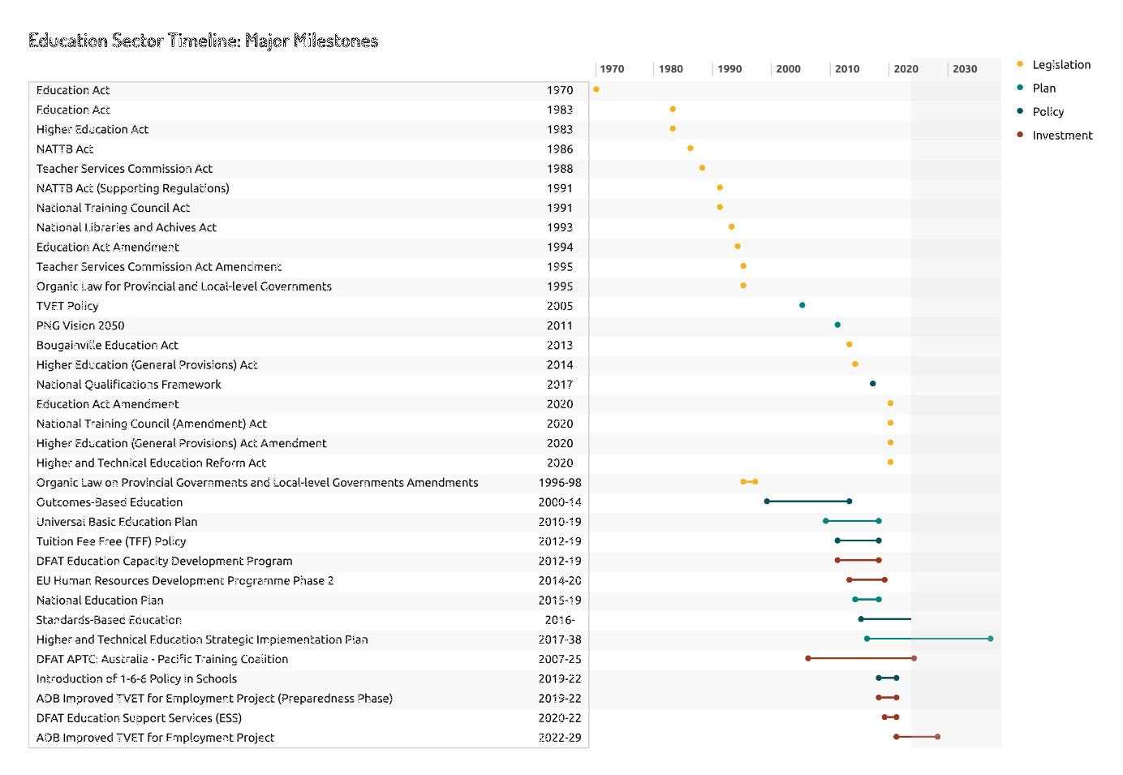Sources: NDoE data and dashboard, DHERST data, Internet searches, and document review.

### Key Findings: TVET Subsector over Time

Legislation

**Key Finding 1**: Legislation has contributed to effecting change in education in PNG. The first Education Act in PNG was legislated in 1970, followed by several more in the 1980s and 1990s. However, four recent pieces of legislation, including the *Higher and Technical Education Reform Act 2020* provided the legislative framework to set reform in motion. The NSDA was established at this time as well.

Policies and Plans

**Key Finding 1**: The *TVET Policy* (2005), *PNG Vision 2050* (2011), and the *National Qualifications Framework* (2017) are the seminal policies and strategies that have shaped the current TVET subsector in PNG.

Investments

**Key Finding 1:** Development partners (DPs) have invested substantially in TVET in recent years. Three DPs have been active investors in the TVET sector: DFAT since 2007, the European Union (EU) from 2014 to 2020 and, more recently, the ADB, whose investments are ongoing. Table 5 indicates the length and value of these investments. The investments are discussed in more detail in subsequent sections of the report.

Table 5. Summary of donor Investments in the TVET subsector since 2007

|  |  |  |
| --- | --- | --- |
| Development Partner | Investment Timeframe | Value (AUD) |
| DFAT: APTC | 2007–2011; 2011–2015; 2018–2025 | Bilateral extension SNGI: AUD45 million |
| DFAT: ESS | 2020–2022 | AUD5.96 million |
| EU | 2014–2020 | AUD64 million |
| ADB: ITVET4E | 2019–2022  2022–2029 | AUD430,000 (DFAT grant for Project Preparation) and AUD15 million (DFAT grant for Project Implementation) |

Sources: Donor information provided, and document review.

### Key Findings: Current TVET System

Transition of Technical Colleges to DHERST

As part of the higher education reform, technical colleges from nine different organisations were transferred to DHERST. Colleges under faith-based non-profit organisations were not transferred.[12] See Table 6 below for details.

Table 6. Transition of colleges

|  |  |  |
| --- | --- | --- |
| Department before Reform | College/Organisation | Shift to DHERST |
| Department of Agriculture and Livestock (DAL) | Highlands Agricultural College (Mt Hagen, Western Highlands) | Yes |
| Department of Labour and Industrial Relations (DOLIR) | 260 Registered Training Organisations (nationwide) | Yes |
| Department of Personnel Management (DPM) | Somare Institute of Leadership and Governance (Port Moresby) | Yes |
| Department of Works | Mechanical Engineering Training Campus (Lae, Morobe) | Yes – now RTO |
| Department of Works | Works Institute of Technology (Port Moresby) | Yes – now RTO |
| Department of Works | Civil Engineering Training Campus (Madang, Madang) | Yes – now RTO (likely not functional) |
| Mineral Resources Authority of PNG | Small Scale Mining Training Centre (Lae, Morobe) | Yes – now RTO |
| National Fisheries Authority | National Fisheries College (Kavieng, New Ireland) | Yes – now RTO |
| PNG Forest Authority | Timber and Forestry Training College (Goroka, Eastern Highlands) | Yes – now RTO |
| National Department of Education | Port Moresby Technical College (POMTECH); National Polytechnic Institute of PNG (Lae, Morobe); Bougainville Technical College (Tinputz, Autonomous Region of Bougainville (ARoB)); Mt Hagen Technical College (Mt Hagen, Western Highlands) | Yes |
| National Department of Education | 21 Technical High Schools | No |
| National Department of Education | 157 Vocational Training Centres | No |
| Department of Labour and Industrial Relations | National Apprenticeship and Trade Testing Board (NATTB) | No |
| Church Agencies | Teachers Colleges | No |

Sources: Information from DHERST KIIs and data, NDoE KIIs and data supplied, and DOLIR.

**Key Finding 1:** It is taking longer than planned to transfer job conditions for all TC administrators and trainers. The *Higher and Technical Education Reform Act 2020* stipulated one year for the transfer; however, the task remains undone after more than two years. Neither education administrators (principals, deputy principals, and heads of departments) nor trainers have had conditions transferred. Four TC principals interviewed noted that none of have them have had their conditions transferred.

‘Transformation – a big bang then 5 to 10 years of work!’ (DHERST interviewee)

Location of TVET Institutions

Figure 2. TVET institutions by type and location (region and province)

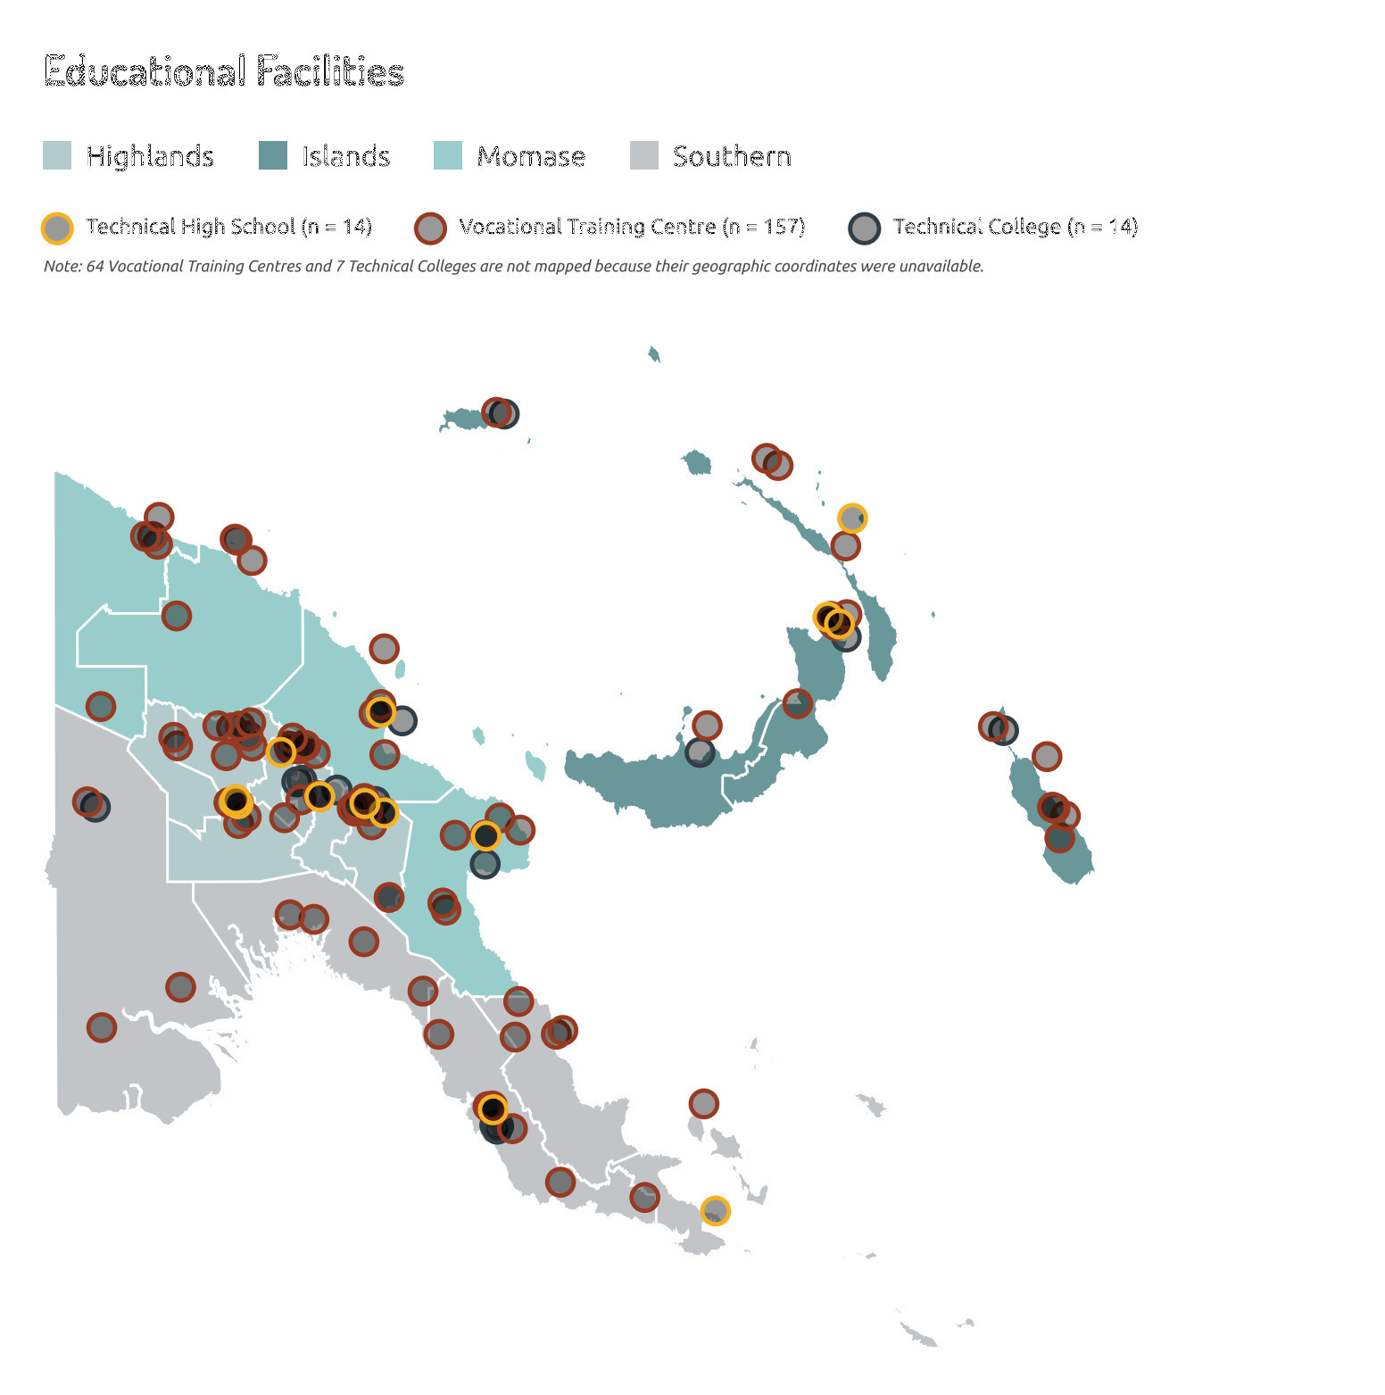

Sources: TVET institutions’ locations were mapped using Global Positioning System (GPS) data and from data provided by DHERST and NDoE.

**Key Finding 1:** There are currently 192 TVET institutions, which are mainly concentrated in the Highlands Region and major urban centres nationwide, including 157 vocational training centres (VTCs) situated mainly at the district level, and 21 technical high schools (THSs – five of which offer technical courses) under NDE, and 14 TCs (mainly in large centres) under DHERST.

**Key Finding 2**: Currently, 57,600 students are enrolled in TVET institutions: 35,000 in VTCs, 15,500 in Technical High Schools, and 7,100 in TCs.[13]

Registered Training Organisations[14]

**Key Finding 1**: The TVET subsector also includes TVET RTOs, which comprise 260 organisations registered with the government that now fall under DHERST jurisdiction.

**Key Finding 2**: RTOs have tripled in number since 2002, when they first began to be registered under the PNG National Training Council (NTC). This phenomenon appears to be driven in part by an increase in companies that provide their own in-house training programs.

**Key Finding 3**: The RTOs are diverse. They vary in size (regardless of type) and range from very large with multiple locations to very small. For example, some for-cost/standalone RTOs have fewer than five trainers. As there is no formal typology to categorise the different types of RTOs, the review team produced one: an ‘Industry In-house RTO’ is an entity that sits within a company such as Hornibrooks and Tininga Limited; a ‘Private Standalone RTO’ is a standalone business for which students pay to attend; and a ‘Government RTO’ is a public sector entity that students also pay to attend. See Figure 3 for details. For a list of RTOs, see Annex 4.

Figure 3. Registered Training Organisations by number and type

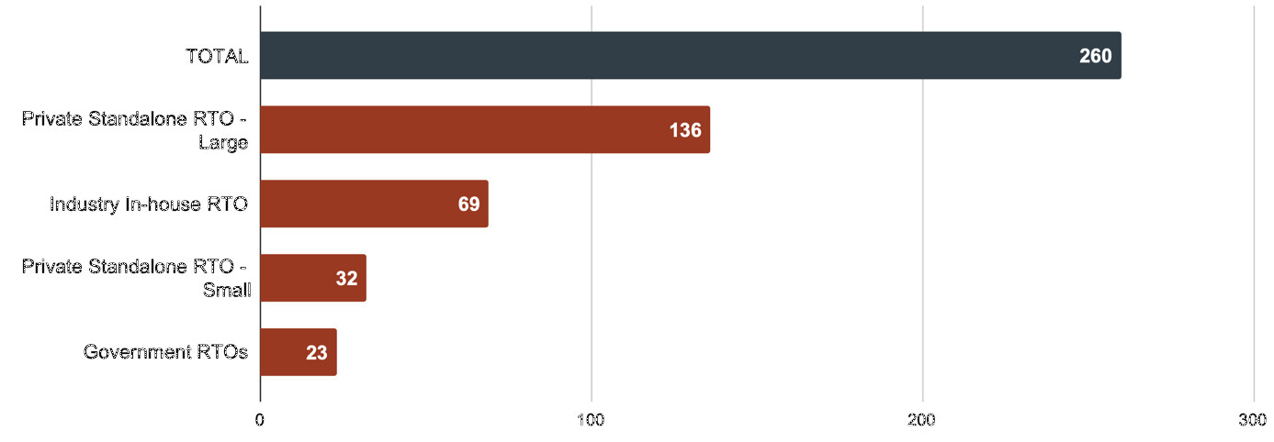

Institutional Assessment and Accreditation[15]

**Key Finding 1**: Both DHERST and NDoE have assessment/accreditation responsibilities. The *Higher and Technical Education Reform Act 2020* transferred assessment/accreditation registration functions for TCs and RTOs to DHERST. DHERST now has nearly 300 entities to oversee, monitor, assess, and accredit. NDoE assesses and accredits the THSs and VTCs. It is not clear whether the assessment/accreditation processes and tools used by the two departments are aligned/harmonised.

**Key Finding 2**: DHERST has limited capacity to assess and accredit institutions. For example, of the 260 RTOs, 14 have been assessed and none have been accredited. NDoE may have similar challenges. The review team estimates that at the current pace, it will take DHERST three to five years to complete all assessments. Accreditation is based on meeting quality benchmarks; if benchmarks are not met, the quality of TVET provision is suspect.

Education Qualifications and Student Pathways[16]

**Key Finding 1**: The PNG National Qualifications Framework (NQF) established in 2017 lays out the 10 qualification levels available and the ‘pathways’ by which students can acquire qualifications. The NQF does not provide recognition of prior learning as a part of the qualifications pathway. Figure 4 shows which parts of the NQF fall under NDoE, DHERST, and DOLIR.

**Key Finding 2**: There are two fractures in the articulation of the qualifications pathway. The first fracture occurs at the juncture between the Vocational Training Centre National Certificate 2 level under NDoE and the Technical College National Certificate 3 level under DHERST. A student who wishes to pursue a National Certificate 3 cannot do so unless they obtain another National Certificate 1 and 2 from a technical college first. The second fracture is under DHERST only. A student with an advanced diploma from a technical college who wishes to pursue a bachelor's degree at a university generally cannot do so unless they repeat the diploma and advanced diploma levels at a university. However, there may be informal arrangements in place; for example, one key informant noted that the University of Goroka appears to be accepting students directly into degree programs without requiring them to repeat the university diploma/advanced diploma levels.

Figure 4. National Qualifications Framework with fracture points

#### Diagram summarising the NQF level of each qualification, the type of institution that offers it, the governing authority, and the various pathways for students to progress through the levels, including where these pathways have 'fracture points'.

Sources: DHERST, NDoE, and DOLIR.

### Conclusions: TVET Subsector over Time

* The TVET subsector is disparate and fragmented, with key stakeholders working in isolation – a situation that has likely become more problematic over the decades. Inter-stakeholder communication and engagement need to be improved to rapidly address TVET subsector and workplace challenges and address gaps that affect students (e.g. the NDoE/DHERST student learning pathway, and NTC and NSDA being under different departments). (See Recommendations 2, 5, 17.)
* Structural reform is underway and recent legislation – the *Higher and Technical Education Reform Act 2020* – is a notable achievement and a foundational step forward in addressing the fragmentation, rationalisation, and harmonisation of the subsector. However, the transition process is constrained by resourcing challenges within DHERST, a situation that will continue to impede progress unless addressed. At current staffing levels, processing the 300 necessary accreditations is estimated to take three to five years. (See Recommendations 2, 3, 5, 7, 11, 14.)
* TVET training is not engaged with industry or employers, and the curriculum is outdated and inappropriate for employment needs. (See Recommendations 5, 9, 13.)
* The TVET opportunities for students are many and varied. RTOs provide a different industry-focused source of training separate from formal institution-based TVET. However, the proliferation of RTOs, the large number of VTCs, and the limited oversight capacity of DHERST (and likely NDoE), suggest that teaching and learning quality is variable (with possible exceptions being the large companies with embedded training provision such as Hornibrooks, which has International Organization for Standardization (ISO) accreditation, and Tininga Limited), or faith-based providers (such as Don Bosco Technical Institute). (See Recommendations 2, 3, 6, 7, 13.)
* Although the NQF articulates the pathway from the lowest qualification level (National Certificate: Level 1) to the highest (PhD: Level 10), the pathway is not seamless; consequently, it is likely that the fractures in the pathway are disincentives due to additional time and cost for students who wish to continue to progress up the framework. This situation has implications not only for individual students, but also for the development of PNG human capital overall. (See Recommendations 4, 13, 16.)
  1. Joint Statement of Intent

As there is no monitoring and evaluation framework underpinning the JSOI, the review team used a novel approach to analyse progress against the respective commitments. Each commitment was broken into several phrases and the review team looked for evidence that could demonstrate progress against the respective parts of each commitment through KIIs, small group discussions (SGDs), site visits, and document analysis.

Based on the available evidence, the team used a simple process to score each phrase: strong evidence/achieved, moderate evidence/partially achieved, no or little evidence/not or little achieved or unable to be assessed (no information was available). The team then used a colour-coding system: if a commitment’s respective phrases all scored ‘strong evidence’, the commitment was coded teal/[A] for ‘Achieved’, and so on. See Figure 5 and the coding legend. Annotated ratings can be found in Annex 5.

Figure 5. Progress against commitments in the Joint Statement of Intent

| 8 Joint Commitments | Progress against commitments |
| --- | --- |
| (i)a. Reform agenda | [A] |
| (i)b. Knowledge and research | [PA] |
| (i)c. Strengthen selected institutions | [NA] |
| (i)d. GEDSI | [LA] |
| (i)e. Flexible programs | [NA] |
| (i)f. Adhering to joint agreements | [PA] |
| (i)g. Joint governance | [LA] |
| (i)h. Good faith | [PA] |

| 4 GoA Commitments | Progress against commitments |
| --- | --- |
| (ii)a. Expand role of APTC | [LA] |
| (ii)b. Support development of TVET institutions | [A] |
| (ii)c. Co-finance ADB scoping | [A] |
| (ii)d. Engage with GoPNG regarding lessons learned | [LA] |

| 6 GoPNG Commitments | Progress against commitments |
| --- | --- |
| (iii)a. Leadership | [PA] |
| (iii)b. Coordinate all development partners’ assistance | [LA] |
| (iii)c. Link industry and institutions via NSDA | [NA] |
| (iii)d. Provide funding to transform East Lorengau facilities | [UA] |
| (iii)e. Whole-of-GoPNG approach for APTC partnerships | [UA] |
| (iii)f. Execution and sustainability of TVET investments | [LA] |

| Category | Legend |
| --- | --- |
| **Achieved** | [A] |
| **Partially Achieved** | [PA] |
| **Little Achieved** | [LA] |
| **Not Achieved** | [NA] |
| **Unable to Assess** | [UA] |

Sources: KIIs, site visits, primary source data, and document analysis.

### Key Findings: JSOI

Overall Achievements across the JSOI

##### 8 Joint (Shared) Commitments

**Key Finding 1:** One of the eight joint commitments – Support for the GoPNG sector reform (i)a – has been achieved. DFAT has supported DHERST by providing essential TA personnel to work with DHERST in its legislation and operational planning to enact the reform. For example, TA guided the development of the *Technical College and RTO* *Accreditation System Mapping* including accreditation standards, and amendments to the *Higher and Technical Education Reform Act 2020*. The TCs have been transferred from a disparate group of nine departments to DHERST. Regulatory and personnel functions are in the process of being transferred but are moving forward slowly. The transition of TCs to DHERST is described in section 2.1 on the TVET Subsector.

**Key Finding 2**: Three of the eight joint commitments have been partially achieved – Knowledge and research (i)b, Adhering to joint agreements (i)f, and Good faith (i)h. New knowledge and some research studies (such as a Labour Market Survey in 2022) were generated, and other investigations needed to inform policy and reform have been developed by ESS TA, and underpinned the DHERST agenda. DFAT and DHERST have adhered to joint agreements, made efforts to adopt joint governance arrangements, and held meetings. Both parties have demonstrated good faith and trust in each other through open communication. With some exceptions, there is limited awareness about the JSOI among the 140 individuals interviewed. For example, no staff at the four APTC–SNGI TCs and no industry representatives were aware of the JSOI. However, senior officials in DHERST (4/5), DFAT (2/2), and ‘Knowledgeable People’ (4/6) had deep or some knowledge of the JSOI.

**Key Finding 3**: Two of the eight joint commitments have achieved little – GEDSI (i)c and Joint governance (i)g. The student data available to the review team, including data disaggregated by sex, disability and other social inclusion descriptors, were limited and not trustworthy. Electronic applications are not used across the subsector – the bulk of applications are paper-based and are received at college level; it was not possible to use these applications as data sources. The team attempted to obtain and interrogate applicant and accepted student data, but this effort was not successful. Additionally, there are no tracer studies that could inform a view about women gaining employment in male-dominated industries[17] or access of other groups to TCs. A GEDSI Toolkit and supporting documentation were developed for DHERST with technical adviser assistance, and a GEDSI subsidy to support women and vulnerable people in their studies was supported by DFAT, though with mixed results. Anecdotal evidence based on direct observation during site visits and KII data indicate that there may be a small but increasing number of women enrolled in non-traditional courses, although this cannot be substantiated through the available quantitative data.

**Key Finding 4:** Regarding joint governance (i)g, there are four established governance and coordination bodies used by the GoA and GoPNG for the TVET subsector. The Ministerial Forum is a high-level forum that is held annually and is co-chaired by the GoA and GoPNG Ministers for Foreign Affairs[18] and attended by ministers from both governments (including the Prime Ministers/Deputy Prime Ministers, and Ministers for Defence, Trade and Tourism, and Climate Change). The APTC–SNGI investment and the ITVET4E project both have steering committees. It is not clear whether the ESS had a steering committee.

The APTC–SNGI Joint Steering Committee[19] meets at least three times per year, including holding one meeting per year in a selected province to build understanding between JSC members and technical college administrators. For example, in 2024, the JSC convened at the Madang Technical College in Madang Province. The JSC was originally established to provide oversight just for SNGI, but was expanded to include the regional program for greater visibility. The JSC provides high-level policy advice and strategic direction and guides coordination and implementation of the APTC–SNGI investment, and is co-chaired by the DFAT Education Counsellor and DNPM Secretary with the DHERST Secretary as an alternative chair. Members include representatives from the DPLGA, NSDA (Chair and representatives of ISGs), PNG Business Coalition for Women, and APTC PNG (Country Director). APTC PNG provides secretariat support for the JSC. The JSC sometimes struggles to achieve a quorum and to meet as scheduled.

A Project Steering Committee for the ITVET4E[20] provides advice and resolution of issues for the project sponsor, stakeholders, and management unit. The PSC meets quarterly and is co-chaired by the DHERST Deputy Secretary, DNPM First Assistant Secretary, and members include Department of Works, Department of Treasury, National Procurement Commission, NDoE, and other DHERST representatives. DFAT and the ADB are members. The PSC meets according to its designated schedule and with a quorum of members. In the past 12 months, the PSC met four times. As part of shared governance efforts, DFAT and ADB have commenced joint monitoring visits.

The NSDA is a critical coordinating body for public, private and non-profit entities involved in TVET and the world of work[21], but has lost momentum. DFAT is a member. The NSDA appears to struggle to undertake its mandate.

Forums are not apparent for broad and effective engagement with industry leaders at the national and subnational levels (including through Chambers of Commerce), and for Technical Colleges to interact and learn from each other.

**Key Finding 5:** Two of the eight joint commitments have not been achieved: Strengthening institutions (i)c and Flexible programs (i)e. The strengthening of selected institutions was not observed by the review team and there was limited evidence to show that this was occurring. As presented later in the report, there is no evidence of modernisation of curricula – which were found on average to be 25 or more years old – or specific content knowledge and skills upgrading for trainers, or professional development for education administrators. Some infrastructure and equipment have been provided, but an integrated approach to institutional strengthening/organisational development was not evident and interviewees were unable to point out organisational development strategies.

##### 4 GoA Commitments

**Key Finding 1:** Two of the four GoA commitments have been achieved: Supporting the development of TVET institutions (ii)b, and Co-financing ADB scoping (ii)c. Both the support for the development of TVET institutions through APTC, and DFAT’s willingness to co-finance ADB scoping work and future programs are in place. Although (ii)b is similar to (i)c, this commitment focuses on institutions in specified regions, which has taken place. As indicated above, the selected institutions in the specified regions have received some help.

**Key Finding 2**: Two of the four GoA commitments have achieved little: Expand the role of APTC (ii)a, and Engage with GoPNG on lessons learned (ii)d. The review team found limited data that could demonstrate any increase in the number of TVET graduates. The GoA through DFAT has engaged well with GoPNG on TVET, but there is no evidence that lessons have yet been learned that will improve future programs (e.g. lessons on infrastructure and equipment provision), nor is there evidence of alignment with industry needs and opportunities. Industry representatives in Bougainville and Mt Hagen indicated that there has been no contact with colleges and no consultations with the TVET sector on skills needs and opportunities during the last 10 years. Exceptions include interactions between Don Bosco Technical Institute (DBTI) in Port Moresby and Remington, but DBTI is not one of the targeted institutions.

##### 6 GoPNG Commitments

**Key Finding 1**: One of the six GoPNG commitments has been partially achieved: Leadership (iii)a. GoPNG, through DHERST, has provided leadership and developed policies in the higher education and TVET sectors, but the review team was unable to determine whether the operational and general TVET environment was improved to be conducive to learning.

**Key Finding 2**: Two of the six GoPNG commitments have achieved little: Coordination of partners (iii)b, and Execution and sustainability of investments (iii)f. The coordination of all TVET stakeholders/partners was not apparent, with regard to reference or skills groups and the NSDA functionality is not readily apparent. The review team observed limited preparation to date in PNG for the closure of APTC Stage 3, which presents an opportunity to maximise the benefits and ensure sustainability of some of its interventions.

**Key Finding 3**: One of the six GoPNG commitments has not been fully achieved: Link industry with institutions via the NSDA (iii)c. Linking industry and institutions via the NSDA has not been achieved, as discussed above.

**Key Finding 4:** The review team was unable to assess two of the six GoPNG commitments: Funding for East Lorengau facilities (iii)d, and Whole-of-GoPNG approach for APTC partnerships (iii)e. There is no data on or certainty regarding the GoPNG intentions for the East Lorengau facilities. The future status of the Manus Training Centre is also caught up in these considerations with land ownership and compensation issues. The review team found no evidence that a whole-of-government approach is in place. DHERST is the main partner, but other influential departments (e.g. Department of Treasury) do not seem to be engaged and active.

‘The JSOI is a reinforcement of commitments.’ (DHERST Interviewee)

### Conclusions: JSOI

(All relate to Recommendations 1–6)

* DFAT and DHERST have demonstrated good success and made progress in several – seven (40%) – of the 18 commitments. With regard to the eight joint commitments, Support for the GoPNG sector reform agenda (i)a has been achieved, and also the DFAT and DHERST relationship is sound, and there is trust and ongoing open communication and engagement between the two parties. It is likely that these strengths will continue, provided the key actors remain or their replacements are equally committed. There has been little or no progress in other commitments, for several reasons, not least of which is a lack of definitional parameters and clarity on how to operationalise a respective commitment.
* The joint commitments and DHERST commitments are, by and large, appropriate; however, DFAT’s commitments are limited and could be expanded, especially with an eye to a leadership or coordinating role among donors, potential relationship brokering with other GoPNG stakeholders and the private sector, and to reflect the scope of future GoA investments.
* Some modifications to the commitments are needed, as is expanding the JSOI to become a more effective and substantive partnership document. This could include specifications for governance, communication, monitoring, evaluation, and learning. Both actions might also help mitigate risks to continued collaboration should key actors in either organisation change. A more substantive document could also be socialised more widely and used as a broader collaboration tool.
* Lack of a strategy or strategic framework for TVET (separate from but informing the JSOI Partnership Framework) that tracks results and indicators expected across investments inhibits government-led strategic-level decision-making and flexibility. This framework would need to be informed by a mapping of subsector needs against elements of current and future planned investments to see where there are gaps being filled and gaps remaining.
* Overall, the JSOI is a well-crafted strategic document with commitments that reflect the nature and importance of the partnership and that are generally fit for purpose. However, in its current state, the JSOI is a partial partnership document that cannot (yet) be used as a practical tool for monitoring, and evaluating, and communicating about the partnership.
  1. DFAT Investments

While the scope of the strategic review did not include a formal review of the performance of the APTC–SNGI or ITVET4E, or an ex-post evaluation of the ESS, the review team did seek to accrue enough evidence and insights to enable a rapid assessment of each investment’s contribution to progressing the JSOI. The investments’ end of program outcomes are shown in Table 7.

Table 7. End of Program/Investment Outcomes (EOPOs or EOIOs) or Aims

|  |  |
| --- | --- |
| Investments | Outcomes/Aims |
| APTC–SNGI | EOPO1: Graduates have improved employment outcomes  EOPO2: Co-investment in skills training increases  EOPO3: Selected TVET partners demonstrate quality TVET provision |
| ESS | EOIO1: Strengthened organisational capacity in DHERST and NDoE to implement key reforms in higher, technical, and basic education. |
| ITVET4E | Support the GoPNG in reforming the TVET system to enhance student competitiveness and responsiveness to employment and industry needs. |

Additional information on the three investments is provided in Table 8.

Table 8. Summary of DFAT investments under the JSOI

|  |  |  |  |  |
| --- | --- | --- | --- | --- |
| Modality & Donor | Program Name & Timeframe | Implementing Organisation | Funding Amount | Notes |
| 1a. Bilateral Grant/DFAT PNG | Sub-National Growth Initiative (SNGI)  2020–2025 | TAFE Queensland | AUD45 million  PGK123 million | Bilateral extension to regional program (1b).  3 technical colleges (Bougainville Technical College, Highlands Agricultural College, Mt Hagen Technical College) and Manus Training Centre  New bilateral program design expected in 2024. |
| 1b. Regional Grant/DFAT Canberra | APTC Regional Program Stage 3, 2018–2025 | TAFE Queensland | AUD251.2 million  (ca AUD5 million for PNG) | 10 countries: PNG, Fiji, Kiribati, Nauru, Timor-Leste, Samoa, Tonga, Tuvalu, Solomon Islands, Vanuatu.  APTC campuses in five locations: Fiji, PNG, Samoa, Solomon Islands, Vanuatu.  APTC PNG supports and is co-located with Port Moresby Technical College.  New design underway in 2024. |
| 2. Bilateral Grant/DFAT co-financing with ADB | Improved TVET for Employment (ITVET4E)  Preparation Phase, 2019–2022;  Implementation Phase 1, 2022–2024 and Phase 2, 2025–2029 | ADB and DHERST | AUD100 million (ADB USD50 million/ca AUD75 million loan, DFAT AUD15 million grant, GoPNG/ DHERST AUD8 million | Concessional loan  Supports 10 technical colleges including four colleges currently supported by APTC–SNGI (Bougainville Technical College, Highlands Agricultural College, Mt Hagen Technical College, and Manus Technical College) and six other TCs. |
| 3. Bilateral Grant/DFAT | Education Support Services, 2020–2022 | Abt Associates | AUD5.96 million | TA provided to DHERST and NDoE. |

Sources: KIIs and documents and secondary source data from ADB, DFAT, and TAFE Queensland

### Key Findings: Investment 1 APTC–SNGI[22]

**Key Finding 1:** APTC, Australia’s regional TVET program, is in its third stage and will conclude in early 2025. APTC3 offers Australian certificate standards in vocational courses such as carpentry, commercial cookery, tourism and hospitality, and light vehicle mechanics, through its Port Moresby campus. APTC PNG is co-located with POMTECH (the campuses are side-by-side), which APTC3 supports. In 2020, APTC3 expanded its scope to provide support to the Bougainville Technical College (BTC), Highlands Agricultural College (HAC), Mt Hagen Technical College (MHTC), and in 2023 Manus Training Centre (MTC) through the DFAT PNG bilateral SNGI. Support included a combination of International Skills Training (IST), flexible learning centres, and equipment. APTC3 has continued to face the chronic challenges present in the TVET subsector over time (limited capacity and human resources in PNG’s TVET system, a complex political economy, geography and travel), as well as the COVID-19 global pandemic emergency period (March 2020 to mid-2022).

To provide an overall view of the progress of the TVET investments, the review team did a rapid assessment of seven Technical Colleges/Institutes, including the four SNGI-funded locations that have been supported by APTC3 (BTC, HAC, MHTC, and MTC), and POMTECH whose support is provided through the APTC regional program budget. The National Polytechnical Institute of PNG (NPIPNG) in Lae, and DBTI in Port Moresby were included as comparators. The rapid assessment looked at performance against the standard pillars of an education system: curriculum, student assessment, trainer development, leader (administrator) development, infrastructure (buildings), and equipment. The review also considered student support services such as student tracer studies and student job placement. A criterion was selected and rated for each pillar (refer to the legend in Figure 6). Detailed data for each school can be found in APTC–SNGI Annex 6.

Figure 6. Technical college performance against education system pillars

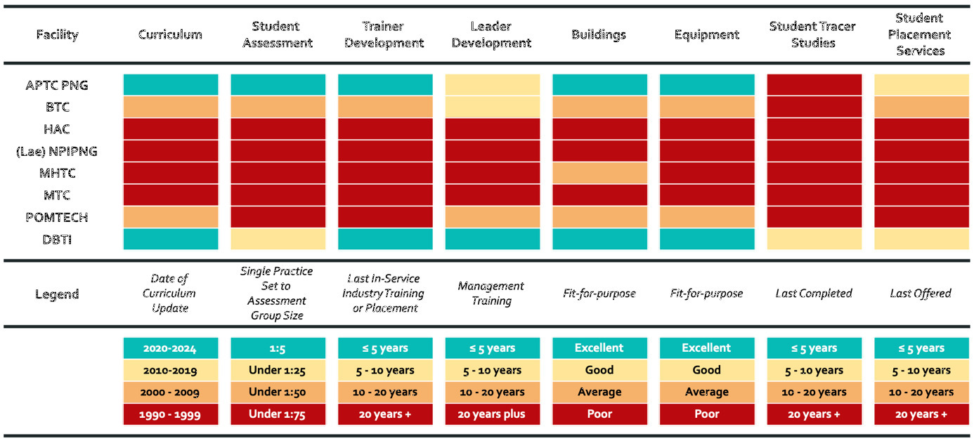

Sources: Data from direct observation during site visits, KIIs, SGDs, and document analysis.

Curriculum

**Key Finding 1**: There is no overarching TVET curriculum framework with a modern approach to teaching and learning, standards, assessment, trainer guides, and student books and materials; instead, there are subject-specific course materials. Courses that are taught reflect a modified 1998–2002 competency-based training and assessment approach, and the availability of the full suite of teaching and learning tools (trainer guides including assessments and student books and materials) is highly variable. The absence of core teaching and learning tools means the ‘trainer is the textbook’ in most courses.

**Key Finding 2**: The courses’ subject matter is outdated, and most courses have not been updated since before 2000. Given the substantial advancements in technology, particularly in electronics, and the digitisation of control processes over the past 25 years, the TVET course curricula do not reflect modern industry needs, standards, and emerging technologies. At present, labour market studies do not inform course redesign. This was verified in interviews with 12 private sector employers. In a survey of 19 industry employers, 12/19 (63%) disagreed or strongly disagreed that the current cohort of TVET graduates are prepared to meet the demands of their industry. In addition, 12/19 (63%) also strongly disagreed that collaboration between TVET institutions and local industries is effective in shaping the curriculum to meet industry needs.

**Key Finding 3**: DHERST has no TVET curriculum function or personnel. This means that the department is limited in its ability to provide guidance and oversight regarding high-quality curricula and specific course syllabi.

‘BTC is the place for building Bougainville’s future.’ (ARoB interviewee)

Student Assessment

**Key Finding 1**: The review found that, on average, there was one set of testing equipment for practical examinations or assessments per 45 students. The international standard is one set per five students, a ratio that was only observed at APTC PNG. The high student-to-testing equipment ratio indicates that students do not have sufficient access to equipment during practical assessments, which would hinder their ability to develop practical skills. This limitation was confirmed by 10/12 private sector employers interviewed, who stated that TVET students had low practical skills on arrival at the workplace.

**Key Finding 2**: The validity of practical assessments is compromised when conducted under conditions of equipment scarcity. Six trainers confirmed this, stating that TVET students are unable to address weaknesses and meet industry standards to be ‘work ready’.

Trainer Development

**Key Finding 1**: Of the 47 TVET heads of departments and trainers interviewed, 44 (93%) said that they had not received any professional development in the last 10 years. The average length of time since their last training session is 16 years. APTC has trained 33/107 trainers in four targeted colleges in International Skills Training (IST); 74 have not yet participated in the IST.[23]

**Key Finding 2**: Most trainers interviewed do not have formal qualifications (TAFE certificate/diploma/degree), and are teaching based on what they did on the job 20 years ago. Professional development enhances TVET teaching quality by providing educators with new tools, strategies, and perspectives. Without ongoing professional development, TVET instructional quality is likely to decline over time. For example, 27 (90%) of 30 private company interviewees also stated that students are not ‘work ready’ and need training from the employer for at least nine months before they become productive.

**Key Finding 3**: The importance of qualified and motivated trainers for student achievement and learning outcomes is well-established.[24] The lack of professional development opportunities hinders trainers’ ability to improve their content knowledge. Fifteen (50%) of the 30 trainers interviewed believed that the TVET colleges would struggle to attract and retain high-quality trainers, exacerbating the problem over time.

‘The BTC trains (students) in what the lecturers can train (in) and not what the employers and the community needs.’ (ARoB private sector interviewee)

Leader Development

**Key Finding 1:** Most of the principals and deputy principals interviewed reported having no management training for 15 years or more.

Buildings

**Key Finding 1:** Most buildings are pre-1990s and not modern, except for facilities at APTC PNG and DBTI and, to a certain extent, POMTECH.

**Key Finding 2**: TCs do not set aside or do not have budgets for infrastructure maintenance and repair.

**Photographs taken by review team**



Image above: The Manus Training Centre Computer Lab building, constructed through the APTC–SNGI investment, is in relatively good condition.

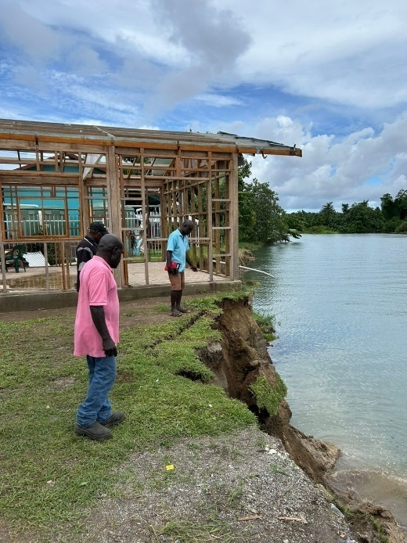

Image above: A new Commercial Cookery building and Women’s Dormitory were constructed on the Bougainville Technical College campus through the APTC–SNGI investment. Flooding in 2024 eroded the riverbank and the buildings cannot be used.

**Images courtesy of HDMES**



Image above: The Manus Training Centre’s Heavy Mechanical Workshop is very old and in poor condition.



Image above: The Bougainville Technical College has benefited from the construction of new buildings, including the Business Studies building shown here. Even though BTC has no allocated maintenance budget or staff, the building appears to be well-maintained.

Equipment

**Key Finding 1:** There are issues with the learning equipment and machinery. Most of the equipment and machinery are over 20 years old and do not reflect modern industry standards and technological advancement. Equipment is poorly maintained and/or not replaced, due to the lack of an established annual maintenance, repair and replacement budget, and the absence of dedicated maintenance staff. Equipment provided may not or cannot be used for several reasons (including an inability to service the equipment locally).

**Photographs taken by the review team**

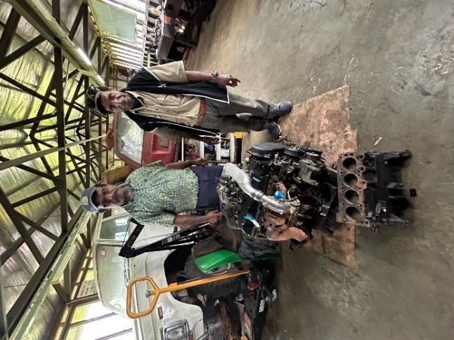

Image above: The Mt Hagen Technical College Light Mechanicals Workshop has learning machinery, but it is obsolete. The Nissan utility vehicle motor pictured above is 20 years old and has no electricals. Graduates will not be equipped to work as mechanics on the cars of today.

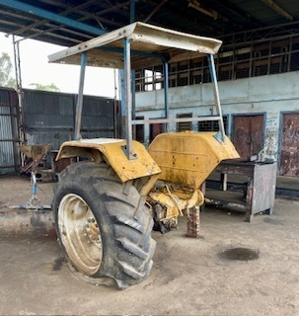

Image above: The Highlands Agricultural College is one of the three remaining agricultural colleges. HAC has 250 hectares of land, of which 2–3 hectares are under cultivation. Most of HAC’s farming equipment has not been functional for several years. According to a HAC staff member, ‘X (a trainer) has been drawing a tractor on the chalkboard for 8 years’.

**Images courtesy of HDMES**

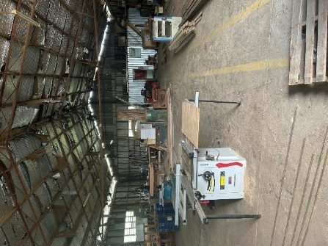

Image above: The Mt Hagen Technical College’s Building and Construction Workshop has wood working equipment that is in good condition, but there is no steel framing equipment.

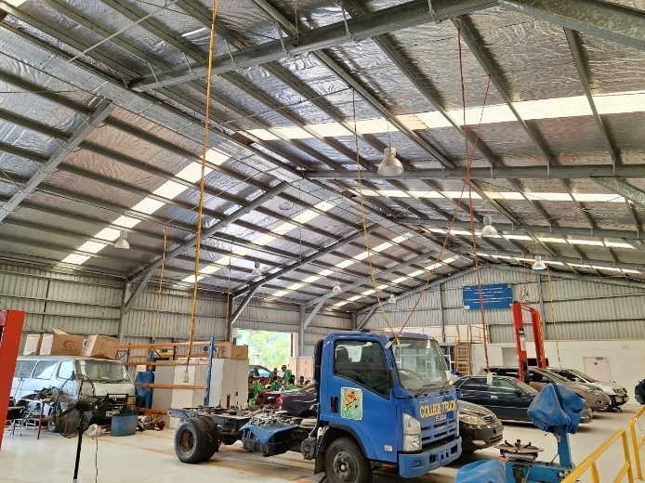

Image above: The APTC PNG campus in Port Moresby has a Vehicle Workshop that is well-equipped with modern engines and digital technology. Skills gained in such a workshop will enable graduates to repair today’s vehicles.

Student Tracer Studies

**Key Finding 1**: Across the colleges visited, recent graduate tracer studies are absent[25], highlighting a gap in understanding of the employment or entrepreneurship outcomes for graduates.

Student Services

**Key Finding 1:** Technical colleges do not appear to have a student services division or active student groups. During informal conversations, some students said they had tried to raise issues such as overcrowding, and safety and security, with school management, but no actions were taken. There is no proactive engagement with industry partners and potential employers to facilitate job placements for upcoming graduates, with the possible exception of DBTI.

**Key Finding 2:** Overcrowded classrooms and classrooms set up in workshops present health and safety and pedagogy concerns. Most colleges had personal protection equipment/supplies, but other aspects of health and safety seemed to be lacking. For example, at POMTECH, there is not enough classroom space to accommodate all students enrolled in the heavy diesel fitting and mechanics National Certificate course; consequently, classes are held in the diesel fitting workshop amidst the machinery. A POMTECH trainer noted that this situation is a common occurrence. Moreover, during a DFAT visit to MHTC, it was observed that class sizes were very large, in some cases approximately 70 students.

Class sizes can limit a trainer’s ability to implement and assess competency-based training. The review team observed some well-maintained and well-functioning workshops at APTC PNG, POMTECH, DBTI, and NPIPNG, and the Flexible Learning Centres appear to be popular and well-maintained for the most part.

**Photographs taken by review team**

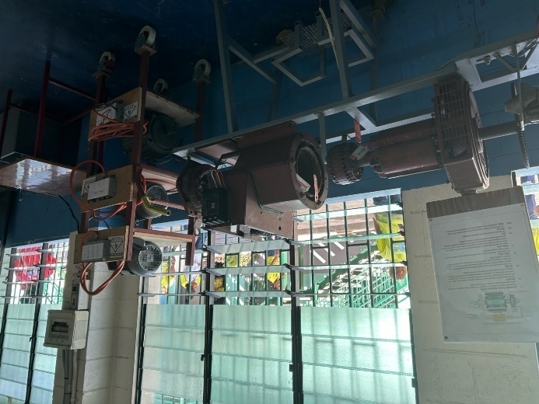

Image above: The Don Bosco Technological Institute Port Moresby Campus has a well-functioning Electrical Motors Workshop.

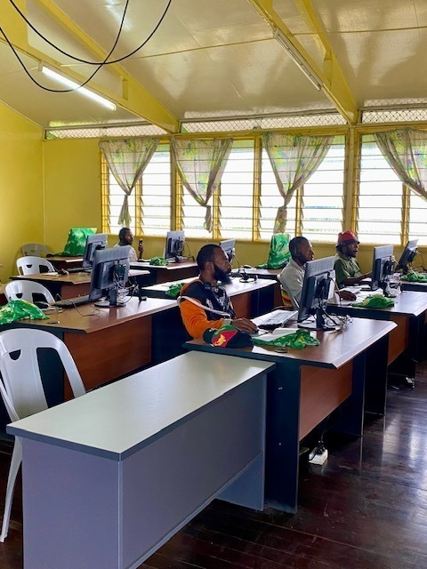

Image above: Flexible learning centres were introduced through APTC–SNGI. The HAC FLC (pictured left) is well-maintained.

**Images courtesy of DHERST**

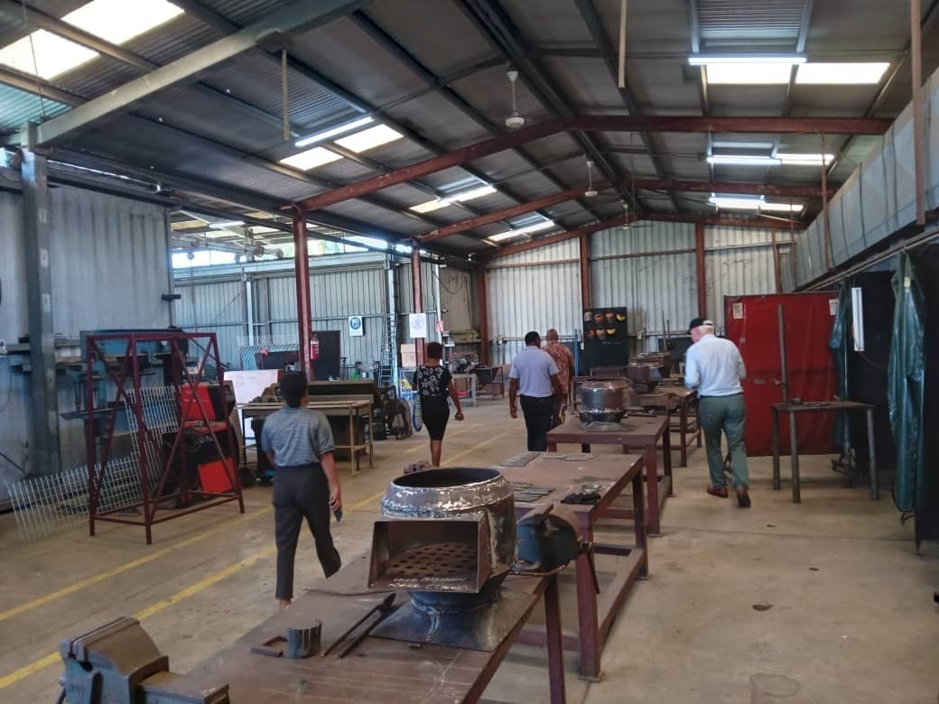

Image above: The National Polytechnic Institute of PNG in Lae, Morobe has a well-maintained Welding Workshop.

Value for Money

**Key Finding 1**: There is a wide range in annual costs per student. The review team analysed data specifically based on the completion of a one-year diploma and the associated fees for delivering that program. APTC PNG has the highest annual cost per student for diplomas, amounting to AUD19,118 (PGK47,097). POMTECH follows, with an annual cost per student/diploma of AUD8,437 (PGK20,787).DBTI represents the most cost-effective option, with an annual cost per student/diploma of AUD4,193 or PGK10,331, while maintaining equivalent quality training standards.

Overall Assessment of APTC–SNGI

**Key Finding 1:** There is limited evidence that the investment modality used for the SNGI program under APTC3 implementation is showing progress towards meeting the EOPOs, in particular, EOPO3: Improving the quality of TVET. APTC–SNGI colleges have received some equipment and new or upgraded infrastructure, but investment in training quality and curriculum is not evident and, in some instances, the material resources provided are not used. The relevance and effectiveness of TVET courses are not demonstrated in practice.[26]

**Key Finding 2**: Collaborative investment efforts with APTC–SNGI have not yielded discernible progress towards increased graduation rates (up to 600 annually per JSOI commitment (ii)a). The review team was not provided with graduation data from TCS collected by APTC–SNGI, if it has been collected. During interviews, education administrators and trainers were not able to identify support provided by APTC–SNGI or enhancements made in curriculum, learning machinery, trainer trade/vocational content training, graduate tracer studies or labour market studies, to guide course design and updates.

**Key Finding 3**: Data (e.g. on student retention as well as graduation) is lacking and the limited data that is available does not appear to be reliable. APTC noted that it was undertaking a Planning, Monitoring, Evaluation and Learning investment in May 2024 and the data would be available in June 2024 (following the completion of the strategic review). Well-organised financial data is not readily available to respond to information requests.

**Key Finding 4:** The investment modality involves multiple stakeholders, including DFAT PNG, DFAT Canberra, DHERST, NDoE, NATTB, the private sector, and the managing contractor, TAFE Queensland. TAFE Queensland interviewees noted that it engages with ISGs and industry more broadly through workshops, internships, and industry placements; DFAT confirmed that it had attended ISG workshops for the Hospitality National Training Package and Construction. APTC PNG has organised internships for students of Bougainville Technical College in 2023 and 2024.

Despite this, some stakeholders felt their views were not being considered in project management; however not all key stakeholders are included in existing governance arrangements described earlier, and engagement and collaboration among these bodies was not observed during site visits or indicated in KIIs and SGDs.

‘The handbrakes have been on in SNGI.’ (Official)

### Conclusions: Investment 1 APTC–SNGI

(All inform Recommendations 2, 4, 9)

* Outdated curricula, limited/no trainer and education administrator professional development, and inadequate infrastructure, mean students are not industry-ready. Graduates may face challenges securing employment or retraining to meet contemporary job market needs. These deficiencies hinder progress towards the EOPOs (especially EOPO1 and 3).
* APTC–SNGI has had a relatively short timeline of implementation (2020 to date) and the challenges of low quality and resourcing in the TCs have worked against a rapid ramping of industry-ready graduates from the four colleges supported.[27]
* Managing coordination and communication among these entities can be challenging, leading to inefficiencies and delays in oversight, implementation, and adaptive management. Limited institutional capacity within DHERST has hampered the effective implementation of the APTC–SNGI investment modality. This has manifested in challenges related to project management, monitoring and evaluation, and overall coordination of activities.
* Limited availability and use of labour market studies limits the relevance of TVET curricula to industry needs and opportunities, and national development.
* Challenges in effectively monitoring and evaluating the outcomes (and outputs) of the APTC–SNGI investment modality have hindered its ability to demonstrate progress and make evidence-based decisions. Insufficient data collection, the lack of a robust PNG-specific evaluation framework, and limited capacity for data analysis, have contributed to gaps in understanding the impact of interventions.
* The lack of current tracer studies makes assessing the return on investment overall or for specific colleges difficult.
* Positive efforts in most colleges visited appear to be driven by individuals and not institutionalised systems, processes, and practices; consequently, sustainability of successes are at risk if the motivated individual moves on.
* Although it is too early to definitively judge the sustainability of interventions made under APTC–SNGI, it is important that those interventions lead to lasting impact and enhanced capacity in DHERST. Issues such as limited local ownership of curricula used by APTC, reliance on external expertise, and inadequate consideration of local contexts have undermined sustainability.

### Key Findings: Investment 2 Improved TVET for Employment Project

**Key Finding 1:** The seven-year (2022–2029) Improved TVET for Employment Project has two phases: Phase 1 (2022–2024) and Phase 2 (2025–2029). A Project Preparation Phase was carried out from 2019 to 2022 and, as part of the ADB due diligence processes, several analyses and assessments were undertaken and related reports produced between November 2021 and July 2022, including on Governance and Management, Capacity Assessment, Financial Analysis, Financial Management Assessment, Procurement Assessment, Fraud and Corruption Assessment, Skills Demand and Supply, Access and Equity, Gender, Social and Poverty Assessment, and Sector Assessment.[28] A final report that consolidated the various studies was also produced.

Phase 1 was expected to commence in November 2022; however, Phase 1 commencement was delayed to May 2023 and the project has struggled to move beyond a prolonged inception stage. To date, three short-term technical advisers have been engaged through parallel ADB systems, focusing on Governance and Leadership, Asset Management, and Teacher Training. No monitoring and evaluation mechanism has been established yet. The focus of Phase 2 is not yet defined. The fragmentation of the TVET subsector and difficulties over the definition of the loan arrangement, coupled with the COVID-19 pandemic, appear to have contributed to the difficulty in making progress with implementation.

**Key Finding 2**: The project is financed and overseen by three partners – ADB, DFAT PNG, and DHERST. All partners have contributed their portions of the AUD100 million budget: the ADB concessional loan of ca AUD70 million[29] is designated mainly for infrastructure and equipment; the DFAT grant of AUD15 million that runs to March 2025 is currently earmarked for curriculum development, and education administrator and trainer professional development (however, DFAT may reconsider the earmarking of its funds to expand its overall influence on the project); and the GoPNG contribution is AUD8 million. DFAT also provided an AUD430,000 grant for the Project Preparation Phase (2019–2022).

**Key Finding 3:** All three partners appear to be collaborating and working well together in project coordination and governance. DHERST implements the project through a Project Management Unit. The Project Steering Committee (PSC) [30] provides oversight and is described in the JSOI section of the report.

**Key Finding 4**: The project appears to be well-aligned to GoPNG priorities. It aims to support the GoPNG in reforming the TVET system to enhance student competitiveness and responsiveness to employment and industry needs, specifically in the construction trades and agriculture. It supports 10 TVET colleges recognised by GoPNG as centres of excellence, which are meant to serve as models for subsequent reforms across other TVET colleges nationwide; however, there are only four TCs that are not part of the project/centres of excellence. The ADB is also co-financing training, workshops, and capacity building activities under national TVET governance, and part of curriculum development, including developing bridging courses and developing teaching, learning, and assessment materials in agriculture and construction trades, and enhancing analytical and creative thinking, adaptability, flexibility, and teamwork in curriculum development. There have been discussions about expanding the project’s focus in Phase 2 to explore nursing colleges alongside other courses (e.g. tourism), but no decision has been made. Climate change is part of the ongoing project and will be further considered in the next phase. Specific details are yet to be finalised.

‘There’s a chance for a major footprint in the TVET space!’ (DHERST interviewee)

### Conclusions: Investment 2 Improved TVET for Employment Project

(See Recommendations 4, 6, 13, 15)

* Given the delays in implementation, substantial insights regarding the achievements of the project to date are limited. However, a clear success is the functionality of the PSC: this demonstrates strong GoPNG buy-in and interest in the project.
* Effective partnerships between TVET institutions and industry stakeholders are an intended output and ongoing process, which should help the project align with industry needs and opportunities and enhance graduate employability.
* The time taken to procure an M&E firm is problematic; however, once the firm is in place and work on the M&E system has commenced, it would be in DFAT’s interests to understand how the system and reporting could accommodate DFAT needs.
* While challenges persist due to the limited capacity of DHERST and other GoPNG agencies, and the rigorous standards set by the ADB, it is probable that ADB and DHERST will deliver the essential infrastructure and equipment components of the project. However, to unlock the project’s transformative potential, additional support is vital. This includes comprehensive capacity building and robust organisational strengthening in TVET institutions, supported by dedicated in-house advisory assistance for DHERST.
* The project has the potential to support improvements in TVET, and contribute to achieving the commitments of a refreshed JSOI, and to benefit from improved quality, avoid duplication of efforts, and provide synergies with other investments. However, the focus on 10 of 14 technical colleges, and the focus on two industry streams as well as the national level interventions, may present challenges for knitting together a holistic approach to the TVET subsector. Given the budget and scope of the project, it is a critical piece of the TVET landscape, and coherence across investments is essential.
* It is likely in DFAT’s best interests to ‘un-earmark’ its funding for strategic as well as practical reasons, related to ease of reporting on results associated with its contribution.
* The PSC appears to be functioning well and with good engagement from members. This is a notable achievement.

### Key Findings: Investment 3 Education Support Services Project

**Key Finding 1:** Over the past decade, Australia has provided funding for technical assistance through the 10-year, AUD9 million Education Capacity Development Facility (ECDF) (2011–September 2020), the primary provider of Australia-funded TA to the GoPNG in higher education (DHERST) and basic education (NDoE).

DFAT established the 2020–2022 AUD5.96 million Education Support Services program to provide technical support to DHERST and NDoE. The ESS was not established specifically to support the JSOI or TVET; however, from the start of the JSOI period in 2020, the ESS provided TA to DHERST and NDoE, as shown in Table 9 (which also includes an earlier example from the ECDF). In total, DHERST and NDoE were supported through 12 ESS TA engagements between 2020 and 2022. For more details about TA investments, see Annex 7.

Table 9. Summary of DFAT technical assistance achievements

|  |  |  |  |  |
| --- | --- | --- | --- | --- |
| For | Focal Area | Project | Adviser | Products/Key Outputs |
| DHERST | Transition support | ESS 2020–2022 | Senior TVET Adviser | *Technical College and RTO Accreditation System Mapping* (including 10 accreditation standards).  Application guidance and assessment guidance. |
| DHERST | Transition support | ESS 2020–2022 | Transition Reform Adviser | Technical Colleges *Governing Councils Manual* and F2F training. |
| DHERST | Transition support | ESS 2020–2022 | Legal Adviser | Amendments to the *Higher and Technical Education Reform Act 2020*. |
| DHERST | Transition support | ESS 2020–2022 | Budget and Finance Adviser | Higher Education Loans Policy (HELP) Financial Policy. |
| DHERST | Labour market | ESS 2020–2022 | Not available | Labour Market Survey (Report) Conducted by Business Council of PNG, reviewed by ESS, completed December 2021 (Authorship unclear). |
| DHERST | GEDSI | ESS 2020–2022 | GEDSI Adviser | GEDSI Toolkit (draft). |
| NDoE | Costing; gender equality and social inclusion; national assessment; inclusive education; M&E | ESS 2020–2022 | Not available | Strengthened organisational capacity in DHERST and NDoE to implement the transition reform. |

**Key Finding 2:** Five ESS TA engagements supporting DHERST produced at least one substantive output, each supporting the transition over the period of the ESS program, including the: *Technical College and RTO Accreditation System Mapping*; the *Governing Councils Manual* and training; amendments to the *Higher and Technical Education Reform Act 2020*; and a GEDSI Toolkit for DHERST.

**Key Finding 3**: Of the five substantive TA outputs noted by the review team, all are still being used effectively beyond the completion of the TA assignments. Work has been carried on into transition implementation under the Reform Act. For example, DHERST was able to complete several innovations in support of higher education reform, such as:

* **Sector Reset and Refresh**: The January 2022 launch of the *National Higher and Technical Education Plan 2021–2030* and the *National Skills Development Plan 2021–2025* delivered major changes in sector policy and planning.
* **GEDSI Policy and Practice**: DHERST collaborated with higher education institution representatives to develop customised higher education GEDSI policies and practices. This work aligns with new reporting practices requiring higher education institutions to report against auditable policies and procedures on GEDSI performance.

**Key Finding 4:** It is not clear whether the ESS had a steering committee and, if it did, whether it was functional.

### Conclusions: Investment 3 Education Support Services Project

(All relate to Recommendations 2, 4, 6, 11, 13, 15, 16, 17)

* TA can achieve substantial outputs in short periods of time, benefiting both the host department and stakeholders across the sector. The development and implementation of the GEDSI Toolkit (once it is completed) can potentially benefit women and people with disabilities across the education sector.
* The sustainability of TA contributions can be demonstrated, for example, when key outputs of technical adviser assignments, such as pieces of legislation, are effective in ensuring transition implementation under the Reform Act or when a new management information system is shown to be used effectively.
* Good practice in capacity development seems to have taken place with the technical advisers working on specific outputs and involving GoPNG personnel through mentoring, coaching, modelling, and advice. This approach could be looked into more deeply and replicated in any future TA investments.
* Well-managed and timely support in key areas or times of change can assist under-resourced government departments in achieving specific goals. A good example is the TA work in DHERST at the transition stage in higher and technical education reform. Feedback from DHERST personnel also indicates that support can help build good relationships between the donor (DFAT) and the government.
* Several of the TA outputs clearly supported the achievement of the ESS EOIO.
* The ESS was effective in helping to realise the JSOI.

### Conclusions: Investments Overall

* DFAT and GoPNG do not have the data to determine the benefits against the costs to inform future decisions. Filling this data and knowledge gap is essential for making informed decisions about future investments.
* The return on investment cannot be determined, due to the absence of cost-benefit analyses. Additionally, without graduate and employment data, it is not possible to assess the contribution to economic growth of investments. Effective M&E processes are also needed to comprehensively measure these impacts.
* Current investments are potentially coherent with the policy and context of TVET in PNG; however, the lack of progress towards quality improvement, and the absence of alignment with industry needs, indicate a lack of coherence at the implementation and outcome levels.
* Prioritising comprehensive data collection and analysis (minimum regular, reliable enrolment and graduation data) is essential to developing a strategic understanding and facilitating informed decision-making in the TVET subsector.
* Many of the review’s lessons and recommendations will feed into DFAT’s new investment approach, particularly those relating to DFAT’s potential role in TVET support (Recommendations 6, 8); support for DHERST (Recommendations 7, 11–15); improving quality of TVET (Recommendations 2, 4, 5, 9, 17). The proposed new JSOI (Recommendation 1) will also potentially improve governance, management and reporting of investments in the TVET subsector.[31]

1. Lessons Learned

These lessons will be familiar and should inform development assistance investments.

* **Lesson 1**: Relationships are essential for successful collaboration, but are only half the equation. Processes, procedures, strategies, and structures need to be institutionalised to safeguard against the loss of key change agents. This holds for relationships at every level.
* **Lesson 2**: Partnerships and co-funding arrangements need clear and agreed lines of oversight, management, and reporting to achieve implementation success and development outcomes.
* **Lesson 3**: Qualitative data alone is inadequate for determining project success and value for money. Available, trustworthy quantitative data, such as graduate tracer studies, are essential for monitoring, decision-making and management, as is the use of tried and tested methods such as cost-benefit analysis. Lack of quantitative data and rigorous quantitative analytical methods will undermine even the best strategic plan or investment design and implementation, and limit the ability to make informed decisions about and monitor and evaluate investments. Cost-benefit analyses can provide useful insights that could inform the new designs.
* **Lesson 4:** Establishing clarity about intellectual property rights from the investment design stage and into the implementation stage is essential for safeguarding the broader benefits that should accrue to the TVET system, GoPNG, and GoA.
* **Lesson 5:** The lack of absorptive and management capacity of organisations (including DFAT PNG, DHERST, and technical colleges) affects the effective use of development assistance; TA can be one way of addressing this situation.
* **Lesson 6:** Provision of infrastructure, hardware, and software without a practical plan for maintenance, storage, and repair (e.g. a recurrent maintenance budget, servicing contracts, and local repairers) will result in wasted investments. Planning and managing the sustainability of capital (and other) investments can help reduce wastage.
* **Lesson 7:** Professional development and organisational/institutional development require an intentional and structured approach, informed by both capacity and political economy assessments and appropriate indicators and data. The absence of such an approach can result in a limited ability to understand: (a) how professional development changes attitudes/beliefs, improves knowledge and skills and changes behaviour; and (b) how an organisation’s systems, processes and procedures change and can be institutionalised over time.
* **Lesson 8**: A robust engagement between the public and private sector stakeholders in TVET and the world of work can benefit the stakeholders, TVET system graduates, and the PNG workforce, and also PNG’s economic growth. A lack of collaboration brings many problems – for individuals, the TVET system, and industries and economic development.

Lesson learned from a Millennium Challenge Corporation TVET investment

In 2023, the Millennium Challenge Corporation (MCC) released a guidance note on Education and Workforce Development. While intended as a guide for cost-benefit analysis practitioners, it provides a history of the MCC’s investments in this sector, including lessons learned from almost two decades of investment. In its ‘first generation’ TVET investments (between 2008 and 2014), the MCC invested over USD148 million in skills development, particularly for out-of-school youth. However, independent evaluations found that, while many of the investments met output targets, they failed to achieve intended labour market outcomes. This finding mirrors the experiences of other global actors. Weak TVET service provider accountability and curricula that did not address private sector needs were among the key factors that resulted in a limited impact on labour market outcomes. The lack of results motivated the MCC to pivot in its ‘second generation’ projects and focus on improving TVET provider accountability and, critically, strengthening ties with the private sector, moving from supply-driven to demand-driven investments. For more information about the MCC’s history with TVET investments and approaches to the economic analysis of TVET investments, see [Education and Workforce Development Cost-Benefit Analysis Guidance](https://www.mcc.gov/resources/doc/education-sector-cost-benefit-analysis-guidance/).

1. Overall Conclusions against Key Review Questions

Based on key findings and the review team’s broader experience in TVET globally, conclusions[32] regarding the nine Key Review Questions are presented below.

1. To what extent have the Papua New Guinean and Australian Governments delivered on their commitments in TVET, including those in the Joint Statement of Intent?

DFAT and DHERST have demonstrated good success and made progress in seven (40%) of the 18 commitments, with: Supporting the reform agenda (i)a, Supporting the development of TVET institutions (ii)b, Co-financing ADB scoping (ii)c, and Leadership (iii)a – all fully achieved; and Knowledge and research (i)b, Adhering to joint agreements (i)f, and Acting in good faith (i)h – all partially achieved. With regard to the eight joint commitments, the review team observed that support for the GoPNG sector reform agenda has been achieved, the DFAT and DHERST relationship is sound, and there is trust and ongoing open communication and engagement between the two partners. There has been little or no progress with other commitments for various reasons, not least of which is a lack of definitional parameters and clarity on how to operationalise a commitment. (See a deeper analysis in the JSOI section and in Annex 5.)

Overall, the JSOI is a well-crafted strategic document with commitments that reflect the nature and importance of the partnership and are generally fit for purpose. The joint commitments and DHERST commitments are, by and large, appropriate; however, DFAT’s commitments are limited and could be expanded, especially with an eye to a leadership role among donors and potential relationship brokering with other GoPNG stakeholders and the private sector. However, in its current state, the JSOI is a partial partnership document and, as such, it cannot be used to practically guide, monitor and evaluate the partnership. Some modifications to the commitments are needed, as is expanding the JSOI to become a more substantive partnership document that provides guidance on partnership governance, monitoring and evaluation, and communication at a minimum – in short, a concise handbook for the two partners. Both actions might help mitigate risks to continued collaboration should key actors in either organisation change. A more substantive document could also be socialised more widely and used as a broader collaboration tool.

2. To what extent have the governance and management arrangements for cooperation been appropriate for tracking and meeting the commitments in the JSOI, including between GoA and GoPNG stakeholders, within DFAT, and across the investment modalities?

There are four established governance and coordination bodies used by the GoA and GoPNG for the TVET subsector. The GoA–GoPNG Ministerial Forum, co-chaired by the two Ministers of Foreign Affairs, meets annually to provide high-level oversight of TVET investments. The APTC PNG and SNGI investment Joint Steering Committee[33], co-chaired by the DFAT Education Counsellor and the Secretary of the DNPM (with the DHERST Secretary as an alternative chair), meets at least three times per year and provides high-level policy advice and strategic direction, and guides coordination and implementation of the APTC PNG and SNGI investment in PNG. Members are from the DPLGA, NSDA (including the Chair and representatives of ISGs), PNG Business Coalition for Women, and APTC PNG (Country Director) which also provides secretariat support for the JSC.

The Improved TVET for Employment Project[34] Steering Committee, co-chaired by the DHERST Deputy Secretary and DNPM First Assistant Secretary, meets quarterly[35] and provides advice and resolution of issues for the project sponsor, stakeholders, and management unit. Members are from the DOW, DOT, National Procurement Commission, NDoE, DHERST, DFAT, and the ADB. The NSDA is a critical coordinating body for public, private and non-profit entities involved in TVET and the world of work, but has lost momentum. DFAT is a member.

Overall, the existing governance and coordination structures are appropriate for meeting the JSOI commitments, but there is room for improvement. Although there is good stakeholder representation and involvement in the Ministerial Forum and the PSC, the JSC and NSDA struggle to have a quorum, and the NSDA could benefit from a broader representation of and effective engagement with industry leaders. A forum for technical colleges to interact with and learn from each other could be of benefit.

3. To what extent have the investment modalities for cooperation contributed to delivering on the JSOI and intended outcomes?

Technical assistance through the ESS has likely contributed the most to helping the partners deliver on the JSOI and its intended outcomes. The APTC–SNGI has made a limited contribution to the JSOI, and there has been a (perceived) lack of visibility and engagement with various GoPNG stakeholders. The ITVET4E has provided opportunity for DFAT and DHERST to collaborate and engage with one another, but there is no obvious contribution to the other commitments at this juncture.

4. What are the key achievements delivered by the investments?

Achievements of the APTC–SNGI investment are limited to short rounds of professional development for about 30% of the trainers in the target technical colleges, the flexible learning centres, and equipment provision. Given the delay in the ITVET4E implementation, substantial insights regarding the project’s achievements to date are limited. DHERST and NDoE benefited from 12 ESS technical adviser engagements between 2020 and 2022. The technical advisers provided several substantive outputs to support the transition to DHERST of specified TVET roles and responsibilities, and technical colleges and registered training organisations (RTOs). This support helped to produce the *Technical College and RTO Accreditation System Mapping including accreditation standards*; *Governing Councils Manual* and training; amendments to the *Higher and Technical Education Reform Act 2020*; and the Higher Education Loans Policy.

Although a sustainability plan does not seem to have been factored into the program design (which can tend to limit impact over time), there are solid examples of TA work that has been sustained over time. For example, DHERST is using the *Technical College and RTO Accreditation System Mapping* and the *Governing Councils Manual* and the NDoE is using its Integrated Management Information System. The ESS technical advisers were appreciated for the quality of their work and ability to enhance the capacity of DHERST personnel, and a panel of pre-qualified advisers who could be responsive to DHERST needs could benefit both partners.

The APTC–SNGI, ITVET4E, and ESS, were all implemented at the start and throughout the height of the COVID-19 pandemic (March 2020 to approximately early 2022 when the urgency of the pandemic began to wane). The pandemic presented unique challenges, particularly for the APTC–SNGI and ITVET4E.

5. Have there been any unanticipated outcomes (positive or negative) from the investments?

An unanticipated positive outcome from the investments is the success of ESS in providing on-the-job capacity enhancement and delivering good quality products that have had cogency beyond the life of the investment. Also unanticipated were the limited effects of the APTC–SNGI on the four technical colleges visited, the absence of essential education data, and unrealised opportunities for adaptive management and responsiveness to expressed needs/suggestions from stakeholders. One initiative that could have had great success was the GEDSI Subsidy, but it was discontinued due to unmet expectations.

6. What lessons can be identified that could inform future investments?

See Lessons section in this report.

7. To what extent are the current investment commitments and planned investments relevant to the fulfilment of GoPNG and GoA commitments in TVET, including the Joint Statement of Intent? Are there gaps that need to be incorporated into planned investments?

The current investments are all relevant, especially given the needs associated with the reform agenda, the resourcing challenges across the subsector (including at the NDoE), and the fragmentation of the subsector. However, with future investments unclear, and without a detailed mapping of the subsector that would enable all stakeholders to have a shared vision (and visual) for strategic planning, monitoring and evaluation, it will be difficult to ascertain the relevance of planned investments or initiatives for addressing new and emerging needs. A specific gap that needs urgent attention is the collection, analysis, and use of trustworthy data.

8. To what extent are the current and planned investment commitments coherent with the current context and political landscape (of both governments, other donors, and at the country and regional levels)?

Again, without a detailed mapping of the subsector, it is challenging to determine whether and how the current and planned investments and the respective initiatives within those investments fill gaps in the TVET landscape, complement other investments, or build on the work of prior and existing investments. A coherent and cohesive approach to TA is an example of an immediate need to ensure the TA is filling targeted gaps in the TVET subsector landscape or building on prior work.

9. To what extent do the current and planned investment commitments provide opportunities for economic growth, especially stimulating demand?

There is not sufficient data on current investments for the review team to draw conclusions about opportunities for economic growth, including stimulating demand. Industries are increasingly turning to their own in-house TVET training and workers from overseas to meet their workforce needs for competent employees.

Current and future investments under the Papua New Guinea–Australia Partnership program (2025–2029) present the opportunity to lay a foundation that would enable DFAT to determine whether the investments are contributing to economic growth, including stimulating demand. Many of the review’s lessons and specific recommendations can be of use, particularly those relating to DFAT’s potential role in TVET support (Recommendations 6, 8); support for DHERST (Recommendations 7, 11–15); and improving the quality of TVET (Recommendations 2, 4, 5, 9, 17). The proposed new JSOI (Recommendation 1) will also improve governance and management of and reporting on investments in the TVET subsector.

1. Recommendations

Table 10 provides 17 recommendations for DFAT and DHERST to consider and address jointly and individually. The recommendations in **bold** are regarded as immediate and relatively low-cost priorities. Other recommendations will take more time to plan for, and will cost more and require more effort to implement. All recommendations are based on findings and conclusions drawn from the review’s key informant interviews, field work and site visits, and document analysis. The Conclusions sections in section 2 of the report include references to relevant recommendations.

Table 10. Recommendations

DFAT–DHERST

|  |  |
| --- | --- |
| # | Recommendations |
| 1 | **Review and update JSOI commitments** with a view to make them more relevant and clearer. |
| 2 | **Produce a TVET subsector strategic framework (visual) that maps elements required for subsector transformation**, to inform decisions about the subsector and to manage and monitor and evaluate interventions. This framework would lay out in a visual form all of the elements of subsector transformation, and plot what specific elements are being addressed and by whom. Ultimately this mapping will show where there are gaps and overlap. Consider using the map as the basis for a dashboard to track subsector transformation over time. This tool would benefit multi-partner meetings as well. |
| 3 | Support existing governance structures and other mechanisms that are needed to rapidly transform the TVET subsector, such as the Industry Skills Groups, and explore whether any additional structure/mechanisms are needed over time. Structures/mechanisms often fail because of a lack of implementation support, and secretariats may be necessary (also see Recommendation 8). |
| 4 | **Carry out a tracer study of TVET subsector graduates**, initially focusing on technical college graduates, but consider expanding to include other types of TVET training to understand where graduates end up and to inform subsector planning for success. |
| 5 | Investigate ways to incentivise industry to engage with local TVET colleges with a view to employing successful graduates, in collaboration with other GoPNG stakeholders. |

DFAT

|  |  |
| --- | --- |
| # | Recommendations |
| 6 | Build on DFAT’s long-standing engagement in the TVET subsector and **consider a leadership and coordinating role** among other donors. If DFAT is committed to being a lead donor, revisit the joint and DFAT-specific commitments in the JSOI, and consider modifications to support this leadership role. |
| 7 | **Reinstate TA resourcing to DHERST** (DFAT and DHERST) based on identified and priority areas of support and appropriate counterpart availability. Establish this support as soon as possible (also see Recommendation 2). |
| 8 | Ensure that DFAT can influence decisions made about multilateral investments at the strategic, tactical, and operational levels, and can help ensure harmonisation initiatives across investments. To exercise influence, DFAT will need to be well-versed in project implementation. Joint monitoring visits, established from the start of implementation and scheduled in advance, are essential if DFAT is going to remain a key donor or lead.  M&E is a key area of focus. Investigate and incorporate strategies for deeper engagement as soon as possible. |
| 9 | Consider new ways of working to enhance quality TVET provision for greater numbers of students, including: consideration of the political economy of TVET, working with the pool of competent TVET providers (especially faith-based and industry providers); instigating demand-driven planning for and development of TVET course curricula and course provision; encouraging linkages between technical colleges and Australian training providers; and incorporating organisational capacity/gendered political economy assessments and development plans for technical colleges that can be monitored and evaluated. |
| 10 | **Engage an in-house TVET subsector expert to support DFAT PNG.** An expert with experience in organisational development, change management, institutional strengthening, and human capacity development would be advisable. |

DHERST – Internal Facing

Fast-track Recommendations 11–14, potentially through short-term targeted surge support.

|  |  |
| --- | --- |
| # | Recommendations |
| 11 | **Complete human resources tasks** related to the migration of personnel from other GoPNG entities to DHERST, with the aim of completing within 18 months. |
| 12 | Complete Registered Training Organisations’ assessments/accreditation, with the aim of completing within 18 months. |
| 13 | Support the NSDA to successfully undertake its role and responsibilities, including establishing Industry Reference Groups[36], to deepen and strengthen sustainable linkages between PNG and Australian TVET systems to enhance industry engagement, and education market integration, including assistance to complete high-quality curricula rapidly, trial efficient development methods, and prioritise fields/trades that urgently provide the most job opportunities. **Consider immediate additional secretariat support to NSDA**. |
| 14 | **Reinstate the previous process of site visits for collecting data** from technical colleges and simultaneously support the development of a functional management information system that can provide trustworthy data on students, personnel, and colleges.[37] In addition, clean and mine existing data to start to gain a clearer picture of what is happening in the subsector (DHERST and NDoE). |
| 15 | Undertake an organisational functional review and assessment of DHERST (national level) with regard to its TVET role and responsibilities (such as curriculum development and contract supervision) and consider a targeted staff development program that is workplace and competency-based. |

DHERST – External Facing

|  |  |
| --- | --- |
| # | Recommendations |
| 16 | Identify and consider drafting regulations that would support enactment of the *Higher and Technical Education Reform Act 2020*, which would enable DHERST to fulfil its role as a regulator, along with clear and robust guidelines within the existing legislation that address quality assurance control. |
| 17 | **Through NSDA, conduct a stakeholder mapping** **and social network analysis** that will enable the NSDA to understand the range of stakeholders and analyse their interactions over time, and implement a targeted visibility strategy to highlight the value of the TVET subsector. Integrate a communication strategy to effectively convey updates and progress to industry and stakeholders. |

# Annexes

The list below is a complete list of annexes compiled to support this report and may be provided as a separate document by email request to [Public-Affairs-PortMoresby@dfat.gov.au](mailto:Public-Affairs-PortMoresby@dfat.gov.au). Annexes 8 and 9 are also included in this document, on the following pages.

Annex 1 – Methodology Plan

Annex 2 – Strategic Review Team Schedule

Annex 3 – Key Informants

Annex 4 – TVET Subsector Visuals

Annex 5 – Joint Statement of Intent Analysis

Annex 6 – Investment: APTC PNG–SNGI

Annex 7 – Investment: Australia (or GoA)-supported Technical Assistance

Annex 8 – Bibliography

Annex 9 – Joint Statement of Intent

## Annex 8 – Bibliography

AidWorks. (2021, October). *Annual investment monitoring report*. Australian Government, Department of Foreign Affairs and Trade.

AidWorks. (2024, January). *INN 566 – Education Support Services: Final investment monitoring report*. Australian Government, Department of Foreign Affairs and Trade.

Abt Associates. (2021, January). *Mobilisation report January 2021.* Australian Government, Department of Foreign Affairs and Trade.

Abt Associates. (2021, June). *PNG Education Support Services: Work plan January 2021–June 2021.* Government of Australia, Department of Foreign Affairs and Trade.

Abt Associates. (2021, August). *PNG Education Support Services Program: Six-monthly progress report January–June 2021.* Australian Government, Department of Foreign Affairs and Trade.

Abt Associates. (2022, July). *PNG Education Support Services Program: Program completion report 2020–2022.* Australian Government, Department of Foreign Affairs and Trade.

Asian Development Bank (ADB). (2016). *GEDSI in schools policy and standards.* Australian Government, Depart of Foreign Affairs and Trade.

Asian Development Bank (ADB). (2019, August). *Proposed loans Papua New Guinea: Improved Technical and Vocational Education and Training for Employment*. Government of Papua New Guinea.

Asian Development Bank (ADB). (2019a, September). *Papua New Guinea:* *Preparing the Improved TVET for Employment*. Technical Assistance Report. <https://www.adb.org/projects/53083-002/main>

Asian Development Bank (ADB). (2019b, September). *Preparing the Improved TVET for Employment Project (TRTA PNG 53083-002): Draft terms of reference*. <https://www.adb.org/projects/53083-002/main>

Asian Development Bank (ADB). (2022a, November). *Proposed loan and administration of grant Papua New Guinea: Improved Technical and Vocational Education and Training for Employment Project*. <https://www.adb.org/projects/53083-001/main>

Asian Development Bank (ADB). (2022b, November). *Sector assessment (summary): Education (technical and vocational education and training)*. <https://www.adb.org/projects/53083-001/main>

Australia Pacific Training Coalition (APTC). (n.d.). *Papua New Guinea Joint Steering Committee terms of reference*. Australian Government, Department of Foreign Affairs and Trade.

Australia Pacific Training Coalition (APTC). (2020, July). *Proposal for PNG Skills for Sub-National Growth Investment*. Australian Government, Department of Foreign Affairs and Trade.

Australia Pacific Training Coalition (APTC). (2021, January). *Design document for* *PNG Skills for Sub-National Growth Investment*. Australian Government, Department of Foreign Affairs and Trade. <https://www.dfat.gov.au/sites/default/files/skills-sub-national-growth-investment-design.pdf>

Bishop, S.M., & Glick, P. (2023). *Education and workforce development cost-benefit analysis guidance*. Millennium Challenge Corporation. Department of Policy and Evaluation, Economic Analysis Division. <https://assets.mcc.gov/content/uploads/pub-2023001283901-edu-scdp.pdf>

Department of Education. (n.d.). *Gender Equity, Disability and Social Inclusion in Schools Policy: Consultation plan*. Government of Papua New Guinea.

Department of Employment and Workplace Relations. (2019, December). *Vocational Education and Training International Engagement Strategy 2025*. Government of Australia. <https://www.dewr.gov.au/international-skills-engagement>

Department of Foreign Affairs and Trade (DFAT). (2018a). *Australia Partnering with Papua New Guinea: Education and Leadership Portfolio Plan 2018–2022*. Port Moresby, Australian High Commission.

Department of Foreign Affairs and Trade (DFAT). (2018b). *Performance assessment framework for the Education and Leadership Portfolio Plan*. Government of Australia.

Department of Foreign Affairs and Trade (DFAT). (2020a, August). *Papua New Guinea–Australia Comprehensive Strategic and Economic Partnership*. Government of Papua New Guinea and Government of Australia.

Department of Foreign Affairs and Trade (DFAT). (2020b, August). *Papua New Guinea–Australia Joint Statement of Intent on Technical and Vocational Education and Training in Papua New Guinea.* Government of Papua New Guinea and Government of Australia.

Department of Foreign Affairs and Trade (DFAT). (2023, August). *Australia’s International Development Policy*. Commonwealth of Australia. <https://www.dfat.gov.au/sites/default/files/international-development-policy.pdf>

Department of Higher Education, Research, Science and Technology (DHERST). (n.d. a). *Organizational structure of higher education institutions*. Government of Papua New Guinea.

Department of Higher Education, Research, Science and Technology (DHERST). (n.d. b). *Project Steering Committee Terms of Reference*. [for ITVET4E]. Government of Papua New Guinea.

Department of Higher Education, Research, Science and Technology (DHERST). (n.d. c). *Providing the enabling environment for the attainment of GoPNG strategic goals as they relate to donor inputs into the TVET sector*. Government of Papua New Guinea.

Department of Higher Education, Research, Science and Technology (DHERST). (2014, October). *Higher Education (General Provisions) Act 2014.* Government of Papua New Guinea. <https://www.parliament.gov.pg/uploads/acts/14A-34.pdf>

Department of Higher Education, Research, Science and Technology (DHERST). (2016a, October). *National standards for higher education and program accreditation*. Government of Papua New Guinea. <https://web.dherst.gov.pg/images/Sector_Policy_Documents/National_Standards_for_Higher_Education_Programme_Accreditation_Amended_and_Updated_2017.pdf>

Department of Higher Education, Research, Science and Technology (DHERST). (2016b, October). *National standards for higher education institutional registration*. Government of Papua New Guinea. <https://web.dherst.gov.pg/images/Sector_Policy_Documents/National_Standards_for_Higher_Education_Institutional_Registration.pdf>

Department of Higher Education, Research, Science and Technology (DHERST). (2017a). *Higher and Technical Education Strategic Implementation Plan (2017–2038): A roadmap to achieve the aims of the higher and technical education sector in Papua New Guinea*. Government of Papua New Guinea. <https://web.dherst.gov.pg/images/Sector_Policy_Documents/HE_-_SIP_compressed.pdf>

Department of Higher Education, Research, Science and Technology (DHERST). (2017b). *Papua New Guinea National Qualifications Framework*. Government of Papua New Guinea. <https://www.web.dherst.gov.pg/images/Sector_Policy_Documents/PNGNQF-Second-Edition.pdf>

Department of Higher Education, Research, Science and Technology (DHERST). (2020a, August). *Higher and Technical Education Reform Act 2020*. Government of Papua New Guinea. <https://www.parliament.gov.pg/uploads/acts/20A_35.pdf>

Department of Higher Education, Research, Science and Technology (DHERST). (2020b, August). *Higher Education (General Provisions) (Amendment) Act 2020*. Government of Papua New Guinea. <https://www.parliament.gov.pg/uploads/acts/20A_36.pdf>

Department of Higher Education, Research, Science and Technology (DHERST). (2021). *National Skills Development Plan 2021–2025*. Government of Papua New Guinea.

Department of Higher Education, Research, Science and Technology (DHERST). (2024, January). *Governance manual for governing councils, leadership, and management of PNG higher education institutions*. Government of Papua New Guinea. [https://web.dherst.gov.pg/students/downloads/category/9-governance-manuals#](https://web.dherst.gov.pg/students/downloads/category/9-governance-manuals)

Education Support Services. (2021, October). *Report of labour market survey*. Government of Papua New Guinea and Australian Government.

Human Development Monitoring and Evaluation Services (HDMES). (2021, June). *Education and Leadership Portfolio Plan: Annual progress report January to December 2020*. Australian Government, Department of Foreign Affairs and Trade.

Human Development Monitoring and Evaluation Services (HDMES). (2023, July). *Review of the ATPC-PNG GEDSI tuition subsidy – final report*. Australian Government, Department of Foreign Affairs and Trade.

Jan, C. (2020, February). *Establishment of National Skills Development Agency*. Government of Papua New Guinea, Department of Higher Education, Research, Science and Technology.

Kate, H., Bob, P., Denise, S., Stuart, K., & Jenny, G. (2021, March). *Australia Pacific Training Coalition: Stage 3 strategic review*. Australian Government, Department of Foreign Affairs and Trade. <https://www.dfat.gov.au/sites/default/files/apct-3-strategic-review-executive-summary.pdf>

Mak, K. (2019, August). *Situation analysis of Bangladesh TVET sector: A background work for a TVET swap*. RMDG Australia. <https://webapps.ilo.org/wcmsp5/groups/public/---asia/---ro-bangkok/---ilo-dhaka/documents/publication/wcms_735704.pdf>

National Skills Development Agency (NSDA). (2021). *National Skills Development Plan 2021–2025*. Government of Papua New Guinea, Department of Higher Education, Research, Science and Technology.

Office of the Minister for Education. (2018). *Independent review of the technical and vocational education training institutions education system in the Autonomous Region of Bougainville*. Autonomous Bougainville Government, Department of Education.

Ochsenreither, U., & Hähnke, A. (2021, March). *TA-9807 PNG: Preparing the Improved Technical and Vocational Education and Training for Employment – Recruitment of consulting firm for project design, due diligence and project readiness, and capacity building support (53083-002)*. Particip for Asian Development Bank.

Papua New Guinea Governance Facility. (2016). *[Part One] Workforce participation survey report*. Autonomous Bougainville Government, Department of Education.

National Statistical Office. (2022). *BHCP Population and household data*. Government of Papua New Guinea.

Richard, C. (2016, July). *Regional: Improving the performance of labor markets in the Pacific*. Asian Development Bank. <https://www.adb.org/projects/46154-001/main>

Uke, K. (2013). *Papua New Guinea’s TVET: At the crossroads.* Manila, Philippines, Colombo Plan Staff College (CPSC). <https://www.cpsctech.org/2013/07/papua-new-guineas-tvet-at-crossroads.html>

World Bank. (2022, September). *Support NDoE to implement National Education Plan 2020–2029 technical assistance mission, 1–9 Sep 2022*. Government of Papua New Guinea, Education Programmatic Advisory Services and Analytics (PASA).

World Bank. (2023, February). *Support NDoE to implement National Education Plan 2020–2029 technical assistance mission, 30 January–16 February 2023*. Government of Papua New Guinea, Education Programmatic Advisory Services and Analytics (PASA).

World Bank. (2023, May). *Support NDoE to implement National Education Plan 2020–2029 technical assistance mission, 24–28 April 2023*. Government of Papua New Guinea, Education Programmatic Advisory Services and Analytics (PASA).

World Bank. (2023, October). *Support NDoE to implement National Education Plan 2020–2029 technical assistance mission, 16 September–7 October 2023*. Government of Papua New Guinea, Education Programmatic Advisory Services and Analytics (PASA).

World Bank. (2023, December). *Education sector budget in Papua New Guinea: 2024 budget at a glance*. Government of Papua New Guinea, Department of Education.

World Bank. (2023, December). *Support NDoE to implement National Education Plan 2020–2029 technical assistance mission, 18 November–2 December 2023*. Government of Papua New Guinea, Education Programmatic Advisory Services and Analytics (PASA).

Photo Credits

Icons from flaticon.com by made by Parzival, Icongeek26, and Freepik.

## Annex 9 – Joint Statement of Intent



Papua New Guinea–Australia Joint Statement of Intent on Technical and Vocational Education and Training in Papua New Guinea

This Joint Statement of Intent by the Government of Australia (‘GoA’) and Government of Papua New Guinea (‘GoPNG’) (‘the Participants’) confirms their shared commitment to work together to improve outcomes from Papua New Guinea’s Technical and Vocational Education and Training (TVET) sector and to grow the number of skilled workers to enable Papua New Guinea to seize economic growth opportunities.

The Participants acknowledge the critical contribution that education makes to national development and the establishment of a vibrant economy, and the longstanding cooperation between the two countries in education. The Participants note that TVET remains a priority within the Papua New Guinea–Australia Partnership, especially in post COVID-19 economic recovery efforts. The Participants made a joint commitment to expand support for TVET at the 27th Papua New Guinea-Australia Ministerial Forum on 26 August 2019. The Participants recognise that the improvement of TVET across Papua New Guinea will enable more Papua New Guineans to support growing industries around the country and benefit from opportunities offered by Australia’s Pacific labour mobility programs.

The objective of this Statement of Intent is to frame joint efforts to improve TVET in Papua New Guinea and to define each Participant’s role and responsibilities in that enterprise:

1. Together the Participants commit to:
   1. Supporting the GoPNG’s reform agenda for the tertiary sector, led by the Department of Higher Education, Research, Science and Technology’s (‘DHERST’), under which joint efforts to improve TVET outcomes are shaped;
   2. Ensuring that knowledge and research inform DHERST’s policies and shape investment in the TVET subsector;
   3. Targeting a select number of Papua New Guinea’s TVET training institutions and strengthening their training programs for recognised accredited qualifications in industry relevant trades and skills in priority economic sectors;
   4. Cooperating to ensure that females and disadvantaged or vulnerable groups are able to access and complete TVET training and, in the case of women, to gain access to qualifications and employment in industries that are dominated by men;
   5. Ensuring that their joint programs are adequately flexible to allow adjustments that reflect performance, resource availability and emerging training needs;
   6. Adhering to their joint agreements on targeting, financing, resourcing, managing and overseeing TVET programs funded by the Department of Foreign Affairs and Trade, including support provided by the Australia Pacific Training Coalition (‘APTC’), subject to annual joint reviews;
   7. Establishing joint governance arrangements that provide the Participants strategic oversight of their investments, including the placement of GoA on the National Skills Development Agency; and
   8. Acting in good faith with open communication, including the sharing of information relevant to either Participant in facilitating both the delivery of high-quality TVET training and in ensuring that their respective investments produce their anticipated outcomes and overall value for money.
2. The GoA commits to:
   1. Expanding the role of APTC in Papua New Guinea to develop a limited number of subnational TVET institutions over an agreed period, with the goal of assisting these institutions to jointly work towards an overall increase of up to 600 graduates annually in industry relevant trades and skills in priority economic sectors;
   2. Supporting, if both technically and financially feasible, via its expanded APTC program, the development of TVET training institutions including potentially in the Highlands, Autonomous Region of Bougainville and Manus;
   3. Co-financing Asian Development Bank’s scoping work to prepare the Improved TVET for Employment for Papua New Guinea project and to support adequate planning and technical design of any subsequent work; and
   4. Engaging with GoPNG to ensure lessons learned from TVET activities are used to refine future TVET programs and improving alignment with industry needs.
3. The GoPNG commits to:
   1. Through DHERST, providing leadership to ensure that policies, governance, and the operational and the general TVET training environment is conducive to the Participants’ joint programs meeting their objectives in a timely manner;
   2. Coordinating all development partners’ assistance to the TVET sector, and ensuring complementarity between internally and externally funded TVET programs at the tertiary level, including facilitating the National Skills Development Agency’s role in this effort;
   3. Linking, via the National Skills Development Agency, Papua New Guinea institutions to local and national industries appropriate to course development and execution, and post-training employment of course graduates;
   4. Providing funding and other necessary support to transform the proposed facilities at the former East Lorengau Refugee Transit Centre into training facilities, and that existing assets are utilised, and ensuring that these resources are maintained and sustained over time;
   5. Ensuring that a whole-of-GoPNG commitment exists to establish, finance and maintain institutions that participate in APTC partnerships; and
   6. Making, in a timely and consistent manner, all necessary preparations for the start-up, execution and closure of the Australian-financed, APTC-supported, TVET program in a way that ensures that the gains made in the quality and volume of TVET delivery can be maintained and improved under DHERST’s ongoing resourcing and stewardship.

Signed in duplicate on the fifth day of August 2020 in the English language both copies being equally valid.

1. For example, analyses and assessments of Governance and Management, Capacity Assessment, Skills Demand and Supply, among others.
2. Although the review team did not use a Focus Group Discussion methodology, the team did have semi-structured conversations with groups of 2–10 individuals.
3. Findings and key findings are the objective facts and evidence collected through KIIs, direct observation, document analysis, and collection and analysis of primary source data, and interrogation of secondary source data. Conclusions are the review team’s informed (subjective) judgement about the facts/evidence, taking into account the review team’s professional experience and insights. Conclusions form the basis for recommendations.
4. See APTC PNG Joint Steering Committee Terms of Reference (n.d.).
5. See DHERST Project Steering Committee Terms of Reference (for ITVET4E) (n.d. b). The TOR is being amended and the Department of Finance and Department of Personnel Management National Education Commission (DPMNEC) will become members as well to help expedite procurement processes and invoice payments.
6. One meeting per year is held in a selected province to build understanding between PSC members and technical college managers. In 2023, the PSC convened at the Madang Technical College in Madang Province.
7. The proposed Industry Reference Groups (IRGs) are different from the Industry Skills Groups under the NSDA that have an industry representative per group. IRGs would have a much broader representation of industry leaders and would be established at the subnational level. There might be a peak IRG body at the national level as well.
8. The Mathematica Education to Workforce Indicator Framework and resources are excellent and could be of benefit. <https://www.educationtoworkforce.org/>.
9. For example, analyses and assessments of Governance and Management, Capacity Assessment, Skills Demand and Supply, among others.
10. Although the review team did not use a Focus Group Discussion methodology, the team did have semi-structured conversations with groups of 2–10 individuals.
11. May also be referred to as a Management Information System.
12. There are also 14 Teachers Colleges and Nursing Colleges that are under the NDoE but are not included in this table, as the review team was unable to ascertain whether these are considered part of the TVET subsector.
13. Sources: DHERST and NDoE KIIs and secondary data provided by DHERST and NDoE. However, these figures may not be trustworthy.
14. Sources: Private sector key informants, site visits, and DHERST secondary source data.
15. Sources: KIIs and DHERST data provided.
16. Sources: DHERST KIIs and NDoE data supplied.
17. One might argue that investments should also be considering the involvement of men in non-traditional fields as well. In addition, the more desirable focus for women could be on courses/fields that are well-paying, regardless of whether the field is traditionally male-dominated. Economic empowerment versus employment in non-traditional fields would bring greater benefits to women (and their families).
18. 29th Australia–Papua New Guinea Ministerial Forum Joint Communique 17 February 2023.
19. See APTC PNG Joint Project Steering Committee Terms of Reference (n.d.).
20. See DHERST Project Steering Committee Terms of Reference (n.d. b). The TOR is being amended and the Department of Finance and Department of Personnel Management National Education Commission (DPMNEC) will become members as well to help expedite procurement processes and invoice payments.
21. The ‘world of work’ is a commonly used phrase that refers to where people work or are employed.
22. Sources: KIIs, SGDs, direct observation during site visits, and data provided by APTC and TCs.
23. APTC Annual Report 2022.
24. See <https://learningforward.org/wp-content/uploads/2017/08/professional-development-matters.pdf> and https://www.oecd.org/education/ceri/background_document_to_symposium_itel-final.pdf
25. While when asked interviewees did not supply tracer studies, it was reported that APTC conducts an annual graduate tracer survey and employer engagement survey, and has conducted two longitudinal graduate tracer surveys (2019 and 2022).
26. Sources: KIIs, SGDs, and document analysis.
27. APTC notes that in relation to staff professional development it has supported four BTC internship programs to gain industry experience in POM and is about to roll out similar for the two Mt Hagen colleges. Each TC has sent trainers to APTC PNG to complete Certificate III Australian-recognised courses, which also include industry placement.
28. ADB, 2011, Output 10 – Sector Assessment, The PNG Improved TVET for Employment Project. August 2021. The Sector Assessment noted that in 2021, the share of gross domestic product (GDP) from agriculture, fisheries, and forestry in was estimated at 20.3% and construction at 5.9%. Agriculture and construction industries are key potential employment hubs for domestic TVET graduates if training is more closely aligned with the needs of employers.
29. Or USD50 million.
30. See DHERST Project Steering Committee Terms of Reference (n.d. b). The TOR is being amended and the Department of Finance and Department of Personnel Management National Education Commission (DPMNEC) will become members as well to help expedite procurement processes and invoice payments.
31. DFAT, 2024, Vision PNG TVET, May 2024.
32. Findings and key findings are the objective facts and evidence collected through KIIs, direct observation, document analysis, and collection and analysis of primary source data, and interrogation of secondary source data. Conclusions are the review team’s informed (subjective) judgement about the facts/evidence, taking into account the review team’s professional experience and insights. Conclusions form the basis for recommendations.
33. See APTC PNG Joint Steering Committee Terms of Reference (n.d.).
34. See DHERST Project Steering Committee Terms of Reference (n.d. b). The TOR is being amended and the Department of Finance and Department of Personnel Management National Education Commission (DPMNEC) will become members as well to help expedite procurement processes and invoice payments.
35. One meeting per year is held in a selected province to build understanding between PSC members and technical college managers. In 2023, the PSC convened at the Madang Technical College in Madang Province.
36. The proposed Industry Reference Groups are different from the Industry Skills Groups under the NSDA that have an industry representative per group. IRGs would have a much broader representation of industry leaders and would be established at the subnational level. There might be a peak IRG body at the national level as well.
37. The Mathematica Education to Workforce Indicator Framework and resources are excellent and could be of benefit. <https://www.educationtoworkforce.org/>.