UNDP Pacific Centre
INDEPENDENT PROGRESS REPORT
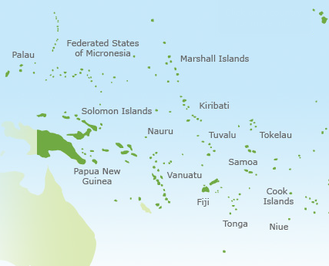

SEPTEMBER 2011
Michael Miner
Contents
Aid Activity Summary ii
Acknowledgments ii
Author’s Details ii
Executive Summary 1
Evaluation Criteria Ratings 4
1.0 Introduction 5
1.1 Activity Background 5
1.2 Activity Context 5
1.3 Situation Analysis 6
2.0 Evaluation Objectives, Scope and Methods 6
2.1 Evaluation Objectives and Questions 6
2.3 Evaluation Scope and Methodology 7
2.5 Limitations to the Evaluation 8
3.0 Evaluation Findings and Recommendations – 3.1-3.5 DAC Criteria 9
3.1 Relevance: Pacific Centre focus Efforts on Small Island States 9
3.2 Effectiveness: Leverage up Effective Role as a Facilitator 11
3.3 Efficiency: Roles & Responsibilities Clarified & Increased Joint Coordination Efforts 14
3.4 Impact: Increased Focus on Exchange of Skills and In Country Knowledge 17
3.5. Sustainability: Improved Linkages and Succession Planning 20
3.6 Gender Equality and Other Cross-Cutting Issues 21
3.7 Monitoring and Evaluation: More Harmonized Monitoring and Evaluation and Future Major Evaluation 24
3.8 Analysis and Learning: Publications and Website 25
4.0 Conclusion and Evaluation Criteria Ratings 27
4.1 Conclusion 27
4.2 Evaluation Criteria Ratings 28
Annexes 29
Annex 1: Terms of Reference 30
Annex 2: Evaluation Plan 40
Annex 3: Documents and Materials 46
Annex 4: List of 65 Stakeholders 48
Annex 5: Stakeholder Meetings Schedule 50
Annex 6: Aide Memoire for Review of UNDP Pacific Centre 53
Annex 7: Findings at a Glance 58
Annex 8: Strengths and Challenges at a Glance 63

Aid Activity Summary

Aid Activity Name | UNDP Pacific Sub Regional Centre
Aid Works initiative number | ING482
Commencement date | 1 January 2006 | Completion date | 31 December 2012
Total Australian $ | $13,331,246.00
Delivery organisation(s) | UNDP Pacific Centre
Implementing Partner(s) | UNDP Pacific Centre
Country/Region | Pacific region
Primary Sector | Multisector education/ training

Acknowledgments
Thanks are due to the AusAID team in Canberra (in particular to Alison George of Performance and Quality) and in Suva (to Nilesh Goundar, Programme Manager) for their assistance in planning the schedule and arranging the logistics for the mission and also to Nilesh for taking part in many meetings. Thanks are also due to the UNDP Pacific Centre (and particularly to UNDP Pacific Centre Director Garry Wiseman) for assistance with arrangements during the short mission. Finally a big thank you to all stakeholders who gave of their time to attend focus group meetings and/or key informant interviews.

Author’s Details
This Independent Evaluation Report was completed by Michael Miner after his visit to AusAID in Canberra, Australia and the mission to Suva, Fiji, in May, 2011 which followed his participation in a similar AusAID evaluation mission earlier in May, 2011 in Papua New Guinea. In addition to receiving the assistance of AusAID and the UNDP Pacific Centre, Michael was assisted by Melinda MacDonald (Gender and Human Rights Specialist) and Tom Litchfield (Associate).

Acronyms and Abbreviations
ACR | Activity Completion Report
AIDS | Auto-Immune Deficiency Syndrome
AusAID | Australian Agency for International Development
CEDAW | Convention on the Elimination of all forms of Discrimination Against Women
CO | Country Office (UNDP)
DAC | Development Assistance Committee
DRM | Disaster Risk Management
EU | European Union
FEMM | Forum Economic Ministers Meeting
FRSC | Forum Regional Security Committee
FSPI | Foundation of the Peoples’ of the South Pacific
FWRM | Fiji Women’s Rights Movement
GCCA | Global Climate Change Alliance
GEF | Global Environment Fund
HIV | Human Immuno-Deficiency Virus
IMEF | Integrated Monitoring and Evaluation Framework
IMF | International Monetary Fund
MCO | Multi-Country Office (UNDP)
MDG | Millennium Development Goals
NAC | National AIDS Council
NZAP | New Zealand Aid Programme
OECD | Organisation for Economic Co-operation and Development
PACE-SD | Pacific Centre for Environment & Sustainable Development
PACFAW | Pacific Foundation for the Advancement of Women
PC | UNDP Pacific Centre
PFIP | Pacific Financial Inclusion Programme
PICs | Pacific Island Countries
PIFS | Pacific Islands Forum Secretariat
PIFTAC | Pacific Financial Technical Assistance Centre
RBAP | Regional Bureau for Asia and the Pacific
SFCCO | Strategic Framework for Change Coordinating Office
SOPAC | South Pacific Geosciences Commission
SPC | Secretariat of the Pacific Community
UNCDF | United Nations Capital Development Fund
UNDP | United Nations Development Program
UNFPA | United Nations Population Fund
UNICEF | United Nations Children’s Fund
USP | University of the South Pacific

Executive Summary
The UNDP Pacific Centre was set up in early 2006 in partnership with the UNDP offices in the Pacific to provide policy and technical advice to fifteen Pacific Islands Countries (PICs) and deliver programs in partnership with governments, intergovernmental organisations and regional non-government agencies. The four pillars of the work of the Pacific Centre are:

1. Achievement of the Millennium Development Goals (MDGs);
2. Democratic governance;
3. Crisis prevention and recovery; and
4. Financial inclusion.
As noted in Annex 1, the Terms of Reference describe that this process is to conduct “an evaluation of the United Nations Development Program (UNDP) Pacific Centre (‘the Centre’) and prepare an Independent Progress Report’ (IPR). The evaluation assesses the partnership against the five OECD Development Assistance (DAC) evaluation criteria and the three AusAID evaluation criteria.”
Specifically, the TORS note that this evaluation was intended to “primarily assess the effectiveness and impact of Australian and New Zealand funding support to the UNDP Pacific Centre” and its “provision of technical assistance and advisory services at the country and regional levels.” Effectiveness and impact are two of the 5 DAC criteria. With reference to the other 3 DAC criteria (relevance, efficiency and sustainability) and the 3 AusAID criteria (monitoring and evaluation, gender and other cross cutting and analysis and learning), the TORS note that only “a cursory assessment of the remaining DAC criteria” and AusAID criteria are necessary although ratings of all 8 criteria on a 1 to 6 rating scale are required.
Therefore this IPR and Executive Summary include evaluation of all 8 Criteria with a focus on effectiveness and impact. This Executive Summary includes the Criteria ratings and the 8 Recommendations in the report which are based on the findings of the review of relevant documentation, key informant interviews and focus group meetings with 65 stakeholders primarily in Fiji but also in Samoa, the Solomon Islands, and New York by telephone, and in person in Canberra, Australia and Bangkok, Thailand.
The 2 major recommendations of this report are on effectiveness and impact. Specifically, on effectiveness, the report finds that the PC is effective as both a facilitator and a provider of technical services. The report recommends that to increase effectiveness, the PC needs to clarify its roles and responsibilities within UNDP and also build on its relationships with all its partners through increased joint planning and joint fundraising. Similarly on impact, the work of the PC in the target areas does have impact but for the future the key point is that the PC and its partners at all levels need to go beyond traditional client-contractor relationships and work in a more balanced joint collaboration among partners which focuses on exchange of skills and in country knowledge rather than on the transfer of technology and technical assistance from international to local and/or regional partners.
In summary, in the view of this Independent Progress Report, AusAID and NZ should continue to support the UNDP PC as an independent entity continuing to provide its well perceived present level of services including its roles as a facilitator and provider of technical services and supporting a balanced exchange of skills and in country knowledge on each island and at the regional level. The rest of this Executive Summary includes 8 recommendations directed towards the UNDP Pacific Centre and 8 recommendations to AusAID and NZ Aid as well as the 8 Evaluation Criteria Ratings.
Recommendations for the UNDP Pacific Centre
1. Relevance: Pacific Centre Continue to focus Efforts on Small Island States
The Pacific Centre should continue with its present approach which is relevant to the Pacific Plan, UNDP’s mandate and AusAID and NZ priorities and also continue to place increased focus on sharing its high quality expertise with Small Island States (SIS) which really do need, and want, increased access to Pacific Centre expertise.
2. Effectiveness: Leverage up Joint Planning and Coordination
The Pacific Centre should ensure that it’s present level of joint planning and coordination with MCOs, COs, CROPs, and CSOs continues. The Pacific Centre should also set up project committees with a wide range of partners, donors (and a few independent knowledgeable voices as members) to advise, keep track and input into M&E for all programs/projects.
3. Efficiency: Roles and Responsibilities Clarified
Issues related to lack of clarity in roles and responsibilities between UNDP MCOs and the UNDP PC must continue to be addressed through approaches used in the past 2 years which have included preparation of Rules of Coordination between the Pacific Centre and the 3 Country Offices.
4. Impact: Increased Focus on Exchange of Skills and In Country Knowledge
To leverage up the Pacific Centre’s unique role as a trusted and independent voice supporting work on sensitive subjects in the Pacific, and to ensure continued impact, the Pacific Centre needs to continue to play its present role but also go beyond the traditional client-contractor relationship and work in a balanced joint collaboration among partners through exchange of skills and in country knowledge rather than transfer of technology from international to local or regional partners.
5. Sustainability: Succession Planning
A succession plan for the Pacific Centre Manager position needs to be developed and implemented as soon as possible to ensure institutional sustainability.
6. Gender Equality and Other Cross‐Cutting Issues: Balancing Issues
The Pacific Centre should review its work on cross-cutting issues and focus on those that most closely fit its objectives and those of its key stakeholders. Gender and human rights should continue to be mainstreamed across programs. In trying to balance regional and international issues, the Pacific Centre should help PICS meet their international obligations, support OHCHR in its work helping countries comply with CEDAW, and support CSOs and governments to address cultural and other structural barriers in the Pacific.
7. Monitoring and Evaluation: Implement Keeping on Track
The Pacific Centre should report on how it addressed the 15 Recommendations in the 2008 Keeping on Track Report. The Keeping on Track system should be institutionalized as agreed previously and completed annually to address and implement the recommendations. The Pacific Centre needs to put processes in place to ensure that reporting is more focussed on outcomes.
8. Analysis and Learning: Increasing Impact of Knowledge Products
The Pacific Centre should establish processes for ensuring follow-up and effective use of knowledge products produced by UNDP PC. To help disseminate these knowledge products, processes should include a database, a corporate knowledge retention process, and the website.

Recommendations for AusAID and NZ
9. Relevance: Continued Support for the Pacific Centre
AusAID and NZ should continue to support the relevant work of the Pacific Centre.
10. Effectiveness: Participation in Project Advisory Committees
AusAID and NZ should be part of these project advisory committees and part of the planning processes to ensure that the strategic objectives and policies of AusAID and NZ are integrated into Pacific Centre programming.
11. Efficiency: Streamlining Reporting
AusAID (and NZ) should streamline agreements and reporting processes since at present there are too many agreements with the PC which have their own reporting and acquittal processes. Flexibility needs to be built in so when additional monies are granted to the PC, the reporting will continue to be part of the overall annual reporting.
12. Impact: Implement Social Return on Investment (SROI) Analysis
AusAID and NZ should carry out a Social Return on Investment (SROI) analysis to understand, measure and report on the social, environmental and economic value being created by the Pacific Centre.
13. Sustainability: Support for Program Sustainability
AusAID and NZ should continue core funding to the UNDP Pacific Centre until at least the end of the strategic planning cycle in 2013. Post-2013 funding should be considered on the basis of achievements and future priorities.
14. Gender Equality and Other Cross-Cutting Issues: Continued Support
AusAID and NZ should continue to support the PC in its gender and human rights work and coordinate with the Pacific Centre in its efforts to balance regional and international issues and on deciding which other cross cutting issues should be a focus. Regarding human rights, donors should support OHCHR and regional and local Pacific organizations working to create regional human rights mechanisms in the Pacific.
15. Monitoring and Evaluation: Increased Harmonization
Increased efforts need to be made to harmonize Monitoring and Evaluation and reporting among donors to reduce the burden and help create an improved and harmonized approach to Monitoring and Evaluation.
16. Analysis and Learning: Editorial and Advisory Support
AusAID and NZ should be on the editorial board and advisory committees for knowledge products produced by the UNDP Pacific Centre.

Evaluation Criteria Ratings

Evaluation Criteria | Explanation | Rating (1-6)
Relevance | PC programs/projects are relevant to the UNDP mandate (supported by AusAID and NZ) to support regional and national priorities by providing countries and CSOs with needed technical assistance appropriate to their contexts and relevant to the stated needs of beneficiaries. The PC is a trusted facilitator in the key thematic areas of: MDGs and Poverty Reduction, Crisis Prevention and Recovery, Democratic Governance and Financial Inclusion. More effort needs to be placed on responding and focusing on the needs of Small Island States. | 5
Effective-  Ness | The PC is perceived as effective in achieving most of its objectives by almost all of the 65 stakeholders met during this evaluation mission with the possible exception of a few CSOs who were critical of perceived duplication of gender programs. This overall positive finding was verified in other evaluations of the PC including the 2011 AusAID Quality at Implementation review. Specifically, re Objective 1 on TA, the regional partners view PC TA as valuable and high calibre in helping them achieve their goals. Re Objective 2, coordination and coherence of work with stakeholders is being done but more joint programming (including with MCOs) is necessary. On Objective 3, the PC is perceived as politically neutral and able to carry forward sensitive issues effectively. Increased joint collaboration including fundraising could increase effectiveness. | 4
Efficiency | The PC is viewed by most stakeholders as responsive, efficient, well led and supported by very good international TA who produce high quality technical solutions for the most part. Many note that more effort is needed to include complementary regional expertise. (Often in regional programs, it is difficult to strike the right balance between responsiveness to stakeholders and directive programming. For the most part, the PC balances this well). Future programming should include more joint planning with other stakeholders to ensure the most efficient balance of responsive and directive programming that meets partner and PC objectives. Some delays in TA procurement were noted. Role confusion continues between UNDP and the PC although strides have been taken to bridge this. The PC needs to link more with SIS, the UN, and UNDP etc. | 4
Impact | Overall, stakeholders met, and documentation reviewed (including evaluations); verify that the PC is producing results that are contributing to change in the Pacific region. Nevertheless to demonstrate the accuracy of this definitively, a Social Return on Investment (SROI) analysis should be done as recommended in this report. Beneficiaries point to examples of how they have benefitted from the PC through its technical assistance, support with sensitive issues, and facilitation assistance including increasing space for change. To leverage up impact, in addition to continuing its present approach, the PC needs to go beyond the traditional client-contractor relationship and work in a more balanced joint collaboration among all its partners. | 4
Sustain-  ability | Continued efforts to transfer PC knowledge to regional institutions should be a priority. For the PC to be sustainable, continued donor core and program funding is essential. The PC Manager is excellent at fund raising and seen as a multi-talented leader with the confidence of all stakeholders (as verified by interviews and documentation). His impending retirement makes succession planning imperative immediately. | 4
Gender Equality (and other Cross cutting issues) | PC programming is responsive to a wide range of cross cutting issues including aid effectiveness but the number of areas should be narrowed. Specifically re gender equality, responding to previous criticism, the PC now supports gender mainstreamed programming. The PC also engages in effective advocacy and successfully supports: women and girls empowerment; women parliamentarians, and increased school enrolment for girls. Gender, and human rights which is related, should continue to be a focus. A balanced approach to gender and human rights which includes both international platforms and local issues is most appropriate. | 4
Monitoring & Evaluation | The PC has been evaluated positively multiple times. The PC tracks its work in an annual progress report Keeping on Track (KOT). Reporting has improved since PC start up with more outcomes reported on as opposed to mostly activity and output level reporting at the outset. AusAID, NZ and the PC held trilateral consultations to harmonize reporting to increase efficiency and reduce the PC reporting burden. External Monitoring and Evaluation should be harmonized including the next evaluation which should be a full evaluation which includes visits to multiple countries and observation of activities in multiple sectors. | 4
Analysis & Learning | Substantial research has been undertaken by the PC which has produced analyses and documentation of findings. Increased effort should be made to highlight the results to a wider audience using a more interactive PC website. | 5
Rating scale: 6 = very high quality; 1 = very low quality. Below 4 is less than satisfactory.

1.0 Introduction

1.1 Activity Background
The United Nations Development Program (UNDP) Pacific Centre was set up in 2005, and officially opened in 2006 as a ‘Sub-Regional’ Centre to assist 15 Pacific Island Countries (PICs) to strengthen the services UNDP provides to governments and other development partners through UNDP Country Offices. This Regional Centre is similar to the UNDP Regional Centre in Bangkok (and one that has since been closed in Colombo).
Specifically the Pacific Regional Centre was intended to provide policy and technical advice and national capacity building support to the 15 PICs and to deliver programs in partnership with governments, intergovernmental organizations and regional non-governmental agencies.
The work of the Centre, which has its head office in Suva, Fiji, and offices in Papua New Guinea and Samoa (plus a sub-office in the Solomon Islands), focuses on 4 pillars:
1. Achievement of the Millennium Development Goals (MDGs)
2. Democratic governance
3. Crisis prevention and recovery
4. Financial inclusion (which was added after the program began)
The Pacific Centre program falls under the UNDP Asia-Pacific program office in Bangkok which is responsible to provide support throughout Asia and backup support to the Pacific in areas not available through the Pacific Centre. The Pacific component of the UNDP Asia Pacific Regional Program (APRP) was designed to complement support provided through the country offices in the sub region under the Pacific (14 countries) joint United Nations Development Assistance Framework (UNDAF), the Papua New Guinea UN joint program document as well as the global strategy for UNDP and the overall One UN policy.
In financial terms, UNDP regular regional resources to support the Pacific Centre totalled USD 7.85 million for 2008-2011 to which the Centre generated additional funding of US 23.87 million (triple the core funding), including USD 4.80 million from other UN sources, USD 19.07 from external donors (principally Australia and New Zealand etc.). Present support from the key external donors ends later in 2011.

1.2 Activity Context
The work of the Pacific Centre is intended to support the Pacific Plan which was endorsed by government leaders at the Pacific Islands Forum Meeting in October, 2005 and promotes the concept of regionalism with the Pacific Island Countries (PICs) working together for joint and individual benefit. The Pacific Centre program areas are intended to be aligned with, and complimentary to, the four pillars of the Pacific Plan–economic growth, sustainable development, good governance and security.
The UNDP Strategic Plan 2008-2011 focuses on achieving the MDGs, with the aim of eradicating poverty through development, equitable and sustained economic growth and capacity development, democratic governance, crisis prevention and recovery and sustainable development. The UNDP Asia Pacific Regional Programme 2008-2011 is intended to focus on supporting regionalism. Similarly the UN Development Assistance Frameworks (UNDAFs) and Country Programme Action Plans (CPAPs) for Fiji, Samoa and PNG Country Teams, focus on providing technical support primarily in these same four key areas related to: achieving the Millennium Development Goals, democratic governance, crisis prevention and recovery and financial inclusion.

1.3 Situation Analysis
The situation in the Pacific has been well documented in the five Pacific Centre reports to date. In the most recent 2010 report, they note that “all Pacific economies including PNG and Solomon Islands record large current account deficits with the exception of the Cook Islands, which had a very modest surplus… The economic trends continue to remind us of the vulnerability and fragility of the economic structure in most Pacific Islands.” It is important to understand this since counteracting this situation underlies most of the development work being carried out in the PICs. The link between economic and governance challenges also must be identified. The Asian Development Bank’s 2009 report documents weaknesses in much of the region in statistical terms as follows:
Table 1: Basic Indicators
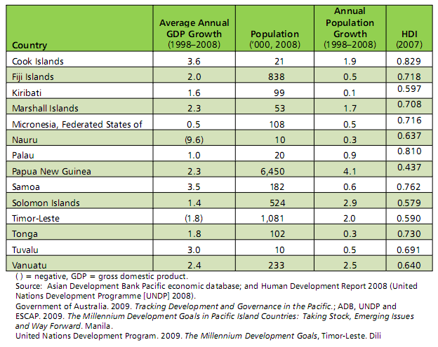

2.0 Evaluation Objectives, Scope and Methods

2.1 Evaluation Objectives and Questions
The purpose of this evaluation is to conduct a review of the UNDP Pacific Centre program and prepare an Independent Progress Report which assesses the partnership against the five OECD DAC evaluation criteria (with particular focus on effectiveness and impact) plus carry out a cursory assessment of the remaining DAC criteria of relevance, efficiency and sustainability and the three AusAID evaluation criteria of monitoring and evaluation, gender equality and analysis and learning. The IPR provides information for AusAID and NZ’s international development program to assist them to see if their stated objectives for the UNDP Pacific Centre are being achieved. The TORS (in Annex 1) include the basic questions addressed by this evaluation.

2.2 Evaluation Team

The review was undertaken by one independent evaluation consultant, Michael Miner, RBMG, assisted by Melinda MacDonald (Gender and Human Rights Specialist), and Tom Litchfield, (Project Associate), with on the ground assistance in Suva, Fiji from Nilesh Goundar (Programme Manager, AusAID), who arranged mission meetings and focus groups and took part in most Review meetings. The mission was also supported by Alison George (Performance and Quality, AusAID) in Canberra.

2.3 Evaluation Scope and Methodology
The approach to the evaluation included a document review, onsite observations and stakeholder consultations followed by analysis and preparation of an Independent Progress Report which reflects on the implementation of the programme including the plans of the Pacific Centre and confirms achievements and identifies lessons learned. It provides a reasoned perspective to assist AusAID and NZ to assess the quality of monitored activities.

A complete analysis of all relevant documents, key informant interviews and focus groups was carried out and findings and recommendations were drafted on the basis of a triangulated approach which considered all lines of evidence and focussed on contributions to the overall objectives rather than attribution which is not possible in development work such as this where multiple stakeholders contribute to the results achieved.
The methodology used in this evaluation drew on results of previous evaluations, monitoring reports, Quality at Implementation Reports and Pacific Centre and other UNDP documents etc. Specifically some key questions used were similar to those in previous studies. For example, this review asked the following 3 questions from the Keeping On Track review of the UNDP PC:
- How is the Pacific Centre perceived as a partner?
- How is the Pacific Centre contributing to partners’ progress and achievements?
- How well is the Pacific Centre mainstreaming gender and integrating the human rights based approach through their work?
In addition to the introduction (Section 1), and this section describing the evaluation methodology (Section 2), the evaluation includes findings and recommendations (Section 3), which were formulated from triangulation of all lines of evidence. The report is completed by the conclusion and evaluation criteria ratings (Section 4).
The Terms of Reference for the Evaluation are included as Annex 1 followed by the Evaluation Plan as Annex 2. The schedule of interviews and focus groups is included in Annex 3 while the actual list of 65 stakeholders interviewed is included in Annex 5. The documents reviewed are contained in Annex 4. Finally, at the end of the mission, an aide memoire was prepared and presented to AusAID which is included as Annex 6. Annex 7 includes the Findings at a Glance on the areas of focus of the work of the PC while Annex 8 includes Strengths and Challenges of the Pacific Centre at a Glance. This second draft of the report was revised based on feedback to the first draft from AusAID and the Pacific Centre. The report will be finalized based on feedback from AusAID, New Zealand and the Pacific Centre.

2.4 Evaluation Activities
In addition to reading and reviewing numerous documents, evaluation activities were limited to a 1 week mission time frame. This included 1 day in Canberra, Australia visiting AusAID headquarters on Monday, May 15, 2011 followed by travel to Fiji on Tuesday, May 16. Three days of meetings took place in Suva, Fiji between Wednesday, May 17 and Friday, May 19, 2011 culminating in the afternoon of Friday, May 19, 2011 with an Aide–Memoire discussion with AusAID representatives at their office in Suva, Fiji. During the mission, telephone interviews were placed to UNDP in New York and with UNDP offices in Samoa and Papua New Guinea and a sub-office in the Solomon Islands.

After the mission, in Bangkok, an additional telephone interview took place with the AusAID Manager for the program. As well, a face to face meeting took place at the UN Building in Bangkok with the UNDP Manager responsible for the Pacific Centre. The total evaluation included individual interviews or focus group consultations with 65 stakeholders including: UNDP Regional Office, UNDP Pacific Centre, other UNDP representatives as noted above, AusAID, New Zealand Aid Program, CROP agencies, Civil Society Organisations, Pacific Island Governments and other UN Agencies.

2.5 Limitations to the Evaluation
The evaluation was impacted by the following:

- This evaluation was originally envisioned as a desk review but was extended to include a planned field mission to Fiji. The evaluation mission did not include travel to any other of the 14 Pacific Island States so the evaluation team was unable to meet with beneficiaries of UNDP-PC at the country level. The timing for face to face meetings in Nadi, Fiji was planned to take place over a three day period which was realized. It was determined that this was all that was required because this was not a detailed evaluation that required travel to more PICs. Telephone interviews did take place to 3 Pacific Islands.

- Although a very good mixture of stakeholders attended focus group meetings in Nadi, Fiji, an insufficient number of PIC Government representatives (2), and members of other UN agencies (2), took part in those 2 focus groups. Meetings in other focus groups and in key informant interviews from CSOs, UNDP (both the Pacific Centre and the MCO), and with the donors included wide representation and resulted in substantive responses to questions.

- A very large number of complex issues were reviewed in a short period of time with only 1 country visit as noted. It should be emphasized that this was not a comprehensive review of each of these issues or of the UNDP country programs in the Pacific.

3.0 Evaluation Findings and Recommendations – 3.1-3.5 DAC Criteria
For each of the 5 DAC and 3 AusAID criteria, questions from Annex A are included below:

3.1 Relevance: Pacific Centre focus Efforts on Small Island States
Are the projects/programs relevant to the UNDP mandate, national and regional priorities and are they flexible enough to respond to emerging needs? What are the recommendations for the future on this?
With respect to AusAID objectives:
1. Contribution to achievement of MDGs is a work in progress since, even though most governments track MDGs in their annual reports, some still report insufficient information to report fully. Work in the area of poverty analysis is, and continues to be, well received.
2. Crisis prevention and recovery is widely seen as successful and functioning collaboratively among partners;
3. Significant successes in democratic governance initiatives are coloured by some perceptions of competition (rather than cooperation) between MCOs and PC in providing thematic assistance; and
4. Financial Inclusion (which is a joint UNCDF/UNDP initiative) has generated substantial excitement about achievements to date and appears to have matured sufficiently to be mainstreamed to national banking sectors. For example, as highlighted in the PFIP Final Report to the European Union, “Financial Inclusion is now part of the agenda of six central banks in the region”, two countries have developed national strategies and a task force to oversee its implementation, and five central banks are testing mobile banking.
With respect to NZ’s strategic objectives, PC work in Financial Inclusion, achieving MDGs to help reduce poverty, championing Human Security (rather than narrower traditional security) and work with SPC/SOPAC to strengthen disaster risk reduction and climate change adaptation linkages have all contributed to NZ goals of a ‘more secure, equitable and prosperous world.”
With respect to the overall UNDP mandate, national and regional priorities, projects/programs of the PC have been sufficiently flexible to respond to emerging needs including women’s rights/CEDAW, conflict HIV and the law, financial inclusion, budgetary processes, solution exchange work, climate change and sensitive issues re peace and development. With respect to the role and relevance of the PC, documentation, interviews and focus groups all repeatedly described the PC as playing an effective facilitative role for the following reasons:
- The Pacific Centre’s focus is on relevant thematic areas including: achievement of the MDGs and Poverty Reduction, Crisis Prevention and Recovery, Democratic Governance, and Financial Inclusion all of which contribute to mutually agreed goals.
- The Centre is located in the Pacific Region where it combines the experience of international experts with local on the ground expertise.
- The PC has developed positive partnerships with Pacific Island governments, the CROP agencies, regional and national CSOs based in the Pacific and with the UNDP Multi-Country and the Country Offices which allows it to act as a facilitator amongst the stakeholders.
Many examples of facilitative work were mentioned that are well represented by the following quote from one of the focus groups “the PC has been particularly effective when it facilitated linkages between international expertise with local knowledge and local partners to address problems of real concern in the Pacific such as climate change etc.”

Are technical solutions and associated implementation arrangements appropriate to the context?

The work of the PC has been evaluated numerous times and all reports indicate that much of the work is generally of high quality and relevant to the needs of the region. This finding was verified by most interviewees in this evaluation. Most respondents indicated that they perceived the PC as relevant, although a few CSOs, especially working on human rights, reported that they feel that there has been some duplication by the PC in their area of focus. Others pointed to work on gender as being complementary to the work of UNDP PC. Please see 2 charts in the annexes: 1) Summary of PC work in each of its 4 key theme areas; and also, 2) Summary of PC strengths and weaknesses gleaned from the combination of documentation, interviews and focus groups. This content has been woven throughout the findings section. Overall, the PC, through technical assistance, program support, capacity building (i.e., training and workshops) and knowledge products, provides the Pacific with global level expertise from its headquarters in Suva, Fiji. An example of a technical solution appropriate to the local context is the checklist on the Human Rights Based Approach to Disaster Management for Humanitarian actors in the Pacific which was created in collaboration with OCHA and used during immediate response phases to Tsunami events in the Pacific (i.e. Samoa).

Were the objectives relevant to the context/needs of beneficiaries?
Similar to the above example, the PC has met objectives relevant to the context and needs of beneficiaries in several cases including ground breaking research and advocacy on HIV and the law (and recently community based research on HIV transmission risks that should influence prevention programs in the Pacific). Another example is work on temporary special measures and other measures to increase women’s participation in parliament with PIFS, SPC and UN Women. Overall, all stakeholders should step up their efforts to meet the MDGs.

If not, what changes should have been made to the activities or objectives to ensure continued relevance?
Documentation, interviews and focus groups identified the need for the PC to be more responsive and work more closely with the 9 Small Island States (Nauru, Niue, Tuvalu, Cook Islands, Kiribati, Federated States of Micronesia, Republic of Marshall Islands, Palau and Tokelau) to help them address their specific needs. These states have very limited access to international level expertise within their governments, UNDP MCOs (i.e. Samoa), CSOs etc., and thus would especially benefit from working with the PC.
It is positive that the Pacific Centre is placing more focus on building local capacity and linking international expertise with Small Island States. To do this as effectively as possible, some PC international staff may require additional experience grounded in the local context of the small islands of the Pacific. This particular point needs to be balanced with the Centre’s need to collaborate more closely and strategically with the UNDP Multicountry Offices and UNDP Regional Bureau. Under the current arrangements, MCOs lead the contact with SIS and the PC only supports when asked by relevant MCOs. Sometimes this process is slow since the PC must wait for an official request.
Recommendation 1: Relevance: Pacific Centre focusing Efforts on Small Island States
The PC should continue with its present approach which is relevant to the Pacific Plan, UNDP’s mandate and AusAID and NZ priorities and also continue to place increased focus on sharing its high quality expertise with Small Island States (SIS) which really do need, and want, increased access to PC expertise.
Recommendation 9: Relevance: Support for the Pacific Centre
AusAID and NZ should continue to support the relevant work of the Pacific Centre.

3.2 Effectiveness: Leverage up Effective Role as a Facilitator
To what extent have the outcomes (and any intermediary outcomes and outputs) been achieved?
Despite concerns regarding scarcity of resources, the PC and its achievements were often described very favourably as producing and maintaining results in the Pacific. The most frequent attribution made about the PC was its role a facilitator with respect to addressing the following development issues in particular: MDGs, Democratic Governance, Capacity Development, Crisis Prevention and Recovery, HIV AIDS, Poverty Reduction and Gender.
For example, through the strategic partnership with SPC/SOPAC, the PC has strengthened the capacity of regional, national and provincial level agencies to mainstream Disaster Risk Management into planning and budgetary processes through mid-term strategic planning (PNG), budget process allocations for Disaster Risk Management (DSM) in Vanuatu, PNG, and the Cook Islands; integrating DRM into agriculture in Fiji; education sector policy and plans in PNG and the Solomon Islands and actual implementation of tangible DRM measures including strengthening early warning capabilities in Vanuatu. UNDP, with UNISDR, has established a platform with CROP agencies to mainstream Disaster Risk Management (DRM). This platform is applied to knowledge sharing, coordination of programming and development of targets mainstreaming DRM as well as for pursuing the integration of Climate Change Adaptation in DRM work.
Issues around using the human-rights-based approach, South-South Cooperation, and Public-Private Partnerships seemed to (in varying degrees) receive more criticism. Thus, notwithstanding issues around competition for funding and cooperation, stakeholders who were met during the evaluation mission, and as verified in the documentation reviewed, the PC and its work are viewed as positive and strategic in terms of achieving Pacific Centre stated goals. At the same time, CSOs and MCOs indicated their desire to have an increased level of planning take place with the Pacific Centre.

Are the activities and outputs of PC’s work adequately addressing the established outcomes of the program?

The Pacific Centre prides itself and many of its stakeholders agree that its effectiveness is due to its approach which includes:
- Consultation with national and regional partners, i.e., UNDP MCOs, CROP Agencies, Governments, and CSOs.
- Promotion of regional cooperation amongst CSOs, CROP Agencies, Governments, UNDP MCOs, playing the role of “honest broker” especially around sensitive issues. It is able to do this because of its role as a trusted neutral party.
- Encouragement, whenever possible, of the leadership of its regional partners in pilot projects, while at times taking the lead to provide a platform for innovative projects where gaps exist, i.e., the Financial Inclusion Project.
In addition, although, the implementation of pilots (along with the overall flexibility of the PC) are among the Centre’s greatest strengths, at times such pilots have led to tensions with regional partners and particularly with UNDP MCOs. Many see the PC as technical assistance or coordinators of TA but not as implementers, and therefore see on the ground implementation as outside the mandate of the PC. There is not a full understanding among all stakeholders of the dual role and principles for what is included in a regional program under UNDP rules. An example of the PC being perceived as doing more than it should, as noted by several women’s organizations and the Pacific Regional Rights Resource Team program of the Secretariat of the Pacific Community, was the PC’s preparation of a human rights handbook which appeared to these stakeholders as duplicating work which had already been done by CSOs. On the other hand, publications such as translating CEDAW into Law completed with UNIFEM, or the Temporary Special Measures Program completed with PFIFS, were very well received and not viewed as duplication.
Some of these criticisms, in the view of the evaluation, are almost axiomatic to regional projects or initiatives. Regional initiatives have to tread carefully so that partners don’t feel that the regional agency is treading on their territory. This is challenging when gaps in programming are readily identified and filled by the regional initiative. In our view, the PC is addressing the established outcomes of the program working with many partners in the Pacific.
To what extent is the provision of technical and advisory support to UNDP country offices, national and regional counterparts effective and how can this be enhanced?
Indeed, CSOs (especially at the regional level) reported to the evaluation team that it is a struggle to secure sustainable funding in the Pacific which causes stress and potential conflict with other regional and/or national players seeking funding and makes collaboration more difficult to foster. When asked about the effectiveness of the PC, reactions were mixed. Many expressed positive regard towards the Centre and its work in particular but there was some concern that: 1) the PC was a magnet for regional funding and 2) although the PC facilitated many activities very effectively sometimes they implemented activities that others could do. It was also clear that many organizations still find it difficult to distinguish between the role of the UNDP PC and the UNDP MCOs.
To what extent has the Centre been able to address sensitive and emerging issues and to create the space for those issues to be taken up at the national level?
The PC has been successful in raising the quality of UNDP engagement in the region in dealing with sensitive subjects using its competent team of specialists located in one place in the region. There are numerous examples of the PC drawing visiting program design and fact finding teams (from the WB and ADB etc.) to the Pacific and benefitting from the quality advice and opportunity for partnering in dealing with sensitive issues. A clear strength of the PC is the ability to link international and regional partners and connect the Pacific with the global agenda, highlighting regional successes and challenges and drawing on global expertise and experience to address sensitive issues.
For example, the PC has enabled and facilitated sensitive discussions between governments and civil society on peace and development issues. Regionally, a peace practitioner community has been established that brings together government and civil society to work together on peace building initiatives, share knowledge, resources and expertise. Also regional level engagement led to creating processes and initiatives in the polarized Fiji context that have functioned as one of the few spaces for dialogue and confidence building; thereby making an important contribution to reduce tensions. Through ongoing support, the broader UN has been able to cultivate trust among stakeholders. Government, civil society and the private sector have acknowledged and emphasized the need for the UN to play the role of honest broker and provide a neutral space for conversations to continue. This process also supports other local dialogue processes led by national actors.
Finally, the Pacific Centre worked with UN agencies, IFC, ADB and AusAID to focus on the emerging issue of financial inclusion. The PC supported initiatives in several countries and carried out initiatives on development of legal frameworks to promote microfinance, partnerships with banks, insurance companies etc., and broadened access to financial services including financial literacy training.
Activities dealing with sensitive and emerging issues are the kind of activities which the PC, as a neutral broker, is ideally equipped to do and should continue to do.
What are the main factors (positive and negative) that are affecting the achievements of the stated outcomes?
Pacific Island Countries benefit from the highest per capita amount of aid in any region in the world, making aid coordination and effectiveness a very significant issue. However, although there is substantial per capita donor support, the Pacific Region does not have a wide range or diversity of donor support beyond Australia and New Zealand, WB, ADB, EU and the UN. In fact, beyond this, there are few sustained sources of funding in the Pacific, for example: “Australia and New Zealand play a dominant role in the overall aid in the Pacific, and they are both members of the principal inter-governmental bodies in the Pacific as well. The Centre works primarily with these intergovernmental bodies, as well as with NGOs that are active on a regional level. The intergovernmental bodies are members of the Council on Regional Organizations in the Pacific. Although this is well known to the donors, it is worth noting because it is of such importance to partner agencies in the Pacific needing funding.
This funding reality and the interconnectivity of stakeholders, impacts on programming by stakeholders in the highly competitive environment with respect to funding for end beneficiaries. This reality sometimes contributes to tensions among regional and national seekers of ODA and has affected the PC relationship with a few stakeholders who are concerned that the PC plays too central a role and therefore secures the bulk of available donor funding. The PC, for example, receives both core funding and additional programme funding.
The one area which the audit identified as a challenge however, concerned which UNDP (PC or MCO) is the so-called “face” of UNDP. This is partly a legacy issue that has been addressed by effective leadership by the UNDP RC and UNDP PC and their senior staffs who have been working closely together in the past year to bridge this gap through joint initiatives and strategic planning together.
Nevertheless, confusion continues to persist on the part of partners and other stakeholders as to the roles of the various UNDP actors and the differences among these actors, especially at the country level where the Pacific Centre supports the UNDP pillars: Fighting Poverty, Building Democracy, Preventing Crisis and Enabling Recovery, Protecting the Environment, Empowering Women and Growing National Capacity. The PC has considerable potential to advance UNDP regional strategies by working with the MCOs and Governments, CROP Agencies and CSOs. The UNCDF-PC partnership has been positive and is having a demonstrable impact on achieving the Pacific Inclusive Financial program outputs which are well supported by PC management. Evaluations, other reports, and interviews verify that this is a very strong program. It is an example of positive collaboration among UN agencies.
In summary, the PC is effective as a facilitator and as a deliverer of technical services but to rectify issues of perceived competition with some local partners, joint planning and coordination needs to continue to involve as many stakeholders as possible including donors. A commitment to work more closely with the PC, as part of the joint planning exercises, is necessary on the part of all players including especially the donors.
Recommendation 2: Effectiveness: Leverage up Joint Planning and Coordination
The PC should ensure that it’s present level of joint planning and coordination with MCOs, COs, CROPs, and CSOs continues. The PC should also set up project committees with a wide range of partners, donors and a few independent knowledgeable voices as members to advise, keep track and input into M&E for all programs/ projects.
Recommendation 10: Effectiveness: Participation in Project Advisory Committees
AusAID and NZ should be part of these project advisory committees and part of the planning processes to ensure that the strategic objectives and policies of AusAID and NZ are integrated into programming.

3.3 Efficiency: Roles & Responsibilities Clarified & Increased Joint Coordination Efforts
To what extent does the activity provide good value for money?
Although, the evaluator thinks that the PC provides value for money, this cannot be substantiated quantitatively without a comprehensive analysis being carried out. Therefore, this evaluation will recommend that AusAID carry out a Social Return on Investment (SROI) analysis which “is a process of understanding, measuring and reporting on the social, environmental and economic value that is being created by an organization…SROI measures the value of the benefits relative to the costs of achieving those benefits.” The SROI approach is in “widespread use in both the non-profit and increasingly for-profit sectors for describing any number of approaches to estimating or calculating the social output or outcomes or impact of a program or enterprise.”

To what extent does the allocation of required financial and human resources serve the needs of the region (as stated in strategic and other planning documents)?
In the administrative sense, the Internal Audit done in December 2008 reported, the PC’s overall performance is Satisfactory which means that “internal controls and risk management practices were adequately established and functioning well.” Satisfactory is the best possible audit rating on this scale. In addition, the Audit did not identify any high-risk areas. As the Audit concludes, “Overall, the office objectives are likely to be achieved.” So in conclusion, administratively the Pacific Centre is competently managed, well staffed, and the staff morale also appears high.
In terms of its approach, the Pacific Centre has an entrepreneurial orientation which contributes to its responsiveness to government agencies and CSOs in the Pacific, as well as its ability to leverage up its resources. This flexible approach has not had a negative impact on how the Pacific Centre manages its internal systems but has instead enhanced it. Overall, although a conclusion about value for money cannot be made without completion of the proposed SROI analysis, it appears to the evaluation that the breadth and scope of the responsive activities carried out by the PC are, for the most part, serving the needs of the region. Many examples will be provided later in this section.

Are technical solutions and associated implementation arrangements high quality and good value for money?
As noted above, given that there should be a full ‘value for money’ study, this section comments on the value of some of the PC technical and administrative solutions. Administratively, the cost of procurement is seen by some partners as too high, which may exclude some regional partners from benefiting from PC expertise. Some partners also indicated that they were not happy with the bidding process for joint collaborations and the client-contractor relationship. When partners come to the PC with ideas for new projects, the UNDP required the PC to accept bids from other organizations to identify the most “suitable” partner. This causes some hesitation on the part of some who naturally fear losing their idea to another organization through this process. The only other administrative issue mentioned was by AusAID who want the UNDP Pacific Centre and UNDP MCOs to document clearly how they bill each other for services.
In the area of Environment and Energy, support is more directly linked to providing technical support at the country level in the preparation of the large Global Environment Facility (GEF) and other funded projects managed by MCOs/COs. These include technical support towards:
- Implementation of a regional UNDP/GEF USD $5.23 million. Renewable energy covers 11 PICs, a national USD$1mil. UNDP/GEF renewable energy project in Palau and a national USD $1million. UNDP/GEF renewable energy project in RMI.
- Significant input in the preparation of the new Pacific regional energy policy and associated implementation plan.
- As part of a Cook Islands national energy sector review in April 2011 prepared (i) ‘Overview of Key Findings and Recommendations from Cook Islands National Level Energy Sector Reviews in the period 1998-2011’, provided (ii) comprehensive comments on draft ‘Renewable Energy Policy Framework 2011’ and (iii) provided input towards preparation of Cook Island Renewable Energy Chart (CIREC).
- As part of ‘A Comparative Analysis of Experiences with Expanding Energy Services for the Poor in Asia-Pacific’, prepared (i) a comprehensive case study of Fiji’s Rural Electrification Program; (ii) provided technical support to a joint Government of Vanuatu, SPC, Pacific Power Association and UNDP evaluation of a bio-fuel power project in Santo Island, Vanuatu including organized energy household survey (prepared questionnaire, undertook surveyor training, survey supervision and data entry) and prepared survey report; and (iii) provided technical assistance for a joint Government of Cook Islands and UNDP household energy survey in Rakahanga atoll, Cook Islands including organized energy household survey and survey report.

To what extent have programs been able to leverage resources both in-cash and in-kind?

Although there could be more, there are several examples of leveraging. For example, the South-South project, which encourages sharing of knowledge and experiences to strengthen community safety and resilience to natural disasters in both the Pacific and the Caribbean, is funded by UNDP’s Special Unit for South-South Cooperation and by the UNDP-Japan Partnership Fund, with in-kind contributions from UNDP PC which coordinates it.
Other examples of leveraging include: design of a USD $1 million UNDP/GEF renewable energy project in Fiji, a major solar photovoltaic project in Tokelau, a USD $ 4 million solar photovoltaic project Samoa, a USD $2 million solar photovoltaic project in Pukapuka, Cook Islands and the Pacific component of the USD $14.5 million AOSIS/Denmark/WB/UNDP global SIDS Partnership Programme on Renewable Energy and Energy Efficiency (‘SIDS.DOCK’). A concept note has also been prepared for a USD $1 million photovoltaic solar project in Rakahanga, Cook Islands that was endorsed by the Pacific Islands Forum Secretariat (PIFS) in Dec 2010 and subsequently a detailed project proposal was prepared.

Has management of the activities been responsive to changing needs?

Management by the PC has responded well to changing needs i.e. climate change, Pacific inclusion, gender etc., but one area of responsiveness could be questioned. This is the issue of replicability. In responding to the changing needs in the region, when decisions are made to support activities, those selected to be carried out should be able to be replicated on other islands to widen the impact of each investment. In principle, future activities which are supported should allow as many Pacific Island States as possible to use the results of the investments for their benefit. However, it should be recognised that while some factors remain the same, PICTs are still very different from each other and in many cases; some activities are not directly replicable due to local variation/factors.

Did activities suffer from implementation delays? If so, why and what was done about it?
According to the representatives of several of the partner agencies which were interviewed, UNDP policy and bureaucracy limit and slow implementation8. Many stakeholders indicate that the PC’s procurement policies and bureaucracy hinder work on the ground. Partners complain that the PC is too slow and so at times they need to move forward without the PC23. Regarding PFIP, at times activities have been limited in effectiveness due to procurement and budgeting issues between UNDP and UNCDF. These caused service provision delays and incurred management time opportunity costs to resolve. Although these issues have not had demonstrably negative impacts on overall program effectiveness, value-adding synergies have been limited by this challenge. The PC is working with the MCOs to address what is possible.
Did the activities have sufficient and appropriate staffing resources?
The PC staff composition includes primarily international experts with no regional personnel at the specialist or management levels, which attracts criticism in terms of higher costs for international experts and for sustainability, if and when, international funding stops. Working together on joint planning during retreats, and being co-located, have brought the Fiji Multi Country Office (MCO) and the Pacific Centre closer together. The previous tension over administration support has been resolved through creating the Joint Operations Office in 2010 which has decreased the flat fee of 6% of contracts plus 7% administration fee payable to UNDP. This had increased tension which now is resolved through the PC Manager having a role in the management and decisions to pay for services based on actual use rather than pay a flat fee. Finally, written rules of engagement between the UNDP partners has also helped reduce tensions. Now there is an opportunity for MCO and PC staff to work more closely together. One other point made by some partners, is that PC capacity does not always keep up to demand, and should consider establishing a contingency fund and an expanded roster to respond to the need for technical assistance.

Was a risk management approach applied to management of the activity (including anti-corruption)? What were the risks to achievement of objectives? Were the risks managed appropriately?
According to a 2008 audit by the UNDP Office of Audit and Investigations (OAI), and as noted earlier, the overall performance of the PC was satisfactory, meaning that “internal controls and risk management practices were adequately established and functioning well. No high-risk areas were identified. Overall, the office objectives are likely to be achieved.” Most of the key controls in project management were noted to be operating effectively. Further, within the relatively short span of its existence, since its establishment in 2005, the Pacific Centre had been able to develop capacity to provide relevant advice and technical assistance for the region with low risk.
In summary, continued efforts are needed to clarify roles, responsibilities and strategies at the PC and expand them to the country level in order to efficiently use internal resources and leverage up the work of the PC. Efforts are being made in Suva but this process should continue with MCOs and COs in the Pacific as well. These efforts should be expanded and clarified in writing while the present leadership of the PC and MCO are both in place in Suva. Also these positive developments need to be better communicated to other stakeholders outside UNDP. For increased efficiency, UNDP MCOs and COs need to be better informed about PC activities, especially those dealing with governments with respect to implementation of activities in their location. Joint planning exercises expanding on joint coordination and strategy sessions in Suva should take place to help ensure buy-in and avoid duplication. Finally, activities which are replicable and have benefit for many Pacific Island states should be a focus.
To economize on resources, the number of regional workshops and publications should be limited and managed by a small committee including donor representation. Events and reports should also be targeted more precisely to meet specific needs especially in regard to issues unique to individual small island states. Finally administrative fees in the one UN need to be fleshed out to ensure that the system is more efficient and decreases the costs.
Recommendation 3: Efficiency: Roles and Responsibilities Clarified
Issues related to lack of clarity in roles and responsibilities between UNDP MCOs and the UNDP PC must continue to be addressed through refinement of approaches used in the past 2 years which have included preparation of Rules of Coordination between the PC and the 3 Country Offices.
Recommendation 11: Efficiency: Streamlining Reporting
AusAID (and NZ) should streamline its agreements and reporting processes since at present there are too many agreements with PC which have their own reporting and acquittal processes. Flexibility needs to be built in so when additional monies are granted to the PC, the reporting will continue to be part of overall annual reporting.

3.4 Impact: Increased Focus on Exchange of Skills and In Country Knowledge
Are the activities and outputs contributing to changes in the Pacific region?
All but two Pacific Island nations, Palau, and Tonga, have now ratified CEDAW. Most recently, Nauru ratified the CEDAW on June 23, 2011. The PC launched a report with UNIFEM (now UN Women) called Translating CEDAW into Law which provided a concrete set of measures on how national laws should be framed in order to fully comply with CEDAW. This action provides a platform for women’s rights advocates and reformers to use the CEDAW to help pressure national governments to make national changes which are consistent with the convention. For example, work on family law has recently been undertaken by the PC with the Cook Islands which has already resulted in significant progress and is likely to result in the enactment of its first family law bill in just over two years.
The Centre also has a strong focus on anti-corruption activities and provides policy support and technical assistance to PICs on ratifying UNCAC and the development and implementation of national policies and strategies on anti-corruption. In Nov., 2010, the Vanuatu Parliament passed a Bill approving the ratification of the UN Convention Against Corruption (UNCAC). On 12 July 2011, Vanuatu acceded to the UN Convention against Corruption (UNCAC), becoming the fourth Pacific Island country to become a State party to this ground-breaking international treaty. With Vanuatu’s accession, UNCAC has now been ratified by 155 States, including PNG, Fiji (2008), Palau (2009) and Vanuatu in the Pacific.
With respect to Crisis Prevention and Recovery, the Forum Secretariat increased capacity to deal with conflict which led to development of a Regional Human Security Framework for conflict prevention which has been endorsed by the 15 Island countries11. The Government of Fiji approved the first Disaster Risk Management Agriculture Strategy for Fiji, and UNDP is currently developing a three year program to implement the strategy13.
PFIP began implementation of financial education in primary and secondary schools in Fiji (FinEd Fiji) which will deliver financial literacy to approximately 200,000 students. Also in Fiji, 17,000 most-vulnerable beneficiaries have successfully adopted electronic payment, while 362,000 are now using M-wallets (mobile banking). Six central banks agree to permit mobile money services to operate in their country. The Bank of Papua New Guinea issued two statements of support for mobile money. The Central Bank of Samoa agreed to add financial inclusion and financial literacy to its mandate.
PFIP financial institution partners have reached an additional 37,620 depositors and USD $6.5 million in savings through the program. PFIP mobile money partners reach 362,749 subscribers of which an estimated 113,750 report being unbanked at time of enrolment. PFIP pilots government-to-person payments to social welfare beneficiaries with up to 25,000 low-income persons now having their own bank accounts. There is potential to reach over 500,000 unbanked Pacific Islanders with 5 approved partners active in 6 countries. PFIP will extend outreach of branchless banking projects to PNG, Solomon Islands, Tonga and Samoa in 2011. The first micro-insurance product was piloted in the Pacific with PFIP assistance.
Since 2006, the PC has led regional advocacy with PIFS that ensured that the newer concept of human security was seriously discussed in the Pacific, as can be seen by PIF Leaders agreement to guiding principles of land management and conflict minimization; structured dialogue between PIFS Political Governance and Security Program and regional CSOs taking place twice yearly to inform the agenda and priorities of the FRSC. The SGBV is recognized as a security threat by FRSC and PIF Leaders. FRSC endorses UNDP's approach to enhancing the democratic governance of security institutions in the region and FRSC endorsing principles for tackling youth involvement in crime and violence in the Pacific.

What are the impacts/key results of the technical and advisory support functions of the Centre both at regional and country levels?

Overall, in terms of the impact of the PC, there is agreement that the Centre has three key functions: the provision of: technical assistance, role as facilitator or coordinator, and being an effective politically neutral voice on sensitive issues among stakeholders as follows:
Technical Assistance - The regional agencies report valuing the technical assistance of the PC (although not evenly, and in some thematic areas more than others). Indeed, there is a great deal of interest in obtaining technical assistance from the Centre but this is not always possible given the limited resources. At times there is a sense that technical assistance from the region itself (or at least TA that has been living in the region for an extended amount of time) would be more appropriate than internationals “parachuted” into the Pacific. This is a balancing act for the PC which seeks to be regionally focused and meet international standards. This challenge of maintaining this balance is not appreciated by some stakeholders. Overall, the work of the PC has impact and is perceived that way by most interviewees.
Facilitating greater coordination and coherence – Over the last couple of years there has been greater cooperation possible with the UNDP Regional Centre and the Offices in Fiji and other Pacific Islands. This has largely been facilitated by the positive leadership of both the UNDP Regional Representative and the Pacific Centre Manager. This period has witnessed greater joint programming between the PC and the UNDP/UN system; more use of TA from the PC in UNDP initiatives; and, structurally, there is a move to formalize the cooperation between UNDP MCOs and UNDP PC by carrying out strategic planning workshops with joint training exercises and the creation of complementary workplans. Work is also needed with other COs and MCOs i.e. Samoa. The attitude among some RCs in the smaller island nations, for example, is that, given limited resources, they should be the special focus of PC technical assistance. Within UNDP, some people think that the MCOs should provide the leadership while the PC should simply provide the technical assistance working with the UNDP MCO or governments in identification of thematic areas and initiatives. However, according to the PC, this last point is often not practical and would hinder the flexibility of the PC and its ability to be responsive to other regional partners and stakeholders. The evaluator agrees with this and sees the recent collaborative approach between the PC and the UNDP MCOs as very positive.
Neutral Voice on Sensitive Issues - The PC has greater ability to provide a neutral voice to sensitive issues, which the UNDP country offices and other indigenous regional actors cannot easily address, i.e., Fiji is a case in point. This position is helped by evidence of strong trust in the PC, i.e., it is endorsed by the following important regional players: Forum Regional Security Council; Pacific Island Forum Leaders; and the Women’s Parliament (through, i.e., temporary special measures), to name a few. Indeed, in individual and group interviews, this theme of “providing a voice for sensitive issues” came up over and over again as an important reason for retaining the independence of the PC and not subsuming it under the UNDP MCO. Although there is a strategy to integrate PC programming into national strategies of the PICs, this is a long-term objective which will take time to realize, given the realities in the region and the limited available resources. However a partnership between the PICs and the UNDP PC is developing.
The unique central role of the PC as a neutral coordinator or facilitator carrying forward agendas between partners and stakeholders is critical at this time. PC technical assistance is viewed by many as highly responsive to the concerns of government agencies and CSOs. There is also strong partnership with intergovernmental regional organizations and regional umbrella CSOs. There is a clear consensus among CROP, CSOs, and UNDP, that the PC has contributed to impact both, through its significant contributions to the work of most partners, and through its own deliverables.
Did the activity produce intended or unintended changes in the lives of beneficiaries and their environment, directly or indirectly?
Regarding PFIP activities, electronic payments are now being used in Fiji to distribute funds to social welfare recipients. Specific examples and quotes from individual Fijians benefiting from the payment system are included in the Annex along with information on the administration time and cost savings which the new system is providing.
The PC also provided assistance to beneficiaries regarding disaster management through support to the Cook Islands, Fiji, Tonga and Samoa on assessing, designing and implementing recovery (and reconstruction) programs and government plans following major disaster events in the region.
The PC also ensured that 1325/Women, Peace and Security (WPS) is firmly established on the regional conflict prevention agenda by setting up a Pacific Regional Working Group (made up of UN, CROP, government and CSOs), securing global support (Pacific SIDS & PIC statements at UNSC Open Debate) and a regional mandate from Triennial, FRSC and Pacific Women's Ministers for the policy task of developing a regional action plan on WPS and seeking PIF Leaders endorsement in 2012. Women beneficiaries in particular pointed to this, and to CEDAW work as having benefitted and improved women’s lives in the Pacific.
Were there positive and/or negative impacts from external factors?
As noted in this section, the PC has reacted to external factors and initiatives and programmed in such as a way so as to link local issues with external factors. For example, the CEDAW legislative compliance indicators, that were jointly developed by the UNDP PC and UNIFEM Pacific (now UN Women), are now considered regional and global good practice by the CEDAW Committee, the Secretariat of the Pacific Community and UNESCAP. They have been applied to additional countries in SE Asia, and there is interest in using them in other countries, including by UNFPA in Malawi and Azerbaijan, and by other UN agencies and development partners. In summary, globally recognized CEDAW legislative compliance reviews in 10 Pacific countries, have been picked up for application in other regions.
In summary, the professional TA and coordination services of the PC have contributed to producing a variety of impacts in all its areas of focus as described in the findings and annexes.
Increased effort needs to be placed on strategically linking the CROP agencies, SIS and the regional platforms to create a sustainable platform for change in the region. The work of the PC needs to be institutionalized into the regional platforms as well as being better coordinated within UNDP and the UN including making integrated funding proposals to donors. This should foster increased collaboration among all stakeholders in the region. Similarly, the key donors should encourage increased collaboration among stakeholders in the Pacific region including the submission of integrated funding proposals from the UN (and particularly UNDP MCOs and PC) and other stakeholders.
Recommendation 4: Impact: Increased Focus on Exchange of Skills and In Country Knowledge
To leverage up the PC’s unique role as a trusted and independent voice supporting work on sensitive subjects in the Pacific, and to ensure continued impact, the PC needs to continue to play its present role but also go beyond the traditional client-contractor relationship and work in a balanced joint collaboration among partners through exchange of skills and in country knowledge rather than transfer of technology from international to local or regional partners.
Recommendation 12: Impact: Implement Social Return on Investment (SROI) Analysis
AusAID and NZ should carry out a Social Return on Investment (SROI) analysis to understand measure and report on the social, environmental and economic value being created by the Pacific Centre.

3.5. Sustainability: Improved Linkages and Succession Planning
What is the evidence and likelihood that the Centre’s programming achievements can be enhanced and sustained after withdrawal of UNDP support?

The PC partnership with PICs, and national and regional stakeholders, is critical to building long-term sustainable development results in the region, where programming can be institutionalized into regional institutions. This relationship building will help foster dissemination related to regional capacity building and promotion of knowledge products developed by the PC throughout the Pacific’s platforms and institutions. These activities will increase the Centre’s influence with respect to the direction of behaviour and attitude change, influence on policies and the implementation on key development objectives: governance, human rights, conflict prevention and recovery and gender mainstreaming and temporary special measures for the promotion of women in parliament. Ownership from the governments of the region is perceived by CSOs as a “work in progress” but, in focus group meetings, CSO representatives said that PC support is helping to promote sustainable change in the Pacific.
What lessons learned to date can be applied for the rest of the regional program period?
Several practices undertaken by the PC can be replicated for the rest of the program period.
Work by the PC has raised awareness of the importance of MDG monitoring and reporting in the first instance (prior to production of the first regional MDG report that was completed by UNDP/SPC/PIFS in 2005, there were no national reports and low awareness). With reporting on MDGs now better understood, the PC is working on strengthening planning and budgeting and addressing broader governance issues that impact on achievement of MDG objectives.
Through advocacy, policy dialogue and sharing of new knowledge, security sector governance (SSG) is now seen as an important issue on FRSC’s agenda. Furthermore, substantially because of PC facilitation and support in PNG, Solomon Islands and Vanuatu, there is increasing political commitment to developing comprehensive national security policies based on SSG principles.
Sharing of best practices in disaster risk management and climate information assessment, by the PC enabled SIDS countries to learn from each other about suitable technologies and approaches for increasing their resilience to disasters using only the limited resources they have available.
How can the sustainability of the Centre’s efforts be maintained and improved?
A key approach to sustainability of the Centre’s efforts is through linking the activities and initiatives to organizations that will continue to exist for the long term. While the PC was not specifically designed to lead UN coordination, its solid short term funding particularly from AusAID has allowed it sufficient support to forge solid partnerships with a number of UN agencies. Most notably the PC governance team has partnered with UNODC on anti-corruption work, with UNIFEM (now UN Women) on a range of areas; with UNHCR and OCHA on human rights; and with UN Women, UNFPA and UNCEF on work with Parliaments. The PFIP team is implementing a project which joins UNCDF and UNDP and, more recently the micro-insurance work now includes ILO. The Crisis Prevention and Recovery team is partnering with UN Women and OCHA as well as UNESCO. Finally, the MDG team partners with UNAIDS, UN Women, UNESCAP, UNICEF and UNFPA.
Are there any areas of the activity that are clearly not sustainable? What lessons can be learned from this?
As noted above, the activities can be sustained but the PC itself cannot be sustained without addressing the question of succession planning for the Centre which was raised in reports and in some interviews. As noted earlier in this report, the Centre’s current Manager Garry Wiseman is seen as central to the on-going success of the PC. He is seen as a multi-talented individual who has the confidence of the diverse stakeholders connected with the Centre. In fact, in this evaluator’s experience, it is extremely unusual to have so many people feel so positively toward the performance of one manager. It is clear that he is doing a great job! That is why the issue of succession planning is so critical since Garry needs to retire next year solely because of UNDP’s age restriction rules which force his early retirement.
Several options are possible with respect to succession planning but a formal plan is needed to reassure partners and other stakeholders. At present, there is also no Deputy at the PC so there is no one in house who can easily take over. Options which could be considered include: Garry staying on as a Senior Consultant to the PC for a time to give the Centre a chance to transition well, and/or, a Deputy Director being brought in soon to help that transition be as smooth as possible. But it is important to consult partners and stakeholders to plan for the future. Relationships are critical to the success of the Pacific Centre. At present the working relationship between the PC Manager and the MCO Regional Representative is very good, thus the upcoming turnover in senior staff is a threat to the sustainability of the PC. Therefore, the solid gains made to date in the two parts of UNDP (MCOs and PC) working together, need to be solidified and a widely agreed upon succession plan put in place quickly.
In summary, regarding sustainability, increased effort could be made to link UNDP PC programming to overall UNDP strategies as part of working towards the ‘Delivering as One UN’ approach and to supporting the work of key regional partners and national governments. Improved linkages can be enhanced substantially through implementation of an integrated sub-regional UNDP program (supported by AusAID and NZ) that focuses on agreed critical development results at the regional and national levels. The status quo is still somewhat fragmented between the PC and MCO programs in the Pacific Islands and in PNG but the new more integrated model is helping bring the parts of UNDP together to work better with other parts of the UN and other stakeholders.
The present leadership of UNDP in the region (PC Manager and MCO Resident Representative) provides a window of opportunity to solidify recent gains and better integrate the program but the time frame is short. Related to this is the issue of succession planning. Given the excellent work and profile of the present Manager of the Pacific Centre who will be forced to retire for age reasons in 2012, and the fact that there is no deputy, a succession plan needs to be developed immediately.
As noted above, the donors need to support an integrated sub-regional UNDP program in which UNDP’s MCO and PC programs are well linked and integrated and also support and take part in carrying out the necessary succession planning to ensure solid leadership of the Pacific Centre.
Recommendation 5: Sustainability: Succession Planning
For PC - a succession plan needs to be developed and implemented as soon as possible to ensure institutional sustainability.
Recommendation 13: Sustainability: Support for Program Sustainability
AusAID and NZ should continue core funding to the UNDP Pacific Centre until at least the end of the strategic planning cycle in 2013. Post-2013 funding should be considered on the basis of achievements and future priorities.

3.0 Evaluation Findings and Recommendations – 3.6-3.8 AusAID Criteria

3.6 Gender Equality and Other Cross-Cutting Issues
To what extent is the Centre’s programming responsive to crosscutting issues such as gender, disability, environment (including climate change), human rights and aid effectiveness principles, including the Cairns Compact?

3.6.1 Gender and Human Rights
In terms of gender, the PC has made important strides to incorporate gender mainstreaming elements into their policy, programming and implementation and is responsive to gender in its programming. In addition, the PC engages in effective gender advocacy and has had success promoting women’s and girls’ empowerment in the Pacific, i.e., evidence of more support for women parliamentarians and increased school enrolment for girls etc. The gender unit has successfully embedded activities in the 4 strategic pillars (achievement of MDGs; democratic governance; crisis prevention; and financial inclusion) of the PC's work. However, although there have been improvements, there is still a sense that gender is under-resourced and needs more management support to mainstream gender throughout all programming.
Some stakeholders in the focus groups noted that the PC works on some themes which may be driven by the international rather than the regional or local agenda. Although most documentation and interviews agree that the PC approach is human rights based and gender sensitive, which guides their work well in the region, some members of focus groups noted that they think that the PC is too internationally focused on gender and human rights and not contextualized enough in the region using regional platforms.
The proponents of regionalism suggest that the international arena is too far removed and that cultural realities need to be acknowledged and addressed (within the universal nature of women’s rights) if they are to be effective in the region. The purpose is multi-faceted. For example, it is argued that local interventions are more meaningful to the women and girls of the Pacific Region and that supporting local organizations will help to build their capacity and have a multiplier effect with respect to building regional capacity on gender.
These issues were discussed as far back as 1997 when the Triennial Conference of Pacific Women highlighted 5 strategic areas of concern that continue to be problematic including: overall physical quality of life; empowerment of women; enhancement and protection of women’s rights; women’s contribution to the realization of just and peaceful societies in the Pacific; and institutional arrangements and mechanisms (including CEDAW).
A training and Mock Parliament for Women was held on August 8 and 9, 2011, spearheaded by the Kiribati Parliament and the Kiribati Department of Women. It is supported by the Pacific Islands Forum Secretariat and UNDP with additional funding from the Commonwealth Local Government Forum. Kiribati will be holding national elections this year. This training and Mock Parliament have been designed to provide an opportunity for potential women candidates to develop and apply their public advocacy skills. It is an also an opportunity for the community to be encouraged to reflect on the importance of supporting the inclusion of more women in decision-making positions in Kiribati (See Annex).
Organizations in the Pacific, such as the Pacific Regional Rights Resource Team of the Secretariat of the Pacific Community (SPC), and several CSOs, despite issues with Fiji, harbor ambitions for creation of a human rights mechanism in the Pacific which address gender issues. These proponents would like the PC to be more anchored within Regional Platforms. Some CSO stakeholders noted that ASEAN established “human rights mechanisms”, including those focused on women and children, which can also be created in the Pacific building on existing mechanisms, i.e., Pacific Platform for Action. In addition, regional platforms provide avenues for greater contextualization of Pacific Island State issues with respect to gender beyond Beijing + 10 or other platforms. They point out that supporting regional platforms, such as Gender and Development and Triennial Conference of Pacific Women, helps sustain and build their capacity.
An example of how work on a cross cutting issue can have an effect, is the Peace, Stability and Development Analysis process in Fiji, which published a report highlighting key issues, lessons and opportunities for integration of gender in conflict analysis processes. This has informed the development of global guidelines on gender and conflict analysis, and similar processes as Fiji, in the Democratic Republic of Congo, Iraq and Kyrgyzstan.

A few partners who were interviewed said that PC should continue to tailor particular issues for audiences that have different views on Gender Mainstreaming and the Human Rights Based approach and adjust their approach to be culturally sensitive and realistic for the Pacific. Finally, in summary, many partners reported that the PC either helped them to initiate gender related work or reinforced and added value to what they were already doing.
The PC Centre has mainstreamed gender (and human rights) throughout its programming and should continue to include these linked programming areas as areas of focus.

3.6.2 Other Cross Cutting Issues including Cairns Compact
Overall, the Pacific Centre is responsive to many other cross-cutting issues as outlined below.
Anti-Corruption: The Centre has a strong focus on anti-corruption activities and provides policy support and technical assistance to PICs on ratifying UNCAC and the development and implementation of national policies and strategies on anti-corruption.
Aid Coordination: The PC was actively progressing the Cairns Compact – in particular through contributing to the MDG Tracking report and participation by the PC Manager in the peer review of Nauru and active engagement with PIFS on streamlining reporting.
Climate Change: The South-South project is coordinated by UNDP Pacific Centre, with extensive support from the regional UNDP Caribbean Risk Management Initiative (CRMI) and UNDP’s sub-regional Centre in Trinidad and Tobago. Regional partners who are involved in the project’s governance structure, and who lead the implementation of various activities, include: Caribbean Disaster and Emergency Management Agency (CDEMA), CARICOM Climate Change Centre, and University of the West Indies (UWI) from the Caribbean region. Key partners from the Pacific include the Pacific Islands Applied Geo-Science Commission (SOPAC), South Pacific Regional Environmental Program (SPREP), Secretariat of the Pacific Community (SPC) and the University of the South Pacific (USP).
Climate Change and Disaster Risk Reduction: In collaboration with partners, the Pacific Centre has carried out a range of activities on climate change adaptation and disaster risk reduction at the regional, national, local and sectoral level.
Disability: Reports do not provide clear data on the inclusivity of disability issues or mainstreaming into programming. In the past, the Centre has produced knowledge products on disability and included disability in programming.
Environment and Energy: The Centre provides technical assistance for the implementation of a regional renewable energy program covering 11 PICs.
HIV/AIDS: The Centre has a strong focus on mitigating the impact of HIV/AIDS on human development. It continues to provide policy advice and technical support for strengthened multi-sectoral approaches and joint programming, as well as program formulation, reviews and assessments.
One UN: The lead agency for this initiative is the UNDP Multi Country Office. When called upon, the Pacific Centre cooperates and collaborates on initiatives and programs including joint programming initiatives.
Although most respondents felt that the PC was doing good work on all these issues, which is supported by most documentation and reporting available, some respondents felt that the PC is overstretched trying to cover too many cross-cutting themes. These respondents suggest that the PC should decide which themes fit its objectives best and narrow its focus and cut others.

To what extent are crosscutting issues integrated into design and implementation of the Centre’s programs? What is the effect and is it sustainable?

Crosscutting issues, in particular gender and human rights, which are mainstreamed across programs, are integrated into the design and implementation of the Centre’s programs. But, as noted above, although all the other areas are well regarded, both in reporting and in interviews, the PC needs to review all the cross cutting issues to see if there are some that others are doing and which the PC could decrease its activity. Realizing that this is not easy, where possible, leadership of initiatives should be turned over to other organizations which can integrate particular activities into sustainable programs.
Recommendation 6: Gender Equality and Other Cross‐Cutting Issues: Balancing Issues
The PC should review its work on cross-cutting issues and focus on those that most closely fit its objectives and those of its key stakeholders. Systems need to be in place to ensure gender and human rights mainstreaming across programs. In trying to balance regional and international issues, the PC should help PICS meet their international obligations, support OHCHR in its work helping countries comply with CEDAW, and support CSOs and governments to address cultural and other structural barriers in the Pacific.
Recommendation 14: Gender Equality and Other Cross-Cutting Issues: Continued Support
AusAID and NZ should continue to support the PC in its gender and human rights work and coordinate with the PC in its efforts to balance regional and international issues and on deciding which other cross cutting issues should be a focus. Regarding human rights, donors should support OHCHR and regional and local Pacific organizations working to create regional human rights mechanisms in the Pacific.

3.7 Monitoring and Evaluation: More Harmonized Monitoring and Evaluation and Future Major Evaluation
What is the quality of the program’s internal monitoring and evaluation practices, including the M&E framework, how well the framework is implemented, and whether quality data is being produced to support a judgment on effectiveness of the aid activity?
The PC has been through many evaluations and reviews (internal and external). Internally in UNDP, progress is reported annually in its Keeping on Track (KOT) report which tracks the progress of the UNDP PC. AusAID posts also monitor the PC using the 2008-2011 Monitoring and Evaluation Framework and AusAID’s Quality at Implementation Reports. Reviews from regional partners are also used to monitor progress and evaluate the work of the PC. Three outcome evaluations of the regional cooperation framework 2002–2006 were undertaken during 2006 and a “meta-evaluation” was undertaken in 2007. In 2009, the Centre had 2 internal reviews, an audit, and was part of a program review. Although the 2009 review echoed many of the same issues found by other reviewers including tensions between the PC and the Multi-Country Offices, i.e., notably in Suva and Apia, the review also concluded that the Pacific Centre has been moving in the right direction to build on its strengths.
The December 2008 Audit of the Pacific Centre by UNDP scored the PC as Satisfactory on all criteria except planning and monitoring where they recommended a review of the relationship between the MCO and the PC to improve efficiency and effectiveness. As noted elsewhere in this report, this is being addressed. In terms of internal monitoring, that Audit recommended that a staff person be assigned specifically to monitoring which was done by the PC. This is helping the PC to report against the targets included in the detailed Strategy and Project documents (2008-2011) and the ‘Keeping on Track” Monitoring and Evaluation Framework prepared by the PC to outline their Results and Resources Frameworks in each of the four key program areas – Crisis Prevention and Recovery, Democratic Governance, MDG Achievement and Poverty Reduction and Pacific Financial Inclusion.
Is reporting timely and does it provide clarity to Pacific country partners and donors on aid effectiveness and level of national and regional progress and impact?

In its early years of the PC, issues were raised with respect to reporting in AusAID Canberra’s comments on reporting at that time being slow and not fully adequate. The Post in Suva indicated that the lack of adequate reporting was due partly to the absence of clear articulation of AusAID’s own priorities, performance framework and reporting requirements. The NZAID report noted that the diverse ways of working and the emphasis on supporting capacity building makes it very difficult to assess the outcomes and impacts of the UNDP PC work.
Reporting has improved now with more outcomes being addressed and reported on as opposed to the activity and output level reporting of the past. However, there is a need for more work towards two-way accountability and harmonization of reporting. In the past year, the PC, AusAID and New Zealand have held trilateral consultations to work toward this harmonization of reporting to increase efficiency and reduce the burden on the Pacific Centre with respect to reporting.
How can monitoring and evaluation be enhanced?
Developing the Keeping On Track (KOT) system and the PC assigning a specific staff person to track the results of the KOT system were very good initiatives. But no evidence was found that the Pacific Centre had addressed the 15 recommendations in the 2008 KOT report. Addressing those recommendations, and those for subsequent years, will enhance the monitoring and evaluation system and demonstrate that data is being collected and used by the PC. Finally, although the PC has moved from reporting at the output level to the outcome level, this needs to be fully institutionalized so that reporting focuses at the outcomes level.
In summary, the PC has had many evaluations, monitoring visits, and reviews (both internal and independent) over the years. Each evaluation had added to the workload and burden on the Pacific Centre. There is a need to review the benefits of so many evaluative processes. The next required evaluation of the PC should be harmonized among all stakeholders and be a full external donor supported evaluation with an evaluation team from multiple sectors and include a Social Return on Investment (SROI) analysis. Its mandate should include missions to at least 4 Pacific Countries and key informant interviews and participant observations in at least all 4 major program areas.
Recommendation 7: Monitoring and Evaluation: Implement Keeping on Track
The PC should report on how it addressed the 15 Recommendations in the 2008 Keeping on Track Report. The Keeping on Track system should be institutionalized as agreed previously and completed annually to address and implement the recommendations. The Pacific Centre needs to put processes in place to ensure that reporting is more focussed on outcomes.
Recommendation 15: Monitoring and Evaluation: Increased Harmonization
Increased efforts need to be made to harmonize Monitoring and Evaluation and reporting among donors to reduce the burden and help create an improved and harmonized approach to Monitoring and Evaluation.

3.8 Analysis and Learning: Publications and Website
How well has the UNDP Pacific Centre addressed previous learning and analysis?
The PC has done a good job producing written reports in each of its main areas of focus – Crisis Prevention and Recovery, Democratic Governance, MDG Achievement and Poverty Reduction and Pacific Financial Inclusion as well as in other areas including HIV-AIDS, gender etc. In addition, the PC has produced success stories which outline lessons learned from PC work which have been created in readable form. They also produce a quarterly newsletter Pasifika Focus which documents key events and stories of anticipated interest to stakeholders in the Pacific. Some stakeholders mentioned these as useful sources of development related information while others were unaware of them.
The PC has also worked with other agencies to create linkages among stakeholders such as the Pacific Solution Exchange: Development Effectiveness Community which is a knowledge facilitation approach initiated by UNDP, Pacific Islands Forum Secretariat, the Asian Development Bank and the University of the South Pacific. This initiative started in October 2010 to share knowledge by email and leverage, connect and expand the expertise pool throughout the Pacific and bridge the knowledge gap using digital technology. This service produces Consolidated Replies on development topics which are a useful way of sharing information and knowledge among a large variety of stakeholders.
All of the above are available on the Pacific Centre website which includes over 100 relevant and useful documents including checklists, reports and links with other relevant websites and sources of information. As noted in the recommendation below, these very useful materials could be better featured and attention drawn to them using a more interactive webpage.
The background reports are laudatory about the complementarity of knowledge products to the work of the PC. Comments made during the key informant interviews and focus groups also highlighted the fact that the Pacific Centre has produced, analysed and communicated its products in a professional and accessible manner.
How well was learning from implementation and previous reviews (self-assessment and independent) integrated into activities/programs?
The findings from the 2008 The Keeping on Track evaluation recommendations have not been integrated. The Keeping on Track evaluation needs to be on-going and demonstrate outcomes and not just outputs.
What lessons from the UNDP Pacific Centre’s activities/programs can be applied to subsequent activities/programs, etc.
The most important lesson learned is that the documents and results that can be used by the widest possible audience in the Pacific are the ones into which major effort should be placed in terms of writing, production and document circulation. These should be studies and reports that can be replicated in many island locations using what has been learned on 1 or 2 PICs.
In summary, the PC should focus efforts on identifying studies and results that can be replicated in other Pacific Islands and support efforts to achieve the result of leveraging results on 1 or 2 islands to a large number of PICs. In addition, the PC website should be optimized so that it better guides visitors towards the specific objectives that the PC wants visitors to see. For example, the site should ensure that visitors are steered towards strategically placed calls to action and products they can use. In addition, the website should complement the present PC publications with an improved variety of multimedia options – video and audio which will respond to visitors with sight and/or hearing disabilities. Efforts should also be made by the PC to increase linkages among CROP agencies and CSOs into the widening network evolving at present through the Pacific Solution Exchange. More success stories and lessons learned should also be drafted and shared.
Finally, if and when the PC does not exist, its publications should be available on the web and in public locations i.e. UNDP offices, PI Forum Secretariat, CROP agencies, offices on the various islands etc.
The donors should support the PC in focusing on supporting activities which can be replicated and leveraged up in as many Pacific islands as possible and also the PCs efforts to share its publications and results through as many forms of multimedia options as possible to the widest possible audience in the Pacific islands.
Recommendation 8 Analysis and Learning: Knowledge Products
The PC should establish processes for ensuring follow-up and effective use of knowledge products produced by the UNDP PC. Processes should include database, corporate knowledge retention process, and website to help disseminate knowledge products.
Recommendation 16: Analysis and Learning: Editorial and Advisory Support
AusAID and NZ should be on the editorial board and advisory committees for knowledge products produced by the UNDP Pacific Centre.

4.0 Conclusion and Evaluation Criteria Ratings

4.1 Conclusion
Below is a visual representation of the words used by partners to describe their perceptions of the Pacific Centre (based on the 65 key informant interviews and focus groups and the series of reports by evaluators and others). Without question, as the largest text size indicates, the majority of the comments and perceptions are very positive with words such as ‘support’, ‘positive’ and ‘impact’ standing out and used most often. In a smaller text size, it is clear that what is also needed in the future is ‘better coordination’, ‘need local expertise’, ‘greater engagement’ and more cross cultural sensitivity training to ensure that the rating for ‘respectful’ receives a higher rating. The findings, recommendations and evaluation criteria ratings reflect these conclusions.

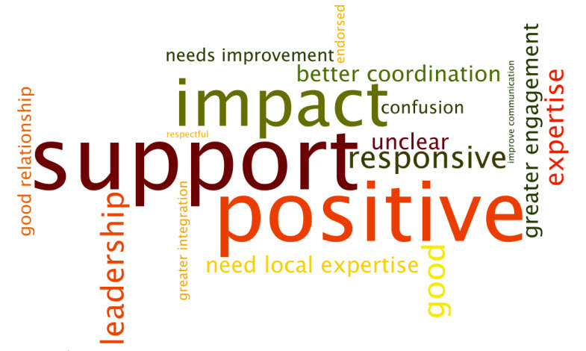

With respect to the Conclusion of this report, please refer to the Annexes for substantiating background material. The Findings at a Glance Chart (Annex 7), includes Strategies and Report Outcomes which were gleaned primarily from the documentation reviewed (see Annex 3) while the list of Interview Findings were written based on the 65 key informant interviews and focus groups (see Annex 4).
Annex 8 contains Strengths and Challenges at a Glance in which the left side is derived from the multiple Monitoring and Evaluation Reports (noted in Annex 3) while the right side is labelled as Evaluator Findings gleaned from the 65 key informant interviews and focus group meetings (listed in Annex 4).

4.2 Evaluation Criteria Ratings

Evaluation Criteria | Explanation | Rating (1-6)
Relevance | PC programs/projects are relevant to the UNDP mandate (supported by AusAID and NZ) to support regional and national priorities by providing countries and CSOs with needed technical assistance appropriate to their contexts and relevant to the stated needs of beneficiaries. The PC is a trusted facilitator in the key thematic areas of: MDGs and Poverty Reduction, Crisis Prevention and Recovery, Democratic Governance and Financial Inclusion. More effort needs to be placed on responding and focusing on the needs of Small Island States. | 5
Effective-  Ness | The PC is perceived as effective in achieving most of its objectives by almost all of the 65 stakeholders met during this evaluation mission with the possible exception of a few CSOs who were critical of perceived duplication of gender programs. This overall positive finding was verified in other evaluations of the PC including the 2011 AusAID Quality at Implementation review. Specifically, re Objective 1 on TA, the regional partners view PC TA as valuable and high calibre in helping them achieve their goals. Re Objective 2, coordination and coherence of work with stakeholders is being done but more joint programming (including with MCOs) is necessary. On Objective 3, the PC is perceived as politically neutral and able to carry forward sensitive issues effectively. Increased joint collaboration including fundraising could increase effectiveness. | 4
Efficiency | The PC is viewed by most stakeholders as responsive, efficient, well led and supported by very good international TA who produce high quality technical solutions for the most part. Many note that more effort is needed to include complementary regional expertise. (Often in regional programs, it is difficult to strike the right balance between responsiveness to stakeholders and directive programming. For the most part, the PC balances this well). Future programming should include more joint planning with other stakeholders to ensure the most efficient balance of responsive and directive programming that meets partner and PC objectives. Some delays in TA procurement were noted. Role confusion continues between UNDP and the PC although strides have been taken to bridge this. The PC needs to link more with SIS, the UN, and UNDP etc. | 4
Impact | Overall, stakeholders met, and documentation reviewed (including evaluations); verify that the PC is producing results that are contributing to change in the Pacific region. Nevertheless to demonstrate the accuracy of this definitively, a Social Return on Investment (SROI) analysis should be done as recommended in this report. Beneficiaries point to examples of how they have benefitted from the PC through its technical assistance, support with sensitive issues, and facilitation assistance including increasing space for change. To leverage up impact, in addition to continuing its present approach, the PC needs to go beyond the traditional client-contractor relationship and work in a more balanced joint collaboration among all its partners. | 4
Sustain-  Ability | Continued efforts to transfer PC knowledge to regional institutions should be a priority. For the PC to be sustainable, continued donor core and program funding is essential. The PC Manager is excellent at fund raising and seen as a multi-talented leader with the confidence of all stakeholders (as verified by interviews and documentation). His impending retirement makes succession planning imperative immediately. | 4
Gender Equality (and other Cross cutting issues) | PC programming is responsive to a wide range of cross cutting issues including aid effectiveness but the number of areas should be narrowed. Specifically re gender equality, responding to previous criticism, the PC now supports gender mainstreamed programming. The PC also engages in effective advocacy and successfully supports: women and girls empowerment; women parliamentarians, and increased school enrolment for girls. Gender, and human rights which is related, should continue to be a focus. A balanced approach to gender and human rights which includes both international platforms and local issues is most appropriate. | 4
Monitoring & Evaluation | The PC has been evaluated positively multiple times. The PC tracks its work in an annual progress report Keeping on Track (KOT). Reporting has improved since PC start up with more outcomes reported on as opposed to mostly activity and output level reporting at the outset. AusAID, NZ and the PC held trilateral consultations to harmonize reporting to increase efficiency and reduce the PC reporting burden. External Monitoring and Evaluation should be harmonized including the next evaluation which should be a full evaluation which includes visits to multiple countries and observation of activities in multiple sectors. | 4
Analysis & Learning | Substantial research has been undertaken by the PC which has produced analyses and documentation of findings. Increased effort should be made to highlight the results to a wider audience using a more interactive PC website. | 5
Rating scale: 6 = very high quality; 1 = very low quality. Below 4 is less than satisfactory.

Annexes
Annex 1: Terms of Reference
Annex 2: Evaluation Plan
Annex 3: Documents and Materials
Annex 4: List of 65 Stakeholders
Annex 5: Stakeholder Meetings Schedule
Annex 6: Aide Memoire for Review of UNDP Pacific Centre
Annex 7: Findings at a Glance
Annex 8: Strengths and Challenges at a Glance

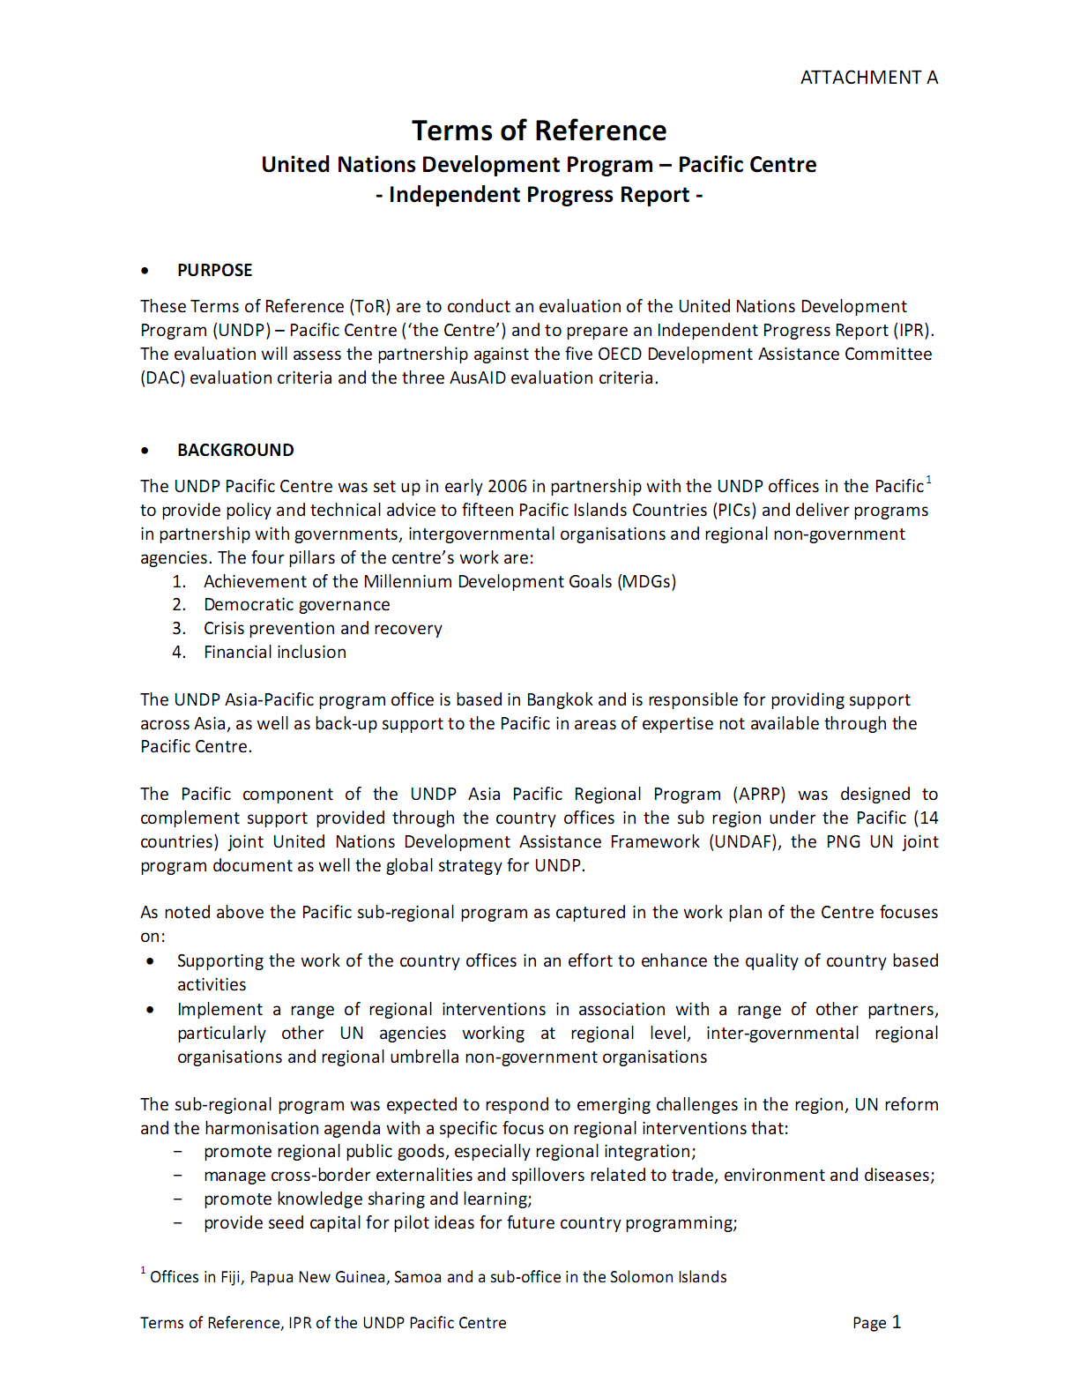
Annex 1: Terms of Reference
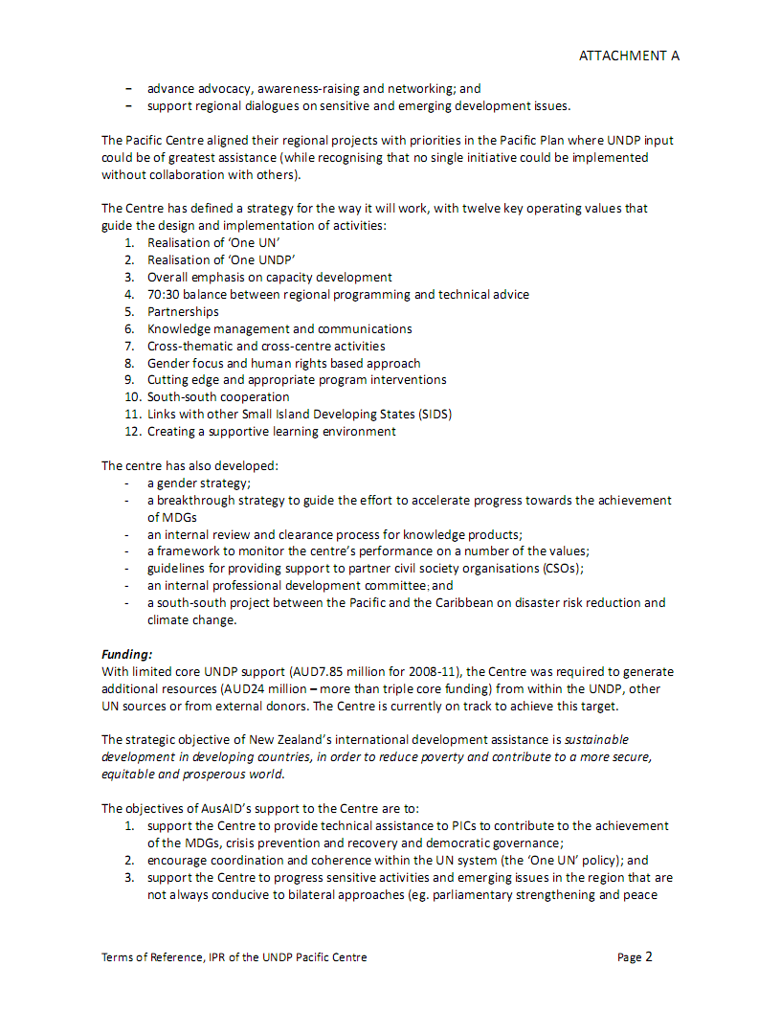
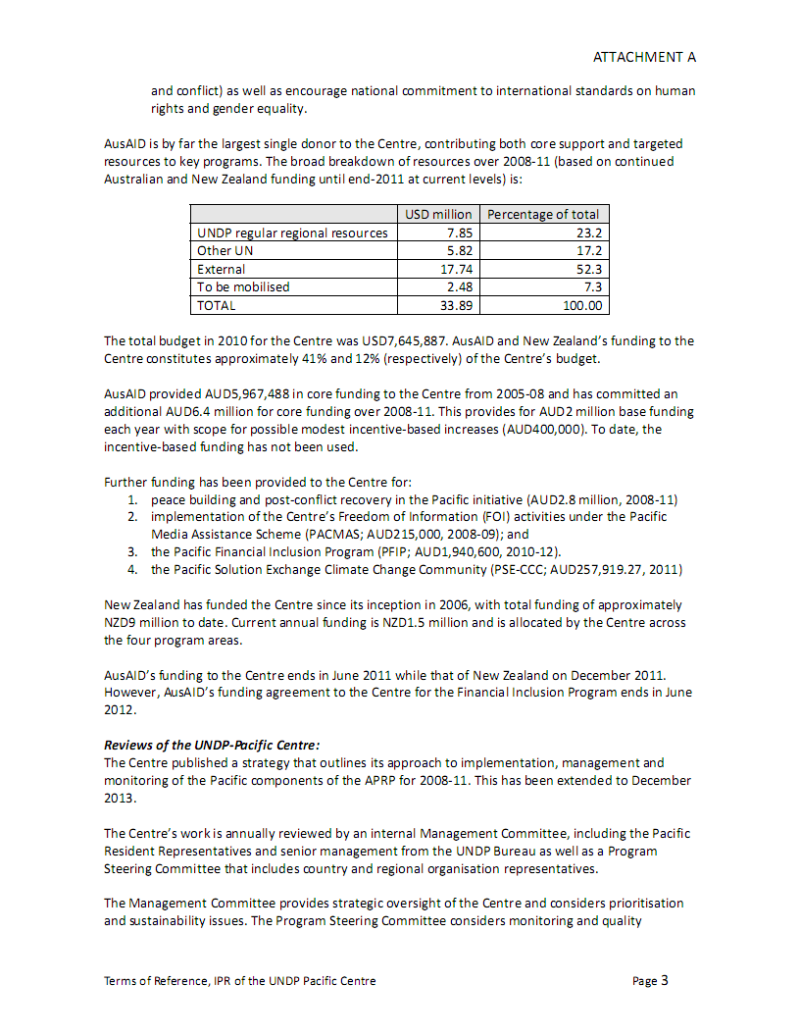
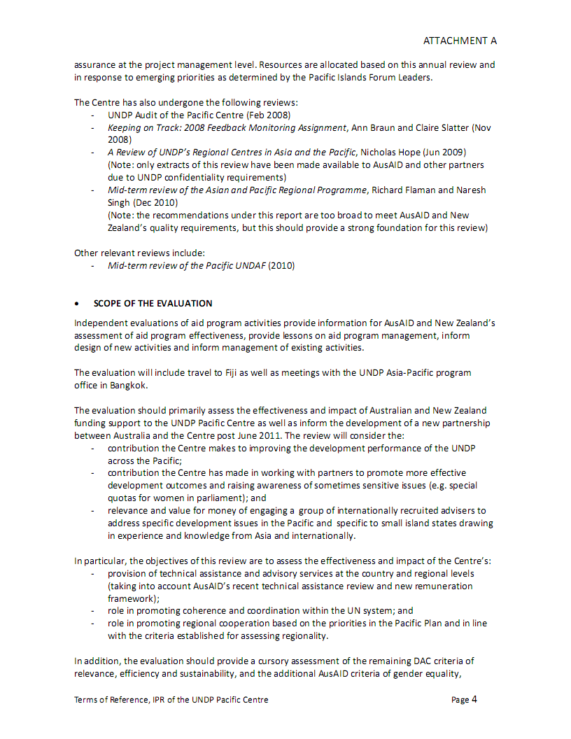
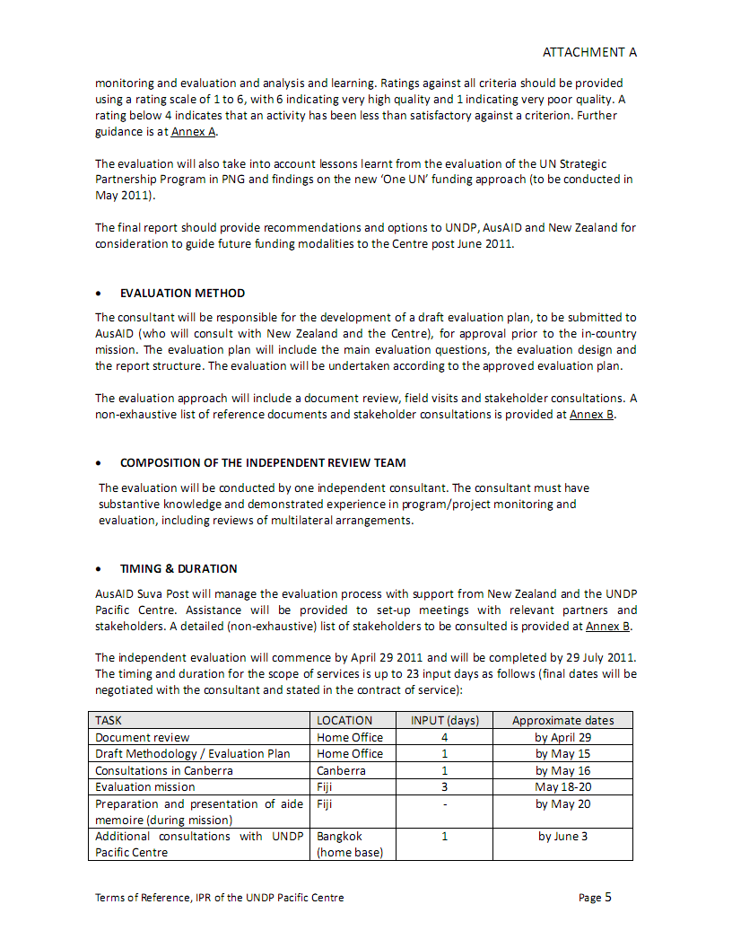
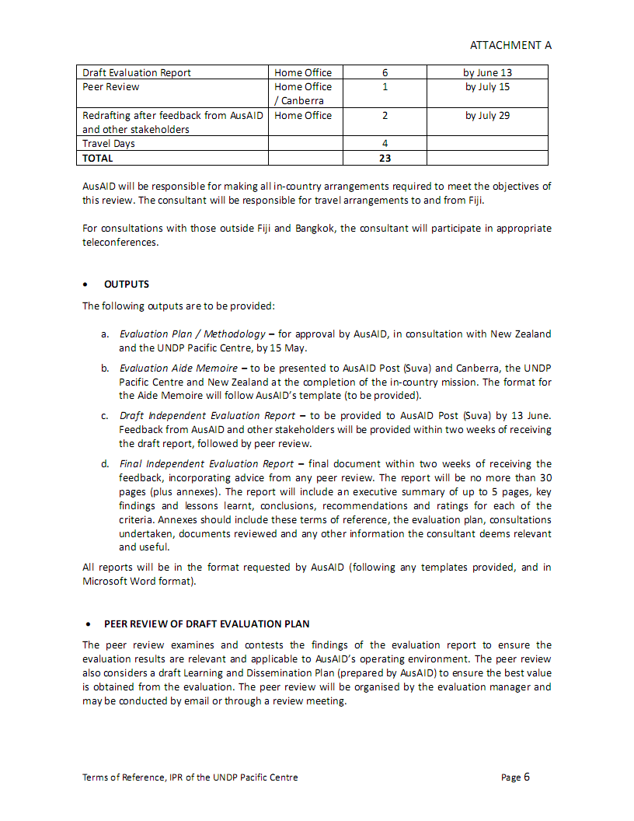
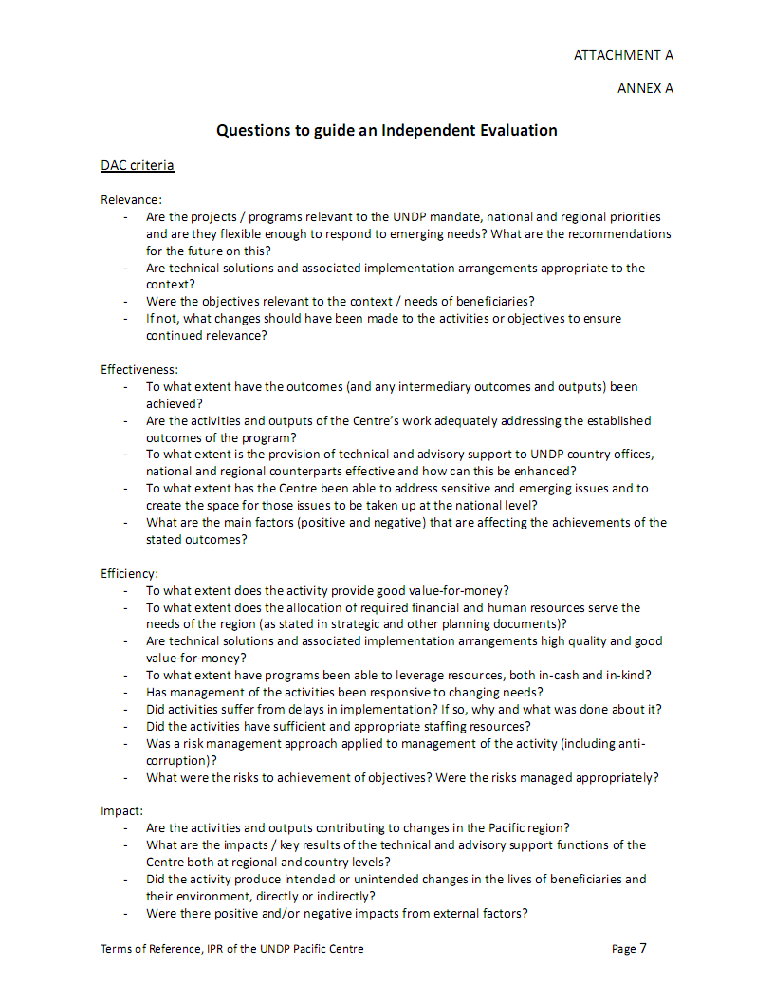
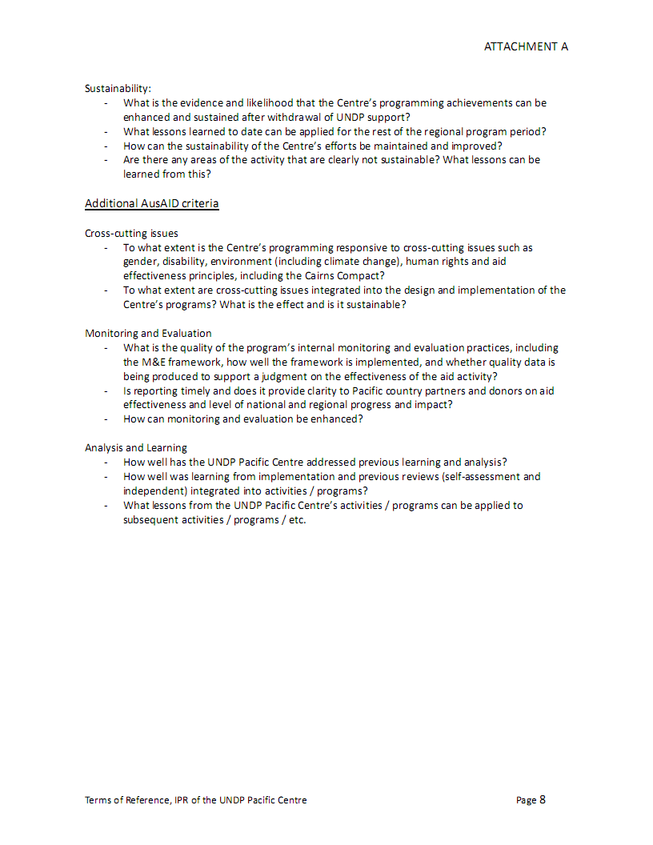
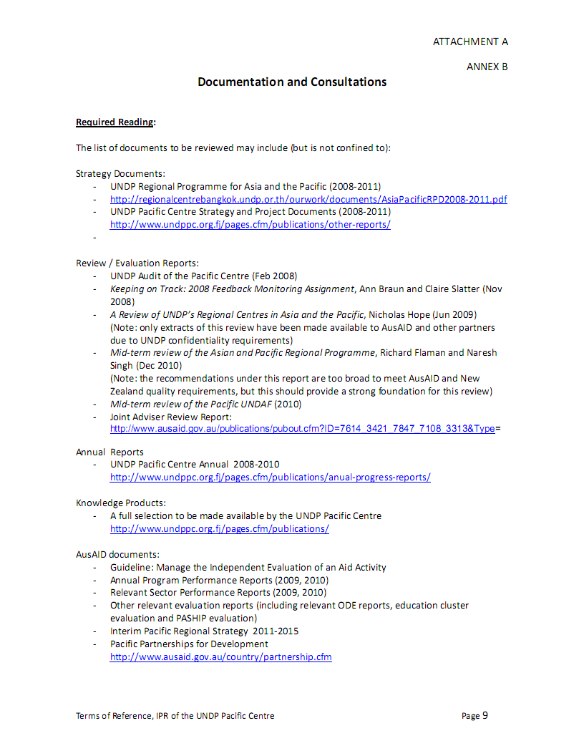
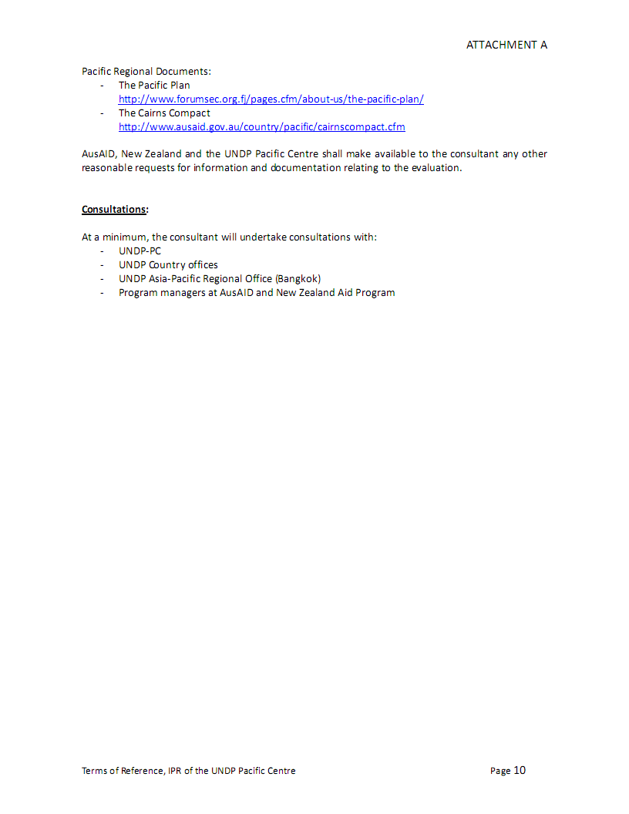

Annex 2: Evaluation Plan
Plan for Independent Progress Report for UNDP Pacific Centre
- Purpose

To conduct an evaluation of the United Nations Development Program (UNDP) - Pacific Centre and prepare an Independent Progress Report (IPR). The evaluation will assess the partnership against the five OECD Development Assistance Committee (DAC) evaluation criteria with a specific focus on relevance and effectiveness and the three AusAID evaluation criteria.

- Background
The UNDP Pacific Centre was set up in early 2006 in partnership with the UNDP offices in the Pacific (Fiji, PNG, Samoa and a sub-office in the Solomon Islands) to provide policy and technical advice to fifteen Pacific Island Countries (PIDS) and deliver programs in partnership with governments, intergovernmental organisations and regional non-government agencies. The four pillars of the Centre’s work are:
- Achievement of the Millennium Development Goals (MDGs)
- Democratic Development
- Crisis prevention and recovery
- Financial inclusion
The UNDP Asia-Pacific program office is based in Bangkok and is responsible for providing support across Asia as well as back-up support to the Pacific in areas of expertise not available through the Pacific Centre. The Pacific component of the UNDP Asia Pacific Regional Program (APRP) was designed to complement support provided through the country offices in the sub region under the Pacific (14 countries) joint United Nations Development Assistance Framework (UNDAF), the PNG UN Joint program document as well as the global strategy for UNDP.
As noted above, the Pacific sub-regional program, as captured in the work plan of the Centre focuses on:
- Supporting the work of the country offices in an effort to enhance the quality of country based activities
- Implement a range of regional interventions in association with a range of other partners, particularly other UN agencies working at the regional level, inter-governmental regional organizations and regional NGO’s.
The sub-regional program was expected to respond to emerging challenges in the region, UN reform and the harmonization agenda with a specific focus on regional interventions that:
- Promote regional public goods, especially regional integration;
- Manage cross-border externalities and spill-overs related to trade, environment and diseases;
- Promote knowledge sharing and learning;
- Provide seed capital for pilot ideas for future country programming;
- Advance advocacy, awareness-raising and networking; and
- Support regional dialogues on sensitive and emerging development issues.
The Pacific Centre aligned its regional projects with priorities in the Pacific Plan where UNDP input could be of greatest assistance (while recognizing that no single initiative could be implemented without collaboration with others). The Centre has defined a strategy for how it works which will be assessed during the review as will the Centre’s gender strategy, its strategy to guide achievement of the MDGs, its monitoring strategy and its approaches to working in partnership with the other organizations working in the sub-region.
3.0 Evaluation Focus
The Independent Progress Report (IPR) will reflect on the implementation of the programme, confirm achievements and identify lessons learned. The report will monitor UNDP Pacific Centre activities and provide information for AusAID and New Zealand’s assessment of aid program effectiveness, provide lessons on aid program management, inform management on the effectiveness of existing activities and inform management on the design of new activities.
The review will primarily assess the effectiveness and impact of Australian and New Zealand funding support to the UNDP Pacific Centre as well as inform the development of a new partnership between Australia and the Centre post June 2011. The review will consider:

- Contribution that the Centre makes to improving the development performance of UNDP across the pacific;
- Contribution that the Centre has made in working with partners to promote more effective development outcomes and raising awareness of sometimes sensitive issues (e.g. special quotas for women in parliament);
- Relevance and value for money of engaging a group of internationally recruited advisers to address specific development issues in the Pacific and specific to small island states drawing in experience and knowledge from Asia and internationally.
In particular, the review objectives are to assess the effectiveness and impact of the Centre’s:

- Provision of technical assistance and advisory services at the country and regional levels (taking into account AusAID’s recent technical assistance review and new remuneration framework);
- Role in promoting coherence and coordination within the UN system; and
- Role in promoting regional cooperation based on the priorities in the Pacific Plan and in line with the criteria established for assessing regionality.
In addition the evaluation will provide a cursory assessment of the remaining DAC criteria of relevance, efficiency, and sustainability, and the additional AusAID criteria of gender equality, monitoring and evaluation and analysis and learning. Ratings against all criteria should be provided using a rating scale of 1 to 6, with 6 indicating very high quality and 1 indicating very poor quality. A rating of below 4 indicates that an activity has been less satisfactory against a criterion.
The evaluation will take into account lessons learnt from the just completed UN Strategic Partnership Program (UNSPP) in Papua New Guinea evaluation and findings on the new ‘One UN’ funding approach being conducted in May, 2011 (should they be available in June, 2011).
The final report will provide recommendations and options to UNDP, AusAID and New Zealand for consideration to guide future funding modalities to the Centre post June, 2011.
4.0 Approach to the Evaluation Methodology
The approach to be used in this evaluation will be to triangulate evidence from three lines of enquiry into a set of findings from which conclusions and recommendations will be logically derived. The sources of data will be:

- Desk review of documents and cursory content analysis of reasonable set of key documents identified to be of most relevance. During the mission, additional documents including evaluations, sector reports, and other documents originating in the Pacific will be added to the list;
- Individual interviews in Canberra, Bangkok and Suva with key stakeholders including AusAID, New Zealand, UNDP and key beneficiaries;
- Focus groups with a wide range of stakeholders in Suva, Fiji including: UNDP in Suva, the Pacific Centre, other UN agencies, relevant regional organizations in the Pacific, governments of Pacific Islands, multilateral organisations, other donors, NGOs and universities.
The 30 page (plus annexes) Independent Progress Report (IPR) will include an executive summary of up to 5 pages, key findings and lessons learned, conclusions, recommendations and ratings for each of the criteria. Annexes will include the terms of reference, the evaluation plan, aide memoire, names and organizations of those stakeholders with whom consultations took place, list of documents reviewed, and any other information deemed useful and relevant including comments upon compliance of the Pacific Centre with the key tenets of the Paris Declaration and the Accra Accord.

5.0 Specific Evaluation Outputs
The following outputs will be provided:
- Evaluation Plan / Methodology;
- Evaluation Aide Memoire – To be presented to the AusAID post in Suva on May 20;
- Draft Independent Progress Report – To be provided to the AusAID post and Canberra in June (date to be agreed) after which feedback will be provided;
- Final Independent Progress Report – Final document incorporating advice of AusAID etc. to be presented to AusAID within 2 weeks of feedback being received.

  - Evaluation Timetable and Planned Itinerary

Day/Date | Location | Tasks
Saturday, May 14 & Sunday, May 15 | Travel to Canberra | Continue document review and draft evaluation plan
Monday, May 16 | Canberra | Consultations with AusAID
Tuesday, May 17 | Travel to Suva | Review documents
Wed. , May 18-Friday, May 20 | Suva, Fiji | Meetings with a wide variety of stakeholders – May 18-20  Preparation and presentation of Aide Memoire on Friday, May 20
May 21-22 | Travel to Bangkok via Sydney | Review notes
Late May and early June (final date to be agreed) | Bangkok | Additional meetings by phone and at UNDP Bangkok; Finalise report after incorporating feedback from AusAID

7.0 Audience for the Evaluation
The main audience for the IPR will be the key stakeholders who include AusAID and New Zealand, UNDP in New York, Bangkok, Suva and in the Pacific and the Pacific Centre, other UN agencies, relevant regional organizations in the Pacific, governments of Pacific Islands, multilateral organisations, other donors, NGOs and universities.

8.0 Evaluation Resources of Evaluation Team
The evaluation will be conducted by one independent consultant assisted by his evaluation team and the appropriate AusAID representative in Suva, Fiji.

9.0 Basic Evaluation Questions (to which sub questions will be added as required)

Relevance | Are the projects/programs relevant to the UNDP mandate, national and regional priorities and are they flexible enough to respond to emerging needs? What are the recommendations for the future on this?
 | Are technical solutions and associated implementation arrangements appropriate to the context?
 | Were the objectives relevant to the context/needs of beneficiaries?
 | If not, what changes should have been made to the activities or objectives to ensure continued relevance?
Effectiveness | To what extent have the outcomes (and any intermediary outcomes and outputs) been achieved?
 | Are the activities and outputs of the Centre’s work adequately addressing the established outcomes of the program?
 | To what extent is the provision of technical and advisory support to UNDP country offices, national and regional counterparts effective and how can this be enhanced?
To what extent has the Centre been able to address sensitive and
emerging issues and to create the space for those issues to be taken
up at the national level?
What are the main factors (positive and negative) that are affecting
the achievements of the stated outcomes?
Efficiency | To what extent does the activity provide good value-for-money?
 | To what extent does the allocation of required financial and human resources serve the needs of the region (as stated in strategic and other planning documents)?
 | Are technical solutions and associated implementation arrangements high quality and good value-for-money?
 | To what extent have programs been able to leverage resources, both in-cash and in-kind?
 | Has management of activities been responsive to changing needs?
 | Did activities suffer from delays in implementation? If so, why and what was done about it?
 | Did the activities have sufficient and appropriate staffing resources?
 | Was a risk management approach applied to management of the activity (including anti-corruption)?
 | What were the risks to achievement of objectives? Were the risks managed appropriately?
Impact | Are the activities and outputs contributing to changes in the Pacific  Region?
What are the impacts/key results of the technical and advisory
support functions of the Centre both at regional and country levels?
 | Did the activity produce intended or unintended changes in the lives of the beneficiaries and their environment, directly or indirectly?
 | Were there positive and/or negative impacts from external factors?
Sustainability | What is the evidence and likelihood that the Centre’s programming  achievements can be enhanced and sustained after withdrawal of  UNDP support?
 | What lessons learned to date can be applied for the rest of the regional program period?
 | How can the sustainability of the Centre’s efforts be maintained and improved?
 | Are there any areas of the activity that are clearly not sustainable? What lessons can be learned from this?
Cross-Cutting issues | To what extent is the Centre’s programming responsive to cross-cutting issues such as gender, disability, environment (including climate change), human rights and aid effectiveness principles, including the Cairns Compact?
 | To what extent are cross-cutting issues integrated into the design and implementation of the Centre’s programs? What is the effect and is it sustainable?
Monitoring and Evaluation | What is the quality of the program’s internal monitoring and evaluation practices including the M&E framework? How well was the framework implemented and is quality data being produced to support a judgment on the effectiveness of the aid activity?
 | Is reporting timely and does it provide clarity to Pacific country partners and donors on aid effectiveness and level of national and regional progress and impact?
 | How can monitoring and evaluation be enhanced?
Analysis and Learning | How well has the UNDP Pacific Centre addressed previous learning and analysis?
 | How well was learning from implementation and previous reviews (self-assessment and independent) integrated into activities/programs?
 | What lessons from the UNDP Pacific Centre’s activities / programs can be applied to subsequent activities / programs etc.?

Annex 3: Documents and Materials
Category | Title
Progress Reports | UNDP Solomon Islands
Progress Reports | United Nations Development Programme Pacific Centre
 | UNCDF MID TERM REVIEW Pacific Financial Inclusion Programme October 2010
 | Pacific Sub Region United Nations Development Assistance Framework (UNDAF) (2008-2012) Mid Term Review
 | UNCP Action Plan Revised Result Matrix December 2008
 | PFIP Pacific Financial Inclusion Programme FINAL REPORT TO THE EUROPEAN UNION 2011
 | UNDP Pacific Centre CRISIS PREVENTION & RECOVERY TEAM CONCRETE RESULTS ACHIEVE 2007-MAY 2011
 | MDG Team Summary 2005-2013
 | REVIEW OF UNDP'S REGIONAL CENTRES IN ASIA & THE PACIFIC, Hope June 2009
 | UNDP Pacific Centre Monitoring Assignment: Report for NZAID and the Pacific Centre April 2008
 | Connecting with Partners for Transformational Change in the Pacific Annual Report UNDP PC 2010
 | A Review of UNDP’s Regional Centers in Asia and the Pacific, Nicholas Hope (Jun 2009)
 | AusAID Desk Review of UNDP Pacific Centre December 2007
 | Keeping on Track: 2008 Feedback Monitoring Assignment, Ann Braun and Claire Slatter (Nov 2008)
 | Connecting with Partners for Transformational Change in the Pacific Annual Report UNDP Pacific Centre 2010
 | Annual Report 2009 UNDP Pacific Centre Partners in achieving prosperity & stability in the Pacific
 | Annual Report 2008 UNDP Pacific Centre Partners in achieving prosperity & stability in the Pacific
 | AUDIT OF UNDP PACIFIC CENTRE Audit Report No. RCM 0186-08 (16 December 2008)
 | Midterm Review of the Asian & Pacific Regional Programme, Richard Flaman & Naresh Singh 2010
Project Documents | UNDP Terms of Reference
Project Documents | UNDP PROGRESS REVIEW LIST OF NAMES CONFIRMED FOR 19TH MAY 2011
 | UNDP Regional Programme for Asia and the Pacific (2008-2011)
 | “Keeping on track” The UNDP Pacific Centre Strategy 2008-2011 M&E Framework
 | Rules of Coordination Pacific Multi-Country CO, PNG CO and the Pacific Centre
 | UNDP Pacific Centre Strategy and Project Documents 2008 - 2011
 | Points for consideration of the External Review of the Pacific Centre (2006-2011)
 | UNDP Pacific Centre A Partner in achieving prosperity and stability in the Pacific
 | Independent Progress Review: UNDP Pacific Centre In-Country Visit Fiji (18-20 May 2011)
 | Midterm Review List of Stakeholders
UN Documents | United Nations Development Programme Asia-Pacific Regional Centre PRC Annual Report 2010
UN Documents | United Nations Country Programme 'Nupela wei long wokim wok'
 | UNITED NATIONS Papua New Guinea DELIVERING AS ONE Annual Progress Report 2009
 | UN WOMEN United Nations Entity for Gender Equality and the Empowerment of Women Summary of Initiative on Pacific Women's Economic Security and Rights
 | THE POWER OF HOW The UNDP and SNV Capacity Development Initiative
 | UNDP Business Call to Action
 | UNDP PC Migration, Mobility and HIV
 | UNDP Power, Voice and Rights
 | Partnership Framework between AusAID and UNICEF 2008-2015
 | State of the World’s Children 2011, UNICEF
 | UNDP Human Development Index Report 2007-2008, UNDP, 2007
 | United Nation’s Country Programme 2012-2015
 | Addressing Conflict-Related Sexual Violence: An Analytical Inventory of Peacekeeping Practice

Category | Title
AusAID Documents | Who is AusAID?
AusAID Documents | AusAID About AusAID March 2009
 | AusAID Gender equality and the Australian aid program
 | AusAID Woman, Peace and Security AusAID's implementation of United Nations Security Council Resolution 1325
 | AusAID Pacific Partnerships for Development
 | AusAID Millennium Development Goals
 | AusAID Office of Development Effectiveness
 | AusAID Financial Services for the Poor A Strategy for the Australian aid program 2010-15
 | AusAID Review of the UNDP Pacific Centre Contribution of the PC Governance Project
 | AusAID Promoting Gender Equality through the Millennium Development Goals
 | AusAID Woman leading change AusAID's support for woman's leadership and decision making
 | AusAID ANNUAL REPORT 09 I 10
 | AusAID STOP VIOLENCE Responding to violence against women in Melanesia & East Timor Australia's response to the ODE report
 | Achieving the millennium development goals: Australia's support 2000-2010
 | AusAID Manage the Independent Evaluation of an Aid Activity
 | Child Protection Procedures Manual 2008
 | Child Protection Policy 2008
 | Helping health systems deliver 2006
 | AusAID Statistical Summary 2005-2008
Research Documents | ILO in Asia and the Pacific Online Resource: A Guide for Researchers
Research Documents | ADDRESSING CONFLICT-RELATED SEXUAL VIOLENCE AN ANALYTICAL INVENTORY OF PEACEKEEPING PRACTICE
 | Watch and Listen International keynote speakers talking on Country-led
 | Transforming Conversations Into Collaboration Connect-Share-Collaborate
 | Public - Private Partnerships for Service Delivery
 | Violence against Women in Melanesia and East Timor
 | ILO in Asia and the Pacific Online Resources: A Guide for Researchers (Booklet)
 | ILO in Asia and the Pacific Online Resources: A Guide for Researchers (Bookmart)
 | VIOLENCE AGAINST WOMEN IN MELANESIA AND EAST TIMOR BUILDING ON GLOBAL AND REGIONAL PROMISING APPROACHES 2008
 | Pasifika Focus Newsletters (Oct 2006, January 2007, March 2009, September 2010)
Annexes 7 and 8 primarily utilized the following documents:
- AusAID Desk Review of UNDP Pacific Centre December 2007
- AUDIT OF UNDP PACIFIC CENTRE Audit Report December 2008
- UNDP Pacific Centre Monitoring Assignment: Report for NZAID and the PC 2008
- Keeping on Track: 2008 Feedback Monitoring Assignment, Braun and Slatter (2008)
- UNDP PC Annual Report 2009
- A Review of UNDP’s Regional Centres in Asia and the Pacific, Hope (2009)
- Annual Report UNDP PC 2010
- MTR of the Asian & Pacific Regional Programme, Flaman and Singh 2010
- PIFP Pacific Financial Inclusion Program FINAL REPORT TO THE EU March 2011

Annex 4: List of 65 Stakeholders
Organisation | Name | Position
Suva Fiji
Head of Mission Office | Ms. Judith Robinson | Acting High Commissioner Australia
AusAID | Ms. Romaine Kwesius | Counsellor, Development Cooperation Section
AusAID | Mr. Nilesh Goundar | Program Manager, Development Cooperation Section
 | Ms. Melinia Nawadra | Program Manager, Development Cooperation Section
NZ MFAT | Ms. Emma Dunlop-Bennett | NZAID Regional Manager
NZ MFAT | Ms. Chris Day | Manager in Wellington, via PLU
NZ MFAT | Ms. Arati Sudhakar | Development Programme Coordinator
UNDP Pacific Centre | Mr. Garry Wiseman | Pacific Centre Manager
UNDP Pacific Centre | Mr. Tillman Bruett | Pacific Financial Inclusion Adviser
UNDP Pacific Centre | Ms. Tracy Vienings | Pacific Regional Crisis Prevention & Recovery Adviser
UNDP Pacific Centre | Mr. Ernesto Bautista | Pacific Regional Governance Adviser
UNDP Pacific Centre | Mr. Ahmed Moustafa | MDG’s & Poverty Reduction Team Leader
UNDP Pacific Centre | Ms. Moneeba Hanif | Programme Management Services Unit Team Leader PC
UNDP Pacific Centre | Mr. Ferdinand Strobel | Programme Specialist, HIV and AIDS
UNDP Pacific Centre | Ms. Karen Bernard | Programme Specialist, Disaster Risk Reduction & Recovery
UNDP Pacific Centre | Ms. Mereseini Senikau-Tuivuniwai | PFIP Programme Associate
UNDP Pacific Centre | Ms. Jennifer Namgyal | Knowledge Management Officer
CROP | Ms. Joanne Kunatuba | Gender Officer, Pacific Islands Forum Secretariat (PIFS)
CROP | Dr. Priya Chattier | Gender Studies Coordinator, School of Social Science, University of the South Pacific (USP)
CROP | Prof. Murari Lal | Director, Pacific Centre for Environment & Sustainable  Development (PACE-SD), University of South Pacific (USP)
CROP | Mr. Mosese Sikivou | Manager, Community Risk Programme, Secretariat of the Pacific Community (SOPAC)
CROP | Mr. Matt Davies | Coordinator – Pacific Financial Technical Assistance Center (PIFTAC) International Monetary Fund (IMF)
CROP | Mr. Rick Nimmo | Director, Political Governance & Security, Pacific Islands Forum Secretariat (PIFS)
CROP | Dr. Helen Jacot Des Combes | Lecturer, Pacific Centre for Environment and Sustainable Development (PACE-SD) at the University of the South Pacific
CROP | Ms. Ashmita D. Ali | Research Assistant - European Union (EU) – Global Climate Change Alliance (GCCA) at the University of the South Pacific (USP)
CROP | Mr. Alfred Shuster | Strategic Partnership & Coordination, Secretariat, Pacific Islands Forum (SPC)
CROP | Mr. Tarusila Bradburgh | Coordinator – Pacific Youth Council, Secretariat of the Pacific Community (SPC)
CROP | Dr. Manoranjan Mohanty | Development Studies, University of South Pacific (USP)
CROP | Ms. Sandra Bernklau | Programme Manager Pacific Regional Rights Resource Team (RRRT), Secretariat of the Pacific (SPC)

Organisation | Name | Position
Suva Fiji
UNDP MCO | Mr. Knut Ostby | Resident Representative
UNDP MCO | Mr. Toily Kurbanov | Deputy Resident Representative
UNDP MCO | Ms. Mereseini Bower | Poverty Team Leader
UNDP MCO | Ms. Emma Mario | Environment Programme Analyst
UNDP MCO | Mr. Patrick Tuimaleali’ifano | UNDP Poverty Analyst
UNDP in NY | Mr. Deodat Maharaj | UNDP – Chief, Regional Support Unit at UNDP Regional Bureau for Asia and the Pacific (RBAP)
UN Cluster Group | Dr. Annette Robertson | Deputy Resident Representative, UNFPA
UN Cluster Group | Mr. Tim Wabuhembat | Regional Coordinator – UNAIDS Pacific
Fiji CSOs | Ms. Sharon Bhagwan-Rolls | Executive Director, FemLink Pacific
Fiji CSOs | Ms. Jane Keith Reid | Coordinator – AIDS Taskforce Fiji
Fiji CSOs | Mr. Neeraj Singh | Disaster Risk Management Programme at UNDP
Fiji CSOs | Ms. Virisila Buadromo | Fiji Women’s Rights Movement (FWRM)
Fiji CSOs | Ms. Susana Tuisawau | Pacific Foundation for the Advancement of Women (PACFAW)
Fiji CSOs | Mr. Rodney Yee | Citizen's Contribution Forum
Fiji CSOs | Mr. Albert Cerelala | Foundation of the Peoples’ of the South Pacific (FSPI)
Fiji CSOs | Ms. Sheela Venkataya | Then India Sanmarga Ikya (TISI) Sangam
Small Islands States (SIS) | Ms. Peniana Lalabalavu | Director of Monitoring and Evaluation Unit in the Office of the Prime Minister, Government of Fiji
Small Islands States (SIS) | Mr. Edward Tunidau | SFCCO Deputy Secretary, Government of Fiji
Small Islands States (SIS) | Mr. Peter Jacob | First Secretary, Government of Nauru
UNDP Samoa | Ms. Nileema Noble | Resident Coordinator and Resident Representative
UNDP Samoa | Ms. Georgia Bonin | Assistant Resident Representative (Programme)
UNDP Samoa | Mr. Armstrong Alexis | Programmes and Operations Manager
UNDP Soloman Islands | Ms. Akiko Suzaki | Deputy Resident Representative
UNDP Soloman Islands | Ms. Shabram Mallicle | Country Programme Manager
UNDP Soloman Islands | Ms. Jude Devesi | Governance Team Leader
UNDP Papua New Guinea | Mr. David McLachlan-Karr | Resident Coordinator of the UN System in PNG and Resident Representative of UNDP
UNDP Bangkok | Mr. Nicholas Rosselini | Deputy Assistant Administrator and Deputy Regional Director, Asia Pacific Regional Centre (APRC)
Canberra
AusAID | Mr. Chris Chung | Director, UN Section
AusAID | Mr. David Geyer | UN and Commonwealth Section
AusAID | Ms. Alison George | Pacific Performance and Quality Section
AusAID | Ms. Yvonne Green | Pacific Performance and Quality Section
AusAID | Mr. James Gilling | First Assistant Director-General, Pacific Division
AusAID | Ms. Kate Eversteyn | Child Protection Specialist
 | Ms. Lucy Carlsen | Pacific Law & Justice Sub-section
 | Mr. Bernard Pearce | Ending Violence Against Women Adviser (A/g)
 | Mr. Bill Costello | Assistant Director-General, Pacific Quality and Effectiveness Branch

Annex 5: Stakeholder Meetings Schedule

Independent Progress Review: UNDP Pacific Centre
Stakeholders Met In-Country Visit to Fiji (18-20 May 2011)
Consultant: Michael Miner

Date | Time | Meetings | Venue | Comments/logistics | Contacts | Confirmed
Monday  16 May | Consultations in CBA, organised by Alison George
Tuesday  17 May | Michael Miner arrives in Suva, Fiji  Flight details:  Accommodation:
Wednesday  18 May | 9:00am | Meeting with AusAID | Dawn Fraser Room, AusAID Office  Australian High Commission, Princes Road, Suva. | AusAID (Nilesh Goundar) to organise meetings and logistics
Wednesday  18 May | 10:00am | Courtesy Visit to Acting HOM and DFAT | HOM’s office
Wednesday  18 May | 10:45am | Meeting with NZ MFAT | NZHC | NZ MFAT (Emma) to arrange Wellington PLU
Wednesday  18 May | 12:00pm | Meeting with Pacific Centre Manager | UNDP-PC
Wednesday  18 May | 1.00pm | Working lunch with UNDP-PC team leaders | UNDP-PC | PC to organise lunch
Wednesday  18 May | 2:00pm | Focus Group meeting with PC team leaders | UNDP-PC Conference Room
Wednesday  18 May | 3.00pm | Meeting with UNDP MCO | UNDP MCO  8th Floor, Kadavu House  Victoria Parade, Suva
Wednesday  18 May | 4.00pm | Focus Group meeting with UNDP MCO team leaders | UNDP MCO  8th Floor, Kadavu House  Victoria Parade, Suva
Thursday  19 May | 8:30am | Teleconference Call with Mr. Deodat Maharaj | UNDP-PC Conference room
 | 9.00am | Focus Group with CROP agencies | UNDP-PC Conference room | PC to organise morning tea
 | 11:00am | Meeting with UN Cluster group
 | 1:00pm | Spillover into lunch | UNDP-PC Conference room | PC to organise lunch
 | 2.00pm | Focus group with CSOs | UNDP-PC Conference room
 | 3.30pm | Focus group with SIS govt partners | UNDP-PC Conference room | PC to organise afternoon tea
Friday  20 May | 9.00am | Focus group with other govt partners [Fiji, PNG, SI, Vanuatu] | UNDP-PC Conference room | PC to organise morning tea
 | 10:30am | PLU with UNDP PNG – Res Rep | UNDP-PC Conference room | PC to organise PLU
 | 11.30am | PLU with UNDP Samoa – Res Rep | UNDP-PC Conference room | PC to organise PLU
 | 1:00pm | Lunch | Own arrangement
 | 2:15pm | Presentation of Evaluation Aide Memoire to AusAID, NZ MFAT and UNDP-PC and next steps | AusAID Office, AHC  VCU room
Saturday 21 May |  | Flight back to Bangkok  Flight details:

Annex 6: Aide Memoire for Review of UNDP Pacific Centre
(This reflects the views of the evaluation consultant not necessarily those of AusAID)
Review Background
UNDP activities are implemented within the framework of the UNDP Strategic Plan 2008-2011 approved in 2007 by the UNDP Executive Board (a steering and oversight body consisting of 36 UN member countries on a rotating basis). The UNDP Asia Pacific Regional Program was designed to complement support provided through the country offices in the Pacific (14 countries) joint United Nations Development Assistance Framework (UNDAF) and the PNG UN joint program. The UNDP Asia Pacific program office is based in Bangkok and responsible for providing support across Asia as well as back-up expertise when it is not available through the UNDP Pacific Centre.

The Pacific Centre was set up in early 2006 as a partnership with UNDP offices in the Pacific (Fiji, PNG, and Samoa) to provide policy and technical advice to 15 Pacific Island Countries and deliver programs in partnership with governments, intergovernmental organizations and regional NGOs. The four pillars of the work of the Pacific Centre at present are: 1. Achievement of MDGs; 2. Democratic Governance; 3. Crisis Prevention and Recovery, and 4. Financial Inclusion (identified later to improve access to services among one of the world’s least banked regions).

The purpose of the review is to conduct a review of the UNDP Pacific Centre program and prepare an Independent Completion Report (IPR) which assesses the partnership against the five OECD Development Assistance Committee (DAC) evaluation criteria (with particular focus on effectiveness and impact) plus a cursory assessment of the remaining DAC criteria of relevance, efficacy and sustainability); the three AusAID evaluation criteria: (monitoring and evaluation, gender equality and analysis and learning); and, to prepare an Independent Progress Report (IPR). The IPR will provide information for AusAID and NZ’s international development program to assist them to see if their stated objectives for the UNDP Pacific Centre are being achieved.
The review was undertaken by Michael Miner of RBMG, assisted by Melinda MacDonald, (Gender and Human Rights Specialist), and Tom Litchfield, (Project Assistant), with on the ground assistance from Nilesh Goundar (Programme Manager, AusAID), who arranged the mission and took part in most of the Review meetings. A complete analysis of all relevant documents, key informant interviews and focus groups will be carried out and findings and recommendations made on the basis of a triangulated methodology which focuses on contributions to the overall objectives rather than attribution which is not possible in development work such as this where there are contributions by multiple stakeholders to achieving results.
Given the short time frame of the evaluation, it will draw on the results of previous evaluations, monitoring reports, Quality at Implementation Reports etc. Specifically some of the key questions will be similar or the same as those used in previous studies. For example, three questions from the Keeping On Track review of the UNDP Pacific Centre which this evaluation also used were:
- How is the Pacific Centre perceived as a partner?
- How is the Pacific Centre contributing to partners’ progress and achievements?
- How well is the Pacific Centre mainstreaming gender and integrating the human rights based approach through their work?
The audiences for the IPR will be AusAID staff and management, New Zealand representatives, Governments of the Pacific, Regional governmental organizations in the Pacific, UNDP and other UN organizations and CSOs in the Pacific.
Description of Evaluation Activities
The IPR team met with a total of 65 stakeholders in 3.5 days of meetings during the week of May 16-20, 2011, first on May 16 in Canberra and then between May 18-20 in Suva. The evaluation did not include visits to project sites in the Pacific islands but did include teleconferences with UNDP Multi Country offices in PNG, Solomon Islands, Samoa, and New York and will include a face to face meeting in Bangkok later in May. Other stakeholders who were interviewed as key informants or who took part in 1 of 5 focus groups included: representatives of AusAID, New Zealand, UNDP Pacific Centre and Multi Country Office in Suva, some UN agencies based in Suva, and representatives of CROP (Council of Regional Organizations in the Pacific), Pacific Governments, and Regional CSOs.
Initial Findings and Recommendations (Agreed that these categories would be used as a blueprint to be explored and analysis further).
This section is preliminary and based on a quick review of the documents, and notes taken during the key informant interviews and the 5 focus groups. The evaluation report’s findings and recommendations will be the result of triangulating the content of the document review, the key informant interviews and the focus groups.
- Stakeholders Perception of the Contribution of Pacific Centre – After meetings with 65 stakeholders, it is clear that there is consensus among CROP, CSOs, the two key Donors, and UNDP, at multi levels, that the Pacific Centre has made very significant contributions to the work of most of its partners. The sample of Pacific Governments (2) and other UN Agencies (2) was too small to make the same conclusion but they also mentioned the work of the Pacific Centre in a positive light. Overall the only detracting comments were with respect to occasional competition rather than full cooperation between the Centre and the partners on issues of mutual concern. Comments about the PC Manager were universally positive across all stakeholders. The work of PC staff was mostly positive with the only caveat being that international staff needs to ensure that their valuable expertise is balanced by a full understanding of the local context in each island to ensure full relevance to each local situation. Overall the PC is seen as a high quality professional and well managed provider of policy and technical advice in specific areas which is based in the Pacific.
- Clarification of primary constituency of the UNDP Pacific Centre is necessary – A key question which surfaced in many interviews was who is the Pacific Centre’s main constituency? Is it the Regional Organizations (CROP), Governments, the UNDP MCOs or all of these plus CSOs? The finding is that there is a lack of clarity around this which causes tension for some stakeholders. Nevertheless, all report that when they ask the Pacific Centre for assistance, it is provided. The primary focus should be the regional actors, i.e., the CROP organizations, along with the CSOs, to reflect local ownership and alignment, in line with the Paris Declaration. In this sense supporting the UNDP MCO’s and other organizations contributes to this focus.
- Further Clarification of Roles and Responsibilities at UNDP - Historically since 2006 when the Centre began operation, there have been issues around the lack of clarity in roles and responsibilities between the UNDP Country Offices and the UNDP Pacific Centre. Substantial strides have been made to improve coordination and avoid duplication and competition between the MCOs and the Pacific Centre in the past 2 years including preparation of Rules of Coordination between the Pacific Centre and the 3 Country Offices. Establishment of the PC Management committee comprised of the 3 Resident Representatives chaired by the Deputy Regional Director appears to have given impetus to stronger coordination among UNDP’s regional and national initiatives and more opportunity for feedback and mutual accountability. In addition, recent concrete steps in this direction are the joint operations unit and the joint communication function being operationalized between the MCO in Suva and the Pacific Centre. Challenges re the MCOs/PC relationship in the past did affect perceptions of UNDP, i.e., especially with respect to which institution was seen as the Face of the UNDP in the Pacific? The March, 2011 a joint retreat also appears to have been a valuable step towards creation of a joint programming approach between UNDP MCO’s and the Pacific Centre. This approach appears to be very beneficial to continuing the momentum to overcome this issue. Also, roles and responsibilities of both offices need to be further clarified ideally through signing a joint agreement or MOU. This will help to overcome the present lack of clarity between the two parts of UNDP and continue to move towards an integrated coordinated UNDP in the Pacific providing assistance to a wide variety of regional and national stakeholders.
- Structure enabled by Positive Relationships - There is a sense that another key driver for effectiveness and efficiency is the improved positive working relationships between the UNDP MCOs and the UNDP Pacific Centre and with other regional and national stakeholders. This is in part due to the leadership styles of the Resident Representatives of UNDP MCOs and the Regional Manager of the Pacific Centre and their senior staff. The importance of leaders and staff building respectful and culturally sensitive relationships was highlighted by many interviewees.
- Value Added of Experienced International Experts - There is a general view that there is value for money with respect to the use of “experienced international experts” at the Pacific Centre according to the stakeholders consulted in the focus groups. However, there could be more focus providing support to the Small Island States (SIS) which really need and want increased access to the Centres’ expertise. More focus could also be placed on building local capacity and linking local and international expertise. Staff with substantial expertise and knowledge of best practices as well as an understanding of the local context in the islands of the Pacific are highly valued.

- Addressing Concerns Around Succession – Given that Garry Wiseman is universally seen as an excellent leader and innovative manager and will be retiring from UNDP within 2 years, a long term succession plan needs to be put in place now.
- Integration of Gender & Human Rights Based Approach – The stakeholders have noted that there is strong commitment vis a vis gender mainstreaming in all areas of work at the Pacific Centre. However the issue of whether the Centre has too “international” a focus on gender than on regional platforms needs to be analysed. Some felt that the CSW was not the most appropriate platform for the Pacific. There is also strong support for their overall Human Rights Based Approach, although some criticism emerged around putting peace-building principles related to inclusion of stakeholders such as the Fijian government at the table, as problematic with respect to use of the human rights based approach. Furthermore there were criticisms around the willingness of the Centre to use agreements developed by the Fijian Military Government, if these agreements were considered solid. Some felt that such agreements, secured in a non-democratic fashion, should not be considered consistent with a human rights based approach and therefore not used. This is however a long standing debate among human rights activists (who claim that there can be no peace without human rights) and peace activists (who claim that there can be no human rights without peace).
- Objectives of AusAID and NZAID – With respect to the objectives of AusAID, A) – 1. The contribution to the achievement of the MDGs is a work in progress (many governments still lack the information required, i.e., relevant statistics to measure MDG progress substantively. The focus on poverty analysis has been well received. 2. Crisis prevention and recovery are widely seen as successful and function very collaboratively among partners; 3. Significant successes in democratic governance initiatives are coloured by some perceptions of competition (rather than cooperation) between MCOs and the Pacific Centre in providing thematic assistance; and 4. With respect to Financial Inclusion (which is a joint UNCDF/UNDP initiative project), there is substantial excitement about its achievements to date. It now appears to have matured sufficiently to be mainstreamed to the national banking sectors. B) With respect to integrated UN approaches, the UNDP, UNFPA and UNICEF have a joint UN presence in 8 Pacific countries and a 1 UN Fund in Kiribati. There are also a growing number of joint programs at country level and stronger interagency dialogue. The Pacific Centre has also provided support to the integrated Monitoring and Evaluation Group (UNDAF). C) There is substantial evidence that the Pacific Centre is a valuable voice for sensitive and emerging issues (i.e., parliamentary strengthening, peace and conflict, anti-corruption initiatives, temporary special measures and encouraging of national commitment to human rights and gender equality). With respect to New Zealand’s strategic objectives, the Centre’s work in Financial Inclusion, achievement of MDGs to help reduce poverty, and the Centre’s championing Human Security (rather than just the narrower view of traditional Security) and its work with SPC /SOPAC to strengthen disaster risk reduction and climate change adaptation linkages has contributed to NZ goals of a ‘more secure, equitable and prosperous world.”

- Value added of Partnership with the Pacific Centre – Many of the stakeholders referred to their partnership with the UNDP Pacific Centre as “the pivotal partnership” and as a “catalyst” through which action on sensitive issues can be taken. It is viewed as primarily a responsive mechanism which adds value to the work of Pacific stakeholders. Its work and contributions were only questioned by a few respondents who said that, although they were very positive overall about the value of the Pacific Centre, their perception is that occasionally the Pacific Centre has done work which they thought competed with them.
- Future of the UNDP Pacific Centre - It is clear that the present direction of the PC working more closely with the MCOs in terms of programming, communication including knowledge management and operations is both beneficial and workable and will contribute to a more integrated UNDP program. Efforts could be increased to link UNDP programming with that of other UN agencies as part of working towards the ‘one UN’. Value can be enhanced substantially through implementation of an integrated sub-regional UNDP program (supported by AusAID and NZ) that focuses on agreed most critical development results at the regional and national levels as compared with the status quo in which there is some fragmentation in the Pacific and PNG programs of the PC and MCOs UNDP which are managed separately by the UNDP Executive Board.
Other Issues to Be Explored (as discussed during the Aide Memoire meeting):
- Relationship between contribution and attribution with respect to results. Regional projects can only really talk about contribution not attribution since many variables and stakeholders contribute collaboratively to overall results. This will be elaborated upon in the report.
- Sustainability, including both succession planning and capacity building for regional organizations, i.e., CROP
- Exploring the benefits and challenges between further integration into UNDP and the benefits of autonomy, i.e., flexibility and creativity
- Further exploration of risk and mitigation factors
- Approaches to billing for services between parts of UNDP
Next Steps
After the detailed analysis of the different lines of evidence is completed with the focus on effectiveness and impact, the draft Independent Progress Report will be provided to AusAID Canberra and AusAID in Suva and be subject to peer review. The report will be finalised following incorporation of consolidated feedback from AusAID by the end of July, 2011 (or date agreed).
Acknowledgements
The IPR team sincerely thanks AusAID staff in Canberra and Suva for their cooperation and support, and the UNDP Pacific Centre and MCO staff in Suva and also to the 65 people who were consulted for their time and inputs.

Annex 7: Findings at a Glance
7.1 MDG Poverty Reduction
Objectives: To Support Pacific Island Countries to achieve the MDGs by reducing poverty and inequality.
Strategy | Report Outcomes | From Interviews
Improve achievement of the MDGs for reducing poverty and inequality  Foster regional cooperation & integration for enhanced trade flows leading to increased employment & poverty reduction.  Create an enabling environment and develop capacities to respond to human development, governance and cross-border challenges of HIV/AIDS and mobility.  Enable the poor with improved access to ecosystems assets and sustainable and affordable energy services.  Contribute and strengthen MDG policies, strategies and partnerships that promote access to a broad range of financial services for the benefit of the poor.  Promote more accessible regulatory environments; provide entrepreneurial capacity building and facilitate private sector partnerships. | The PC has published a number of MDG reports and tools that partners use. The PC has also organized MDG conferences, workshops and knowledge sharing events which partners report are useful.  Establishment of a Pacific MDG Network and a review of National Sustainable Development Strategies (NSDS) in Nauru as a direct follow-up to a Pacific MDG workshop in March 2009 that reviewed the linkages among issues such as poverty, gender, human rights, HIV AIDS, climate change, governance and conflict. Integration of enterprise and financial education into the secondary curriculum for Samoa and a request that it be replicated in other countries in the region was another success. The focus of this education is an attempt to boost the number of Pacific Islanders engaged in entrepreneurial activities to better address the needs of the large number of school leavers each year unable to find jobs (estimated to be more than 15,000 each year in Fiji alone). Cumulatively 43,846, mainly rural people, received financial literacy training in Fiji, Solomon Islands, Tonga and Kiribati with 91 trainers trained and financial literacy training institutionalized in 36 national organizations.  A Pacific Conference on the Human Face of the Global Economic Crisis was held in Vanuatu in February 2010. The Conference was an outcome of the 40th Pacific Islands Forum held in Cairns, Australia, in August 2009, where leaders endorsed a proposal by the Government of Vanuatu for a conference to develop effective policy measures and practical responses to support Pacific countries in alleviating the adverse effects of the global economic crisis, with the objective of reducing vulnerability and building sustained resilience. The Chair of the United Nations Development Group (UNDG) and Administrator of the UNDP, Helen Clark delivered the keynote address at the conference. The PC provided technical support to Pacific Island delegations through updating MDGs scorecards, preparing technical documents, briefs, snapshots and roundtable discussion papers on poverty, employment and gender in collaboration with UN agencies. | Collection of information for the MDGs in Pacific Island Nations is still a challenge according to respondents. Much money is being spent and TA provided by i.e., AusAID in particular. However according to respondents, the systems for gathering appropriate data to track MDGs is not yet satisfactory and still need improvement.  Governments in the region suggest that despite help from donors, they still lack the funding to install systems to properly track the MDGs. This is so especially in the Smaller Island Countries in the Pacific.  Tackling issues around poverty alleviation and entrepreneurship and other related programs, i.e., financial inclusion, are areas where the PC can/and has helped assist according to respondents. Since many leave school each year, there is a need to find alternative ways of finding employment and being financially independent.  Information and awareness building are important factors in changing behaviour and the PC has been very proactive in this area, i.e., in arranging conferences, working with UNDP MCOs, governments in the region and CROP agencies. The aim is to develop better policy, open more dialogue, promote scorecards, and also provide needed technology, i.e., as in the financial inclusion project.

7.2 MDG, HIV and AIDs
Objectives: Explore ways to prevent the further spread of HIV and AIDS in the Pacific; to strengthen the Pacific's response to HIV and AIDS by developing local research capacity; to collect qualitative data about perceptions of risk of HIV and STD transmission; and to foster a more collaborative atmosphere that valorises qualitative research.
Strategy | Report Outcomes | From Interviews
Develop tools to assist Pacific Island Governments to ensure that the national legal environment is enabling for the response to HIV/AIDs.  Commission reviews of HIV related laws in the Pacific Islands. Produce “Legislative Drafting Instructions for HIV Related Laws” for policy makers.  Train community members to use qualitative research methods and then conducting research with them on HIV and AIDS, gender and sexuality.  Produce advocacy and knowledge HIV related products. | Capacity was developed and strategic information gathered in support of the national response to HIV/AIDs in Fiji and PNG. The first regional assessment of HIV risk vulnerability related to migration and mobility (jointly with SPC) was completed with substantiated policy recommendations. The PC, through its collaborative work on Human Rights, contributed to the Fiji Human-Rights based HIV Law drafting.  Provided region-wide technical assistance and backstopping on gender, human rights, sexual diversity and socio-economic determinants of HIV risk. Technical and financial partnership with CSOs addressing most at risk populations (MSM, trans-gender, sex workers) was strengthened. Partnership with religious leaders was strengthened and resources and material for pastoral training institutions developed in partnership with UNAIDS and South Pacific Association of Theological Schools. Technical assistance provided to the Country Coordinating Mechanism for the Global Fund and the development and implementation of a National AIDS Spending Assessment exercise in Fiji. Contributed to a number of regional and national policy documents (Fiji, PNG, Cook Islands) to strengthen gender and human rights dimensions and contribution to the International Conference on AIDS for Asia Pacific (ICAAP 9th).  Analysis of key socio-economic determinant HIV risks in the Pacific resulted in policy and programmatic recommendations, and contributed to the Report of the Commission on AIDS for the Pacific which was published as a joint UNDP-Secretariat of the Pacific Community (SPC) knowledge product. The recommendations made on Gender and HIV were endorsed at the 2009 Pacific Ministers of Health meeting.  Pilot initiatives launched including a CSO project to identify men who have sex with men (MSM); networks to facilitate service delivery; basic communication and research skills for HIV risk reduction among MSM in Fiji; a research and capacity development project on Intimate Partner Transmission; and the ‘Positive Research for Positive People: Strengthening HIV social research capacity in Fiji’ 5 week, part-training workshop, part-research project held in Suva, Fiji in June to August 2010. | With respect to funding for HIVAIDS, according to respondents, multi-sector collaboration was strongly encouraged by funders. Specifically, the consultants were told that there was a stipulation by funders that there had to be collaboration if funding was to take place.  Apparently, donors insistence did help lead to good multi-stakeholder collaboration on HIVAIDS. However, many reported this type of collaboration to be an anomaly. Again, apparently the competitive nature of the funding environment in the Pacific sometimes dampens the collaborative spirit.  Good relationships were fostered with the help of the PC among CSOs, UNAIDS and Pastoral personnel and further improved through training.  Despite positive development, there still a great deal of discrimination that persists in the Pacific. For example, one participant came to a focus group at the PC wearing a sling on his arm and told a story of being subjected to both physical and psychological abuse because of his sexuality. He also mentioned that it had been a struggle for him to go the police since he didn’t trust them and felt that he would experience further abuse if he did so. He also suggested that since the person involved was also associated with the military this would cause him deeper harm at this time in Fiji. The young man also mentioned that his socio-economic status complicated matters. It seems that there are over-lapping vulnerabilities that should be considered systemically and not just addressed discretely.  It is important to promote collaborative working arrangements as part of donor funding in other areas: gender, human rights, etc. Perhaps the HIV AIDS area can be an area to study?

7.3 Democratic Governance
Objectives: Building approaches to improving democratic processes are substantially guided by the country context and the orientation of country strategies and are likely to benefit from a detailed policy framework.
Strategy | Outcomes | From Interviews
The Democratic Governance team works in five key areas:  a) Strengthening a commitment to rights-based development and human rights  b) Enhancing the capacity for the achievement of increased regional cooperation and integration amongst Pacific Countries  c) Strengthening national legislatures to support them to engage more effectively in national development processes  d) Enhancing capacity for participatory local governance and decentralized development; and  e) Improving public sector and community responsibility to reduce corruption. | The first step in supporting the practical implementation of CEDAW by Pacific Governments was the launch of a report in March 2007 with UNIFEM on “Translating CEDAW into Law”. This publication provides a concrete set of measures on how national laws should be framed in order to fully comply with the CEDAW. The CEDAW Legislative compliance Indicators and Review represents groundbreaking work. The Cook Islands Government has requested the PC undertake a national CEDAW compliance review (2008). On-going efforts are also underway in partnership with the UNDP Regional Centre in Bangkok and UNIFEM to undertake a similar initiative in Southeast Asia.  Developed tools to assist Pacific Island Governments to ensure that the national legal environment is enabling for the response to HIV/AIDs has included “Legislative Drafting Instructions for HIV Related Laws” which were produced using the vehicle of a workshop with Pacific Policy makers, including Health and Justice Ministers in April 2007.  The Pacific Centre’s work on Parliamentary strengthening included: a) Reviewing UNDP’s parliamentary support work in the Pacific to-date, with a view to learning lessons and developing regional approaches to the provision of parliamentary support services; b) bringing together actors providing parliamentary assistance and promoting coordination of those working on parliamentary support activities; and c) developing a Pacific Parliamentary portal to bring resources on Pacific legislatures together with information supporting parliaments engaging in development issues such as MDGs, human rights and gender.  Raising awareness with Pacific policy makers and CSOs on the value of access to information for participatory development and responsive democracy. Activities included supporting key stakeholders to attend the 6th International Conference of Information Commissioners which included a specific session on the special needs and challenges of PICs. | With respect to the interviews, the following topics were discussed with a wide range of stakeholders during the interviews and focus groups, i.e., CROP, MCOs, UNDP in Suva, Government Representatives, UNDP staff in other countries (in person and by telephone). Governance themes included:  - Strengthening Parliaments and Democratic Institutions – this was seen as fairly positive although there was still some issues with respect to building capacity in the national context, with CSOs on the ground, and with MCOs. Also there is some concern among CSOs and some regional organizations with respect to the relationship with Fijian government officials  - Justice and Human Rights - Using a HRBA is not always well understood. Peace-building and truth and reconciliation have been hot topics in some PICs with the PC taking the lead in building regional institutions to secure peace and human security.  - Accountability and Transparency Frameworks - The link between lack of education in the poor PICs and political will on the part of governments to address poverty, was highlighted in many interviews. On the positive side of this vis a vis the PC was the view that the PC was often seen as a neutral voice to help ensure that there is discussion of sensitive issues such as speaking out against corruption or violations of HRs. It was also mentioned that weak governance and accountability was linked to human rights abuses and especially abuses aimed at women and children.  - Capacity Development of Local Government and Civil Society - This is well appreciated by government and civil society but sometimes still a cause for concern by the UNDP MCOs. Also, there is a sense from the Small Island Countries that they need support to develop greater integration and increased capacity.  - Finally, many partners noted that it would be useful to have a centralized data-base that can be accessed by all key stakeholders.

7.4 Crisis Prevention and Recovery
Objectives: Develop a framework that combines support for the prevention of conflict as well as ways to reduce the risks of disasters.
Strategy | Outcomes |  | From Interviews
The Crisis Prevention and Recovery team works to build capacity and facilitate the development of a body of knowledge, policies and practices that enable regional and national actors to increase resilience and reduce vulnerability to violence, conflict and natural disasters. To reduce vulnerability of Pacific Island communities, the team focuses on both prevention and recovery. They aim to improve the capacity of Governments and CSOs to prevent, manage and respond to conflict and natural disasters and enhance capacity to carry out early and post-conflict/disaster recovery.  Partner with financial institutions to develop money transfer services for the poor and low-income. | A community of practice has been established to address regional and national issues of peace and for building the capacity in a number of countries of governance institutions to oversee and manage security institutions. In disaster risk reduction, the PC led the establishment of an innovative South-South project that has seen exchanges and knowledge sharing between the Caribbean and the Pacific. This work, as well as support for specific initiatives on climate change, has attracted international attention.  Development of a Human Security Framework for the Pacific was presented to the Forum Regional Security Committee (FRSC) in June 2007. The FRSC endorsed further analytical work on the underlying causes of human insecurity in the Pacific in four PICs. Following the consultations, a regional partnership was developed for the advancement of women’s human security concerns.  Initiating a Pacific Peace Building and Development Institute (PIPAD) along with key partners was carried out to deliver learning resources for Pacific leaders, government, civil society and UN agencies to help build a critical and competent Pacific practice in Crisis Prevention and Recovery.  Under the auspices of the Pacific Partnership Network for Disaster Risk management, support was provided to SOPAC and PIFS, and the Governments of Vanuatu and the Cook Islands to develop National Action Plans for Disaster Management. The plans have been developed to assist these countries to mainstream disaster risk reduction into national planning and budgetary processes with the overall aim of building communities that are resilient to the impacts of disasters.  The PC held 2 regional workshops on Disaster Risk Reduction and Development and Risk Sensitive Development Planning. Both workshops were designed to draw on the experience of participants by providing them with the opportunity to reflect on the relevance of risk reduction to their own work as well as providing them with a range of participatory methodologies to use in risk sensitive development planning.  A systematic and practical guide was produced (along with OHCHR) on addressing human rights in the design and implementation of disaster management assistance. This toolkit is another innovative tool that has attracted interest from other regions. |  | In the interviews it was understood that the Pacific Centre worked towards the development of security in terms of human security, i.e., – addressing the vulnerabilities that make people insecure - not simply issues related to national security.  Reframing security in terms of human security, as opposed to national security, helped to change perceptions among CSOs interviewed about security as evidenced by the following examples cited by participants:  - General understanding of the need for a “Development of a Human Security Framework for the Pacific” endorsed by the FSCS  - A regional partnership for the advancement of women’s human security, grounded in issues relevant to the Pacific  - A pilot project to build the Pacific Peace Building and Development Institute (PIPAD) with key partners in the Pacific: delivering learning resources to diverse regional stakeholders.  - Development of National Plans of Action for Disaster Management by SOPAC and PIFS and the Governments of Vanuatu and the Cook Islands.  - Access to financial services, i.e., partnering with financial institutions to develop money transfer services for the poor and low-income was seen as a security concern not just poverty reduction.  Although there was overall support for this approach of human security and human development, it sometimes clashed with some people’s deeply held beliefs about the human rights based approach. Some participants for example, were not comfortable with the engagement of the Fijian government, even though it is understood that it might be better to have them at the table dealing with issues concerning the human security needs of Islanders.
7.5 Pacific Financial Inclusion
Objectives: Eradicate extreme poverty and hunger in the Pacific; develop initiatives to strengthen and grow economic activities; increase sustainable access to financial services for the poor and low-income population; and provide financial literacy for the poor.
Strategy |  | Outcomes |  | From Interviews
Coherence with the Pacific Plan and Pacific Forum Economic Ministers Meeting (FEMM)  Regional approach with country-level engagement on projects  Financial Systems Approach, working at the macro (legal, regulatory, policy), meso (financial infrastructure and support), micro (financial service providers), and client levels as needed  Building partnerships, including public-private partnerships and donor coordination |  | During 2007, the team secured support from the Forum Economic Ministers for the Pacific Financial Inclusion Programme (PFIP). The project aims to increase access by low income and rural women and men to sustainable financial services. It promotes the creation of knowledge and dissemination of that knowledge among policy makers, regulators, banks, non-financial institutions etc., and provides capacity development support to financial services providers to implement pro-poor financial services.  A pilot project to integrate entrepreneurship and financial education into the secondary school curriculum was initiated in Samoa. PFIP began implementation of financial education in primary and secondary schools in Fiji (FinEd Fiji) which will deliver financial literacy to around 200,000 students.  In Fiji, 17,000 most-vulnerable beneficiaries have successfully adopted electronic payments. Most beneficiaries are elderly, disabled, chronically ill, or single and dependent spouses, so this saving of time and money is extremely valuable to them providing further evidence that even the most vulnerable can be banked. 362,000 Fijians are now using M-wallets (mobile banking).  Knowledge generation and sharing highlights: 38 partners attended regional and international learning events; 8 knowledge products completed and widely disseminated; PFIP presented at over 40 regional events; PFIP sponsored 16 events with over 800 attendees; 10 informal information exchanges held in 6 countries; PFIP organized 4 learning events on micro-insurance, monitoring, financial literacy and training; PFIP supports regional Pacific Microfinance Week in 2009 attracting over 150 participants; and PFIP supported development of Microfinance Pasifika Network business plan.  Six central banks agree to permit mobile money services to operate in their country. The Bank of Papua New Guinea issued two statements of support for mobile money. The Central Bank of Samoa agrees to add financial inclusion and financial literacy to its mandate.  PFIP financial institution partners have reached an additional 37,620 depositors and $6.5 million in savings. PFIP mobile money partners reach 362,749 subscribers of which an estimated 113,750 report being unbanked at time of enrolment. PFIP pilots government-to-person payments to social welfare beneficiaries with up to 25,000 low-income persons now having their own bank accounts. There is potential to reach over 500,000 unbanked Pacific Islanders with 5 approved partners active in 6 countries. PFIP will extend outreach of branchless banking projects to PNG, Solomon Islands, Tonga and Samoa in 2011. The first micro-insurance product was piloted in the Pacific with PFIP assistance. |  | Two main projects were mentioned in the interviews over and over with respect to poverty reduction: Progress on the MDGs and Financial Inclusion.  Although not providing much analysis, many stakeholders said that the progress on MDGs has been difficult while comments about financial inclusion were positive and included examples.  Participants noted that the PFIP (Pacific Financial Inclusion Project) helps bring financial services and financial education to low income households. This is one of the best known and the most popular PC supported programmes. For those who were interviewed, this project exemplified new opportunities for achieving efficiencies in the delivery of financial services and reaching the currently unbanked. Since these opportunities call for innovation with respect to technology and strategic partnerships, this seemed like a natural project for the PC.

Annex 8: Strengths and Challenges at a Glance
8.1 Structure Enabled by Positive Relationships
Monitoring and Evaluation Reports* |  | Evaluator Findings
Strengths | Challenges | Strengths |  | Challenges
Capacity building and partnerships are clearly central to the PC’s work; partners are pleased with the quality of their relationship with the PC and are seeking greater engagement. | The PC needs better coordination of sub-regional programs with the MCOs, and increased local expertise to provide better service to MCOs. Some partners feel that the PC capacity does not always keep up with demand and needs improvement. Communication could also be improved, especially in clarifying the nature of partner relationships. UNDP policy and bureaucracy limit and slow implementation8. | A key driver for effectiveness and efficiency is the improved positive working relationships between the UNDP MCO and the UNDP Pacific Centre and with other regional and national stakeholders. This is in part due to the leadership styles of the Resident Representative of UNDP in Fiji and the Regional Manager of the Pacific Centre and their senior staffs. The importance of leaders and staff building respectful and culturally sensitive relationships was highlighted by many interviewees. |  | Since the relationships are critical to the success of the PC, a risk in the future is that there will be turn-over in the Res. Representative and also that Garry Wiseman will be retiring in the near future. There is a good working relationship between the current the leadership of the UNDP (i.e., Resident Representative Knut Ostby) and the leadership of the PC (Garry Wiseman). There is an opportunity to solidify gains made during this period but this is time sensitive.
Partners acknowledge the leadership of the PC in MDG initiatives, in crisis prevention and recovery, and in some areas of democratic governance. |  | The perceived strength of the PC was noted by most respondents as its ability to respond to a wide range of requests and deliver quality work in each of these areas. |  | Some comments re MDGs focussed on the importance of leveraging up the work on MDGs at the national levels to assist with national development plans.
The UNCDF - PC partnership has been positive and is having a demonstrable impact on achieving PFIP programme outputs thanks to cooperation among stakeholders. | Regarding PFIP, value-adding collaborations have been limited in effectiveness due to management time, opportunity costs, some procurement delays, and budgeting issues. | In many ways the PFIP is seen as a model of effectiveness and as a model for what the PC (working with others) can achieve. |  | Even though the PFIP is well regarded the costs are still considered high, although given the success of the program most are willing to see issues related to management time, procurement delays and budgeting issues as “growing pains”.
The PC is well staffed, competently managed, and the morale appears high. The PC is highly responsive to government agencies and CSOs in part due to its approach to management and entrepreneurial orientation9. | Procurement costs can be too high for some partners. Some partners are unhappy with the bidding process for joint collaboration and the client-contractor style relationship8. When partners come to the PC with ideas for new projects, the UNDP requires the PC to accept bids from others to identify the most suitable partner. In some cases the partner who originated the proposal may not win the bid, thus feel their idea was “stolen”. | The Pacific Centre is viewed very positively by almost all stakeholders. The only negative comments the evaluators heard during the 50 interviews were from AusAID (re value for money) and one UNDP MCO (re whether the PC was responding to their needs). |  | As noted above, the challenge will be with the departure of Garry Wiseman since he and his work is viewed so positively and integral to the success of the PC.

8.2 Stakeholders Perception of the Contribution of the Pacific Centre
Monitoring and Evaluation Reports |  |  | Evaluator Findings
Strengths | Challenges |  | Strengths |  | Challenges
Canberra Desk and Suva Post acknowledge the strengths of the PC, particularly the strong management, leadership and openness for dialogue of PC Manager Garry Wiseman. Meetings, emails, peer reviews, missions, and general communication occurs across AusAID and PC offices. | Posts report that communication between AusAID and PC can be ad hoc and is often based on staff availability, personalities and previous personal associations11. NZAID has regular engagement with the PC and notes that in the past year it has taken firm positive steps to engage in more Pacific-focused, consultation and reporting mechanisms. |  | There is clear consensus among CROP, CSOs, and UNDP that the Pacific Centre has made very significant contributions to the work of most of its partners. |  | International TA of PC needs to ensure that their valuable expertise is balanced by a full understanding of the local context on each island to ensure that their work is fully relevant to the each local situation. More briefings on the context in the Pacific is needed to assist some international TA to understand the context fully.
 | The Fiji MCO has stated that the PC tends to bypass the MCO in reaching out to governments and CSOs, thereby confusing clients that have difficulty distinguishing between the PC and the MCOs. |  | The PC is flexible in its approach and can reach governments and CSOs quickly thanks to this flexibility. Governments and CSOs feel that they are able to get a quick response from the PC. |  | At times there is a sense from the UNDP MCO’s in PICs that the Pacific Centre “gets ahead of them”. This they feel causes problems because the governments and CSOs are not clear on the difference between the PC and MCO.
 | The Samoa MCO believes that the PC is doing less than expected for Samoa because more attention is paid to the Fiji MCO13. |  | The PC is in Fiji which is also the centre for the UN in the region and the largest of the 14 Island Nations. Fiji is also facing many challenges which the PC is working on with the government with respect to human rights, women’s rights, health, gender, poverty reduction etc. |  | Resources are limited and it is difficult for the PC to be on the ground in every country on every issue. There is also a sense that the PC should be working more in the smaller Island Nations, i.e., Samoa, since they are experiencing challenges but feel that their issues are somewhat neglected.
PC provides regular official reporting including bulletins and annual and half-yearly reports these are general and focused on centralized UN reporting requirements. AusAID receives an annual report specifically tailored to reporting outcomes of the implemented activities under the programs. | AusAID Canberra noted that reporting has been slow and not focused on an independent assessment of outcomes. Suva Post notes that reporting issues are due to a lack of understanding of AusAID priorities, performance framework and reporting requirements. The reporting mechanism is of limited value until AusAID clarifies its requirements and augments reporting with PC engagement on policy and programming issues. NZAID reports that the diverse ways of working and the emphasis on supporting capacity building makes it very difficult to assess the outcomes and impacts of the PC. |  | Discussions, around harmonization of reporting with the two major donors, AusAID and New Zealand and the PC, are positive.  Early in 2010, the PC, AusAID and New Zealand held trilateral consultations to work toward this harmonization of reporting in order to increase efficiency and reduce the burden on the Centre with respect to reporting requirements. This will help clarify the reporting and provide clear objectives for all concerned. |  | The Centre also reports on separate programmes with respect to Peace and Conflict, Freedom of Information, and Financial Inclusion to the donors. These should all be harmonized to lower the burden of multiple reporting.
8.3 Clarification of Primary Constituency of the UNDP Pacific Centre
Monitoring and Evaluation Reports |  |  | Evaluator Findings
Strengths |  | Challenges | Strengths | Challenges
The PC is highly responsive to the concerns of government agencies and CSO’s which approach it. There is a strong partnership with intergovernmental regional organisations and regional umbrella CSO’s. |  | Because of tension between the PC and some MCOs, there is an urgent need to establish clearer definitions of the roles and responsibilities of individual offices along with better cooperation in servicing clients in the sub-region. | All stakeholders report that when they ask the Pacific Centre for assistance, it is provided effectively and efficiently. | There is a lack of clarity around this which causes tension for some stakeholders. The primary focus should be the regional actors, i.e., the CROP organizations, along with CSOs, to reflect local ownership and alignment with the Paris Declaration.
The PC has achieved considerable success in mobilizing support from CSOs for priorities such as pursuit of the MDGs, women's empowerment, and improving financial services to the poor. The PC often interacts directly with regional organizations, which creates interaction with governments without the involvement of the MCOs. |  | Many partners are unclear as to whether the PC is able to provide substantive follow through in their country. Service quality would improve, and is essential, for Country Offices if the PC had more specialists that could provide local policy and technical expertise. Partners have suggested the PC recruit Pacific Islanders as advisers to provide local expertise and to foster improved joint collaboration. | Many pilot projects, such as improving financial services to the poor and mobile banking, have been extremely successful. This is a case in point where PC interacts directly with regional organizations and national governments and has had a very positive outcome. It is not likely that such a project would be easily designed and implemented without the flexibility, access and trust that the Pacific Centre enjoys. | The Pacific Centre is involved in many priority areas but some areas are not doing as well as others (despite resources) including the pursuit of the MDGs. This is partially due to the need for better government tracking of the MDGs. With respect to women’s empowerment issues, there is also some dissatisfaction in the platforms used by the PC. The Centre, according to some CSOs, should focus less on international and more on local or regional platforms.  The reasons for confusion are two-fold: 1) Regional platforms are closer to the issues central to the Pacific Islanders concerns, and 2) Regional platforms need to be supported in order to build capacity in the region itself. The double-bind that the Centre finds itself in at times is that it does work closely on the ground with these nations, i.e., with governments or CSOs and then faces criticism for doing so. The balance is difficult to find. This is especially true since there are conflicting views on what or who is the constituency of the PC: UNDP Country Office or other regional actors, or both? The way this question is answered, frames perceptions on what/who the PC should be focusing on and how.

8.4 Further Clarification of Roles and Responsibilities at UNDP
Monitoring and Evaluation Reports |  | Evaluator Findings
Strengths | Challenges | Strengths | Challenges
The PC has provided the COs with good service in some areas: MDG costing, renewable energy, and cross-practicing issues. The PC has elevated UNDP service in the Pacific to a new level. | There is still confusion among client governments about the roles of the PC and MCOs. Some PC regional initiatives have no origin in the CPs, and might be unsupported by the COs and governments. These projects may receive direct support from donors which may deprive the COs from donor resources.  There needs to be a better sense of what PC-sponsored workshops are designed to achieve. | Establishment of the PC Management Committee, comprised of the 3 Resident Representatives chaired by the Deputy Regional Director, appears to have given impetus to stronger coordination among UNDP regional and national initiatives and more opportunity for feedback and mutual accountability. In addition, recent concrete steps in this direction are the joint operations unit and the joint communication function being operationalized between the MCO in Suva and the Pacific Centre. The Pacific Centre provides another avenue for technical support in the Pacific along with avenues for innovative programming. | There have been issues around the lack of clarity in roles and responsibilities between the UNDP Country Offices and the UNDP Pacific Centre. Substantial strides have been made to improve coordination and avoid duplication and competition between the MCOs and the Pacific Centre in the past 2 years including preparation of Rules of Coordination between the Pacific Centre and the 3 Country Offices.
 | There needs to be only one UNDP in the Pacific. The multi-country focus of the Fiji and Samoa offices contributes to confusion about the roles of the PC and MCOs. |  | There is still a challenge re the ‘face’ of UNDP but this is partly a legacy issue that is being addressed by the leadership through joint staff initiatives and planning.
 | MCOs feel under-informed about PC activities. More effort is needed by the PC to formalize relationships and engage in high-level discussion, coordination, and planning with partners17. |  | Although there are many improvements and joint initiatives, including a joint planning exercise between the UNDP and the PC, there is still a sense, by some members of UNDP in their island offices that they would like to be more informed about PC activities, especially when they are dealing with governments and the implementation of activities.

8.5 Value Added of Experienced International Experts
Monitoring and Evaluation Reports |  | Evaluator Findings
Strengths | Challenges | Strengths | Challenges
The UNDP has stressed the importance of keeping the PC staffed with highly-skilled personnel and specialists. This emphasis has allowed the PC to be effective and provide high quality services using expertise not available to others. | The COs lack the expertise needed to effectively offer the services. In addition, the lack of skills prevents some COs from interacting productively with the PC.  Expert knowledge is not being disseminated effectively to all agency levels. The UNDP should create a centralized database that could be accessed by all agency levels. | There is a general view that there is value for money with respect to the use of “experienced international experts” at the Pacific Centre according to the stakeholders consulted in the focus groups and those who were interviewed individually. | There could be more focus providing support to Small Island States (SIS) which really need and want increased access to the Centre’s expertise. More focus could also be placed on building local capacity and linking local and international expertise. Staff is seen as having substantial expertise and knowledge of international best practices but could have better grounding in the local context in the islands of the Pacific.

8.6 Value Added of Partnership with the Pacific Centre
Monitoring and Evaluation Reports |  | Evaluator Findings
Strengths | Challenges | Strengths | Challenges
Partners identified a number of useful and significant contributions by the PC to their work. These include reports, tools, workshops, conferences and information sharing meetings. The PC has also made contributions to partner products. | Some partners report they have not accessed particular PC resources because they don’t know they exist or are viewed as irrelevant to their country. Many partners have suggested that the real value of the PC will only be seen when work is followed through at an in-country level. | Many of the stakeholders referred to their partnership with the UNDP Pacific Centre as “the pivotal partnership” and as a “catalyst” through which action on sensitive issues can be taken. It is viewed as primarily a responsive mechanism which adds value to the work of Pacific stakeholders. | PC's work and contributions were only questioned by a few respondents who said that, although they were very positive overall about the value of the Pacific Centre, their perception is that occasionally the Pacific Centre has done work which they thought competed with them.
Partners report they are receiving advice and mentoring. The PC has also helped “open doors” for partners on contentious issues through networking and information sharing19. | Partners would like to have greater reciprocity in their interaction with the PC, instead of a client-contractor type relationship. Partners have suggested the PC recruit Pacific Islanders as advisers to cultivate relationships and collaboration19.

8.7 Integration of Gender & Human Rights Based Approach
Monitoring and Evaluation Reports |  | Evaluator Findings
Strengths | Challenges | Strengths | Challenges
The gender unit of the PC has successfully embedded activities into the four strategic pillars (achievement of the MDGs; democratic governance; crisis prevention; and financial inclusion). | The gender unit is clearly under-resourced and needs more management support to integrate gender activities more deeply into the present programs and also into whatever cross-cutting areas are supported. | The stakeholders noted that there is strong commitment for gender mainstreaming in all areas of work at the Pacific Centre. There is also strong support for their overall Human Rights Based Approach. | The issue of whether the Centre has too “international” a focus on gender rather than on regional platforms needs to be analysed. Some felt that the Committee on the Status of Women (CSW) was the most appropriate platform for the Pacific. Some criticism emerged around putting peace-building principles related to inclusion of stakeholders such as the Fijian government at the table, as problematic with respect to use of the human rights based approach. There were criticisms around the willingness of the Centre to use agreements developed by the Fijian Military Government. Some felt that such agreements, secured in a non-democratic fashion, should not be considered consistent with a human rights based approach and therefore not used.
The PC is seen by partners as a strong advocate for Gender Mainstreaming (GM) and Human Rights Based Approach (HRBA). The Centre’s management has provided strong direction and made significant advances in building conceptual understanding of GM and HRBA among staff.  Some partners report that the PC has either helped them to initiate gender related work or has reinforced and added value to what they were already doing. | Though there is strong commitment by the PC for incorporating GM and HRBA in its work, implementation has been weak. Staff understand GM and HRBA concepts but are unclear on how to apply their knowledge in practice across programs. Some staff feel that the PC lacks a true GM and HRBA implementation strategy. Perhaps as a result of inconsistent HRBA deployment, some partners report they are not familiar with HRBA approaches, while others say engagement is just beginning. A few partners expressed that the PC needs to take a closer look at particular issues for audiences that have different views on GM and HRBA and adjust their approach to be more sensitive and realistic21.

8.8 Objectives of AusAID and NZAID
Monitoring and Evaluation Reports |  | Evaluator Findings
Strengths | Challenges | Strengths | Challenges
The PC has provided support and technical assistance in AusAID priority areas including legislative and parliamentary strengthening, MDG achievement and peace and conflict which are areas of comparative advantage for the PC. These areas meet AusAID’s objectives to support the Centre’s TA and work in sensitive areas. | The PC has had some difficulty engaging and retaining skilled staff in areas such as peace and conflict which has detracted from its ongoing effectiveness in those areas. AusAID needs to spell out the PC’s reporting outputs, request specific reporting against indicators on gender, environment, and anti-corruption; share critical policy and information on future planned programming; and clarify regional priorities22. | The focus on poverty analysis has been well received. Crisis prevention and recovery are widely seen as successful and function very collaboratively among partners. Significant successes in democratic governance initiatives are coloured by some perceptions of competition (rather than cooperation) between some MCOs and the Pacific Centre in providing thematic assistance. With respect to Financial Inclusion, there is substantial excitement about its achievements to date. It now appears to have matured sufficiently to be mainstreamed into the national banking sectors. With respect to integrated UN approaches, the UNDP, UNFPA and UNICEF have a joint UN presence in 8 Pacific countries and a 1 UN Fund in Kiribati. There are also a growing number of joint programs at country level and stronger interagency dialogue. The Pacific Centre has also provided support to the integrated Monitoring and Evaluation Group (UNDAF). There is substantial evidence that the Pacific Centre is a valuable voice for sensitive and emerging issues. | One area in which there is a challenge is the difference in perception of roles and focus for the work of the Pacific Centre within UNDP. The issue is that some MCOs outside Fiji do not see the PC as being focussed enough on meeting their needs. Clearly this difference in perception needs to be addressed.  For AusAID, the question they wanted to be addressed is whether they are getting value for money.
The PC has had a number of achievements that meet NZ Aid Program’s strategic objectives which were highlighted by: securing support from the Forum Economic Ministers for a Pacific Financial Inclusion Programme (PFIP); implementation of CEDAW by Pacific Governments with the help of the PC; and development of a Human Security framework for the Pacific and a Pacific Peace Building and Development Institute with partners. | The PC’s procurement policies and bureaucracy hinder progress especially work on the ground. Partners complain that the PC is too slow and so at times they need to move forward without the PC23. | With respect to New Zealand’s strategic objectives, the Centre’s work in Financial Inclusion, achievement of MDGs to help reduce poverty, the Centre’s championing of Human Security and its work with SPC /SOPAC to strengthen disaster risk reduction and climate change adaptation linkages, have contributed to NZ goals of a ‘more secure, equitable and prosperous world.” | The issue which was mentioned as a challenge most often for the Pacific Centre was the procurement issue. For NZ Aid, the challenge they expressed was internal to them and their ability to provide funding at this particular point in time.

8.9 Future of the UNDP Pacific Centre
Monitoring and Evaluation Reports |  | Evaluator Findings
Strengths | Challenges | Strengths | Challenges
The PC strongly supports the pillars of the UNDP and has considerable potential to advance UNDP regional strategies.  Leadership by the Manager of the Pacific Centre is strong. | To reach the PC's potential in providing technical expertise and services to the region, more resources are needed.  The PC mandate is too thinly spread. The PC might pursue a partner capacity and mandate analysis to see what other players might contribute while also helping the programme to apply more focus.  The PC Manager is retiring due to UNDP age requirements. | The present direction of the PC working more closely with the MCOs in programming including knowledge management and operations is both beneficial and workable and will contribute to a more integrated UNDP program. | Efforts could be increased to link UNDP programming with that of other UN agencies as part of working towards the ‘one UN’. Value can be enhanced substantially through implementation of an integrated sub-regional UNDP program (supported by AusAID and NZ) that focuses on agreed most critical development results at the regional and national levels as compared with the status quo in which there is some fragmentation in the Pacific and PNG programs of the PC. Different parts of UNDP are managed from separate UNDP locations, i.e., Bangkok, New York, etc. The new integrated UNDP structure appears to have addressed this concern.
 |  | Garry Wiseman is universally seen as an excellent leader and innovative manager. | Garry Wiseman will be retiring from UNDP within 2 years and thus, a succession plan needs to be put in place now.

Annex 1: TORS page 4
Annex 1: TORS page 7
Annex 1: TORS page 7
Annex 1: TORS “Ratings against all criteria should be provided using a rating scale of 1 to 6, with 6 indicating very high quality and 1 indicating very poor quality. A rating below 4 indicates that an activity has been less than satisfactory against a criterion.”
Annex 3: Documents and Materials Used
Annex 5: Stakeholder Meetings Schedule
Pacific Financial Inclusion Programme Final Report to the EU (2011)
Some CSOs interviewed were concerned about the interaction between the PC and the Fiji Government (especially with respect to the Centre’s Conflict Resolution Strategies. This last point is an often seen criticism of human rights groups against those who would also like to incorporate peace building as part of human rights however. The Centre feels that it is important to draw the Government of Fiji into the dialogue despite issues in order to help affect changes and protect rights. This view is not shared by all however.
Five countries in the region are classified as the least developed countries: i.e., Samoa, Kiribati, Solomon Islands, Tuvalu, and Vanuatu
Audit of UNDP Pacific Centre, 2008
MEASURING REALVALUE: A DIY Guide to Social Return on Investment, NEF, pg 3
MEASURING AND/OR ESTIMATING SOCIAL VALUE CREATION: Insights Into Eight Integrated Cost Approaches, Tuan, pg 33
On a scale of N/A Not Assessed, US –Unsatisfactory, PS –Partially Satisfactory and S – Satisfactory
Details provided by Garry Wiseman gleaned from Pacific Centre documents
Audit of the Pacific Centre, 2008
Regional Centres Review, Hope, 2008
http://www.ratifycedaw.org
UNDP Pacific Centre Annual Report 2010
Pacific Financial Inclusion Programme Report to the European Union 2011
Association of South East Asian Nations, the ASEAN Charter, Jakarta Indonesia, August 2008 and the ASEAN Commission for the Promotion and the Protection of the Rights of Women and Children in 2010.
CSOs have suggested that, although they are often included in consultations, they are rarely included in any follow-up, i.e., such as receiving evaluation reports.
Keeping on Track: Feedback Monitoring Assignment, Ann Braun and Claire Slatter (2008)
UNDP Pacific Centre 2010 Annual Report
Keeping on Track: Feedback Monitoring Assignment, Ann Braun and Claire Slatter (2008)
A Review of UNDP’s Regional Centres in Asia and the Pacific (2009)
Audit of the UNDP Pacific Centre (2008)
AusAID Desk Review (2007)
NZAID Monitoring Assignment, Rosalind David (2008)
A Review of UNDP’s Regional Centres in Asia and the Pacific (2009)
A Review of UNDP’s Regional Centres in Asia and the Pacific (2009)
AusAID Desk Review (2007)
Keeping on Track: Feedback Monitoring Assignment, Ann Braun and Claire Slatter (2008)
A Review of UNDP’s Regional Centres in Asia and the Pacific (2009)
A Review of UNDP’s Regional Centres in Asia and the Pacific (2009)
Keeping on Track: Feedback Monitoring Assignment, Ann Braun and Claire Slatter (2008)
NZAID Monitoring Assignment, Rosalind David (2008)
Keeping on Track: Feedback Monitoring Assignment, Ann Braun and Claire Slatter (2008)
AusAID Desk Review (2007)
NZAID Monitoring Assignment, Rosalind David (2008)

