Review of *Vanuatu Policing and Justice Support Program* Report   
  
  
  
  
  
  
  
  
  
  
  
  
  
  
  
  
  
Prepared for DFAT  
April 2016

Contents

Executive Summary i

Introduction and Purpose of the Review i

Key Findings ii

Relevance ii

Effectiveness iii

Efficiency vi

Recommendations viii

Introduction 1

Background and Purpose of the Review 1

Review Methodology and Limitations 1

Review Questions 2

Issues considered / not considered 3

A note on the joined-up PJSPV 3

Key Findings 4

Relevance 4

Effectiveness 6

Efficiency 13

Conclusions 18

Relevance 18

Effectiveness 18

Efficiency 22

Recommendations for Design Refinement 24

Annex 1: PJSPV Review ToR 26

Annex 2: PJSP Review Plan 31

Annex 3: PJSPV Review Key Issues Brief 49

Review Plan Annex 4: Reference Materials 53

Annex 3: List of Persons Consulted for PJSPV Review 54

Annex 4: List of Reference Documents 56

Annex 5: Capacity Building Lessons Learned 58

Annex 6: ODE Law and Justice Review Recommendations 64

Annex 7: Vanuatu Courts System 66

Annex 8: VPF Police Training College 2016 Training Calendar 68

Annex 9: MJCS Structure 69

Annex 10: Vanuatu Police Force Organisation Charts 70

Annex 11: PJSPV’s Key Capacity Building Achievements 89

### Program data, acknowledgement and disclaimer

|  |  |
| --- | --- |
| **Country**: | Republic of Vanuatu |
| **Activity Name**: | Policing and Justice Support Program – Vanuatu (PJSPV) |
| **Program:** | Bilateral Sector wide support to policing, justice and community services |
| **Goal:** | *Jastis, sefti, digniti, respek mo gud fasin blong evriwan* (justice and community services sector) and ‘working together for a safe and secure Vanuatu’ (police) [1] |
| **Objective:** | All justice services promote justice, provide fair and equitable services to meet the needs of the community, the rule of law and the protection of human rights[2] |
| **End of Program Outcomes:** | 1. Networks within the police, justice and community services agencies influence positive change. |
|  | 2. Police, justice and community services agencies demonstrate improved service delivery to women, children and youth. |
|  | 3. a) Police, justice and community services agencies use evidence to support improved responses to the needs of women, children and youth. |
|  | 3. b) Police, justice and community services agencies implement targeted initiatives that deliver better services to women, children and youth.[3] |
| **Key Program Activities:** | Policing and legal advice; professional development; improving case and data management; and piloting approaches for community-based child protection and improved justice outcomes for women. |
| **Location of Program**: | National |
| **Counterpart Organisations:** | Vanuatu Law and Justice Sector (LJS), including Judiciary (e.g. Supreme Court, Magistrate’s Courts, Island Courts); Ministry of Justice and Community Services (MJCS), including its departments, agencies, and statutory and constitutional bodies; State Law Office; Public Prosecutor’s Office; Public Solicitor’s Office; Department of Correctional Services; Vanuatu Police Force; the Prime Minister’s Office; the Vanuatu Women’s Centre; and Save the Children. |
| **Implementing Agencies**: | DFAT; Palladium International Pty Ltd; AFP |
| **Key Program Dates**: | Commencement: 1 July, 2104 |
| **End Date:** | 31 December, 2016 |
| **Approved Cost of Activity:** |  |
| **GoA**: | AU$15.9 million over 2.5 years |
| **GoV:** | AU$TBC |
| **Reviewer**: | James Mc Govern |

The Reviewer wishes to acknowledge the kind assistance provided by GoV representatives, justice agencies, CSOs, the PJSPV team in Port Vila (both policing and justice), as well as DFAT Port Vila. In particular, thanks go to DFAT’s Ms Patricia Fred and Ms Helen Corrigan for their guidance and support to the process. The Reviewer also wishes to thank the AFP’s Ms Mardi Grundy for her in-country support to this process. The views expressed in this document are the Reviewer’s.

### Abbreviations and Acronyms

|  |  |
| --- | --- |
| 3P | Partnership for Pacific Policing (New Zealand) |
| AFP | Australian Federal Police |
| AU$ | Australian Dollar |
| AusAID | Australian Agency for International Development (now integrated into DFAT) |
| BIP | Basic Investigations Program (developed by the AFP implemented Pacific Police Development Program) |
| CSO | Civil Society Organisation |
| CSU | Corporate Services Unit |
| DFAT | Department of Foreign Affairs and Trade |
| DV | Domestic violence |
| FPU | Family Protection Unit |
| FSB | Financial Services Bureaux |
| GoA | Government of Australia |
| GoV | Government of Republic of Vanuatu |
| HOAG | Heads of Agencies Group |
| HRM | Human Resources Management |
| IDD | Investment Design Document |
| IDG | International Deployment Group |
| IPAM | Institute of Public Administration and Management (Solomon Islands) |
| JCSSS | Justice and Community Services Cross Sector Strategy |
| LJS | Law and Justice Sector |
| LSIP | Law Students’ Internship Program |
| M&E | Monitoring and Evaluation |
| MEF | Monitoring and Evaluation Framework |
| MJCS | Ministry of Justice and Community Services (GoV) |
| MoU | Memorandum of Understanding |
| NGOs | Non-Governmental Organisations |
| OECD-DAC | Organisation for Economic Cooperation and Development – Development Assistance Committee |
| OGCIO | Office of Government Chief Information Officer (GoV) |
| PAF | Performance Assessment Framework (GoA) |
| PGS | Partner Government Systems |
| PFM | Public Financial Management |
| PJSPV | Policing and Justice Support Program (Vanuatu) |
| PMG | Program Management Group |
| PNG | Papua New Guinea |
| PPDVP | Pacific Prevention of Domestic Violence Programme (New Zealand) |
| PPO | Public Prosecutor’s Office |
| PPTAG | Pacific Police Training Advisory Group (reports annually to the Pacific Islands Chiefs of Police) |
| PSO | Public Solicitor’s Office |
| PSU | Professional Standards Unit |
| PTC | VPF Police Training College |
| RCS | Rapid Charge System |
| SoPs | Standard Operating Procedures |
| SPD | State Prosecutions Department (staffed by VPF officers conducting prosecutions) |
| SRBJ | Vanuatu Law and Justice Partnership Program also known as *Stretem Rod Blong Jastis* (previous justice program) |
| TA | Technical adviser |
| TNA | Training Needs Analysis |
| VAPP | Vanuatu Australia Police Project (previous policing program) |
| VPF | Vanuatu Police Force |
| WAN | Women’s Advisory Network |

# Executive Summary

## Introduction and Purpose of the Review

The Australian Government (GoA) has been providing support to the Vanuatu policing and justice sector since 2000. In the past this has been through separate and distinctive programs of support to the Vanuatu Police Force, and to the Ministry of Justice and Community Services and the public legal offices.[4] The PJSPV design in 2014 combined two existing investments; the Vanuatu Australia Police Project (VAPP) and Vanuatu Law and Justice Partnership Program also known as *Stretem Rod Blong Jastis* (SRBJ). This was done to create efficiencies and ensure Australian support to the sector had shared outcomes.

PJSPV commenced in July 2014 and will run to December 2016 with the Australian Federal Police (AFP) implementing the policing element, and Palladium implementing the justice element and whole-of-Program administration support. DFAT-Vanuatu manages PJSPV. DFAT funding for the Program for the period July 2014 to December 2016 is AU$15.9 million. The PJSPV is a blend of working at the organisational / agency level, and on a set of issues and practical challenges at the service delivery level. The key partners are the Vanuatu Police Force (VPF), the departments, agencies, statutory and constitutional bodies that make up the Ministry of Justice and Community Services (MJCS), the Prime Minister's Office, the Vanuatu Women's Centre and Save the Children.

PJSPV aims to provide:

* support for greater coordination, collaboration and communication across the law, justice, community services and policing sector;
* organisational and capacity development for the whole of sector; and
* a series of inclusive, community based pilots, focussing on protecting children, and improving the responsiveness of the sector to women and girls experiencing violence and youth in conflict with the law.

The IDD emphasised links on significant programming endeavours while maintaining flexibility and responsiveness within each of the justice and policing elements.

Both the justice and policing elements focus on:

* cross-sector collaboration;
* capacity development, which in turn would drive;
* improved service delivery, in particular to children, women and youth.

Additionally, the policing element focuses on:

* the VPF’s Corporate Services Unit;
* Public Financial Management;
* Professional Standards;
* Professional Development;
* Investigations;
* Systems and Processes;
* Community Engagement; and
* Gender.[5]

The review sought to appraise PJSPV’s relevance, effectiveness and efficiency focussing on:

* The aid modality – i.e. the AFP and the managing contractor (Palladium) delivering separate elements of a joined-up program;
* Capacity development achievements;
* The use of M&E for program improvement;
* The relationship between program governance arrangements and program effectiveness; and
* Options to increase program effectiveness within the current modality.

This review did not consider impact and sustainability of the PJSPV. DFAT-Vanuatu informed the independent reviewer that given DFAT-Vanuatu’s thorough knowledge of program performance and interim outcomes, the review would be limited to relevance, effectiveness and efficiency.

## Key Findings

## Relevance

### *How appropriate is the current modality given the political economy and broader context?*

The amalgamation of SRBJ and VAPP into PJSPV is the optimal modality for Australia to deliver law and justice assistance to the Vanuatu law and justice sector. There are clear Program management and delivery efficiencies to Australia in combining the previously separate activities. Considering diplomatic and institutional relationships between Vanuatu and Australia, the combined approach provides an opportunity for one informed voice from the GoA on LJS issues. The modality affords Australia an evidence-based sector-wide perspective on policing and justice issues in Vanuatu. This is useful in dialogue with the GoV in support of justice agencies’ efforts to secure the necessary GoV operational / service delivery budgets. The perspective also provides Australia with an in-depth appreciation of justice and policing issues. Most significant of these in the current circumstances is the need to depoliticise the VPF, or at least the role of the VPF Commissioner. The modality will support Australia’s ongoing work in supporting the GoV’s acceptance that improved service delivery in the Vanuatu law and justice sector (LJS), particularly by the VPF, will require both decreasing politicisation of policing and justice agencies and increasing resources to enable improvements in service delivery. These are sensitive issues.

Evidence of the appropriateness of the aid modality can be found in the GoV’s confirmation of its support through the 24 June 2014 signature of the Subsidiary Arrangement for the PJSPV with the GoA. This is a key milestone for the PJSPV. The Subsidiary Arrangement describes the GoV’s commitment to provide materials, services and equipment, facilitate engagement with key stakeholders, and importantly, gradually uptake increased responsibility for decision-making and implementation. This provides a solid platform on which the PJSPV (both policing and justice elements) can work. Integrating policing and justice assistance also makes sense from the criminal law perspective, reflecting the life cycle of crime, and facilitates identification of multi-agency PJSPV activities that strengthen LJS agencies.

A political economy analysis, prepared prior to the design refinement, would provide an opportunity to reflect on and analyse the capacity development approaches employed in the LJS. This would assist with development of a range of implementation approaches to stimulate knowledge learning and positivity on the part of the GoV agencies, including within the GoV Prime Minister’s Office (PMO). Such a political economy analysis would assist the Program to address leadership and motivational challenges in mechanisms such as the JCSSS Working Groups.

## Effectiveness

### *What changes to knowledge attitudes and skills have been contributed to by PJSPV capacity development activities?*

PJSPV’s capacity development is intended to take place at five levels: (i) individual; (ii) sub-functional groups; (iii) institutions; (iv) cross sector; and (v) sector to stakeholder (service delivery). As the PJSPV Capacity Development Evaluation notes, PJSPV has a well-considered and strategic approach to capacity development, although different approaches exist with varying degrees of success and achievement in justice and policing agencies.[6]

The Program’s capacity development activities have realised impressive changes in knowledge, attitude and skills in the LJS, including: strengthening financial management and budget preparation processes, improving monitoring and evaluation (M&E) and annual reporting, training in technical areas (including investigations), improving data quality and management, supporting cross-sector initiatives, such as the Justice and Community Services Cross Sector Strategy (JCSSS) Working Groups, conducting of research and pilots, revising Standard Operating Procedures (SoPs) for investigations involving children, internal investigations at the VPF, strengthening human resources management (HRM), achieving efficiencies, including through less expensive options, such as bicycles, stimulating the introduction of the time efficient Rapid Charge System (RCS), providing stable advice to VPF executive in a period of institutional and political turmoil, and promoting the VPF’s community engagement and involvement in pilots and research.

Colocation across both elements of the Program continues to be the optimal implementation approach, providing GoV counterparts with ease of access to Program support, advice, and opportunities for PJSPV technical adviser (TA) to easily provide on the job mentoring and coaching. Colocation is also fundamental to development and maintenance of interpersonal relationships on which so much of the day to day elements of international development are built.

Differences in capacity development approaches exist within the Program between the policing and justice elements. This is not surprising given that each agency is at its own level of development. The Program’s ongoing use of a range of development approaches is to be commended and the Program needs to be encouraged to both acknowledge and harness the different capacity development approaches to maximise impact.

Of particular note is the change in attitudes and outcomes advanced by the policing element, including:

* Training of 250 VPF on new VPF disciplinary procedures has led to increased inclusion of discipline section and nomination of a discipline officer in VPF Operational Orders.
* Building on work initiated by the Program prior to integration, development of a positive relationship between the Vanuatu Ombudsman’s Office and the VPF Professional Standards Unit (PSU), including working towards rationalisation of internal investigation processes, finalising an agreement to conduct joint investigations (where appropriate), and working towards the Vanuatu Ombudsman’s Office’s external oversight of a percentage of PSU cases for compliance with VPF internal investigation processes. These are all extremely positive internal and external accountability progressions for the VPF and for the establishment of an integrity investigations network in Vanuatu;
* Updating domestic violence and youth in conflict with the law modules saw graduation of 30 new recruits trained in these important areas into the VPF on 30 September, 2014;
* Facilitation of improved Corporate Services Unit (CSU) vetting of operational funding requests has reduced reliance on the Operational Fund (although this remains significant);
* have increasingly engaged with the justice sector through participation at Heads of Agency Group (HOAG) meetings and justice element’s Program Management Group (PMG) meetings, and with communities (e.g. at Blacksands);
* Funding and advisory support to the VPF’s Women’s Advisory Network (WAN) has seen the successful holding of a WAN conference generally felt by female VPF members as a great success, with the highest number of female participants, and in part due to participation of male champions which was described by one female participant as being ‘so beautiful’[7];
* PJSPV’s TA have supported development of a PJSPV gender strategy, which has already resonated within the VPF and the inclusion of a female representative from the Women’s Advisory Network (WAN) in VPF executive meetings with observer status at this time;
* Adoption by the VPF and State Prosecutions Department (SPD) of the RCS – charging offenders at the time of arrest and bailing offenders to a Court date at the time of arrest. This allows paperwork to be completed within approximately one hour. This RCS is aimed at reducing the statistic that some 60-70% of cases are abandoned and do not reach Court due to difficulties in locating offenders following release after initial arrest. The RCS applies to five most common offences.[8] Results show that the RCS process takes approximately one third of the time when compared to the non-RCS process – RCS matters take 10 days to reach Court, while non-RCS matters take on average 92 days to get to Court.[9]
* Development of an annual training calendar at the VPF Police Training College (PTC); and
* Supporting links between the VPF and regional bodies has seen the VPF host regional conferences, including on policing policy.

For the justice element, key changes include:

* Significant improvement at the PSO in terms of case preparation and trial readiness through TA personnel accompaniment and through targeted trial management training sessions (December 2014 and June 2015) by the Victoria Bar Association, supported by members of the judiciary.
* Closure of dormant files at the Public Solicitor’s Office (PSO) evidences a desire to attain case and data accuracy at the PSO. While the writer is not apprised of the reasons for case dormancy, opportunities exist to disambiguate case data cleanliness from justice outcomes, particularly where cases have not progressed due to delay (not necessarily the PSO’s delay).
* Incorporation of the Law Students’ Internship Program (LSIP) into Law Clinic Course, evidencing a recognition of the usefulness to the LJS of LSIP’s sustainability.
* Examples of increased willingness to engage in cross-sector collaboration include:
* Increased number of justice agencies contributing to the MJCS’ preparation of the 2014 Annual Report (from eight to ten), evidencing improvement in reporting skills and perception that the MJCS’ role in the process is useful to justice agencies.
* The MJCS’s preparation of a Budget Narratives Standard Guideline and its consultation activities evidence positive gains in knowledge and skills on Business Planning and Budget Narratives. Linking these efforts to service delivery measurement is desirable.
* Implementation of a common case and data management platform across some of the justice agencies, supported by the Office of Government Chief Information Officer (OGCIO), evidences an understanding of efficiencies in and the practicalities of use of a common software platform across the LJS.

Achievements in both justice and policing elements are impressive. It has been little over 18 months since the integration of the two previous programs.

Opportunities exist, particularly with support of the policing element, to conduct a comprehensive training needs analysis (TNA) of the VPF, which links functional responsibilities to training needs. The VPF is understood to be conducting an internal structural review and has just completed its strategic planning and these present opportunities to advance such a TNA.

Similarly, if opportunities present themselves, the Program could usefully support the recruitment of a civilian / internationally-recruited CSU manager. This would assist in depoliticising this important administrative engine room for the VPF, while providing capacity development and leadership opportunities afforded by the presence of an experienced and skilled recruit.

The justice element has faced some challenges in successfully lobbying for uptake by the GoV of a position (M&E Officer) which the Program had funded since November 2015 at higher than national salary level rate. Contemplation of such processes in the bilateral arrangement between the GoV and the GoA would highlight the importance of addressing capacity shortfalls in this way, and maximising the effectiveness of Australian taxpayer money invested in Vanuatu through the Program.

Similarly, opportunities exist to rationalise the Grants Fund on the justice element side and the Operations Fund on the policing side, to highlight the need for the GoV to more fully assume its responsibilities for the delivery of justice services. A graduated process of decreasing the proportion of these funds available to support justice and policing agencies’ operational shortfalls due to insufficient GoV budgets would serve to highlight this important issue.

### *How has M&E by the Program been used to support continuous Program improvement?*

At the outset of the joined up PJSPV, the monitoring and evaluation framework (MEF) was revamped, moving away from reliance on evaluations and reports, and moved towards gathering data which justice agencies generate as a part of business practices. The MEF contemplates both the policing and justice elements. PJSPV’s MEF contains two sets of indicators – one for each element – with common end of program outcomes. This was a sensible approach to development of the MEF, given the background to fusion of two separate programs into the PJSPV.

Key features of the MEF are that it is integrated into the JCSS Capacity Development Strategy, feeds information in the Sector MEF, usefully links with DFAT Performance Assessment Framework (PAF) indicators and DFAT development results, promotes justice agencies’ efforts to build M&E capacity, and contributes to measurement of the extent of changes in capacity at sector and agency level.

Building on the LJS and agencies’ strategic planning processes, opportunities exist to further strengthen M&E processes at the agency level. There is an opportunity to use available resources to collect data, monitor progress and use evidence to inform future priorities / planning for the Program’s assistance in a more coordinated way. For example, a project linked to agency strategic plans which cut across both policing and justice elements (with joint planning support by the justice and policing elements) could be used as a vehicle to build expertise within justice agencies to use (and value) performance information, particularly about service delivery. Given that the VPF in terms of numbers is the largest agency in the LJS, responding to these challenges will need to be a key priority for the Program’s support going forward.

There appears to be two realms of M&E, with the justice element investing in significant M&E processes, including building M&E capacity in the ‘hub’ at the MJCS. The justice element tracks capacity development improvements to improvements in service delivery, including a focus on facilitating strong links between community based work and decision and policy makers.[10] This is yet to be realised with the VPF. Additionally, there is no overall sector performance reporting, although 8 out of 11 justice agencies produced individual annual reports in 2015. PJSPV’s policing element uses the baseline indicators to guide its work and reports against these – both these approaches are to be commended. Further investment in building M&E capacity in the VPF would advance the use of M&E both for the VPF and for the Program’s improvement. The case and data management approaches already underway will support this.

M&E are yet to be fully harnessed in a program-wide sense to link both the policing and justice elements in mutually reinforcing ways for program improvement. For example, conducting domestic violence (DV), ‘tracing’ studies, which track DV cases reported to VPF, and following these through to prosecution, and then through the Courts and corrections systems would contribute to building a sector-wide picture of the criminal justice stream, its challenges and opportunities. This would provide important data for program-wide planning.

While it is notable that the PJSPV’s policing element uses baseline indicators to guide its work and for reporting, opportunities exist for the policing element to use M&E more effectively to support a synchronised work plan which has some areas which are mutually reinforcing. The decision not to implement the AFP-developed Community Perceptions Survey presents some difficulties in linking policing element inputs to community perceptions about improvements in service delivery.

### *To what extent have the Program governance arrangements contributed to Program effectiveness?*

The HOAG is an important opportunity to bring everyone together, but even in this process, issues are missed – i.e. the PSO had not heard of the implementation of the RCS – a positive innovation in the administration of justice in Vanuatu. The justice element’s PMG is active and houses lively debates about challenges and strategies to advance the sector. The policing element’s PMG is formal, and acts more as a reporting fora rather than a discussion fora. Each PMG is very different but these are appropriate to the institutions they serve. While it would be beneficial for the PJSPV to have a combined PMG from the perspective of time efficiency, given the political elements at play, the nature of the VPF / AFP, the stage of advancement in program implementation of the justice (more advanced) than the policing element, there is a number of complex factors which support maintenance of separate PMGs at this time.

Rather than a focus on the architecture (two PMGs or one combined one), improved communication, jointly planned activities, and joint implementation between both the policing and the justice elements is the key to improved effectiveness within the current governance arrangements.

## Efficiency

### *Within the current modality are there more efficient ways to achieve the intended outputs?*

One of the rationales for the combined policing and justice approach was to create efficiencies by reducing administrative burden on the policing element in order to free up police advisors to provide specialist technical support. The Program has made solid progress on this. The Program has achieved this with the support of Palladium, the managing contractor. Co-location of AFP technical advisors at Port Vila Station, SPD, VPF PTC, and the PSU evidences the benefit of the modality. Efficiencies created through the current modality need to be seen within the institutional context of the AFP as a policing organisation. Although the cost implications of the AFP’s and a managing contractor’s involvement are different, there are clear benefits to the GoV-GoA relationship, to regional policing efforts, to the VPF and to the LJS of having access to AFP technical and organisational expertise. These institutional benefits are beyond those that a managing contractor can provide and reflect recommendations made by the DFAT Office of Development Effectiveness (ODE) Law and Justice Review encouraging GoA agencies to build institutional and personal relationships between government agencies across the Pacific. The Australian government continues to support AFP representation in the PJSPV which supports its aid and strategic outcomes.

A regular meeting between justice and policing coordinators and the Deputy Partnership Coordinator would facilitate communication.

In addition to this informal communication, a regular *modality management team* meeting, with both coordinators and perhaps chaired by DFAT would provide opportunities to discuss emerging issues for the Program as a whole, identify Program-wide challenges, areas for Program-wide synergy and joint activity planning. Opportunities also exist to engage justice agencies’ strategic planning and business planning processes to develop a synchronised Program annual work plan. Progress against the synchronised Program annual work plan could then be shared in the above modality management team meeting.

Looking across both elements of the PJSPV, opportunities exist in the short-term to hone the use of grants funding through application of a set of criteria which supports longer-term planning and development. Establishing appropriate criteria and prioritisation for the use of the operational fund in the policing element – i.e. a percentage of the fund to be spent on organisational development activities in addition to operational responses – would also highlight the VPF executive’s efforts to encourage the GoV to provide adequate operational budget to meet the VPF’s needs. A demonstrated history of grants fund financial management by justice agencies, particularly the VPF, could increase comfort levels that justice agencies have the capacity to manage financial resources professionally. The Program currently contributes around 36% through the operational fund.

An annual reduction of 5% over the next four years would be an interesting target. This would require, at least for state agencies, an increased focus by PJSPV on building evidence for successful budget submissions to fund longer-term self-improvement. A fusion of the two separate funds into a PJSPV Grants Facility, combined with the requirement of individual HOAGs to present their case for operational funding requests, would further stimulate an increased focus on longer-term planning and resourcing. This might also help to shift GoV perceptions about funds management and budget execution, particularly for the VPF.

If the feasibility of conducting a Fiduciary Risk Assessment of policing and justice agencies were explored in the design refinement, this would permit the PJSPV to establish a set of PFM criteria used to trigger graduation of policing and justice agencies (or sections, departments and units thereof) to receive agency-level PJSPV budgetary support (i.e. using PGS). The GoA and the GoV could agree on nominal budgetary support amounts to be provided to each policing and justice agency over the PJSPV’s four year term. This approach would enliven resourcing, particularly for agencies such as the VPF and the Courts, and would both increase the efficiency and effectiveness of PJSPV’s capacity development efforts and also dispel the reasoning of poor service delivery based on low budgets.

## Recommendations

The PJSPV Review recommendations below are intended for action through the PJSPV Design Refinement process anticipated for May 2016.

### *Unified modality facilitates dialogue and adds to strength of PJSPV’s outcomes*

Retaining the unique DFAT-managed and AFP-Palladium implementation approach for the next phase would allow time for the Program to maximise cohesive Program management arrangements and progress sector-wide development outcomes. The current modality offers a sound ‘one Australia’ approach. Opportunities exist for greater Program cohesiveness as the AFP-Palladium working relationship matures.

Opportunities also exist for DFAT’s greater harnessing of the modality to highlight how the low level of GoV financial management and leadership in the sector inhibits service delivery and diminishes results expected from GoA support. Dialogue on potential for budgetary support through PJSPV and the use of partner government systems (PGS) would spotlight the GoV’s responsibilities to adequately fund service delivery in the LJS.

### *Governance Arrangements are adequate but improved communication needed*

Retaining separate PMGs for justice and policing elements, with the addition of an appropriate process which promotes engagement between justice and policing elements of PJSPV would add to Program cohesiveness.

Regularising the informal management level approach to information sharing and meetings would enhance the cohesiveness of Program management, implementation, and outcomes, while also acknowledging different institutional contexts and approaches required for police and justice.

Scheduled meetings between the justice partnership coordinator, the policing Coordinator and possibly including the DFAT Senior Program Manager – *modality management team* – would provide opportunities to exchange information, discuss strategies, ideas and challenges, and advance understanding on both policing and justice sides, while seeking, where possible, common approaches. Justice and policing technical advisors or experts could be included, as agreed, to discuss specific issues or provide updates on progress.

### *Develop a common / synchronised approach to work plans*

Building on progress to date-particularly by utilising program M&E to inform planning and improvement, and prioritising a common approach to work plans (*synchronised high level annual Program work plan) -* would ensure a more cohesive approach to the allocation / use of shared technical resources, contribution to Program outcomes, and would support DFAT’s reporting requirements. This process would need to acknowledge the desire of the VPF and VAPP to retain a level responsiveness to emerging and unknown operational needs.

### *Harness the AFP’s organisational development analytical resources*

Harnessing the AFP’s broader regional workforce planning and institutional development expertise would assist the VPF structural review and longer-term institutional development. Given the recent success of the VPF strategic planning process, opportunities exist for the Program to leverage short-term expertise from the AFP, complemented with existing in-country technical assistance, to support implementation of the strategic plan, including training needs assessments of the VPF.

### *Use of M&E Data to support Performance Management Focus: agency / sector performance reporting needed*

Continuing to enhance the collection and management reflection on agency performance information (generation of which is supported by the Program) would support a sharpened agency service delivery focus. The desire for improved performance is noted across the sector (both justice and policing elements) at both management and service delivery levels.

### *Joint planning would increase translation of research into practical activities*

Using relevant research to inform the design of multi-agency Program activities, where possible, would stimulate improved service delivery across the sector. It appears timely for the Program to draw on important research and lessons garnered through M&E processes. For example, the Program has generated evidence that would support a management decision to reallocate resources to VPF community engagement, Family Protection Unit (FPU) and victims support services. Joint planning processes which take activities beyond parallel approaches, but are implemented jointly and mutually re-enforcing would help to draw focus from the GoV on resourcing important service delivery gaps – a workstream focusing on the Blacksands research, VPF community engagement, and Magistrates’ Court appears warranted.

### *A range of LJS organisational development approaches needed*

Acknowledging the unique institutional and organisational challenges of each law and justice sector agency is allowing the Program to more effectively tailor its development strategies to the needs of each institution. The PJSPV is now mature enough to tolerate different approaches, appropriate to justice agencies, with these brought together through the modality management team approach fostering improved communication, collaboration and implementation.

### *Take note of lessons learned about capacity development and law and justice*

AusAID (circa 2006) identified the following five capacity development lessons learned which hold true in the Vanuatu context and deserve to be highlighted in the design refinement.

* Leadership matters most.
* Make Sure there are ‘Internal Incentives’ for Change.
* Training ‘Methods’ First: ‘Content’ Later.
* Make the Most of Scholarships.
* Find the Right Advisers.

The recommendations of the DFAT Office of Development Effectiveness’ 2012 Review - *Building on Local Strengths Evaluation of Australian Law and Justice Assistance*[11]*,* set out in Annex 6 to this Review Report – also need to be revisited.

Of particular relevance is recommendation 6 concerning whole of government support. The recommendation urges the DFAT Aid Program (in this case through the Managing Contractor) to provide support to other agencies to help them build their capacity in development assistance and understand the principles of aid effectiveness and to provide greater technical support to other agencies in program design, implementation and M&E.

Similarly, for whole of government agencies, such as the AFP, recommendation 6 requires acknowledgement that entering into the international development sphere involves a commitment to building up expertise on development assistance and a willingness to follow the DFAT Aid Program’s guidance on aid effectiveness, providing active input into DFAT Aid Program-led processes for developing country strategies and program design and ensuring that all support is tailored to the country context and supports agreed priorities.

# Introduction

## Background and Purpose of the Review

The Australian Government (GoA) has been providing support to the Vanuatu policing and justice sector since 2000. In the past this has been through separate and distinctive programs of support to the Vanuatu Police Force (VPF), and to the Ministry of Justice and Community Services (MJCS) and the public offices within the justice and community services sector. The PJSPV design in 2014 combined two existing investments; the Vanuatu Australia Police Project (VAPP) and Vanuatu Law and Justice Partnership Program also known as *Stretem Rod Blong Jastis* (SRBJ). This was done to create efficiencies and ensure Australian support to the sector had shared outcomes.

PJSPV commenced in July 2014 and will run to December 2016 with the Australian Federal Police (AFP) implementing the policing element, and Palladium implementing the justice element[12] and whole-of-Program administration support. DFAT-Vanuatu manages PJSPV. DFAT funding for the Program for the period July 2014 to December 2016 is AU$15.9 million. The PJSPV is a blend of working at the organisational / agency level, and on a set of issues and practical challenges at the service delivery level. The key partners are the Vanuatu Police Force (VPF), the departments, agencies, statutory and constitutional bodies that make up the Ministry of Justice and Community Services (MJCS), the Prime Minister's Office, the Vanuatu Women's Centre and Save the Children.

PJSPV aims to provide:

* support for greater coordination, collaboration and communication across the law, justice, community services and policing sector;
* organisational and capacity development for the whole of sector; and
* a series of inclusive, community based pilots, focussing on protecting children, and improving the responsiveness of the sector to women and girls experiencing violence and youth in conflict with the law.

Field work for this Review was conducted from 17–24 March, 2016. DFAT contracted an independent consultant, James McGovern, to conduct the Review. The AFP’s Mardi Grundy, and DFAT’s Patricia Fred accompanied the independent reviewer, joining in most of the interviews.

## Review Methodology and Limitations

The methodology adopted for this review together with its limitations are described in the Review Plan set out in Annex 2.

In addition to the independent reviewer, Ms Patricia Fred, Program Manager – Governance of DFAT Vanuatu, and Ms Mardi Grundy of the Design and Evaluation Section of the AFP’s International Operations in Canberra also attended most stakeholder meetings.

Ms Fred’s participation in review meetings was aimed at apprising her of the sector and its stakeholders, with a view to her increased uptake of responsibilities for program management for DFAT Vanuatu.

As an Australian Government partner, the AFP’s Ms Grundy’s participation was aimed at furnishing the review process with AFP International Operations’ experience and perspectives, including organisational benefits and limitations. Both Ms Fred and Ms Grundy’s roles are independent of program implementation.

A representative of the managing contractor, Palladium, was not required to participate in review meetings on the basis that through regular DFAT-managing contractor program management meetings, the managing contractor is provided with opportunities to contribute to progress review and to discuss implementation. The review process included individual interviews with the managing contractor’s senior in-country Program representatives in the presence of the AFP representative. The managing contractor’s senior in-country Program representatives also participated in a separate meeting without the AFP to discuss the review.

During the review process, stakeholders were also provided with an opportunity to meet with the independent reviewer in the absence of the AFP and DFAT representatives. Four individuals took up this offer and separate meetings were convened. This report maintains confidentiality and does not individually attribute statements made to the independent reviewer in those meetings.

In conducting this review, interviewees’ levels of comfort with the review process and perceptions of independence have been weighed against the benefits to the review process of the DFAT and AFP representatives’ participation. The independent reviewer holds the view that participation of the DFAT and AFP representatives in interviews greatly facilitated elicitation of accurate information and triangulation of data obtained through the review methods used.

# Review Questions

The review sought to appraise PJSPV’s relevance, effectiveness and efficiency focussing on:

* The aid modality – i.e. the AFP and the managing contractor (Palladium) delivering separate elements of a joined-up program;
* Capacity development achievements;
* The use of M&E for program improvement;
* The relationship between program governance arrangements and program effectiveness; and
* Options to increase program effectiveness within the current modality.

DFAT-Vanuatu provided key guiding questions. The independent reviewer developed a series of subsidiary questions to support exploration of each key question, contained in the Review Plan set out in Annex 2.

**Relevance**

*How appropriate is the current modality given the political economy and broader context?*

**Effectiveness**

*What changes to knowledge attitudes and skills have been contributed to by PJSPV capacity development activities?*

*How has M&E by the Program been used to support continuous Program improvement?*

*To what extent have the Program governance arrangements contributed to Program effectiveness?*

**Efficiency**

*Within the current modality are there more efficient ways to achieve the intended outputs?*

## Issues considered / not considered

This review did not consider impact and sustainability of the PJSPV. DFAT-Vanuatu informed the independent reviewer that, given DFAT-Vanuatu’s thorough knowledge of program performance and interim outcomes, the PJSPV Review ToR were drafted to focus on the aid modality, program governance arrangements, M&E and capacity development achievements.

## A note on the joined-up PJSPV

Greater efficiency and effectiveness underpinned the DFAT rationale for integrating two, until then, separate programs (VAPP and SRBJ).[13] PJSPV’s IDD describes that the policing and justice elements are to work ‘*in a coordinated and collaborative manner….to achieve the goals of the integrated PJSPV design*.’[14] The IDD emphasised links on significant programming endeavours while maintaining flexibility and responsiveness within each of the justice and policing elements.

Both the justice and policing elements focus on:

* cross-sector collaboration;
* capacity development, which in turn would drive;
* improved service delivery, in particular to children, women and youth.

In addition, the policing element focuses on:

* the VPF’s Corporate Services Unit;
* Public Financial Management;
* Professional Standards;
* Professional Development;
* Investigations;
* Systems and Processes;
* Community Engagement; and
* Gender.[15]

It is noted that these approaches, although related, are quite different, although good effort has been made within both policing and justice elements to link the two approaches, particularly through monitoring and evaluation processes.

# Key Findings

## Relevance

### How appropriate is the current modality given the political economy and broader context?

The combined modality provides the GoA and the GoV with a sector-wide perspective. This has been important to the GoA in identifying opportunities to support service delivery improvements. The unique perspective has also assisted the GoA and the GoV to backstop stability, particularly in light of an in-flux policing sphere, where there have been six different individuals acting in the VPF Commissioner’s role over the last year. The combined approach has also highlighted service delivery challenges, particularly on the part of the VPF, in proactively addressing key community safety concerns, such as violence against women (VAW). Opportunities to exchange experience and learning between policing and justice elements ab out high quality TA personnel accompaniment, and the appointment of a Ni-Van Program Coordinator in the justice element evidence the Program’s ongoing relevance to the LJS. GoV signature of a Subsidiary Arrangement for the PJSPV with the GoA on 24 June 2014 also evidences the current modality’s appropriateness. The subsidiary arrangement includes commitments by the GoV to provide materials, services and equipment, facilitate engagement with key stakeholders, and importantly, gradually uptake increased responsibility for decision-making and Program implementation. The Program is heading in a positive direction on this front.

***Combined modality provides GoV and GoA with unique sector-wide perspective***

Considering diplomatic and institutional relationships between Vanuatu and Australia, the combined approach is highly relevant as it provides one informed voice from the GoA on LJS issues. The modality affords Australia an evidence-based sector-wide perspective on policing and justice issues in Vanuatu. This is useful in dialogue with the GoV in support of justice agencies’ efforts to secure the necessary GoV operational / service delivery budgets and the necessary improvements in service delivery.

In the current circumstances, one of the most pressing needs facing the LJS is the need to depoliticise the VPF, especially the role of the VPF Commissioner – there have been six different acting incumbents appointed over the last year, in part associated with the continuously evolving political landscape. The modality supports Australia’s ongoing work in supporting the GoV’s acceptance that improved service delivery in the LJS, particularly by the VPF, will require both depoliticisation of policing and justice agencies and also increased resources. AFP representatives, conscious of the political sensitivities associated with optics of their role as GoA representatives, have taken an understandably measured approach to these issues.

The PJSPV policing element has embarked on the process of working with the VPF executive to highlight the need for the VPF’s stability within the criminal justice chain by identifying service delivery weaknesses, and then working with the VPF to strengthen those areas. Opportunities also exist to reframe the VPF (both internally and externally, including for the GoV) more clearly as a service delivery organisation, which can only fully assume its place in the criminal justice chain when appropriately resourced and capacitated in a de-politicised context.

The GoA’s unique perspective of the Vanuatu LJS, afforded by virtue of the current modality, places the GoA in a strong position to dialogue with the GoV about increasing financial and human resources for justice agencies, especially the VPF, as well as the political benefits in terms of positive constituency perspectives of increasing the quality of the VPF’s service delivery, afforded through stability and solid executive leadership and management.

***Key LJS challenges***

Key challenges facing the LJS sector include[16]:

* weak GoV interest in strengthening the LJS justice – most interest is short-term and reactive;
* falling budgets, which severely hamper justice agencies’ capacity to deliver their mandates. The VPF is significantly under-resourced and relies heavily on the PJSPV operations fund to backstop its already low service delivery;
* weak levels of interest in working across the sector and in harnessing external support;
* weak levels of interest in implementing the JCSS strategies – cross-sectoral working groups approach appears to have failed (it is noted that this was also weak in the sector-wide approach pursued in the Papua New Guinea (PNG) LJS, indicating that the cross-sectoral approach can conflict with line agencies’ responsibilities);
* low levels of retention of GoV lawyers – conditions of employment in the private sector are more attractive (this is a worldwide phenomenon); and
* challenges to consistent and sustained leadership – the VPF has had six Commissioners / Acting Commissioners in the last year – MJCS has rotated its Director General between the Ministry of Land and the MJCS.

***Signature of the Subsidiary Arrangement a key milestone evidencing appropriateness***

Evidence of the appropriateness of the aid modality can be found in the GoV’s confirmation of its support through the 24 June 2014 signature of the Subsidiary Arrangement for the PJSPV with the GoA. This is a key milestone for the PJSPV. The Subsidiary Arrangement describes the GoV’s commitment to provide materials, services and equipment, facilitate engagement with key stakeholders, and importantly, gradually uptake increased responsibility for decision-making and implementation. This provides a solid platform on which the PJSPV (both policing and justice elements) can work. The agreement has emerged on the back of solid work in the LJS, and in the context of the aid modality, which has facilitated cross-sector discussion between governments, including on shared responsibility (between the GoV and the GoA) within PJSPV. The aid modality remains highly relevant both to the GoV and to the GoA.

***Combined modality permits sector-wide exchange of learning about innovations***

The ongoing efforts to promote leadership through targeted courses as well as mentoring and coaching have been greatly facilitated through the combined modality. Program support to the Financial Services Bureaux (FSB) at provincial level has excited justice agencies about increased ease in service delivery. The combined modality has also provided opportunities for the Program to benefit from exchange of learning on these fronts, enhancing relevance and effectiveness.

***Appointment of justice element Ni-Van Partnership Coordinator evidences maturity***

The recent appointment of a Ni-Vanuatu Partnership Coordinator in the justice element evidences the Program’s level of maturity. Wisely, the Program is supporting transition of the newly appointed justice element’s Partnership Coordinator from an in-line legal role to a donor-funded development management role. Such a transition is not always easy and it is hoped that this appointment will assist facilitate the combined Program’s implementation and results. A key challenge for this role will be taking forward the relationship with AFP counterparts in a constructive and positive way.

***Opportunities for exchange of TA personnel accompaniment approaches***

The relevance of the Program’s current modality is also evidenced in agencies such as the Public Solicitor’s Office (PSO) where on the job technical accompaniment has made a real contribution to the quality of advocacy and representation and to the agency’s processes. Sustained, consistent and appropriately pitched TA personnel accompaniment over a number of years at the PSO has been of particularly high quality, and this resource is now being extended more formally to other agencies, such as SPD. This also serves as a healthy example for the Program of a sensible capacity development approach which has produced tangible results. This has meshed well with efforts the Public Prosecutor’s Office (PPO) and in the VPF, and opportunities to exchange experience and learning about best practice accompaniment approaches are being pursued in the PMGs. Good quality TA personnel inputs were also noted at the SPD in the development of the rapid charge system (RCS). The aid modality continues to facilitate enhancements in the LJS’ backbone – administrative, financial, HRM skills and processes – through solid TA personnel inputs across the agencies, including at the VPF. A VPF strategic planning exercise facilitated by the HRM TA personnel was favourably viewed. The Program continues to pursue opportunities to harmonise approaches across the justice agencies, including the VPF, on these key machinery areas.

## Effectiveness

### What changes to knowledge attitudes and skills have been contributed to by PJSPV capacity development activities?

### Changes in knowledge, attitudes and skills attributable to PJSPV

PJSPV’s capacity development is intended to take place at five levels: (i) individual; (ii) sub-functional groups; (iii) institutions; (iv) cross sector; and (v) sector to stakeholder (service delivery).

***Organisational development inhibited by continuing leadership woes at VPF***

While organisational development was already on foot in the justice element, the combined approach has facilitated and increased focus on important skills that contribute to organisational development of the justice agencies, such as strategic planning, leadership, professional standards and policy writing.[17]

***Good colocation and accompaniment approaches can only get you so far***

Given that each agency is at its own level of development, the Program’s ongoing use of a range of development approaches is to be commended. Hard work has been devoted to justice agencies’ organisational development, although sustainability has yet to be fully realised, including at the MJCS. The MJCS ‘hub’ for example continues to receive significant Program support, including funding a number of positions. Retaining colocation across both elements of the Program is the optimal implementation approach, providing GoV counterparts with ease of access to Program support, advice, and opportunities for PJSPV TA to easily provide on the job mentoring and coaching. Co-location is also fundamental to the development and maintenance of interpersonal relationships on which so much of the day to day elements of international development are built.

***Leadership in justice stronger than police***

A significant achievement of the Program’s multi-agency approach is the level of understanding and vision of leadership across the sector, with agency heads well versed in the LJS’ challenges and resolution strategies from various perspectives. This is a significant result, although ongoing challenges remain in translating this understanding into committed action. Opportunities exist to provide a clearer line of sight between policing and justice agencies’ challenges and successes and senior GoV core decision-makers, particularly on financial matters, such as in the Prime Minister’s Office and in the Department of Finance and Treasury.

***Progress made on oversight and data collation***

Training of 250 VPF on new VPF disciplinary procedures has led to increased inclusion of discipline section and nomination of a discipline officer in VPF Operational Orders. Training and public awareness campaigns about police complaint procedures have increased the number of complaints – perceived as a recognition of an increased openness on the part of the VPF to receive and process such issues – and seen a decrease in complaints lodged by women. With assistance from the Capacity Development Adviser and the Case and Data Management Adviser, a training needs analysis and database scoping have been conducted, which led to introduction of a case tracking system, providing accurate data about complaints in the VPF. Revised PSU standard operating procedures (SoPs) have seen case backlogs cleared and improvements in time and transparency of internal investigations.

Justice and Policing element TA inputs have seen development of a positive relationship between the Vanuatu Ombudsman’s Office and the VPF PSU, including rationalisation of internal investigation processes, agreement to conduct joint investigations (where appropriate), and the Vanuatu Ombudsman’s Office’s external oversight of a percentage of PSU cases for compliance with VPF internal investigation processes. These are all extremely positive internal and external accountability progressions for the VPF and for the establishment of integrity investigations network in Vanuatu. Case and data management TA input has seen VPF’s participation in procurement of appropriate software which will enable the VPF to improve data management. Support to addressing the data entry process in the Crime Reporting Information Management System (CRIMS) has seen an increase in data entry of incidents to around 85%.

***Improved operations at Southern Command***

Improved operations coordination, particularly by Southern Command, including rolling three month work plans, detailed monthly plans, and improved reporting. This change is significant and due largely to proactive and enthusiastic leadership.

***Corporate Services Unit (VPF)***

Support to CSU administrative rationalisation of procurement – fuel – has seen adoption of new processes, including a fuel card and supervision of its use, and an increased level of reporting and acquittals. Ninety-six percent of the VPF’s budget is consumed by salary payments. Input and mentoring, by both the PFM TA and the Ministry of Finance including VPF’s participation in financial officer training across the sector, has seen increased responsiveness in the VPF’s CSU to these issues. Facilitation of improved CSU vetting of operational funding requests has reduced reliance on the Operational Fund (although this remains significant).[18]

***Graduation of new DV and youth in conflict trained recruits, including largest number of women,***

Updating domestic violence and youth in conflict with the law modules saw graduation of 30 new recruits trained in these important areas into the VPF on 30 September, 2014. 13 / 30 new recruits were females – the highest number ever in Vanuatu – of which all graduated with driver’s licences, ensuring their potential to drive police vehicles when the VPF’s driving policy, currently under review, is updated. Funding of the Family Protection Unit has supported clearing cases of domestic violence and assaults on women.

Encouragement to use of VPF assets, such as bicycles, quad bikes and the boat RVS Tuorora instead of more expensive vehicles or flights has reduced operational costs for the VPF.

Through the policing element TAs’ encouragement, particularly by the coordinator, the VPF Acting Commissioner(s) have increasingly engaged with the justice sector through participation at HOAG and justice element’s PMGs, and with communities (e.g. at Blacksands). Relationships are strong, with the policing element coordinator attending VPF executive meetings, and providing advice on VPF strategic issues. Attendance at the policing element’s PMG (which the VPF Acting Commissioner attends) by an increasing number and range of VPF-external partners, such as the Prime Minister’s Office, evidences an increasingly open and collaborative attitude on the part of the VPF executive.

***Women’s Advisory Network (WAN) and women in policing***

Funding and advisory support to the VPF’s WAN has seen the successful holding of a WAN conference generally felt by female VPF members as a great success, with the highest number of female participants, and in part due to participation of male champions which was described by one female participant as being ‘so beautiful’.[19] Nonetheless, challenges remain in terms of operationalising the WAN’s work plan developed at the conference. A series of recommendations from the Women in Policing Review remains to be worked through. The WAN itself also requires ongoing support.

Opportunities exist for both elements of the Program to coalesce around the issue of women’s role in the VPF, to establish positive practical strategies for the VPF, both in terms of corporate policies and the benefits of women’s appropriately supported involvement in front-line policing roles. The policing element’s capacity development activities relating to women’s participation and leadership in the VPF are considered important initiatives which could be used to not only benefit the individuals involved and bring skills to the VPF, but may assist in the future to retain its well qualified and high-performing women.[20] The WAN remains active and regularly engages with the Program. The benefits of fully harnessing the power of female police officers on the front line engaging with communities and in management have yet to be realised.

PJSPV’s TA have supported development of a PJSPV gender strategy, which has already resonated within the VPF and the inclusion of female representatives in the VPF executive meetings to date with observer status.[21] The strategy reflects key elements of the AFP’s IDG Gender Strategy. The policing element continues to discuss and support the VPF’s implementation of some of the recommendations from the 2015 Evaluation of Participation of Women in the VPF, including for example, input into the development of a merit-based promotion process in the VPF and input into development of the VPF’s Family Violence Policy and associated SoPs, linked to the Family Protection Act 2009.

Following a female VPF constable’s volunteering to be transferred to Malekula, the VPF executive travelled to the police station there to speak with all officers and the OIC, reinforcing the VPF executive’s expectations and required behaviour towards the female constable. PJSPV’s efforts have also seen deployment of a representative of the VPF’s Family Protection Unit to the Vanuatu Women’s Centre, the aim being to diminish embarrassment for victims when reporting.[22]

Given the very high rates of VAW in Vanuatu, promotion of women, and harnessing their power to engage with communities, both men and women, on VAW needs to be a key priority for the Program going forward.

***Rapid Charge System (RCS)***

Through solid work by the Investigations, Community Engagement and Systems and Processes (ICES) TA, the VPF and SPD adopted a rapid charge system (RCS) – charging offenders at the time of arrest and bailing offenders to a Court date at the time of arrest. This allows paperwork to be completed within approximately one hour. This RCS is aimed at reducing the statistic that some 60-70% of cases are abandoned and do not reach Court due to difficulties in locating offenders following release after initial arrest. The RCS applies to five most common offences.[23] Results show that the RCS process takes approximately one third of the time when compared to the non-RCS process – RCS matters take 10 days to reach Court, while non-RCS matters take on average 92 days to get to Court.[24] Training of all PTC managers and trainers in the RCS has reduced reliance on policing element TA to provide training.[25] The ICES TA has facilitated a more coherent approach with NZ Police, resulting in clearer understanding, particularly for the VPF Crime Prevention Unit, on how to work together.

***Strategic Planning***

Policing element TA facilitated provincial level strategic planning workshops, providing opportunities for VPF in provincial locations to learn about strategic planning and to contribute ideas to the VPF’s future vision. This bottom-up planning process is highly commendable. PJSPV’s capacity development TA facilitated a strategic planning workshop with VPF executive, supported by the HRM TA and the FSM TA. A solid strategic plan for 2016-20 and functional unit specific Business and Activity Plans were produced, with participants’ feedback being very positive about the usefulness of this process and TA input sought on their development.

In concert with the AFP’s regional networks, the VPF was involved in regional efforts, including:

* the Pacific Prevention of Domestic Violence Programme (PPDVP);
* the Partnership for Pacific Policing (3P);
* hosting a *Cybersafety Pasifika* conference in Port Vila; and
* hosting and attending for the first time the Pacific Policing Policy Group meeting.

The VPF PTC Director attended Pacific Police Training Advisory Group (PPTAG) and subsequently approached PJSPV for support in developing an annual training calendar for 2016; and engagement with a Fiji-based forensic pathologist – a more cost effective use of Regional resources. Justice element inputs have resulted in interest and understanding in developing relationships with the local media, e.g. establishment of weekly media column in the local newspaper, increasing the reach of the VPF monthly newsletter and web page development. Input into the PTC’s training approach has seen tailoring for Vanuatu of the AFP-developed *Basic Investigations Program* (BIP), as well as other programs, which can be sustainably delivered by VPF trainers at the PTC.[26] As with the justice element, given the scale of the PJSPV, these are impressive achievements over a period of little more than 18 months since the integration of the two previous programs.

### Training Needs Analysis

PJSPV civilian specialist TAs (HRM, PFM, and Capacity Development) have worked closely across both policing and justice elements with significant success. Some work has been implemented on training needs analyses of VPF units. Opportunities exist, particularly on the back of the very good strategic planning processes facilitated in the VPF, and in light of the current VPF structural review, to fully harness civilian TA to support a VPF-wide TNA. This would complement both the structural review and work of the HRM, PFM and capacity development TA. While the PTC has taken forward steps in terms of sustainability of training, there are some elements of capacity and institutional development of the VPF which lie beyond this agency’s competency and scope.

### Engagement of internationally-recruited personnel – a capacity development strategy

The 1 August 2015 appointment of the Fijian Mr. Josiah Naigulevu to the position of Public Prosecutor is expected to minimise the risk of political accusations associated with this position, particularly in respect of dealing with public officials who find themselves in conflict with the law. Subject to available budget, appointment of internationally-recruited personnel to positions within the GoV reflects international practice, particularly where finding the required combination of skills, experience and political neutrality is difficult within the country. Appointment of experienced senior individuals in management positions also maximises opportunities for justice agencies to develop the necessary processes to develop junior staff, with the eventual view of not only improving service delivery, but of identifying and developing talented staff from whom future leaders can be selected.

***Engagement of externally recruited personnel to head the CSU needed***

This raises an interesting option for the VPF’s CSU. The CSU’s management is currently dysfunctional, as highlighted in the GoV’s report on the VPF, including the CSU. PJSPV TA have been deployed to work with the CSU staff to improve performance. The PJSPV provides some 36% of funds to support VPF operations. Poor practices exist at the CSU in terms of financial management, HRM, procurement, logistics and administration. Until the VPF can improve the CSU’s management, the conundrum remains is that it would be arguably unwise for the GoV to increase the VPF’s budget due to risks associated with the CSU’s management of funds. The CSU is intended to be the administrative backbone to police operations. The CSU and the VPF need to demonstrate good practices to be convincing in any bids for increased GoV budget. The policing element through the PFM TA is seeking to address CSU management issues through targeted support, but this TA personnel input addresses only part of the issues and from a peripheral advisory perspective.

***New Acting Commissioner VPF’s appointment an opportunity***

With the change in Acting Commissioner opportunities exist to explore appointment of a VPF-externally-recruited manager. Appointment of an externally-recruited professional civilian to the CSU manager’s role (either Ni-Vanuatu or international) would be a major contribution to the capacity of the CSU, which is the engine room of the VPF’s operations. Such an appointment would also provide leadership, role modelling and an opportunity to strengthen processes and provide a ‘demonstration effect’ for the VPF, the LJS and for the GoV, particularly about improved financial management performance by the CSU (if this can be achieved). An outsider is also more likely to be able to resist VPF internal networks and adopt a clean administrative style of the kind required to drive VPF operations at the CSU.

### Migrating PJSPV-funded positions to justice agencies

Following the Public Service Commission’s approval of a new MJCS structure, the Program funded three positions.[27] These are to be migrated to the GoV although it is noted that the PSC approved one position at a lower salary scale than requested by the MJCS. This may influence the willingness of incumbent to continue in their current role at the reduced salary level.

### Infrastructure

The GoA has made funds available to the GoV post 13 march 2015’s tropical cyclone Pam, including for immediate and long-term priorities. GoV delays have impeded the sector’s access to that assistance. For example, it is understood that at significant expense, the PSO currently transports its lawyers by plane to at least one provincial location, as the PSO accommodation in the province was destroyed by cyclone Pam. Sign-off is awaited on expenditure to fund procurement of repairs (understood to be less than AU$10,000). In the interim, the PSO continues to incur travel costs impacting its already challenged budget.[28] There may be other similar examples – the lack of infrastructure and equipment, including for the VPF, continues to hobble service delivery outside Port Vila. There is an opportunity for the PJSPV to support development of a costed sector-wide infrastructure development plan to provide a framework for improved service delivery.[29]

### Grants Facility

A 2015 review of the justice element’s Grants Facility confirmed its relevance and efficiency, with 50% of the grants awarded scoring 2.5 / 3 (or above).[30] The majority of grants was centred geographically on Port Vila, although only 38% of the funds went to justice agencies. Sixty per cent of the grants were directed towards service delivery (implemented either by justice agencies or CSOs). As with the policing element, the majority of grants funding was directed towards operations to support service delivery. ‘Often agencies have difficulty meeting their core operational responsibilities and the program becomes a strong support to assist in the achievement of service delivery outputs.’[31] While this approach evidences the relevance of the PJSPV’s support to backstopping core functionality, over the medium to long-term this approach will need to be amended so that justice agencies fully assume responsibility for core funding delivery of functions.

This operational challenge also plagues the VPF, where the policing element’s Operations Fund supports 36% of VPF operations requirements. This is unsustainable.

### Cyclone Pam

It is noted that cyclone Pam, which struck Vanuatu on 13 March 2015, delayed achievement of some PJSPV results, but has not resulted in significant deviations from the Program’s trajectory or its expected outcomes – some are considered to be less advanced along the intended pathway due to the cyclone’s interruption.

### How has M&E by the Program been used to support continuous improvement?

***Merged MEF sensible***

At the outset of PJSPV, the MEF was revamped, moving away from reliance on evaluations and reports, and moved towards gathering data which justice agencies generate as a part of business practices. The MEF aligns both the policing and justice elements, containing two sets of indicators – one for each element – with common end of program outcomes. This is a sensible approach to development of the MEF, given the background to fusion of two separate programs into the PJSPV.

Key features of the MEF are that it is integrated into the JCSS Capacity Development Strategy, feeds information in the Sector MEF, usefully links with DFAT PAF indicators and DFAT development results, promotes justice agencies’ efforts to build M&E capacity, and contributes to measurement of the extent of changes in capacity at sector and agency level.[32]

The use of M&E to inform Program planning is exhibited in different ways across the agencies. The M&E adviser’s work has contributed to joining up the Program’s efforts at a ‘strategic level’ although there remain varying levels of M&E maturity across the LJS. The justice element has supported an M&E officer to work with the MJCS which has had the benefit of over four years’ support on M&E. Since the amalgamation, the policing element has embraced a holistic M&E approach, participating in Program-wide MEF, supporting VPF M&E processes, and reporting against the M&E indicators. A VPF M&E Officer has been identified and trained in the Region by the AFP to support this increased focus on results. This has provided valuable context to the policing element’s activities and progress, but more work can be done to generate and share M&E data both internally within the Program, and with agencies to stimulate reflection on their own performance. The VPF M&E Officer is also frequently pulled away from M&E activities to attend to operational matters, including investigations, diminishing somewhat the effectiveness of this role.

***A project directly linking monitoring activities to service delivery management needed***

Building on the LJS and agencies’ strategic planning processes, opportunities exist to further strengthen M&E processes at the agency level. There is an opportunity to use available resources to collect data, monitor progress and use evidence to inform future priorities / planning for the Program’s assistance in a more coordinated way. For example, a project linked to agency strategic plans which cuts across both policing and justice elements (with joint planning support by the justice and policing elements) could be used as a vehicle to build expertise within justice agencies to use (and value) performance information, particularly about service delivery. One example could be attendance of VPF officer at the VWCC about which inconsistent information was noted.[33] Another would be areas covered by VPF patrols. Given that the VPF in terms of numbers is the largest agency in the LJS, responding to these challenges will need to be a key priority for the Program’s support going forward.

***VPF’s structural review an opportunity to identify support required from Program***

It is noted that the VPF is conducting a structural review. Building on this, consideration could be given to the Program supporting planning for the VPF’s medium-long term needs. Such a process could touch upon the VPF’s organisational priorities, provide a stocktake of organisational development support provided to date to the VPF, and clarify the future shape of support required from the Program (both policing and justice elements). It is noted that the VPF, with policing element support, has already commenced activities which would support this approach in its bottom up strategic planning discussions held at provincial level in 2015. Various documents also exist and a synthesis of existing work is likely to respond to this need.

Building and harnessing M&E systems will contribute greatly to the VPF’s work in reflecting on the tension between its legal mandate and the challenges of operationalising that mandate into responsive services, given the limitations of the current operations budget.

### To what extent have the Program governance arrangements contributed to Program effectiveness?

***HoAs’ level of participation in HOAG reflects their levels of interest***

Participants noted that the HOAG remains functional, although its sustainability will be challenged when Program support is withdrawn. The MJCS devotes significant effort to facilitating HOAG meetings – not all HoAs attend every meeting – and the level of participation reflects agency interest. Discussion is most lively when the agenda includes concrete shared issues.

***Would using the HOAG as a forum to discuss legal policy issues enliven it?***

Opportunities exist for the HOAG agenda to include discussion of legal policy issues – topics related to legislative reform, etc. – which touch a number of justice agencies, and which might never be the subject of a referral by Parliament to the Law Reform Commission. The impact of the sector speaking with a unified voice on key legislative reform issues could be transformative.[34] The HOAG mechanism remains important for the LJS, particularly in this phase of intensive external support to justice agency development. Bringing the group together regularly to exchange information and discuss issues – even if participation is sometimes lacklustre – truly maximises the opportunity for cohesive development and efficiency.

***Amalgamated PMGs not recommended – police PMG hierarchical; justice PMG vocal***

While it may be desirable from a donor perspective to amalgamate both the justice and policing PMGs, at this stage a cautious approach is warranted, given the current political landscape in the LJS. At this stage, the two PMGs reflect the institutions they serve. There appear to be different processes for raising / discussing issues within the respective agencies (i.e. police day-to-day interactions / ever changing environment – Justice PMG open forum robust debate).

In seeking to operate more effectively within existing PMG parameters, the onus rests on each of the justice and policing elements of the Program to appreciate the ‘development culture’ of each other and to tailor their engagement / interactions accordingly. That is, justice might need to raise issues with the policing element outside the policing PMG and the policing element might need to accept that it will be expected to actively participate in formulating ideas and planning activities jointly across the Program.

***Differing methods of stimulating change***

It is the role of development programs to stimulate discussion at meetings such as the PMGs. Other forms of communication, particularly with the policing element of the Program and its stakeholders, might garner better results. At this stage the policing PMG is geared toward receiving and considering updates, and appears useful to the VPF.

The presence of AFP implementing the policing element, provides access for the VPF executive to the AFP executive, to in-country strategic TA assistance (i.e. through the policing element’s Coordinator), and to technical specialists in areas such as investigations, gender etc. At this stage, maintenance of the two PMGs appears sensible, but there is a need to boost internal communication, coordination, and collaboration between PJSPV policing and justice elements at a number of levels.

## Efficiency

The combined modality sees program management effectiveness and efficiencies of a managing contractor being well placed to complement the policing institutional benefits resulting from AFP-VPF colocation and links. Reduction of administrative burden on the policing element continues to be realised, creating financial and management efficiencies. Some echoes of the two previously separate programs continue, with only a small number of bilateral meetings between the justice and policing coordinators having commenced after January 2016, and no joint AFP-DFAT-managing contractor meeting currently taking place. Given the hierarchical decision-making culture of the VPF a combined justice-policing PMG would not result in increased management efficiencies – these can be achieved through each element’s Program management teams increasing their cultural literacy of the other element. A joint synchronised work plan would facilitate the already good work in establishing the harmonised M&E approach. Improving CSU management is key to improving the VPF’s PFM. Establishing prioritisation criteria for operations fund would demonstrate sound budget management practices by the VPF as would establishing a combined contestable PJSPV Grants Facility to stimulate justice agencies’ focus on long-term planning. Establishing milestones for graduation of GoV justice agencies to budget support/use of PGS would also increase efficiency. Opportunities also exist to increase efficiency through targeted jointly planned justice and policing element activities focussed at Magistrates’ Court work – this could be facilitated by an ex-police TA personnel input, given PJSPV’s overall budget limitations. Finally, JCSSS Working Groups appear to have stalled, and ongoing Program-stimulated efforts will be needed to support them; acknowledgement is needed that the JCSSS Working Groups are not self-sustaining.

### Within the current modality are there more efficient ways to achieve the intended outputs?

***Justice element management and budget efficient***

For the justice element, program activity costs are approximately 24% of the overall budget, with TA personnel being the significant proportion of overall expenditure. This is not an uncommon situation and can really only be addressed when the main type of aid is budget support using PGS. It is noted that the PJSPV’s PGS approach currently includes the Office of the Government’s Chief Information Officer (OGCIO), which is playing a central role in building case and management capabilities across the sector.[35]

***Managing Contractor’s uptake of administration allows police advisors for technical support***

One of the rationales for the combined policing and justice approach was to create efficiencies by reducing administrative burden on the policing element in order to free up police advisors to provide specialist technical support. The Program has made good inroads here but further efficiencies can be achieved with the support of Palladium, the managing contractor. Co-location of AFP technical advisors at Port Vila Station, SPD, the PTC, and the PSU evidences the benefit of the modality.

***Improved institutional cross-cultural literacy by management teams would increase management efficiency***

Efficiencies created through the current modality need to be seen within the institutional context of the AFP as a policing organisation. The current combined approach in Vanuatu is innovative from both DFAT’s and the AFP’s perspective.[36] Although the cost implications of the AFP’s and a managing contractor’s involvement are different, there are clear benefits to the GoV–GoA relationship, to regional policing efforts, to the VPF and to the LJS of having access to high quality AFP technical and organisational expertise. From a policing institutional development perspective, the benefits of high quality AFP technical and organisational experience on the ground to the VPF, the GoV and the GoA, are beyond those that a managing contractor can provide. The potential to access AFP resources and experience within the Pacific and in Australia is a bonus for the PJSPV. The mix of skills and personalities of the AFP’s current deployment, if continued in subsequent deployments, augurs well for the combined modality. The managing contractor’s program management effectiveness and efficiencies can complement the policing institutional benefits resulting from AFP-VPF links - relationships are key to this equation.

***Regular Coordinators’ Meeting and Modality Management Team meetings would increase efficiency***

A regular meeting between justice and policing coordinators would provide an opportunity to ‘check in’. At the time of field work only two such meetings had taken place. It might also be of benefit to involve the Deputy Partnership Coordinator who is already actively involved in supporting implementation of the policing element’s activities and has a solid background in the justice element’s work.

In addition to this informal communication, a regular *modality management team* meeting, with both coordinators and perhaps chaired by DFAT would provide opportunities to discuss emerging issues for the Program as a whole, identify Program-wide challenges, areas for Program wide synergy and joint activity planning. This meeting would also provide opportunities for DFAT to receive progress updates on the use of Program funding, particularly progress on reducing PJSPV’s contribution to operational funding within both the policing and justice elements.

***Synchronised work plan, which complements the harmonised M&E approach, would increase efficiency***

Opportunities also exist to engage justice agencies’ strategic planning and business planning processes to develop a synchronised Program annual work plan. Progress against the synchronised Program annual work plan could then be shared in the above modality management team meeting. The meeting would provide opportunity for information exchange regarding broader LJS development issues (from both police and justice elements’ perspectives), ensuring both justice and police are cohesive in approach, while maintaining their independence. Finally, such a meeting ideally would provide the opportunity to identify activities which would support both elements’ individual work plans.

### Budget and financial management

***Establishing prioritisation criteria for operations fund would demonstrate sound budget management practices by the VPF***

For the VPF, efficiencies were also noted in the management of the operational fund, receiving positive feedback from the VPF, who praised the swift pace of responsiveness from the Program. Quarterly prioritisation of the operational fund is occurring as is consideration of whether criteria applicable to the fund would encourage the GoV to uptake responsibility for financing the VPF’s operational budget. The Program currently contributes around 36% through the operational fund. It is acknowledged by the Program that long-term support to the operational fund creates a parallel funding stream and diminishes the need for the GoV to adequately fund VPF operations.

Consultations during this review highlighted the significant concern that VPF Executive and senior officers have about the VPF’s underfunded budget’s impact on operations and the areas where the Executive considers resource investment is required. The VPF needs to re-establish its budget management and budget execution credentials; underfunding is due in part to a lack of confidence in the VPF’s budget management associated with poor past performance. Establishing appropriate criteria and prioritisation for the use of the operational fund, i.e. a percentage of the fund to be spent on organisational development activities in addition to operational responses is an option. This would also serve as a demonstration to the GoV of solid budget management by the VPF. The fund could then also be used to build on work in leadership, training, development of M&E processes, workforce planning, rank qualifying skills (update the career pathways) and strengthening administrative, financial and HRM capacities in the VPF CSU. This would support the VPF to manage its own sustainability, financial and workforce planning, and service delivery. It is noted that on the justice element side, some $380,000 operating costs savings were successfully applied to fund program activity costs, highlighting efficiencies achieved.[37]

***Program’s ongoing use of some cash payments with VPF maximises responsiveness to urgent operations***

Risk of fraud within the Program is considered to be significant.[38] VPF-related issues include capacity gaps in management of cash payments for urgent operations, inconsistent application of GoA procurement guidelines, and poor planning practices for non-urgent activities. Strategically, the Program continues to use some cash payments for urgent operations. This enables the Program to respond quickly on weekends and out of hours to urgent issues in circumstances where the VPF is unable to access cash and to respond quickly to operational requirements. The PJSPV’s PFM Adviser is working closely with the VPF’s CSU to address systemic financial management issues. The PFM Adviser successfully fostered establishment of a Finance Officers Practice Group, providing collegiality as well as training. The PFM Adviser has also facilitated the uptake by justice agencies of FSB at provincial level, which has greatly assisted provincial level service delivery by avoiding the need to travel to Port Vila.

***Improving CSU management key to improving VPF’s PFM***

A key challenge to the program’s efficiency going forward is how best to support the VPF to continue its efforts to transform the CSU into a responsive well-functioning unit that drives operational efficiency for the VPF. The Program now has the benefit of a number of years’ experience working with justice agencies, such as MJCS, on similar development issues in Vanuatu. This experience and the lessons learned provide a sound basis which the Program’s combined approach can apply to address CSU management. Consideration could also be given to appointment through the Program of an in-line civilian CSU head to directly build the core capacities required of the CSU.

### PJSPV’s approach to funding

***Contestability of a combined PJSPV Grants Facility would stimulate focus on long-term planning***

Looking across both elements of the PJSPV, opportunities exist in the short-term to hone the use of grants funding through application of a set of criteria which supports longer-term planning and development, specifically by public justice agencies. This is not to suggest that the PJSPV would not be responsive to justice agencies’ short-term operational funding requirements, but that this responsiveness could be limited to a percentage of the fund (i.e. for each of the justice elements grants fund and policing element’s operations fund). An annual reduction of 5% over the next four years would be an interesting target. This would require, at least for agencies, an increased focus by PJSPV on building evidence for successful budget submissions to fund longer term self-improvement. A fusion of the two separate funds into a PJSPV Grants Facility, combined with the requirement of individual HOAs to present their case for operational funding requests (facilitated by appropriate PJSPV capacity development assistance), would further stimulate an increased focus on longer-term planning and resourcing. This might also help to shift GoV perceptions about funds management and budget execution, particularly for the VPF.

The scheduled PJSPV design refinement provides an opportunity for the GoV and the GoA to acknowledge: (i) that the GoV’s level of budgetary support currently limits service delivery in the LJS; and (ii) the effectiveness and impact of the GoA’s programmatic support to the LJS delivered through the PJSPV is accordingly diminished.

***Milestones for graduation of GoV justice agencies to PGS proposed***

If the feasibility of conducting a Fiduciary Risk Assessment of policing and justice agencies were explored in the design refinement, this would permit the PJSPV to establish a set of PFM criteria used to trigger graduation of policing and justice agencies (or sections, departments and units thereof) to receive agency-level PJSPV budgetary support (i.e. using PGS). The GoA and the GoV could agree on nominal budgetary support amounts to be provided to each policing and justice agency over the PJSPV’s four year term. This approach would enliven resourcing, particularly for agencies such as the VPF and the Courts, and would both increase the efficiency and effectiveness of PJSPV’s capacity development efforts and also dispel the reasoning of poor service delivery based on low budgets. Criteria or ear-marking of the PJSPV funds provided in this manner would be advisable. This approach would highlight GoV’s responsibilities for service delivery and at the same time mesh with the five levels of the PJSPV’s capacity development strategy.

### Synchronised Work plan

***Joint planning and synchronised work plan would increase implementation efficiency***

Both justice and policing elements’ work plans mirror each other, centred on the three components: (i) sector coordination, collaboration and communication; (ii) capacity development; (iii) targeted thematic support for women, children and youth. While this reflects attempts to realise coherence, there are opportunities for application of proactive approaches.

For example, opportunities exist to develop a synchronised work plan which flows from a joint planning process involving all agencies (including the VPF). A synchronised work plan would permit the Program to move beyond the current approach of describing how activities in the police and justice elements both contribute to the PJSPV’s common Program outcomes, to a position where activities, particularly linking police, community engagement and Magistrate’s Courts, would mutually reinforce each other. This approach could be implemented either thematically (i.e. the finance officers’ training is a good example) or at discrete points in the justice chain. The current approach is open to an interpretation that the two elements are operating relatively independently of each other, but using the same MEF.

***A closer link between policing and justice elements on Magistrates’ Courts work would prioritise service delivery requirements***

It is noted that while the justice element has worked closely with the executive justice agencies, including MJCS, and with Vanuatu’s various Courts (Court of Appeal, Supreme Court, Magistrates Court, and Island Court)[39], significant progress is yet to be made in addressing case throughput and case management challenges in Magistrates’ Courts, as the Supreme Court has required that it be the current focus. A closer link between policing and justice elements, including mutually reinforced efforts to increasing the number of and success rate in police prosecutions the Magistrates’ Courts would help to drive the sector’s focus to this important jurisdiction, particularly for women, children and youth. This is an area where an increased integrated approach by the Program could bear positive service delivery results. Intense activity by the VPF on prosecutions in the Magistrates’ Courts might stimulate increased focus on this jurisdiction by the judiciary, and acknowledgement that PJSPV assistance would be of benefit.

***A community engagement jointly policing and justice elements planned approach required***

The Program has already conducted research and generated information which could inform service delivery oriented joint activity planning that cuts across both the policing and the justice elements (including both the executive MJCS and the Courts). Child protection, violence against women (VAW) and community engagement appear areas ripe for such a joint approach. Joint planning of activities which cut across the LJS would increase PJSPV’s efficiency and effectiveness and impact. The RCS is an example of a very good idea which was not well known beyond implementing agencies (VPF and SPD). Joint planning and communication would avert such knowledge gaps and provide opportunities for discussion and progress in the LJS.

Given the Program’s budget, in cost efficient terms, consideration could be given to embedding a civilian (ex-police) TA in the VPF to support work linking police and justice elements at an operational level across these areas. Reallocation of funding within the Program appears warranted to achieve this service-delivery focus, particularly in Component 3.

### JCSSS Working Groups

The June 2014 JCSSS Working Groups Status Report identified that this mechanism has some risks, including member commitment, availability and the capacity to identify a core and achievable focus for their activities. Mixed messages have also been received about the priority of the JCSSS and the contribution that the Working Groups make.[40] Despite its challenges, the mechanism has highlighted the essentiality of collaboration, that rigorous planning is necessary – providing opportunities to use planning tools – and that some solutions do not require funding or extensive resources but simply doing things differently.[41] Participants also view the mechanism positively about the opportunities it provides to share ideas, experiences and responsibility, and about the positive feeling generated in meetings, when they take place.

PJSPV’s justice element is continuing down a path of ongoing support to the mechanism, including use of a range of motivational strategies to keep members enthused and focused, and political and strategic environment approaches which are aimed at ensuring that the JCSSS remains on the priority radar. Given the experience in other countries which have used this approach in their LJS, a level of acceptance may be required that this cross-sector mechanism is perceived to be in conflict with (or irrelevant to) line agency responsibilities and will require ongoing Program support.

# Conclusions

## Relevance

### How appropriate is the current modality given the political economy and broader context?

### PJSPV’s combined approach is the optimal modality

The amalgamation of SRBJ and VAPP into PJSPV is the optimal modality for Australia to deliver law and justice assistance to the Vanuatu law and justice sector. There are clear Program management and delivery efficiencies to Australia in combining the previously separate activities. The Program now provides Australia with a sector-wide perspective of the challenges in the LJS and the capacity to partner with Vanuatu law and justice agencies to seek tailored solutions to those challenges. Clear benefits also accrue to the GoV through engagement of Australia’s sector-wide approach, which maximise consistency.

Integrating policing and justice assistance also makes sense from the criminal law perspective, reflecting the life cycle of crime, and facilitates identification of multi-agency PJSPV activities that strengthen LJS agencies. In doing so, the Program has demonstrated that it remains alive to the very real need to respect the statutory / constitutional / operational independence of the various agencies. This provides significant legitimacy for the Program, evidenced by its supportive and collaborative development strategies, particularly through targeted technical training and on the job mentoring and coaching, matching like with like – police–police / lawyer–lawyer, etc.

### LJS political economy analysis needed

Opportunities exist to prepare a written political economy analysis of the sector, with a view to clarifying engagement strategies, i.e. for the JCSSS Working Groups, there may be operational approaches which might resonate more strongly with the Working Groups mechanism. Without abandoning many of the current activities, opportunities exist to transform these groups into Practice Groups, highlighting to members the opportunities of participation, rather than the obligation to work. This might permit the MJCS and the PJSPV to facilitate discussion and generate a positive energy amongst Practice Group members. That said, leadership and internal motivation to participate are needed to these kind of mechanisms to progress.[42]

A political economy analysis would provide an opportunity to reflect on and analyse the sector, with a view to developing a range of implementation approaches to stimulate knowledge learning and positivity on the part of the GoV agencies, including within the PMO. Written analysis of this kind would also assist to record the Program’s institutional memory, much of which rests with individual Program and LJS personnel, some of whom will depart imminently.

## Effectiveness

### What changes to knowledge attitudes and skills have been contributed to by PJSPV capacity development activities?

### PJSPV has contributed to changes in knowledge, attitudes and skills in the LJS

As the PJSPV Capacity Development Evaluation notes, PJSPV has a well-considered and strategic approach to capacity development.[43] Legal advocacy skills amongst lawyers have improved as a result of in-house training, mentoring and advice by advisers in SPD and PSO; and advocacy training delivered by the Victorian Bar Association.[44] The sound support provided by the PSO TA, including preparation of sentencing guidelines and case law summaries, has led to requests from Public Prosecutor’s Office (PPO) for similar approaches. PSO lawyers have received commendations from the judiciary on the quality of submissions. Law student interns report that their participation in the Program has generally enhanced their capacity through opportunities to consolidate legal skills and knowledge and by being exposed to a wider breadth of work.[45] The case and data management support is noted to have supported changes in attitudes and work practices, including ease of management and understanding of caseloads. Ongoing Program investment is required to cement justice agencies’ development and implementation of case and data management.

While knowledge, attitudes and skills were not specifically baselined, measured or linked to service delivery level measurements, a number of key changes was noted and includes:

* *Improvements in skill levels and confidence*: Significant improvement at the PSO in terms of case preparation and trial readiness through TA personnel accompaniment and through targeted trial management training sessions (December 2014 and June 2015) by the Victoria Bar, supported by members of the judiciary. Legal practitioners in the LJS noted the usefulness of this senior trial readiness mentoring and the exposure to international mentors. Direct impact in terms of skills and confidence to manage cases at the PSO was noted.
* *Desire to increase case and data accuracy*: Closure of dormant files at the PSO evidences a desire to attain case and data accuracy at the PSO. While the writer is not apprised of the reasons for case dormancy, opportunities exist to disambiguate case data cleanliness from justice outcomes, particularly where cases have not progressed due to delay (not necessarily the PSO’s delay).
* *Sustainable approaches* *adopted*: Incorporation of the Law Students’ Internship Program into Law Clinic Course, evidencing a recognition of the usefulness to the LJS of LSIP’s sustainability. Bringing this course in-house is a key achievement or the Program and augurs well for the future training of law students in the sector.
* *Increased collaboration within the sector*: Examples of increased willingness to engage in cross-sector collaboration include:
* Increased number of justice agencies contributing to the MJCS’ preparation of the 2014 Annual Report (from eight to ten), evidencing improvement in reporting skills and perception that the MJCS’ role in the process is useful to justice agencies.
* The MJCS’s preparation of a Budget Narratives Standard Guideline and its consultation activities evidence positive gains in knowledge and skills on Business Planning and Budget Narratives. Linking these efforts to service delivery measurement is desirable.
* Implementation of a common case and data management platform across most of the justice agencies, supported by the OGCIO, evidences an understanding of efficiencies in and the practicalities of use of a common software platform across the LJS.
* VPF input into SOPS, conduct of training and input into the Component 3 research and community engagement, evidences positive changes in knowledge, attitudes and skills.

Despite the above, there are challenges in measuring the PJSPV’s contribution to changes knowledge, attitudes and skills. These include:

* An incomplete baseline for knowledge, attitudes and skills across the LJS.
* Challenges in demonstrating (through the MEF) how the PJSPV’s capacity development strategy and any measurement of changes in knowledge, attitudes and skills would be linked to changes in service delivery levels (theory of change).
* A generally low-level GoV interest in increasing LJS service delivery levels. There is no clear PJSPV strategy to change knowledge, attitudes and skills of decision-makers and leaders with influence over budget allocations and in interest in advancing LJS service delivery, particularly outside Port Vila. Such a strategy might require specific GoA–GoV dialogue on the topic, particularly in light of the GoV–GoA Subsidiary Arrangement.
* Political influences in justice agencies, (i.e. six VPF Commissioners / Acting Commissioners in one year – two Ministers at the MJCS), cut across efforts to change knowledge, attitudes and skills and improve service delivery. Conduct of a detailed political economy analysis of the LJS would provide a useful guide on how the PJSPV and the GoA could work toward limiting the ill effects on the LJS of such political influence.[46]
* The absence of a knowledge, attitudes and practice (KAP) survey, or similar, which tracks changes in levels of knowledge, attitudes and practice, presents challenges to the identification changes in knowledge, attitudes and skills. It is noted for example that while PJSPV has invested heavily in capacity development and training, as at July 2015 there were no data against the baseline indicator S2.1.5 – *The extent to which capacity development initiatives have led to increase capacity in justice and community services*.[47] It is understood efforts are underway to build this baseline.

### Changes in knowledge, attitudes and skills recorded at technical levels – changes at GoV political & finance decision-maker level not yet realised

Changes in knowledge, attitudes and skills have been achieved by the Program in both the justice and policing elements. Varying degrees of success are noted, taking into account political economy environments in each element, somewhat different capacity development approaches, and the difference in contracting arrangements (managing contractor v GoA institutional contributor). As noted elsewhere in this report, both justice and policing elements need to learn from each other, and improve the effectiveness of their collaboration. Much is to be learned from the capacity development experience of the justice element in Vanuatu, but this needs to be presented in a user friendly and digestible manner, which seeks to include and support improvement rather than to direct and foster distain for short-comings. Similarly, policing institutional constraints will continue to influence the approach required within the VPF to change attitudes, skill levels, and knowledge.

***Changes in knowledge ant attitudes required at PMO – PJSPV/DFAT needs to enage on this***

Given it’s almost sector wide scope, a strategy for engaging the PMO and financial decision-makers appears warranted. While engagement with the PMO might understandably attract DFAT attention, it is suggested that a working-level relationship between the Program and the PMO needs to be fostered, not only to discuss policing issues (the VPF’s line ministry was the PMO at the time of writing), but also to engage with PMO and other GoV leaders on law and justice issues at a strategic level outside the HoAG mechanism. Regular joint policing and justice coordinator briefings to the PMOs office, (together with DFAT), would provide opportunities to build trust that the Program is delivering and responding to needs and also to explore important policy issues which impact on service delivery. This level of engagement, founded on PEA strategy, is absent from the Program.

### How has M&E by the Program been used to support continuous Program improvement?

### M&E harnessed to differing degrees between police and justice elements

***M&E has been used to support continuous Program improvement but no sector-wide performance reporting***

There appears to be two realms of M&E, with the justice element investing in significant M&E processes, including building M&E capacity in the ‘hub’ at the MJCS. This investment has yet to realise solid results across the agencies. The justice element tracks capacity development improvements to improvements in service delivery, including a focus on facilitating strong links between community based work and decision and policy makers.[48] Monitoring information is also used to improve agencies’ responsiveness to women, children and youth. This is yet to be realised at the VPF. Despite this, there is no overall sector performance reporting, although 8 out of 11 justice agencies produced individual annual reports in 2015.

***GoV underfunding of justice agencies most significant challenge in responding to the realities of crime, particularly VAW***

PJSPV’s policing element uses the baseline indicators to guide its work and reports against these – both these approaches are to be commended. Further investment in building M&E capacity in the VPF would advance the use of M&E both for the VPF and for the Program’s improvement. The case and data management approaches already underway will support this. The GoV’s underfunding of the VPF’s operational budget remains its most significant challenge in responding to the realities of crime in Vanuatu.

A key area is VAW - Vanuatu has one of the highest rates of VAW in the Pacific and VAW and girls is recognised by government of Vanuatu as a growing social and economic issue.[49] At least 60 percent of women interviewed in a 2010 prevalence study had experienced physical or sexual violence from their partners and 30 percent had experienced childhood sexual abuse while under the age of 15 years.[50] This is an epidemic. Without financial resources the VPF is unable to build its capacity to provide the level of service delivery required to meet community expectations and crime realities

***Practical projects needed to link monitoring to management of key crime issues i.e. VAW***

M&E are yet to be fully harnessed in a program-wide sense to link both the policing and justice elements in mutually reinforcing ways for program improvement. For example, taking DV, ‘tracing’ studies, which track DV cases reported to VPF, and following these through to prosecution, and then through the Courts and corrections systems would contribute to building a sector-wide picture of the criminal justice stream, its challenges and opportunities. This would provide important data for program-wide planning.

While it is notable that the PJSPV’s policing element uses baseline indicators to guide its work, make decisions and for reporting, opportunities exist for the policing element to contribute to a high level synchronised work plan which includes some mutually reinforcing areas.

### To what extent have the Program governance arrangements contributed to Program effectiveness?

### Improved communication between justice and policing needed to drive effectiveness

The HOAG is an important opportunity to bring everyone together, but even in this process, issues are missed – i.e. the Rapid Charge System. It is a somewhat artificial approach, however, bringing justice agencies together to discuss information and challenges is essential at this point in the LJS’ development.

The justice element’s PMG is active and houses lively debates about challenges and strategies to advance the sector. The policing element’s PMG is formal, and acts more as a reporting fora rather than a discussion fora. Each PMG is very different but these are appropriate to the institutions they serve. While it would be beneficial for the PJSPV to have a combined PMG from the perspective of time efficiency, given the political elements at play, the nature of the VPF / AFP, the stage of advancement in program implementation of the justice (more advanced) than the policing element, there is a number of complex factors which support maintenance of separate PMGs at this time.

Rather than a focus on the architecture (two PMGs or one combined one), improved communication, jointly planned activities, and joint implementation between both the policing and the justice elements is the key to improved effectiveness within the current governance arrangements.

## Efficiency

### Within the current modality are there more efficient ways to achieve the intended outputs?

### Stakeholder engagement styles

The justice element’s working approach is different, as highlighted in the following.

*‘Relationships with key counterparts within the MJCS are respectful and honest and function on a daily basis in the spirit of collaboration which also allows the space for robust discussion of issues as they arise. SRBJ now will be seeking to develop and maintain effective relationships with the VPF executive and various units within the VPF (such as the CSU, FPU, PSU, CID, UIB and Crime Prevention).’[51]*

In addition to acknowledging the need to nurture the relationship between the policing and justice elements, given the different approaches each element uses to deliver aid, there is a need to acknowledge the implications of the hierarchical nature of policing agencies. The VPF has a particular hierarchical work culture, currently associated with heightened levels of anxiety and uncertainty given the six changes in VPF Commissioner / Acting Commissioner over the preceding year. The AFP’s work culture also includes hierarchical characteristics. Opportunities for robust discussions with representatives of both the VPF and the AFP are more likely to take place ‘in the margins’, rather than in open fora such as the PMG or the HOAG.

Linked to this are the peer to peer relationships which both policing and justice elements have developed with their counterparts. Such interaction through peer-to-peer relationships builds permanent institutional links with Australian law and justice institutions and counterparts in the region.[52] There justice element’s engagement with VPF needs to acknowledge the existing VPF-AFP personal and institutional relationships and policing element responsibilities, and to seek to work more collaboratively within those circumstances. The policing element’s approaches, achievements, cost, and results are quite different to those of the justice element and this difference needs to be accepted. Opportunities exist for the Program to further leverage the sense of openness and collaboration noted in the policing element, including the use of civilian TA personnel as a shared resource. Equally, reciprocal acknowledgement that many justice element TA personnel have existing working relationships with VPF members, established during the period when the AFP was not providing advisory support to the VPF. The justice element, implemented by a MC, also has access to a pool of highly skilled TA personnel who are already working collaboratively across the Program. Opportunities exist for the policing element to fully harness those resources, particularly on capacity development strategies and results. The levels of openness and respectful engagement at the technical level are yet to be fully realised at program management level.

### Modality management team

Any lag in perceptions about the benefits of the combined modality would be addressed through the proposed modality management team meeting (justice coordinator, policing coordinator and DFAT Program Manager). A regular modality management team meeting, with both coordinators and perhaps chaired by DFAT would provide opportunities to discuss emerging issues for the Program as a whole, identify Program-wide challenges, areas for Program wide synergy and joint activity planning. This meeting would also provide opportunities for DFAT to receive progress updates on the use of Program funding and to apply the already solid tripartite approach to risk management, through ongoing discussion of risks relevant to program implementation, such as the potential to use PGS.

# Recommendations for Design Refinement

### Unified modality facilitates dialogue and adds to strength of PJSPV’s outcomes

Retaining the unique DFAT-managed and AFP-Palladium implementation approach for the next phase would allow time for the Program to maximise cohesive Program management arrangements and progress sector-wide development outcomes. The current modality offers a sound ‘one Australia’ approach. Opportunities exist for greater Program cohesiveness as the AFP-Palladium working relationship matures.

Opportunities also exist for DFAT’s greater harnessing of the modality to highlight how the low level of GoV financial management and leadership in the sector inhibits service delivery and diminishes results expected from GoA support. Dialogue on potential for budgetary support through PJSPV and the use PGS would spotlight the GoV’s responsibilities to adequately fund service delivery in the LJS.

### Governance Arrangements are adequate but improved communication needed

Retaining separate PMGs for justice and policing elements, with the addition of an appropriate process which promotes engagement between justice and policing elements of PJSPV would add to Program cohesiveness.

Regularising the informal management level approach to information sharing and meetings would enhance the cohesiveness of Program management, implementation, and outcomes, while also acknowledging different institutional contexts and approaches required for police and justice.

Scheduled meetings between the justice partnership coordinator, the policing coordinator and possibly including the DFAT Senior Program Manager – *modality management team* – would provide opportunities to exchange information, discuss strategies, ideas and challenges, and advance understanding on both policing and justice sides, while seeking, where possible, common approaches. Justice and policing technical advisors or experts could be included, as agreed, to discuss specific issues or provide updates on progress.

### Develop a common / synchronised approach to work plans

Building on progress to date, particularly the use of M&E to inform Program planning and improvement, a common approach to work plans (*synchronised high level annual Program work plan)* would ensure a more cohesive approach to the allocation / use of shared technical resources, contribution to Program outcomes, and support DFAT’s reporting requirements. This process would need to acknowledge the desire of the VPF and VAPP to retain a level responsiveness to emerging and unknown operational needs.

### Harness the AFP’s organisational development analytical resources

Harnessing the AFP’s broader regional workforce planning and institutional development expertise would assist to support the VPF structural review and longer-term institutional development. Given the recent success of the VPF strategic planning process, opportunities exist for the Program to leverage short-term expertise from the AFP, complemented with existing in-country technical assistance, to support implementation of the strategic plan, including training needs assessments of the VPF.

### Use of M&E Data to support Performance Management Focus: agency / sector performance reporting needed

Continuing to enhance the collection and management reflection on agency performance information (generation of which is supported by the Program) would support a sharpened agency service delivery focus. The desire for improved performance is noted across the sector (both justice and policing elements) at both management and service delivery levels.

### Joint planning would increase translation of research into practical activities

Using relevant research to inform the design of multi-agency Program activities, where possible, would stimulate improved service delivery across the sector. It appears timely for the Program to draw on important research and lessons garnered through M&E processes. For example, the Program has generated evidence that would support a management decision to reallocate resources to VPF community engagement, FPU and victims support services. Joint planning processes which take activities beyond parallel approaches, but are implemented jointly and mutually re-enforcing would help to draw focus from the GoV on resourcing important service delivery gaps – a work stream focusing on the Blacksands research, VPF community engagement, and Magistrates’ Court appears warranted.

### A range of LJS organisational development approaches needed

Acknowledging the unique institutional and organisational challenges of each law and justice sector agency allowing the Program to more effectively tailor its development strategies to the needs of each institution. The PJSPV is now mature enough to tolerate different approaches, appropriate to justice agencies, with these brought together through the modality management team approach fostering improved communication, collaboration and implementation.

### Take note of lessons learned about capacity development and law and justice

AusAID (circa 2006) identified the following five capacity development lessons learned which hold true in the Vanuatu context and deserve to be highlighted in the design refinement.

* Leadership matters most.
* Make sure there are ‘internal incentives’ for change.
* Training ‘methods’ first: ‘content’ later.
* Make the most of scholarships.
* Find the right advisers.

The recommendations of the DFAT Office of Development Effectiveness’ 2012 Review - *Building on Local Strengths Evaluation of Australian Law and Justice Assistance*[53]*,* set out in Annex 6 to this Review Report – also need to be revisited.

Of particular relevance is recommendation 6 concerning whole of government support. The recommendation urges the DFAT Aid Program (in this case through the Managing Contractor) to provide support to other agencies to help them build their capacity in development assistance and understand the principles of aid effectiveness and to provide greater technical support to other agencies in program design, implementation and M&E.

Similarly, for whole of government agencies, such as the AFP, recommendation 6 requires acknowledgement that entering into the international development sphere involves a commitment to building up expertise on development assistance and a willingness to follow the DFAT Aid Program’s guidance on aid effectiveness, providing active input into DFAT Aid Program-led processes for developing country strategies and program design and ensuring that all support is tailored to the country context and supports agreed priorities.

# Annex 1: PJSPV Review ToR

### Terms of Reference

Review of the current Policing and Justice Support Program – Vanuatu (PJSPV). Any lessons and recommendations from the review will be used in a design refinement of PJSPV in early 2016.

### Background

The Australian Government (GoA) has been providing support to the policing and justice sector since 2000. In the past this has been through separate and distinctive programs of support to the Vanuatu Police Force, and to the Ministry of Justice and Community Services and the public legal offices.

The PJSPV design in 2014 combined two existing investments; the Vanuatu Australia Police Project (VAPP) and Vanuatu Law and Justice Partnership (VLJP). This was done to create efficiencies and ensure Australian support to the sector had shared outcomes.

PJSPV commenced in July 2014 and will run to December 2016 with the Australian Federal Police (AFP) implementing the policing element, and the Palladium Group (Palladium) implementing the justice element and whole-of-program administration support. DFAT funding for the program for the period July 2014 to December 2016 is AU$15.9 million.

The PJSPV is a blend of working at the organisational / agency level, and on a set of issues and practical challenges at the service delivery level.

The key partners are the Vanuatu Police Force (VPF), the departments, agencies, statutory and constitutional bodies that make up the Ministry of Justice and Community Services (MJCS), the Prime Minister's Office, the Vanuatu Women's Centre and Save the Children.

PJSPV aims to provide:

* support for greater coordination, collaboration and communication across the law, justice, community services and policing sector;
* organisational and capacity development for the whole of sector; and
* a series of inclusive, community based pilots, focusing on protecting children, and improving the responsiveness of the sector to women and girls experiencing violence and youth in conflict with the law.

Expected outcomes of the investment are:

* networks within the VPF, justice and community services agencies influence positive change in work practices;
* the VPF, and justice and community services agencies demonstrate improved service delivery to women, children and youth; and
* the VPF and justice and community services agencies use evidence to support improved responses to the needs of women, children, and youth; and implement targeted initiatives that deliver better services to women, children and youth.

Key activities include; targeted policing and legal advice, targeted professional development, improved case and data management, and piloting approaches for community-based child protection and improved justice outcomes for women.

The DFAT aid programming cycle requires a review of the current program followed by a re-design. DFAT does not envisage a major re-design of the program as the program was redesigned recently in July 2014 and good progress has been made by PJSPV to date.

### Purpose of the review

The review will examine project relevance, effectiveness and efficiency. It will also provide lessons learnt for current program improvement and to inform the planned design refinement later in 2016. The lesson learnt should cover the areas of programming, aid modality and governance arrangements.

The primary users of the information will be the Australian High Commission Aid Program in Port Vila, the Australian Department of Foreign Affairs and Trade Vanuatu Desk in Canberra, the Australian Federal Police, the Policing and Justice Support Program, the Vanuatu Government’s Prime Minister’s Office (as the office responsible for Police), the Vanuatu Police Force, the Police Services Commission, and the Ministry of Justice and Community Services.

### Scope and approach of the review

The reviewer will develop a review plan that is consistent with DFAT Monitoring and Evaluation Standards: Standard 5 on Evaluation Plans, and appropriate to the size of this review. This will be submitted for DFAT’s approval prior to starting the review.

The review approach will largely consist of document and literature review and a meta-analysis of the smaller evaluative pieces and reports produced by the program. Once initial findings from the desk -based review and analysis are complete, the consultant will do an in-country visit to meet selected stakeholders to verify and / or follow up on initial findings from the desk -based review. The reviewer will develop an initial finding brief following the desk-based review that will identify areas for verification and consultation before coming into country.

A non-exhaustive list of reference documents can be found in Annex A.

### Priority review questions

The review will focus on three evaluation criteria: relevance, effectiveness and efficiency. The following primary review questions are to be addressed in the evaluation plan and the final review report. These may be supplemented with secondary questions when developing the evaluation plan or during the desk -based analysis or the in-country visit.

### Relevance

Noting the complex political economy context, is the modality (i.e. the use of Australian Federal Police and managing contractors) the most appropriate to achieve its intended outcomes?

### Effectiveness

* What changes to knowledge, attitudes and skills have been contributed to by PJSPV capacity development activities?
* How has monitoring and evaluation by the program been used to support continuous program improvement?
* To what extent has the program governance arrangements contributed to program effectiveness?

### Efficiency

* Within the current modality, are there opportunities for additional efficiencies that haven’t yet been realised?

### The independent reviewer

The reviewer should have the following skill set:

* methodological monitoring and evaluation expertise;
* knowledge of development in the Pacific;
* good understanding of law and justice development and lessons learned in this arena;
* thorough understanding of the Australian aid program and experience in aid program development, planning, reviews, and monitoring and evaluation;
* excellent interpersonal and communication skills, including a proven ability to liaise and communicate effectively with a range of stakeholder;
* ability to deliver timely and high-quality written reports; and
* working knowledge of Bislama (desirable but not essential).

The reviewer will:

* plan, guide and develop the overall approach and methodology for the review;
* manage the review’s activities and lead any required consultations with government officials, NGOs, **Palladium, Australian Federal Police, other development partners**; and
* produce an initial findings brief, aide memoire, synthesise review material into a clear draft review report and incorporate feedback as appropriate into a final review report.

### Duration and Phasing

|  |  |
| --- | --- |
| **Desk based Preparation** | **No of days** |
| Initial review of documentation and identify issues | 1.5 |
| Draft Evaluation Plan | 1.5 |
| **Desk based Documentation / Report Review and Analysis** |  |
| Document review, synthesis and analysis | 8 |
| Initial findings brief that identifies areas for verification and consultation during the in-country visit | 1 |
| **In-Country Mission** |  |
| Travel days | 2 |
| Undertake consultations to verify / contest / follow-up on findings from the findings desk based review and analysis | 4 |
| Draft Aid Memoire of initial findings of lessons learnt | 0.5 |
| Aide Memoire / Workshop presentation of initial findings of lessons learnt | 0.5 |
| **Writing** |  |
| Draft Review Report | 5 |
| Finalise Review Report based on comments | 3 |
| **TOTAL Days** | **27** |

### Reporting and outputs

The following reports will be submitted to the Senior Program Manager – Law and Justice, Australian High Commission, Port Vila, Vanuatu (*dates and timing to be determined*):

* An Evaluation Plan following DFAT Monitoring and Evaluation Standards: Standard 5.
* An initial findings brief that identifies areas for verification and consultation during the in-country visit.
* Review Mission Aide Memoire – initial findings to be presented at workshop with key stakeholders in Port Vila, including Vanuatu and Australian Government agencies, at the completion of the in-country mission. The format for the Aide Memoire will follow DFAT’s template (to be provided).
* Draft Review Report, following DFAT Monitoring and Evaluation Standards: Standard 6.
* Finalised Review Report, incorporating comments as appropriate, following DFAT Monitoring and Evaluation Standards: Standard 6. The final review report will be published on DFAT’s website.

### PJSP Review ToR Annex A

### Documents for Review

DFAT will provide hyperlinks / electronic copies of documents prior to the evaluation commencing. DFAT appreciates the documentation is extensive although not exhaustive.

*Program documents:*

* Vanuatu Policing and Justice Program Design Document, including all annexes. Vanuatu Policing and Justice Program M&E Plan.
* All program progress reports; both those produced by Palladium and by the AFP. Evaluation of the participation of women in the VPF
* Case and data management evaluation report Law Student Internship Program Desk Review *Stretem Rod Blong Jastis* Grants review
* Evaluation of capacity development in the Policing and Justice Support Program Review of the Vanuatu Australia Police Project 2012
* Design document for the Vanuatu Law and Justice Support Program
* Most recent Baseline Reports and Six Monthly M&E Reports under the M&E Plan

*Other relevant reports and documents that can be made available to the reviewer on request:*

* Vanuatu Priority Action Agenda
* Planning Long Acting Short 2009-2012
* Vanuatu Law and Justice Sector Strategy and Action Plan 2009-2014
* Vanuatu National Survey on Women’s Lives and Family Relationships, 2011
* Sexual Offenders – An analysis of 50 offenders and their offences, 2009
* Department of Corrections Detainees census for 2012 and 2014
* Mapping Report: Informal and Formal Systems to Protect Children in Vanuatu, 2011
* UNICEF 2008: Protect me with love and care

# Annex 2: PJSP Review Plan

**Review Plan & Initial Findings Brief**

**Policing and Justice Support Program – Vanuatu**

**6 March, 2016**

**Prepared by: James McGovern**

**11 March, 2016**

Table of Contents

Abbreviations and Acronyms ii

Program Data, Acknowledgement and Disclaimer iii

Introduction 1

Rationale for Review 1

Activity to be reviewed 1

Background 1

Review Design 2

Scope 2

Review Objectives 2

Outcomes 2

Review Approach 2

Review Criteria 3

Methods 4

Approach to Analysis 6

Cross-cutting issues 7

Ethics 7

Limitations 7

Key Data Sources 8

Key Sources of Information 8

Key PJSPV Documents 8

Review Reference Group 8

Review Fieldwork Itinerary 8

Presentation of Findings 8

Review Report 8

Review Questions 9

Review Plan Annex 1: Fieldwork Itinerary 10

Review Plan Annex 2: Review Questions 12

Annex 3: PJSPV Review Key Issues Brief 17

Review Plan Annex 4: Reference Materials 22

**Abbreviations and Acronyms**

|  |  |  |
| --- | --- | --- |
|  |  |  |
| AFP | - | Australian Federal Police |
| AU$ | - | Australian Dollar |
| CSO | - | Civil Society Organisation |
| DFAT | - | Department of Foreign Affairs and Trade |
| GoA | - | Government of Australia |
| GoV | - | Government of Republic of Vanuatu |
| HOAG | - | Heads of Agencies Group |
| IDD | - | Investment Design Document |
| IDG | - | International Deployment Group |
| LJS | - | Law and Justice Sector |
| M&E | - | Monitoring and Evaluation |
| MEF | - | Monitoring and Evaluation Framework |
| MJCS | - | Ministry of Justice and Community Services (GoV) |
| MoU | - | Memorandum of Understanding |
| NGOs | - | Non-Governmental Organisations |
| OECD-DAC | - | Organisation for Economic Cooperation and Development – Development Assistance Committee |
| PJDP | - | Pacific Judicial Development Program |
| PJSPV | - | Policing and Justice Support Program (Vanuatu) |
| SRBJ |  | Vanuatu Law and Justice Partnership Program also known as Stretem Rod Blong Jastis (justice element of the PJSPV) |
| TLPDP | - | Timor-Leste Policing Development Program (AFP) |
| VAPP | - | Vanuatu Australia Police Project (policing element of the PJSPV) |
| VPF | - | Vanuatu Police Force |
|  |  |  |
|  |  |  |
|  |  |  |

**Program Data, Acknowledgement and Disclaimer**

**Country**: Republic of Vanuatu

**Activity Name**: Policing and Justice Support Program – Vanuatu (PJSPV)

**Program:** Bilateral Sector wide support to policing, justice and community services

**Goal:** ‘*Jastis, sefti, digniti, respek mo gud fasin blong evriwan*’ (justice and community services sector) and ‘working together for a safe and secure Vanuatu’ (police) [54]

**Objective:** All justice services promote justice, provide fair and equitable services to meet the needs of the community, the rule of law and the protection of human rights[55]

**End of Program Outcomes:** 1.Networks within the police, justice and community services agencies influence positive change. 2. Police, justice and community services agencies demonstrate improved service delivery to women, children and youth.  
3. a) Police, justice and community services agencies use evidence to support improved responses to the needs of women, children and youth.  
3. b) Police, justice and community services agencies implement targeted initiatives that deliver better services to women, children and youth.[56]

**Key Program Activities:** Policing and legal advice; professional development; improving case and data management; and piloting approaches for community-based child protection and improved justice outcomes for women.

**Location of Program**: National

**Counterpart Organisations:** Vanuatu Law and Justice Sector (LJS), including Judiciary (e.g. Supreme Court, Magistrate’s Courts, Island Courts); Ministry of Justice and Community Services (MJCS), including its departments, agencies, and statutory and constitutional bodies; State Law Office; Public Prosecutor’s Office; Public Solicitor’s Office; Department of Correctional Services; Vanuatu Police Force; the Prime Minister’s Office; the Vanuatu Women’s Centre; and Save the Children.

**Implementing Agencies**: DFAT Aid Program; Palladium International Pty Ltd; AFP

**Key Program Dates**: Commencement: 1 July, 2104

End Date: 31 December, 2016

**Approved Cost of Activity:**

**-GoA**: AU$ 15.9 million over 2.5 years

**-GoV:** AU$ TBC

**Reviewer**: James Mc Govern

**Introduction**

**Rationale for Review**

This review will examine PJSPV’s relevance, effectiveness and efficiency and identify lessons learned for program improvement and to inform the planned design refinement later in 2016. The lessons learned will explore: programming; aid modality; and governance arrangements.

The primary users of the information will be the Australian High Commission DFAT Aid Program in Port Vila, the DFAT’s Vanuatu Desk in Canberra, the AFP, the PJSPV, the GoV Prime Minister’s Office (as the office responsible for Police), the Vanuatu Police Force (VPF), the Police Services Commission, and the MJCS.

This Review Plan describes the approach to the Review, including field work scheduled from 16-24 March, 2016 in Port Vila, Vanuatu. Ms Patricia Fred of DFAT and Ms Mardi Grundy of AFP Design and Evaluation Section will join meetings during the Review.

**Activity to be reviewed**

PJSPV is an AU$15.9 million investment by the GoA’s DFAT Aid Program in the Vanuatu LJS, including police. The Australian Federal Police (AFP) implements PJSPV’s policing element, and Palladium International Pty Ltd (Palladium) implements the broader LJS activities. Palladium-engaged TA personnel (public financial management, human resource management, M&E and capacity development) work across both LJS and policing elements. DFAT-Vanuatu manages PJSPV.[57]

**Background**

The Australian Government (GoA) has been providing support to the Vanuatu policing and justice sector since 2000. In the past this has been through separate and distinctive programs of support to the Vanuatu Police Force, and to the Ministry of Justice and Community Services and the public legal offices. The PJSPV design in 2014 combined two existing investments; the Vanuatu Australia Police Project (VAPP) and Vanuatu Law and Justice Partnership Program also known as *Stretem Rod Blong Jastis* (SRBJ). This was done to create efficiencies and ensure Australian support to the sector had shared outcomes.

PJSPV commenced in July 2014 and will run to December 2016 with the Australian Federal Police (AFP) implementing the policing element, and Palladium implementing the justice element and whole-of-program administration support. DFAT funding for the program for the period July 2014 to December 2016 is AU$15.9 million. The PJSPV is a blend of working at the organisational / agency level, and on a set of issues and practical challenges at the service delivery level. The key partners are the Vanuatu Police Force (VPF), the departments, agencies, statutory and constitutional bodies that make up the Ministry of Justice and Community Services (MJCS), the Prime Minister's Office, the Vanuatu Women's Centre and Save the Children.

PJSPV aims to provide:

* support for greater coordination, collaboration and communication across the law, justice, community services and policing sector;
* organisational and capacity development for the whole of sector; and
* a series of inclusive, community based pilots, focussing on protecting children, and improving the responsiveness of the sector to women and girls experiencing violence and youth in conflict with the law.

**Review Design**

**Scope**

The Review will assess PJSPV’s relevance, effectiveness and efficiency and gather lessons learned. The Reviewer will limit the scope of the review to discernible interim outcomes.

**Review Objectives**

The Review objectives are as follows:

* Assess PJSPV’s relevance, effectiveness and efficiency, and gather lessons learned for input into thinking about PJSPV’s design refinement later in 2016.

**Outcomes**

The key outcomes from the review will be:

* A Review Report assessing the relevance, effectiveness and efficiency of the PJSPV;
* A list of lessons learned from PJSPV implementation, including on programming, aid modality and governance arrangements; and
* Recommendations for the anticipated PJSPV design refinement.

**Review Approach**

The first step of the review approach will be a document and literature review and a meta-analysis of the smaller evaluative pieces and reports produced by the program – desk-based review. Once initial findings from this desk-based review and analysis are complete, the Reviewer will conduct in-country field work to meet relevant stakeholders to verify and / or follow up on initial findings from the desk-based review. The reviewer will develop an *Initial Finding Brief* following the desk-based review that will identify areas for verification and consultation prior to field work.

In conducting this Review, the Reviewer will at all times ensure that the independence of the Review process is maximised. As the term of the field work is short (eight working days) and information elicited is expected to feed into the PJSPV design refinement later in 2016, the Reviewer will consult closely with DFAT, AFP, VAPP, SRBJ and GoV staff, as well as relevant stakeholders, to ensure that their participation in the field mission can be maximised without compromising independence.

The Reviewer will ensure that stakeholders are provided with interview environments which enable frank discussion and reflection on the PJSPV, including the PJSPV management and approaches. Through the Review Questions, interviewees will be provided with an opportunity to provide feedback, and the Reviewer will remain available for informal discussions, if required. The Reviewer will track information and opinions elicited during interviews. This will enable attribution and evidence for the Review Report; confidentiality of information elicited will be maintained in respect of third parties and where interviewees provide information or feedback on a confidential basis.

While the Review is contracted by DFAT, planning, preparation, and design of the Review will aim toward a participatory approach. DFAT and AFP will be integrally involved in the review’s planning, approach and implementation. In addition, the Reviewer has had the benefit of an initial briefing with DFAT by telephone. It is anticipated that following arrival in Vanuatu, DFAT and AFP will provide further guidance throughout the Review, particularly validation of key findings and interpretations. Where a participatory approach is not possible, the Reviewer will consult with PJSPV stakeholders to the maximum extent possible, given limitations. By ensuring that data and feedback are triangulated from multiple sources in an interactive manner, it will be possible for the Reviewer to confirm and verify information received, thereby, promoting the accuracy and value of the Review outcomes.

The Reviewer will conduct a rapid desk-based appraisal of the PJSPV and prepare the Initial Findings Brief. The Review will not be a joint evaluation, (according to OECD-DAC criteria). A DFAT-Vanuatu representative will join in Review meetings. A strengths-based approach will be used to ensure that lessons learned are framed in a way that is useful to the GoV, DFAT and PJSPV stakeholders. Exploration of the quality and relevance of technical and coordination support that PJSPV has provided will include modalities for delivery of support.

The Reviewer will review the PJSPV’s theory of change. This will require exploration of the assumptions made at the outset (during design / formulation) about how PJSPV activities would lead to change. The Reviewer will identify whether concrete tangible steps were present and set against timelines with expected results (outcomes or interim outcomes), and whether the mid-term situation in terms of change was accurately identified (and monitored). The Reviewer will also explore whether these concrete tangible steps were realised and whether the results were as expected and whether they had the effect which was expected (and if not, why not) – i.e. the connections between the activities as implemented and the outcomes or interim outcomes. This will particularly important when assessing PJSPV’s effectiveness across both policing and justice elements.

It is anticipated that interviews conducted during the field work will have three parts in line with the three elements of the scope of the Review set out above.

The first part would be a rapid appraisal of the PJSPV’s implementation, considering its relevance, efficiency and effectiveness.

The second part will identify a list of lessons learned from PJSPV’s implementation, with a particular focus on programming, aid modality and governance arrangements.

The third part will focus on concrete recommendations that could be applied to the design refinement anticipated later in 2016.

Information elicited during the field mission, together with further investigation and reflection following completion of the field work will be required.

In addition to the criteria set out above for the evaluation, the Reviewer will take into account aid effectiveness principles, with particular reference to key principles of management for development results. This may include examination of whether the focus of the dialogue between GoV and GoA about the PJSPV at all phases has been on achieving results for GoV and its stakeholders. This will include planning and design, implementation and governance.

Further, the Reviewer would examine whether the PJSPV’s implementation and monitoring and Review activities were aligned with its expected results, with particular reference to its MEF. In doing this, consideration of the degree of simplicity (or complexity / duplication) of the reporting system will be considered, including its cost-effectiveness, how easily it could be used by stakeholders and managers alike, and whether it easily aligns with GoV LJS reporting.

**Review Criteria**

The PJSPV will be assessed against the following four of the five OECD-DAC criteria.

**Relevance**: whether the activity contributes to higher level objectives of the aid activity (outlined in country and thematic strategies).

Noting the complex political economy context, is the modality (i.e. the use of Australian Federal Police and managing contractors) the most appropriate to achieve its intended outcomes?

**Effectiveness**: whether the activity achieves clearly stated objectives and outcomes.

* What changes to knowledge, attitudes and skills have been contributed to by PJSPV capacity development activities?
* How has monitoring and evaluation by the program been used to support continuous program improvement?
* To what extent has the program governance arrangements contributed to program effectiveness?

**Efficiency**: to assess whether the activity is managed and has processes in place to get value for money from inputs of funds, staff and other resources, and to continually manage risks.

* Within the current modality, are there opportunities for additional efficiencies that haven’t yet been realised?

**Lessons Learned:** to identify and draw lessons from the PJSPV which will assist GoV and the GoA to improve the PJSPV implementation. The Reviewer will draw out lessons from its assessment of each of the Review criterion that might be relevant for the design refinement later in 2016.

* What are PJSPV’s Lessons Learned in the areas of programming, aid modality, and governance arrangements?

**Methods**

The Reviewer will conduct field work in Port Vila, Vanuatu and by telephone to Canberra, including interviews and focus group discussions with representatives of DFAT, AFP, GoV and CSOs, as well as other stakeholders involved in the PJSPV’s implementation. The Reviewer will use the following methods to conduct the Review and to elicit information which will be used to inform the Review Report.

**PJSPV Document Review** – The Reviewer will review documents relevant to PJSPV’s development, implementation and management. This information will be used to provide evidence against the Review criteria. Review of available documentation of similar activities may also be conducted, time permitting.

**Semi-structured interviews** – The Reviewer will interview stakeholders in Port Vila and Canberra using semi-structured interviews. Field visits outside Port Vila are not anticipated due to time constraints, however the Reviewer will interview as many stakeholders as practicable during the field work in Vanuatu. Interviews and / or group discussions are also anticipated with primary stakeholders, including GoV LJS, including the VPF, and CSO representatives, as well as women’s leaders. Performance questions to support the Review will be developed based on Review questions developed by the Reviewer. Interviews may also include secondary stakeholders, such as other donors, as well as strategic partners, such as GoA Agencies and PJSPV partners. Semi-structured interviews will target the elicitation of responses to questions set out in Annex 2. The information gathered will be used to support or to negate assumptions and judgments which the Reviewer will develop over the course of the field work against the Review criteria and aid effectiveness principles.

**Effectiveness (capacity development) assessment** – the Reviewer will assess the PJSPV’s capacity development outcomes by examining its theory of change, and changes in knowledge, attitudes and skills of PJSPV participants, particularly in the GoV. This will involve assessing improvements in skills and knowledge, improvements in the use of skills and knowledge, and improvements in organisational change to see whether these improvements actually impacted on individuals, on GoV. For example, the assessment might look at what skills and knowledge were acquired by individuals (levels of knowledge), how participants used the new knowledge and skills, and how that change in capacity (either systemic or individual) affected individuals (service users), the GoV. These examinations will be dependent upon available data.

**Face to face interviews and discussions** – The Reviewer will where possible seek to interview stakeholders on an individual basis, adopting an approach which permits the most frank discussion of PJSPV’s strengths and weaknesses to gain qualitative and quantitative information. While semi-structured interviews will seek to elicit responses which meet the Review criteria and criteria relevant to aid effectiveness principles, face to face interviews will provide opportunities to elicit more qualitative information, and contextualise information gathered from other sources. Where necessary, due to time constraints, or other factors, the Reviewer may hold group discussions, or may seek split interviewees into groups to conduct interviews if semi-structured interviews or face to face interviews are inappropriate because of the number of stakeholders or the nature of participants. Where peers or specialist areas can be identified, focus group discussions on a specified agenda will be conducted; where group composition is mixed, group discussions will be structured to elicit the most relevant information. The Reviewer will ensure that gender and culture, including differing needs of women and men, old and young, and less powerful and more powerful are taken into account in all interviews, including in group discussions. Where possible, circumstances will be created to ensure that stakeholders feel comfortable speaking. If stakeholders do not feel comfortable, separate arrangements will be made for interviews. Some stakeholders will be interviewed by telephone where it would be too costly or not an efficient use of resources to travel for face to face interviews.

**Review Questions** – The Reviewer has developed a set of Review Questions (set out in **Annex 2**). The Reviewer will amend the Review Questions following feedback from DFAT and the PJSPV throughout the Review period. The questions will provide a framework for triangulation of information. The Reviewer will tailor questions for target audiences and interviewees, where necessary. The Reviewer will compile responses for later consideration. The Reviewer recognises that the questions are intended to provide only a partial confirmation of the key aspects of the Review. The questions comprise a mix of quantitative and qualitative questions, aiming to elicit the most relevant information to the line of inquiry.

**Feedback and validation**– The Reviewer will provide feedback and initial reflections and recommendations to DFAT prior to conclusion of the field work in Port Vila. This feedback might be provided separately or jointly with GoV and PJSPV stakeholders, subject to DFAT-Vanuatu’s guidance. Care will be taken to ensure that expectations of this meeting are carefully managed, as the meeting will be an opportunity for the Reviewer to provide feedback and for general discussion. The Reviewer will clarify the status of the Review Recommendations – noting that the Reviewer is not a decision-maker in respect of future assistance. The Reviewer will write the Review Report on the assumption that it might be made available to PJSPV stakeholders, including GoV, as part of a transparent approach. Where sensitive issues emerge, the Reviewer will prepare a separate note to DFAT.

**Capacity Building** – Opportunities to maximise capacity development will be pursued throughout the evaluation. Through its approach, the Reviewer will seek to support GoV, DFAT and PJSPV capacity development strategies.

**Review Report** – the Reviewer will prepare the Review Report including lessons learned, and recommendations for the PJSPV design refinement later in 2016.

**Approach to Analysis**

Preparatory reading will provide key information which will be used to formulate questions for interviews and information gathering. Information and opinions elicited from interviewees will be triangulated and cross-checked against other information, both written and oral, elicited during the field work, and verification of assumptions will be conducted with interviewees.

Where information is unusual or surprising, a subsequent meeting may be requested for clarification. The field work schedule will need to be sufficiently flexible to allow these important follow-up meetings. Assumptions made about information provided during interviews will be checked with interviewees to verify the correctness of those assumptions.

Information sources will include PJSPV evaluation reports, progress reports, completion reports, exit reports produced by PJSPV TA personnel and management team, GoV reports, such as monthly, quarterly, six monthly and annual reports, and performance data available either from the GoV, PJSPV, DFAT, AFP or from other organisations, such as CSOs. The Reviewer will also refer to documents relevant to PJSPV’s performance produced by external parties, such as CSOs and the media (newspaper). **Annex 2** sets out a table which links proposed Review questions, proposed approach for each question, and relevant documents.

Judgments will be made based on a cross-checking of quantitative and qualitative data compiled. Quantitative data will be cross-checked against as many data sources as possible (multiple reports, interviews, and questionnaires). Qualitative data will also be cross-checked against as many data sources as possible.

Interview techniques will be adopted which ensure that qualitative information obtained during interviews can be verified, either through a dot point summary, or through an oral summation and clarification of understandings and assumptions made during the interview.

**Cross-cutting issues**

The Reviewer will reflect the following DFAT cross-cutting issues into the Review Report, as appropriate: gender; protection; disability inclusiveness; anticorruption; child protection; partnerships; innovation; and private sector engagement.

**Ethics**

The Reviewer will open each interview with a clear and concise description of the purpose of the Review and the use of information and opinions provided, including confidential where applicable.

**Limitations**

The Review will be limited by a number of factors. The Reviewer will take a practical approach to these limitations. Potential limitations, with proposed responses to each, are noted below and include:

Availability of baseline and implementation data – according to the Monitoring and Evaluation update Report July – December 2015 baseline data is available for almost all PJSPV indicators in Components 1 and 2. Where it is difficult to measure progress against indicators, or baseline data are not available, the Reviewer will look to use available implementation data, such as progress reports, and secondary data sources to assess trends. The Reviewer will refer to PJSPV’s monitoring and evaluation framework (MEF).

*Attendance of DFAT in meetings –* Any perceived limitation in independence through DFAT’s Ms Patricia Fred’s and AFP’s Ms Grundy’s attendance in meetings is acknowledged, and is weighed against the benefit to the Review of Ms Fred’s and Ms Grundy’s knowledge of PJSPV and the opportunity for Ms Fred and Ms Grundy to obtain views and opinions from stakeholders. The Reviewer will also seek to ensure that its approaches and actions remain transparent to the GoV, the GoA and PJSPV’s stakeholders. Efforts will be made to ensure that the independence of the Reviewer is maximised, so that the most independent Review possible can be realised. Any potential issues affecting independence or a perceived conflict of interest will be raised with DFAT, openly discussed in that forum, and addressed. Further, triangulation of data and feedback received through the various different methods proposed (discussed in more detail below), is expected mitigate perceived limitations to independence.

*Timing of the field work immediately following development of the Review Plan –* Given the short period between development of the Review Plan and the field mission to conduct interviews etc., it will be important to ensure that interviewees and stakeholders are clear about the Review’s purpose and process.

*Availability of interviewees, such as HOAG members, and representatives from the GoV and CSOs –* Where necessary meetings will be scheduled with interviewees in advance with assistance of DFAT-Vanuatu and PJSPV guidance.

*Communication with some interviewees remotely –* Where communication with remote stakeholders is required, the Reviewer will use email and telephone.

*Seven days’ Review field work –* the Reviewer will adopt a flexible scheduling approach to cover the maximum number of stakeholders, given their availability, in a short period of time (seven working days). Where required, meetings will be conducted on weekends or after 9-5 working hours.

**Key Data Sources**

**Key Sources of Information**

An indicative list of primary and secondary stakeholders is set out below. Stakeholders have been selected based on analysis of their role in the implementation of the PJSPV and the likelihood that they have knowledge of particular subject matters and potential to provide guidance and information to the Reviewer.

**Vanuatu**

* LJS HOAG members (either individually or collectively)(p);
* LJS agency representatives implementing PJSPV-supported activities (p);
* Vanuatu Police Force (p);
* the Prime Minister’s Office (p);
* the Vanuatu Women’s Centre (p);
* Save the Children (p);
* DFAT Aid Program-Vanuatu (p);
* VAPP Vanuatu Contingent members (p);
* SRBJ Advisers (p);
* Palladium management and administration team (p).

**Australia**

* DFAT Aid Program Vanuatu Desk (s);
* AFP International Operations (s);
* Palladium management team (s).

**Key PJSPV Documents**

* A list of key reference materials for the Review is set out in Annex 4.

**Review Reference Group**

A Review Reference Group has not been established for this review. The Reviewer will consult widely with the Vanuatu LJS, including police throughout the Review, and DFAT-Vanuatu will guide the Reviewer.

**Review Fieldwork Itinerary**

A draft fieldwork schedule is set out in Annex 1. The schedule will be revised and updated on a rolling basis, taking into account stakeholders’ and partners’ availability. The Reviewer will use all available time to ensure that the maximum number of relevant stakeholders can be consulted and included in this Review.

**Presentation of Findings**

On Thursday, 24 March, 2016, (last day of review field work in Vanuatu) the Reviewer will present and discuss Review findings and initial observations regarding the Review with DFAT, and other relevant PJSPV stakeholders in Port Vila. An *Aide Memoire* will be provided.

**Review Report**

The Reviewer will use initial feedback from stakeholders to inform preparation of the draft PJSPV Review Report. The draft Review Report will be prepared in accordance with the *DFAT Monitoring and Evaluation Standards.[58]* The draft Review Report will be submitted to DFAT-Vanuatu comment by 31 March, 2016. The Reviewer will submit a Final Review Report incorporating agreed stakeholder comments to DFAT, as appropriate. This is anticipated to be prior to 30 April, 2016.

**Review Questions**

Draft Review questions and the approach which underpins these are set out in Annex 2. These Review questions will be refined through discussions in Port Vila and in Canberra with DFAT and with the AFP, as required.

**Review Plan Annex 1: Fieldwork Itinerary of visits for PJSPV Review Mission 16-24 2016**

|  |  |  |
| --- | --- | --- |
|  | **Thursday 17 March** |  |
| 10.00-10.30 | briefing with DFAT and AFP rep, Mardi Grundy | Australian High Commission (AHC) |
| 10.45-12.15 | meeting with Brett Jackson | Vansec House |
| *12.15-1.30* | *LUNCH* |  |
| 1.30-3.00 | Tony Lansdell | Stretem Rod blong Jastis Offices |
| 3.15-4.45 | Viran | Stretem Rod blong Jastis Offices |
|  | **Friday 18 March** |  |
| 8.00-9.30 | DG Justice | Ministry of Justice and Community Services (MJCS) |
| 9.45-11.15 | VPF Executive | Vasec House |
| 11.30-1.00 | *LUNCH with Sue and Malcolm* |  |
| 1.00-2.30 | John Connoley | Port Vila Police Station |
| 3.00-4.30 | VPF members from Investigations and select SPD | Port Vila Police Station |
|  | **Monday 21 March** |  |
| 8.30-10.00 | Rob and Natalie | Stretem Rod blong Jastis Offices |
| 10.30-12.00 | Heidi | Stretem Rod blong Jastis Offices |
| *12.00-1.30* | *LUNCH with Vicki* |  |
| 1.30-3.00 | finance staff from across agencies | VPF CSU (?) |
| 3.15-4.45 | VPF Professional Standards Unit | Professional Standards Unit |
| 5.00-5.30 | meeting with Australian High Commissioner | AHC |
|  | **Tuesday 22 March** |  |
| 8.00-9.30 | Stephen | Public Solicitor's Office |
| 9.30-11.00 | Save the Children | SCA |
| 11.15-1.15 | Heads of Agencies (including lunch) | Melanesian (TBC) |
| 1.30-2.45 | Pacco Siri (MJCS) and Josiana Jackson (M&E Officer) | MJCS |
| 3.00-4.30 | Court and SLO (case management work) | Court Registry |
|  | **Wednesday 23 March** |  |
| 8.00-9.30 | HR staff from across the agencies | Ministry of Justice and Community Services (MJCS) (venue TBC?) |
| 10.00-12.00 | Vanuatu Women's Centre | Vanuatu Women's Centre |
| *12.00-1.30* | *LUNCH with Mardi, Brett and Rob – before Mardi departs* |  |
| 1.30-3.00 | select SPD staff, PSO, PPO and SLO lawyers | ?venue |
| 3.30-5.00 | VPF women officers | Vansec House |
|  | **Thursday 24 March** |  |
| 3.00-4.30 | aide memoire presentation to stakeholders | Police College (TBC) |

**Review Plan Annex 2: Review Questions**

| **Questions** | **Approach** | **Relevant documents** |
| --- | --- | --- |
| ***Relevance***  *Noting the complex political economy context, is the modality (i.e. the use of AFP and MC) the most appropriate to achieve its intended outcomes?* | | |
| * What were the assumptions about the hybrid modality on the part of DFAT, the AFP, and the MC during design and tendering? * Did subsequent implementation reality match the assumptions? * What are the key advantages and challenges of the hybrid aid modality? i.e. are there examples of where the aid modality has been an advantage for realisation of PJSPV’s outcomes or where it has inhibited realisation of outcomes? * What are the different perspectives of each of DFAT, the VAPP, SRBJ and Palladium about the aid modality? | * Review the assumptions made during the design about the aid modality? * Discussions with GoV, DFAT, AFP, VAPP, SRBJ and Palladium managers about the benefits and drawbacks of the current aid modality in achieving intended outcomes as well as diplomatic objectives for both DFAT and the AFP. | * PJSPV IDD. * GoV LJS management meeting minutes. * PJSPV Progress reports. * AFP Progress Reports. * DFAT reports. |
| ***Effectiveness***  *What changes to knowledge, attitudes and skills have been contributed to by PJSPV capacity development activities?* | | |
| * Is there evidence of changes in knowledge, attitudes and skills for both policing and justice elements? * Is there a difference in results between policing and justice? If so, why? * Is there a consistent / synergistic approach across both policing and justice elements on capacity development? | * Clarification of the PJSPV’s theory of change and capacity development approaches across both policing and justice regarding changing knowledge, attitudes and skills. * Review M&E baseline and progress reports for both justice and policing elements to identify evidence to support / discount changes. * Discussions with GoV, DFAT, AFP, VAPP, SRBJ and Palladium managers, M&E Adviser, Capacity Development Adviser. | * Baseline and Monitoring and Evaluation Update Reports * Capacity Development Evaluation * Evaluation of the Participation of Women in the VPF * Law Internship Program Desk Review * Evaluation Report – PJSPV support for case and data management systems * Progress reports. |
| *How have monitoring and evaluation by the program been used to support continuous program improvement?* | | |
| * What are the internal and external M&E processes which pick up and incorporate learning about implementation and results? * How is this learning communicated across policing and justice elements, and to GoV stakeholders? * Have the recommendations from the evaluative pieces, which have been done on the program, been implemented? * Identify examples of success and failure on use of M&E for program improvement? * Could anything be done differently / better? * Is there a consistent approach across policing and justice elements on M&E? | * Review M&E reports and subsequent work plans – both justice and policing elements and LJS. * Discussions with GoV, DFAT, AFP and Palladium managers, M&E Adviser, Capacity Development Adviser. | * Monitoring and Evaluation Update Reports * Capacity Development Evaluation * Evaluation of the Participation of Women in the VPF * Law Internship Program Desk Review * Evaluation Report – PJSPV support for case and data management systems * Other PJSPV M&E documents, M&E Plan, work plans, reports. * GoV M&E and reporting processes and reports. * Evidence that results referred to in planning documents. |
| * From the perspective of each of the parties, (GoV, DFAT, AFP, Palladium), what were the key M&E strengths and key constraints to achieving the intended outcomes? | * Reflection upon the key strengths and key M&E constraints will be facilitated through individual and focus group discussions. | * Monitoring and Evaluation Update Reports * Other PJSPV M&E documents, M&E Plan, reports. |
| *To what extent have the program governance arrangements contributed to program effectiveness?* | | |
| * How do the governance arrangements operate in practice? * How effective is communication and coordination between VAPP and SRBJ about implementation priorities and working together to achieve end of program outcomes? * What are the views of the GoV (LJS, including VPF), civil society stakeholders, and external parties about the effectiveness of the current governance arrangements? | * Document review; * Discussions with GoV, DFAT, AFP, Palladium, other donors / programs; * Individual and focus group discussions with stakeholders. | * PJSPV IDD. * GoV LJS management meeting minutes. * PJSPV Management meeting minutes. * PJSPV work plans (justice and AFP). * PJSPV Progress reports. * AFP Progress Reports. |
| ***Efficiency***  *Within the current modality, are there opportunities for additional efficiencies?* | | |
| * Is there evidence that the inputs, budgets and costs for the PJSPV could be more efficient? * What would be required to make it so? | * Compare budget, intended outcomes, and political practicability of the PJSPV as designed, weighed against the reality of its implementation and results. | * PJSPV IDD. * GoV LJS management meeting minutes. * PJSPV Management meeting minutes. * PJSPV work plans (justice and AFP). * PJSPV Progress reports. * AFP Progress Reports. |
| * How efficient are the PJSPV’s management processes, taking into account the differing needs of the GoV, the GoA (DFAT and AFP), the MC and stakeholders? * Is there duplication? * Given the modality, how has PJSPV’s implementation played out in terms of efficiency? | * Identification of management strategies and approaches, and examination of their efficacy. * Exploration of the degree to which the PJSPV was stakeholder led. * Exploration of areas to improve efficiency of management processes with the GoV, AFP, Palladium, and DFAT. | * PJSPV IDD. * GoV LJS management meeting minutes. * PJSPV Management meeting minutes. * PJSPV work plans (justice and AFP). * PJSPV Progress reports. * AFP Progress Reports. |
| * What aid modality is most likely to lead to sustainable change for the Vanuatu LJS, given GoV-GoA relationships, including VPF-AFP relationships? | * GoV-GoA and VPF-AFP Relationship reviews. * Mini Political Economy Analysis of Australia’s relationships in the Vanuatu LJS. | * DFAT, AFP, Palladium or other donor’s political economy analysis of LJS, or similar situations elsewhere. * Capacity Development Evaluation * Evaluation of the Participation of Women in the VPF * Law Internship Program Desk Review * Evaluation Report – PJSPV support for case and data management systems |
| * Are there incentives apart from amending the aid modality that can be identified which would improve PJSPV management efficiencies? | * Exploration of incentives in discussions with stakeholders. * Review incentives in other hybrid aid modalities. | * Other hybrid program IDD / Reports. |
| ***Lessons Learned***  *What lessons about programming, aid modality and governance arrangements can be applied to the design of any future assistance?* | | |
| What lessons can be taken from the current programming processes? | * Review quality and efficiency of programming process and results achieved; * Review work plan(s) and reporting for justice and policing elements to identify areas, if any, where greater synergy would have led to better results, * Discussions with GoV, DFAT, AFP and Palladium managers about planning processes, work planning, reporting and results. | * PJSPV IDD. * GoV LJS management meeting minutes. * PJSPV Management meeting minutes. * PJSPV work plans (justice and AFP). * PJSPV Progress reports. * AFP Progress Reports. * Monitoring and Evaluation Update Reports * Capacity Development Evaluation * Evaluation of the Participation of Women in the VPF * Law Internship Program Desk Review * Evaluation Report – PJSPV support for case and data management systems |
| What lessons can be taken from the current aid modality? | * Review the quality and effectiveness of the current aid modality; * Discussions with GoV, DFAT, AFP and Palladium managers about the benefits and drawbacks of the current aid modality; * Review similar hybrid implementation modalities elsewhere, including outside GoA. | * PJSPV IDD. * GoV LJS management meeting minutes. * PJSPV Progress reports. * AFP Progress Reports. * DFAT reports. * Other hybrid program IDD / Reports. * Monitoring and Evaluation Update Reports * Capacity Development Evaluation * Evaluation of the Participation of Women in the VPF * Law Internship Program Desk Review * Evaluation Report – PJSPV support for case and data management systems |
| What lessons can be taken from the current governance arrangements? | * Document review and gap analysis; * Discussions with GoV, DFAT, AFP, Palladium, other donors / programs; * Individual and focus group discussions with stakeholders. * Review of governance arrangements for other hybrid programs. | * PJSPV IDD. * GoV LJS management meeting minutes. * PJSPV Management meeting minutes. * PJSPV work plans (justice and AFP). * PJSPV Progress reports. * AFP Progress Reports. |
| ***Recommendations – programming, aid modality, governance arrangements*** | | |
| What are the key changes recommended, if any, to programming, aid modality and governance arrangements that would improve PJSPV’s implementation? | * Document review and gap analysis; * Discussions with GoA, GoV, AFP, Palladium, other donors / programs; * Individual and focus group discussions with stakeholders. * Review of other hybrid implementation modalities. | * PJSPV, DFAT, AFP, GoV documents. * Evaluation / Review Reports / Progress reporting on PJSPV’s implementation. |
| Are there recommendations about other relevant issues which emerged during the review? | * Ask interviewees if there are other issues which they consider could improve PJSPV’s implementation. | * PJSPV IDD and other GoA and GoV strategic documents, including AFP IDG documents; * Other relevant programs’ documents and reporting. |

# Annex 3: PJSPV Review Key Issues Brief

**Relevance**

*Noting the complex political economy context, is the modality (i.e. the use of Australian Federal Police and managing contractors) the most appropriate to achieve its intended outcomes?*

VPJSP’s outcomes are:

1. networks within the VPF, justice and community services agencies influence positive change in work practices;
2. the VPF, and justice and community services agencies demonstrate improved service delivery to women, children and youth; and
3. the VPF and justice and community services agencies use evidence to support improved responses to the needs of women, children, and youth; and implement targeted initiatives that deliver better services to women, children and youth.

Vanuatu has had significant political turmoil, including corruption convictions of 15 members of parliament and successive changes of VPF Commissioners, with the current Commissioner aligned with previous government. The presence of the AFP policing component provided a sense of continuity in this fluid context, and from time to time AFP’s presence is questioned.

DFAT has not done a political economy analysis (PEA) of the LJS; although it is likely that DFAT, VAPP, SRBJ, Palladium and the AFP have in-depth internal knowledge of their respective counterparts, this knowledge may not be overt. A PEA could contribute to formulating PJSPV-wide implementation strategies.

It will be important to identify the assumptions made at design about the aid modality – why it was chosen – and test whether they have held true. i.e.

*‘The sub-design brings together existing in-country expertise and applied knowledge currently located in two separately funded and managed Australian-aid support programs. The new concept aligns the AFP’s acknowledged expertise in working with law enforcement partners using a police-to-police approach, with SRBJ’s already established coordinated and context specific approach. This sub-design is premised on the assumption that combining efforts increases a number of important synergies, and makes available to the VPF a much wider range of opportunities.’ [59]*

Were synergies achieved and was a wider range of opportunities made available to the VPF?

Another design assumption was:

‘*An integrated design should continue to structure programming broadly around the three components outlined in the SRBJ, namely coordination, collaboration and communication; capacity development; and thematic integrated support targeted at protecting children, justice pathways for women, and working with youth in conflict with the law. It builds also upon the strong relationships between AFP and VPF*.’[60]

Although ‘clunky’ in terms of management, it is understood that both policing and justice elements adhered to this approach, confining activities to the identified components. There may be efficiencies and diplomacy benefits in retaining the aid modality, even with separate PMGs, if activities are achieving their objectives.

**Effectiveness**

*What changes to knowledge, attitudes and skills have been contributed to by PJSPV capacity development activities?*

Significant work has been achieved in establishing baselines and measuring PJSPV’s progress, although it appears that baseline data is not yet available for all indicators within the justice and policing elements, and that there are differences in baseline data available as between both policing and justice elements. It will be necessary to clarify the PJSPV’s theory of change and its approach to capacity development across both policing and justice. Marrying two separate aid activities (VAPP and SRBJ) which were at different stages, used different capacity development approaches, and had different political / diplomacy objectives is unsurprisingly challenging. Has it been possible to achieve a common capacity development approach across both policing and justice elements? It is acknowledged that there can be benefits to police-police interactions – have the areas where police-police v PJSPV-wide capacity development approach is best been clearly identified?

The scale of the baseline data which are yet to be established, particularly for the policing element, will need to be explored further

**Justice Component**

It is noted that good progress has been made on the justice side on finance, human resources and corporate services, and that lawyers training has progressed, as well as transitioning law student internship program to the USP law school. Leadership and mentoring efforts appear to be impressive, particularly at PSO where significant effort has been applied to improving advocates’ preparation for trial and has been noted by the Courts. Understanding whether this approach can be applied elsewhere across PJSPV, particularly in the policing element, would be important. How has the adviser been able to balance hands-on approaches with an advisory role in building capacity and changing knowledge, attitudes and skills?

**Policing Component**

It is understood that different approaches were taken in identifying training needs as between the policing and justice elements. Understanding the current policing element approach to capacity development, and why it has not adopted a consistent approach to the justice element will be important. Is the VPF accessing the kind of development expertise relevant to the design assumptions, and if not, are there opportunities to shift this? For example, exploring the framework that the AFP uses to identify and assess capacity development needs (including training) in the PJSPV would be important. There may be AFP-internal (IDG) approaches that have been adopted. These approaches would need to be appraised to identify the degree of alignment with PJSPV approaches and whether there are opportunities to realise greater coherence.

*How has monitoring and evaluation by the program been used to support continuous program improvement?*

Significant M&E work has been carried out and smaller evaluative pieces have been produced. MESO at MJCS is appointed and working well, although it is noted that many GoV ministries / departments have difficulty in reporting on progress / achievement. While progress reporting is consistent, there appears to be some difference in approaches as between justice and policing on M&E, particularly the use of M&E data, and how these are incorporated into the elements for improvement.

With the decline of working groups, what is the audience within the GoV for the M&E data? What alternative approaches / strategies have been adopted to discuss these data with GoV counterparts, and internally within PJSPV? Have these strategies been consistent across both policing and justice elements?

*To what extent have the program governance arrangements contributed to program effectiveness?*

PJSPV has two Program Management Groups (PMGs), each of which meets largely separately and reports separately. Is there a way this could be streamlined? Could one PMG work and be effective for all concerned? Or is this the best approach given the different agencies and agency cultures? Depends on how they are coordinated and how the meetings are used to discuss program improvements and challenges. Impetus behind the combined program was to streamline administration, but different approaches – policing and justice have separate PMGs, which is a legacy of the two separate programs. There is some cross fertilisation, but how could this be improved? Could the HoAG be used more effectively to steer and direct the program?

**Efficiency**

*Within the current modality, are there opportunities for additional efficiencies that have not yet been realised?*

Would contractors (either ex-police or area specialists (i.e. HRM, M&E)) be more efficient than the AFP at capacity development within the VPF? There are examples where contractors and the AFP have worked effectively together, (i.e. Timor-Leste Policing Development Program), but there contractors were contracted to the AFP, not separately; would adopting that approach for PJSPV be likely to add another layer of complexity? And the use of working through Government systems, is this an option?

If it is the case that there has been limited uptake by the policing element of the use of Palladium TA for M&E, capacity development, HRM etc., why is this? What are the road blocks? Is there a political economy dimension to this or is it more to do with comfort zones for the AFP? Is use of Palladium TA personnel perceived as a weakness by the AFP (potential embarrassment in front of the VPF – admission that the AFP does not have all the answers)?

**Lessons Learned**

**Programming**

Exploration of the results of PJSPV planning, as between justice and policing elements, might reveal some lessons. If planning is not joined-up / cohesive, what are the implications for management and administration, including M&E, progress reporting, and alignment with GoV partner planning initiatives? Is there additional administrative burden that rests on each of the AFP, Palladium, DFAT and the GoV? If so, is there benefit in reducing this burden, or are there political economy incentives to keep separate? Are there other planning examples from other hybrid programs that can be a reference point?

**Aid Modality**

What lessons have been identified about implementation of the current aid modality from perspectives of DFAT, AFP, Palladium and the GoV?

Are there lessons from other programs with hybrid aid modality that could be referenced?

Are there political economy lessons that can be identified from implementation of the hybrid aid modality? GoV officials (outside the VPF which appears to be generally happy with the AFP’s support and contributions) and social media have at times questioned the AFP’s presence. Would tinkering with the aid modality in light of political economy analysis improve perceptions, particularly about the presence of the AFP? Or are there other more appropriate strategies, such as media campaigns, that could address this issue?

To what extent do the AFP use broader PJSP TA personnel and SRBJ use AFP / VAPP personnel? What would each element of the program need to do differently to improve the relationship and work towards better integration for achieving end of program outcomes? Are work practices collaborative and positive? Are there any underlying perceptions across the two parts of the program? Have all PJSPV personnel had the opportunity to be briefed on capacity development, M&E, HRM approaches – i.e. is resistance due to lack of understanding, incentives which conflict with PJSPV’s implementation strategies and approaches. Is there room for personnel to be upskilled on development approaches?

Are there examples of other aid programs that use hybrid aid modality more / less successfully? (TLPDP, PJDP (GJS / FCA) from which lessons can be learned?

**Governance Arrangements**

What lessons can be identified from the two Program Management Groups (PMGs), each of which meets largely separately and reports separately – given the history for having the two PMGs. Is there a way this could be streamlined? Would one combined PMG be more effective? This may depend on how they are coordinated and whether there is sufficient commonality of issues to make a combined meeting effective? Are there opportunities for AFP advisors to be relieved of some of the administrative burdens so that they can concentrate more on delivery of technical assistance?

It appears that an impetus behind the combined program was to streamline administration, but there are different approaches as between the policing and justice elements. DFAT notes that while there is some cross fertilisation, more is needed – i.e. Why have two PMGs? What lessons can be drawn from the implementation of this hybrid aid modality – positive and negative. Where the desire to have two separate PMGs / discussion groups exist, what is the most effective way to respond?

If the current pluralistic approach is retained, how can communication / coordination / synergies be improved?

# Review Plan Annex 4: Reference Materials

Program documents:

* Vanuatu Policing and Justice Program Design Document, including all annexes.
* Vanuatu Policing and Justice Program M&E Plan.
* All program progress reports; both those produced by Palladium and by the AFP.
* Evaluation of the participation of women in the VPF
* Case and data management evaluation report
* Law Student Internship Program Desk Review
* Stretem Rod Blong Jastis Grants review
* Evaluation of capacity development in the Policing and Justice Support Program
* Review of the Vanuatu Australia Police Project 2012
* Design document for the Vanuatu Law and Justice Support Program
* Most recent Baseline Reports and Six Monthly M&E Reports under the M&E Plan

Other relevant reports

* Vanuatu Priority Action Agenda
* Planning Long Acting Short 2009-2012
* Vanuatu Law and Justice Sector Strategy and Action Plan 2009-2014
* Vanuatu National Survey on Women’s Lives and Family Relationships, 2011
* Sexual Offenders – An analysis of 50 offenders and their offences, 2009
* Department of Corrections Detainees census for 2012 and 2014
* Mapping Report: Informal and Formal Systems to Protect Children in Vanuatu, 2011
* UNICEF 2008: Protect me with love and care

# Annex 3: List of Persons Consulted for PJSPV Review

|  |  |
| --- | --- |
| **Thursday 17 March** | |
| Alison George, First Secretary Development Cooperation | Department of Foreign Affairs and Trade (DFAT) |
| Helen Corrigan, Senior Program Manager Law and Justice |
| Patricia Fred, Program Manager Governance |
| Brett Jackson, Coordinator Vanuatu-Australia Police Project (VAPP) | Policing and Justice Support Program Vanuatu (PJSPV) |
| Tony Lansdell, Adviser Case and Data Management |
| Gray Vuke, OIC State Prosecutions Department (SPD) | Vanuatu Police Force (VPF) |
| Viran Molisa Trief, Partnership Coordinator Stretem Rod Blong Jastis (SRBJ) | PJSPV |
| **Friday 18 March** | |
| Mark Bebe, Director General | Ministry of Justice and Community Services (MJCS) |
| Stephen Barlow, Adviser Public Solicitor’s Office (PSO) | PJSPV |
| Sue, Adviser Public Financial Management |
| Malcom, Adviser Human Resource Management |
| John Connolly, Adviser Investigations, Community Engagement and Systems and Processes and now State Prosecutions Department |
| Merilyn Tahi, Director | Vanuatu Women’s Centre |
| Vola Matas, Senior Legal Officer |
| Lynn Rose Tule, Counselling Supervisor |
| **Monday 21 March** | |
| Rob Nicol, Deputy Partnership Coordinator SRBJ | PJSPV |
| Natalie David, Former Partnership Coordinator SRBJ |
| Heidi Tyedmers, Access to Justice Piloting Adviser |
| Vicki Vaartjes, Adviser Capacity Development and Learning |
| Josiana Jackson, M&E Officer | MJCS |
| Pacco Siri, Performance Coordinator, MJCS |
| Laure Chabrolle, Program Manager Child Protection | Save the Children |
| Jeremy Brauer, Australian High Commissioner | DFAT |
| Simon Flores, Australian Deputy High Commissioner |
| Helen Corrigan, Senior Program Manager Law and Justice |
| **Tuesday 22 March** | |
| John Taleo former A / Commissioner and VPF Executive Team | VPF |
| Finance Officers (training session) | MJCS, Ministry of Finance and VPF |
| **Wednesday 23 March** | |
| Clera Seth, OIC Frontline Policing | VPF |
| George XXXXX |
| Harris XXXX |
| XXXX |
| Irene Titek | VPF |
| Hosea Tally | MJCS |
| Frank Andeng | Corrections |
| Alice Tabi | Public Service Commission |
| Delphine Vuti, Supt. | VPF |
| Miltus Fomanu Maliu, Sgt |
| Dora Sahe, Senior Inspector |
| Jane Pakoa, Sgt |
| Harrison Rautes, Junior Lawyer | PSO |
| Tatavola Matas Kelekele | Vanuatu Women’s Centre |
| **Thursday 24 March** | |
| Jacob Kausima, Public Solicitor | PSO |
| **Wednesday 30 March** | |
| Brett Booth, Professional Development and Professional Standards Adviser (VAPP) | PJSPV |

# Annex 4: List of Reference Documents

Program-wide documents:

* PJSPV Design Document, May 2014, including all annexes.
* Vanuatu Policing and Justice Program M&E Plan.
* Case and data management evaluation report (justice only?)
* Gender Strategy, PJSPV, 2015.
* Evaluation of capacity development in the Policing and Justice Support Program
* Most recent Baseline Reports and Six Monthly M&E Reports under the M&E Plan
* PJSPV M&E Updated Report, January – June, 2015.
* PJSPV M&E Update Report, July – December 2015

Justice Documents

* SRBJ Workplan, July 2014 – December 2015, GRM
* SRBJ progress reports:
* Stage One Completion Report, July 2014
* Stage Two Progress Report – July to December 2014, Palladium, 9 February, 2015.
* Stage Two Progress Report – January to June 2015, GRM, 17 July 2015.
* Ministry of Justice and Community Services Annual Report, MJCS, GoV, 2013.
* Preliminary Diagnostic Assessment on Case and Data Management, SRBJ, August, 2013.
* Case and Data Management Briefing, *SRBJ,* 21 November, 2013.
* Case and Data Management Roadmap for the Justice and Community Services Sector, Version 1.0, June 2014.
* Stretem Rod Blong Jastis Grants review
* Law Student Internship Program Mid-Term Evaluation Report, Arthur V. Faerua, Administrator, Law Students Internship Program, March 2014.
* Law Student Internship Program Desk Review, Final Report, February, 2015.
* Child Protection Pilot Monitoring Visit, Tanna Report, Monitoring Officer, SRBJ and Ministry of Justice and Community Services.
* *Yumi Evriwan I Protecktem ol Pikinini* Tool Review, Save the Children Vanuatu, Evaluation Report, 31 March, 2014.
* Vanuatu Child Protection Governance Program (CPP), Activity Completion Report, 27 July 2012 – 30 June 2014, Save the Children Australia (submitted to GRM 18 July, 2014).
* JCSS Working Groups Status Report, June 2014.
* Vanuatu Child Protection Sector Mapping Update, Final Report, August 2014.
* Summary of PSO Training, 31 October, 2012 – June 2014.
* Financial Summary Table for Period 1 March 2012-30 June 2014, Vanuatu Law and Justice Partnership Program.
* Justice and Community Services Sector Capacity Development Strategy 2014-2016, SRBJ & MJCS, Draft version 2: February, 2014.
* 2012 Detainee Census, Vanuatu Correctional Services, September, 2012.
* 2014 Detainee Census, Vanuatu Correctional Services, 2014.
* Sexual Offenders – An analysis of 50 offenders and their offences, Vanuatu Correctional Services, 2009.
* Authorised Persons and Registered Counselors Piloting

Policing documents

* Vanuatu Australia Police Project Independent Progress Report, August, 2012.
* IDG Quarterly Performance Reporting, July-September 2014
* IDG Quarterly Performance Reporting, October 2014-Decmeber 2014
* VAPP Workplan July 2014 – December 2015
* IDG Mission Performance Report, 2nd Period, January-June 2015
* IDG Mission Performance Report, 2nd Period, July-December 2015
* Evaluation of the participation of women in the VPF

Other relevant reports:

* Priorities and Action Agenda 2006-2015, 2012 Update – Committing to Reform to achieve a ‘Just, Educated, Healthy & Wealthy Vanuatu’, February, 2013.
* Planning Long Acting Short 2009-2012
* Vanuatu Law and Justice Sector Strategy and Action Plan 2009-2014
* Vanuatu National Survey on Women’s Lives and Family Relationships, 2011
* Mapping Report: Informal and Formal Systems to Protect Children in Vanuatu – 2011, Prepared on behalf of the MJCS by Michael Copland & Goimel Soalo, Draft, 24 October, 2011.
* UNICEF 2008: Protect me with love and care

DFAT:

* DFAT Monitoring and Evaluation Standards, June 2014.
* 2012 DFAT Office of Development Effectiveness Law and Justice Review - *Building on Local Strengths Evaluation of Australian Law and Justice Assistance.*

Review documents:

* *Aide Memoire*, PJSPV Review 17-24 March, 2016.
* ToR, Review of the PJSPV, 7 January, 2016.

# Annex 5: Capacity Building Lessons Learned

**AusAID’s Capacity Building – Lessons Learned**

### Why do we need another document on capacity building?*[61]*

Capacity building is integral to almost everything AusAID does; it is at the centre of our development aspirations. AusAID has learned a lot of lessons from its vast experience with capacity building and these are documented in many different places like research reports, project evaluations, sectoral reviews and program assessments. The purpose of this paper is to bring together and highlight some of the key lessons that are recurring themes throughout much of the Agency's work on capacity building. This paper makes the lessons ‘real’ for AusAID staff by matching them with relevant case studies and providing some ‘tips’ on how to use each lesson.

### What this document ISN’T

* It is not a comprehensive listing of all lessons learned from capacity building
* It is not a ‘how to’ guide to capacity building that follows the activity cycle
* It is not a repeat of other capacity building documents

### Who is this document for?

AusAID staff. While staff working on AusAID programs do not actually implement capacity building activities, they do have opportunities to influence capacity building at a number of key points. For example in consultation with counterparts, in preparation of program strategies, activity identification, preparation of ToRs for design teams, appraising designs, selecting firms & individuals through TAPs, monitoring implementation and in performance measurement. At each of these points judgments and decisions are required that might benefit from an understanding of ‘lessons learned’.

### Before you start on a capacity building activity

* Get to know the local context – both the internal and external environment.
* Put yourself in your counterpart’s ‘shoes’. The Agency's own capacity building experience over the last two years has been of the implementation of the Strategic Plan. The process has illustrated the challenges of ‘capacity building’ even in a very conducive environment that has strong leadership, generous timeframes, and has not been driven by an external donor. Understanding capacity building in this way results in ‘empathy’ that can be drawn on to inform and guide our work and to ensure that AusAID's expectations are realistic.
* Be prepared to take risks. Capacity building in developing countries will continue to be inherently risky. Learning and applying lessons will not eliminate risks, but may help AusAID to mitigate them.

### Five Key ‘Lessons Learned’

The following pages contain five key ‘lessons learned’ drawn from AusAID’s experience in capacity building. A ‘positive’ case study is included for each lesson along with some ‘tips’ for applying the lesson.

***Leadership Matters Most***

‘Leadership’ is another way of talking about ‘ownership’. It is critical both at senior levels in agency and at the political level in a country. Remember that capacity building is about change. The key point is that if the top person in an organisation is not 100% behind a program of capacity building (i.e. change) then forget it! Sure, there may be technical issues in an organisation that need fixing, but experience tells us that technical solutions will only be effective and sustainable if undertaken in an environment of change led from the top. Even leadership from the top is not enough; a culture of leadership needs to be nurtured at all management levels for the sake of effectiveness and long-term sustainability of the activity outcomes.

***Case Study***

***Samoa Ministry of Agriculture, Forestry, Fisheries and Meteorology (MAFFM) Institutional Strengthening Project***

Historically, the Ministry of Agriculture, Fisheries, Forestry and Meteorology (MAFFM) in Samoa operated under top-down management practices, with poor internal and external communications and a lack of strategic focus. This project is helping to increase the capacity of the Ministry, leading to improved growth and development in the fisheries and agriculture sectors where the majority of Samoans make their livings. It has come about because of effective leadership from the Director of MAFFM and his ownership and commitment to the change management program. Leadership by other key players has also been significant for the project, for example the Secretary of the Treasury approved an increased budget for MAFFM and the Prime Minister created an environment for reform across the whole government system. The project seeks to build on this leadership through a primary focus on the role of the CEO through a specific ‘management improvement and leadership’ component. A key sign of the impact of effective leadership on this project has been the Ministry’s recent completion of a new three-year corporate plan (2002-05), which may be the basis for further Australian support.

**TIPS**

* Ascertain overall political commitment from Government to the capacity building program. This might be demonstrated through its inclusion in National Development Plans, PRSPs, budget allocations and so forth
* Ensure AusAID (post or desk) meets with the agency CEO from the early ‘idea’ stages and at regular intervals thereafter
* Seek written statements of ‘vision’, not just verbal assurances of high-level ‘ownership’

***2. Make Sure there are ‘Internal Incentives’ for Change***

Even with strong leadership from the top there must be ‘ownership’ at middle and junior levels. It is these staff who do most of the work in the counterpart agency, who often go through the most upheaval and whose commitment and efforts will be critical to the success of a capacity building activity. These staff need to have some incentives to get behind a program of change. Incentives must go beyond notions of ‘the good of the country’ to something tangible, something that affects staff in a more personal way (e.g. more resources in the work area, more satisfying work, improved working conditions). Think innovatively about incentives, they can include the expenditure of money on things that are not ‘capacity building’ in themselves, but create openness to capacity building, for example refurbishment of office space.

***Case Study***

***PNG Correctional Services Development Project***

The rationale for this project rests firmly on the need to introduce a system of correctional institutions management that will result in observable, sustainable improvements in terms of humane containment, and meaningful occupation of time. As part of a project extension, a system of ‘incentives’ was introduced to encourage achievement of project objectives. The ‘Performance Fund’ incentives proved themselves highly effective as a performance management tool.

The fund offered rewards for staff demonstrating initiative and taking positive action; previously staff preferred everything to be done through headquarters with resultant bottlenecks, delays and often inaction. The Performance Bonus was used in ways that benefited the institution's staff, their families and its detainees. Rewards included purchase of sports equipment, painting and repairs to staff facilities, support for extra supplies, and so forth.

A spin-off benefit of the Incentive Fund has been the way it has encouraged and positively influenced teamwork. With the incentive system requiring teamwork to operate, it is hoped that a more team-oriented culture becomes a sustainable part of the bureaucracy.

**TIPS**

* Ask yourself ‘what’s in it for the staff in an Agency?’ before getting started
* Include a staff survey into the feasibility / design process
* Include in design ToRs a requirement for appropriate incentives to be included
* Don’t be afraid to spend small amounts of money on ‘incentives’ that don’t fit within the definition of capacity building but create a positive attitude towards capacity building

***3. Training ‘Methods’ First: ‘Content’ Later***

Too often AusAID has approached short-term training as an exercise in transferring technical knowledge – which it is – without giving enough attention to ensuring that the methodologies used will be effective in ensuring sustainable learning outcomes. Design processes have often ignored expertise in educational psychology and adult learning. And technical experts, not skilled trainers, are used to deliver short-term training courses in developing countries. Sustainable learning, and the effective application of this learning in the workplace, has occurred where the initial focus has been on the establishment of an effective and consistent training methodology that can be applied to any content.

### Case Study – Indonesia-Australia Specialised Training Project Phase II

This project is providing approximately 260,000 participant days of structured training to promote community development, good governance and agency capacity building at central, regional and district levels in Indonesia. The training has been assessed as successful not because of the technical content but because the training has been built around a consistent training model and methodology that is grounded in the principles of adult learning.

There are two key features of this training that provide a model for other activities:

Mentors: When partner agencies request training they are asked to nominate

‘mentors’ who will act as the agency representative. Mentors provide support to participants throughout the entire training process and beyond. Their close involvement in course delivery and evaluation also promotes a strong feeling of ownership, which enhances sustainability.

Action Plans: Each participant is assisted to develop an ‘Action Plan’ in

consultation with mentors and training providers that will enable them to transfer the skills or practices they have learned from the training to their own workplace or community. ‘Action Plans’ stimulate a participants' sense of personal responsibility for using what they have gained from the training and can also be shared between a group from the same agency to promote a team based approach for implementation.

Anecdotal evidence suggests that in some parts of the Indonesian bureaucracy the ‘action plan’ approach has developed a life of its own. This method of working with Government of Indonesia counterparts has now been adopted by a number of other projects.

### TIPS

* Include expertise in educational psychology and adult learning in design teams and technical assessment panels (TAPs)
* Include in ToRs for design teams a requirement for training programs to be multi- faceted, e.g. preparation, follow-up, action plans etc

***4. Make the Most of Scholarships***

Scholarships are a huge part of AusAID’s capacity building portfolio. The Agency has high expectations of the medium and long-term impact of scholarships on the overall capacity of developing countries. There are two basic approaches being undertaken by AusAID: 1) the ad hoc approach whereby eligible candidates undertake the course of study of their choice; 2) the targeted approach whereby AusAID and the partner government provide a specified number of scholarships in agreed areas of priority at the most appropriate institutions (in Australia, regional or in-country). Experience to date suggests that the second approach, the targeted approach, provides much greater value for money for the limited scholarships dollar.

***Case Study – Vanuatu ADS***

Like many AusAID programs, throughout the early 1990s the Vanuatu program provided a significant number of tertiary scholarships for study in the area of the candidate’s choosing. As a result the spread of scholarships was very wide and ad hoc. In the second half of the 1990s AusAID and the Government of Vanuatu decided to target the scholarship program more directly.

This was done in a number of ways:

* Supporting a capacity building activity in the Government of Vanuatu’s Training and Scholarships Coordination Unit (TSCU), Ministry of Education
* Targeting scholarships to meet the Vanuatu Government's commitment to CRP priority areas in enhancing human resource development
* Decreasing the number of in-Australia scholarships and increasing the number of regional and in-country scholarships for reasons of cost effectiveness and increasing success rates

The results of these changes have been very impressive:

* More students now obtain scholarships
* More people with appropriate and useful skills
* There are fewer skills gaps in Vanuatu
* Equal opportunities for men and women as beneficiaries of scholarships

### TIPS

* Put the issue of ‘targeting scholarships’ on your next HLC agenda
* Include an analysis of scholarship performance in the next program strategy
* Explore the possibility of providing capacity building assistance to the counterpart ‘Scholarships Unit’

***5. Find the Right Advisers***

The quality of Australian advisers can ‘make or break’ a capacity building activity in implementation. There are two key issues:

* Finding individuals / firms / agencies with the right skills, attitude and cultural awareness
* Maximising the sustainability of capacity building by seeking out individuals / firms / agencies with their own internal incentives to maintain a relationship with the counterpart agency

***Case Study – Thailand Financial Institutions Supervision Project***

This was one of the first projects supported by AusAID following the Asian financial crisis in 1997. It aimed to enhance the capacity of the Bank of Thailand for prudential supervision and regulation. This was achieved by way of technical assistance and training provided by the Australian Prudential Regulation Authority (APRA).

A key factor in the success of this project was the effective and dedicated contribution of APRA staff. While it is true that the project could have benefited from more rigorous training methodology (see Lesson No.3), this was outweighed by the personal skills and commitment of the APRA staff. Both the APRA team and the Bank of Thailand were motivated to cooperate for reasons beyond the AusAID project objectives. They both saw benefits in forging a long-term institutional linkage. The upshot is that when the project finished in 2000 the Bank of Thailand indicated that it would like the activity to continue but it decided not to request assistance from AusAID, instead relying on APRA’s willingness to provide continued support at no cost to the aid program.

### TIPS

* In the early days, research the ‘Australian market’ and ask the following questions:
* Are there Australian experts available? How many?
* Is the expertise available in the public sector? If YES: Does the relevant public sector agency have the motivation to develop a long-term relationship with the counterpart agency?
* Is the expertise available in the private sector?
* Include a partner government representative on the TAP
* Think about what skills the project personnel really need to demonstrate and then how the TAP process can be used to identify the right people, e.g. by including a human resources expert on the TAP, face to face interviews with as many key personnel as possible, and so forth.

# Annex 6: ODE Law and Justice Review Recommendations

Recommendations contained in the 2012 DFAT Office of Development Effectiveness Law and Justice Review - *Building on Local Strengths Evaluation of Australian Law and Justice Assistance* - are set out below.[62]

**The goals of Australian law and justice assistance**

1. That Australian law and justice assistance adopts more modest and specific goals, based on analysis of what is achievable in the political, economic, social and geographical context. Where the overarching goal is stabilisation and conflict reduction, the starting point should be conflict analysis to identify drivers of conflict and instability, leading to a package of support for the institutions and processes best suited for managing them (whether or not in the formal justice system). Where the objective is promoting human rights and access to justice as development goals in their own right, the design should begin from an analysis of the types and sources of injustice or denial of human rights in the society in question, with a package of support to address those issues where Australia is best placed to make a difference.

**Strategies for achieving institutional change**

1. That Australia avoids working towards idealised institutional forms or offering standardised packages of support. Instead, it should take existing law and justice services and the financial constraints within the recipient countries as its starting point and support incremental improvement, building on the strengths of existing providers. To maximise its impact, Australia should take a multi-dimensional approach to promoting institutional change, using topdown capacity building in combination with service-delivery, problem-solving and thematic approaches.

**Investing in cross-cutting issues**

1. That Australia gives higher priority to addressing violence against women within its law and justice assistance, helping to develop services and law enforcement approaches better suited to the needs of women. It should also invest in analysis of the needs of people with disability and other marginalised groups, assessing both their level of access to law and justice services and whether law and justice interventions could help promote their rights to other services and programs. AusAID should consider options for reorganising country teams to improve the integration of law and justice assistance with other elements of the country program.

**Dealing with justice systems**

1. That Australia looks for opportunities to promote collaboration on specific, substantive issues, rather than on aid management, when seeking to address fragmentation in the law and justice sector. Programmatic assistance is appropriate only where genuine country leadership is in place and institutionalised.

**Planning stabilisation and development**

1. That Australia plans its stabilisation and development efforts in post conflict situations in parallel, rather than sequentially, to enable better management of the inevitable tensions between the two phases. In an immediate post conflict situation, Australia may need to support a higher level of justice and security provision than would be sustainable over the longer term. However, this form of support should be provided in such a way as to avoid distorting local institutions and spending patterns, and should be drawn down as soon as feasible, bearing in mind the need to offset the risks of renewed conflict with the risks of long-term dependency. At the same time, longer term development efforts should focus on restoring law and justice services to pre conflict levels and building them up in a sustainable way, paying particular attention to long-term recurrent costs and their affordability.

**Whole of government delivery**

1. That whole-of-government delivery of law and justice assistance is preserved, and its effectiveness ensured. This requires significantly greater investment by AusAID and the other Australian government agencies involved. It requires agreement on overarching goals and approaches, aid effectiveness principles, joint indicators of progress and a clear division of labour, with agency leads on particular themes or areas. Effective whole-of-government delivery requires funds allocation processes that minimise unhelpful competition for resources. It calls for genuine collaboration in developing assistance strategies and priorities in countries where Australia provides substantial law and justice assistance. It would also benefit from closer institutional linkages, including mutual secondments (as already occur between AusAID and the AFP) and stationing representatives from other agencies in AusAID’s Law and Justice Unit.

For AusAID, this means:

* investing more in developing policies and technical guidance for law and justice assistance
* opening up its processes for preparing country plans and designing law and justice programs to allow more effective participation by other agencies
* providing support to other agencies to help them build their capacity in development assistance and understand the principles of aid effectiveness
* providing greater technical support to other agencies in program design, implementation and M&E.

For other agencies, it means:

* acknowledging that entering into the international development sphere involves a commitment to building up expertise on development assistance and a willingness to follow AusAID’s guidance on aid effectiveness
* providing active input into AusAID-led processes for developing country strategies and program design
* committing to reducing fragmentation of aid by ensuring that all support is tailored to the country context and supports agreed priorities—avoiding off-the-shelf or supply-driven assistance
* investing in rigorous M&E systems, or becoming part of AusAID-led M&E processes
* ensuring a high level of transparency in all external assistance.

**Sustainability**

1. That Australia considers whether there is a case for providing long-term financial and technical support in small Pacific Island states to support basic law and order capability and for the more advanced functions needed for effective international law enforcement cooperation. If so, it may be appropriate to move away from short-term project cycles to more sustainable delivery arrangements.

**Scaling up**

1. That Australia takes a gradual approach to scaling up its law and justice programs, based on proven successes, avoiding investments that might distort institutional development and national resource allocation.

**Results management**

1. That AusAID’s Law and Justice Unit invests in developing more detailed guidance for results management in law and justice programs. It should increase the level of technical support available for advisers and program managers in country posts. It should ensure that M&E expertise is included in all design teams and should play an active role in quality assuring the design of results frameworks. Results frameworks should track country-level results, project outcomes and management data, using quantitative and qualitative data, to enable a more holistic picture of the results of Australian law and justice assistance to emerge. Projects should, as far as possible, align with counterpart monitoring systems, making sure that investments in monitoring data are also useful to counterpart institutions, and making efforts to demonstrate to counterparts the practical value of quality results data.

# Annex 7: Vanuatu Courts System

**Vanuatu Courts System**[63]

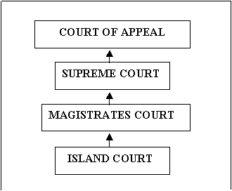

### COURT OF APPEAL

* Hears civil and criminal appeals from the Supreme Court.
* Has the same power, authority and jurisdiction of the Supreme Court.
* May substitute its own judgment or opinion, but may not interfere with the exercise of a discretion unless it is manifestly wrong.

### SUPREME COURT

* Has unlimited jurisdiction to hear and determine civil and criminal proceedings.
* Has jurisdiction to hear questions concerning elections and similar matters; and it has jurisdiction to hear any grievances from citizens about emergency regulations made by the Council of Ministers.
* Has jurisdiction to hear civil and criminal appeals from a magistrate’s court.
* Has jurisdiction to hear appeals from island courts as to ownership of land. Its decision in such cases is final.

### MAGISTRATE'S COURTS

Have jurisdiction to hear cases:

* where the amount claimed or the subject matter in dispute does not exceed VT1,000,000;
* between landlord and tenant where the amount claimed does not exceed VT2,000,000;
* concerning claims for maintenance not exceeding VT1,200,000;
* involving uncontested petitions for divorce or nullity of marriage; and
* that concern any criminal proceedings for an offence for which the maximum penalty does not exceed 2 years imprisonment.
* Have jurisdiction to hear appeals from civil decisions from Island Courts, except decisions as to ownership of land, where appeal is to the Supreme Court.
* Are specifically excluded from exercising jurisdiction in wardship, guardianship, interdiction, appointment of conseil judicare, adoption, civil status, succession, wills, bankruptcy, insolvency and liquidation.

### ISLAND COURTS

May only deal with:

* civil matters in which the Defendant is ordinarily resident within their territorial jurisdiction or in which the cause of action is within their boundaries;
* criminal matters in which the defendant is ordinarily resident within their territorial jurisdiction or in which the cause of action is within their boundaries;
* land cases when the land is within their territorial boundaries.
* If the above criteria is met island courts may determine:
* all claims over ownership of land;
* claims in contracts or tort where the amount claimed or the subject does not exceed VT 50,000;
* claims for compensation under provincial by-laws not exceeding VT50,000; and
* claims for maintenance not limited in amount.
* Are specifically empowered to administer the customary law prevailing within their territorial jurisdiction so far as it is not in conflict with any written law and is not contrary to justice, morality and good order.

# Annex 8: VPF Police Training College 2016 Training Calendar

|  |  |  |  |  |  |  |  |  |  |  |  |  |  |  |  |  |  |  |  |  |  |  |  |  |  |  |  |  |  |  |  |
| --- | --- | --- | --- | --- | --- | --- | --- | --- | --- | --- | --- | --- | --- | --- | --- | --- | --- | --- | --- | --- | --- | --- | --- | --- | --- | --- | --- | --- | --- | --- | --- |
| **Month** | **1** | **2** | **3** | **4** | **5** | **6** | **7** | **8** | **9** | **10** | **11** | **12** | **13** | **14** | **15** | **16** | **17** | **18** | **19** | **20** | **21** | **22** | **23** | **24** | **25** | **26** | **27** | **28** | **29** | **30** | **31** |
| **Apr** | **FRI** | **SAT** | **SUN** | **MON** | **TUE** | **WED** | **THU** | **FRI** | **SAT** | **SUN** | **MON** | **TUE** | **WED** | **THU** | **FRI** | **SAT** | **SUN** | **MON** | **TUE** | **WED** | **THU** | **FRI** | **SAT** | **SUN** | **MON** | **TUE** | **WED** | **THU** | **FRI** | **SAT** |  |
|  |  |  |  |  |  |  |  |  |  |  |  | Mentoring-Santo | |  |  |  |  |  | Ment / P-Vila / RFL | | |  |  |  |  |  |  |  |  |  |
|  |  |  |  |  |  |  |  |  |  |  |  |  |  |  |  |  | Basic Investigation training, P1 Port Vila | | | | |  |  |  | Ethics / Dis-Pros / Cust-Ser / Santo | | | |  |  |
| **May** | **SUN** | **MON** | **TUE** | **WED** | **THU** | **FRI** | **SAT** | **SUN** | **MON** | **TUE** | **WED** | **THU** | **FRI** | **SAT** | **SUN** | **MON** | **TUE** | **WED** | **THU** | **FRI** | **SAT** | **SUN** | **MON** | **TUE** | **WED** | **THU** | **FRI** | **SAT** | **SUN** | **MON** | **TUE** |
|  | HOL |  |  | HOL |  |  |  | VMF Refresher, PORT VILA | | | | |  |  | Use Of Force, Port Vila | | | |  |  |  | F / Violence,Vila / GD / VMF | | | |  |  |  |  |  |
|  |  |  |  |  |  |  | Ethics / Dis-Pros / Cust-Ser / Santo | | | |  |  |  |  | Basic Investigation training, P2 Port Vila | | | | |  | Ethics / Disc-Pros / C-ser / Vila VMF | | | |  |  |  |  |
| **Jun** | **WED** | **THU** | **FRI** | **SAT** | **SUN** | **MON** | **TUE** | **WED** | **THU** | **FRI** | **SAT** | **SUN** | **MON** | **TUE** | **WED** | **THU** | **FRI** | **SAT** | **SUN** | **MON** | **TUE** | **WED** | **THU** | **FRI** | **SAT** | **SUN** | **MON** | **TUE** | **WED** | **THU** |  |
|  |  |  |  |  | Investigation training, Santo 1 | | | |  |  |  | Investigating Juvenile, Port Vila | | | | |  |  | VMF Refresher / Santo | | | | |  |  |  |  |  |  |  |
|  |  |  |  |  |  |  |  |  |  |  |  |  |  |  |  |  |  |  |  |  |  |  |  |  |  | Investigation Training, Luganville Santo 2 | | | | |
| **Jul** | **FRI** | **SAT** | **SUN** | **MON** | **TUE** | **WED** | **THU** | **FRI** | **SAT** | **SUN** | **MON** | **TUE** | **WED** | **THU** | **FRI** | **SAT** | **SUN** | **MON** | **TUE** | **WED** | **THU** | **FRI** | **SAT** | **SUN** | **MON** | **TUE** | **WED** | **THU** | **FRI** | **SAT** | **SUN** |
|  |  |  | Fire Arms Luganville Santo | | | | |  |  | QMS TO BE CONFIRMED | | | | |  |  | GD Refresher, Port Vila | | | |  |  | HOL |  |  |  |  |  | HOL |  |
|  |  |  | Mento / Port Vila | |  |  |  |  |  |  |  |  |  |  |  |  |  |  |  |  |  |  | Mento / santo | |  |  |  |  |
| **Aug** | **MON** | **TUE** | **WED** | **THU** | **FRI** | **SAT** | **SUN** | **MON** | **TUE** | **WED** | **THU** | **FRI** | **SAT** | **SUN** | **MON** | **TUE** | **WED** | **THU** | **FRI** | **SAT** | **SUN** | **MON** | **TUE** | **WED** | **THU** | **FRI** | **SAT** | **SUN** | **MON** | **TUE** | **WED** |
| Investigating Juvenil, Santo | | | | |  |  |  | | | |  |  |  | HOL | **Drivers Training TO BE CONFIRMED** | | | | |  | Use Of Force, Luganville Santo | | | | |  |  |  |  |  |
|  |  |  |  |  |  |  |  |  |  |  |  |  |  | F / Violence / Santo / GD / VMF | | | |  |  |  |  |  |  |  |  |  | Ethics / Disc-Pros / Cus -Ser | | |
| **Sep** | **THU** | **FRI** | **SAT** | **SUN** | **MON** | **TUE** | **WED** | **THU** | **FRI** | **SAT** | **SUN** | **MON** | **TUE** | **WED** | **THU** | **FRI** | **SAT** | **SUN** | **MON** | **TUE** | **WED** | **THU** | **FRI** | **SAT** | **SUN** | **MON** | **TUE** | **WED** | **THU** | **FRI** |  |
| Lakatoro | |  |  | Basic Investigation Training, Lakatoro 1 | | | | |  |  |  |  |  |  |  |  |  | FireArms Port Vila | | | | |  |  | Basic Investigation Training, Lakatoro 2 | | | | |  |
|  |  |  |  |  |  |  |  |  |  |  | Operation Order Santo | | | | |  |  | Ethics / Disc-Pros / Cus-Ser / Tanna | | | |  |  |  |  |  |  |  |  |  |
| **Oct** | **SAT** | **SUN** | **MON** | **TUE** | **WED** | **THU** | **FRI** | **SAT** | **SUN** | **MON** | **TUE** | **WED** | **THU** | **FRI** | **SAT** | **SUN** | **MON** | **TUE** | **WED** | **THU** | **FRI** | **SAT** | **SUN** | **MON** | **TUE** | **WED** | **THU** | **FRI** | **SAT** | **SUN** | **MON** |
|  |  |  |  | HOL |  |  |  |  | SGT Development Course TO BE CONFIRMED | | | | | |  | Fire Arms Lakatoro | | | | |  |  |  |  |  |  |  |  |  |  |
|  |  |  |  |  |  |  |  |  |  |  |  |  |  | | Fire Arms Tanna | | | | |  |  | GD Refresher / Santo | | | | |  |  |  |
| **Nov** | **TUE** | **WED** | **THU** | **FRI** | **SAT** | **SUN** | **MON** | **TUE** | **WED** | **THR** | **FRI** | **SAT** | **SUN** | **MON** | **TUE** | **WED** | **THU** | **FRI** | **SAT** | **SUN** | **MON** | **TUE** | **WED** | **THU** | **FRI** | **SAT** | **SUN** | **MON** | **TUE** | **WED** |  |
|  |  |  |  |  |  |  | | | | |  |  |  |  |  |  |  |  |  | GD Refresher / Lakatoro | | | | |  |  |  | P / HOL |  |  |
|  |  |  |  |  |  | Basic Investigation training, Tanna 1 | | | | |  |  | GD Refresher / Tanna | | | | |  |  |  |  |  |  |  |  |  |  |  |  |
| **Dec** | **THU** | **FRI** | **SAT** | **SUN** | **MON** | **TUE** | **WED** | **THU** | **FRI** | **SAT** | **SUN** | **MON** | **TUE** | **WED** | **THU** | **FRI** | **SAT** | **SUN** | **MON** | **TUE** | **WED** | **THU** | **FRI** | **SAT** | **SUN** | **MON** | **TUE** | **WED** | **THU** | **FRI** | **SAT** |
|  |  |  |  |  | | | | |  |  |  |  |  |  |  |  |  |  |  |  |  |  |  | P / HOL | |  |  |  |  |  |
|  |  |  |  | Basic Investigation training, Tanna 2 | | | | |  |  |  |  |  |  |  |  |  |  |  |  |  |  |  |  |  |  |  |  |
| 1 | 2 | 3 | 4 | 5 | 6 | 7 | 8 | 9 | 10 | 11 | 12 | 13 | 14 | 15 | 16 | 17 | 18 | 19 | 20 | 21 | 22 | 23 | 24 | 25 | 26 | 27 | 28 | 29 | 30 | 31 |

|  |  |  |  |  |  |
| --- | --- | --- | --- | --- | --- |
|  | Mentoring | 2 |  | Investigating Juvenile | 2 |
|  | Basic Investigation Training | 4 |  | GD Refresher | 4 |
|  | Ethics / Dis Prod / Customer Service | 5 |  | QMS to be confirmed |  |
|  | Use of Force | 2 |  | SGT Development course – to be confirmed |  |
|  | Family Violence | 2 |  | Drivers’ Training Course – to be confirmed |  |
|  | VMF Refresher | 2 |  | Operation Order | 1 |
|  | Fire Arms | 4 |  | Public Holiday |  |

# Annex 9: MJCS Structure



*Source: MJCS Annual Report 2013, GoV, p13.*

# Annex 10: Vanuatu Police Force Organisation Charts

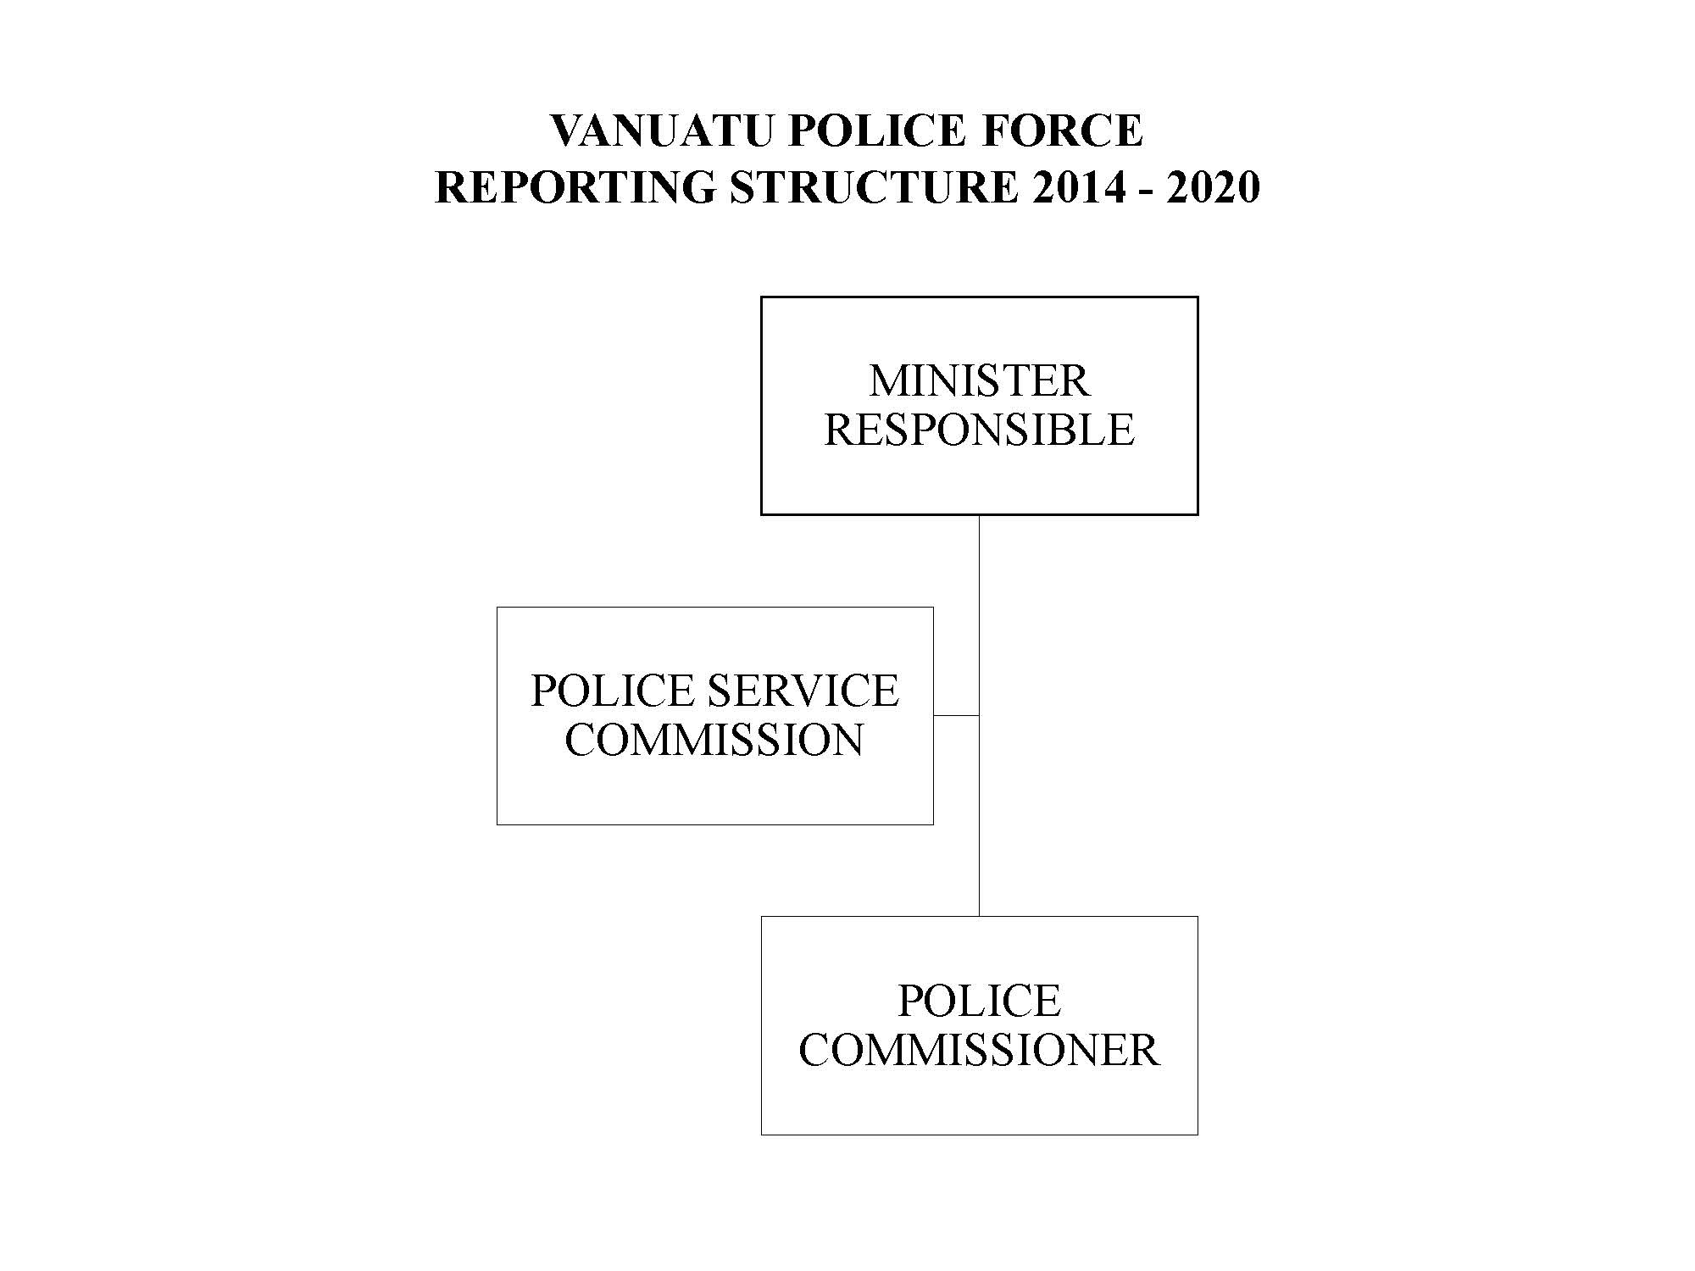

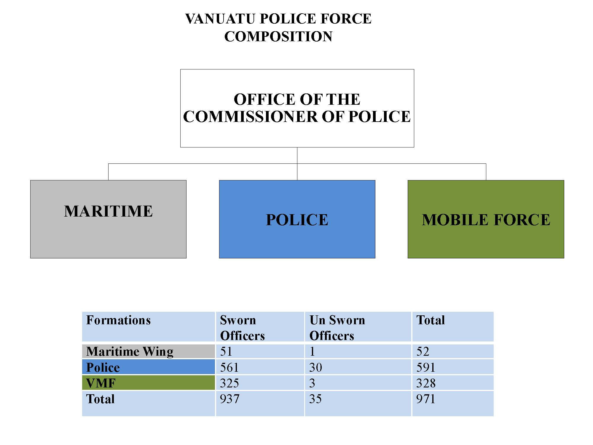

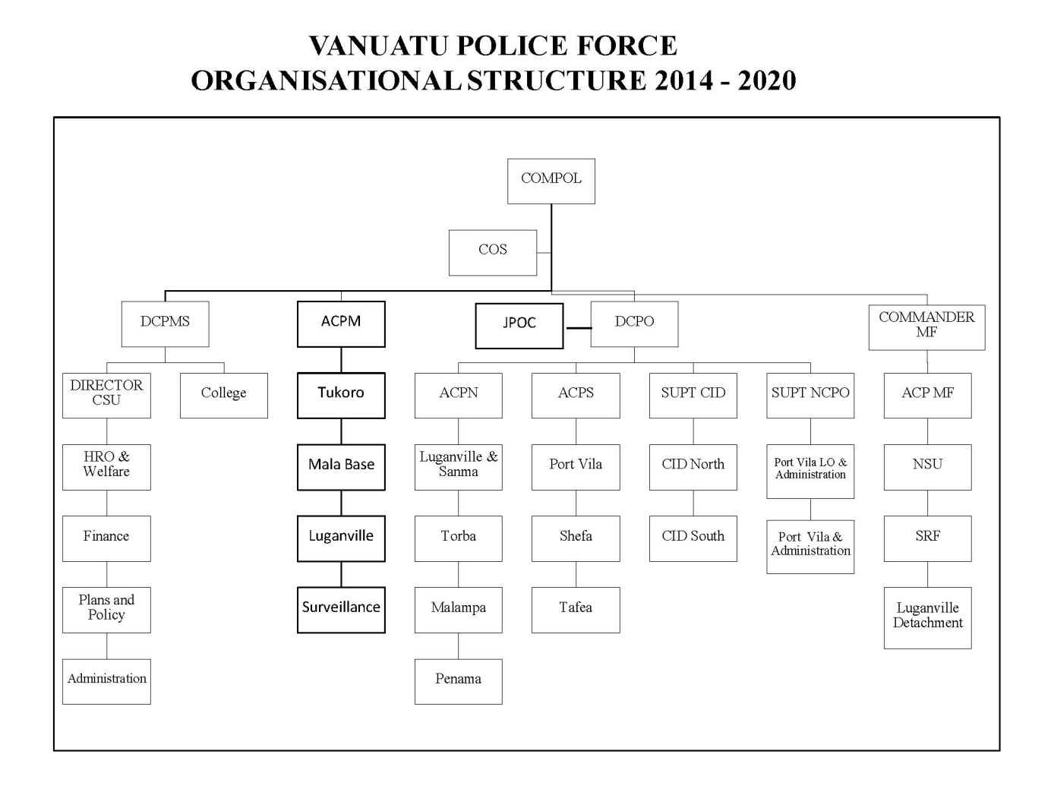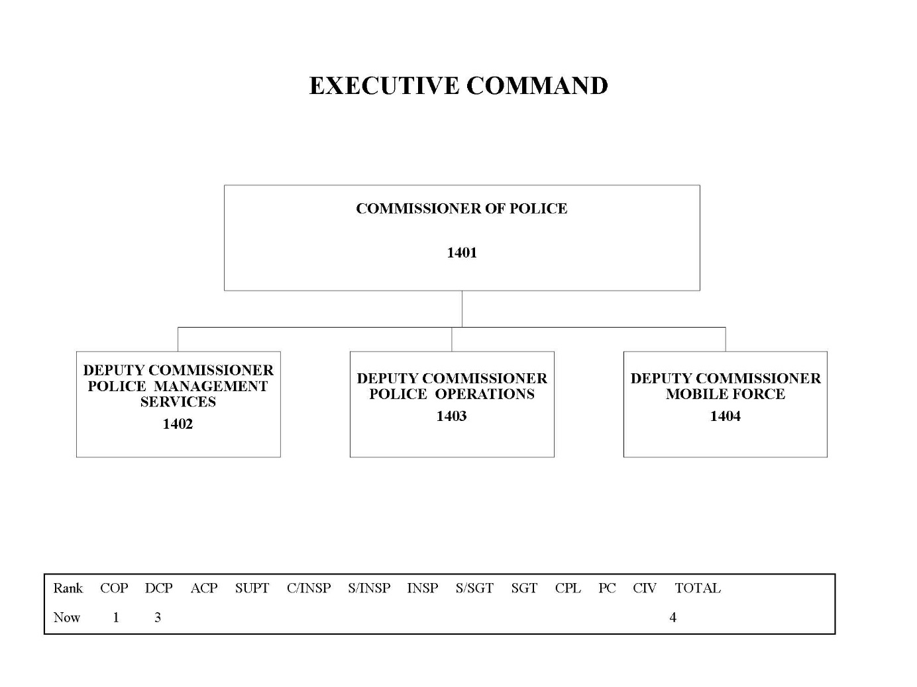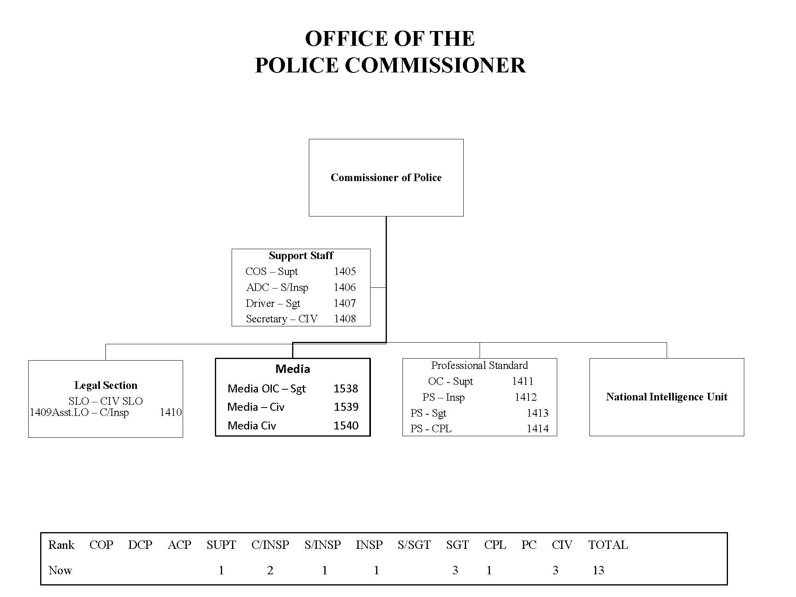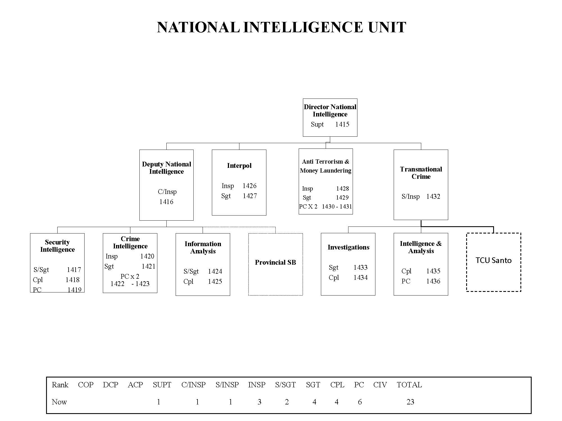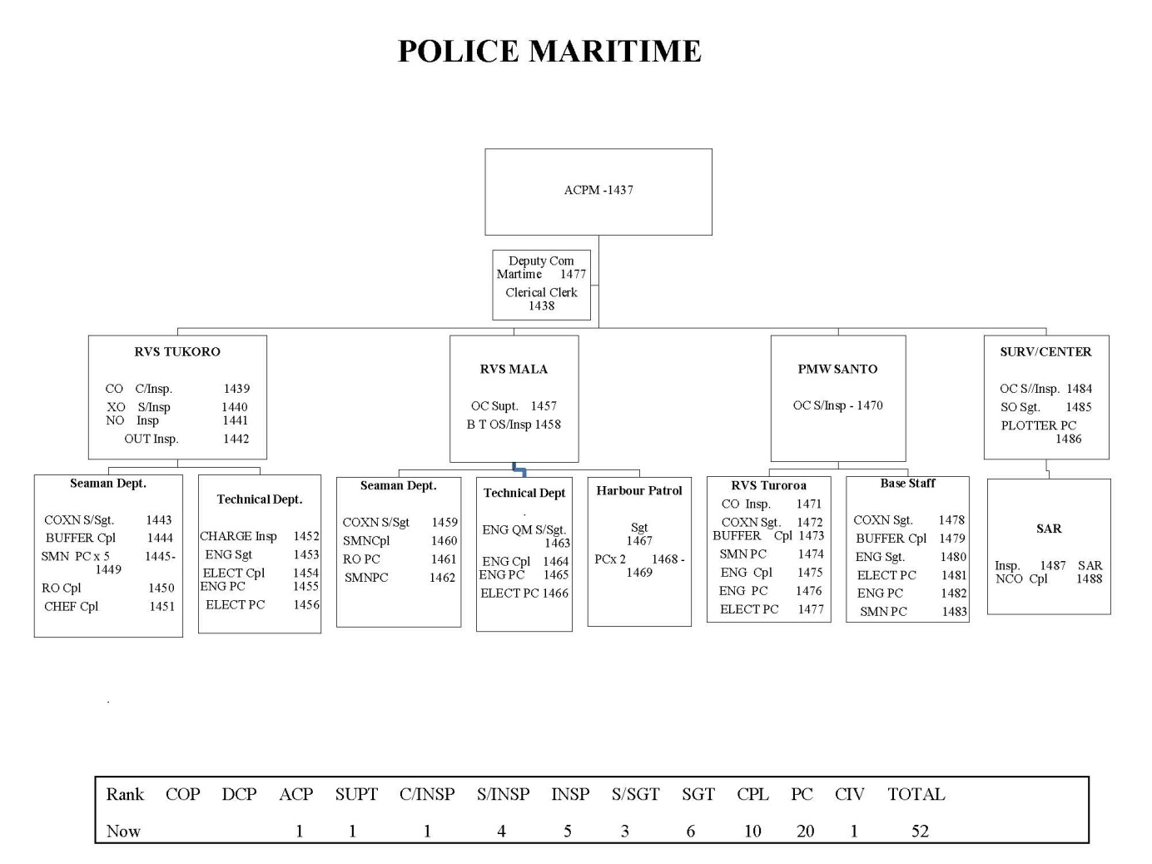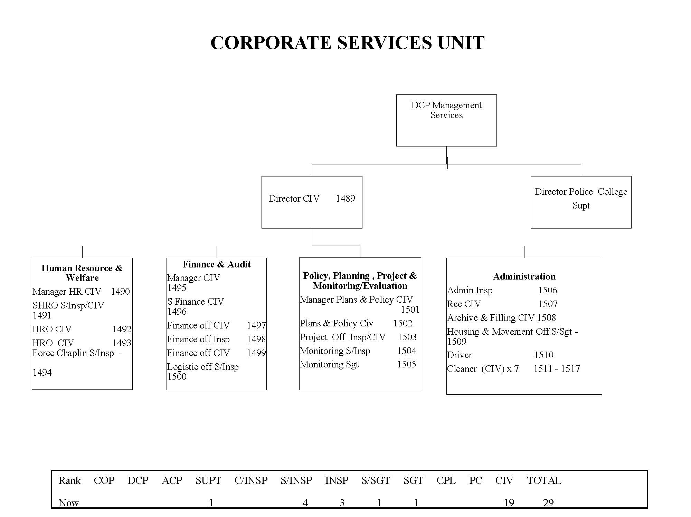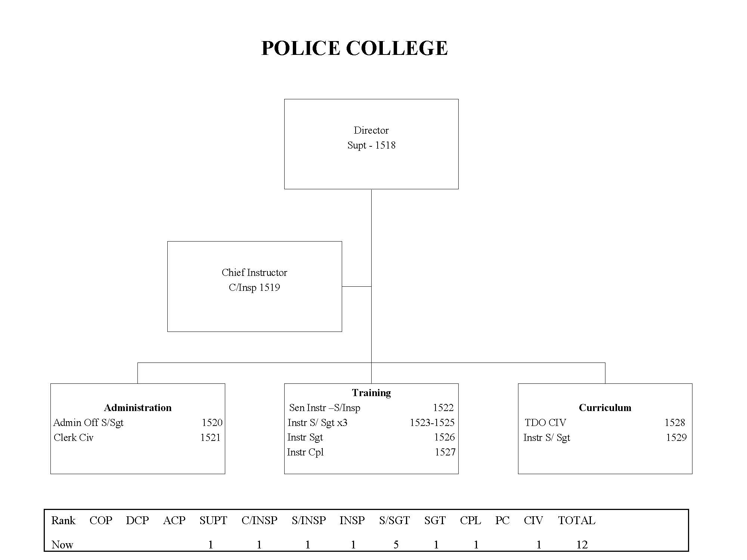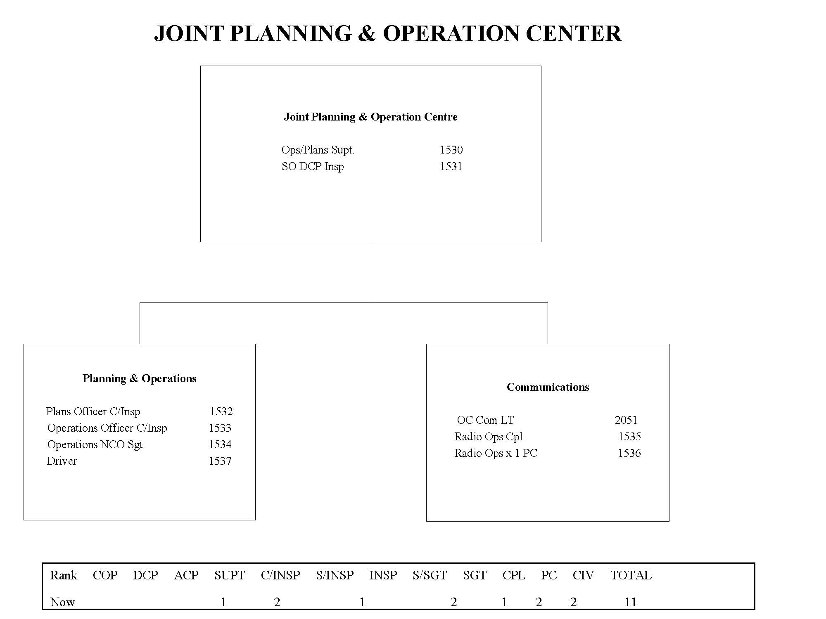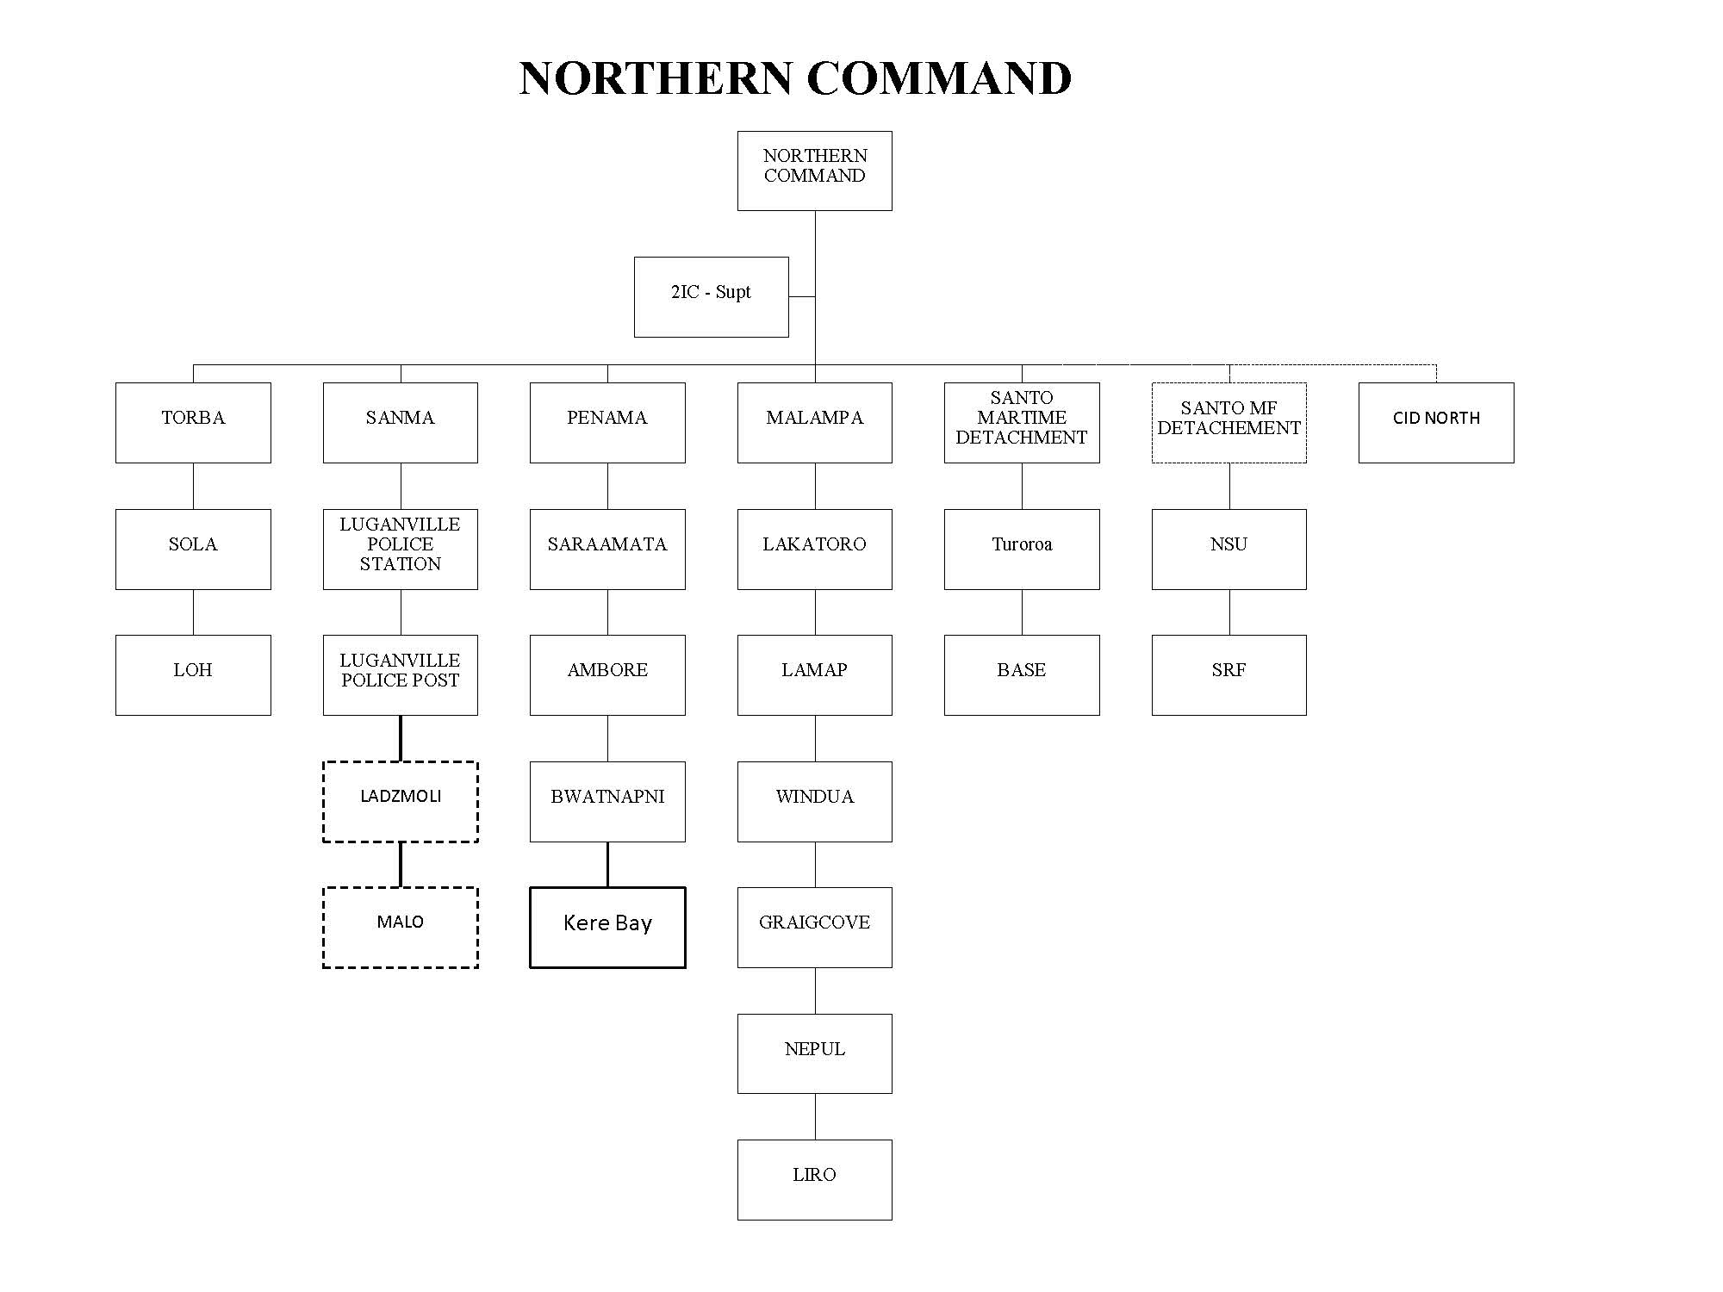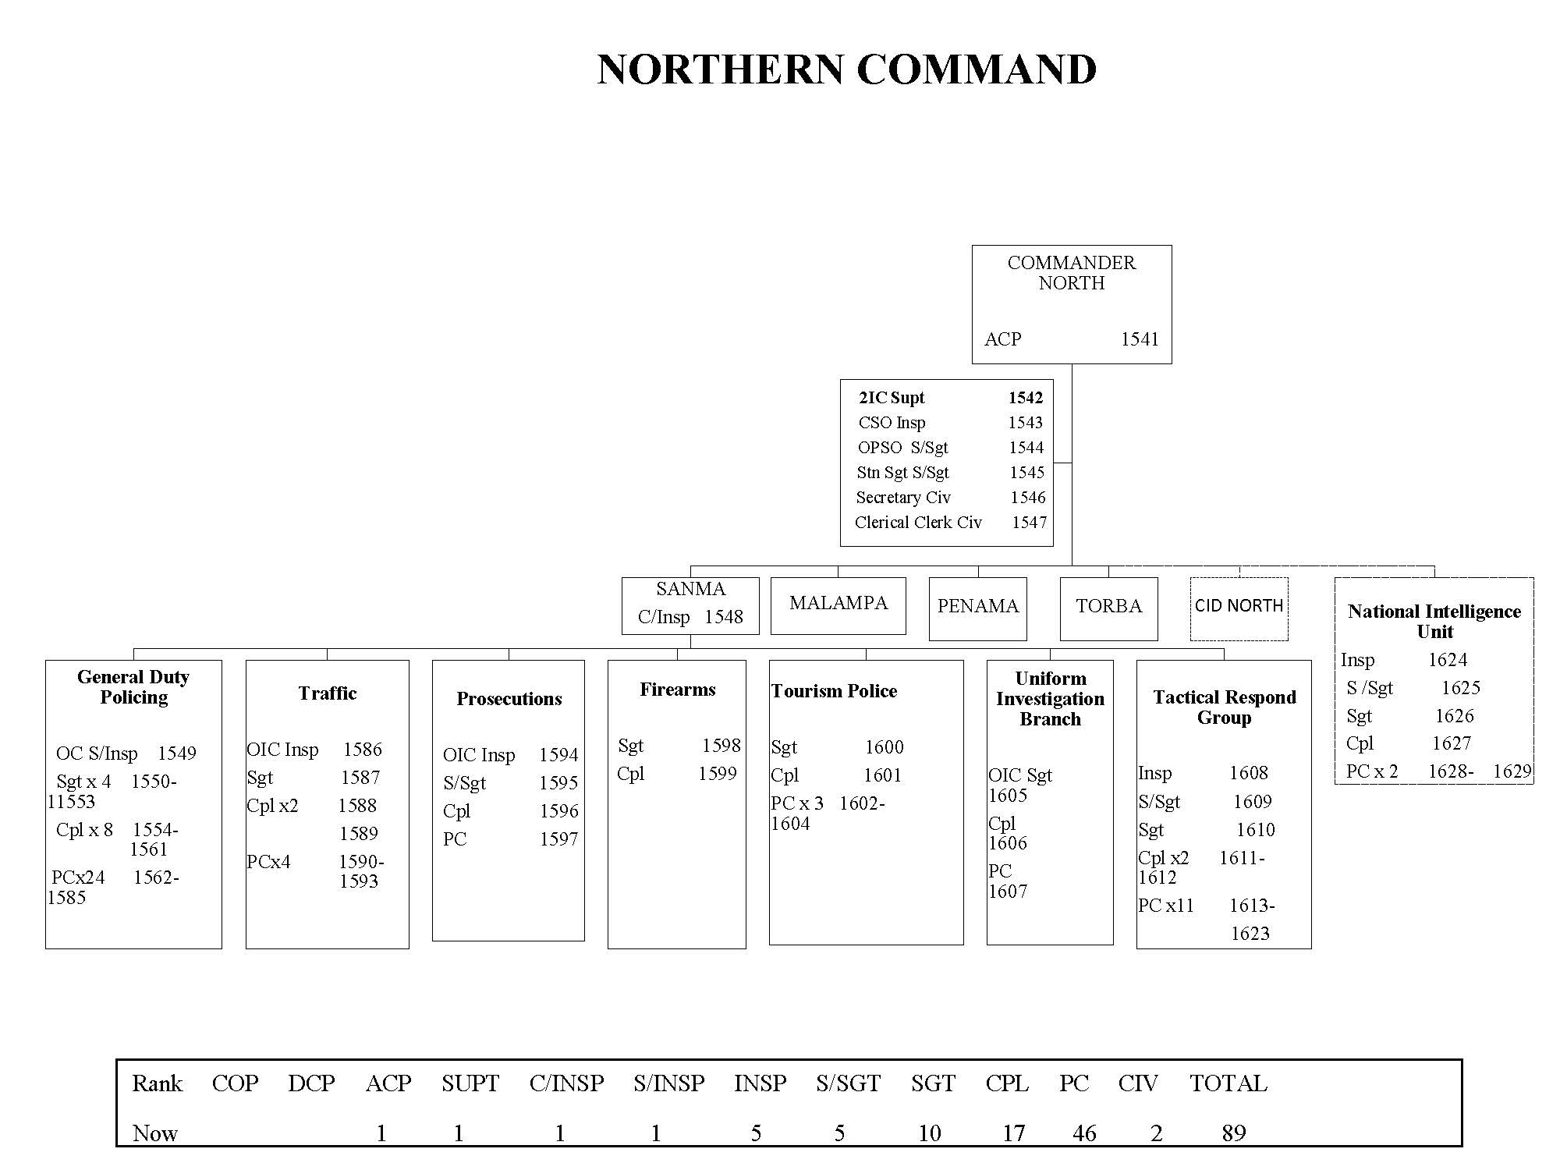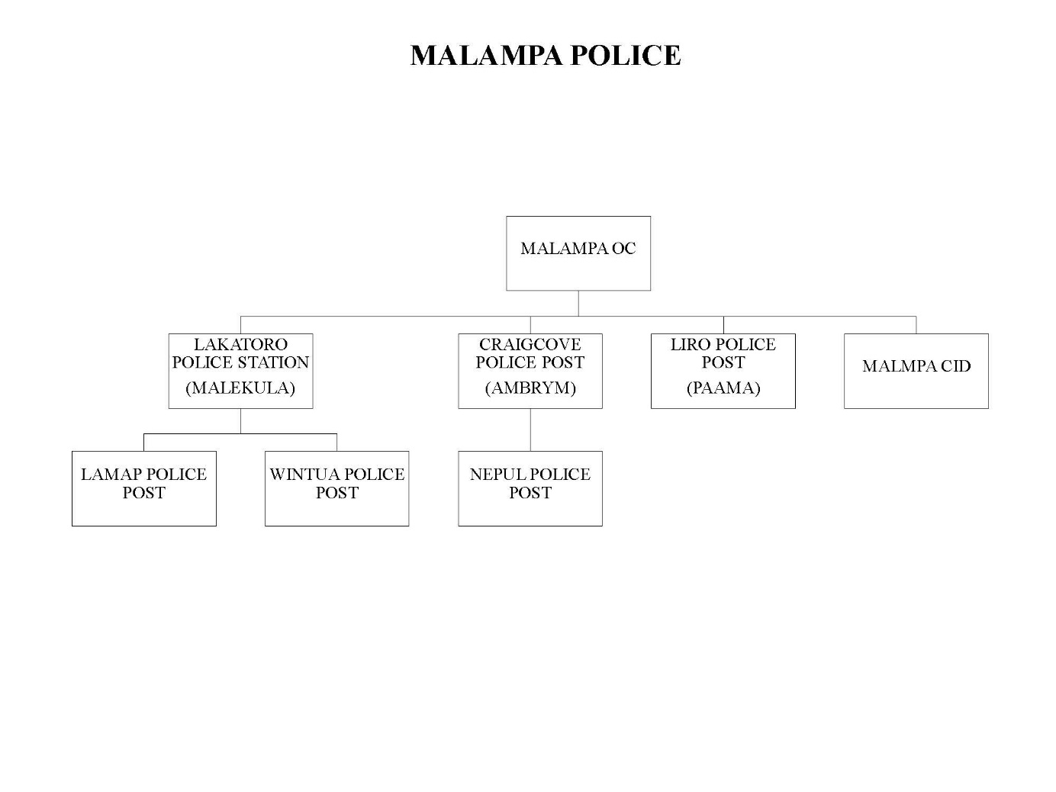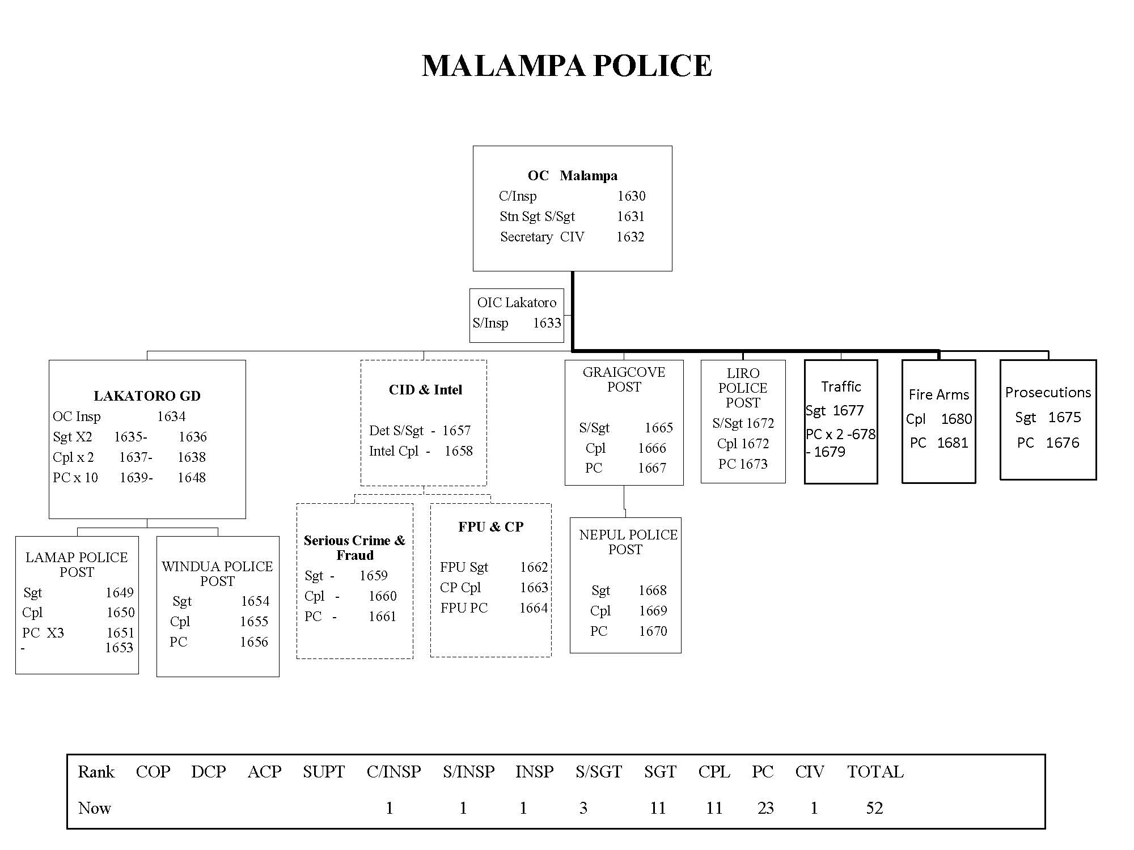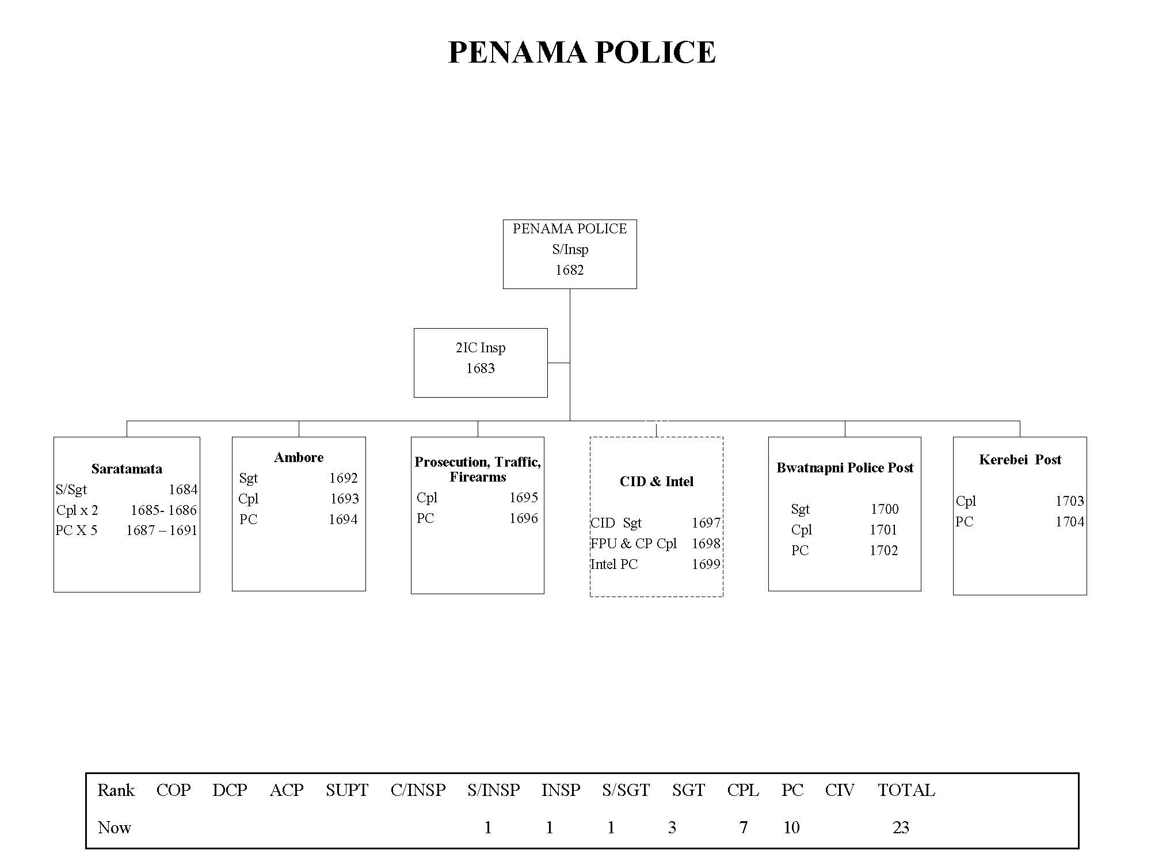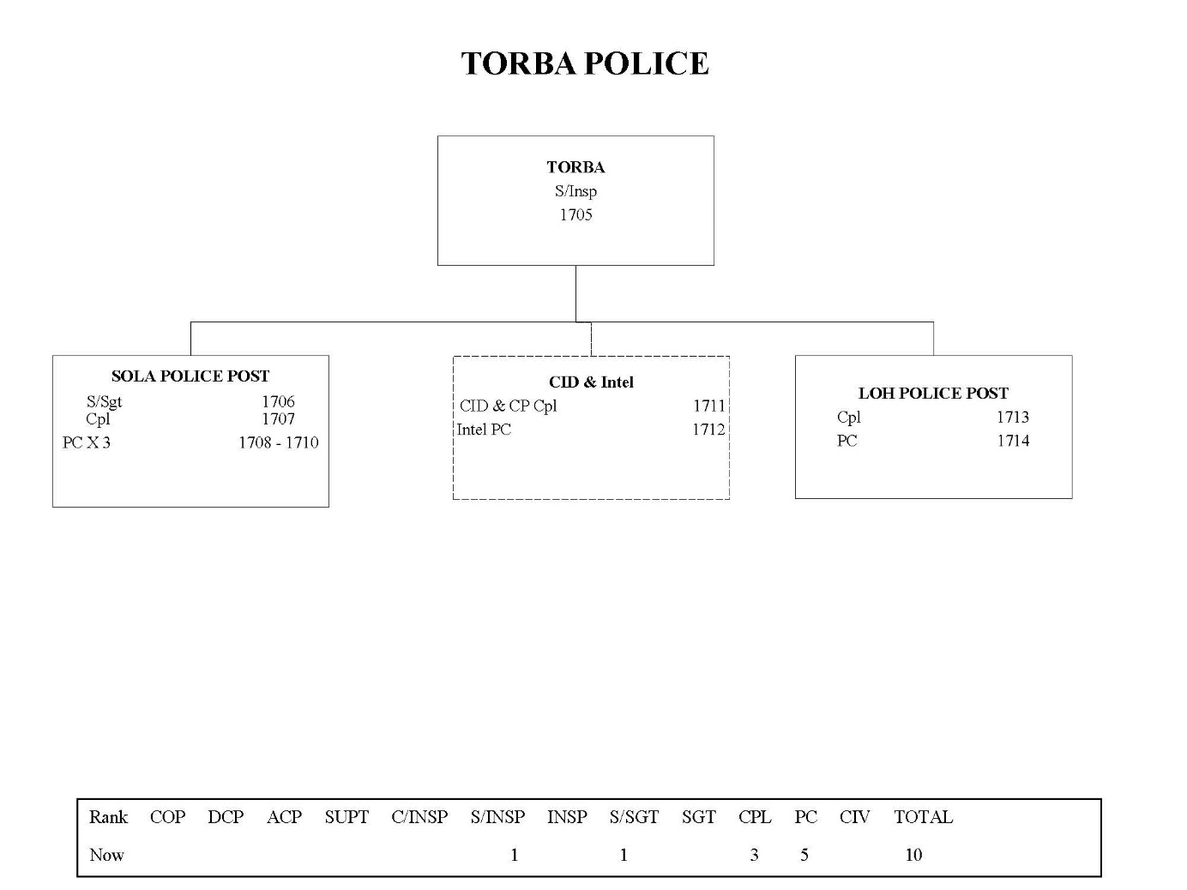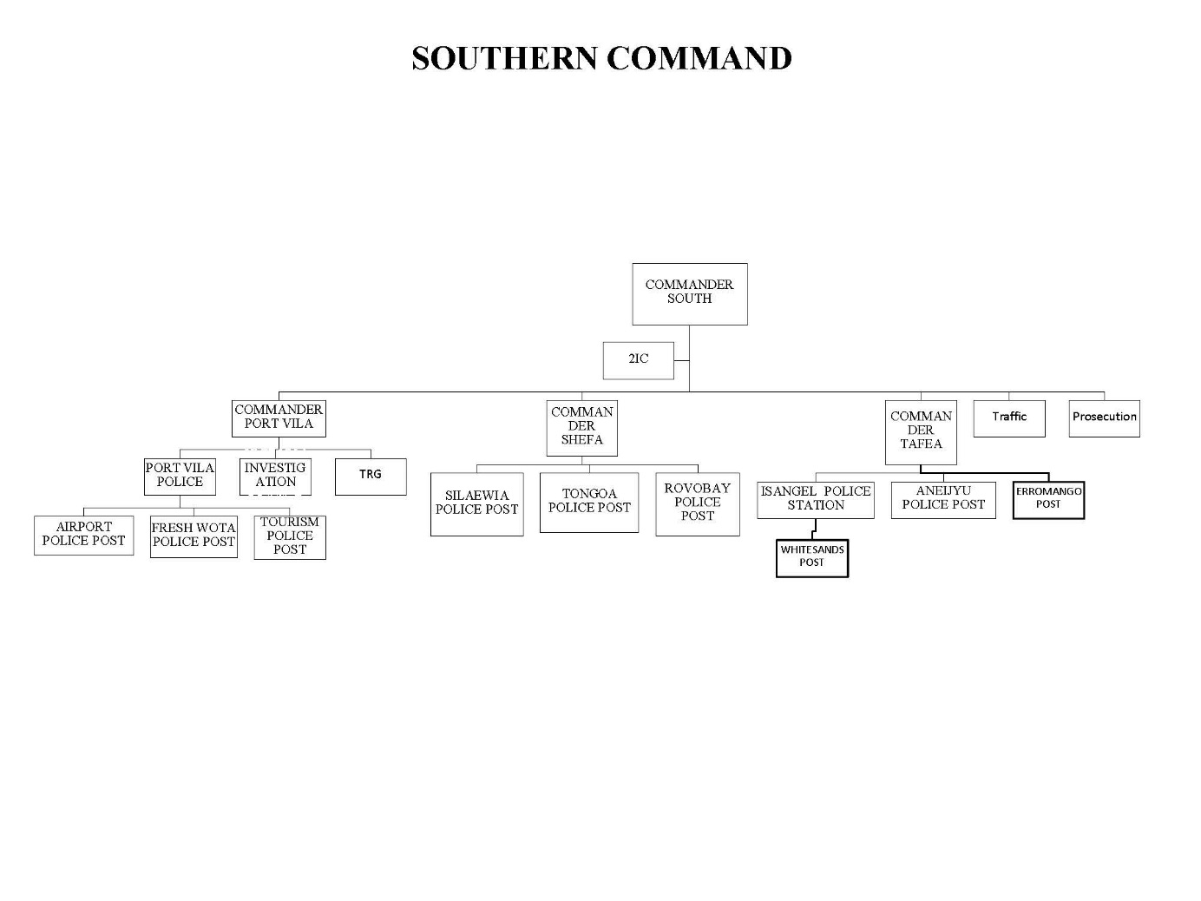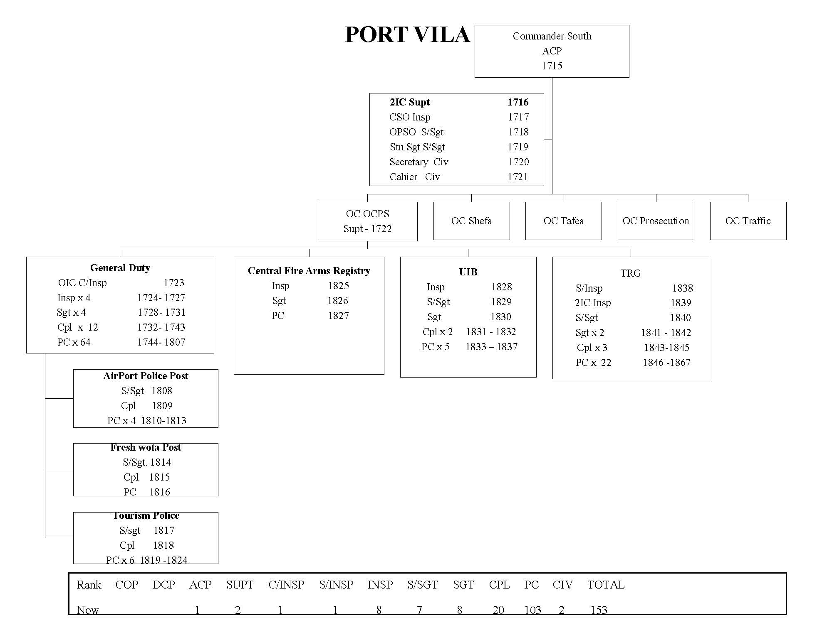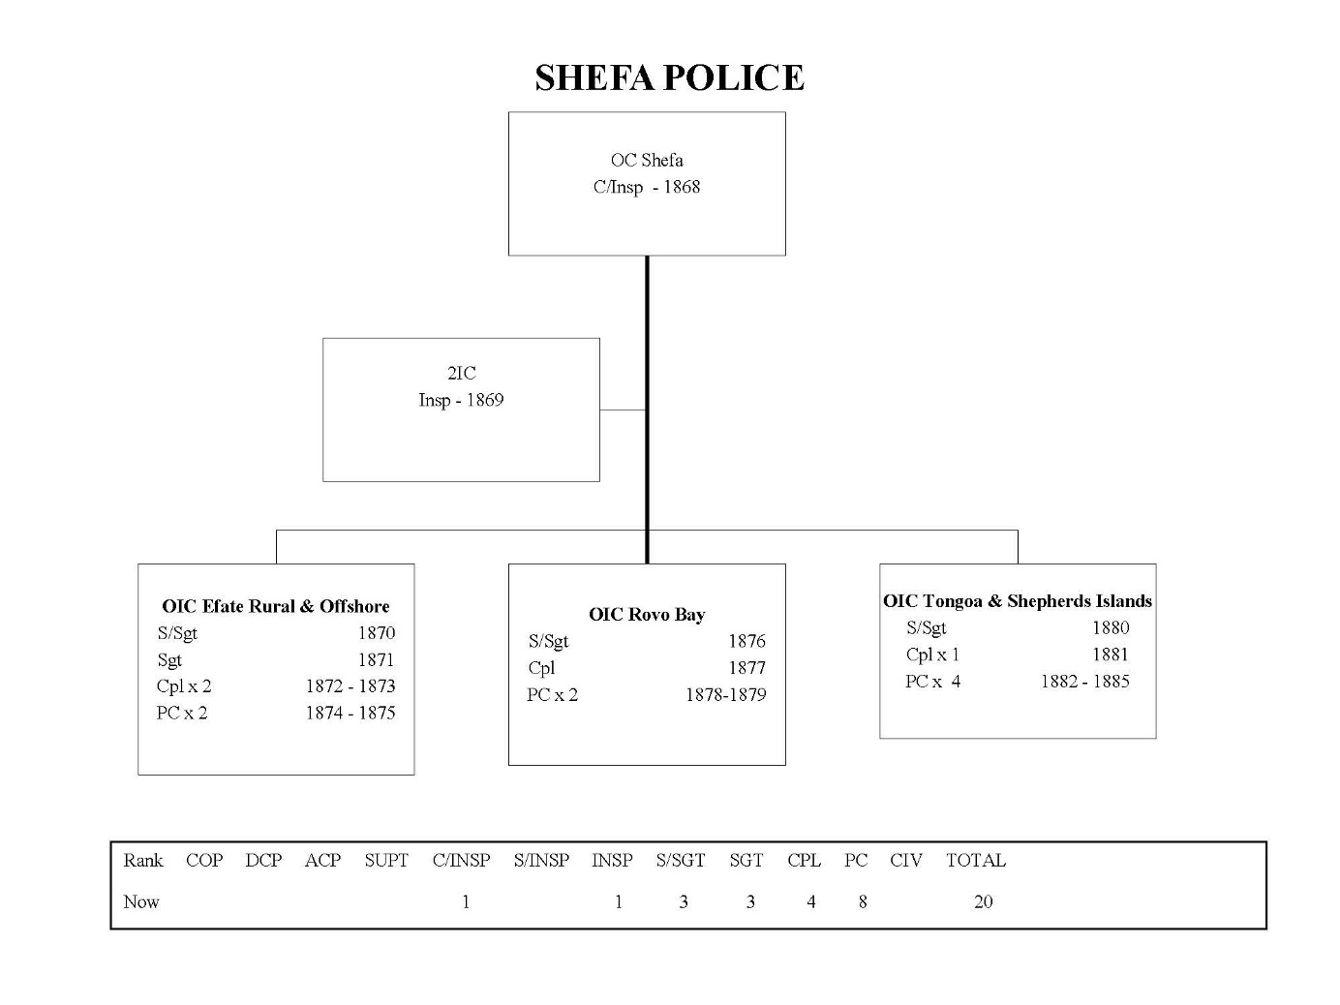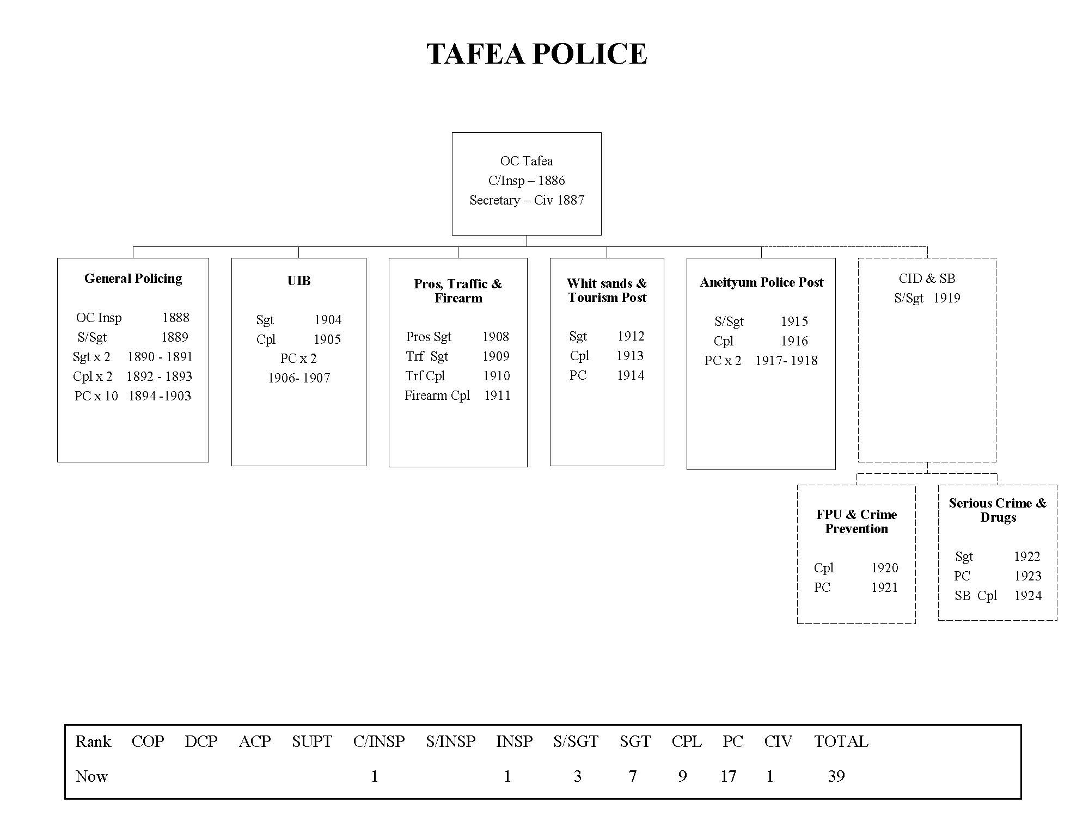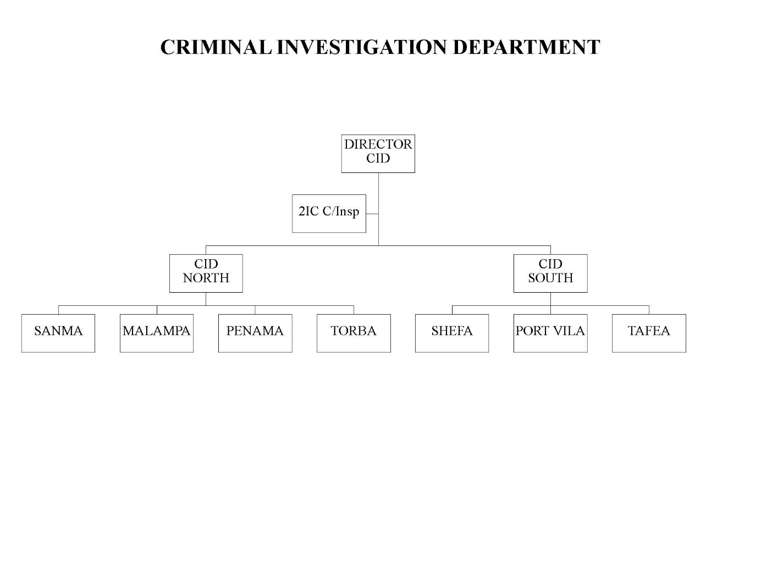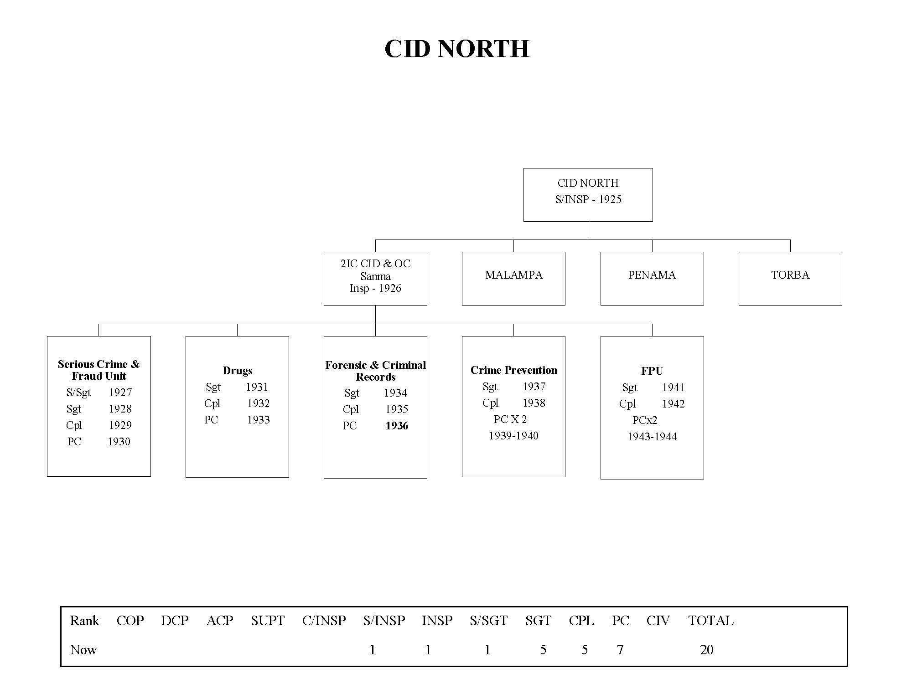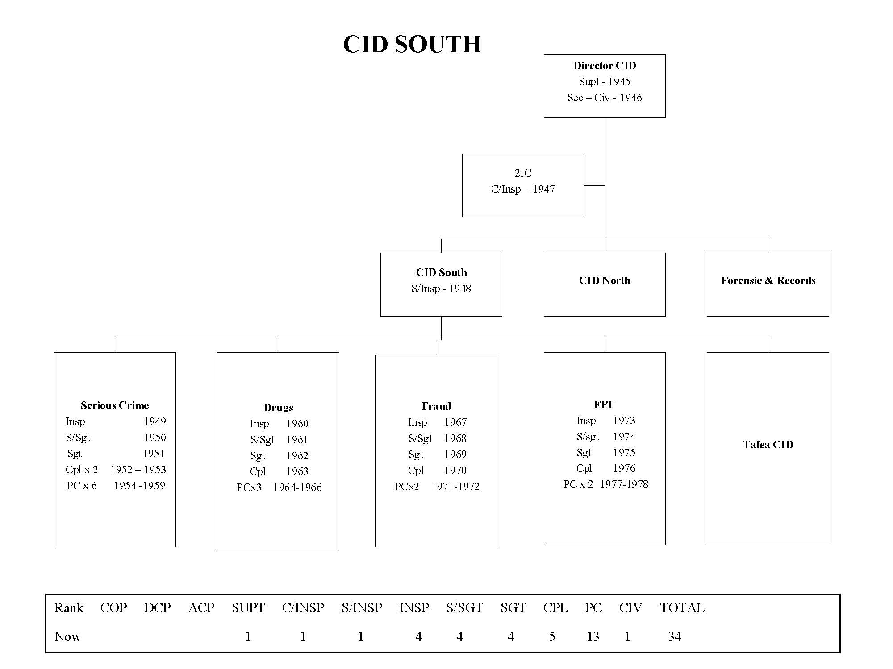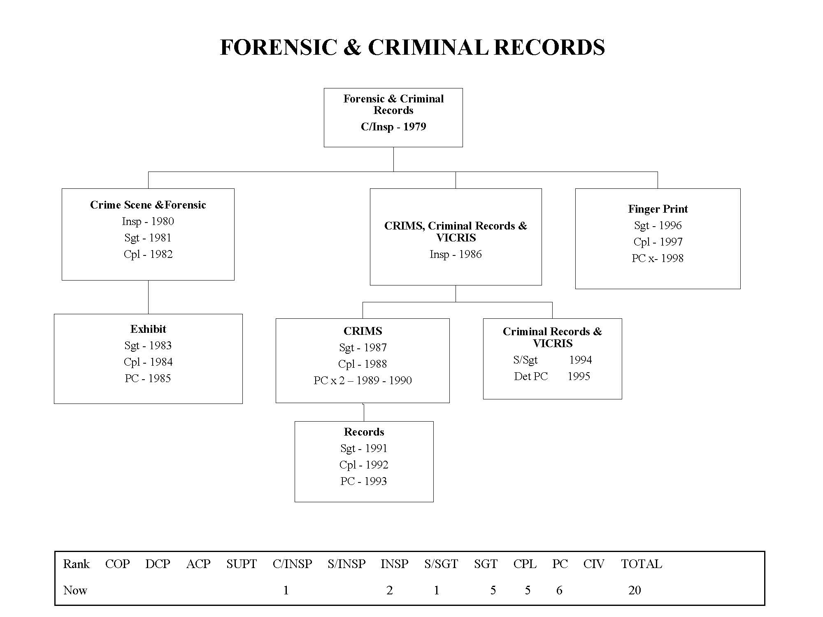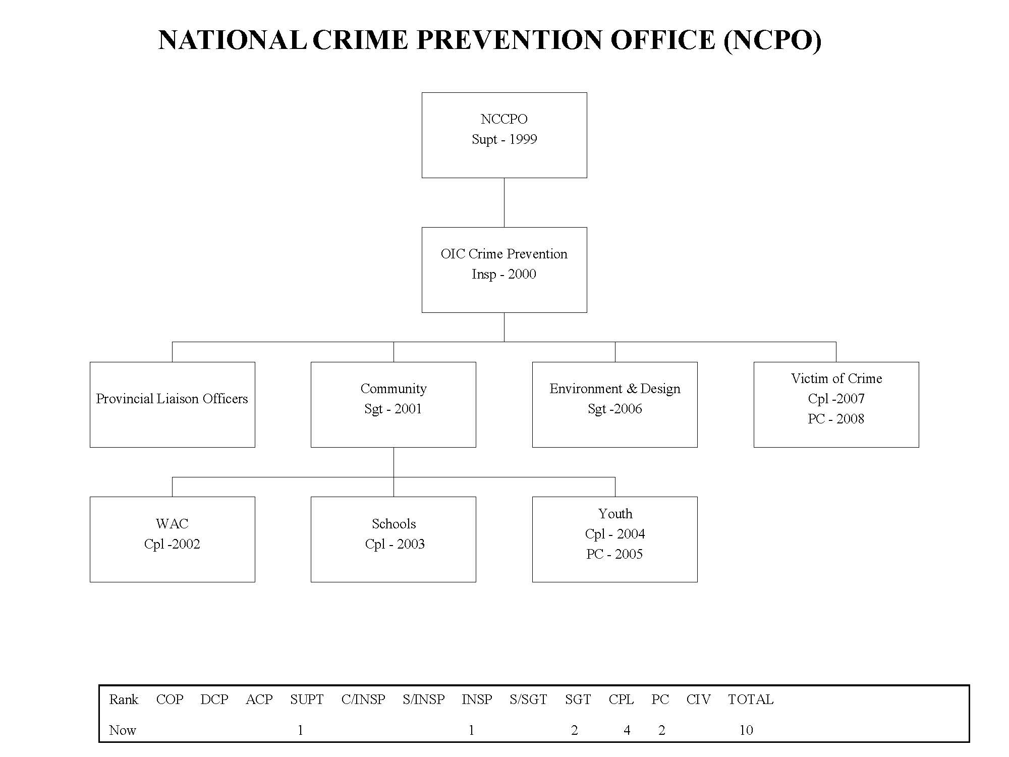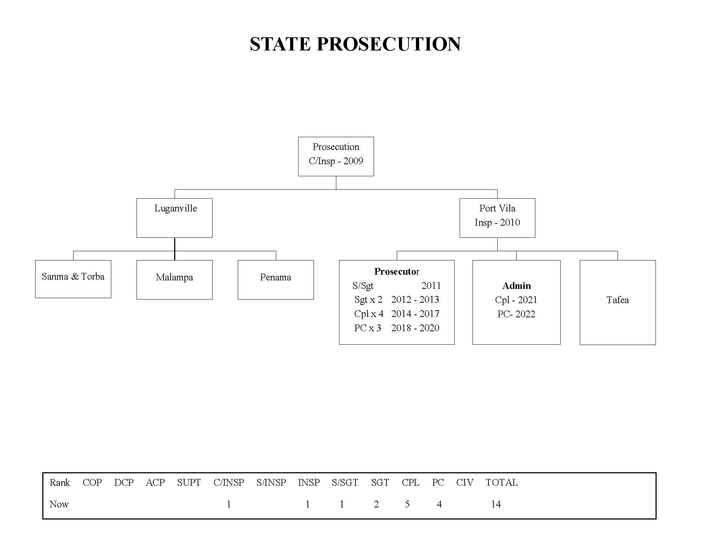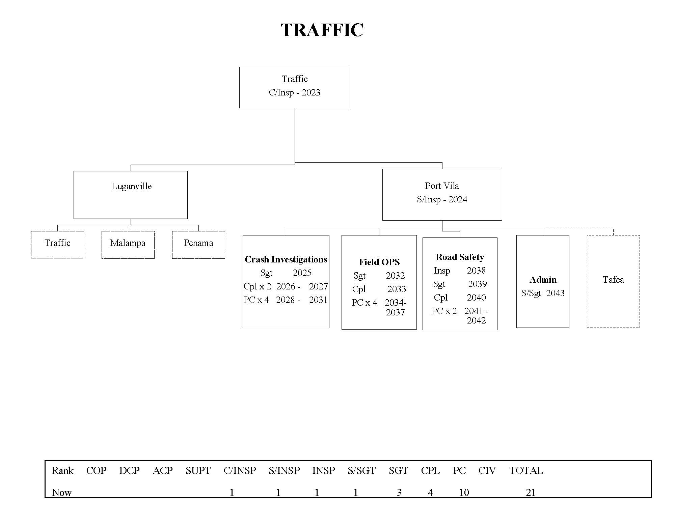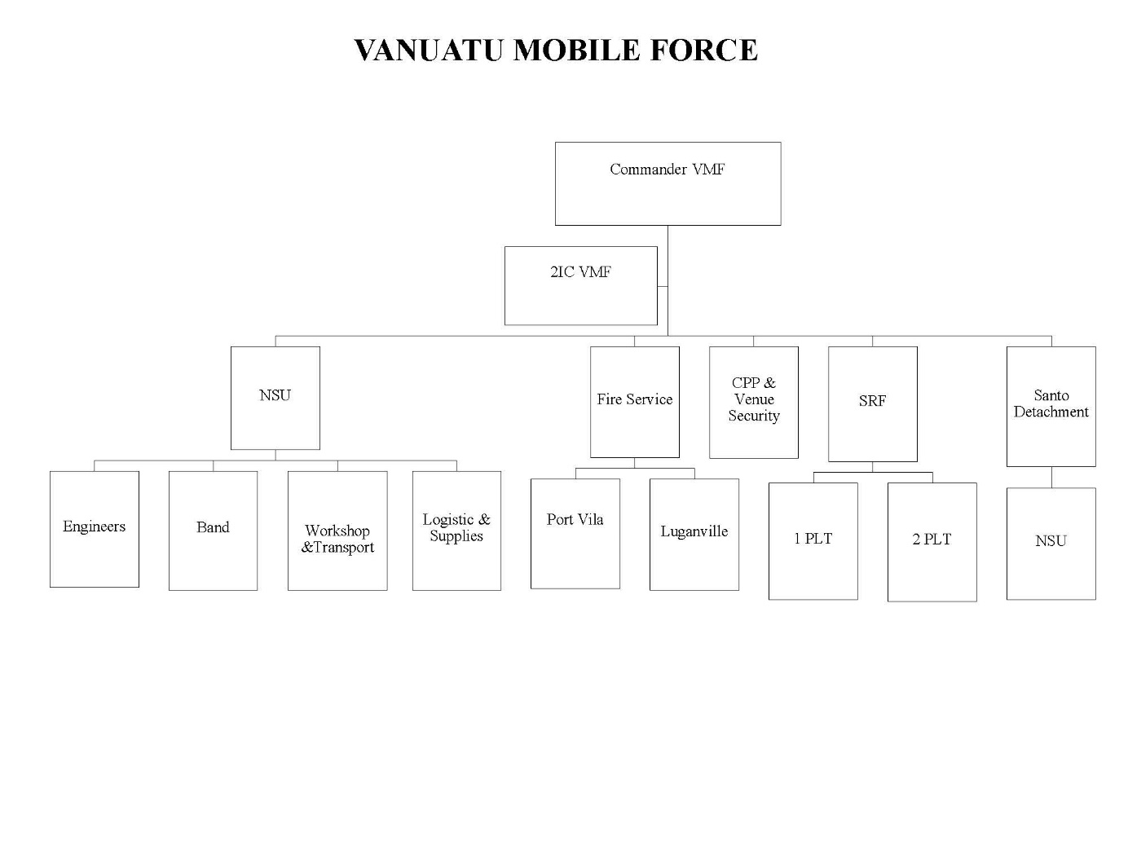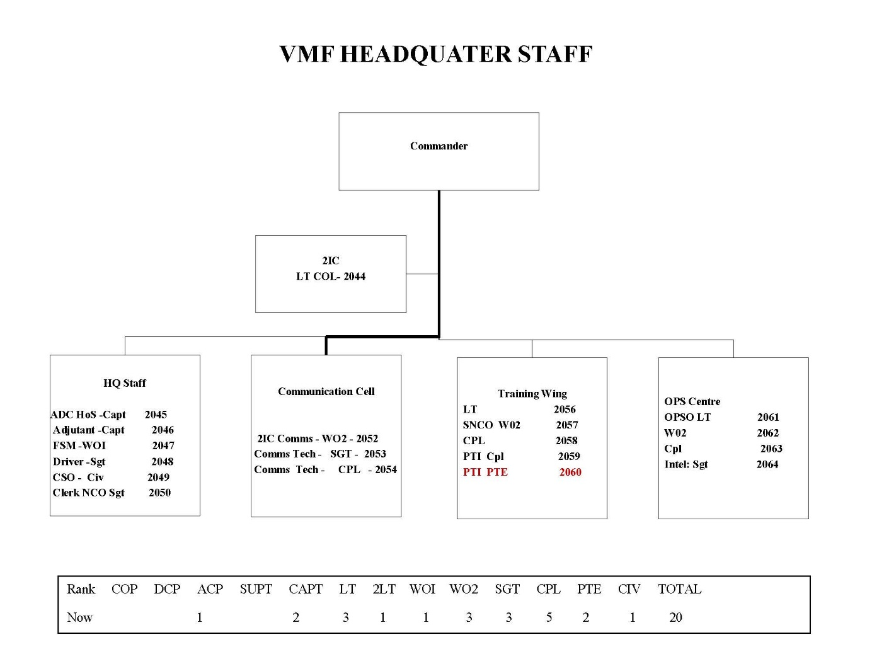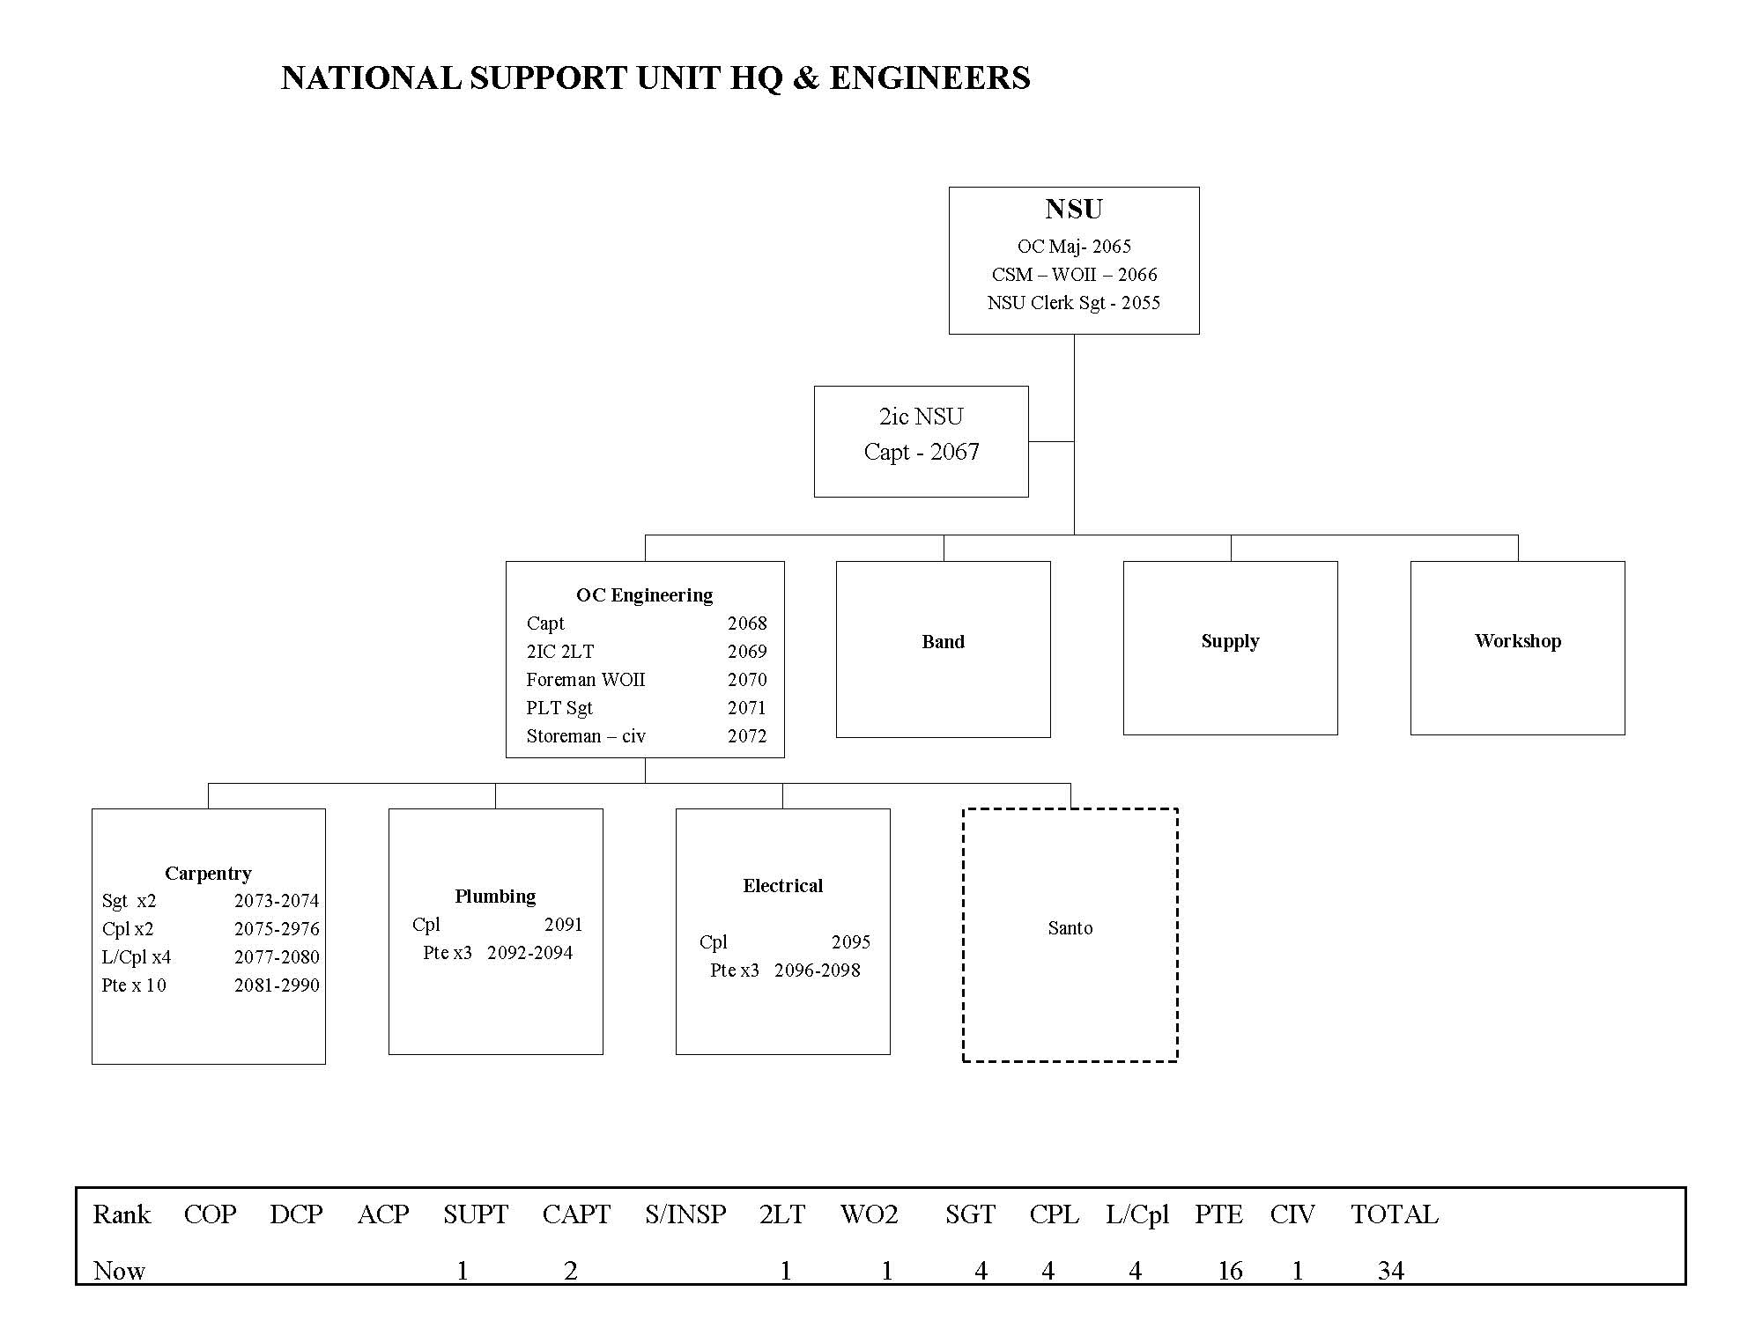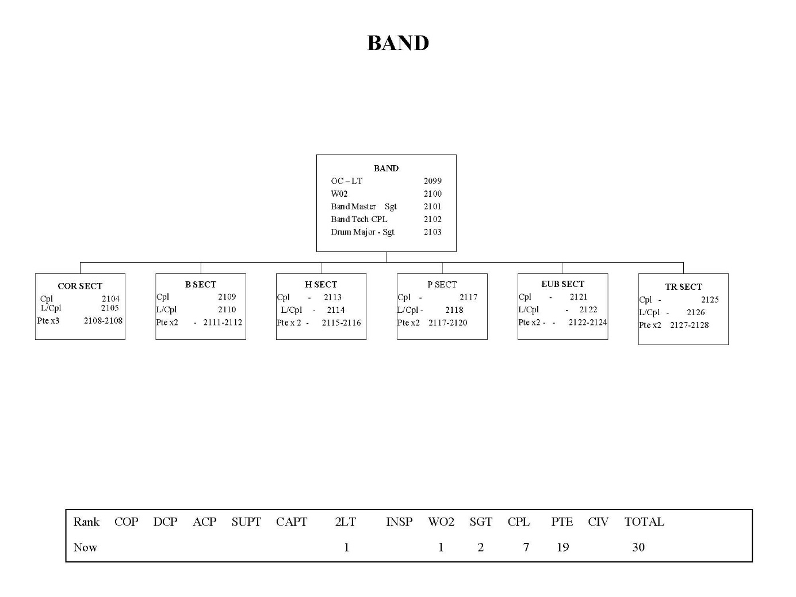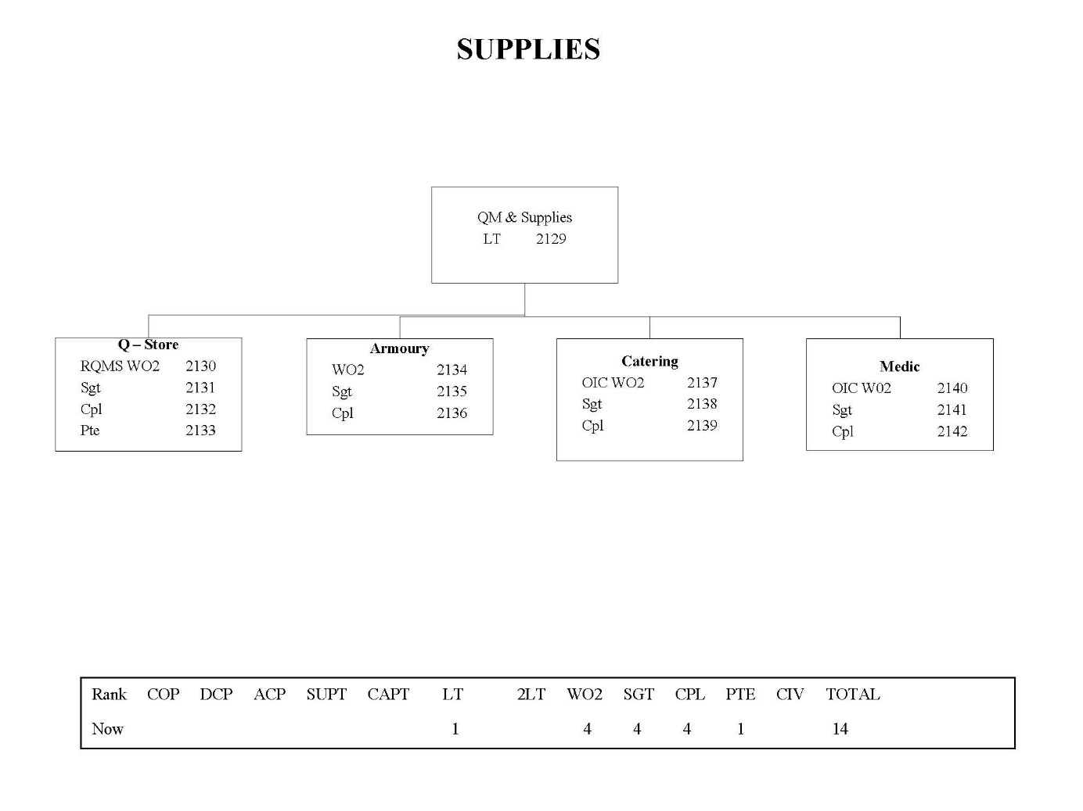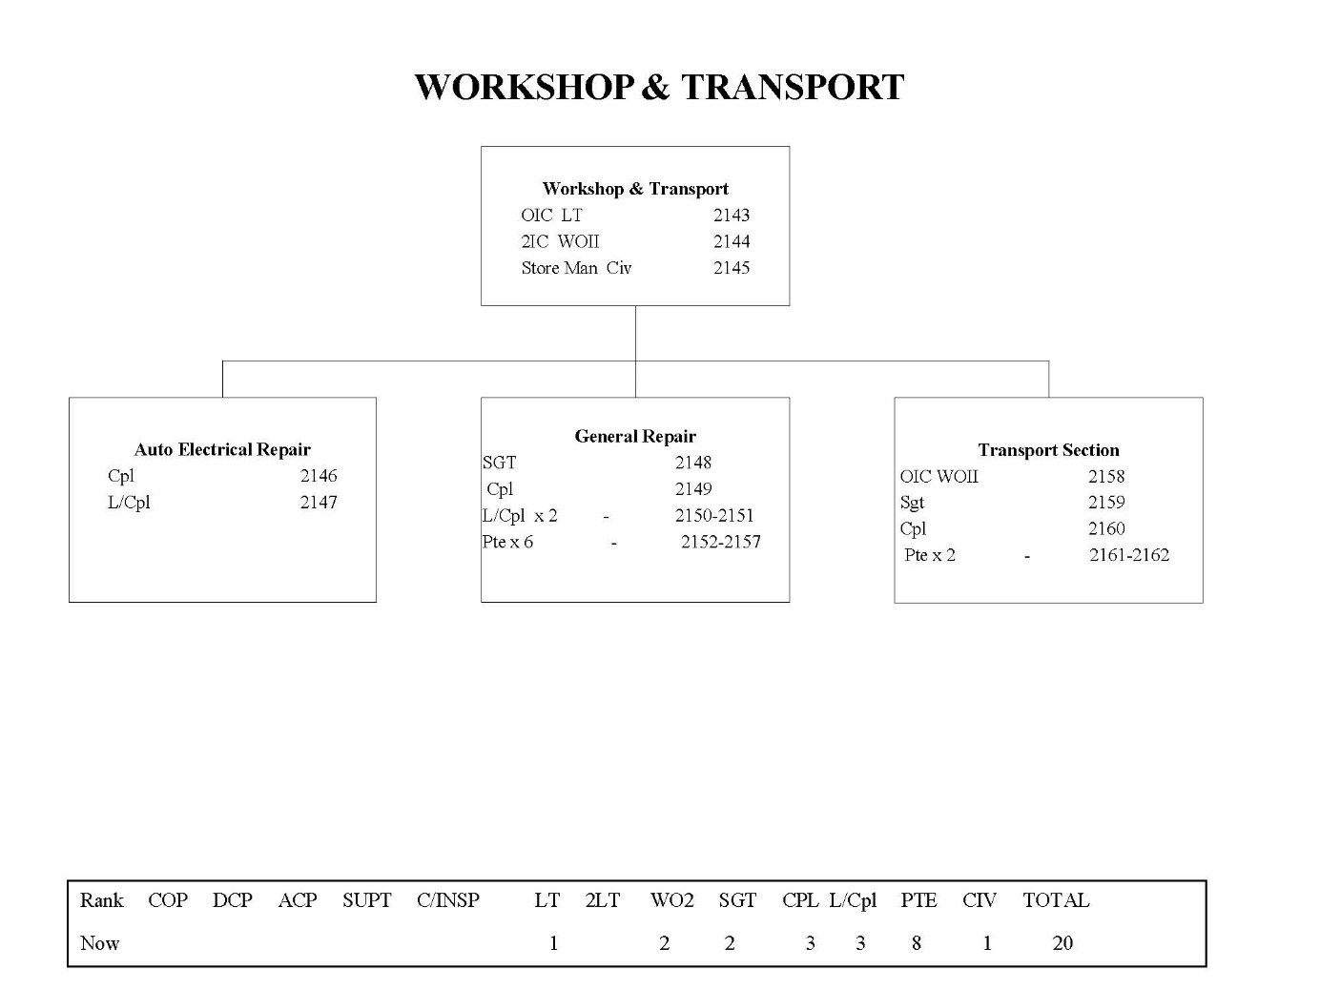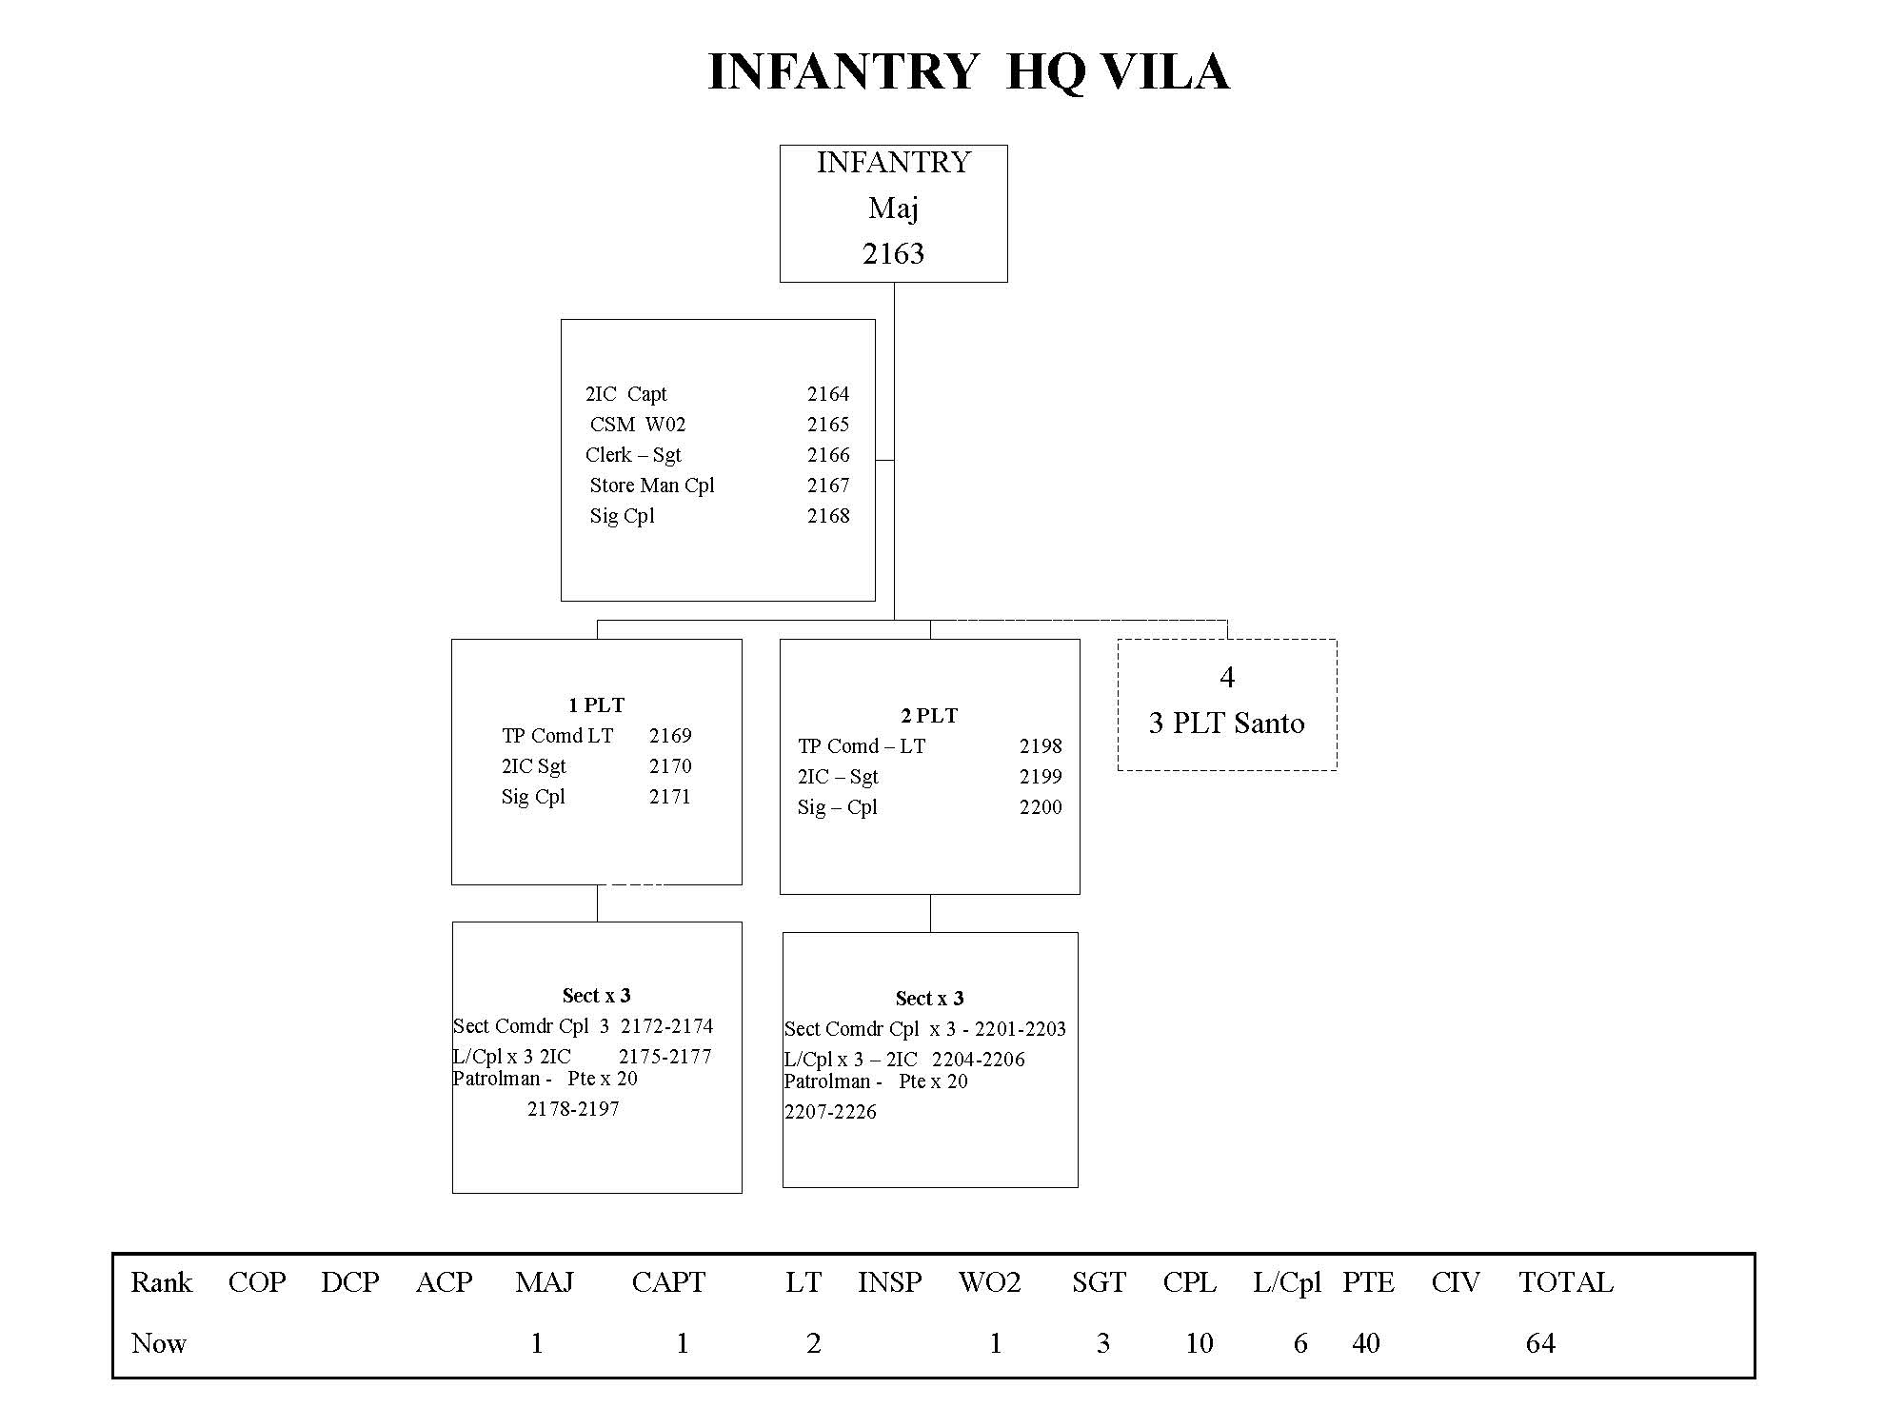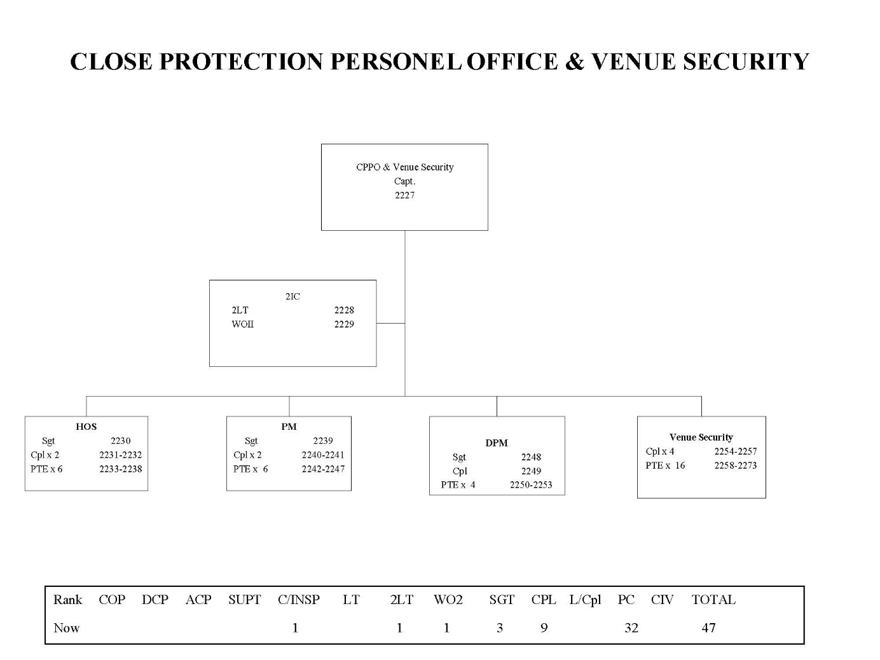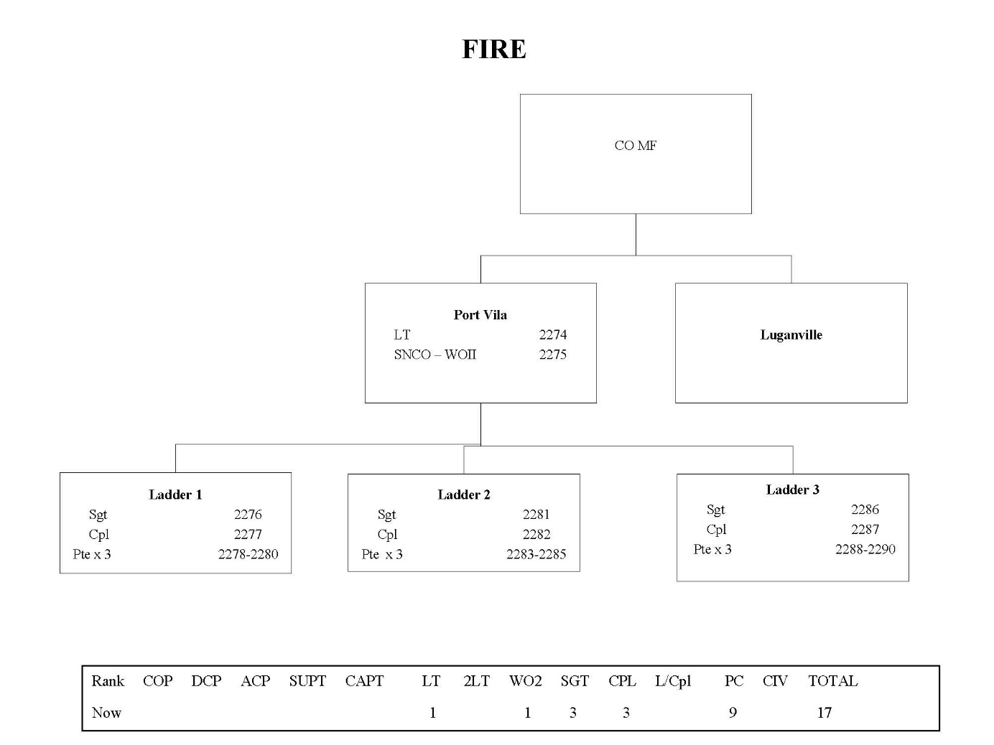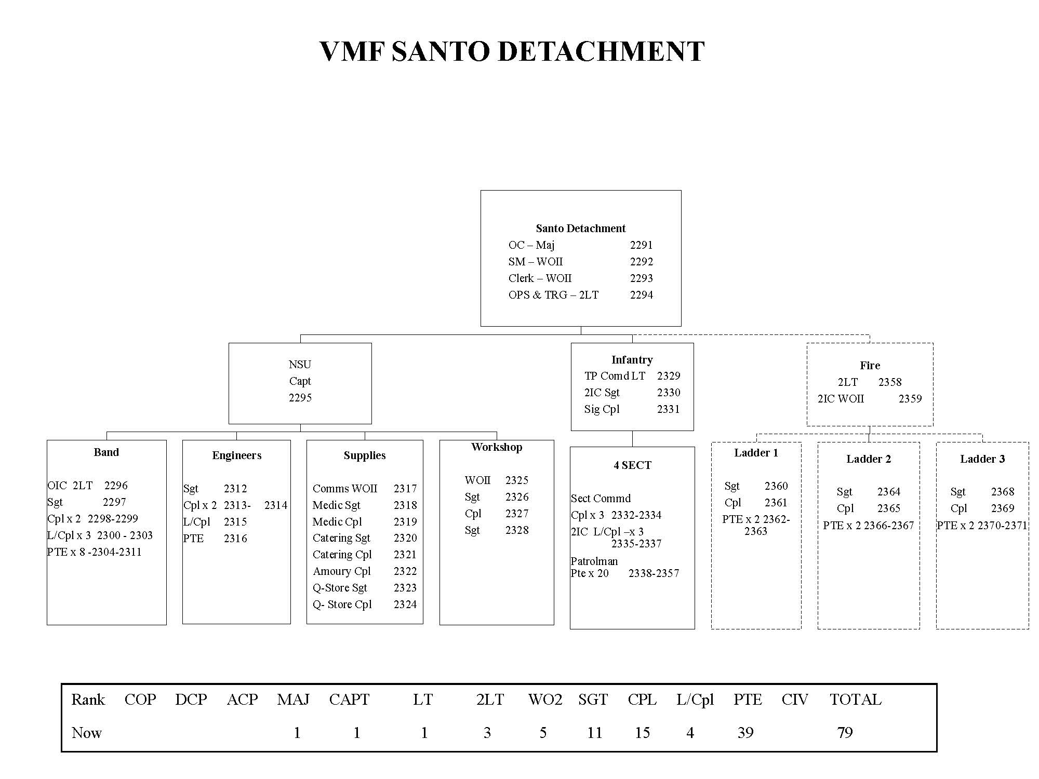

# Annex 11: PJSPV’s Key Capacity Building Achievements

***Justice Element’s Key Capacity Building Achievements***

The justice element’s capacity building achievements during the current phase include:

**Component 1: sector coordination, collaboration and communication**

* Human resource and capacity development support for the MJCS.
* Support to the JCSSS working groups.
* M&E activities, including establishing a baseline and development of MEF, and improvements in MJCS and agency level monitoring and reporting.
* Enhancing financial management in the MJCS, CSU of VPF and the agencies.
* Support to development of a sector wide communications strategy.
* Improving data quality and processes, and procurement of appropriate data systems.
* Completion of payroll support and ad hoc operational support for the VLC.
* Management and implementation of the grant facility.

**Component 2: Capacity Development**

* Strengthening human resource management and financial management (transactional and strategic), including use of Solomon Islands IPAM, HRM Adviser and from the Capacity Development and Leadership Adviser targeting the MJCS and the VPF CSU.
* Sector wide support from the Public Financial Management (PFM) Adviser.
* Specific capacity development targeted at lawyers and prosecutors.
* Agency service delivery assessments, diagnoses, plans, performance indicators.
* Leadership and management mentoring and coaching, including women in leadership.
* Support for cross sector governance, planning and implementation including the HOAG, the Task Force and JCSSS working groups.
* Targeted capacity development for the MJCS’ corporate services.
* Supporting post-training knowledge transfer and a culture of learning.

**Component 3: Protecting Children and Improving Pathways to Justice for Women and Youth**

### 3.1 Child protection

* TA to development of the national CPP, supporting implementation strategy, and MEF.
* TA for the design of the GoV child protection pilots in Tanna and Erromango.
* Highlighting use of national mechanisms for child protection coordination, collaboration and GoV oversight.
* Consideration of support of a child protection officer for GoV.
* Pilots strengthening communities’ capacity to provide protective environments for children.
* Capacity development of key formal justice sector gatekeeper stakeholders.[64]

### 3.2 Violence against women (and girls)

* Completion of a mapping update to support the pilot.
* Development of a refined and detailed 12 month work plan for the pilot to the end of 2015.
* Research to verify evidence for the pilot.
* Development agreement of the pilot communities’ selection approach.
* Commencement of the staged pilot approach in 2015.

### 3.3 Youth in conflict with the law:

* Blacksands pilot research into factors influencing urban youth at risk / resilience to involvement in crime, providing evidence to support urban and peri-urban youth work.[65]
* Development of a staged approach to piloting that is appropriate and contextualised.
* Engaging in targeted institutional advocacy with key actors.
* Establishment of a Youth Justice Focal Point in the MJCS.
* TA into 2012 revision of SoPs for Investigations Involving Children and Youth.
* Targeted justice sector legal literacy and awareness with community and the youth.

***Policing Elements Key Capacity Building Achievements***

The policing element’s capacity building approach is comprised of five priorities, including professional standards, professional development, investigations, community engagement and case and data management. The policing element’s key capacity building achievements in the current phase include:

Component 1: sector coordination, collaboration and communication

* Support for key VPF members to take the lead in working groups which provide access to TA on case management, program management, legal services, and stakeholder consultation.
* M&E TA to VPF to improve monitoring and reporting, independent evaluation;
* Financial management TA to the VPF targeting compliance with CSU process and GoV procurement guidelines for PJSPV operational fund.
* Improving data quality, processes, and procurement of appropriate VPF data system.

**Component 2: Capacity Development**

* Strengthening human resource management and financial management (transactional and strategic), including use of Solomon Islands’ Institute of Public Administration and Management (IPAM), HRM Adviser and from the Capacity Development and Leadership Adviser targeting the MJCS and the VPF CSU and complying with Police Service Commission requirements.
* TA, mentoring and coaching in general and PSU investigations, VPF case management.
* community engagement and strengthening of links between VPF and SPD.
* Leadership and management mentoring and coaching, including women in leadership.
* Evaluative piece exploring barriers for female officers in the VPF; support to the WAN to present strategy paper to the Executive for support.

**Component 3: Protecting Children and Improving Pathways to Justice for Women and Youth**

### 3.1 Child protection

* TA into 2012 revision of SoPs for Investigations Involving Children and Youth.
* Follow-up coaching, mentoring of VPF officers who have received training in use of SoPs.
* Police Standard Operating Procedures for Investigations Involving Children and Youth.

### 3.2 Violence against women (and girls)

* No activities to date.

### 3.3 youth in conflict with the law:

* TA into 2012 revision of SoPs for Investigations Involving Children and Youth.

Some of the most effective capacity development examples for the policing element not listed above include on-the-job/real time support that has solidified previous training/advisory support i.e. linking lessons management and cyclone pam community awareness raising sessions, RCS, clandestine lab experiences (SOPS/Operational procedures), identifying low cost ways to patrol/engage with the community (bike patrols), influencing VPF executive level commitments and public statements on gender equality within the organisation. These achievements have come about as a result of the accompaniment approach which the PJSPV policing element uses.

1. Policing and Justice Support Program (Vanuatu) (PJSPV) Program Design, May 2014.
2. Ibid.
3. Ibid.
4. As well as community services and agencies under other Ministries but within the sector.
5. PJSPV Design, May 2014, p6.
6. PJSPV Capacity Development Evaluation, August 2015
7. Evaluation of the participation of women in the VPF, Leigh Toomey, p45.
8. Idle and disorderly conduct, abusive and threatening language, malicious damage to property, and intentional assault.
9. IDG Mission Performance Report, 2nd Period, July-December 2015, p2, and IDG Mission Performance Report, 2nd Period, July-December 2015, p2.
10. SRBJ Workplan, July 2014 – December 2015, GRM, p10.
11. https://www.oecd.org/derec/australia/australia_lawjustice-building-on-local-strengths.pdf
12. The writer considers that use of the terms ‘VAPP’ and ‘SRBJ’ perpetuates a sense of division between the policing and justice elements. Alternatively, the two elements could be described as ‘components’, although this was thought to be confusing with respect to the PJSPV IDD’s use of the term ‘components’ to refer to the three cross-cutting Program components: 1. Sector Coordination, Collaboration and Communication: 2. Organisational Capacity Development; and 3. Protecting Children and Justice Pathways for Women and Youth. See PJSPV IDD, p55.
13. PJSPV Design, May 2014, p6.
14. PJSPV Design, May 2014, p6.
15. PJSPV Design, May 2014, p6.
16. SRBJ Workplan, July 2014 – December 2015, GRM, p26.
17. Evaluation of Participation of Women in the VPF June-July 2015
18. The writer notes the VPF’s poor financial management record (e.g. an electricity utility bill equivalent to AU$500,000 which went unpaid and resulted in electricity being cut off in operational policing areas such as the Maritime Unit, the SPD, and the Police Training College
19. Evaluation of the participation of women in the VPF, Leigh Toomey, p45.
20. Ibid
21. Appointment of a woman as a member of the VPF Executive would provide a meaningful female voice on the VPF Executive.
22. The VWC informed the writer that there had been some breakdown in this system; the matter was brought to the attention of the PJSPV policing element.
23. Idle and disorderly conduct, abusive and threatening language, malicious damage to property, and intentional assault.
24. IDG Mission Performance Report, 2nd Period, July-December 2015, p2, and IDG Mission Performance Report, 2nd Period, July-December 2015, p2.
25. Further discussion on the RCS can be found under the synchronised work plan section. It is understood the uptake of the RCS varies between commands.
26. The VPF’s 2016 Training Calendar is set out in Annex 8.
27. Organisational Performance Coordinator, Sector Capacity Development Coordinator, Sector Project Coordinator.
28. The GoA is providing AU$50 million of support to Vanuatu following Tropical Cyclone Pam, including: AU$10 million on humanitarian support, AU$45 million on early recovery priorities, and AU$35 million on long-term recovery over three years. See: Australian support to Vanuatu following Tropical Cyclone Pam – Fact Sheet, DFAT, November, 2015.

    http: / / dfat.gov.au / about-us / publications / Documents / australian-support-to-vanuatu-following-tropical-cyclone-pam-fact-sheet.pdf
29. Stage Two Progress Report – January to June 2015, GRM, 17 July 2015, p11.
30. Stage Two Progress Report – January to June 2015, GRM, 17 July 2015, p44.
31. Stage Two Progress Report – January to June 2015, GRM, 17 July 2015, p44.
32. A proposed AFP-developed Community Perceptions Survey was removed from the MEF.
33. VPF informed that this was occurring regularly; VWCC informed that this was an infrequent occurrence, on an on-demand fee for service basis.
34. Vanuatu Law Reform Commission requires a reference from Parliament to conduct law reform work; the HOAG is not stymied in this way.
35. SRBJ Work plan, July 2014 – December 2015, GRM, p25.
36. It is understood that this approach will also be adopted in the upcoming design of support to the Solomon Islands’ LJS, post Participating Police Force drawdown on 1 July 2017.
37. SRBJ Workplan, July 2014 – December 2015, GRM, p6.
38. Three small fraud incidents reported to DFAT during Stage 1 of SRBJ. SRBJ Work plan, July 2014 – December 2015, GRM, p13.
39. See Annex 7 for a description of the jurisdictions of the Courts in Vanuatu.
40. JCSS Working Groups Status Report, June 2014, 41
41. As at 2014, VPF representation was low, although this is understood to have improved in the interim. JCSS Working Groups Status Report, June 2014, p4.
42. Annex 5 sets out five capacity development lessons learned noted by AusAID circa 2006, which include observations that leadership matters most and that there need to be internal incentives for change. Annex 6 sets out the recommendations contained in the DFAT Office Of Development Effectiveness Review of Law and Justice Review - *Building on Local Strengths Evaluation of Australian Law and Justice Assistance*.
43. PJSPV Capacity Development Evaluation, August 2015
44. PJSPV Capacity Development Evaluation, August 2015
45. Law Student Internship Program Desk Review, February 2015
46. DFAT informed the writer that there was some residual political sensitivity to the AFP’s presence, with questions being asked about their activities. There is understandably always a risk to AFP advisors, as GoA representatives, working alongside politically sensitive positions in the GoV (such as the VPF Commissioner) and in agencies which attract a high degree of political interest (i.e. the VPF) due to their role in initiating criminal prosecutions for issues such as fraud. AFP personnel implementing the then separate VAPP were expelled from Vanuatu in May 2012, linked to the AFP’s detention of the Prime Minister’s private secretary, Clarence Marae, at Sydney Airport in April 2012 over an alleged international tax scam. Such sensitivities were not evident in the discussions held by the writer with VPF senior executive or with other justice agency representatives.
47. Stage Two Progress Report – January to June 2015, GRM, 17 July 2015, p40.
48. SRBJ Work plan, July 2014 – December 2015, GRM, p10.
49. "*Elimination and Prevention of Violence Against Women and Girls*", 57th Commission on the Status of Women. 4-15 March, New York, 2013http://www.un.org/womenwatch/daw/csw/csw57/generaldiscussion/memberstates/Vanuatu.pdf
50. 2010 National Prevalence Study. Vanuatu acceded to CEDAW in September 1995. In 2009, Vanuatu Parliament enacted its Domestic Violence legislation, the Vanuatu Family Protection Act, after 11 years of advocacy by women's rights activists. The Vanuatu Family Protection Act criminalises all forms of gender based violence, provides access to protection orders against such violence. It specifically states that customary reconciliation is not a defence. A national Task Force has been established - members are selected from within the government, CSOs and community based institutions - to oversee and advise the government on the overall implementation of the Act. Pilots are being conducted in selected communities on implementation of the Act. A key gap is the current absence of formal legal and support services.
51. SRBJ Workplan, July 2014 – December 2015, GRM, p12.
52. ODE Law and Justice Review, p50.
53. https://www.oecd.org/derec/australia/australia_lawjustice-building-on-local-strengths.pdf
54. Policing and Justice Support Program (Vanuatu) (PJSPV) Program Design, May 2014.
55. Ibid.
56. Ibid.
57. PJSPV’s goal, objective and end of program outcomes are set out in *Program Data, Acknowledgement and Disclaimer* on page iii above.
58. June, 2014.
59. PJSPV Policing Sub-Design *Aide Memoire*, p1.
60. Ibid. p2.
61. AusAID, circa 2006. The author understands this document was prepared by Ms Patricia Lyon.
62. https://www.oecd.org/derec/australia/australia_lawjustice-building-on-local-strengths.pdf
63. For more information on the court system in Vanuatu see Jennifer Corrin-Care, Tess Newton and Don Paterson *Introduction to South Pacific Law*(Cavendish Publishing Ltd, London, 1999) 323-328.

    Source: http: / / www.paclii.org / vu / courts.html
64. This builds on the Standard Operating Procedures developed by UNICEF.
65. Wan Smol Bag currently works with urban and peri-urban youth.