**TVET FOR TOURISM**

**End of Year Report**

**April 2014 - March 2015**

**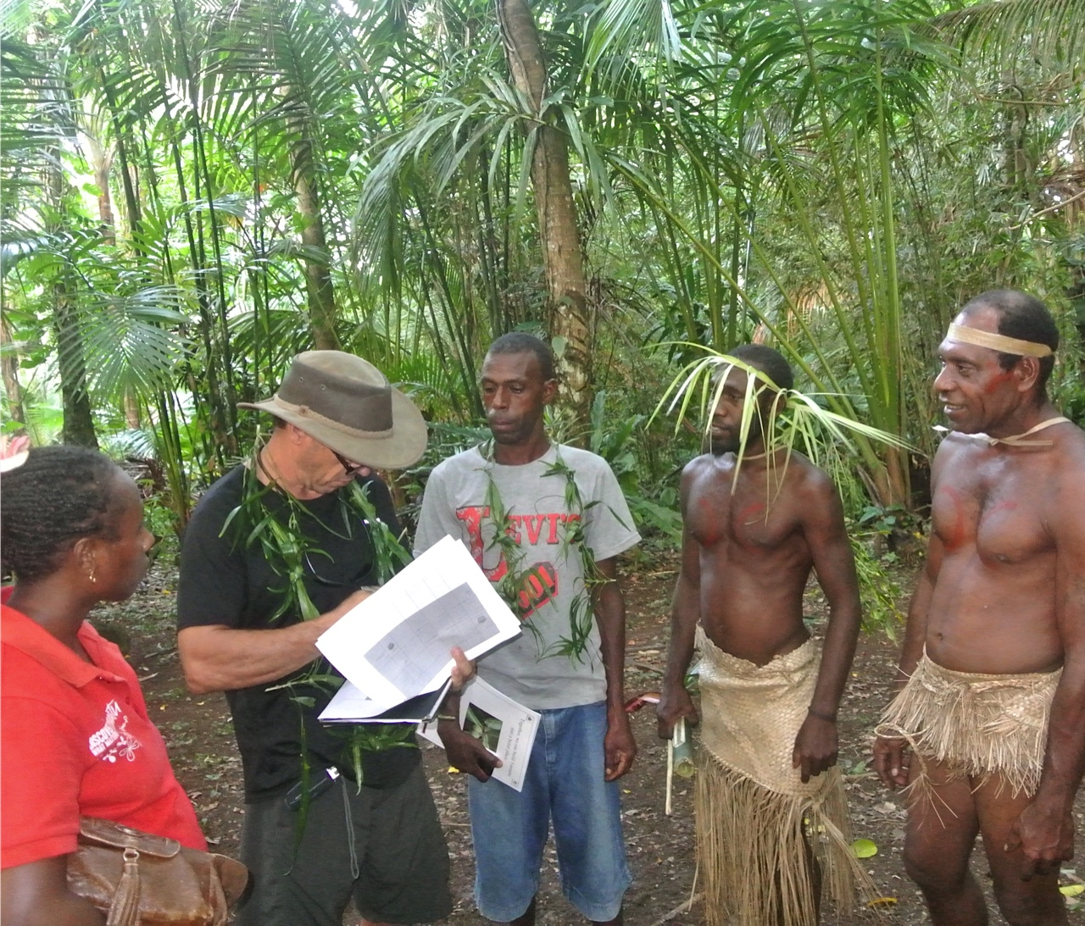**

Contents

[Introduction 4](#_Toc413227022)

[TfT Program Review 4](#_Toc413227023)

[Program Description 4](#_Toc413227024)

[TfT Skill Development Principle 4](#_Toc413227025)

[TfT Client Support Methodology 5](#_Toc413227026)

[Program Objectives 5](#_Toc413227027)

[Evaluation 6](#_Toc413227028)

[TfT Program Implementation 7](#_Toc413227029)

[Renewed Memorandum Of Understanding (MOU) with DOT 7](#_Toc413227030)

[Volume of Activities 8](#_Toc413227031)

[TfT Industry Experts 9](#_Toc413227032)

[TfT Training and Resource Development 10](#_Toc413227033)

[Training Development 10](#_Toc413227034)

[Resource Development 11](#_Toc413227035)

[TfT Program Impact 12](#_Toc413227036)

[Individual Clients & Participants 12](#_Toc413227037)

[Client Performance 13](#_Toc413227038)

[Education Pathways 17](#_Toc413227039)

[Wider Impact - Flow on Effect 18](#_Toc413227040)

[Media and Public Relations 19](#_Toc413227041)

[Malampa Program Review 20](#_Toc413227042)

[Program implementation 20](#_Toc413227043)

[Client achievements 21](#_Toc413227044)

[Malampa Call Centre 24](#_Toc413227045)

[Wala Cruise-Ship Initiative 25](#_Toc413227046)

[Malampa Media and Public Relations 26](#_Toc413227047)

[Conclusions & Future Directions 26](#_Toc413227048)

[Sanma Program Review 27](#_Toc413227049)

[Program implementation 27](#_Toc413227050)

[Client achievements 27](#_Toc413227051)

[Sanma Information and Call Centre 31](#_Toc413227052)

[Sanma Media and Public Relations 32](#_Toc413227053)

[Conclusions & Future Directions 32](#_Toc413227054)

[Torba Program Review 34](#_Toc413227055)

[Program implementation 34](#_Toc413227056)

[Client achievements 35](#_Toc413227057)

[Torba Media and Public Relations 39](#_Toc413227058)

[Conclusions & Future Directions 39](#_Toc413227059)

[TfT & Women 40](#_Toc413227060)

[TfT Inclusion Rate 40](#_Toc413227061)

[Challenges and Next Steps 43](#_Toc413227062)

[Tafea Province 43](#_Toc413227063)

[Mystery Island – Port of Call Skill Development Program 43](#_Toc413227064)

[Tanna Island 43](#_Toc413227065)

[Port of Call Skill Development Program 43](#_Toc413227066)

[Reintegration of Accredited Training in TfT work plan 44](#_Toc413227067)

[New DoT Accreditation System 44](#_Toc413227068)

[Industry Expert Localisation 45](#_Toc413227069)

[Localisation of the TfT Coordinator Role 45](#_Toc413227070)

[Annex 1: TfT Client Monitoring and Evaluation Plan 46](#_Toc413227071)

[Annex 2: Media and Public Relations List 49](#_Toc413227072)

# Introduction

This end of year report for the fifth year of the TVET for Tourism (TfT) Program, under the broader TVET Sector Strengthening Program, covers the Program’s activities from April 2014-March 2015. The report has been compiled using the TfT Client Monitoring and Evaluation Plan (Annex 1) and draws on information gathered by the coordinators, industry experts, training providers and key partners at the Department of Tourism (DoT). The report focuses on the TfT Program contributions to its short and long term objectives.

# TfT Program Review

## Program Description

The TfT Program has grown rapidly since its pilot phase on the island of Malekula in 2009. The program today includes localised programs on eight islands in three separate provinces throughout Vanuatu. As the program has grown its methodology has been adapted to take into account the complex and varying environmental, social and political landscapes in each province. This year has seen major additions to the TfT Program including three islands in Torba province and a second tourism ‘Call Centre’ in Sanma province as well as a larger focus on cruise-tourism development throughout the Program.

Due to the expansion of the TfT Program a full time associate-coordinator was engaged in August 2014 to implement the standardisation and systemisation of TfT policies, processes and tools. This position, under the supervision of the national coordinator, is responsible for the organisation and monitoring of all TfT skill development activities implemented through regular communication with the TVET Centres, training providers, coaches and partner organisations.

The TfT Program is built around a three-stage skill development principle to assist rural tourism stakeholders to grow their ventures from informal projects to formal businesses.

### TfT Skill Development Principle

### TfT Client Support Methodology

As in previous years, the TfT Program has followed a successful on-site methodology including a combination of face-to-face coaching and technical workshops complemented by accredited training and support from the provincial DoT offices.

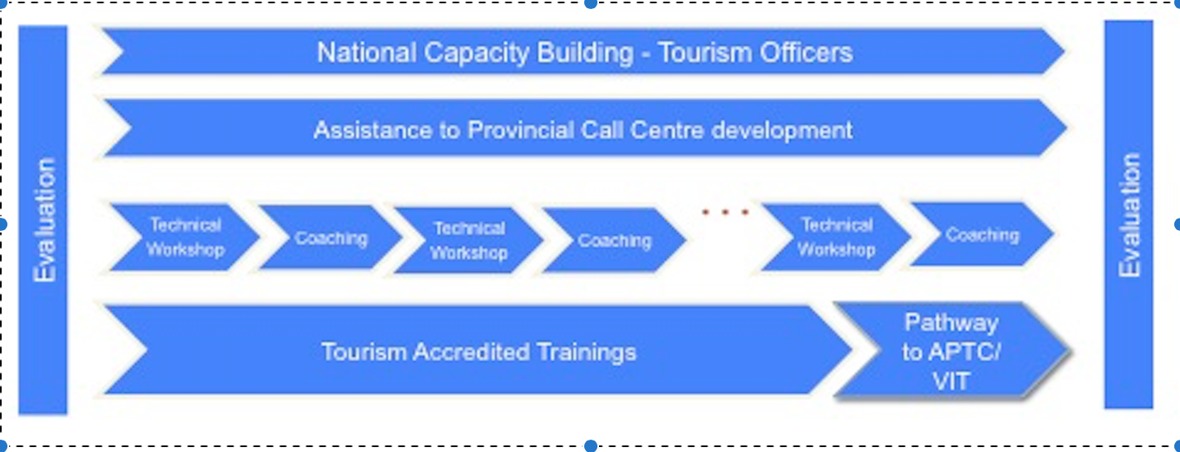

## Program Objectives

The principal goal of the TfT Program is to provide rural tourism operators with skill development services to support their business expansion and increase involvement in the formal economy. At the same time the TfT Program aims to strengthen the capacity and sustainability of tourism product development at the national level through the professional development of relevant government departments and key staff. More specifically these objectives include:

* Generating significant positive changes in the local tourism industry
* Supporting productive participation of ni-Vanuatu in the formal economy
* Supporting existing tourism business development and emphasising sustainability
* Encouraging and assisting the development of new tourism projects
* Building the capacity of local industry coaches, training providers and DoT officers
* Assisting TfT clients to comply with and exceed the DoT accreditation standards
* Assisting TfT clients to operate at an international standard to achieve interaction with the global tourism industry
* Assisting TfT clients with marketing and promotion at individual and destination levels

Key focus areas:

* Local tourism economic growth
* Individual business growth and interaction with the formal economy
* Individual success stories
* Empowerment of women in the tourism industry
* The enhancement and development of other associated sectors via a ‘flow-on effect’ (handicraft, transport, agriculture etc)

Long term objective:

* The provision of effective, flexible and relevant skills development services to rural tourism businesses through a partnership between the DoT (business mentoring/product development) and the Ministry of Education & Training (formal training opportunities).

## Evaluation

As in previous years the evaluation of the TfT 2014-15 work plan has been measured at three levels:

* Client performance- based on Key Performance Indicators (KPIs), business indicators, financial indicators, action plan achievements.
* Program performance- based on program implementation and participants’ satisfaction in each of the focus geographic sites .
* Sectoral performance: based on relevant sectoral data to measure economic impact and growth

|  |
| --- |
| Macintosh HD:Users:lucybattaglene:Desktop:M&E image.png |

Due to the expansion of the TfT Program the monitoring and evaluation system of individual client performances has been standardised in 2014 to ensure consistency across the program. The TfT Client Monitoring & Evaluation Plan has been designed to define specific indicators and data collection procedures to be followed in all three provinces.

In previous years, client performance has been based on KPIs, action plan achievements and financial data only. As of 2014, several key ‘business indicators’ have been added to help monitor the growth and evolution of these businesses. These indicators include DoT approval (minimum standards), business licence registration, call centre registration, a presence on trip advisor and a ranking within the informal, semi-formal or formal sector. Data provided in this report is based on last quarter data collection (December 2014). Final data for the 2014-15 year will be available April 2015.

# TfT Program Implementation

## Renewed Memorandum of Understanding (MOU) with DOT

A renewed MOU with the DoT this year formalised the continuing cooperation between the TVET Program and the Department to secure maximum involvement and future sustainability of the TfT Program. The 2014 partnership agreement was signed following the success of the first MOU in 2013-14 and ensured that the TfT Program would continue to receive DoT’s support and assistance on the ground. This agreement also confirmed the TfT Program’s plan to continue to support the up-skilling and professional development of the DoT and VTO staff through a second phase of the National Capacity Building Program (NCBP). This partnership has strengthened the relationship and linkages between the TfT Program and DoT/VTO both at management and provincial staff levels. Specifically, the ongoing relationship between the TfT Program and provincial DoT officers is crucial for the continuation of quality product development and rural tourism business support, especially with the launch and implementation of formal accreditation standards for all tourism businesses.

**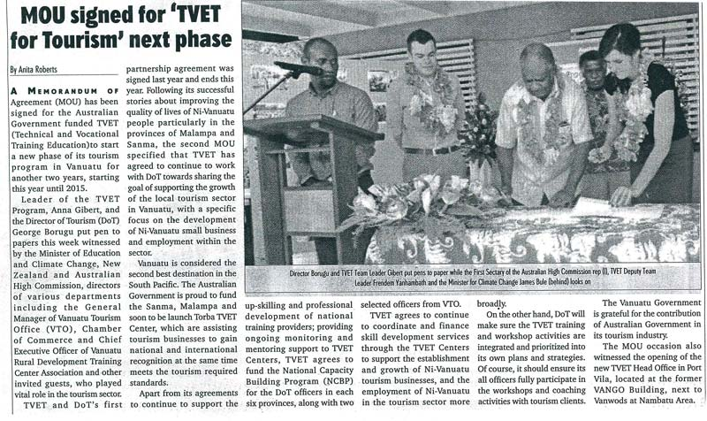**

## Volume of Activities

From April 2014-March 2015 the TfT Program facilitated 404 skill development activities in localised programs in three provinces including individual coaching meetings with business owners, business development workshops, accredited training and a number of special projects. The program also continued its NCBP in Port Vila with DoT and VTO officers from across Vanuatu.

The number of TfT coaching meetings has more than doubled since the 2013-14 programs with the addition of clients from Torba province and new products in Sanma and Malampa. On average, each TfT client has participated in between three to four face-to-face meetings with their coaches over the past twelve months in which their action plans have been discussed and KPIs and other indicators measured. Skills and knowledge developed in these coaching sessions has been reinforced by a range of targeted workshops and formalised accredited training delivered by leading industry experts, registered training providers and government department officers.

## TfT Industry Experts

TfT skill development services this year have been delivered by a team of industry experts, key government organisations, institutions and private sector businesses. Due to growing demand, the number of industry experts contracted by the program has increased dramatically from previous years. In the 2014-15 work plan the TfT Program has made an increased effort to source and support local consultants and trainers wherever possible in line with the objectives of sustainability and localised skill development.

To meet the training demands of rural tourism businesses in Torba, Sanma and Malampa the TfT Program has worked in partnership with a number of local training institutions, government offices and private business to deliver tourism-specific content through both customised workshops and accredited training. These providers have delivered a range of business development workshops and accredited trainings to complement the regular coaching activities.

## 

## TfT Training and Resource Development

### Training Development

In partnership with an international technical adviser, the Program has also provided curriculum development support and coaching to two affiliated trainers to enable them to develop and pilot two training clusters in the areas of Accommodation Services and Tour Guiding. Using the recently launched training packages and units of competency of the Vanuatu Qualifications Authority (VQA), the TfT Program and technical adviser working in partnership with VQA staff to produce two basic accredited training clusters designed for rural accommodation and tour businesses selected from within the Certificate One units.

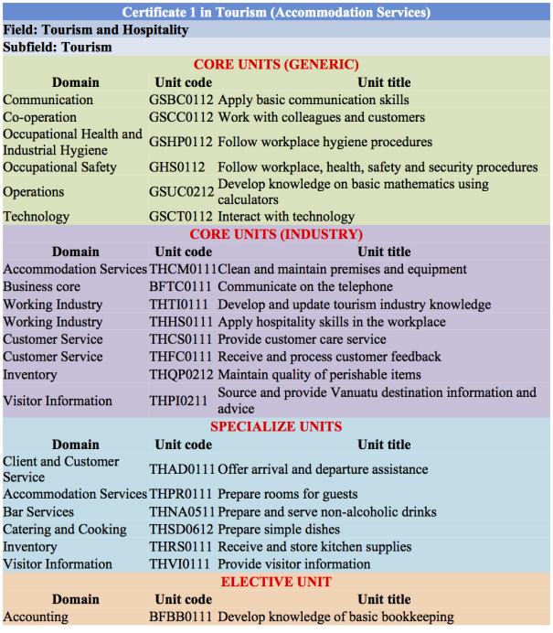

### 

### Resource Development

The TfT Program has worked closely with local training providers and key government offices to design and distribute contextually appropriate resources for rural tourism businesses. This year the Program has facilitated the design of a unique product development resource, ‘Marketing Guidelines for Rural Tourism Businesses’ as well as a bookkeeping workshop resource and delivery plan.

|  |
| --- |
| C:\Users\LBattaglene\AppData\Local\Microsoft\Windows\INetCache\Content.Word\Rural Tourism Bookkeeping workbook  BOOK 2.jpg*CASE STUDY: The Department of Cooperative (DoC)s- Bookkeeping Resource Development.* In 2014 the TfT Program contracted an industry expert to work in partnership with the Malampa DoC to design and produce a bookkeeping resource to meet the needs of rural tourism businesses. This resource includes two learner workbooks as well as a four-day delivery plan and presentation. While ensuring the delivery of contextually appropriate content to TfT clients, this process simultaneously strengthened the capacity of the Malampa DoC to design new BDS material and create tourism-specific content. TfT then facilitated and funded a pilot workshop in Malekula to ensure the quality management and ‘fine tuning’ of the final content. This resource has now been distributed throughout the national and provincial DoC officers with plans to run these BDS workshops in the near future both in provinces with and without TVET Centre support. |

|  |
| --- |
| *CASE STUDY: Marketing Guidelines for Rural Tourism Businesses.* The MoU signed between the TVET Program and the DoT focuses on assisting DoT officers to ‘coach’ island products with their own business development. Marketing has always been a very difficult subject for both clients and DoT officers as absolutely no methodology, tools or training have been previously available. In 2014 the TfT Program allocated a budget for industry experts to write a user-friendly set of guidelines offering advice and ideas on how to start up marketing activities from the islands. This 70 pages guide also contains a marketing directory and action plan sheet to facilitate marketing engagement both domestically and internationally. A two day Marketing workshop has also been developed based on the guide and implemented with the Sanma TVET Centre. The publication was launched and handed over to DoT on 26 February 2015 to be distributed to businesses and government offices. |

# TfT Program Impact

## Individual Clients & Participants

The TfT Program currently provides support through skill development services to 106 ‘clients’ (selected rural tourism businesses, and DoT officers) across Malampa, Sanma and Torba. These numbers have increased by 37% from last year due to the inclusion of the Torba TfT Program (25 clients) as well as the addition of several newly developed products in Sanma and Malampa.

While the TfT Program supports 106 businesses directly, there has been a wider impact on the community through the participation of 300 client employees in skill development activities. An indirect impact on over 500 people in the three provinces has occurred through skills transfer in the workplace between TfT participants and other employees within the businesses.

### Client Performance

The performance of TfT clients overall has been positive with the majority of businesses showing improvement in terms of product development, financial growth and transition from the informal to the formal economy[[1]](#footnote-1). This improvement is highlighted by the number of clients currently meeting or exceeding the DoT Minimum Standards[[2]](#footnote-2). Further to training and coaching 64 clients (%) have reached or exceeded the DoT Minimum Standards in 2014.

Through regular coaching and participation in skill development activities, 38% of TfT clients have progressed from the informal to the semi-formal economy in the last twelve months. These rural tourism businesses now possess the capability for regular income generation and exercise basic business management practices.

Any individual or company in Vanuatu that wants to partake in a form of business enterprise for income generation is required to obtain an annual business license under the Business License Act No.19 of 1998.  This licence costs tourism businesses an annual fee of 10,000vt and formalises the business within Department of Customs and Inland Revenue structure. It is a requirement for tax purposes as well as the DoT Accreditation Standards. The number of TfT clients who have registered for business licenses each year is further evidence of the transition of TfT clients from the informal to formal economy. There are currently twenty TfT clients who are operating with business licenses compared with only three in 2012.

|  |
| --- |
| *CASE STUDY: From Millennium Caves Tour to Millennium Caves Limited.* In November 2014 Millennium Cave Tours became a registered company, signifying its transition from the informal sector in 2011 to the formal economy today. Millennium Caves Limited is an example of a community based tour which, with the support of the TfT Program, has evolved into a successful registered business fully integrated into the formal sector. Millennium Caves Limited’s gross earnings in 2014 totalled above 11 million vatu and today the company employs over 53 members of the local community as tour guides, cleaners, cooks and drivers. Millennium Caves Limited is the major donor of two kindergartens and a local primary school. The company further supports the community through the sponsorship of football teams, youth groups and Promedical Santo.  ceo milenium |

### Education Pathways

In 2014 the TfT Program facilitated the pathways of four participants to attend formal training at the Australian Pacific Technical College in Port Vila. These participants have since graduated with Certificate III in Hospitality and returned home to their businesses and families. A total of 14 TfT participants (4.5%) have now completed a qualification at APTC through the support of the TfT Program.

|  |
| --- |
| *CASE STUDY: Tam Tam Bungalows wins national awards with help of TfT and APTC pathways*  C:\Users\LBattaglene\AppData\Local\Microsoft\Windows\INetCache\Content.Word\image002.jpgAfter five years of coaching and skills development as part of the TfT Program the owner of Tam Tam Bungalows, with the assistance of the TfT Program, enrolled two employees at APTC in Port Vila. After graduating with Certificates in Hospitality these employees were promoted to joint-managers in 2014. With the help of these new skills and knowledge they were able to successfully apply, and win, the award for Best Island Bungalow in Vanuatu 2014. |

## Wider Impact- Flow-on Effect

In 2014-15 the TfT Program has had positive impacts on the wider community in areas where skill development services have been delivered and, as a result, tourism activities have increased. Thanks to regular income generation from tourism businesses many communities have seen their standard of living increase as well as the growth of other complementary sectors such as agriculture, joinery/carpentry, and handicrafts.

The growth of the local tourism industry in Sanma and Malampa provinces has led to a higher demand in local handicrafts and thus more income generation for women, people with disabilities and traditional craftsman. In Sanma the TfT Program has recently facilitated am ‘additional income’ networking event which brought together tourism businesses, craftsman as well as food producers to enable them to view each other products and arrange sales ‘in-store’ at tourism accommodation, activity and restaurant properties.

In Torba province vegetable farmers have begun to diversify their products and increase quantity due to the demand from local bungalow operators. While many of these farmers originally grew products for their families only, many are now beginning to sell their excess yields to these tourism businesses and also other members of the population.

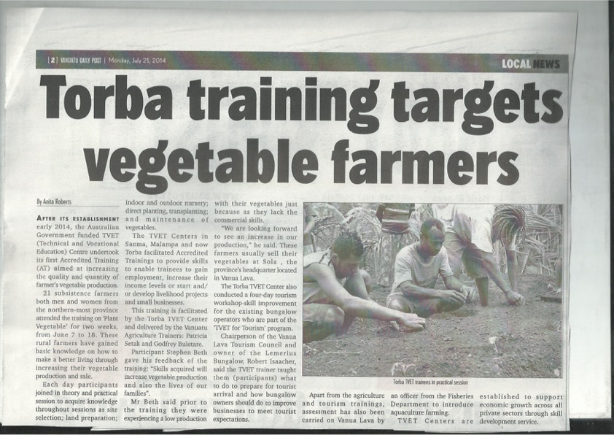

## Media and Public Relations

In 2014-15, the TfT Program received strong local and international press coverage with 22 articles published and regular broadcasting on national and provincial television programs (see complete list in Annex 2). During the last twelve months representatives from the Australian High Commission in Vanuatu have participated in five TfT-related public events including the MOU signing with the DoT, Marketing Guidelines Launch, Millennium Caves Limited Launch, Millennium Caves Limited CEO graduation, and Vanuatu Tourism Awards. These events and public visibility have contributed to the strong partnership between the Vanuatu and Australian Governments in relation to their tourism sector development strategic objectives.

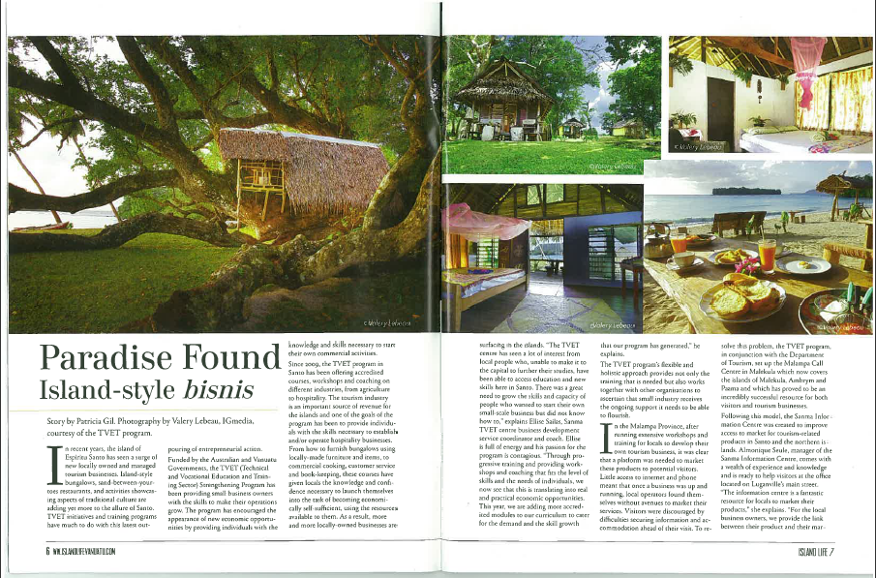

# Malampa Program Review

## Program implementation

The Malampa TfT Program includes two sub-programs on the islands of Malekula and Ambrym. After four years of coaching and other skill development activities in Central Malekula the objectives of the TfT Program in 2014-15 were:

* To secure the sustainability of these products through improved business management and marketing
* To identify and support tourism develop in South East Malekula (the Maskelyne Islands)
* To assist the Malampa Call Centre to achieve sustainability.

The TfT Program on Ambrym entered its third year in 2014-15 with a main objective of continuing the development and support of tourism businesses while increasing volume of tourists to the area via the Malampa Call Centre. More specifically these objectives included:

* To develop business management, marketing and reservation skills for Ambrym clients
* To introduce basic accounting skills
* To continue to engage clients into quality improvement both in tours, activities and accommodation
* To encourage Ambrym destination marketing through the Malampa Call Centre

TfT skill development activities delivered in Malampa province in 2014-15 included:

Several coaching visits and workshops were postponed in Ambrym this year due to a number of extenuating circumstances including the closure of the Craig Cove airport for six months between April-September 2014 as well as the eruption of the Ambrym volcanoes in February 2015 and subsequent continuing risk management issues.

## Client achievements

The TfT Program currently supports 43 tourism businesses in Malampa province through skill development activities. This includes nineteen clients from Central Makeula, fifteen from Ambrym and nine additional clients from South East Malekula. The ongoing improvement of these businesses can be appreciated in the increasing number of clients meeting the DoT minimum standards in the region. Currently 75% of Malampa clients meet or exceed the DoT minimum standards and are thus able to be commercialised, and sold online, through the Malampa Call Centre.

The number of Malampa clients with business licenses is also slowly improving emphasising the transition of these businesses from the informal to formal sector. Currently 11.6% of clients are registered compared to only 6.6% in 2013 and none in 2011.

The TfT program uses seventeen specific KPIs in areas such as site maintenance; operation, marketing and service; to determine a KPI score for each client out of 85. This score assists coaches and business owners when evaluating the progress of these tourism businesses and determine ‘next steps’.[[3]](#footnote-3) The average KPI scores of Malekula clients (excluding new clients from the south east) have improved from 42 in 2013 to 44 in 2014. While the overall increase is not as high as previous years this can be attributed to a healthy plateau and movement towards sustainability of these businesses.

Ambrym client KPI scores also improved from 33 in 2013 to 34 in 2014. This small increase can be attributed to a six month period of stagnation due to the airport closure and cancellation of workshops and coaching visits as well as a loss of over 1 million vatu worth of tourist arrivals.

|  |
| --- |
| *CASE STUDY: TfT Industry Expert and DoT staff developed Tourism Packages that are now commercialised overseas.*  This year a TfT Industry expert supported the Malampa DoT office to consolidate local activities from the region of South East Malekula into an adventure package to be commercialised overseas. This is an example of the TfT’s multi-stakeholder coordination role:   * **Industry Expert** up-skilled operators and assisted in tour development (mentoring) * **Malampa DoT** validated the package * **VSA volunteers** assisted in product description and online marketing * **Vanuatu Tourism Office** (VTO) in Port Vila engaged French speaking expert to promote the package in New Caledonia * **Malampa Call Centre** organized bookings and follow-up with interested Caledonian wholesalers   This practical approach has generated tangible tourism impact in a region where very few tourists previously visited.  C:\Users\LBattaglene\AppData\Local\Microsoft\Windows\INetCache\Content.Word\maskelyne-islands-outrigger-canoe-adventure.jpg |

## Malampa Call Centre

Malampa Call Centre was created in 2011 after local stakeholders identified the need for access to telecommunication and online marketing. In December 2014, after three years of operation, the centre broke even with over 600 visitors booked through the centre that year. The estimated booking value generated by the call centre is estimated at 18 Million vatu. This pilot initiative has demonstrated that such projects can be sustainable in other provinces or perhaps nationally. Through TfT Technical support and coordination with NZ Volunteer Service Abroad (VSA) several marketing improvements were also achieved:

* full google mapping of all Malampa accredited products
* full integration of Facebook portal into Malampa.travel web site
* automatic translation of the Web site into over 60 languages
* development of a 35 page Malampa travel guide distributed online

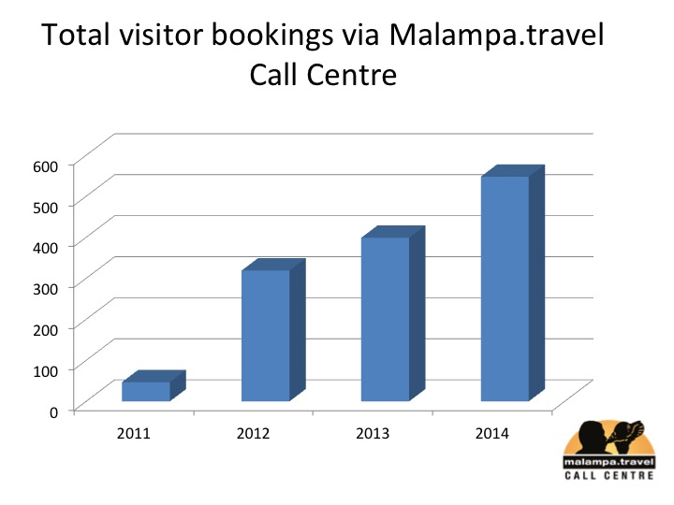

During the last Call Centre Board meeting and TfT coaching meeting, major decisions were taken to further develop online marketing and business generation for local tourism members by:

* Employing a second officer (Francophone) to comply with increasing booking inquiries and New Caledonia market development
* allocating a budget to start advertising online with Google and Facebook advertising platforms
* starting to distribute local island bungalows through Online Travel Agents (OTA) such as Wotif.com and Booking.com

These decisions show the capacity of provincial stakeholders to take care of their own product marketing, to master technologies and concepts that were before used only by Port Vila foreign investors.

## Wala Cruise-Ship Initiative

The Wala Cruise-Ship initiative was developed through a formal request by the DoT based on their National Cruise Tourism Action Plan. Wala Island in Malekula is one of the six Ports of Call in Vanuatu. After some years of community tension it had begun to attract negative attention and was in danger of losing future calls. This was largely due to the Port of Call Committee mismanagement of funds and low quality of community customer service. The TfT Program was asked to initiate a skills development program with the support of Carnival Australia, DoT and local communities. A pilot program was developed, and partially implemented until tribal tensions on the island, unrelated to the initiative, made it necessary to withdraw due to security risks and direction from TVET Program and DFAT management.

Despite its short implementation (50% of initial proposal), many lessons were learnt from this initiative. Namely, TfT Program, Carnival Australia and DoT realised the importance of skills development and rural community awareness raising in relation to the development of Ports of Call and the wider cruise industry. It also became evident that skill development activities to strengthen the capacity of the management committees at the Port of Call were crucial for future development. From this experience, and from the achievements recorded, Carnival Australia and the TVET sector Strengthening Program are working together on a national ‘”Ports Of Call Skills Development Program” to be potentially implemented in other priority Ports of Call.

Wala island Tour Promotion

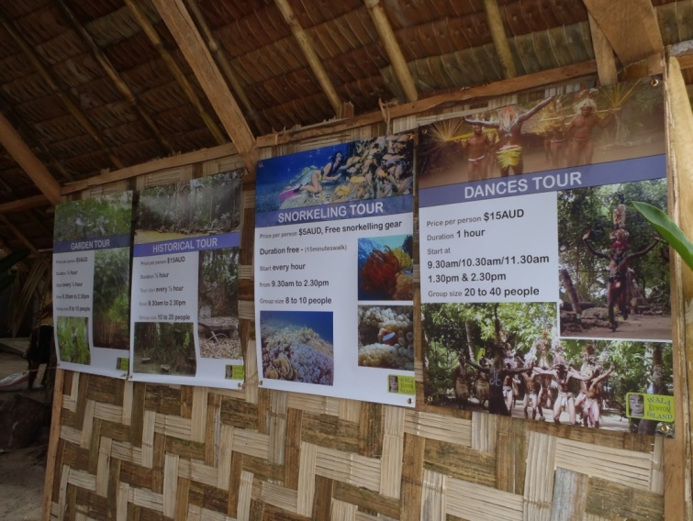 Before TfT initiative: After TfT initiative:

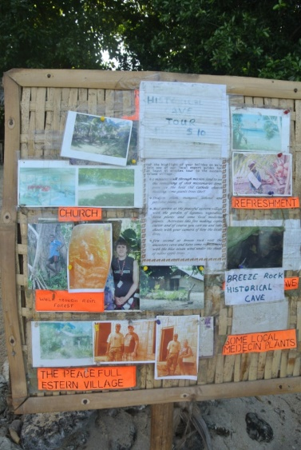

## Malampa Media and Public Relations

Eight articles relating to the Malampa TfT Program were published in the national and international press in 2014-15. Highlights from these include three articles promoting the new tourism packages in Ambrym and Malekula.

****

## Conclusions & Future Directions

TfT activities in Central Malekula have been ongoing for five years, since the pilot program in 2009. The DoT and TfT coordinators now believe these clients have achieved a satisfactory level of skills and knowledge to manage their own business without TfT assistance. With this in mind, Central Malekula clients will not receive any coaching support in plans for the coming years. Two other potential tourism destinations, South East and South West, have been identified by the DoT for coaching assistance and product development.

Ambrym represents a very large potential for adventure tourism with its active volcano and strong custom and culture. After a successful first stage of product development, the second stage of business development started in April 2014but was postponed due to a land dispute culminating with six months of airport closure. After eight months of no activities, the TfT Program was re-launched in December 2014 to encourage tourism stakeholders to re-activate their businesses. Unfortunately, increasing volcano activity in February 2015 reduced access of tourists and triggered the cancelation of foreseeable activities due to the TfT risk management policy.

The TfT Program in Ambrym 2015-16 will be focused again on business development with a strong emphasis on marketing and basic business management. All trainings and workshops that were planned in 2014-15 will be allocated to next year’s program.

No training activities are to be planned for Wala Island in the coming years.

# Sanma Program Review

## Program implementation

The TfT Sanma Program entered its fourth year in 2014-15 with the goal of continued product development. More specifically, objectives included:

* Providing strong support to existing clients and empowering them toward the achievement of sound business management, improvement of their quality standards and profits.
* Engaging identified new clients into a process of coaching and training with a strong emphasis on tours/activities and adventure bungalows.
* Assisting in Sanma Call Centre development

TfT skill development activities delivered in Sanma Province in 2014-15 included:

## Client achievements

The TfT Program currently supports 34 tourism businesses in Sanma province through skill development activities including 33 clients from Espiritu Santo Island and one client from Malo Island. This number includes the addition of five new products in 2014. The Sanma TfT Program provides coaching and other skill development services to tourist accommodation, tours & activity businesses and also tour operators. In 2014-15 there has been a dramatic increase in the standard of TfT clients due largely to better business management, higher quality standards and improved revenue. Currently 79% of clients in Sanma have met DoT minimum standards compared with 37% in 2013.

The number of Sanma clients with business licenses has risen greatly in 2014-15 due largely to the refocus of the TfT Program on correct business management, rules and regulations. This increase highlights the transition of these businesses from the informal to formal sector. Currently 41.2% of clients are registered compared to only 22.2% in 2013 and 8.3% in 2011.

The average KPI scores of Sanma TfT clients have improved from 30 in 2013-14 to 33 in 2014-15 which reflects the slow moving nature of product development in Sanma province.

|  |
| --- |
| *CASE STUDY: Luganville Tour Operators*  Espiritu Santo has always been one of the major tourism destinations in Vanuatu with regular international flights and two ports of call. Ni-Vanuatu tour operators specialising in airport transfers and tour organisation have been successfully operating in the main town Luganville for many years. The continuous stream of tourist arrivals has made these businesses reluctant to invest in product development or upgrade their services.  In 2014 the TfT Program was asked to provide these businesses with support to help them make themselves more competitive. The industry experts focused on business development strategic advice including specific workshops and coaching sessions tailored to suit these long-time tour operators. After only one year of coaching many improvements are now being witnessed. Several clients are now investing in bigger buses to reduce their cost per passenger and many have developed new exclusive tours to differentiate themselves from the competition. Some are now investing in internet marketing and proper offices in an attempt to separate their business from their own home and family. |

|  |
| --- |
| *CASE STUDY: Port Orly Tourism Zone- Waste Management*  The area of Port Olry in north eastern Santo has experienced rapid growth in tourism numbers in recent years. The TfT Program works with five tourism operators in Port Orly all have which have seen vast improvement in terms of product development and revenue. In August 2014 the community of Port Orly recognised that the number of visitors combined with improper waste disposal measures was having a disastrous effect on the environment in the area. The TfT Program, recognising a lack of knowledge as a major cause, partnered with the Luganville Municipality Waste Management Unit to deliver community workshops covering correct waste disposal, recycling and composting. The community and tourism operators are now not only producing less waste but ensuring that their future tourism practices are environmentally friendly. A result of this workshop was the addition of Port Orly to the Municipality’s regular recycling pick-up route.  **C:\Users\LBattaglene\AppData\Local\Microsoft\Windows\INetCache\Content.Word\waste.jpeg** |

|  |
| --- |
| C:\Users\LBattaglene\AppData\Local\Microsoft\Windows\INetCache\Content.Word\PORT OLRY_BUNGALOWS_TREE HOUSE_060.jpg*CASE STUDY: Professional Product Photos for TfT Sanma Clients*  C:\Users\LBattaglene\AppData\Local\Microsoft\Windows\INetCache\Content.Word\PORT OLRY_RESTAURANT_CHEZ LOUIS_074.jpgIn 2014 the TfT Program engaged a professional photographer to create product photos and small portfolios for thirteen Sanma tourism clients. These photos have now been distributed to respective business owners as well as Sanma Information and Call Centre and VTO to be used in domestic and international marketing. |

|  |
| --- |
| *C:\Users\LBattaglene\AppData\Local\Microsoft\Windows\INetCache\Content.Word\PORT-OLRY_RESTAURANT_CHEZ-LOUIS_038.jpgCASE STUDY: First cruise passengers now arriving at newly approved clients.*  Further to discussion with Carnival Australia in 2013, TfT industry experts have successfully mediated contracts for four clients with Carnival Australia’s agent for the coming years. These clients are now enjoying their first passenger arrivals direct from the ship on cruise-ship days and the stability of secure bookings via on-board agents. |

## Sanma Information and Call Centre

After the proven success of the Malampa Call Centre, Sanma Province initiated plans to develop its own call centre to assist local tourism stakeholders. The Sanma Information and Call Centre (SICC) was designed during 2013 with the assistance of the TfT Program and funded via a variety of donors including the DoT, VTO, TVL and DFAT’s ‘Governance for Growth’ program. The TfT Program provided industry experts to facilitate implementation of the project and training/capacity building of the newly appointed staff.

SICC was officially launched in March 2014, however, the centre faced several challenges from the start that were not anticipated in the proposal. These included:

* The volume of ‘walk-in’ visitors on cruise-ship days
* Ambiguous communication and reporting lines between the DoT, VTO and Management Board.
* Weakness of in terms of governance and direction from the Management Board
* Underperformance and low productivity from centre staff and centre management
* More inexperience in centre staff than initially anticipated

The TfT Program invested enormous efforts to build up capacity of the centre staff and manager in order for them to run the centre as initially. While the first year of activity has been much lower than expected there are some improvements in 2015 including:

* An updated database of all Santo products
* Active website with over 35 accredited products online
* Increasing interest from local products in SICC registration
* The premium location of the centre has generated large interest from international visitors and passengers and the tourism information aspect of the project has been greatly fulfilled;
* 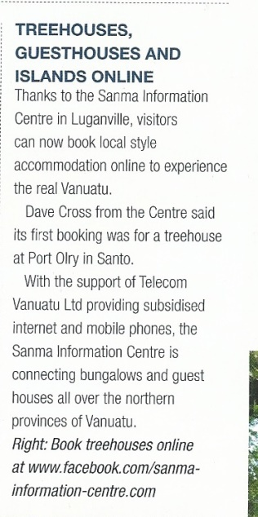Staff are now able to use a reservation system and can manage bookings on their own
* MYOB accounting system is in use and comprehensive reports are issued to the board of management monthly.
* The Management Board has been strengthened and the correct cross-organisational governance arrangements have been implemented.

Although the initial progress of SICC has been slower than expected, it is still anticipated that by the end of 2015 SICC will integrate the commercialisation of products from Torba province.

## Sanma Media and Public Relations

Six articles relating to the Sanma TfT Program were published in the national and international press in 2014-15. Highlights from these include a four page article focusing on the successes of the TfT Program in Port Orly in a popular regional magazine.

## Conclusions & Future Directions

The third year of Sanma TfT Program implementation has shown contrasted results. Clients such as Port Orly tourism zone and Millennium Cave Ltd have demonstrated continued improvements and success and thus increased credibility in the program and its methodology. At the same time many other clients have showed very low achievement and a lack of interest in continuing to develop their products. This is partly due to the continued increase in cruise ship arrivals and mentality that ‘mentoring is not necessary’. The slow start of SICC can also be partly attributed to an initial lack of interest from local tourism businesses.

Given this lack of enthusiasm the TfT Program proposes a new approach in Sanma province:

1. Coaching support ‘per request only’ for existing clients: during the last three years all product owners who registered with TVET program were offered access to the mentoring program. It is now proposed to offer mentoring support only to clients who make a formal request for assistance and sign up on to a ‘mentoring TfT contract’. This contract will be based on a formal discussion between the Sanma TVET Centre and client to first agree on common development objectives.
2. New product development: the increasing number of cruise boats in 2015 & 2016 has led to a request from the DoT to assist in identifying and up-skilling potential new product operators to qualify to Carnival Australia & DoT minimum standards. The TfT Program has recently identified seven new tours and activities that could be assisted in the next year of implementation.

Special projects:

* The TfT Program should assist the VTO and DoT to acquire a Volunteer Service Abroad or AVID full-time volunteer to enhance Call Centre operations in order to secure quicker development and SICC sustainability and reduce costs incurred by the TfT Program in the provision capacity building by the industry consultant.
* Should the TVET Program and NZ Aid agree to develop an accredited training qualification for public transport then TfT can assist with input in the development of a VQA-endorsed specific training cluster dedicated to tour operators & transfer drivers.
* Should Carnival Australia and the TVET Program enter into formal agreement for implementation of the proposed ‘Port Of Call Skills Development’ initiative, TfTcan work with the DoT I, the development of; Champagne Beach and/or Luganville Port of Call, designing specific programs adapted to each local context.

# Torba Program Review

## Program implementation

The TfT Torba Program was launched in March 2014 with an emphasis on basic tourism skills development. The objectives of the first year of this program were:

* To select motivated operators in Gaua, Sola and Motalava/Rah
* To assist with coaching to generate action plans & improve momentum
* To with safety & quality development for tours and activities
* To assist accommodation in reaching minimum quality standards (DoT)

TfT skill development activities delivered in Torba Province in 2014-15 included:

## Client achievements

The TfT Program supports 25 clients on three islands in Torba Province. While previously the industry has been slow to develop in the region due to limited tourism numbers (<300 per year) the momentum and enthusiasm for tourism development within the community were noted both by industry experts and TVET Program staff. While only one product was at standard before TfT Program support, there are currently six products which meet the DoT minimum standards.

Since the TfT Program has been operating in Torba, the industry experts coaching individual businesses have worked to raise awareness of both tourist expectations as well as government regulations and the responsibilities of tourism business owners. As a result, 24% of TfT clients are now registered businesses compared to 4% when the program first began.

These improvements are further highlighted by the increase in average KPI scores from 16 during the first scoping exercises in late 2013 to 23 in 2014.

|  |
| --- |
| *CASE STUDY: Local Private/Public Partnership*  Like most of the outer islands of Vanuatu, one of the main challenges for tourism businesses attempting to reach minimum DoT standards is access to water. At the start of the TfT Torba program none of the six clients on Motalava/Rah had access to running water. Thanks to a donor aid program, a community water project had been installed on the two islands earlier in the year, however, the community had ruled that only community housing (not bungalows) would be able to access this. Through local DoT and TfT industry coaching, several meetings were organised to try to evaluate how bungalows’ properties could have access to water without depleting water levels. An agreement was reached with the Water Committee in November to temporarily authorise each bungalow to connect to the water system to fill up their personal water tanks. If water levels remain above a critical level, the Water Committee will then allow these businesses to permanently connect in the future. In exchange for this access, these tourism businesses will contribute financially to the maintenance of the water project to ensure its ongoing sustainability. This agreement is the first one of this kind in Torba. |

|  |
| --- |
| *CASE STUDY : Motalava-Rah Clients show amazing achievements*  When the TfT Program began coaching in Motalava-Rah in March 2014, there were six tourism projects. Five of them were struggling with low visitor numbers and were very far from minimum standards. Only one, a long time established property called Rah Paradise Bungalows, was enjoying 95% of all visitors to the two islands. This situation was creating tension within the community as the five properties did not know how to compete with this one business. Within the 10 months since the TfT program was launched, all properties showed amazing motivation to improve their bungalows. In April 2015, at a high-level launch event, the following will be witnessed:   * 2 re launchings of properties which have completely renovated their product * 3 openings of brand new bungalows * 1 new cultural tour that will revive local culture   Interestingly, the property which was the most advanced and getting all tourists now feel that they will need to move up into providing a higher quality offer and build a new “luxury bungalow” as a prototype for their future development, which is a further indication of progress for the sector on the island. |

Before the TfT Program:

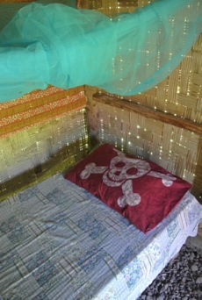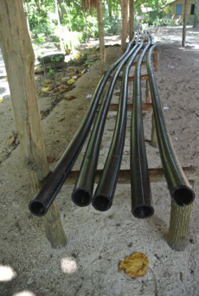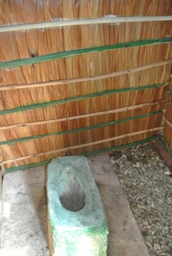

After the TfT Program:

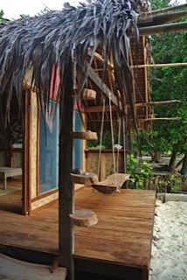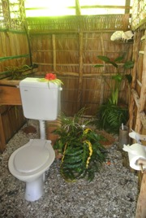

## Torba Media and Public Relations

Since the launch of the TfT Torba program in March 2014 there have been five articles directly related to the program in local and international media. Highlights from these articles include the positive flow on effects of tourism on farmers and vegetable production in the region.

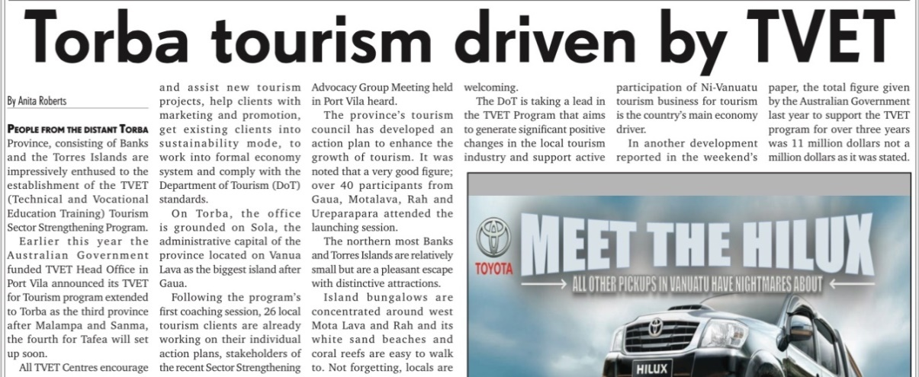

## Conclusions & Future Directions

The initial one year TfT Program in Torba province has been successfully implemented. A second year will now focus on business development and tour & accommodation operations.

Main objectives will be:

* To strengthen operational capacity and focus on customer satisfaction.
* To start basic marketing with clients in coordination with the DoT in preparation to connect to the Sanma Information and Call Centre.
* To facilitate qualifications of tour guides (first aid and tour guiding) to secure quality of all tours especially to Gaua Volcano and Sleeping Mountain Tour which present safety issues.
* To develop specific coaching in Sola area to focus more on business visitors and customer service.

The TfT Program will also conduct two coaching sessions in Ureparapara Island and Loh island to give coaching opportunities to these few operators who have previously existed outside of TfT scope in Torba.

Special projects:

* In parallel, TfT team will adapt to Carnival Australia strategy. The company has expressed the willingness to develop one Port of Call in Torba province. Should this strategy be confirmed, the TFT Program will organise a scoping exercise to develop a Port of Call Skills Development plan if necessary.
* A professional photographer will be engaged to generate the first Torba professional photos to facilitate marketing of the bungalows and tours.
* By the end of the year, TfT should facilitate connection of these clients to a call centre whether in Torba or in Santo. Whatever solution appears to be the most cost efficient and practical.

# TVET for Tourism & Women

## TfT Female Inclusion Rate

The TfT Program has actively promoted equality throughout tourism-based skill development activities since its pilot in 2009. The program encourages women with an interest in tourism to attend its coaching, workshops and accredited training programs. The program also provides support and capacity building opportunities for female industry experts, trainers and DoT partners. Since the launch of the Vanuatu TVET Centres’ Gender Equality Strategy (GES) in 2014 the TfT Program has formalised its gender equality goals in line with key objectives of the strategy.

In line with Objective 1 A in the GES the TfT Program aims to maximise its female participation with a goal of 50% in all provinces. In 2014 the TfT Program had a female inclusion rate of 43% in all TfT skill development activities. As defined in Objective 1 L, ‘Identify female industry experts’, two local female industry experts have been identified and engaged by the TfT Program in 2014 with plans to contract them again for more skill development workshop in the coming years. In total the TfT industry expert pool has a female inclusion rate of 65%. In step with Objective 4 of the GES the TfT Program will now be monitoring and tracking annual gender equality results as well as collecting qualitative data on the experiences of women in rural tourism.

|  |
| --- |
| *CASE STUDY: DoT Officer Capacity Building- Edna Paolo*  C:\Users\LBattaglene\AppData\Local\Microsoft\Windows\INetCache\Content.Word\edna.pngSince 2010 the TfT Program has worked to build the capacity within the DoT through mentoring sessions with industry experts and formal training via the NCBP. Of the fourteen DoT staff, six are women and three are based in provinces in which the TfT Program operates. Edna Paolo, the Malampa Product Development Officer, has been receiving mentoring and support from the TfT Program since the pilot program in 2009. Due to the growth of the tourism industry in Malampa and the success of TfT clients she was recently promoted to Manager of the Malampa DoT and given a second staff member to support her in her work. This is the first time a woman in a provincial DoT office has been promoted to the level of Manager. Edna currently manages a team of seven staff including four volunteers and directs all TfT activities in Malampa. She is currently in negotiation with the VTO in Port Vila for an additional marketing budget specifically for Malampa Province. |

|  |
| --- |
| *CASE STUDY: Individual Clients & Participants- Erima and Naewen*  C:\Users\LBattaglene\AppData\Local\Microsoft\Windows\INetCache\Content.Word\Naewen A.PNG  The TfT Program actively supports and encourages women to engage in the tourism industry both in traditional and non-traditional roles.  Naewen Arnhambath is the Manager of Big Nambas Bungalow in Tenmaru, Malekula. She has been part of the TfT Program since 2012. Through the support of the TfT Program Naewen recently completed a Certificate III in Hospitality at the Australian Pacific Technical College in Port Vila. She lives in Tenmaru and continues to develop her skills in hospitality and tourism through the TfT Program. Naewen recently stated that due to her successful bungalow business “now when I walk through the village the men respect me and you can tell that something has changed”.  C:\Users\LBattaglene\AppData\Local\Microsoft\Windows\INetCache\Content.Word\Erima N.PNG  Erima Nunumbal is a mother, wife and also the lead Tour Guide at Rano Cannibal Site and the Dog Head Tour. As a woman, Erima was initially worried about joining the tour guiding training as it was ‘men’s work’ but since developing her own tours she and her husband have managed to earn money for their children’s secondary school fees. Erima continues to be supported by the TfT Program and recently completed a First Aid course.  Both Erima and Naewen were interviewed recently as part of the TVET Program’s DVD “Skilling Women - Empowering Communities”. |

|  |
| --- |
| *CASE STUDY: Industry Experts – Esline and Serah*  In 2014 TfT Program actively sourced and engaged local industry experts to provide tourism-specific coaching and workshops. As part of this initiative the program contracted two local female industry experts, Serah Tari and Esline Felix, to deliver skill development sessions covering massage therapy and business management. With the support of the TfT coordinators and TVET Centre staff these local business women have been able to transfer their skills to over 25 participants in Sanma and Malampa province with plans for them to deliver further workshops in the near future. Through the TVET Program’s Training Provider Support Services, Esline underwent professional training and completed a Certificate IV in Training and Assessment in December 2014 while Serah plans to attend the same training in 2015.  IMG_9889 |

# Challenges and Next Steps

## Tafea Province

In January 2014 the TfT National Coordinator participated in a scoping exercise in Tafea province to determine tourism skills development needs. Two main findings arising from this trip were:

### Mystery Island – Port of Call Skills Development Program

Mystery Island is the second largest port of call for cruise-ships in Vanuatu with over 75 stops per year. While this high tourism activity is already generating income there are many areas needing skills development within the community both for sustainability and inclusive economic growth outcomes.

### Tanna Island

Tanna is the third most popular destination in Vanuatu for air tourists. First estimates counted over 80 locally owned tourism products on the island at varying levels of development. This represents almost the same number of clients in Malampa and Sanma provinces combined, and therefore engaging all of these businesses is not feasible given the TfT budget.

Instead the TfT Program will develop a pilot program with the 20 largest operators in order to quickly obtain results and set some precedent for other products further down the line. At the same time TfT proposes to capitalise on the success of the NCBP; by giving the Tafea DoT officers the lead role of ‘coaching and mentoring’ this will allow them to gain ‘real life’ coaching experience with the ongoing support of TfT industry experts. This new approach will secure improved sustainability by transferring the mentoring program to the DoT. This new methodology will also drastically reduce the cost of the program. In this new methodology industry experts will only run workshops and offer technical support to DoT junior coaches.

## Port of Call Skill Development Program

Further to the Wala Port of Call initiative and in preparation for discussions between the TVET Program and Carnival Australia ,the TfT Program created a new methodology to implement skill development activities focused on the sustainable development of Ports of Call in Vanuatu. This methodology will be adapted to each Port of Call according to needs and context. A first proposal was developed for Mystery Island. TVET Program management is currently in discussion with Carnival Australia and DFAT to negotiate the implementation of this program through a cost-sharing arrangement..

|  |
| --- |
| Diapositive04 |

## Reintegration of Accredited Training in TfT work plan

The suspension of all registered training providers in 2013 had a large impact on the TfT skill development program and its methodology. The key success factor of the TfT Program in previous years was the blend of business development services with accredited, formalised training. The TfT Program has since identified two crucial needs for accredited training amongst the 100+ client base in the areas of accommodation services and tour guiding. Using the training clusters developed with the VQA and the international technical adviser, the TfT Program anticipates delivering these trainings throughout its programs with specific focus on emerging provinces. The TfT Program and the DoT have also highlighted the need for accredited training cluster development in food and beverage services, accounting, basic computer skills and public transport.

## New DoT Accreditation System

The DoT is in the process of finalising a new accreditation system for tourism businesses based on the previous DoT minimum standards. These requirements are much higher than the original draft and will put TfT clients under a lot of pressure to comply with standards. The new standards include several serious training requirements and there are concerns that the TfT Program is now seen as the ‘official provider’ for this training. This accreditation system creates two new challenges:

* The demand for accredited training in First Aid and Tour Guiding may rise dramatically in each province and the TfT Program will need to negotiate how much of this training it can provide within available budget. A new Tvet Program– DoT MoU will have to be re-negotiated taking this large training request into consideration.
* Coaches assisting clients to comply with standards could now been seen as “DoT assessors” and not skill developers anymore and this needs to be monitored and managed to reduce suspicions and negativity.

## Industry Expert Localisation

A major focus of the TfT Program in 2015-16 is long-term sustainability. To achieve this goal it is essential that training and coaching capacity be available in Vanuatu and that expatriate consultants be used mostly in strategic and highly technical areas. To achieve greater localisation, the TfT Program will:

* Continue to identify local, TAE qualified industry experts and assist them deliver more complex training and coaching activities.
* Encourage DoT officers who have been trained during the NCBP to take active coaching roles within their provinces
  + Two or three DoT officers will also be selected and invited to attend the Certificate IV TAE in 2015
  + Key officers in Malampa, and Tafea will be handed over all coaching responsibilities.

## Localisation of the TfT Coordinator Role

To meet the long term objective of the sustainability in the TfT Program, the roles of TfT Associate Coordinator and National Coordinator will become localised and merged into one role- ‘TfT Coordinator’ before the completion of the 2015-16 work program. The TfT coordination team is currently in the process of identifying potential candidates and plan to employ a counterpart for the Associate Coordinator in the coming months to ensure a long handover period until December 2015.

The current National Coordinator will then continue to support this role as TfT Technical Adviser.

# Annex 1: TfT Client Monitoring and Evaluation Plan

**Definitions**

|  |  |  |
| --- | --- | --- |
| **Indicator/Variable** | **Definition** | **Notes** |
| Client | A business or organization that is being supported and coached by TfT |  |
| Clients- Hospitality | A client based in the hospitality industry such as a restaurant, bungalow or guesthouse |  |
| Clients- Tours and activities | A client based in the tours industry such as a tour operator, dance group or custom display village. |  |
| Clients- Government Bodies | A client which is part of the Vanuatu government or supported by it. | This includes provincial DoT offices as well as call centres. |
| Worker | A person who works for a client and is paid either in vatu or kind | This includes part time and casual staff or even family members who receive benefits for the work their contribution to the business |
| Participant | A person who is linked to a client and participates in any TfT activities | This includes all attendees at client coaching, workshops and accredited training who are linked with a client. |
| Workshop | An unaccredited group activity that is intended to transfer customised skills and/or knowledge |  |
| Coach | An Industry expert who provides ongoing support to a client via face-to-face coaching meetings and workshops |  |
| Coaching Visit | A visit by a coach to a particular island for the purpose of delivering workshops or coaching meetings. |  |
| Coaching Meeting | A face-to-face meeting between a coach and client to discuss this specific business’s action plan |  |
| Key Performance Indicators (KPIs) | A set of 17 quantifiable measures that TfT coaches use to compare performance and development of tourism businesses in terms of meeting their strategic and operational goals | There are two different sets of KPIs for Hospitality clients and Tourism & Activities. Both include 17 individual indicators with ratings of between 0-5 with a total score measured out of 85. |
| APTC Graduate | A worker who holds any qualification from APTC | The worker received this qualification at any time in the past regardless of who they were working for. |
| New APTC Graduate | A worker who has completed an APTC qualification while the last 3 months. | The worker received this qualification in the last 3 months regardless of who they were working for. |
| DoT Minimum Standards | The standards released by the DoT to cover the minimum requirements for all Hospitality and Tourism based businesses in Vanuatu |  |
| Carnival Australia Approval | Businesses approved by Carnival Australia to be promoted and used by P&O Cruise Ships during shore leave | Only refers to Clients- Tours & Activities |
| Business License | Current Business Registration OR Vanuatu Business License issued by the Provincial Government OR Customers & Inland Revenue Department |  |
| Trip Advisor Rating | The rating (1-5) that a business has received from reviews on the trip advisor website | This appears as green circles on the client’s Trip Advisor page. It is different to their ‘ranking’. |
| Stage of development | Whether a client is operating at an informal, semi-formal or formal level. | This is measured by looking at the client’s level of bookkeeping, formal documents and their Accounting KPI rating. |
| Informal Level | A business with little or no formal documentation, irregular income and a rating of less than ‘3’ on the Accounting KPI. |  |
| Semi-Formal Level | A business with a valid business license, proper bookkeeping a rating of ‘3’ or more on the Accounting KPI but does not reach an income of 4,000,000vt per annum. |  |
| Formal Level | A business with a valid business license, proper bookkeeping and documentation, a rating of ‘3’ or more on the Accounting KPI, pays VNPF & VAT, with an income over 4,000,000vt per annum | Note the Vanuatu Government recognizes businesses as a formal economic entity when its incomes reaches 4,000,000vt per annum |

**List of KPIs and Guidelines**

**Hospitality Clients**

|  |  |  |  |  |  |  |
| --- | --- | --- | --- | --- | --- | --- |
| **Indicators** | **Ranking** | | | | | |
| **NA** | **Very Poor** | **Poor** | **Acceptable** | **Good** | **Very Good** |
| 0 | 1 | 2 | 3 | 4 | 5 |
| **Site & Building** |  |  |  |  |  |  |
| Site & construction appearance (access, entrance, garden, beach, parking, view, bungalow design and material used ) | project | land dispute, no view, far from everything, bad access, cement, bad design | far from everything, poor design, not much activity around, minimal view | okay view, moderate distance to everything, average | good view, water access, local material design, site optimized | World-class location, luxury design, quality material, amazing view from the bungalow |
| Quality standards - bedroom (size, view, decoration, bedding & linen, furniture and light) | project | small, no view, no decoration, low quality furniture & equipment | small, very small windows, basic furniture and equipment, poor or no decoration but clean | meets DoT standards | exceed standards on some of the point, nice decorations | exceptional quality furniture and decoration |
| Quality standards- bathroom (water, toilet & shower, size & comfort) | project | very small, no running water, concrete | small, concrete, not comfortable | meets Dot Standards | spacious, light, comfort, well equipped | exceptional design, concept harmony, quality |
| Level of maintenance (site and buildings) | not operating | rusty, dirty, old, water leaking, paint peeling, broken items | getting old, looking 'tired' | no major fix's needed | well maintained with nothing major to be fixed | brand new or very well maintained |
| **Marketing** |  |  |  |  |  |  |
| Marketing material (brochure, business cards, photos, guest book, bungalow description, tour descriptions) | not operating | nothing | guest book only | brochure or business card, product description, few nice photos | most of the material | all material in good condition updated and used |
| Local & International distributors (Key distributors in Vila, NC, Australia, NZ, Europe) | not operating | no distributor | some contacts but nothing formalized | work with some distributors | have distributors in NC, NZ and Australia | Worldwide coverage with both Traditional and internet distributors |
| Advertising & web performance (main travel guides, VTO offices, main websites, Trip Advisor, own website, call center, provincial website, social media, tradeshows) | not operating | no advertising or internet presence | VTO web site only | VTO website + own website + trip advisor | Own web site, several other web sites | multichannel distribution +tradeshow |
| **Operation** |  |  |  |  |  |  |
| Staff performance (quality of guest relations, housekeeping performance, waitress performance, level of hygiene, grooming & uniform, level of training & knowledge) | not operating | not qualified , poor English, bad customer service | basic service but quality & hygiene still minimal | meets DoT standard | good communication, customer service and hygiene | exceptional communication skills, quality customer service |
| Tariff (available and appropriate to services offered for accommodation/restaurant/tours) and billing system | not operating | one fixed price, no proper invoice | fixed price + receipt | menu, international and local prices + proper invoicing | master wholesaler and direct price, variable according to service, packages | master wholesaler and direct price, season and promotion, variable according to service, packages |
| Communication tools (telephone, email, internet) | not operating | unreliable telephone reception | reliable telephone reception | reliable telephone and email | reliable telephone + email + internet access regularly | reliable telephone + email + internet access 24H |
| Booking system (reservation book or reservation software, accuracy of booking , quality of information, occupancy ratio) | not operating | by memory only | in a book or note pad | green book or diary | on excel | reservation software |
| Accounting system (income book, expenses book, receipts & invoices, monthly profit, accuracy of data) | not operating | no accounting | receipts sometime | proper income and expense recorded | detailed book keeping | MYOB |
| Waste Management Plan (WMP) and processes | not operating | no waste management activities | some waste management activities | Steps in place to manage waste more effectively (recycling/compost etc.) | Actively managing waste | Integrate waste management system into the marketing of product "eco" |
| Level compared with Department of Tourism Official Standards | not operating | far away from DoT standards | few DoT standards met, many more to go | has met DoT standards | has gone just above DoT standards | has exceeded DoT standards |
| **Food & Services** |  |  |  |  |  |  |
| Services offered (tours, transfers, bar & cold drink, free activities, kava night) and customer care performance | not operating | no service beside food & accommodation | few activities | transfer, tours & activity some customer care | bar, tour desk | all |
| Kitchen facilities & hygiene (Stove, fridge & freezer, organization and cleanliness) | not operating | basic Melanesian kitchen, hygiene not guaranteed | Melanesian kitchen clean | proper kitchen hygiene | fridge or freezer | professional kitchen |
| Food quality and authenticity (availability, choice, ingredients, taste, presentation) | not operating | basic Melanesian plate | one plate, no desert, no fruit, no drink | no choice  meal, dessert, drink | effort in food preparation, choice and diversity | real menu and Melanesian authenticity |

**Tours & Activity Clients**

|  |  |  |  |  |  |  |
| --- | --- | --- | --- | --- | --- | --- |
| **Indicators** | **Ranking** | | | | | |
| **NA** | **Very Poor** | **Poor** | **Acceptable** | **Good** | **Very Good** |
| 0 | 1 | 2 | 3 | 4 | 5 |
| **Interest & Attractiveness** |  |  |  |  |  |  |
| Tours natural beauty and interest (site quality, view, attraction, uniqueness) | project | not interesting or too far away | poor interest | interesting but limited potential | nice site with some potential | nice site, great potential, unique |
| Tour accessibility (level of difficulties, access to site) | project | not accessible for normal tourists, not safe | not accessible for all, not always safe | accessible for all, not always safe | accessible for all, always safe for all | always safe, easy access for all tourists |
| Tour logistics (organization, timing, stops, availability) | project | not on time, many gaps in between activities, some activities not covered | not on time, gaps in between activities | on time but some gaps in between activities | on time, few gaps in activities | all activities running smoothly and on time as advertised |
| Quality of the site (toilet, pathway, recreation & resting area, shelters, seating, rain protection) | project | no toilet, no shelters, no clear pathway | unclean toilet, basic shelter for resting, no seat | clean toilets, clear pathways, basic resting area and shelters with seats | bucket flush toilets, clear pathways, protected resting areas and shelters with seating | flush toilets, clear and safe pathways, protected resting areas and shelters with seating |
| Value for money | not operating | very expensive or very cheap | expensive or cheap | little bit expensive or little bit too cheap | slightly too expensive or cheap | fairly priced |
| **Marketing** |  |  |  |  |  |  |
| Marketing material (brochure, business cards, photos, guest book, tours description & maps) | not operating | nothing | guest book only | product description, few nice photos | brochure or business card | all material in good condition updated and used |
| Local & International distributors (distribution by hotel& bungalows, Key distributors in Vila, NC, Australia, NZ, Europe) | not operating | no distributor | only few local contacts | work with some distributors | have distributors in NC, NZ and Australia | Worldwide coverage with both Traditional and internet distributors |
| Advertising & web performance (main travel guides, VTO offices, main websites, Trip Advisor, Own website, Call center, provincial website Social Media, tradeshows) | not operating | no advertising or internet presence | VTO web site only | VTO website + call center + trip advisor | Own web site, several other web sites | multichannel distribution +tradeshow |
| **Operation** |  |  |  |  |  |  |
| Guide Quality (quality of expression, knowledge & information, custom care, tour guide training, Uniform & presentation) | not operating | not qualified , poor English, bad customer service, no uniform | basic service but quality & hygiene still minimal | meets DoT standard, some knowledge, can communicate in English, basic hygiene and quality of service | good communication, customer service and hygiene, uniform, knowledgeable | exceptional communication skills, quality customer service and knowledge, uniform and name badge |
| Tours safety and security, tours equipment, first aid kits and first aid training | not operating | no safety and security training, no equipment, no first aid kit | old equipment, basic first aid knowledge | guides have completed a first aid training and carry a first aid kit on tours, up to date equipment | guides trained in first aid as well as search and rescue, up to date equipment | all personnel trained, new equipment, risk management system in place |
| Communication tools (telephone, email, internet) | not operating | unreliable telephone reception | reliable telephone reception | reliable telephone and email | reliable telephone + email + internet access regularly | reliable telephone + email + internet access 24H |
| Booking system (reservation book or reservation software, accuracy of booking , quality of information, occupancy ratio) | not operating | by memory only | in a book | green book or diary | on excel | reservation software |
| Accounting system (income book, expenses book, receipts & invoices, monthly profit, accuracy of data) | not operating | no accounting | receipts sometime | proper income and expense recorded | detailed book keeping | MYOB |
| Waste Management Plan (WMP) and processes | not operating | no waste management activities | some waste management activities | Steps in place to manage waste more effectively (recycling/compost etc.) | Actively managing waste | Integrate waste management system into the marketing of your product "eco" |
| Level compared with Department of Tourism Official Standards | not operating | far away from DoT standards | few DoT standards met, many more to go | has met DoT standards | has gone just above DoT standards | has exceeded DoT standards |
| **Services & Transfer** |  |  |  |  |  |  |
| Customer services (F&B, client equipment, mosquito repellent & sun cream, souvenirs and documentation, photos) | not operating | no services beside tour/activity provided | few extra services, very basic, refreshments | some services such as food and beverages as well as equipment provided | good food and beverage options, up to date equipment, repellent or sun cream also provided | all provided |
| Transportation (hotel pick-up and drop off, quality of transfer to site) | not operating | no transfer offered | transfers in public vehicle, multiple users | transfers offered in private vehicle | transfers offered in twin cab private FWD truck | pick up and drop off in an air conditioned twin cab 4WD |

**TfT M& E Indicator Collection and Storage**

|  |  |  |
| --- | --- | --- |
| **Activity Indicators** | **Storage** | **Collection** |
| # clients- hospitality (by Province) | Client File- TfT Database | Coaching |
| # clients- tours and activities (by Province) | Client File- TfT Database | Coaching |
| # clients- Government Bodies (by province) | TfT Database | Coaching |
| # clients total | Client File- TfT Database | Coaching |
| # participants per client (by sex & Province) | Client File- TfT Database | Client Monitoring Records |
| # participants per TfT activity (by province)- | BDS monthly progress reports- TfT Database | BDS Officers reports |
| Average # workers per client (by Province) | Client Files- TfT Database | Client Monitoring Records |
| # workshops (by province) | BDS monthly progress reports- TfT Database | BDS Officers reports |
| # coaching meetings (by Province) | BDS monthly progress reports- TfT Database | BDS Officers reports |

|  |  |  |
| --- | --- | --- |
| **Performance Indicators** | **Storage** | **Collection** |
| Average KPI performance (%) (by Province) | Client Files- TfT Database | Coaching |

|  |  |  |
| --- | --- | --- |
| **Business Indicators** | **Storage** | **Collection** |
| # clients (Hospitality) meeting DoT standards (by Province) | Client Files- TfT Database | Client Monitoring Records |
| # clients (Tours & Activities) meeting DoT standards (by Province) | Client Files- TfT Database | Client Monitoring Records |
| # clients with a business license (by Province) | Client Files- TfT Database | Client Monitoring Records |
| # clients registered with Call Centre (by Province) | Client Files- TfT Database | Client Monitoring Records |
| # clients at each stage of business development (IF,SF,F) (by Province) | Client Files- TfT Database | Client Monitoring Records |
| #clients with at least 4 starts on Trip Advisor (by Province) | Client Files- TfT Database | Client Monitoring Records |
| # clients approved by Carnival Australia (by Province) | Client Files- TfT Database | Client Monitoring Records |
| # APTC graduates | Client Files- TfT Database | Client Monitoring Records |
| # New APTC Graduates | Client Files- TfT Database | Client Monitoring Records |

# Annex 2: Media and Public Relations List

**2014**

1. ‘TVET kickstarts tourism program in Torba’, *Vanuatu Daily Post*, May 22, p5
2. ‘Inspection to determine Wala’s tourism sustainability’, *Vanuatu Daily Post*, May 28, p3
3. ‘TVET and DoT sign MOU for 2014/15 TVET tourism training program’, *Vanuatu Tourism Nius*, June 2, p3
4. ‘Mou signed for TVET for Tourism next phase’, *Vanuatu Daily Post,* June 5, p4
5. ‘Torba Tourism driven by TVET’, *Vanuatu Daily Post*, July 10, p5
6. ‘Full house attendance at producers’ workshop’, *Vanuatu Daily Post*, July 16, p2
7. ‘Torba Training targets vegetable farmers’, *Vanuatu Daily Post*, July 21, p2
8. ‘Website connection rocketed number of visitors to local bungalow’, *Vanuatu Daily Post*, July 30, p4
9. ‘Tree houses, guesthouses and islands online’, *Island Spirit Magazine*, July Edition
10. ‘Tour Operators embrace waste management solutions’, *Vanuatu Daily Post*, September 12, p2
11. ‘Entries open October 27 for Vanuatu Tourism Awards’, *Vanuatu Daily Post*, October 23, p4
12. ‘Malampa Province packages for travellers’, *Vanuatu Infos*, October 31
13. ‘Malampa Province Packages for tourists’, *The Independent*, November 1, p17
14. ‘Malekula and Ambrym Islands- open to explorers’, *Vanuatu Daily Post*, November 1, p7
15. ‘Millennium Cave becomes a company’, *Vanuatu Daily Post*, November 2, p3
16. ‘CEO of award winning tour company graduates’, *Vanuatu Daily Post,* November 11, p3
17. ‘Week showcases destination Vanuatu’, *The Independent,* November 22
18. ‘Ambrym tourism sector resumes following airport re-opening’, *Vanuatu Daily Post,* November 29, p4

**2015**

1. ‘Paradise Found: Island style bisnis’, *Island Life Magazine,* January 2 p6-9
2. ‘Visitors run out of buses, taxis’, *Vanuatu Daily Post*, January 31, p1
3. ‘TVET trainings help boost local bungalow, Rah Island’, *Vanuatu Times Newspaper,* 25 February, p3
4. ‘Marketing booklet launched for rural businesses’, *Vanuatu Daily Post,* March 2, p3
5. ‘Rural tourism operators acquire first aid skills’, *Vanuatu Daily Post,* March 3, p3

1. For the TfT Program’s working definitions of informal, semi formal and formal economies please refer to the TfT Client Monitoring &Evaluation Plan in Annex 1. [↑](#footnote-ref-1)
2. Since 2011 the TfT Program has collected tourism standards data based on an early draft of the DoT Tourism Minimum Standards. In December 2014 an official version of these ‘Accreditation Standards’ were launched with a grace period for implementation of twelve months for all tourism businesses. As the accreditation system is still undergoing final alterations, the TfT Program will continue to rely on the 2011 draft when determining whether clients meet or exceed standards. [↑](#footnote-ref-2)
3. For further detail of the TfT Program’s KPI system please refer to the TfT Client Monitoring &Evaluation Plan in Annex 1. [↑](#footnote-ref-3)