Appendix 1

# Tabulated Results of Quantitative Questions

The online survey was circulated in late November 2020. It was completed by 35 individuals.

## Wan Smolbag in General

1. Who completed the online survey?

| Completed By | Percentage |
| --- | --- |
| WSB Staff, Management and Actors | 32% |
| Former WSB Volunteers | 17% |
| Core Donor Partners | 14% |
| Partners (including local partners, other donors and government) | 37% |
| Total | 100% |

2. How familiar would you say you are with WSB and its work?

|  |  |
| --- | --- |
| Level of Familiarity | Percentage |
| Extremely familiar | 23% |
| Very familiar | 60% |
| Somewhat familiar | 17% |
| Not so familiar | 0 |
| Not at all familiar | 0 |
| Total | 100% |

3. How would you rate Wan Smolbag’s overall effectiveness?

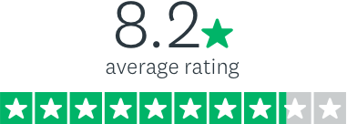

4. In your view how effectively does Wan Smolbag embody, reflect and cultivate the vision and values expressed in the Wan Smolbag Roadmap for Change 2014-25 in their work?

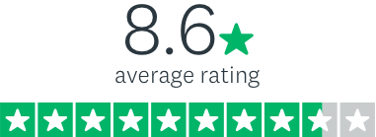

## Is Wan Smolbag doing things right?

In this section, please consider the effectiveness of Wan Smolbag’s OUTPUTS (i.e. their activities, plays, films, classes, etc.) in terms of quality and ‘dose’ (‘dose’ refers to how many times people participate in or are exposed to the materials or activities).

5. How would you rate the overall QUALITY of the services provided by the clinics and the peer educators at Wan Smolbag?

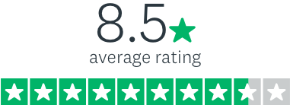

6. In your view, approximately what percentage of people who visit the clinics or who use the peer educators do so more than once?

|  |  |
| --- | --- |
| How many people do so more than once | Percentage |
| 75% to 100% | 23% |
| 50% to 74% | 31% |
| 25% to 49% | 3% |
| 0 to 24% | 0 |
| Unable to comment | 43% |
| Total | 100% |

7. How would you rate the overall QUALITY of the work carried out by the Nutrition Centre at Wan Smolbag?

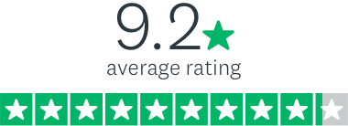

8. In your view, approximately what percentage of people who participate in activities offered by the Nutrition Centre do so more than once?

|  |  |
| --- | --- |
| How many people do so more than once | Percentage |
| 75% to 100% | 31.5% |
| 50% to 74% | 31.5% |
| 25% to 49% | 0% |
| 0 to 24% | 0 |
| Unable to comment | 37% |
| Total | 100% |

9. How would you rate the overall QUALITY of the work Wan Smolbag does in the area of waste management and community clean up (including involvement in the Tagabe River)?

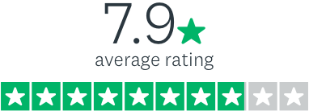

10. In your view, approximately what percentage of people who take part in the waste management and community clean-up work do so more than once?

|  |  |
| --- | --- |
| How many people do so more than once | Percentage |
| 75% to 100% | 20% |
| 50% to 74% | 29% |
| 25% to 49% | 14% |
| 0 to 24% | 0 |
| Unable to comment | 37% |
| Total | 100% |

11. How would you rate the overall QUALITY of the work of Wan Smolbag's Vanua-tai Resource Monitors (also called the ‘Turtle Monitors’)?



12. In your view, approximately what percentage of people who engage with the work of the Vanua-tai Resource Monitors do so more than once?

|  |  |
| --- | --- |
| How many people do so more than once | Percentage |
| 75% to 100% | 31% |
| 50% to 74% | 23% |
| 25% to 49% | 0 |
| 0 to 24% | 0 |
| Unable to comment | 46% |
| Total | 100% |

13. How would you rate the overall QUALITY of the activities provided by Wan Smolbag's Youth Centres (including sports, musical training, sewing, literacy, art, drama etc.)?

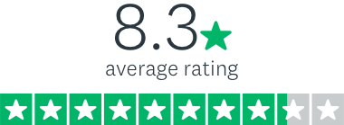

14. In your view, approximately what percentage of people who participate in Youth Centre activities do so more than once?

|  |  |
| --- | --- |
| How many people do so more than once | Percentage |
| 75% to 100% | 40% |
| 50% to 74% | 37% |
| 25% to 49% | 3% |
| 0 to 24% | 0 |
| Unable to comment | 20% |
| Total | 100% |

15. How would you rate the overall QUALITY of the plays and community workshops offered by WSB?

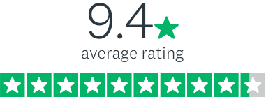

16. In your view, approximately what percentage of people who see a play and/or participate in a community workshop do so more than once?

|  |  |
| --- | --- |
| How many people do so more than once | Percentage |
| 75% to 100% | 46% |
| 50% to 74% | 26% |
| 25% to 49% | 11% |
| 0 to 24% | 0 |
| Unable to comment | 17% |
| Total | 100% |

17. How would you rate the overall QUALITY of the films and other creative media products (including radio plays, Love Patrol, publications) offered by WSB?

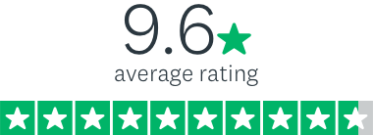

18. In your view, approximately what percentage of people who watch a Wan Smolbag film or engage with other creative media (radio plays, Love Patrol, publications) do so more than once?

|  |  |
| --- | --- |
| How many people do so more than once | Percentage |
| 75% to 100% | 52% |
| 50% to 74% | 31% |
| 25% to 49% | 3% |
| 0 to 24% | 0 |
| Unable to comment | 14% |
| Total | 100% |

## Is Wan Smolbag doing the right things?

This section endeavours to assess the effectiveness of Wan Smolbag’s progress towards OUTCOMES (as articulated in their Program Logic). ‘Outcomes’ refer to what people will be doing differently as a result of Wan Smolbag’s work.

19. How would you rate Wan Smolbag's effectiveness in supporting people in Vanuatu (including youth) to have a greater awareness of issues impacting their health and well-being?

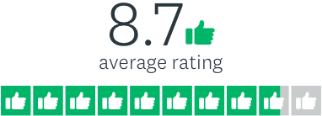

20. How would you rate Wan Smolbag's effectiveness in supporting people in Vanuatu (including youth) to make more informed choices and take concrete steps to improve their sexual and reproductive health?

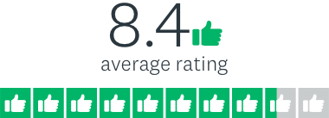

21. How would you rate Wan Smolbag's effectiveness in supporting people in Vanuatu (including youth) to make more informed choices about what they eat and take concrete steps to improve their nutrition?

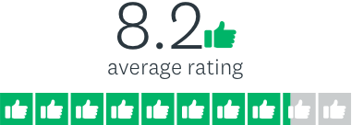

22. How would you rate Wan Smolbag's effectiveness in supporting people in Vanuatu (including youth) to make more informed choices and take concrete steps to improve their health and well-being through increased physical activity?

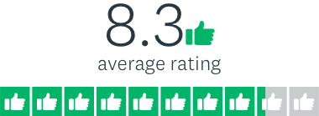

23. How would you rate Wan Smolbag's effectiveness in supporting people in Vanuatu (including youth) to have a greater awareness of environmental issues facing their communities?

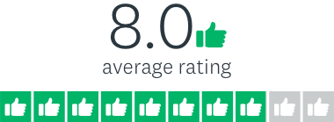

24. How would you rate Wan Smolbag's effectiveness in supporting people in Vanuatu (including youth) to engage in more effective natural resource management in their communities?

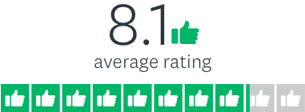

25. How would you rate Wan Smolbag's effectiveness in supporting people in Vanuatu (including youth) to engage in more effective waste management in their communities?



26. How would you rate Wan Smolbag's effectiveness in supporting people in Vanuatu (including youth) to have a greater awareness of human rights, justice and broader issues of governance in Vanuatu society?

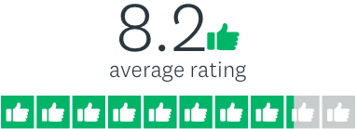

27. How would you rate Wan Smolbag's effectiveness in supporting people in Vanuatu (including youth) to collaborate more with each other to improve issues of governance (including holding leaders more accountable)?



28. How would you rate Wan Smolbag's effectiveness in supporting people in Vanuatu (including youth) to collaborate more with each other to improve respect for diversity and human rights in Vanuatu society?

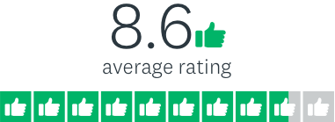

29. How would you rate Wan Smolbag's effectiveness in supporting youth and other vulnerable and 'at risk' groups in Vanuatu to explore and develop their talents, skills and abilities?

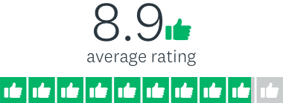

30. How would you rate Wan Smolbag's effectiveness in supporting youth and other vulnerable and 'at risk' groups in Vanuatu to increase their confidence and their capacity to contribute to society?

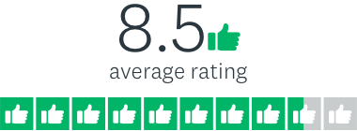

## Wan Smolbag and Gender Equality

31. In your view, how effective is Wan Smolbag in supporting gender equality within their organisation (i.e. through their organisational practices and organisational culture)?

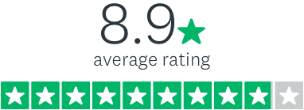

32. In your view, how effective is Wan Smolbag in supporting gender equality through their activities and programming (including those carried out at WSB, through creative media like films and plays, and through their work in communities)?



33. In your view, how effective is Wan Smolbag in supporting gender equality in Vanuatu society more broadly (i.e. through questioning and challenging gendered social norms, raising the profile of gender diverse people and issues, influencing public discourse, etc)?

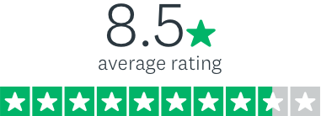

34. Compared to other organisations in Vanuatu working in the area of gender equality, how effective is Wan Smolbag in influencing change in the way women, girls and young women are viewed?



35. Compared to other organisations in Vanuatu working in the area of gender equality, how effective is Wan Smolbag in influencing change in the way we view trans women and gender diverse individuals?



36. Compared to other organisations in Vanuatu working in the area of gender equality, how effective is Wan Smolbag in influencing change in the way we view women and girls with disabilities?



## Some Final Questions about Wan Smolbag

37. In your view, how relevant is Wan Smolbag's work to the issues currently facing individuals, families and communities in Vanuatu?

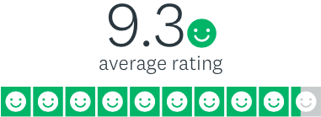

38. In your view, how relevant is Wan Smolbag's work to the issues currently facing young people in Vanuatu?



39. In your view, how relevant is Wan Smolbag's work to the Government of Vanuatu's strategic priorities (i.e. as expressed in Vanuatu 2030: The People's Plan)?

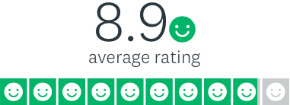

40. Overall, to what extent do you think Wan Smolbag represents good value for money, given their reach and scope, and the diversity and quality of the programming and activities they offer?

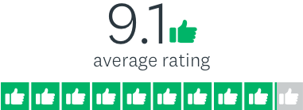

41. How much do you love (or appreciate) Wan Smolbag and their work?

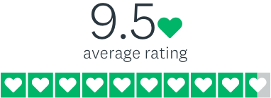

Appendix 2

# Guiding Questions

|  |
| --- |
| 1.Effectiveness |
| 1.1 To what extent has WSB, through their programs and strategic planning, contributed to change at the individual, family, community, organisational, and societal domains in relation to: health and nutrition; environment and resilience; and governance. Are there examples that highlight WSB’s contribution to longer-term change among the individuals and communities in which they work? |
| Overall Approach   * Treated as a higher priority * Examined through a combination of document review, a WSB Management workshop, and interviews with various stakeholders (see below) * Explored to what extent WSB has contributed to change at the individual, family, community, organisational and societal domains in key areas of their work. * Specific aspects or areas of WSB’s work received a greater focus in the evaluation, in a way that supplemented WSB’s existing monitoring and evaluation work. * WSB’s Roadmap for Change outcome statements were used to gauge progress in specific areas. * Considered a range of beneficiaries including vulnerable, marginalised and ‘at risk’ members of society, youth, women and girls, and WSB staff. * Sought specific examples of individuals, groups, communities, organisations that have shown a commitment to institutionalising change. * Some areas were treated as small case studies. |
| Who  These interview questions were posed with:   * WSB staff * Targeted beneficiaries or groups of beneficiaries * Partners * Donors (as appropriate, and to a more limited extent) |
| Indicative Questions   * Both qualitative and quantitative questions were used * Indicative questions:   + What are the key areas in WSB’s work in XXX (health, nutrition, Vanua tai Resource Monitors, etc) where you can see that change has occurred, or WSB’s work has influenced change? What is different now as a result of WSB’s work? Do you have any specific stories of change to share?   + On a scale from 1 to 10 how effective do you think WSB’s work in the area of XXX is in influencing change? Why? Do you have any reasons or examples that support this view?   + In what ways do you think WSB has contributed to change in Vanuatu society? Who are the key groups who have changed as a result of WSB’s work? What are the key areas of change WSB has influenced in Vanuatu society? What questions do people ask as a result of WSB’s work?   + Thinking back on your/WSB’s work over the past few years, can you think of an example where an intervention or activity has resulted in a noticeable change in behaviour or practice? Please provide examples.   + Do you know of any individuals who - as a result of participation in a WSB activity or program - have had an opportunity/ies that they likely would not have had before? Please explain and/or provide examples. |
| 1.2 How effective has WSB been in promoting gender equality (including elimination of violence against women and girls, women and girls in leadership and women’s economic empowerment) and what opportunities are available for them to improve this moving forward? |
| Overall Approach   * Treated as a higher priority * Examined through a combination of document review, a WSB Management workshop, analysis of the staff profile, and interviews with various stakeholders (see below) * Explored WSB’s work in promoting gender equality from a variety of angles: how prominent/prevalent is it in their work; does it get eclipsed by other issues/priorities; how do they view their effectiveness in this area, and how do stakeholders and beneficiaries view their effectiveness in this area; what are key strengths and opportunities, and any missed opportunities. * Each aspect - elimination of violence against women and girls, women and girls in leadership and women’s economic empowerment - was considered separately where this was relevant and possible. * WSB’s organisational practices in the area of gender equality were explored across a variety of angles: strengths, weaknesses, equality of opportunity, pay, treatment, human resources/management handling of domestic violence among staff etc. * Documents including WSB’s reports and monitoring and evaluation products, as well as WSB’s Roadmap for Change were assessed (in a limited way) through a gender analysis lens. * Opportunities to strengthen work into the future were explored. |
| Who  These interview questions were posed with:   * WSB staff * Targeted beneficiaries or groups of beneficiaries * Partners * Donors |
| Indicative Questions   * Both qualitative and quantitative questions were used * Indicative questions:   + Thinking about gender equality and supporting women, young women and girls in all of their diversity, what about WSB makes you especially glad you work here/is particularly noticeable or impressive?   + Thinking back on your time/your experiences with WSB - whether in a community activity, a moment in a play, or a conversation, observation or feeling - when have you seen, heard about, or experienced something relating to gender equality that really impacted you positively and/or had a really positive impact? Explain.   + What unique things/practices/processes does WSB engage in that supports gender equality?   + On a scale from 1 to 10 how effective do you think WSB is in supporting gender equality within their organisation? Through their activities? In Vanuatu society as a whole? Why? Can you provide examples or reasons for your view?   + Compared to other organisations in Vanuatu working more broadly in the area of gender equality, how effective do you think WSB is in influencing change in the way we view women/girls/young women/trans women/women with disabilities, etc. |
| 2. Relevance/Efficiency/Sustainability |
| 2.1 Relevance: Is WSB still focusing on the ‘right’ things? Are there new and emerging issues they could be responding to, and are there aspects of their work that are no longer relevant? |
| Overall Approach   * Treated as a lower priority * Examined through interviews with management, staff, donors and partners (see below) * Explored to what extent WSB is relevant and is able to maintain their ongoing relevance in light of new and emerging issues. * Explored if there are aspects of WSB’s work that are no longer relevant, and if so, how this might be addressed. |
| Who  These interview questions will be posed with:   * WSB management * WSB staff * Partners * Donors |
| Indicative Questions   * A limited number of primarily qualitative questions were posed. * Indicative questions:   + Are there new and emerging issues WSB could or should be focusing on? Is WSB best suited to be providing this activity or service? Why or why not?   + How well positioned is WSB to pivot to new and emerging opportunities? Are there examples of where this has happened/worked well/been problematic? What were the impacts on other work?   + Are there aspects of WSB’s work that are no longer relevant or are less relevant to the broader context in Vanuatu or to their own scope of work and mandate? If so, how might this be managed? |
| 2.2 Efficiency: How well are WSB resources being used? Are there efficiencies that could be gained by adjusting the WSB portfolio (through spinning off, dropping or sharing delivery costs of activities)? |
| Overall Approach   * Treated as a lower priority * Examined through a WSB Management workshop, and interviews with various stakeholders (see below) * Explored the overall efficiency of the use of resources at WSB (economically and in terms of time and organisational efficiency) * Explored WSB’s experiences with spinning off, dropping or cost-sharing activities, in terms of costs and benefits, and lessons learned. * Considered whether greater efficiency has been achieved for WSB through increased donor harmonisation, and whether this aspect can be improved in any way. |
| Who  These interview questions were posed with:   * WSB management * Partners (to a limited extent) * Donors (to a limited extent) |
| Indicative Questions   * Primarily qualitative questions were used, although some quantitative questions were posed as well. * Indicative questions:   + How many programs has WSB ‘spun off’ or dropped in its history? How has this worked? Has this resulted in greater efficiencies?   + How many cost-sharing relationships has WSB engaged in, with which partners/stakeholders? Which have been most effective and why?   + Are there any aspects of WSB’s current work that could be managed in a cost-sharing way (but that currently are fully funded by WSB)? Who takes care of the management and reporting aspects in these situations?   + For Partners: If you are funding aspects of WSB work, how do they compare in terms of efficiency and value for money with other organisations you work with?   + For WSB Management: Since the 2012 review, have things improved in terms of your workload managing your relationship with donors (proposal writing, grant or funds management, reporting, donor engagement/demands, etc.)?   + For WSB Management: Approximately how much of your time do you spend managing donor relationships? Could this be improved? If so, how? |
| 2.3 Sustainability: How potentially sustainable is WSB’s work (financially, socially and environmentally)? |
| Overall Approach   * Treated as a lower priority * Examined through interviews with various stakeholders (see below) * Generally assessed the potential sustainability of WSB and their work (financially, socially and environmentally) * Explored whether WSB benefits will last, and aspects that might influence this positively or negatively. |
| Who  These interview questions were posed with:   * WSB management * Partners (to a limited extent) * Donors (to a limited extent) |
| Indicative Questions   * Primarily qualitative questions were used, although some quantitative questions were posed as well. * Indicative questions:   + What aspects of WSB’s work relate to environmental sustainability? Will some of these benefits last?   + How sustainable might WSB be without core funding? Should economic sustainability be an overarching goal for WSB’s work?   + What are the aspects of WSB’s work that might influence positively and negatively the sustainability of the social aspects of WSB’s work? How does their work/style of work support or inhibit lasting change?   + Has WSB changed the landscape of Vanuatu society? How/in what ways? What are the contributing factors? |

A limited number of stakeholders were also asked about WSB’s Roadmap for Change. Those findings are not part of this report and will be addressed separately.

Appendix 3

# Documents

|  |  |
| --- | --- |
| Wan Smolbag Documents |  |
| 1. | WSB Annual Reports 2015 to 2019 |
| 2. | WSB Progress Reports 2015 to 2020 |
| 3. | WSB Monitoring and Evaluation Framework 2018 |
| 4. | WSB Roadmap for Change 2014-2025 suite of documents, including:   * Overview and Implementation of WSB’s Roadmap * Broader Context * Roadmap for Change 2014 – 2025 * Monitoring, Evaluation and Learning Toolkit * WSB risk management matrix * Financial Sustainability Analysis |
| Previous Wan Smolbag Reviews and Evaluations |  |
| 5. | Wan Smolbag Mid-Term Review Report (2012) |
| 6. | Evaluation of Wan Smolbag Sexual and Reproductive Health Project (2011) |
| 7. | Burnet Institute and WSB Reproductive Health Services Research – Feedback for Wan Smolbag (2010) |
| 8. | Mid-Term Review: Wan Smolbag Vanuatu (2009) |
| 9. | Wan Smolbag Financial Sustainability Review, Nick Gorshenin, Australian Business Volunteer (2016) |
| Key Donor Documents |  |
| 10. | WSB Tripartite Agreement – DFAT, MFAT and Oxfam |
| 11. | WSB Covering Note (MFAT Design Summary) |
| 12. | WSB Design Summary (DFAT) |
| Other Documents |  |
| 13. | Vanuatu’s National Gender Equality Policy 2015-2019 |
| 14. | Vanuatu 2030: The People’s Plan |
| 15. | Gender and LGBTQI+ Policy and Programming in Vanuatu (September 2020) |
| 16. | The Power of Gender-Just Organizations: Toolkit for Transformative Organizational Capacity Building, Oxfam Canada |
| 17. | The Power of Gender-Just Organizations: A Conceptual Framework for Transformative Organizational Capacity Building, Oxfam Canada |
| 18. | Organizational Capacity Assessment Tool for Gender-Just Organizational Strengthening, Oxfam Canada |
| 19. | DFAT Gender equality and women’s empowerment strategy (February 2016) |
| 20. | DFAT Partnerships for Recovery: Australia’s COVID-19 Development Response |
| 21. | DFAT Vanuatu COVID-19 Development Response Plan (October 2020) |
| 22. | ‘“Twisting and spinning” theatre into coastal fisheries management: Informing and engaging communities to address challenges’, Pita Neihapi et al, SPC Women in Fisheries Information Bulletin #30 (September 2019) |
| 23. | What influences the form that community-based fisheries management takes in Vanuatu?, Rolenas Baereleo Tavue et al, SPC Traditional Marine Resource Management and Knowledge Information Bulletin#37 (November 2016) |
| 24. | Documentation of Wan Smolbag’s Vanua-Tai Resource Monitor Program in Vanuatu, Francis R. Hickey and George Petro (March 2005) |
| 25. | Solid Waste Management in the Pacific: Vanuatu Country Snapshot, ADB (June 2014) |
| 26. | Community Clean Up Campaign & Community Awareness Mini Programmatic Report, Ericksen Packett, 19 November 2019 |
| 27. | Environmental Planning Approaches for Mainstreaming the Environment into Development Processes in the Pacific: Vanuatu Case Study, Matt McIntyre et al, SPREP (October 2004) |
| 28. | 6th National Report for the Convention on Biological Diversity: Vanuatu, UN Environment (August 2019) |
| 29. | National Integrated Water Resource Management Diagnostic Report: Vanuatu, SOPAC (November 2007) |
| 30. | Tagabe River Catchment Management Plan 2017-2030, Vanuatu Ministry of Lands and Natural Resources |
| 31. | Learning from survivors of development-induced displacement: Operationalising Vanuatu’s new displacement policy toward an inclusive Capital city, Jennifer Day and Margaretha Wewerinke-Singh, IDMC (2019) |
| 32. | Theatre and Empowerment: Community Drama on the World Stage, Richard Boon and Jane Plastow, Eds, Cambridge University Press (2004) |
| 33. | Sado – A Novel and Expressions of Creativity and Rhetorical Alliance: Ni-Vanuatu Women’s Voices, Mikaela Nyman, PhD Thesis, University of Wellington (2020) |
| 34. | Rethinking “safe spaces” in children’s geographies, Natalie Djohari et al, Children’s Geographies 16:4 (2018) |

Appendix 4

# Schedule

|  |  |
| --- | --- |
| Date | Task/Details |
| 8 October 2020 | Contract signed |
| 9 to 15 October 2020 | Development of Draft Evaluation Plan |
| 16 October 2020 | Circulation of Draft Evaluation Plan to Reference Group |
| TBD Week of 19 October 2020 | Presentation of Draft Evaluation Plan to Reference Group and development of interview guides |
| On or before 30 October 2020 | Final Evaluation Plan submitted to Reference Group -  Completion of Output 1 |
| 1 November 2020 | Complete document review and completion of interview guides |
| 2 November to 4 December 2020 | Interviews and consultations with stakeholders (see Appendix 3 for details on who will be interviewed):   * Week of 2 November – WSB managers/key staff * Week of 9 November – donors/partners * Week of 16 and 23 November – WSB staff, actors and beneficiaries * Week of 30 November – Outstanding interviews |
| 7 to 18 December 2020 | Analysis of findings and preparation of Draft Evaluation Report |
| 15 December 2020 | Presentation of Preliminary Findings/Aide Memoire |
| 24 February 2021 | Circulation of Draft Evaluation Report to Reference Group -  Completion of Output 2 |
| 29 March 2021 | Comments and feedback received from Reference Group |
| 12 April 2021 | Final Evaluation Report submitted to Reference Group -  Completion of Output 3 |

Appendix 5

# Stakeholders Interviewed

Interviews were primarily conducted with individuals; however, some stakeholders were interviewed as a small group and a limited number of focus group interviews were conducted.

|  |  |  |
| --- | --- | --- |
| Organization | Individual/s | Interviewer |
| 1. Wan Smolbag | 1.1 Nelson Johnson, CEO | Team Leader |
|  | 1.2 Peter Walker, Artistic Director | Team Leader |
|  | 1.3 Jo Dorras, Scriptwriter | Team Leader |
|  | 1.4 Jodi Devine, Monitoring and Evaluation | Team Leader |
|  | 1.5 Siula Bulu, Clinic Manager | Team Leader |
|  | 1.6 Emma Dorras, Nutrition Program Manager | Team Leader |
|  | 1.7 Rick Hinton, Youth Centre Manager | Team Leader |
|  | 1.8 Alpha Salong, Youth Centre Manager | Team Leader |
|  | 1.9 Colwick Fred, NCYC Coordinator | Team |
|  | 1.10 Actors (Main Group) | Team |
|  | 1.11 Actors (Rainbow Theatre) | Team |
|  | 1.12 Other WSB staff | Team |
|  | 1.13 Former WSB Volunteers | Team Leader (email) |
| 1. Beneficiaries | 2.1 Young women from the Youth Centre | Team |
|  | 2.2 Young men from the Youth Centre | Team |
|  | 2.3 Nutrition Centre participants | Team |
|  | 2.4 Other beneficiaries | Team |
|  | 2.5 VPride members | Team Leader |
| 1. New Zealand MFAT | 3.1 Minnie Takaro, Programme Manager - Education/Youth/Gender | Team Leader |
|  | 3.2 Esther Jens, Second Secretary - Development | Team Leader |
| 1. Australian DFAT | 4.1 Renie Anderson, Program Manager – Safer Communities (Maternity leave) | Team Leader |
|  | 4.2 Cathy McWilliam, First Secretary | Team Leader |
|  | 4.3 Pamela Carlo, Senior Program Manager | Team Leader |
|  | 4.4 Helen Corrigan, Senior Program Manager | Team Leader |
| 1. Oxfam Vanuatu | * 1. Elizabeth Faerua, Country Director | Team Leader |
| 1. Partners/ Others | 6.1 Megan Chisholm, Country Director, CARE | Team Leader |
|  | 6.2 Yasmine Bjournum, Director, Sista | Team Leader |
|  | 6.3 Michael Taurakoto, Country Coordination Specialist, UN | Team Leader |
|  | 6.4 Kendra Derousseau, Country Director, World Vision Vanuatu | Team Leader |
|  | 6.5 Relvie Poilapa, Senior Program Quality Coordinator, World Vision Vanuatu | Team Leader |
|  | 6.6 Douglas Koran, Vanuatu Fisheries Department | Team |
|  | 6.7 Erickson Packet, PEBBAC/Ministry of Environment | Team |
|  | 6.8 Nerida Hinge, Nutrition Officer, Ministry of Health | Team |
|  | 6.9 Amelia Lawac, Administration Manager, Vanuatu Cricket Association | Team |
|  | 6.10 Ralph Regenvanu, MP, Leader of the Opposition | Team Leader (email) |
|  | 6.11 Pita Neihapi, Coastal Fisheries Programme, SPC | Team Leader |
|  | 6.12 Hanna Wetterstrand, Programme Officer, SwedBio | Team Leader |
|  | 6.13 Dirk Steenbergen, Research Fellow, University of Wollongong | Team Leader |
|  | 6.14 Bill Bellotti, School of Agriculture and Food Sciences, University of Queensland | Team Leader |
|  | 6.15 Karen Fukofuka, NCD Advisor – Food Security, SPC | Team Leader |
|  | 6.16 Anna Naupa, Country Director, Australia Pacific Training Coalition | Team Leader |
|  | 6.17 Kate Duggan, Team Leader, Australia Pacific Climate Partnership | Team Leader |

Appendix 6

# Wan Smolbag Theatre Program Logic (2018)

|  |  |  |  |  |  |  |  |
| --- | --- | --- | --- | --- | --- | --- | --- |
| Program Purpose | Strategies | Outputs |  | Short Term Outcomes (1 year) | Medium Term Outcomes (5 year) | Long Term Outcomes (10 year) | Program Goal |
| Create and promote an environment of change at all levels through opportunities for dialogue and engagement around key social, environmental and governance issues | Health | * Women and men serviced by Reproductive Health (RH) Clinic * Women and men supported by RH Peer Education and Outreach * Women and men serviced by Nutrition Centre | * Creative Med**ia** Productions: plays, films,   audio & print material | * Youth, At Risk Groups (ARG) and community women and men aware of health issues – their causes and prevention | * Youth, ARG and community members adopt informed choices to improve their health and well-being | * Youth, ARG and community members commit to improving health and well-being in their locality / society | A strong and well-governed Vanuatu across all sectors of society |
| Create and promote an environment of change at all levels through opportunities for dialogue and engagement around key social, environmental and governance issues | Environment | * Vanua-Tai Resource Monitors Network data sets and community engagement * Waste Management data sets and community engagement * Disaster Risk Reduction (DRR) data sets and community engagement | * Creative Med**ia** Productions: plays, films,   audio & print  material | * Community women, men, youth and school students aware of environmental issues; their causes and management options | * Community women, men, youth and school students adopt more effective natural resource management, waste management, and DRR strategies in their locality/society | * Communities and school students commit to improving environmental sustainability and community resilience in their locality / society | A strong and well-governed Vanuatu across all sectors of society |
| Create and promote an environment of change at all levels through opportunities for dialogue and engagement around key social, environmental and governance issues | Governance | * Community women, men and youth engaged in workshops and participatory drama * Young women and men engaged by Youth Centre | * Creative Med**ia** Productions: plays, films, audio & print   material | * Community women, men and youth aware of legislation, human rights, justice and governance issues – their causes and management * Youth and ARG explore & develop their talents, skills and capabilities | * Community members collaborate with each other and others to improve governance in their locality * Youth and ARG increase their confidence and capacity to contribute to society | * Community members commit to improving governance in their locality / society * Community members commit to tolerance, acceptance and respect towards Youth and ARG in their locality / society | A strong and well-governed Vanuatu across all sectors of society |
| Organisation and Financial Management | | | | | | | | |
| Monitoring and Evaluation | | | | | | | | |