

# CALL FOR EXPRESSIONS OF INTEREST

VISITING LEGAL FELLOW PROGRAM

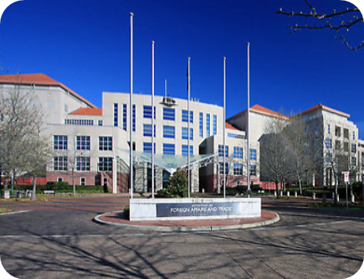**THE DEPARTMENT OF FOREIGN AFFAIRS AND TRADE IS SEEKING EXPRESSIONS OF INTEREST FROM AUSTRALIAN ACADEMICS TO BE APPOINTED AS VISITING LEGAL FELLOWS.**

The purpose of the Visiting Legal Fellow Program is to encourage greater dialogue between the Department’s legal advisers and academia on new and developing international legal issues.

Through this call for expressions of interest, the Department intends to appoint two Visiting Legal Fellows for 2022-2023. To be eligible to apply, you must be an academic at an Australian university and be working on, or have previously worked on, international legal issues.

As a Visiting Legal Fellow, you will deliver an international law lecture in the Department, participate in at least two closed workshops with Departmental staff on your areas of expertise and experience, and deliver an all-staff presentation for the Department’s Legal Division. You may also be invited to participate in other activities, such as joining an Australian delegation. The duration of your appointment as a Visiting Legal Fellow will be for a period of 24 months.

Participation in the program will be self-funded but, for academics not based in Canberra, the Department may reimburse reasonable travel expenses for up to 3 trips to Canberra.

The Department invites eligible academics to submit expressions of interest. Your expression of interest should consist of a statement addressing how your appointment as a Visiting Legal Fellow would be mutually beneficial (no more than 500 words), a biography (no more than 150 words) and a Curriculum Vitae (no more than 3 pages).

Expressions of interest must be submitted to [**DFAT.Legal@dfat.gov.au**](mailto:DFAT.Legal@dfat.gov.au) by **6pm AEST on Friday, 1 October 2021**.

A selection committee will be responsible for recommending appointments to the delegate. The delegate’s decision regarding the appointments will be final.