Government of Mongolia / UNICEF Programme

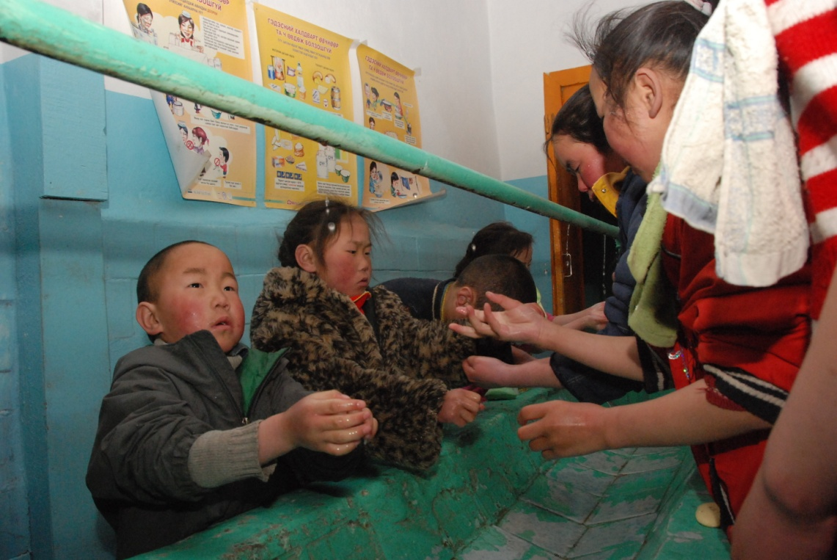

Funding Proposal


Water, Sanitation and Hygiene in rural and peri-urban schools in Mongolia - WASH in Schools

March 2011

Government of Mongolia – UNICEF Programme of Cooperation

Proposal for AusAID
25 March 2011

Title: Water, Sanitation and Hygiene in rural and peri-urban schools in Mongolia - WASH in Schools

Funds requested: $US 3,046,290

Duration: 01 Jan 2012 – 31 Dec 2016 (5 years)

Provinces covered: Selected schools in the most disadvantaged areas

Reporting: One progress report on 31 December of each year and the final report
on 30 June, 2017

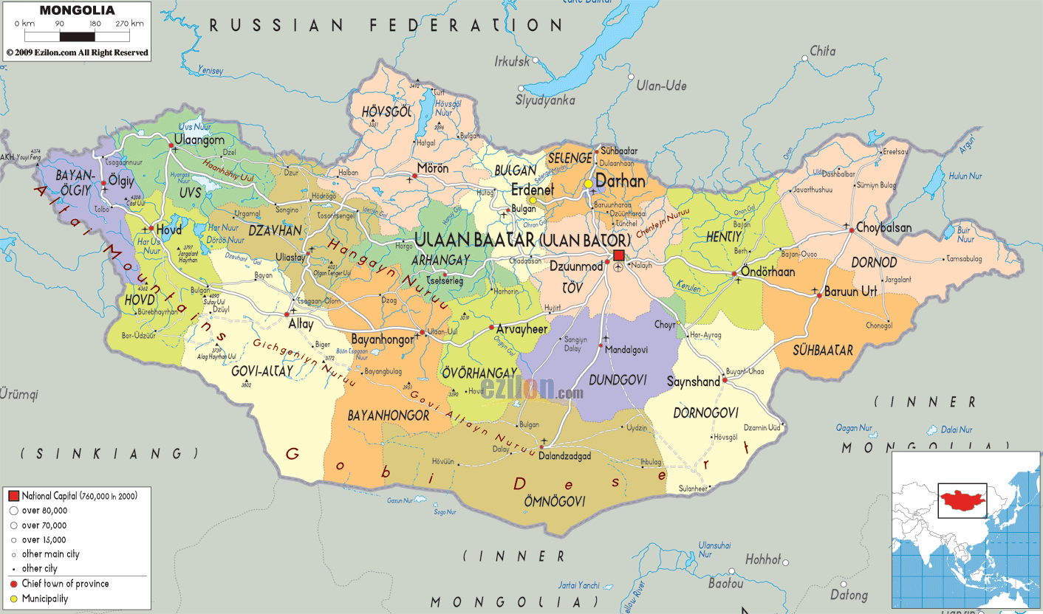
Administrative Map of Mongolia
- Introduction

The lack of appropriate access to water, sanitation and hygiene constitutes a silent emergency for the children of Mongolia. UNICEF is teaming-up with all relevant actors to ensure a comprehensive approach to turn this situation around. UNICEF believes that interventions that combine the provision of safe drinking water, improved sanitation and hand washing facilities in schools along with hygiene education can dramatically improve the health and education of children.

- Analysis

Today, more than 25 percent of the Mongolian population does not have access to safe water, while more than 50 percent have no access to adequate sanitation. There is a large urban-rural gap associated with access to water and sanitation, with approximately twice as many rural people denied access to sanitation and water compared to urban dwellers. Even in urban areas, particularly the ger areas (suburban slums) of Ulaanbaatar, people are forced to live without proper public services.

The lack of access to safe water and hygienic sanitation results in increased levels and severity of diarrhea and hepatitis among the Mongolian population, with children being the worst affected. It is estimated that nearly 2,000 Mongolian children under five years of age suffer from episodic diarrhea each year as a result of poor water and sanitation conditions -- diarrhea is closely linked to child malnutrition, morbidity, and mortality. Hepatitis A poses an even greater threat. Transmitted through fecal contamination of water and food, Hepatitis A is endemic in Mongolia. In 2008, 9,295 cases were diagnosed, accounting for 22 percent of communicable diseases. Of the Hepatitis A cases recorded in 2007, over 36 percent occurred among children between five and nine years of age (Health Indicator, MoH, 2008). Hepatitis A results in considerable long-term costs for health systems, loss of productivity among workers and early death.

Safe and reliable access to water, sanitation and hygiene are also important prerequisites for ensuring the right to basic education. The status of access to water and sanitation in schools constitutes a serious violation of children’s rights in Mongolia, a fact most recently reinforced by the Special Rapporteur on the Right to Education. Mongolian children are often unable to attend classes because they are too busy fetching water from distant sources. A household survey conducted in 2004 showed that 36 percent of children spend an average three to four hours per day collecting water for household use. Anecdotal evidence suggests that the situation has improved little in the years since this survey was conducted.
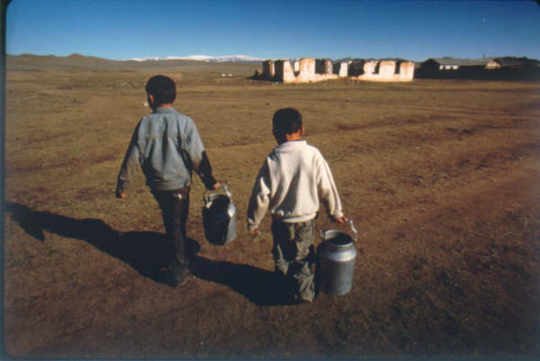
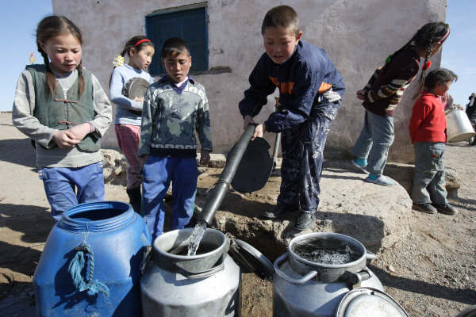
Collecting water is usually a task performed by children © UNICEF Mongolia/2007/Jim Holmes

At the school facility level, a 2005 WHO and Ministry of Health (MoH) survey showed that only 25 percent of district schools had improved sanitation. With regards to water, only 28 percent of district schools had access to water, of which only 50 percent met safety standards for drinking water. However, the most flagrant violation of this right is seen in rural schools where dormitories that house the children of nomadic families almost universally lack safe water sources, adequate sanitation, and hand-washing facilities.

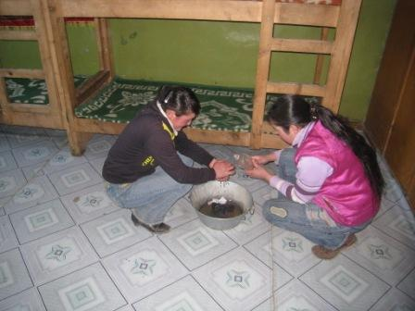
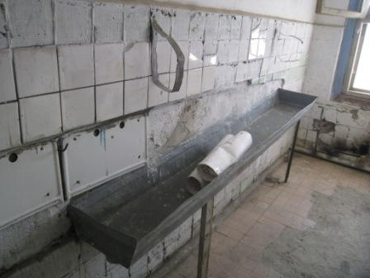
Hand washing facility is ruined in rural school dormitories and children cannot wash their hands properly - ©Takashi Honda/2009

In 2007, a study on school dormitory conditions conducted by the Ministry of Education, Culture and Science (MECS) and UNICEF revealed the difficulties to follow health and hygiene standards in school dormitories due to several factors including non-standard buildings used as dormitories, overcrowded rooms, the lack of an adequate heating systems, lack of proper WASH facilities as well as provisions for other basic necessities. The water supply for 73.9 percent of 502 dormitories currently in use is carried from outside water kiosks and wells, and 45.7 percent of the water supply does not meet hygienic standards. Only 21.7 percent of the dormitories have indoor latrines and the remaining 78.3 percent have outdoor latrines that are mostly unsafe and unhygienic. There is currently no data available on bathrooms where children can take a shower. The study also revealed that the learning achievement of students from grades 4, 6 and 9 staying in a dormitory with a central water supply system and indoor latrines is higher by 9 points in mathematics and 7.4 points in Mongolian language compared to that of students staying in a dormiotry with no such facilities.

The inadequate state of latrines, combined with the harsh winter climate makes open defecation a common practice among primary school-aged children in school and school dormitories` yards. In rural areas, most unimproved sanitation facilities are built some distance behind school yards where children have to walk over 100 meters to reach them. This includes making the trip when temperatures drop as low as -40c, and these same latrines were not designed for use in extreme cold conditions.

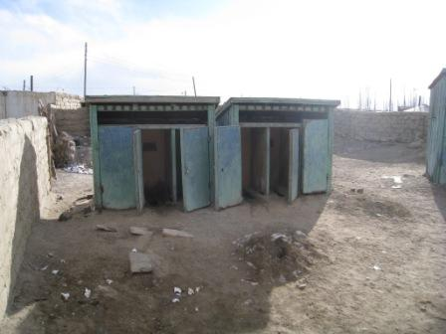
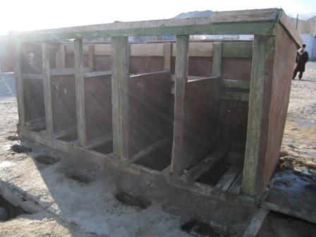

School latrines does not meet hygiene requirement. Open Defecation is seen as common - ©Takashi Honda/2009

- Potential Policy Implications

The proposed activity is directly linked into UNICEF Mongolia’s current programming and the 2012 – 2016 UN Development Assistance Framework (UNDAF). The overall goal of activity directly aims to support the UNDAF four strategic outcomes and links to the UNICEF Country Program in that the activity will support the efforts of the Government on child-related Millennium Development Goals in the National Development Strategy 2015 and supports the National Programme of Action for the Development and Protection of Children, 2002-2010.

The project relates to access-to-water and sanitation. Environmental impacts of improved water and sanitation will benefit from efficient delivery and raised awareness of good practice.

There are no activities at this stage which would suggest an early check on environmental issues that are required to ensure compliance with AusAID's legal obligations; for example, under the Environment Protection and Biodiversity Conservation Act.

This activity would not involve directly working with children. In the instance where children may come into contact under the activity, strict adherence to the UNICEF Child Protection policy would be enforced.

- Activity Description

  - Project Goal:

Through improved access to WASH and the creation of Child-Friendly Schools and Child-Friendly Communities, the project aims to: i) improve the WASH MDG achievement in Mongolia and, ii) to improve the promotion and protection of children’s rights to education and health.

This will not only help directly targeted persons, but also indirectly the whole country, as model project to inform policy and decision makers.

  - Objectives

- In the UNICEF focus areas, model Child-Friendly Schools and Child-Friendly Communities with appropriate WASH are piloted and used as good practice models;
- The partner government and partners’ long-term commitments and buy-in are ensured by the end of the project.

  - Outcomes and Activities

Outcome 1: Model WASH facilities in selected schools, kindergartens and local communities (soums) is piloted and tested.

- Activity 1.1. Construct WASH complexes each year in 2 kindergartens and 2 rural schools, including dormitories in selected target areas, based on feasibility study and Environmental Impact Assessment (EIA).
WASH complex covers:
  - One groundwater well
  - Sanitation rooms for girls and boys
  - Small-scale waste water treatment and
  - Water supply and sewages pipelines

There will be one complex for each kindergarten and schools, including boys and girls dormitories. Feasibility studies and EIA assessments will be carried-out prior to construction work.

- Activity 1.2. Based on the feasibility study and detailed drawings carried-out earlier by the Government and supported by UNDP, the requested contribution is planned to construct 2 model rural district center water supply networks and -water treatment systems, assuring that schools are the largest beneficiary. EIA will be carried out prior to construction works, focusing on sewage networks and waste-water systems. Currently, all district centers are not connected with such systems. Therefore, these selected districts will serve as model cases for further replication in Mongolia for central and local government investment in the future.
- Activity 1.3 Based on the piloted models, document best practices for further community engagement, and scaling-up demonstrations of the health benefits.

Outcome 2: Local Community and School Children behavior on WASH is changed due to promotion of Communication for Development (C4D) activities and advocacy

- Activity 2.1. Evaluate and analyze pilot project outcomes together with local communities, local and central governments, and develop policies with tangible recommendations and strategy paper to replicate in other provinces in future: In collaboration with the government and other participating agencies, a policy brief will be prepared for decision makers based on the best practices and lessons learned from the specific interventions (meetings and press-trips).

- Activity 2.2. Conduct a public awareness campaign on water supply, environmental sanitation and hygiene and develop IEC (Information, Education, Communication) materials to promote Child-Friendly Schools (CFS) concept and strategy for service providers, school teachers and caregivers.

- With the support of public media, various awareness raising campaigns will be conducted to reach out to the general public. This activity is in addition to booklets, guidelines, manuals and brochures and other materials developed, published and disseminated with extensive participation of children and communities to various target groups, including communities, school children, lecturers and healthcare workers and operational application of M&E toolkit for evidence-based C4D planning, implementation and monitoring.

Outcome 3: Capacity of target schools, kindergartens and communities is increased for maintenance of WASH facilities

- Activity 3.1. Training on the operation and maintenance of WASH facilities will be conducted to ensure proper maintenance of the facilities.

- Activity 3.2. Training on safe water supply, proper sanitation and hygiene practices will be conducted among school children and teachers.

- Activity 3.3. Capacity building activities (e.g. study tour, training) will be organized for decision makers and the general public on “WASH in Schools” and CFS.

- Activity 3.4. At each school supported by WASH facilities, establishment of a Child Development Center (CDC) will be created.

- Activity 3.5. Build capacity for school Parent-Teacher Associations (PTAs) on “WASH in Schools” and CFS in collaboration with local governments for their contribution to improve the school environment for school children as well as hygiene promotion in kindergartens and rural schools, including dormitories: The knowledge obtained at the school should be realized at home, in order to have an impact on their families and neighbors. Therefore, collaboration of the parents and teachers is essential. Workshops will be organized for family members and the local community, linking and sharing children’s school experiences.

  - Approach for Delivery

A third party will be hired to execute the planned activities under supervision of a joint committee UNICEF, Government of Mongolia, AusAID and other project beneficiaries.

  - Management Model

The project will be directly managed by UNICEF in close collaboration with the joint committee UNICEF, Government and beneficiaries.

  - Stakeholders and Implementation Partners:

The key implementation partners are as follow:
- Ministry of Education, Culture and Science: Overall management
- Provincial Governments: Monitoring and Coordination
- Ministry of Health : Health Promotion and Water & Sanitation Standards
- WHO : Technical assistance and monitoring access to water and sanitation per JMP standards
- UNDP: Partnership on both planned intervention and policy-making and institutional arrangement on WATSAN
- World Vision / Action Contre La Faim : Community mobilization, service delivery and experience sharing

  - Partner Government Commitments

Commitment to scale up the project into other areas of the country.

- Design, Implementation and Resourcing

  - Design Process

The project will be designed in close collaboration with the beneficiaries and the Government of Mongolia. A design and implementation document will be produced by UNICEF and provided to AusAID for subsequent quality processes.

  - Engagement Plan

The project will be implemented according to the proposal and based on the signed agreement. Please see the attached Engagement Plan detailing AusAID’s proposed role in the project design phase and implementation.

  - Budgeting of the proposed activities

Required budget for project implementation is estimated in below table.

Activity |  | Budget |  |  |  |  | Total
 |  | 2012 | 2013 | 2014 | 2015 | 2016 | Total
1. Provision of WASH facilities
Construction of complex WASH facilities in rural and peri-urban schools and kindergartens (2 schools and 2 kindergartens each year) | Feasibility study, construction designs and Environmental Impact Assessment | 30,000 | 30,000 | 30,000 | 30,000 | 30,000 | 150,000
 | Water supply groundwater well (4 wells*$10,000) | 40,000 | 40,000 | 40,000 | 40,000 | 40,000 | 200,000
 | Sanitation rooms for girls and boys (8 rooms*$8,000) | 64,000 | 64,000 | 64,000 | 64,000 | 64,000 | 320,000
 | Small-scale waste water treatment system (4 units*$20,000) | 80,000 | 80,000 | 80,000 | 80,000 | 80,000 | 400,000
 | Water supply and sewage pipelines (2 soums*$10,000) | 20,000 | 20,000 | 20,000 | 20,000 | 20,000 | 100,000
Construction of a model, rural district (soum) center water supply network and waste water treatment system in selected areas (only connecting public buildings, including schools and kindergartens) |  | 100,000 | 200,000 | 0 | 0 | 0 | 300,000
Based on the piloted models, document the best practices for further community engagement and scaling-up demonstrating the health benefits. |  | 10,000 | 50,000 | 30,000 | 10,000 | 10,000 | 110,000
2. Communication for Development and advocacy
Evaluate and analyze pilot project outcomes together with local communities, local and central governments, and develop policies with tangible recommendations and strategy paper to replicate in other provinces (meetings and press trips) |  | 5,000 | 5,000 | 5,000 | 5,000 | 5,000 | 25,000
Conduct a public awareness campaign and develop IEC (Information, Education, and Communication) materials to promote CFS concept with the use of M&E toolkit for evidence-based C4D. |  | 10,000 | 10,000 | 10,000 | 10,000 | 10,000 | 50,000
Develop and disseminate behavior change communication materials on water supply, environmental sanitation and hygiene. |  | 10,000 | 10,000 | 10,000 | 10,000 | 10,000 | 50,000
3. Capacity Building
Capacity building for proper management of model WASH facilities (trainings) |  | 4,000 | 4,000 | 4,000 | 4,000 | 4,000 | 20,000
Training on safe water supply, proper sanitation and hygiene practices |  | 6,000 | 6,000 | 6,000 | 6,000 | 6,000 | 30,000
Capacity building for decision-makers and the general public (study tour ) |  | 20,000 | 5,000 | 15,000 | 5,000 | 5,000 | 50,000
Support establishment of Child Development Centers at each schools supported by WASH facilities. |  | 18,000 | 18,000 | 18,000 | 18,000 | 18,000 | 90,000
Build capacity for school Parent-Teacher Associations on "WASH in Schools" and CFS (trainings) |  | 5,000 | 5,000 | 5,000 | 5,000 | 5,000 | 25,000
4. Project management
Monitoring of activities and project documentation cost |  | 10,000 | 5,000 | 5,000 | 5,000 | 12,000 | 37,000
Staff cost |  | 200,000 | 200,000 | 200,000 | 200,000 | 200,000 | 1,000,000
Total |  | 632,000 | 752,000 | 542,000 | 512,000 | 519,000 | 2,957,000
UNICEF Headquarters recovery cost (7 %) |  | 44,240 | 52,640 | 37,940 | 35,840 | 36,330 | 206,990
Overall Total |  | 676,240 | 804,640 | 579,940 | 547,840 | 555,330 | 3,163,990

  - Coordination

The project will be coordinated by UNICEF in close collaboration with the joint committee UNICEF, Government and beneficiaries. AusAID will be part of the joint committee.

The project will coordinate the multiple stakeholders and interests to ensure effective implementation and local stakeholder buy-in.

  - Implementation Time-frame

2012 - 2016

  - Critical Risks

The following risks actions have been identified to mitigate the possible risks that could occur during implementation.

# | Potential risks | Actions to address
1 | Construction and designing costs for WASH facilities may change | Adapt allocated budgets based on situations and use UNICEF regular financial resources if needed.
2 | Small-scale waste water system (e.g. septic tank) may not be feasible in some places (e.g. groundwater table could be too close to surface) and negatively affect the environment | Conduct a detailed environmental impact assessment and design environmentally-friendly facilities accordingly. If this implicates additional resources, UNICEF will use its regular financial resources
3 | Ground water well cannot be drilled within estimated depths (50-80 meters). | Adapt allocated budgets based on situations and use UNICEF regular financial resources as needed.
4 | Communities may be not sufficiently involved due to the lack of knowledge and remote location | Outreach engagement with the communities and raising their awareness on the benefits.

  - Monitoring and evaluation

The project monitoring and evaluation will be harmonised with the national, sectoral and local monitoring and evaluation system and will consist of two main components:

Performance monitoring: Performance monitoring will employ UNICEF internal rules and regulations to facilitate the timeliness and quality of services planned under the project. In addition, Government rules and regulations will also be followed particularly in construction in close coordination with the Inspection Office for clearance and certification. The process of project implementation will also be systematically documented in order to make replication of the initiative at national level. This includes management and administrative arrangements and resources management (including human resources and costing of different interventions).

Results monitoring: to monitor the changes for children and community, community based data collection activities will be designed employing both quantitative and qualitative information. National level changes will be monitored using Multiple Indicator Cluster Survey (baseline 2010 and one planned in 2013) and School environment study based on MICS.

M&E Indicators:

Prevalence of diarrhoea among children Community based data collection
Prevalence of hepatitis A among children Community based data collection
Access to improved water Community based data collection
Access to improved sanitation Community based data collection
Hand washing practice Community based data collection
Project annual budget (US$) Community based data collection
Local budget for WASH (US$) Community based data collection
Access to improved water MICS
Access to improved sanitation MICS
Place of hand washing MICS
Availability of soap MICS
Schools with adequate WASH facilities WASH in Schools

Contact Person:
For more information please contact:
Ms. Bolor Purevdorj, Communication Specialist, E-mail bpurevdorj@unicef.org;
Mr. Gilles Fagninou, Deputy Representative – E-mail: gfagninou@unicef.org;
Ms. Rana Flowers, Representative – E-mail: rflowers@unicef.org
Engagement Plan

Institution Requirements
The UNICEF procedures for preparing a project will be followed. These follow a similar approach to that used by AusAID and will include: (i) submission of a Concept Paper; (ii) a Concept Review Meeting; (iii) preparation of the project; (iv) an Independent Appraisal; (v) an Appraisal Peer Review. UNICEF requires that proposed activities are in line with the country programme action plan signed by the partner Government. The above proposed activity has already met this criterion.

The same institutional arrangements that are used by the UNICEF to manage grants/contributions on behalf of other donors would apply to this project.

UNICEF Mongolia would be responsible for contracting and monitoring a third party to implement the project. UNICEF will draw upon in-house expertise to support the project’s management and implementation, and work closely with the partner government to ensure effective communication, information sharing and local buy-in.

Roles and Responsibilities
Design Phase: It is expected that UNICEF Mongolia and Government counterparts will be responsible for preparing the project’s design. The Project Team would be supported by outside consultants, as needed.

The design process will align with AusAID’s quality requirements, and UNICEF will seek input and guidance from AusAID officials during preparation.

Implementation Phase: A third party, contracted by UNICEF will be responsible for supervising the project during implementation, ensuring that funds are used for their intended purpose and within the allocated budget, and reporting. The third party will be managed and monitored by UNICEF in Mongolia.

AusAID officials will participate during implementation, including commenting on the program’s management, coordination and implementation phase.

Information Sharing
All information will be provided to AusAID. In addition, it is proposed to post key documents on UNICEF’s website for Mongolia and possibly, as appropriate, Government websites.

Financial Management and Procurement
All procurement and financial management activities will follow UNICEF’s guidelines and procedures, including the selection of consultants and the acquisition of equipment and supplies. Annual financial audits by an outside accounting firm will be carried out.

Documentation
A Design Summary and Implementation Document will be produced for AusAID’s purposes complementary to any design document produced for the activity, as required by the UNICEF.

Dispute Resolution
Resolution of disputes would follow standard UNICEF procedures.

Of all the MDG targets, Mongolia is least likely to achieve Target 7c: “halve by 2015 the proportion of the population without sustainable access to safe drinking water and basic sanitation”.
The first one, partially funded under this contribution will be constructed in 2012 and the second model, fully funded under this contribution will be constructed in 2013.
These figures are based on estimation, during the implementation small variations could occur.
These arrangements would be confirmed during the design phase.

